Additional Table 1. Baseline characteristics of patients treated with finerenone (n = 91).
Variable | Value
Age, years | 60.47 ± 13.76
Male sex, n (%) | 65 (71.4)
Body mass index, kg/m² | 25.71 (24.11–28.13)
Duration of diabetes, years | 10.00 (4.00–17.00)
Duration of hypertension, years | 8.00 (1.00–14.00)
Systolic blood pressure, mmHg | 136.00 (129.50–142.00)
Diastolic blood pressure, mmHg | 80.00 (72.50–85.00)
HbA1c, % | 7.20 (6.45–7.90)
UACR, mg/g | 84.10 (45.95–218.45)
A3 albuminuria (≥300 mg/g), n (%) | 15 (16.5)
Serum creatinine, μmol/L | 76.00 (62.00–93.50)
eGFR, mL/min/1.73 m² | 89.00 (73.50–105.00)
eGFR ≥60 mL/min/1.73 m², n (%) | 76 (83.5)
Uric acid, μmol/L | 338.00 (279.50–383.50)
Serum potassium, mmol/L | 4.25 ± 0.42
Hypertension, n (%) | 77 (84.6)
ASCVD, n (%) | 17 (19.3)
ACEI/ARB use, n (%) | 81 (89.0)
SGLT2 inhibitor use, n (%) | 49 (53.8)
GLP-1 receptor agonist use, n (%) | 38 (41.8)
Statin use, n (%) | 68 (74.7)
Note: Data are presented as mean ± standard deviation, median (interquartile range), or number (%), as appropriate. Abbreviations: UACR, urinary albumin-to-creatinine ratio; eGFR, estimated glomerular filtration rate; ASCVD, atherosclerotic cardiovascular disease; ACEI, angiotensin-converting enzyme inhibitor; ARB, angiotensin receptor blocker; SGLT2, sodium-glucose cotransporter-2; GLP-1, glucagon-like peptide-1.

Additional Fig. 1 Love plot.
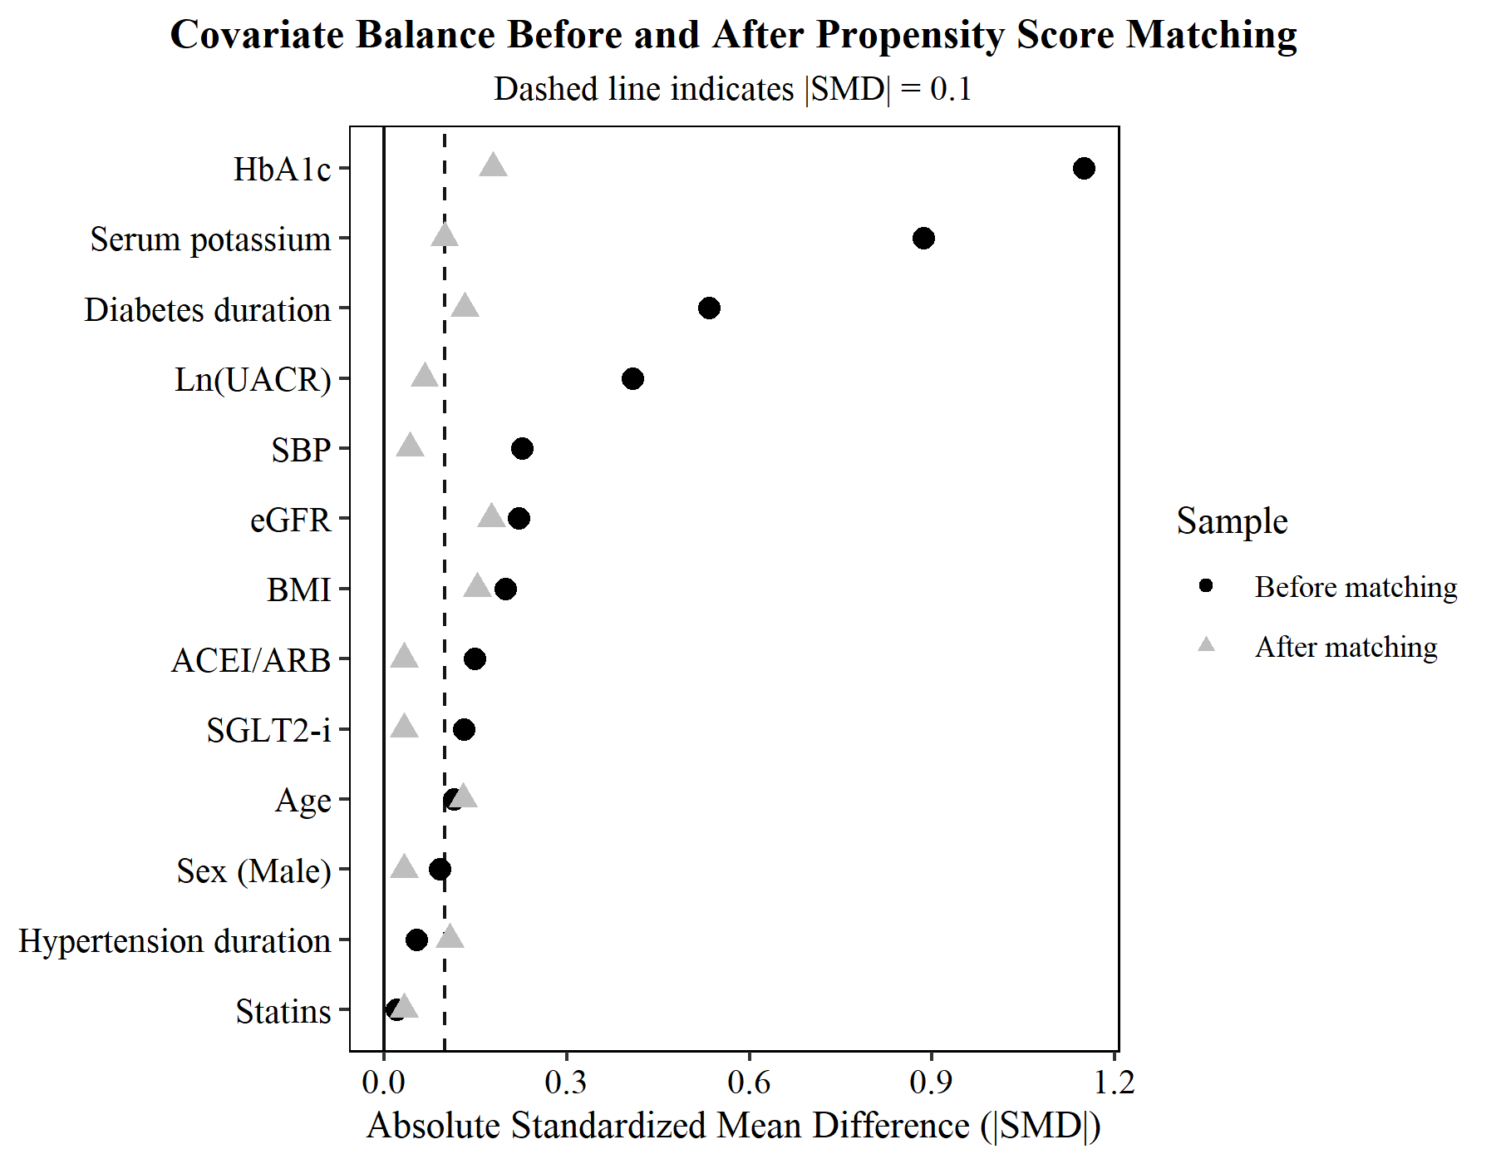

Additional Fig. 2 Sensitivity analysis of individual changes in ln(UACR) from baseline to month 18 among patients with complete 18-month follow-up.
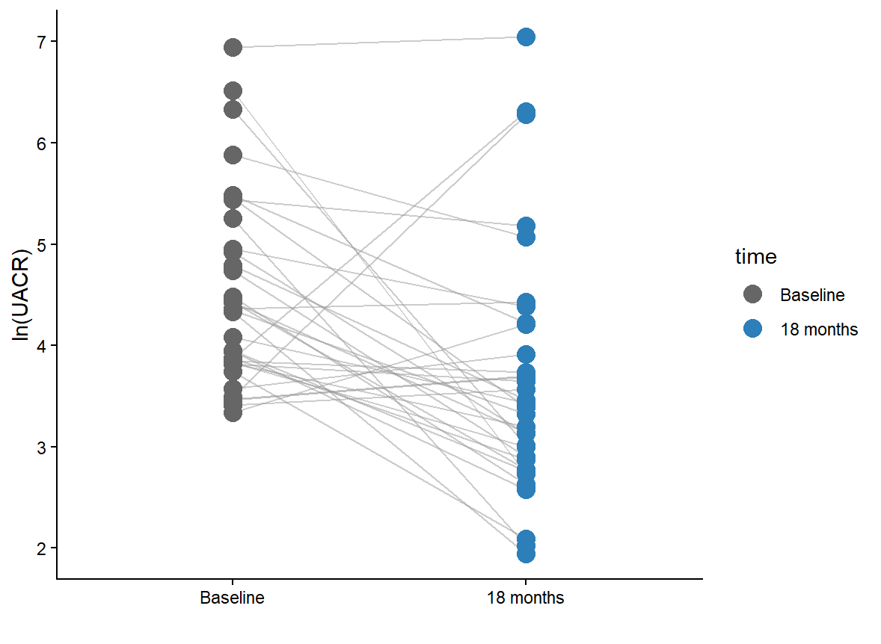
Note: Each line represents an individual patient, with paired measurements connected between the two time points. ln(UACR), natural logarithm-transformed urinary albumin-to-creatinine ratio.

Additional Table 2. Univariable linear regression analyses for predictors of albuminuria response.
Variable | B | Standard Error | P-value
Male /[n (%)] | 0.42 | 0.302 | 0.169
Age (years) | −0.007 | 0.01 | 0.467
BMI (kg/m²) | −0.044 | 0.035 | 0.213
SBP (mmHg) | 0.019 | 0.009 | 0.03
DBP (mmHg) | −0.002 | 0.014 | 0.894
BUN (mmol/L) | −0.059 | 0.067 | 0.376
Scr (μmol/L) | 0.001 | 0.005 | 0.892
UA (μmol/L) | 0.001 | 0.002 | 0.671
eGFR (mL·min⁻¹·1.73m⁻²) | 0.004 | 0.006 | 0.543
ALT (U/L) | −0.002 | 0.009 | 0.812
AST (U/L) | −0.013 | 0.015 | 0.389
Serum sodium (mmol/L) | −0.488 | 1.27 | 0.704
Serum potassium (mmol/L) | −0.245 | 0.354 | 0.49
TC (mmol/L) | 0.145 | 0.13 | 0.271
TG (mmol/L) | 0.03 | 0.104 | 0.772
HDL (mmol/L) | 0.001 | 0.468 | 0.999
LDL (mmol/L) | 0.216 | 0.154 | 0.167
FBG (mmol/L) | −0.020 | 0.086 | 0.818
HbA1c (%) | 0.065 | 0.096 | 0.503
Hypertension duration (years) | −0.024 | 0.017 | 0.161
Diabetes duration (years) | 0.018 | 0.017 | 0.287
Fatty liver /[n (%)] | 0.236 | 0.316 | 0.458
ASCVD /[n (%)] | −0.130 | 0.353 | 0.713
Peripheral neuropathy [n (%)] | −0.192 | 0.275 | 0.487
Retinopathy /[n (%)] | 0.374 | 0.298 | 0.214
Statins/ [n (%)] | 0.292 | 0.328 | 0.378
SGLT2 inhibitors/[n (%)] | −0.221 | 0.273 | 0.421
GLP-1 receptor agonists /[n (%)] | −0.025 | 0.278 | 0.929
Pancreatic kininogenase /[n (%)] | 0.174 | 0.274 | 0.527
ACEI/ARB /[n (%)] | −0.103 | 0.463 | 0.824

Additional Fig. 3 Exploratory longitudinal trajectory of eGFR over 18 months in the finerenone group.
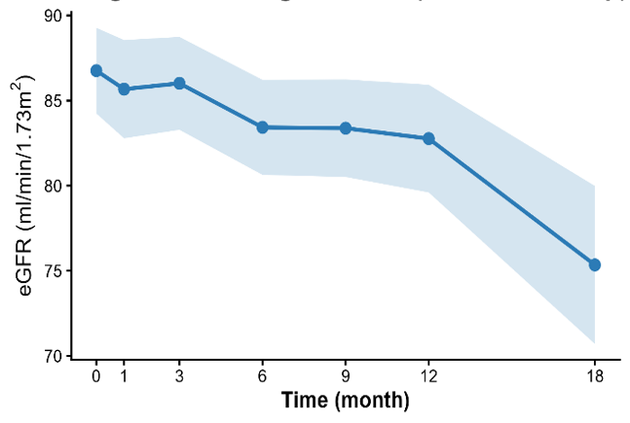
Note: This extended mixed-effects model up to 18 months is provided as an exploratory analysis. The apparent steep decline in the estimated marginal eGFR observed between month 12 and month 18 should be interpreted with extreme caution. At month 18, the number of patients with available eGFR measurements substantially decreased to 30 (representing only 33% of the initial baseline cohort, N = 91). This severe attrition likely introduces a missing-not-at-random (MNAR) bias, where patients remaining in the cohort with frequent extended monitoring may represent a subpopulation with less stable renal function or more frequent clinical visits. Therefore, the trajectory beyond 12 months is prone to significant statistical artifacts and widened standard errors.

Additional Table 3. Sensitivity analysis of the association between finerenone treatment and month-9 eGFR using robust regression.
Variable | Coefficient (β) | Bootstrap 95% CI
Treatment (Finerenone vs. Control) | 0.759 | (−5.116, 6.630)
Note: Robust regression analysis was performed using the Huber M-estimator. The 95% confidence intervals were derived from 2,000 bootstrap resamples. The model was adjusted for baseline eGFR, age, systolic blood pressure, and duration of diabetes.

