A novel Lysinibacillus species from Brazilian biomes: description and polyphasic characterization of Lysinibacillus vittiae sp. nov.

Authors: Marcela Pádua Paulino De Souza¹, Marília Borges Vieira¹, Lucas Sostena Carvalho Silva¹, Samira Marques Faria¹, Jéssica Fiorotti¹, Luisa Caroline Ferraz¹
Affiliation:
¹ VITTIA S.A. – José Plinio Romanini Research, Development, and Innovation Center. Avenida José Miguel Mauad, 2.600, São Joaquim da Barra, São Paulo, Brazil.
ORCID
Marcela Pádua Paulino De Souza (0000-0003-3644-0035)
Marília Borges Vieira (0009-0006-3354-468X)
Lucas Sostena Carvalho Silva (0009-0000-0859-8578)
Samira Marques Faria (0009-0008-1860-8168)
Jéssica Fiorotti (0000-0001-6291-4324)
Luisa Caroline Ferraz (0000-0003-2767-1034)
Corresponding author: Luisa Caroline Ferraz, luisahelene@vittia.com.br; lully_verdevale@hotmail.com.
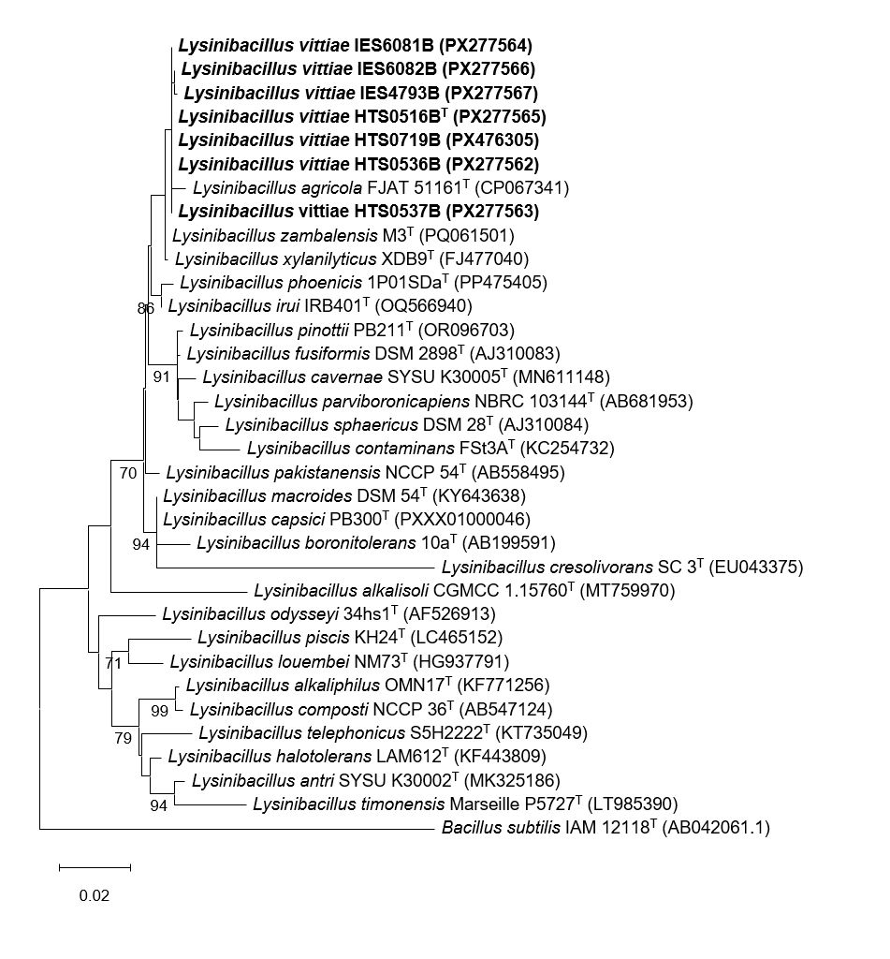
SI1 Maximum-likelihood phylogenetic tree based on partial 16S rRNA gene sequences (1313 bp) of 26 Lysinibacillus type strains and the seven strains of the proposed new species (shown in bold). Bootstrap values >70 % are indicated at the nodes. NCBI GenBank accession numbers are shown in parentheses. Bar indicates two substitutions per 100 nucleotide positions

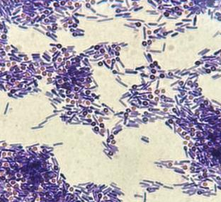
SI2 Gram-stained cells of Lysinibacillus vittiae strain IES6081B showing Gram-stain-positive, rod-shaped morphology with terminal spherical endospores observed using an Olympus CX43 light microscope at 100× magnification

