Supplementary Figures and Tables

- Supplementary Figures
Supplementary Figure 1: Final model adjusted hazard ratios (HR) for non-major osteoporotic fracture death in men and women, centered at the mean age (52 years for women; 50 for men) for variables with age interactions. Models also adjusted for ethnicity and fractional polynomial terms for age, and BMI. 4
Supplementary Figure 2: Final model adjusted hazard ratios (HR) for non-hip fracture death in men and women, centered at the mean age (52 years for women; 50 for men) for variables with age interactions. Models also adjusted for ethnicity and FP terms for age, and BMI. 5
Supplementary Figure 3 Decision curve analyses for major osteoporotic fracture (MOF) and hip fracture comparing Model A, Model B and QFracture in (A) the held-out QResearch validation cohort and (B) the CPRD validation cohort. Net benefit is shown across a range of threshold probabilities and compared with strategies of treating all individuals or treating none. Vertical dashed lines indicate the illustrative treatment threshold of 10% for major osteoporotic fracture. 6
Supplementary Figure 4 : Calibration of Models B and Model C in the held-out QResearch validation cohort by ethnic group. Centile calibration plots compare observed and predicted 10-year risks of major osteoporotic fracture. 8
Supplementary Figure 5 : Calibration of Models B and Model C in the held-out QResearch validation cohort by ethnic group. Centile calibration plots compare observed and predicted 10-year risks of hip fracture. 9
Supplementary Figure 6 : Improvement in 10-year Brier scores with Model B by age group in women. Pairwise differences in inverse-probability-of-censoring-weighted 10-year Brier scores for hip fracture and major osteoporotic fracture are shown by age group in women. Points represent the reduction in Brier score achieved by Model B relative to the comparator model, multiplied by 1,000: Model A minus Model B, Model C minus Model B, and QFracture minus Model B. Horizontal bars show 95% confidence intervals. Positive values favour Model B, negative values favour the comparator, and the vertical line at zero indicates no difference. Model A is the contemporaneously re-estimated QFracture-predictor model accounting for competing mortality. Model B additionally includes the extended predictors. Model C uses the Model B specification but omits ethnicity. QFracture is the original QFracture algorithm. 10
Supplementary Figure 7 : Improvement in 10-year Brier scores with Model B by age group in men. Pairwise differences in inverse-probability-of-censoring-weighted 10-year Brier scores for hip fracture and major osteoporotic fracture are shown by age group in men. Points represent the reduction in Brier score achieved by Model B relative to the comparator model, multiplied by 1,000: Model A minus Model B, Model C minus Model B, and QFracture minus Model B. Horizontal bars show 95% confidence intervals. Positive values favour Model B, negative values favour the comparator, and the vertical line at zero indicates no difference. Model A is the contemporaneously re-estimated QFracture-predictor model accounting for competing mortality. Model B additionally includes the extended predictors. Model C uses the Model B specification but omits ethnicity. QFracture is the original QFracture algorithm. 11
Supplementary Figure 8 : Improvement in 10-year Brier scores with Model B by ethnic group in women. Pairwise differences in inverse-probability-of-censoring-weighted 10-year Brier scores for hip fracture and major osteoporotic fracture are shown by ethnic group in women. Points represent the reduction in Brier score achieved by Model B relative to the comparator model, multiplied by 1,000: Model A minus Model B, Model C minus Model B, and QFracture minus Model B. Horizontal bars show 95% confidence intervals. Positive values favour Model B, negative values favour the comparator, and the vertical line at zero indicates no difference. Model A is the contemporaneously re-estimated QFracture-predictor model accounting for competing mortality. Model B additionally includes the extended predictors. Model C uses the Model B specification but omits ethnicity. QFracture is the original QFracture algorithm. Ethnic groups are based on the categories recorded in the QResearch validation cohort. 12
Supplementary Figure 9 : Improvement in 10-year Brier scores with Model B by ethnic group in men. Pairwise differences in inverse-probability-of-censoring-weighted 10-year Brier scores for hip fracture and major osteoporotic fracture are shown by ethnic group in men. Points represent the reduction in Brier score achieved by Model B relative to the comparator model, multiplied by 1,000: Model A minus Model B, Model C minus Model B, and QFracture minus Model B. Horizontal bars show 95% confidence intervals. Positive values favour Model B, negative values favour the comparator, and the vertical line at zero indicates no difference. Model A is the contemporaneously re-estimated QFracture-predictor model accounting for competing mortality. Model B additionally includes the extended predictors. Model C uses the Model B specification but omits ethnicity. QFracture is the original QFracture algorithm. Ethnic groups are based on the categories recorded in the QResearch validation cohort. 13

- Supplementary Tables
Supplementary Table 1: Discrimination analysis for Model A, Model B and QFracture for major osteoporotic fracture in the held-out QResearch validation cohort in people aged 30-100 overall, by age band, ethnic group and clinical conditions. 14
Supplementary Table 2: Discrimination analysis for Model A, Model B and QFracture for hip fracture in the held-out QResearch validation cohort in people aged 30-100 overall, by age band, ethnic group and conditions. 16
Supplementary Table 3: Calibration of Model B for major osteoporotic fracture and hip fracture in women in the held-out QResearch validation cohort by age and ethnicity and selected comorbidity (Learning disability, Down Syndrome and care home residence). 18
Supplementary Table 4: Calibration of Model B for major osteoporotic fracture and hip fracture in men in the held-out QResearch validation cohort by age and ethnicity and selected comorbidity (Learning disability, Down Syndrome and care home residence). 19
Supplementary Table 5: Brier scores at 10 years for Model A and Model B by fracture outcome, sex and age band in QResearch held-out validation cohort. Lower Brier scores indicate better prognostic accuracy. 20
Supplementary Table 6: Characteristics of participants at high-risk of major osteoporotic fracture based on equal sized groups. Model B selected the same number at high-risk based on the number identified with ≥10% QFracture score for major osteoporotic fracture (n=367,297). Counts < 10 are suppressed. 21
Supplementary Table 7: Characteristics of people at high risk of hip fracture based on equal sized groups. Model B selected the same number of high-risk people based on the number of people identified with ≥3% QFracture score for hip fracture (n=497,738). Counts < 10 are suppressed 22
Supplementary Table 8: Discrimination and calibration of Model B compared with Model C in the held-out QResearch validation cohort. Performance was evaluated in people aged 30-100 years for the major osteoporotic fracture and hip fracture outcome. Model C includes the same predictors as Model B but without ethnicity. 23
Supplementary Table 9: Discrimination analysis for Model B and Model C for major osteoporotic fracture and hip fracture in the held-out QResearch validation cohort in people aged 30-100 overall and by ethnic group. 24
Supplementary Table 10: ICD-10 codes used to identify fracture outcomes on linked hospital and mortality data. 25
Supplementary Table 11 SNOMED-CT codes used to identify outcome, established and new predictors on GP electronic health care records. The SNOMED-CT codes are published as the following URL https://www.qresearch.org/data/qcode-group-library/. The groups referenced by the Group ID. 26

Supplementary Figure 1: Final model adjusted hazard ratios (HR) for non-major osteoporotic fracture death in men and women, centered at the mean age (52 years for women; 50 for men) for variables with age interactions. Models also adjusted for ethnicity and fractional polynomial terms for age, and BMI.
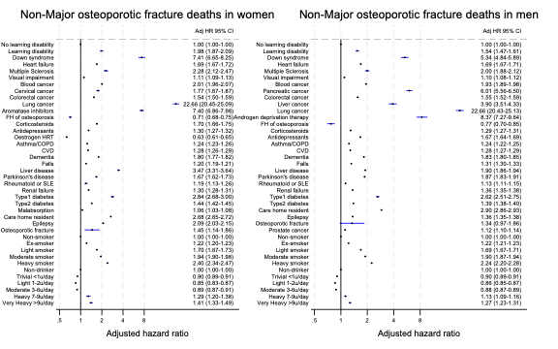
Supplementary Figure 2: Final model adjusted hazard ratios (HR) for non-hip fracture death in men and women, centered at the mean age (52 years for women; 50 for men) for variables with age interactions. Models also adjusted for ethnicity and FP terms for age, and BMI.
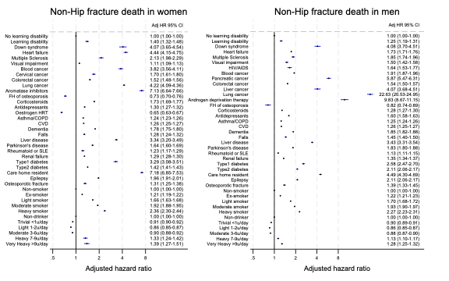
Supplementary Figure 3 Decision curve analyses for major osteoporotic fracture (MOF) and hip fracture comparing Model A, Model B and QFracture in (A) the held-out QResearch validation cohort and (B) the CPRD validation cohort. Net benefit is shown across a range of threshold probabilities and compared with strategies of treating all individuals or treating none. Vertical dashed lines indicate the illustrative treatment threshold of 10% for major osteoporotic fracture.
A: QResearch held-out validation cohort (England only 2013-2024)
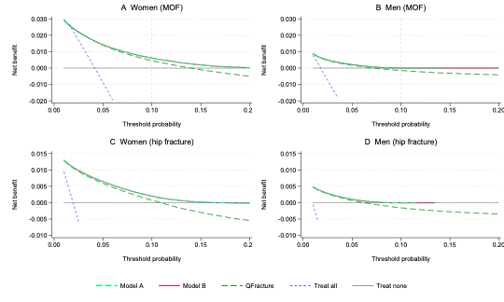
B: CPRD external validation cohort (England and Wales 2001-2012)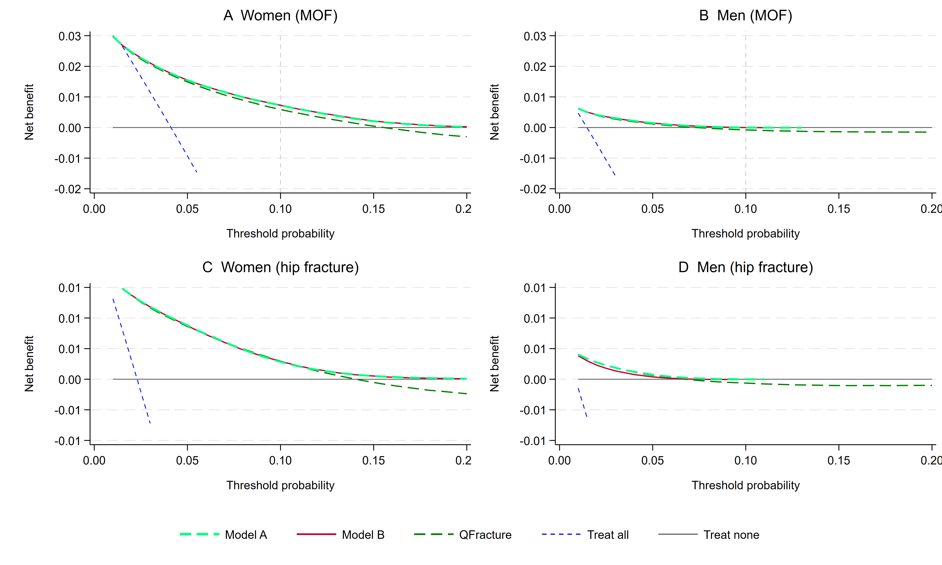
Supplementary Figure 4 : Calibration of Models B and Model C in the held-out QResearch validation cohort by ethnic group. Centile calibration plots compare observed and predicted 10-year risks of major osteoporotic fracture.
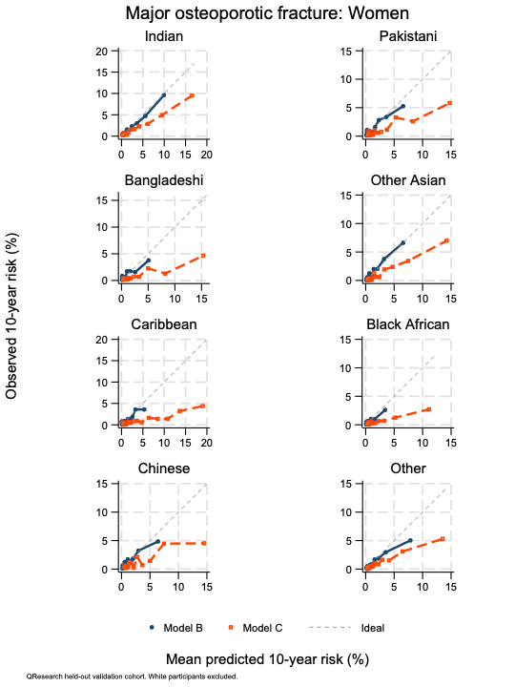 | 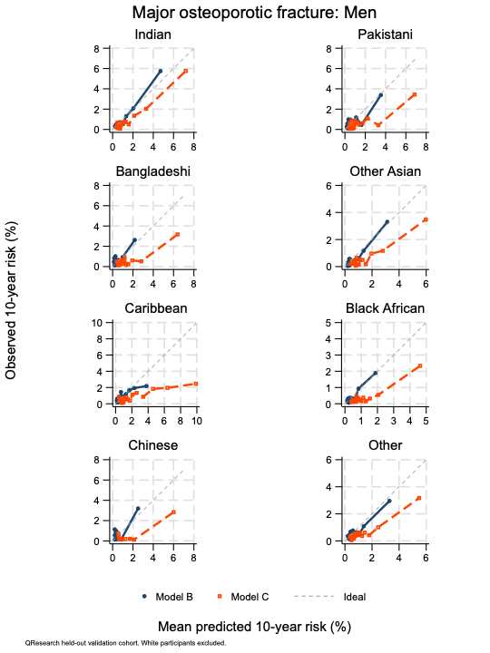
Supplementary Figure 5 : Calibration of Models B and Model C in the held-out QResearch validation cohort by ethnic group. Centile calibration plots compare observed and predicted 10-year risks of hip fracture.
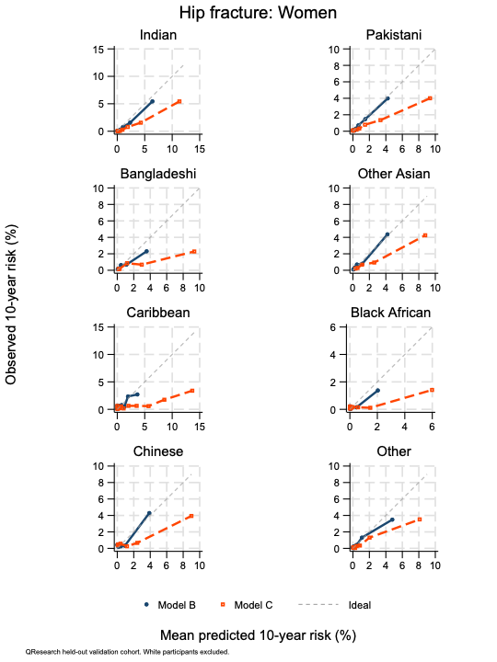 | 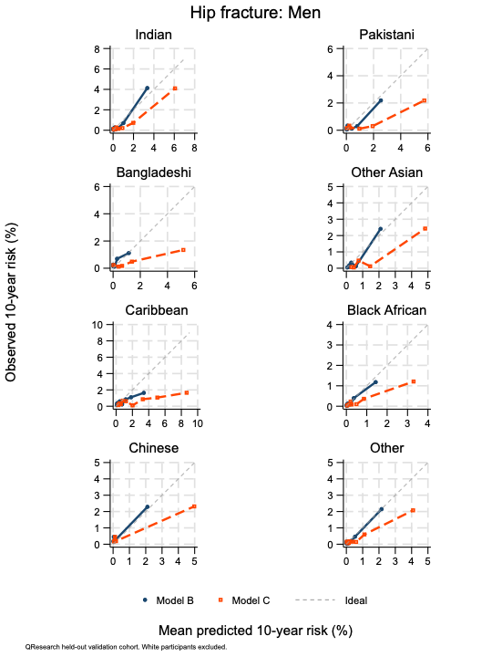

Supplementary Figure 6 : Improvement in 10-year Brier scores with Model B by age group in women. Pairwise differences in inverse-probability-of-censoring-weighted 10-year Brier scores for hip fracture and major osteoporotic fracture are shown by age group in women. Points represent the reduction in Brier score achieved by Model B relative to the comparator model, multiplied by 1,000: Model A minus Model B, Model C minus Model B, and QFracture minus Model B. Horizontal bars show 95% confidence intervals. Positive values favour Model B, negative values favour the comparator, and the vertical line at zero indicates no difference. Model A is the contemporaneously re-estimated QFracture-predictor model accounting for competing mortality. Model B additionally includes the extended predictors. Model C uses the Model B specification but omits ethnicity. QFracture is the original QFracture algorithm.
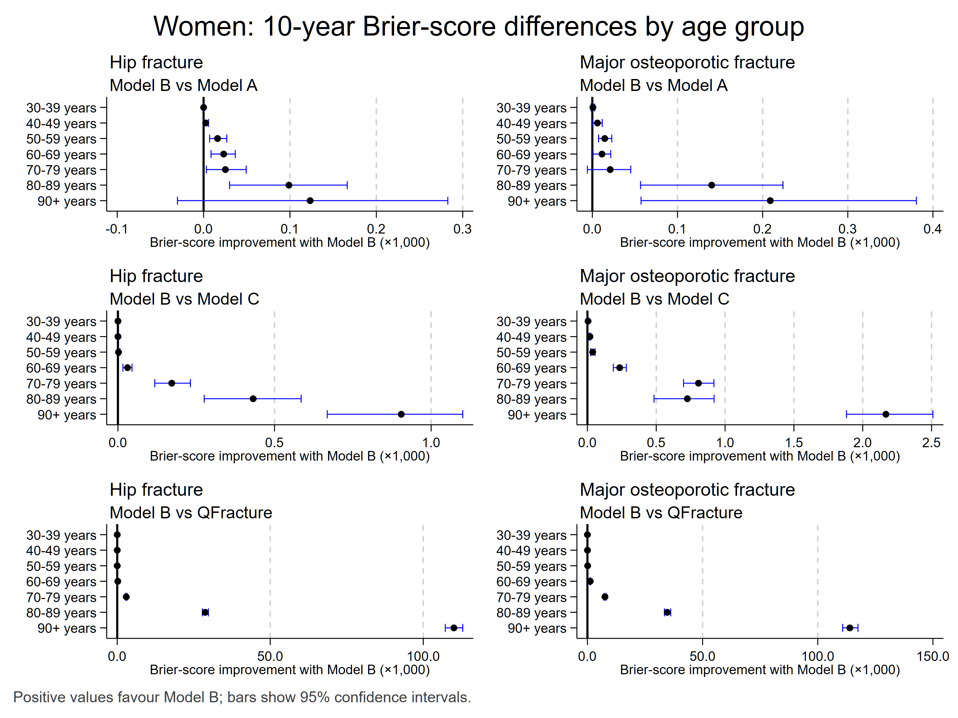

Supplementary Figure 7 : Improvement in 10-year Brier scores with Model B by age group in men. Pairwise differences in inverse-probability-of-censoring-weighted 10-year Brier scores for hip fracture and major osteoporotic fracture are shown by age group in men. Points represent the reduction in Brier score achieved by Model B relative to the comparator model, multiplied by 1,000: Model A minus Model B, Model C minus Model B, and QFracture minus Model B. Horizontal bars show 95% confidence intervals. Positive values favour Model B, negative values favour the comparator, and the vertical line at zero indicates no difference. Model A is the contemporaneously re-estimated QFracture-predictor model accounting for competing mortality. Model B additionally includes the extended predictors. Model C uses the Model B specification but omits ethnicity. QFracture is the original QFracture algorithm.
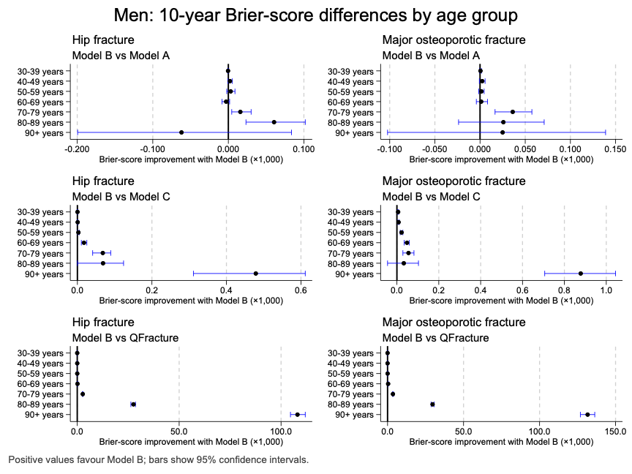

Supplementary Figure 8 : Improvement in 10-year Brier scores with Model B by ethnic group in women. Pairwise differences in inverse-probability-of-censoring-weighted 10-year Brier scores for hip fracture and major osteoporotic fracture are shown by ethnic group in women. Points represent the reduction in Brier score achieved by Model B relative to the comparator model, multiplied by 1,000: Model A minus Model B, Model C minus Model B, and QFracture minus Model B. Horizontal bars show 95% confidence intervals. Positive values favour Model B, negative values favour the comparator, and the vertical line at zero indicates no difference. Model A is the contemporaneously re-estimated QFracture-predictor model accounting for competing mortality. Model B additionally includes the extended predictors. Model C uses the Model B specification but omits ethnicity. QFracture is the original QFracture algorithm. Ethnic groups are based on the categories recorded in the QResearch validation cohort.

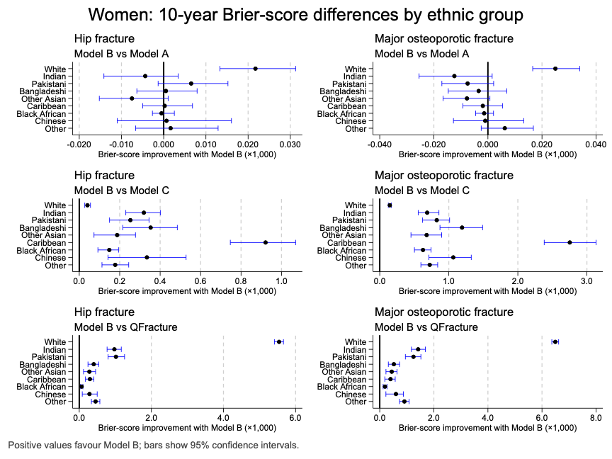

Supplementary Figure 9 : Improvement in 10-year Brier scores with Model B by ethnic group in men. Pairwise differences in inverse-probability-of-censoring-weighted 10-year Brier scores for hip fracture and major osteoporotic fracture are shown by ethnic group in men. Points represent the reduction in Brier score achieved by Model B relative to the comparator model, multiplied by 1,000: Model A minus Model B, Model C minus Model B, and QFracture minus Model B. Horizontal bars show 95% confidence intervals. Positive values favour Model B, negative values favour the comparator, and the vertical line at zero indicates no difference. Model A is the contemporaneously re-estimated QFracture-predictor model accounting for competing mortality. Model B additionally includes the extended predictors. Model C uses the Model B specification but omits ethnicity. QFracture is the original QFracture algorithm. Ethnic groups are based on the categories recorded in the QResearch validation cohort.

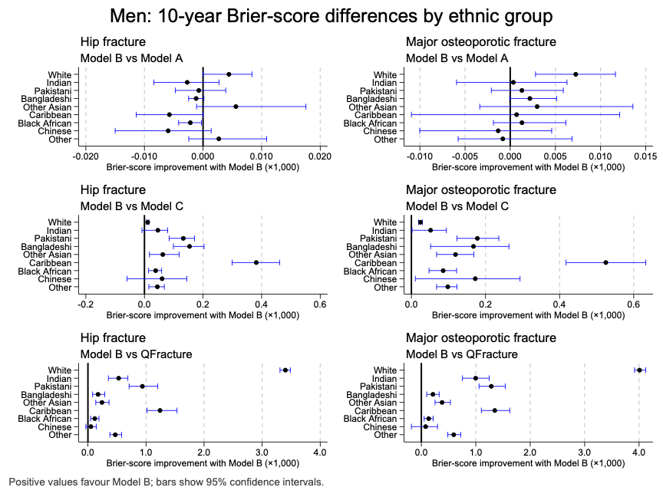

Supplementary Table 1: Discrimination analysis for Model A, Model B and QFracture for major osteoporotic fracture in the held-out QResearch validation cohort in people aged 30-100 overall, by age band, ethnic group and clinical conditions.
 | C-Index  Model B Women | C-Index  Model A Women | C-Index  QFracture Women | C-Index  Model B Men | C-Index  Model A Men | C-index  QFracture Men
Overall | 0.816 (0.814 to 0.818) | 0.815 (0.813 to 0.817) | 0.814 (0.812 to 0.816) | 0.784 (0.780 to 0.788) | 0.783 (0.779 to 0.787) | 0.782 (0.778 to 0.786)
Age band
30-39 | 0.635 (0.616 to 0.654) | 0.630 (0.611 to 0.649) | 0.632 (0.613 to 0.651) | 0.640 (0.622 to 0.656) | 0.638 (0.621 to 0.655) | 0.636 (0.619 to 0.653)
40-49 | 0.652 (0.639 to 0.665) | 0.650 (0.636 to 0.663) | 0.653 (0.640 to 0.667) | 0.646 (0.630 to 0.661) | 0.644 (0.629 to 0.660) | 0.645 (0.630 to 0.661)
50-59 | 0.653 (0.644 to 0.661) | 0.650 (0.641 to 0.659) | 0.650 (0.641 to 0.659) | 0.659 (0.645 to 0.673) | 0.659 (0.645 to 0.673) | 0.660 (0.646 to 0.673)
60-69 | 0.630 (0.623 to 0.638) | 0.628 (0.621 to 0.636) | 0.625 (0.618 to 0.633) | 0.664 (0.652 to 0.676) | 0.661 (0.649 to 0.673) | 0.659 (0.647 to 0.671)
70-79 | 0.631 (0.623 to 0.638) | 0.630 (0.623 to 0.637) | 0.624 (0.617 to 0.630) | 0.651 (0.641 to 0.660) | 0.647 (0.638 to 0.656) | 0.641 (0.632 to 0.650)
80-89 | 0.596 (0.589 to 0.602) | 0.594 (0.587 to 0.600) | 0.578 (0.571 to 0.584) | 0.594 (0.585 to 0.603) | 0.591 (0.582 to 0.600) | 0.582 (0.572 to 0.591)
90-100 | 0.574 (0.562 to 0.586) | 0.571 (0.559 to 0.583) | 0.554 (0.542 to 0.565) | 0.568 (0.547 to 0.588) | 0.570 (0.549 to 0.590) | 0.556 (0.537 to 0.575)
Ethnic Group
White | 0.797 (0.794 to 0.799) | 0.796 (0.793 to 0.798) | 0.795 (0.792 to 0.797) | 0.769 (0.765 to 0.774) | 0.768 (0.764 to 0.773) | 0.768 (0.764 to 0.773)
Indian | 0.822 (0.800 to 0.842) | 0.823 (0.801 to 0.843) | 0.823 (0.801 to 0.843) | 0.786 (0.748 to 0.819) | 0.787 (0.749 to 0.820) | 0.790 (0.753 to 0.823)
Pakistani | 0.799 (0.752 to 0.838) | 0.801 (0.755 to 0.840) | 0.799 (0.753 to 0.838) | 0.672 (0.606 to 0.733) | 0.671 (0.604 to 0.732) | 0.669 (0.601 to 0.730)
Bangladeshi | 0.792 (0.706 to 0.858) | 0.794 (0.707 to 0.860) | 0.795 (0.708 to 0.861) | 0.658 (0.554 to 0.749) | 0.650 (0.545 to 0.742) | 0.649 (0.546 to 0.740)
Other Asian | 0.856 (0.824 to 0.883) | 0.857 (0.825 to 0.884) | 0.856 (0.824 to 0.883) | 0.766 (0.707 to 0.816) | 0.767 (0.708 to 0.817) | 0.764 (0.704 to 0.815)
Caribbean | 0.751 (0.697 to 0.798) | 0.753 (0.699 to 0.800) | 0.753 (0.699 to 0.800) | 0.701 (0.636 to 0.758) | 0.701 (0.636 to 0.758) | 0.699 (0.636 to 0.756)
Black African | 0.769 (0.717 to 0.814) | 0.766 (0.714 to 0.811) | 0.769 (0.717 to 0.814) | 0.722 (0.649 to 0.784) | 0.720 (0.647 to 0.783) | 0.726 (0.653 to 0.788)
Chinese | 0.838 (0.790 to 0.877) | 0.839 (0.791 to 0.877) | 0.839 (0.792 to 0.877) | 0.681 (0.525 to 0.805) | 0.682 (0.526 to 0.805) | 0.671 (0.512 to 0.799)
Other | 0.776 (0.742 to 0.806) | 0.771 (0.738 to 0.802) | 0.775 (0.742 to 0.805) | 0.673 (0.629 to 0.714) | 0.674 (0.630 to 0.715) | 0.671 (0.627 to 0.712)
Conditions
Learning disability | 0.730 (0.684 to 0.771) | 0.726 (0.680 to 0.767) | 0.729 (0.684 to 0.770) | 0.706 (0.651 to 0.755) | 0.707 (0.653 to 0.755) | 0.694 (0.638 to 0.744)
Down syndrome | 0.777 (0.666 to 0.859) | 0.750 (0.655 to 0.825) | 0.762 (0.689 to 0.822) | 0.636 (0.471 to 0.774) | 0.612 (0.467 to 0.739) | 0.563 (0.408 to 0.707)
Heart failure | 0.629 (0.612 to 0.645) | 0.631 (0.614 to 0.647) | 0.603 (0.587 to 0.620) | 0.654 (0.636 to 0.671) | 0.655 (0.637 to 0.672) | 0.649 (0.631 to 0.665)
Multiple sclerosis | 0.717 (0.680 to 0.751) | 0.711 (0.675 to 0.745) | 0.703 (0.667 to 0.737) | 0.687 (0.596 to 0.765) | 0.689 (0.598 to 0.767) | 0.694 (0.610 to 0.767)
Visual impairment | 0.703 (0.689 to 0.716) | 0.704 (0.691 to 0.718) | 0.694 (0.680 to 0.707) | 0.714 (0.694 to 0.733) | 0.715 (0.695 to 0.734) | 0.711 (0.691 to 0.730)
HIV/AIDS | 0.733 (0.579 to 0.846) | 0.734 (0.578 to 0.847) | 0.742 (0.592 to 0.852) | 0.730 (0.617 to 0.819) | 0.730 (0.616 to 0.820) | 0.714 (0.597 to 0.808)
Aromatase inhibitors | 0.651 (0.623 to 0.679) | 0.651 (0.623 to 0.678) | 0.646 (0.618 to 0.672) | 0.800 (0.578 to 0.921) | 0.600 (0.384 to 0.783) | 0.920 (0.703 to 0.982)
Androgen deprivation therapy | N/A | N/A | N/A | 0.634 (0.607 to 0.660) | 0.632 (0.606 to 0.657) | 0.618 (0.592 to 0.644)
Blood cancer | 0.705 (0.678 to 0.731) | 0.708 (0.682 to 0.733) | 0.694 (0.668 to 0.718) | 0.702 (0.667 to 0.735) | 0.705 (0.669 to 0.738) | 0.706 (0.671 to 0.738)
Pancreatic cancer | 0.654 (0.485 to 0.791) | 0.683 (0.510 to 0.817) | 0.576 (0.418 to 0.720) | 0.514 (0.369 to 0.657) | 0.615 (0.452 to 0.756) | 0.671 (0.495 to 0.809)
Cervical cancer | 0.725 (0.667 to 0.776) | 0.720 (0.662 to 0.771) | 0.715 (0.658 to 0.765) | N/A | N/A | N/A
Colorectal cancer | 0.666 (0.639 to 0.692) | 0.665 (0.638 to 0.691) | 0.661 (0.635 to 0.686) | 0.702 (0.669 to 0.733) | 0.704 (0.670 to 0.735) | 0.688 (0.656 to 0.718)
Liver cancer | 0.787 (0.587 to 0.906) | 0.756 (0.521 to 0.898) | 0.801 (0.547 to 0.930) | 0.531 (0.360 to 0.694) | 0.576 (0.431 to 0.709) | 0.642 (0.456 to 0.793)
Lung cancer | 0.599 (0.544 to 0.652) | 0.582 (0.527 to 0.636) | 0.560 (0.506 to 0.613) | 0.596 (0.528 to 0.660) | 0.593 (0.525 to 0.658) | 0.613 (0.538 to 0.682)
Learning disability | 0.730 (0.684 to 0.771) | 0.726 (0.680 to 0.767) | 0.729 (0.684 to 0.770) | 0.706 (0.651 to 0.755) | 0.707 (0.653 to 0.755) | 0.694 (0.638 to 0.744)
Down syndrome | 0.777 (0.666 to 0.859) | 0.750 (0.655 to 0.825) | 0.762 (0.689 to 0.822) | 0.636 (0.471 to 0.774) | 0.612 (0.467 to 0.739) | 0.563 (0.408 to 0.707)

Supplementary Table 2: Discrimination analysis for Model A, Model B and QFracture for hip fracture in the held-out QResearch validation cohort in people aged 30-100 overall, by age band, ethnic group and conditions.
 | C-Index  Model B Women | C-Index  Model A Women | C-Index  QFracture Women | C-Index  Model B Men | C-Index  Model A Men | C-index  QFracture Men
Overall | 0.900 (0.898 to 0.902) | 0.899 (0.897 to 0.900) | 0.897 (0.895 to 0.899) | 0.885 (0.881 to 0.888) | 0.883 (0.880 to 0.887) | 0.882 (0.879 to 0.886)
Age band
30-39 | 0.677 (0.591 to 0.752) | 0.644 (0.558 to 0.722) | 0.653 (0.564 to 0.733) | 0.733 (0.688 to 0.774) | 0.724 (0.680 to 0.765) | 0.730 (0.685 to 0.771)
40-49 | 0.765 (0.727 to 0.799) | 0.764 (0.726 to 0.799) | 0.768 (0.730 to 0.801) | 0.735 (0.704 to 0.765) | 0.729 (0.697 to 0.758) | 0.729 (0.697 to 0.759)
50-59 | 0.756 (0.736 to 0.775) | 0.743 (0.723 to 0.762) | 0.751 (0.731 to 0.770) | 0.764 (0.742 to 0.785) | 0.759 (0.737 to 0.780) | 0.754 (0.731 to 0.775)
60-69 | 0.728 (0.716 to 0.740) | 0.719 (0.707 to 0.731) | 0.722 (0.710 to 0.733) | 0.729 (0.713 to 0.744) | 0.723 (0.707 to 0.739) | 0.719 (0.703 to 0.735)
70-79 | 0.688 (0.680 to 0.696) | 0.686 (0.678 to 0.694) | 0.679 (0.671 to 0.687) | 0.689 (0.678 to 0.700) | 0.685 (0.673 to 0.695) | 0.678 (0.667 to 0.689)
80-89 | 0.623 (0.616 to 0.629) | 0.621 (0.614 to 0.628) | 0.604 (0.598 to 0.611) | 0.613 (0.603 to 0.623) | 0.611 (0.601 to 0.621) | 0.602 (0.592 to 0.612)
90-100 | 0.584 (0.571 to 0.596) | 0.588 (0.576 to 0.600) | 0.562 (0.550 to 0.574) | 0.585 (0.563 to 0.607) | 0.595 (0.574 to 0.616) | 0.570 (0.551 to 0.590)
Ethnic Group
White | 0.887 (0.885 to 0.889) | 0.885 (0.883 to 0.887) | 0.884 (0.882 to 0.886) | 0.872 (0.868 to 0.875) | 0.870 (0.866 to 0.874) | 0.869 (0.866 to 0.873)
Indian | 0.931 (0.907 to 0.949) | 0.931 (0.908 to 0.949) | 0.930 (0.907 to 0.947) | 0.926 (0.898 to 0.947) | 0.926 (0.897 to 0.947) | 0.925 (0.896 to 0.947)
Pakistani | 0.909 (0.858 to 0.943) | 0.907 (0.854 to 0.942) | 0.906 (0.853 to 0.941) | 0.877 (0.786 to 0.932) | 0.871 (0.778 to 0.928) | 0.869 (0.778 to 0.927)
Bangladeshi | 0.924 (0.865 to 0.959) | 0.908 (0.807 to 0.959) | 0.916 (0.835 to 0.959) | 0.843 (0.654 to 0.938) | 0.848 (0.663 to 0.941) | 0.847 (0.664 to 0.940)
Other Asian | 0.953 (0.933 to 0.967) | 0.951 (0.930 to 0.966) | 0.951 (0.931 to 0.966) | 0.927 (0.873 to 0.959) | 0.914 (0.842 to 0.955) | 0.915 (0.844 to 0.956)
Caribbean | 0.837 (0.770 to 0.888) | 0.837 (0.770 to 0.887) | 0.838 (0.772 to 0.887) | 0.842 (0.784 to 0.886) | 0.846 (0.791 to 0.889) | 0.839 (0.784 to 0.883)
Black African | 0.838 (0.741 to 0.904) | 0.834 (0.731 to 0.903) | 0.836 (0.734 to 0.904) | 0.845 (0.749 to 0.908) | 0.848 (0.753 to 0.911) | 0.845 (0.749 to 0.908)
Chinese | 0.929 (0.871 to 0.962) | 0.927 (0.867 to 0.961) | 0.931 (0.874 to 0.963) | 0.829 (0.581 to 0.945) | 0.833 (0.584 to 0.946) | 0.829 (0.572 to 0.946)
Other | 0.928 (0.904 to 0.946) | 0.924 (0.900 to 0.943) | 0.926 (0.902 to 0.944) | 0.862 (0.798 to 0.908) | 0.863 (0.799 to 0.908) | 0.866 (0.804 to 0.910)
Conditions
Learning disability | 0.770 (0.721 to 0.813) | 0.776 (0.725 to 0.821) | 0.780 (0.729 to 0.824) | 0.757 (0.700 to 0.807) | 0.751 (0.691 to 0.803) | 0.748 (0.689 to 0.799)
Down syndrome | 0.827 (0.684 to 0.914) | 0.808 (0.683 to 0.892) | 0.808 (0.710 to 0.878) | 0.621 (0.460 to 0.759) | 0.617 (0.438 to 0.768) | 0.586 (0.398 to 0.752)
Heart failure | 0.670 (0.652 to 0.687) | 0.671 (0.653 to 0.688) | 0.644 (0.626 to 0.661) | 0.696 (0.678 to 0.713) | 0.698 (0.681 to 0.715) | 0.692 (0.674 to 0.709)
Multiple sclerosis | 0.753 (0.708 to 0.794) | 0.747 (0.703 to 0.786) | 0.746 (0.703 to 0.784) | 0.737 (0.642 to 0.813) | 0.758 (0.657 to 0.837) | 0.752 (0.653 to 0.829)
Visual impairment | 0.741 (0.728 to 0.755) | 0.745 (0.732 to 0.759) | 0.734 (0.720 to 0.747) | 0.756 (0.736 to 0.774) | 0.763 (0.743 to 0.782) | 0.755 (0.735 to 0.774)
HIV/AIDS | 0.671 (0.443 to 0.839) | 0.705 (0.479 to 0.862) | 0.692 (0.470 to 0.851) | 0.719 (0.522 to 0.857) | 0.724 (0.532 to 0.858) | 0.713 (0.524 to 0.849)
Aromatase inhibitors | 0.745 (0.710 to 0.777) | 0.745 (0.711 to 0.777) | 0.738 (0.704 to 0.769) | N/A | N/A | N/A
Androgen deprivation therapy | N/A | N/A | N/A | 0.667 (0.637 to 0.696) | 0.668 (0.638 to 0.697) | 0.655 (0.627 to 0.683)
Blood cancer | 0.766 (0.739 to 0.791) | 0.770 (0.743 to 0.795) | 0.758 (0.731 to 0.782) | 0.778 (0.745 to 0.808) | 0.785 (0.750 to 0.816) | 0.786 (0.751 to 0.817)
Pancreatic cancer | 0.680 (0.526 to 0.802) | 0.693 (0.501 to 0.835) | 0.620 (0.451 to 0.764) | 0.602 (0.423 to 0.757) | 0.668 (0.512 to 0.794) | 0.729 (0.555 to 0.854)
Cervical cancer | 0.832 (0.783 to 0.872) | 0.823 (0.772 to 0.865) | 0.824 (0.771 to 0.866) | N/A | N/A | N/A
Colorectal cancer | 0.721 (0.689 to 0.750) | 0.722 (0.690 to 0.752) | 0.710 (0.680 to 0.737) | 0.741 (0.708 to 0.772) | 0.746 (0.713 to 0.777) | 0.741 (0.707 to 0.771)
Liver cancer | 0.953 (0.872 to 0.984) | 0.936 (0.846 to 0.975) | 0.953 (0.874 to 0.984) | 0.474 (0.322 to 0.631) | 0.577 (0.406 to 0.731) | 0.695 (0.457 to 0.860)
Lung cancer | 0.680 (0.618 to 0.737) | 0.684 (0.625 to 0.738) | 0.684 (0.625 to 0.737) | 0.607 (0.512 to 0.694) | 0.610 (0.516 to 0.697) | 0.601 (0.503 to 0.692)
Learning disability | 0.770 (0.721 to 0.813) | 0.776 (0.725 to 0.821) | 0.780 (0.729 to 0.824) | 0.757 (0.700 to 0.807) | 0.751 (0.691 to 0.803) | 0.748 (0.689 to 0.799)

Supplementary Table 3: Calibration of Model B for major osteoporotic fracture and hip fracture in women in the held-out QResearch validation cohort by age and ethnicity and selected comorbidity (Learning disability, Down Syndrome and care home residence).
 |  | O/E ratio (95% CI) | Intercept (95% CI) | Slope (95% CI)
 | Age band
Major osteoporotic fracture | 30-39 | 1.128 (1.059 to 1.201) | 0.106 (0.020 to 0.191) | 1.093 (0.876 to 1.310)
Major osteoporotic fracture | 40-49 | 1.036 (0.992 to 1.080) | 0.042 (-0.012 to 0.096) | 1.126 (0.996 to 1.255)
Major osteoporotic fracture | 50-59 | 1.134 (1.101 to 1.167) | 0.110 (0.076 to 0.144) | 0.945 (0.876 to 1.014)
Major osteoporotic fracture | 60-69 | 0.992 (0.969 to 1.015) | -0.027 (-0.053 to -0.001) | 0.924 (0.864 to 0.983)
Major osteoporotic fracture | 70-79 | 0.949 (0.930 to 0.969) | -0.064 (-0.086 to -0.042) | 0.908 (0.858 to 0.958)
Major osteoporotic fracture | 80-89 | 1.068 (1.047 to 1.089) | 0.055 (0.033 to 0.078) | 0.766 (0.710 to 0.822)
Major osteoporotic fracture | 90-100 | 0.772 (0.743 to 0.802) | -0.292 (-0.335 to -0.250) | 0.868 (0.746 to 0.990)
Major osteoporotic fracture | Ethnic Group
Major osteoporotic fracture | White | 1.071 (1.059 to 1.082) | 0.003 (-0.010 to 0.016) | 0.905 (0.890 to 0.920)
Major osteoporotic fracture | Indian | 1.189 (1.081 to 1.306) | 0.098 (-0.026 to 0.222) | 0.986 (0.851 to 1.121)
Major osteoporotic fracture | Pakistani | 1.044 (0.886 to 1.224) | 0.000 (-0.215 to 0.216) | 0.982 (0.742 to 1.222)
Major osteoporotic fracture | Bangladeshi | 1.087 (0.826 to 1.410) | 0.057 (-0.303 to 0.417) | 1.124 (0.252 to 1.995)
Major osteoporotic fracture | Other Asian | 1.295 (1.112 to 1.501) | 0.298 (0.106 to 0.491) | 1.033 (0.842 to 1.223)
Major osteoporotic fracture | Caribbean | 1.024 (0.853 to 1.222) | -0.070 (-0.293 to 0.152) | 0.956 (0.640 to 1.272)
Major osteoporotic fracture | Black African | 1.122 (0.937 to 1.336) | 0.036 (-0.229 to 0.300) | 1.063 (0.737 to 1.390)
Major osteoporotic fracture | Chinese | 1.161 (0.899 to 1.479) | 0.157 (-0.184 to 0.499) | 1.100 (0.639 to 1.561)
Major osteoporotic fracture | Other | 0.994 (0.885 to 1.114) | -0.104 (-0.273 to 0.065) | 0.953 (0.774 to 1.133)
Major osteoporotic fracture | Selected morbidity
Major osteoporotic fracture | Learning disability | 1.069 (0.879 to 1.285) | -0.234 (-0.467 to -0.001) | 0.511 (0.359 to 0.663)
Major osteoporotic fracture | Down syndrome | 0.964 (0.483 to 1.722) | -0.032 (-0.715 to 0.651) | 0.816 (0.228 to 1.405)
Major osteoporotic fracture | Care home | 1.048 (1.011 to 1.087) | -0.023 (-0.066 to 0.019) | 0.512 (0.420 to 0.603)
Hip fracture | 30-39 | 1.481 (1.162 to 1.875) | -0.308 (-0.865 to 0.249) | 0.754 (0.658 to 0.850)
Hip fracture | 40-49 | 1.348 (1.193 to 1.519) | 0.133 (-0.129 to 0.395) | 0.842 (0.754 to 0.931)
Hip fracture | 50-59 | 1.091 (1.016 to 1.170) | 0.076 (-0.039 to 0.192) | 0.965 (0.852 to 1.078)
Hip fracture | 60-69 | 0.938 (0.898 to 0.978) | -0.070 (-0.124 to -0.016) | 0.933 (0.876 to 0.990)
Hip fracture | 70-79 | 0.957 (0.930 to 0.984) | -0.072 (-0.104 to -0.040) | 0.857 (0.816 to 0.899)
Hip fracture | 80-89 | 1.023 (0.999 to 1.047) | -0.008 (-0.034 to 0.018) | 0.741 (0.690 to 0.791)
Hip fracture | 90-100 | 0.796 (0.765 to 0.829) | -0.280 (-0.325 to -0.235) | 0.695 (0.603 to 0.786)
Hip fracture | Ethnic Group
Hip fracture | White | 1.027 (1.011 to 1.043) | -0.062 (-0.080 to -0.043) | 0.839 (0.822 to 0.856)
Hip fracture | Indian | 0.954 (0.803 to 1.126) | -0.047 (-0.251 to 0.157) | 0.945 (0.790 to 1.101)
Hip fracture | Pakistani | 1.074 (0.815 to 1.396) | -0.056 (-0.392 to 0.279) | 0.761 (0.602 to 0.920)
Hip fracture | Bangladeshi | 0.823 (0.506 to 1.291) | -0.310 (-1.020 to 0.400) | 9.542 (-8.533 to 27.62)
Hip fracture | Other Asian | 1.299 (1.002 to 1.664) | 0.209 (-0.104 to 0.522) | 0.924 (0.665 to 1.183)
Hip fracture | Caribbean | 1.075 (0.818 to 1.395) | -0.060 (-0.387 to 0.267) | 0.992 (0.470 to 1.515)
Hip fracture | Black African | 0.968 (0.670 to 1.371) | -0.285 (-0.819 to 0.248) | 0.900 (0.597 to 1.204)
Hip fracture | Chinese | 1.408 (0.928 to 2.076) | 0.316 (-0.218 to 0.851) | 1.001 (0.694 to 1.309)
Hip fracture | Other | 1.172 (0.962 to 1.419) | -0.105 (-0.366 to 0.156) | 0.768 (0.625 to 0.910)
Hip fracture | Selected morbidity
Hip fracture | Learning disability | 1.052 (0.806 to 1.347) | -0.721 (-1.055 to -0.386) | 0.345 (0.252 to 0.437)
Hip fracture | Down syndrome | 1.447 (0.621 to 2.904) | 0.279 (-0.663 to 1.222) | 1.120 (-1.562 to 3.802)
Hip fracture | Care home | 1.038 (0.999 to 1.078) | -0.036 (-0.080 to 0.008) | 0.649 (0.555 to 0.742)
Supplementary Table 4: Calibration of Model B for major osteoporotic fracture and hip fracture in men in the held-out QResearch validation cohort by age and ethnicity and selected comorbidity (Learning disability, Down Syndrome and care home residence).
 | Subgroup category | O/E ratio (95% CI) | Intercept | Slope (95% CI)
Major osteoporotic fracture | 30-39 | 0.995 (0.938 to 1.055) | -0.014 (-0.090 to 0.061) | 1.011 (0.853 to 1.169)
Major osteoporotic fracture | 40-49 | 1.031 (0.981 to 1.082) | 0.017 (-0.047 to 0.082) | 0.981 (0.872 to 1.089)
Major osteoporotic fracture | 50-59 | 0.899 (0.858 to 0.941) | -0.132 (-0.189 to -0.076) | 0.935 (0.848 to 1.023)
Major osteoporotic fracture | 60-69 | 0.908 (0.873 to 0.944) | -0.094 (-0.139 to -0.049) | 0.997 (0.923 to 1.071)
Major osteoporotic fracture | 70-79 | 1.062 (1.028 to 1.097) | 0.050 (0.015 to 0.085) | 0.928 (0.856 to 0.999)
Major osteoporotic fracture | 80-89 | 1.123 (1.087 to 1.160) | 0.090 (0.056 to 0.125) | 0.697 (0.611 to 0.783)
Major osteoporotic fracture | 90-100 | 0.713 (0.666 to 0.762) | -0.371 (-0.443 to -0.299) | 0.797 (0.553 to 1.042)
Major osteoporotic fracture | Ethnic Group
Major osteoporotic fracture | White | 1.046 (1.028 to 1.064) | 0.026 (0.005 to 0.047) | 0.940 (0.921 to 0.959)
Major osteoporotic fracture | Indian | 1.196 (1.055 to 1.351) | 0.324 (0.157 to 0.492) | 1.084 (0.961 to 1.208)
Major osteoporotic fracture | Pakistani | 1.052 (0.870 to 1.263) | -0.036 (-0.302 to 0.230) | 0.924 (0.727 to 1.120)
Major osteoporotic fracture | Bangladeshi | 1.452 (1.081 to 1.919) | 0.340 (-0.061 to 0.740) | 0.926 (0.682 to 1.169)
Major osteoporotic fracture | Other Asian | 0.949 (0.768 to 1.162) | 0.112 (-0.188 to 0.412) | 1.047 (0.862 to 1.232)
Major osteoporotic fracture | Caribbean | 1.062 (0.857 to 1.304) | -0.148 (-0.416 to 0.119) | 0.706 (0.509 to 0.903)
Major osteoporotic fracture | Black African | 0.966 (0.782 to 1.184) | 0.161 (-0.133 to 0.455) | 1.144 (0.908 to 1.380)
Major osteoporotic fracture | Chinese | 0.868 (0.558 to 1.307) | 0.398 (-0.237 to 1.034) | 1.765 (1.080 to 2.449)
Major osteoporotic fracture | Other | 0.970 (0.842 to 1.113) | -0.054 (-0.269 to 0.161) | 0.923 (0.789 to 1.057)
Major osteoporotic fracture | Learning disability | 1.029 (0.835 to 1.253) | -0.124 (-0.364 to 0.115) | 0.664 (0.464 to 0.865)
Major osteoporotic fracture | Down syndrome | 0.487 (0.213 to 0.957) | -0.857 (-1.632 to -0.082) | 0.548 (-0.260 to 1.356)
Major osteoporotic fracture | Care home | 1.163 (1.091 to 1.237) | 0.060 (-0.009 to 0.129) | 0.400 (0.298 to 0.502)
Hip fracture | 30-39 | 1.315 (1.116 to 1.543) | -0.255 (-0.537 to 0.027) | 0.692 (0.609 to 0.775)
Hip fracture | 40-49 | 1.082 (0.970 to 1.205) | -0.095 (-0.343 to 0.152) | 0.867 (0.707 to 1.027)
Hip fracture | 50-59 | 0.868 (0.798 to 0.943) | -0.245 (-0.395 to -0.094) | 0.867 (0.746 to 0.989)
Hip fracture | 60-69 | 0.848 (0.800 to 0.897) | -0.226 (-0.299 to -0.152) | 0.849 (0.790 to 0.907)
Hip fracture | 70-79 | 0.973 (0.935 to 1.013) | -0.081 (-0.127 to -0.036) | 0.814 (0.755 to 0.872)
Hip fracture | 80-89 | 1.061 (1.023 to 1.100) | 0.013 (-0.026 to 0.052) | 0.701 (0.623 to 0.779)
Hip fracture | 90-100 | 0.770 (0.716 to 0.827) | -0.302 (-0.382 to -0.223) | 0.783 (0.578 to 0.988)
Hip fracture | Ethnic group
Hip fracture | White | 1.045 (1.021 to 1.069) | -0.040 (-0.068 to -0.012) | 0.854 (0.831 to 0.876)
Hip fracture | Indian | 1.318 (1.089 to 1.585) | 0.361 (0.125 to 0.597) | 0.981 (0.826 to 1.137)
Hip fracture | Pakistani | 0.850 (0.601 to 1.182) | -0.164 (-0.585 to 0.257) | 0.895 (0.716 to 1.073)
Hip fracture | Bangladeshi | 1.555 (0.895 to 2.587) | -0.017 (-0.661 to 0.627) | 0.643 (0.506 to 0.781)
Hip fracture | Other Asian | 1.075 (0.747 to 1.518) | 0.212 (-0.254 to 0.678) | 0.944 (0.685 to 1.203)
Hip fracture | Caribbean | 0.741 (0.517 to 1.040) | -0.585 (-1.017 to -0.152) | 0.667 (0.393 to 0.942)
Hip fracture | Black African | 0.957 (0.678 to 1.329) | 0.001 (-0.546 to 0.547) | 1.059 (0.419 to 1.699)
Hip fracture | Chinese | 1.019 (0.523 to 1.863) | 0.474 (-0.324 to 1.273) | 1.314 (0.711 to 1.917)
Hip fracture | Other | 1.180 (0.922 to 1.495) | 0.104 (-0.286 to 0.494) | 0.919 (0.554 to 1.283)
Hip fracture | Selected morbidity
Hip fracture | Learning disability | 1.014 (0.765 to 1.319) | -0.574 (-0.937 to -0.212) | 0.429 (0.300 to 0.557)
Hip fracture | Down syndrome | 0.593 (0.240 to 1.231) | -1.261 (-2.259 to -0.263) | 0.240 (-0.111 to 0.590)
Hip fracture | Care home | 1.097 (1.024 to 1.173) | -0.057 (-0.133 to 0.018) | 0.376 (0.274 to 0.478)
Supplementary Table 5: Brier scores at 10 years for Model A and Model B by fracture outcome, sex and age band in QResearch held-out validation cohort. Lower Brier scores indicate better prognostic accuracy.
 | Sex | Age band | Model A Brier score | Model B Brier score
Hip fracture | Women | Overall | 0.0178 (0.0176 to 0.0181) | 0.0178 (0.0175 to 0.0180)
Hip fracture |  | 30-39 | 0.0004 (0.0003 to 0.0005) | 0.0004 (0.0003 to 0.0005)
Hip fracture |  | 40-49 | 0.0016 (0.0014 to 0.0018) | 0.0016 (0.0014 to 0.0018)
Hip fracture |  | 50-59 | 0.0053 (0.0050 to 0.0057) | 0.0053 (0.0049 to 0.0057)
Hip fracture |  | 60-69 | 0.0170 (0.0162 to 0.0176) | 0.0170 (0.0162 to 0.0176)
Hip fracture |  | 70-79 | 0.0500 (0.0488 to 0.0511) | 0.0499 (0.0487 to 0.0511)
Hip fracture |  | 80-89 | 0.0991 (0.0967 to 0.1013) | 0.0990 (0.0966 to 0.1012)
Hip fracture |  | 90+ | 0.0832 (0.0800 to 0.0859) | 0.0830 (0.0799 to 0.0858)
Hip fracture | Men | Overall | 0.0091 (0.0089 to 0.0093) | 0.0091 (0.0089 to 0.0093)
Hip fracture |  | 30-39 | 0.0009 (0.0007 to 0.0010) | 0.0009 (0.0007 to 0.0010)
Hip fracture |  | 40-49 | 0.0017 (0.0015 to 0.0019) | 0.0017 (0.0015 to 0.0019)
Hip fracture |  | 50-59 | 0.0036 (0.0032 to 0.0039) | 0.0036 (0.0032 to 0.0039)
Hip fracture |  | 60-69 | 0.0096 (0.0090 to 0.0102) | 0.0096 (0.0090 to 0.0102)
Hip fracture |  | 70-79 | 0.0279 (0.0269 to 0.0291) | 0.0278 (0.0268 to 0.0290)
Hip fracture |  | 80-89 | 0.0581 (0.0560 to 0.0601) | 0.0580 (0.0560 to 0.0600)
Hip fracture |  | 90+ | 0.0548 (0.0508 to 0.0577) | 0.0549 (0.0509 to 0.0578)
Major osteoporotic fracture | Women | Overall | 0.0377 (0.0373 to 0.0380) | 0.0377 (0.0373 to 0.0380)
Major osteoporotic fracture |  | 30-39 | 0.0056 (0.0052 to 0.0059) | 0.0056 (0.0052 to 0.0059)
Major osteoporotic fracture |  | 40-49 | 0.0121 (0.0116 to 0.0126) | 0.0121 (0.0116 to 0.0126)
Major osteoporotic fracture |  | 50-59 | 0.0292 (0.0285 to 0.0300) | 0.0292 (0.0285 to 0.0300)
Major osteoporotic fracture |  | 60-69 | 0.0537 (0.0525 to 0.0548) | 0.0537 (0.0525 to 0.0548)
Major osteoporotic fracture |  | 70-79 | 0.0897 (0.0884 to 0.0914) | 0.0897 (0.0884 to 0.0914)
Major osteoporotic fracture |  | 80-89 | 0.1347 (0.1322 to 0.1368) | 0.1345 (0.1320 to 0.1367)
Major osteoporotic fracture |  | 90+ | 0.1022 (0.0990 to 0.1051) | 0.1020 (0.0988 to 0.1049)
Major osteoporotic fracture | Men | Overall | 0.0171 (0.0169 to 0.0175) | 0.0171 (0.0169 to 0.0175)
Major osteoporotic fracture |  | 30-39 | 0.0059 (0.0055 to 0.0063) | 0.0059 (0.0055 to 0.0063)
Major osteoporotic fracture |  | 40-49 | 0.0082 (0.0077 to 0.0086) | 0.0082 (0.0077 to 0.0086)
Major osteoporotic fracture |  | 50-59 | 0.0112 (0.0106 to 0.0117) | 0.0112 (0.0106 to 0.0117)
Major osteoporotic fracture |  | 60-69 | 0.0197 (0.0189 to 0.0205) | 0.0197 (0.0189 to 0.0205)
Major osteoporotic fracture |  | 70-79 | 0.0413 (0.0399 to 0.0424) | 0.0413 (0.0399 to 0.0423)
Major osteoporotic fracture |  | 80-89 | 0.0722 (0.0699 to 0.0745) | 0.0722 (0.0699 to 0.0745)
Major osteoporotic fracture |  | 90+ | 0.0640 (0.0601 to 0.0681) | 0.0640 (0.0602 to 0.0681)

Supplementary Table 6: Characteristics of participants at high-risk of major osteoporotic fracture based on equal sized groups. Model B selected the same number at high-risk based on the number identified with ≥10% QFracture score for major osteoporotic fracture (n=367,297). Counts < 10 are suppressed.
 | High Model B | High QFracture | Reclassified up by Model B | Reclassified down  By Model B
Total | 367,297 | 367,297 | 37,209 | 37,209
Mean Age (SD) | 77.6 (9.4) | 78.9 (8.8) | 66.4 (5.8) | 78.3 (8.4)
Female | 298042 (81.1) | 270034 (73.5) | 34339 (92.3) | 6331 (17.0)
Male | 69255 (18.9) | 97263 (26.5) | 2870 (7.7) | 30878 (83.0)
<60 | 8176 (2.2) | 5275 (1.4) | 3841 (10.3) | 940 (2.5)
60-69 | 68968 (18.8) | 50301 (13.7) | 23113 (62.1) | 4446 (11.9)
70-79 | 131478 (35.8) | 135545 (36.9) | 9751 (26.2) | 13818 (37.1)
80-89 | 116792 (31.8) | 131619 (35.8) | 504 (1.4) | 15331 (41.2)
90-100 | 41883 (11.4) | 44557 (12.1) | * | *
Learning disability | 1709 (0.5) | 890 (0.2) | 845 (2.3) | 26 (0.1)
Down syndrome | 246 (0.1) | 73 (0.0) | 193 (0.5) | 20 (0.1)
Heart failure | 17580 (4.8) | 23059 (6.3) | 361 (1.0) | 5840 (15.7)
Multiple Sclerosis | 2221 (0.6) | 1554 (0.4) | 749 (2.0) | 82 (0.2)
Visual impairment | 16151 (4.4) | 16923 (4.6) | 985 (2.6) | 1757 (4.7)
HIV/AIDS | 104 (0.0) | 131 (0.0) | 16 (0.0) | 43 (0.1)
Aromatase inhibitors | 4848 (1.3) | 4323 (1.2) | 688 (1.8) | 163 (0.4)
Androgen deprivation therapy | 4011 (1.1) | 3277 (0.9) | 955 (2.6) | 221 (0.6)
Blood cancer | 4480 (1.2) | 5570 (1.5) | 314 (0.8) | 1404 (3.8)
Pancreatic cancer | 254 (0.1) | 395 (0.1) | * | *
Cervical cancer | 988 (0.3) | 933 (0.3) | 98 (0.3) | 43 (0.1)
Colorectal cancer | 5832 (1.6) | 7277 (2.0) | 221 (0.6) | 1666 (4.5)
Liver cancer | 63 (0.0) | 161 (0.0) | * | *
Lung Cancer | 1486 (0.4) | 2869 (0.8) | 123 (0.3) | 1506 (4.0)
Supplementary Table 7: Characteristics of people at high risk of hip fracture based on equal sized groups. Model B selected the same number of high-risk people based on the number of people identified with ≥3% QFracture score for hip fracture (n=497,738). Counts < 10 are suppressed
 | High Model B | High QFracture | Reclassified up by Model B | Reclassified down by Model B
Total | 497738 | 497738 | 22791 | 22791
Mean Age (SD) | 77.8 (8.8) | 78.1 (8.4) | 65.1 (9.5) | 69.8 (6.5)
Female | 316330 (63.6) | 321033 (64.5) | 7014 (30.8) | 11717 (51.4)
Male | 181408 (36.4) | 176705 (35.5) | 15777 (69.2) | 11074 (48.6)
<60 | 10234 (2.1) | 4797 (1.0) | 6031 (26.5) | 594 (2.6)
60-69 | 71478 (14.4) | 75875 (15.2) | 7738 (34.0) | 12135 (53.2)
70-79 | 206219 (41.4) | 205514 (41.3) | 8872 (38.9) | 8167 (35.8)
80-89 | 159772 (32.1) | 161298 (32.4) | 150 (0.7) | 1676 (7.4)
90-100 | 50035 (10.1) | 50254 (10.1) | * | 219 (1.0)
Learning disability | 2474 (0.5) | 1296 (0.3) | 1181 (5.2) | *
Down syndrome | 402 (0.1) | 97 (0.0) | 305 (1.3) | *
Heart failure | 29290 (5.9) | 29052 (5.8) | 1104 (4.8) | 866 (3.8)
Multiple Sclerosis | 3134 (0.6) | 1895 (0.4) | 1247 (5.5) | 8 (0.0)
Visual impairment | 22075 (4.4) | 21106 (4.2) | 1341 (5.9) | 372 (1.6)
HIV/AIDS | 365 (0.1) | 250 (0.1) | 137 (0.6) | 22 (0.1)
Aromatase inhibitors | 4856 (1.0) | 4859 (1.0) | 137 (0.6) | 140 (0.6)
Androgen deprivation therapy | 5160 (1.0) | 4614 (0.9) | 592 (2.6) | 46 (0.2)
Blood cancer | 7296 (1.5) | 7288 (1.5) | 376 (1.6) | 368 (1.6)
Pancreatic cancer | 392 (0.1) | 501 (0.1) | * | 114 (0.5)
Cervical cancer | 1104 (0.2) | 1076 (0.2) | 48 (0.2) | 20 (0.1)
Colorectal cancer | 8859 (1.8) | 9195 (1.8) | 102 (0.4) | 438 (1.9)
Liver cancer | 189 (0.0) | 213 (0.0) | 13 (0.1) | 37 (0.2)
Lung cancer | 2844 (0.6) | 3541 (0.7) | 77 (0.3) | 774 (3.4)

Supplementary Table 8: Discrimination and calibration of Model B compared with Model C in the held-out QResearch validation cohort. Performance was evaluated in people aged 30-100 years for the major osteoporotic fracture and hip fracture outcome. Model C includes the same predictors as Model B but without ethnicity.

 |  |  | O/E ratio  (95% CI) | Calibration Intercept  (95% CI) | Calibration Slope  (95% CI) | C-index  (95% CI)
Major osteoporotic fracture | Women | Model B | 1.122 (1.110 to 1.134) | 0.045 (0.032 to 0.059) | 0.930 (0.915 to 0.945) | 0.816 (0.814 to 0.818)
Major osteoporotic fracture |  | Model C | 0.951 (0.941 to 0.961) | -0.123 (-0.137 to -0.110) | 0.931 (0.915 to 0.946) | 0.812 (0.809 to 0.814)
Major osteoporotic fracture | Men | Model B | 1.088 (1.071 to 1.106) | 0.065 (0.045 to 0.086) | 0.954 (0.936 to 0.973) | 0.784 (0.780 to 0.788)
Major osteoporotic fracture |  | Model C | 0.920 (0.905 to 0.935) | -0.087 (-0.108 to -0.067) | 0.971 (0.952 to 0.989) | 0.778 (0.774 to 0.782)
Hip fracture | Women | Model B | 1.079 (1.063 to 1.096) | -0.017 (-0.035 to 0.002) | 0.852 (0.835 to 0.869) | 0.900 (0.898 to 0.902)
Hip fracture |  | Model C | 0.946 (0.932 to 0.961) | -0.151 (-0.169 to -0.132) | 0.858 (0.840 to 0.875) | 0.898 (0.897 to 0.900)
Hip fracture | Men | Model B | 1.095 (1.071 to 1.120) | 0.006 (-0.022 to 0.034) | 0.865 (0.843 to 0.886) | 0.885 (0.881 to 0.888)
 |  | Model C | 0.937 (0.916 to 0.958) | -0.136 (-0.163 to -0.109) | 0.882 (0.859 to 0.904) | 0.882 (0.879 to 0.886)

Supplementary Table 9: Discrimination analysis for Model B and Model C for major osteoporotic fracture and hip fracture in the held-out QResearch validation cohort in people aged 30-100 overall and by ethnic group.
 |  | C-index Women Model B | C-index Women Model C | C-index Men Model B | C-index Men Model C
Major osteoporotic fracture | Overall | 0.816 (0.814 to 0.818) | 0.812 (0.809 to 0.814) | 0.784 (0.780 to 0.788) | 0.778 (0.774 to 0.782)
Major osteoporotic fracture | White | 0.797 (0.794 to 0.799) | 0.796 (0.794 to 0.799) | 0.769 (0.765 to 0.774) | 0.769 (0.765 to 0.773)
Major osteoporotic fracture | Indian | 0.822 (0.800 to 0.842) | 0.822 (0.800 to 0.842) | 0.786 (0.748 to 0.819) | 0.788 (0.751 to 0.821)
Major osteoporotic fracture | Pakistani | 0.799 (0.752 to 0.838) | 0.799 (0.753 to 0.838) | 0.672 (0.606 to 0.733) | 0.674 (0.608 to 0.734)
Major osteoporotic fracture | Bangladeshi | 0.792 (0.706 to 0.858) | 0.793 (0.707 to 0.858) | 0.658 (0.554 to 0.749) | 0.661 (0.557 to 0.752)
Major osteoporotic fracture | Other Asian | 0.856 (0.824 to 0.883) | 0.857 (0.825 to 0.883) | 0.766 (0.707 to 0.816) | 0.768 (0.710 to 0.818)
Major osteoporotic fracture | Caribbean | 0.751 (0.697 to 0.798) | 0.749 (0.695 to 0.797) | 0.701 (0.636 to 0.758) | 0.700 (0.635 to 0.757)
Major osteoporotic fracture | Black African | 0.769 (0.717 to 0.814) | 0.770 (0.718 to 0.815) | 0.722 (0.649 to 0.784) | 0.720 (0.647 to 0.783)
Major osteoporotic fracture | Chinese | 0.838 (0.790 to 0.877) | 0.837 (0.789 to 0.876) | 0.681 (0.525 to 0.805) | 0.685 (0.531 to 0.806)
Major osteoporotic fracture | Other | 0.776 (0.742 to 0.806) | 0.777 (0.744 to 0.807) | 0.673 (0.629 to 0.714) | 0.675 (0.632 to 0.716)
Hip fracture | Overall | 0.900 (0.898 to 0.902) | 0.898 (0.897 to 0.900) | 0.885 (0.881 to 0.888) | 0.882 (0.879 to 0.886)
Hip fracture | White | 0.887 (0.885 to 0.889) | 0.887 (0.885 to 0.889) | 0.872 (0.868 to 0.875) | 0.871 (0.868 to 0.875)
Hip fracture | Indian | 0.931 (0.907 to 0.949) | 0.930 (0.906 to 0.949) | 0.926 (0.898 to 0.947) | 0.927 (0.899 to 0.948)
Hip fracture | Pakistani | 0.909 (0.858 to 0.943) | 0.909 (0.858 to 0.943) | 0.877 (0.786 to 0.932) | 0.877 (0.786 to 0.932)
Hip fracture | Bangladeshi | 0.924 (0.865 to 0.959) | 0.924 (0.866 to 0.958) | 0.843 (0.654 to 0.938) | 0.841 (0.653 to 0.937)
Hip fracture | Other Asian | 0.953 (0.933 to 0.967) | 0.952 (0.933 to 0.966) | 0.927 (0.873 to 0.959) | 0.927 (0.877 to 0.958)
Hip fracture | Caribbean | 0.837 (0.770 to 0.888) | 0.838 (0.770 to 0.889) | 0.842 (0.784 to 0.886) | 0.841 (0.783 to 0.886)
Hip fracture | Black African | 0.838 (0.741 to 0.904) | 0.839 (0.742 to 0.904) | 0.845 (0.749 to 0.908) | 0.847 (0.753 to 0.910)
Hip fracture | Chinese | 0.929 (0.871 to 0.962) | 0.928 (0.870 to 0.961) | 0.829 (0.581 to 0.945) | 0.827 (0.582 to 0.943)
Hip fracture | Other | 0.928 (0.904 to 0.946) | 0.928 (0.904 to 0.946) | 0.862 (0.798 to 0.908) | 0.862 (0.798 to 0.907)

Supplementary Table 10: ICD-10 codes used to identify fracture outcomes on linked hospital and mortality data.
Code | Description | Type
S525 | Colles fracture (ICD10) | Wrist
S5250 | Colles fracture (ICD10) | Wrist
S5251 | Colles fracture (ICD10) | Wrist
S720 | Fracture neck of femur | Hip
S7200 | Fracture neck of femur | Hip
S7201 | Fracture neck of femur | Hip
M484 | Vertebral fracture (ICD10) | Spine
M4840 | Vertebral fracture (ICD10) | Spine
M4841 | Vertebral fracture (ICD10) | Spine
M4842 | Vertebral fracture (ICD10) | Spine
M4843 | Vertebral fracture (ICD10) | Spine
M4844 | Vertebral fracture (ICD10) | Spine
M4845 | Vertebral fracture (ICD10) | Spine
M4846 | Vertebral fracture (ICD10) | Spine
M4847 | Vertebral fracture (ICD10) | Spine
M4848 | Vertebral fracture (ICD10) | Spine
M4849 | Vertebral fracture (ICD10) | Spine
M8041 | Fracture proximal humerus (ICD10) | Proximal humerus
M8042 | Fracture proximal humerus (ICD10) | Proximal humerus
M8051 | Fracture proximal humerus (ICD10) | Proximal humerus
M8052 | Fracture proximal humerus (ICD10) | Proximal humerus
S422 | Fracture proximal humerus (ICD10) | Proximal humerus
S4220 | Fracture proximal humerus (ICD10) | Proximal humerus
S4221 | Fracture proximal humerus (ICD10) | Proximal humerus

Supplementary Table 11 SNOMED-CT codes used to identify outcome, established and new predictors on GP electronic health care records. The SNOMED-CT codes are published as the following URL https://www.qresearch.org/data/qcode-group-library/. The groups referenced by the Group ID.

Established predictors |  | New predictors
Family history of osteoporosis | 399 | Learning disability | 16758
Corticosteroids | 1194 | Down syndrome | 65
Antidepressants | 2351 | Heart failure | 25
Oestrogen hormone replacement therapy | 897 | Multiple Sclerosis | 38
Asthma/Chronic obstructive pulmonary disease | 16763 | Visual impairment | 60
Any cancer | 81 | HIV/AIDS | 330
Cardiovascular disease | 411 | Aromatase inhibitors | 18296
Dementia | 35 | Androgen deprivation therapy | 1685
Falls | 617 | Blood cancer | 58
Chronic liver disease | 325 | Pancreatic cancer | 216
Parkinson's disease | 37 | Cervical cancer | 55
Rheumatoid or SLE | 16772 | Colorectal cancer | 2009
Chronic kidney disease | 322 | Liver cancer | 2522
Type 1 diabetes | 1913 | Lung cancer | 51
Type 2 diabetes | 2411
Endocrine disorders | 382
Malabsorption | 379
Care home resident | 39 | Outcomes
Epilepsy diagnosis or treatment | 832 | Hip fracture | 557
Prior osteoporotic fracture | 2075 | Major osteoporotic fracture | 2075
Smoking recorded
Non smoker | 2239
Ex smoker | 2238
Light smoker | 2244
Moderate smoker | 2242
Heavy smoker | 2243
Alcohol units | 17070
Non-drinker | 17064
Trivial drinker <1u/day | 17065
Light drinker 1-2u/day | 17066
Moderate drinker 3-6u/day | 17067
Heavy drinker 7-9u/day | 17068
Very heavy drinker >9u/day | 17069

