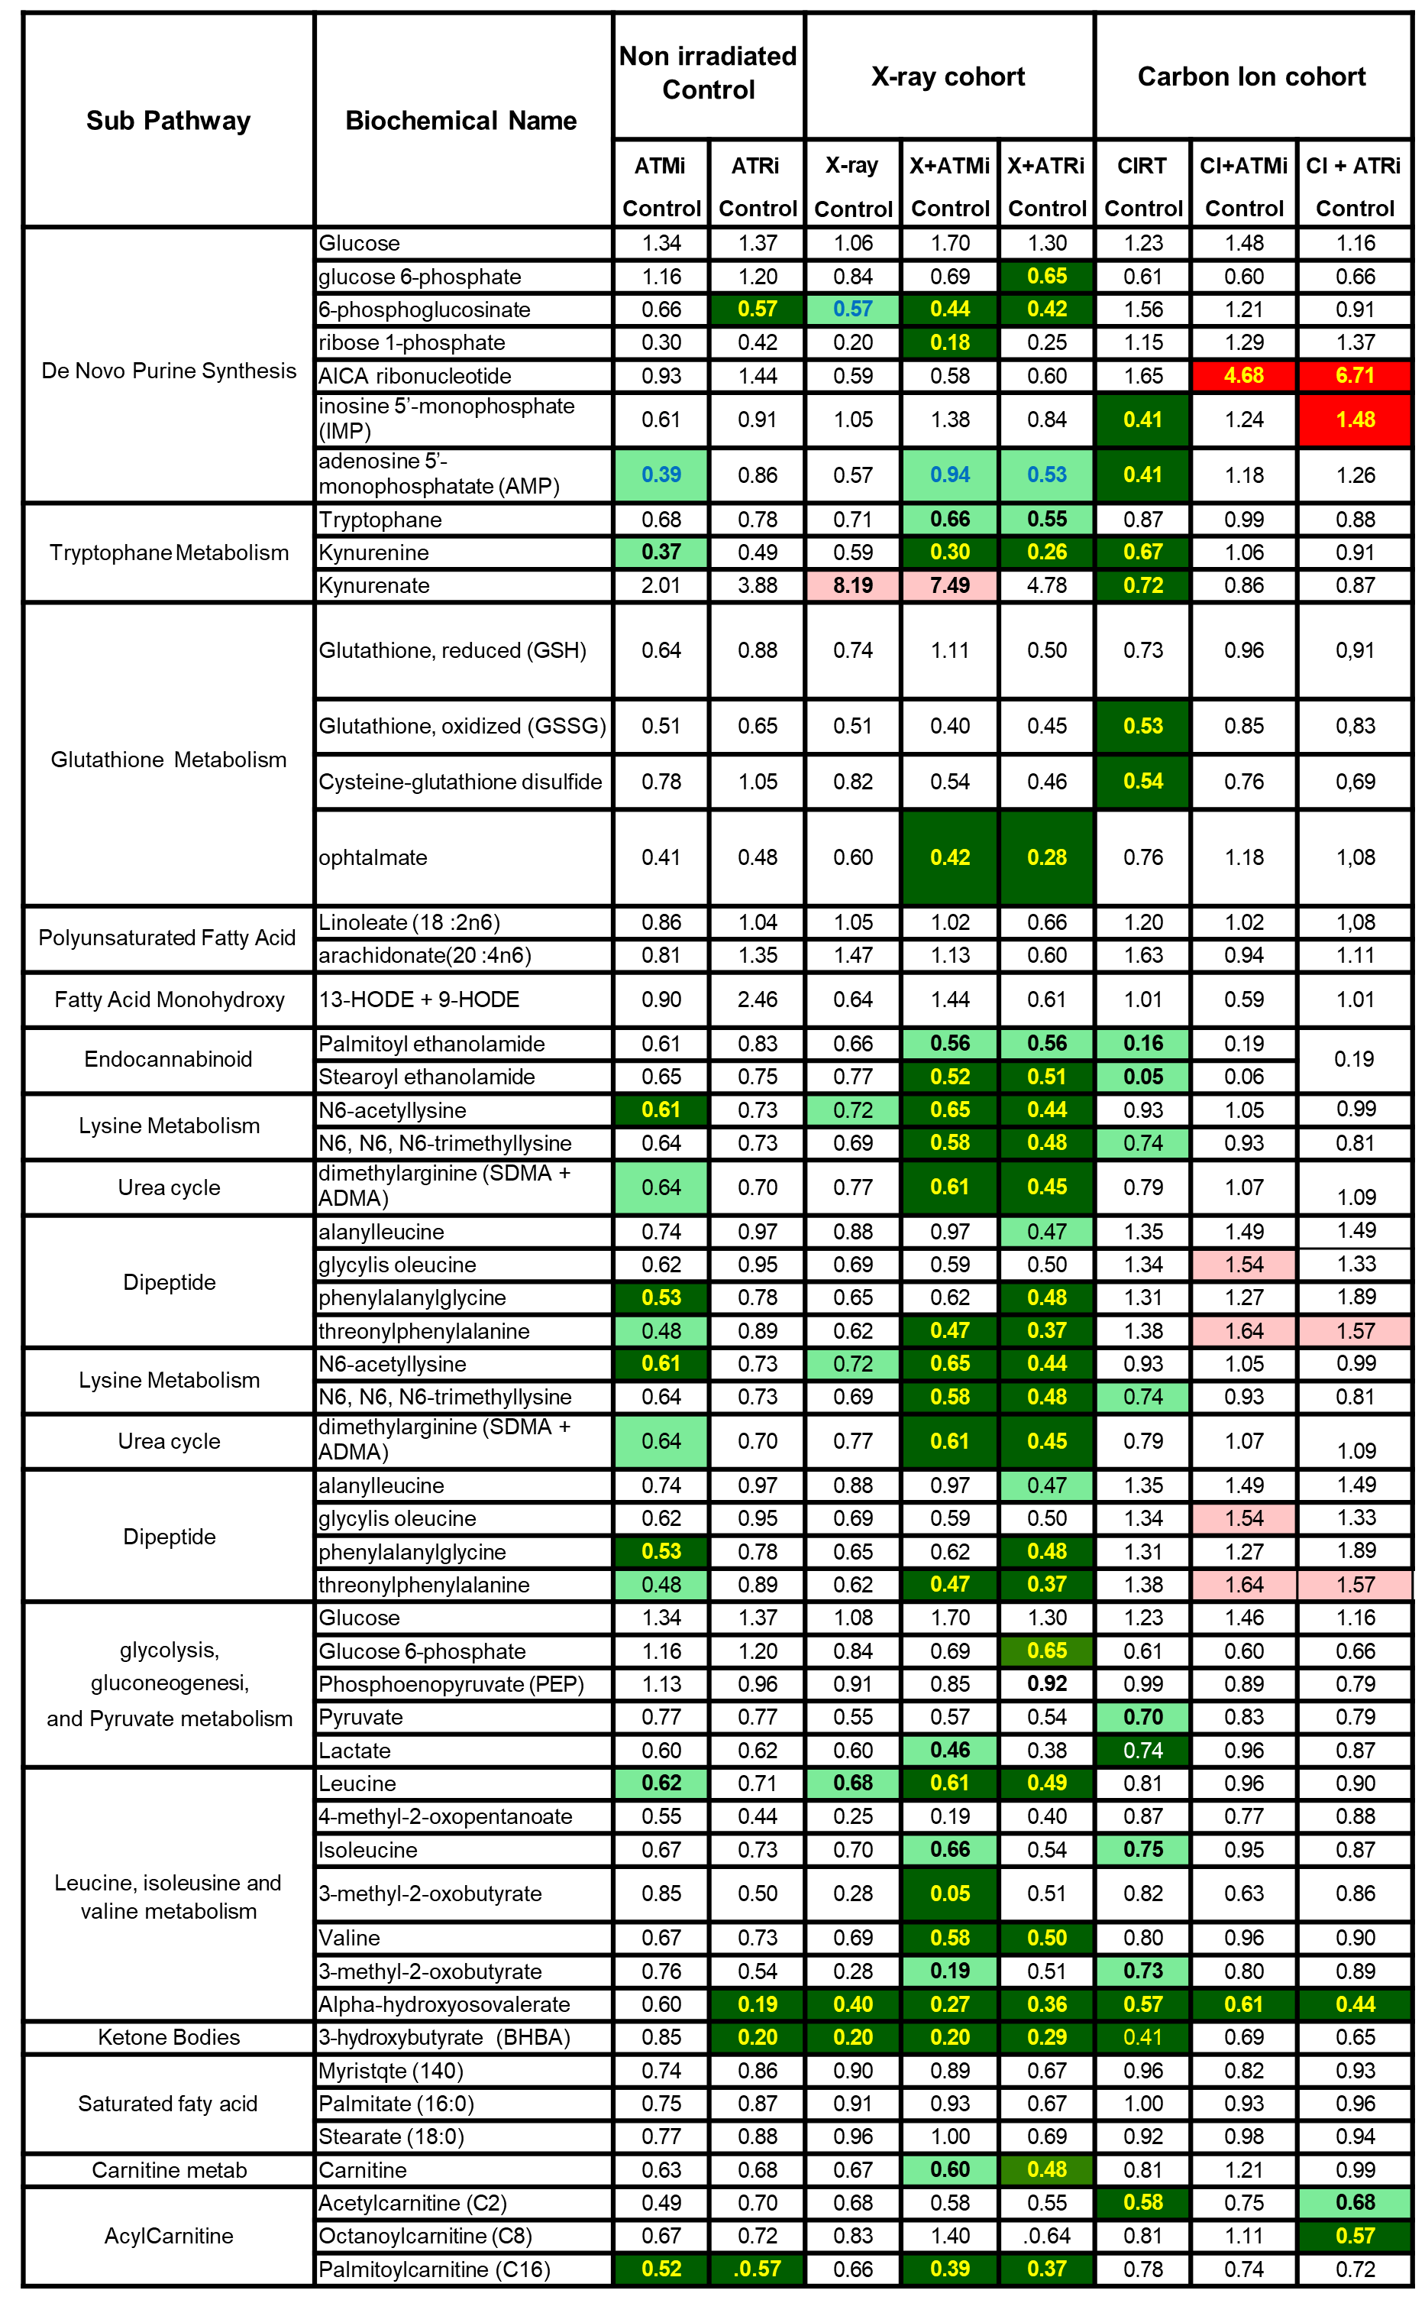
Table 1: statistical heatmap of observed biochemical differences in metabolomics, trending (0.05 < p < 0.10) and significant (p ≤ 0.05) elevations were indicated by pink and red, respectively, while trending and significant reductions were represented by light green and dark green, respectively.

