Supporting Information

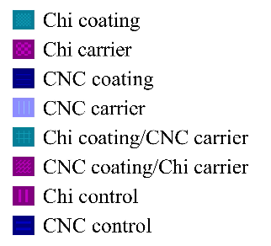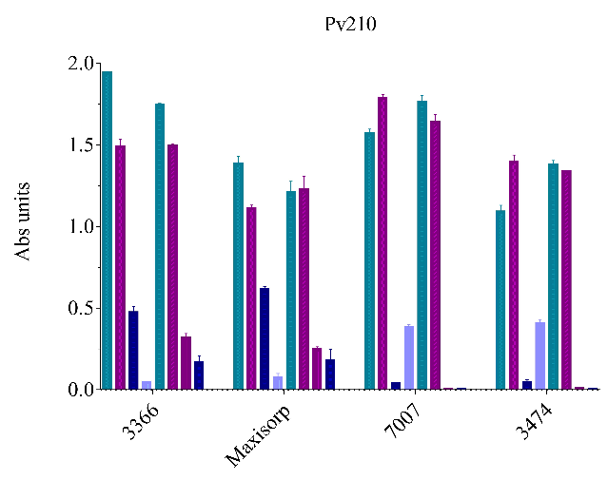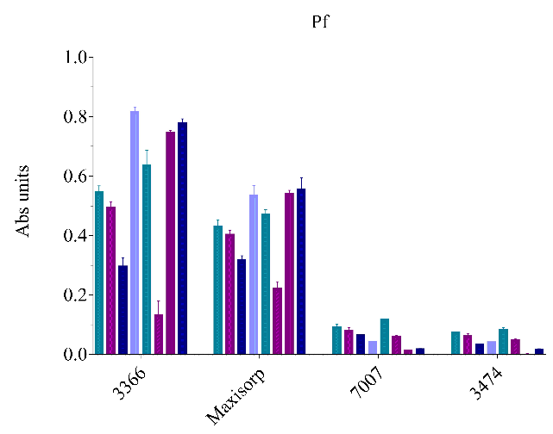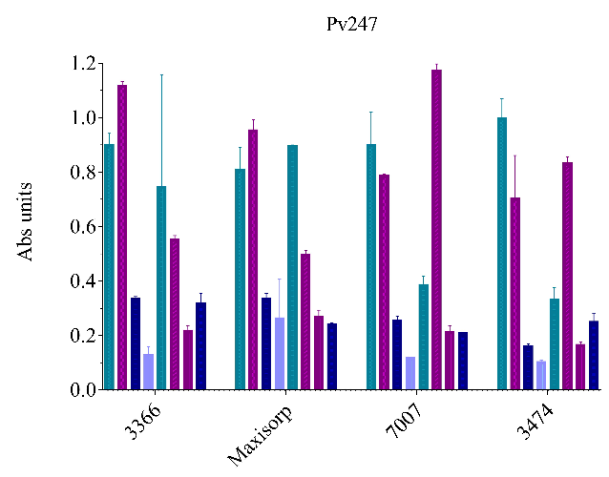
Figure S1: ELISA results for Pf, Pv210 and Pv247 performed on high binding (Corning 3366 and MaxiSorp™/Nunc-Immuno) and ultra-low attachment (Corning® 7007 and Corning® 3474) 96-well plates. Abs units on the y-axis indicates aborbance (λ=405nm). The conditions tested were: a) chitosan as an antibody-carrier or well- coating (Chi coating), b) chitosan as an antibody carrier (Chi carrier), c) cellulose nanocrystal as an antibody-carrier or well-coating (CNC coating), d) cellulose nanocrystal as an antibody-carrier (CNC carrier), e) chitosan as an antibody-carrier or well-coating, f) cellulose nanocrystal as an antibody-carrier (Chi coating / CNC carrier), g) and cellulose nanocrystal as an antibody carrier or well coating and chitosan as an antibody-carrier (CNC coating / Chi carrier). The assays were conducted using the recombinant proteins: 2 µg/µl for Pf, 182 µg/µl for Pv210 and 91 µg/µl for Pv247. Bars represent mean ± SD (n=3).

Figure s2. Paper csELISA results for all antibody-carrier and plate-coating assays tested with recombinant proteins at the working concentrations for each species. Recombinant proteins were tested in duplicate, and a picture was imported to Adobe Photoshop to obtain CMYK values. CMYK values were then averaged, blank values were subtracted, and data was imported and plotted is Prisma.

