Supplemental Materials

Part I. Supplemental Tables and figures
Table S1. Univariate survival analysis on risk factors for OS in patients undergoing Car-T cell therapy
 | Variation |  | Non-adjusted |  |  | Model 1
 | Variation |  | HR (95% CI) | p value |  | HR (95% CI) | p value
 | Gender, male vs. female |  | 1.73 [0.74, 4.05] | 0.208 |  | - | -
 | Age (year), ≥ 60 vs. ＜ 60 |  | 0.86 [0.26, 2.90] | 0.813 |  | - | -
 | Hypertension, Yes vs. No |  | 0.94 [0.66, 1.34] | 0.729 |  | 1.01 [0.61, 1.67] | 0.956
 | Diabetes, Yes vs. No |  | 1.02 [0.65, 1.58] | 0.945 |  | 1.07 [0.57, 2.02] | 0.832
 | Blast (%), > 20% vs. ≤ 20% |  | 1.47 [0.44, 4.93] | 0.537 |  | 1.41 [0.42, 4.80] | 0.579
 | HSCT, Yes vs. No |  | 1.02 [0.42, 2.46] | 0.973 |  | 0.95 [0.39, 2.32] | 0.918
 | Diagnosis_AL, Yes vs. No |  | 0.82 [0.36, 1.86] | 0.638 |  | 0.83 [0.36, 1.92] | 0.664
 | CRS_stage,high risk vs low risk |  | 18.73 [6.98, 50.26] | <0.001*** |  | 19.06 [7.10, 51.21] | <0.001***
 | CRS, Yes vs. No |  | 8.22 [1.11, 60.88] | 0.039* |  | 8.37 [1.13, 62.08] | 0.038
 | Transfusion, Yes vs. No |  | 7.35 [2.19, 24.65] | 0.001** |  | 7.21 [2.15, 24.22] | 0.001
 | Car-T Cell, ≥ 0.5X10^7 vs. < 0.5X10^7 |  | 0.82 [0.56, 1.20] | 0.309 |  | 1.06 [0.47, 2.39] | 0.886
 | CART-CD19,Yes vs. No |  | 0.36 [0.12, 1.06] | 0.063 |  | 0.36 [0.12, 1.06] | 0.063
 | CR,Yes vs. No |  | 0.15 [0.06, 0.39] | <0.001*** |  | 0.16 [0.06, 0.40] | <0.001***
 | Before infusion of Car-T cells
 | WBC counts, <4X10^9 vs. ≥ 4X10^9 |  | 1.29 [0.79, 2.12] | 0.304 |  | 2.51 [0.93, 6.77] | 0.068
 | Hemoglobin, < 100g/L vs. ≥ 100g/L |  | 5.73 [1.96, 16.82] | 0.001** |  | 5.58 [1.90, 16.38] | 0.002
 | Platelet, < 30X10^9 vs. ≥ 30X10^9 |  | 3.97 [1.57, 10.06] | 0.004** |  | 3.84 [1.51, 9.73] | 0.005
 | FIB(g/L),≥ 3.065 vs. < 3.065 |  | 1.96 [0.85, 4.53] | 0.113 |  | 1.91 [0.82, 4.43] | 0.132
 | APTT(s),≥ 31.4 vs. < 31.4 |  | 1.15 [0.51, 2.57] | 0.74 |  | 1.18 [0.52, 2.65] | 0.691
 | PT(s), ≥ 12.2 vs. < 12.2 |  | 1.48 [0.66, 3.32] | 0.337 |  | 1.53 [0.68, 3.44] | 0.299
 | TT(s), ≥ 16.15 vs. < 16.15 |  | 2.21 [0.66, 7.43] | 0.199 |  | 2.27 [0.67, 7.65] | 0.187
 | After infusion of Car-T cells
 | Platelet, < 30X10^9 vs. ≥ 30X10^9 |  | 3.61 [1.58, 8.26] | 0.002** |  | 3.48 [1.52, 7.99] | 0.003
 | CRP(mg/L), ≥ 23.325 vs. < 23.325 |  | 3.17 [1.26, 7.99] | 0.015* |  | 3.06 [1.21, 7.74] | 0.018
 | FIB(g/L), ≥ 3.44 vs. < 3.44 |  | 1.47 [0.65, 3.32] | 0.349 |  | 1.38 [0.61, 3.14] | 0.435
 | APTT(s), ≥ 38.42 vs. < 38.42 |  | 1.50 [0.66, 3.38] | 0.332 |  | 1.42 [0.63, 3.20] | 0.404
 | PT(s), ≥ 13.24 vs. < 13.24 |  | 0.88 [0.39, 1.98] | 0.765 |  | 0.88 [0.39, 1.97] | 0.754
 | TT(s), ≥ 16.15 vs. < 16.15 |  | 2.45 [1.02, 5.92] | 0.046* |  | 2.53 [1.04, 6.14] | 0.04
 | IL-2(pg/mL), ≥ 4.875 vs. < 4.875 |  | 2.54 [1.05, 6.13] | 0.038* |  | 2.53 [1.05, 6.10] | 0.039
 | IL-4(pg/mL), ≥ 2.42 vs. < 2.42 |  | 0.90 [0.40, 2.02] | 0.792 |  | 0.95 [0.42, 2.15] | 0.899
 | IL-6(pg/mL), ≥ 15.09 vs. < 15.09 |  | 5.90 [2.00, 17.38] | 0.001** |  | 5.74 [1.95, 16.90] | 0.001
 | IL-10(pg/mL), ≥ 5.91 vs. < 5.91 |  | 7.61 [2.26, 25.64] | 0.001** |  | 7.49 [2.22, 25.27] | 0.001
 | TNFa(pg/mL), ≥ 2.12 vs. < 2.12 |  | 0.94 [0.42, 2.12] | 0.879 |  | 0.94 [0.42, 2.13] | 0.884
 | IFNy(pg/mL), ≥ 9.41 vs. < 9.41 |  | 2.65 [1.04, 6.71] | 0.04* |  | 2.73 [1.07, 6.93] | 0.035
 | IL-17A(pg/mL), ≥ 3.4 vs. < 3.4 |  | 0.91 [0.41, 2.04] | 0.821 |  | 0.90 [0.40, 2.01] | 0.793
 | DIC,Yes vs. No |  | 8.11 [3.17, 20.71] | <0.001*** |  | 8.24 [3.16, 21.46] | <0.001***
 | Bleeding,Yes vs. No |  | 13.04 [5.82, 29.18] | <0.001*** |  | 12.72 [5.65, 28.62] | <0.001***
Abbreviation: HR, hazard risk; Car-T Cell, Chimeric Antigen Receptor T-cell; WBC, white blood cell; Hb, hemoglobin; PLT, platelet; FIB, fibrinogen; APTT, activated partial thromboplastin time; PT, prothrombin time; TT, thrombin time; IL-2, interleukin 2; IL-4, interleukin 4; IL-6, interleukin 6; IL-10, interleukin 10; TNFa, tumor necrosis factor a; IFNy, interferon y; IL-17A, interleukin 17A; AL, acute leukemia; HSCT, hematopoietic stem cell transplantation; CD19, cluster of differentiation 19; CRS, cytokine release syndrome; CR, complete remission; MR, minimum remission; NR, non-remission; PR, partial remission; DIC, disseminated intravascular coagulation; ***p<0.001, **p<0.01, *p<0.05.
Model 1: adjusted by age and gender.

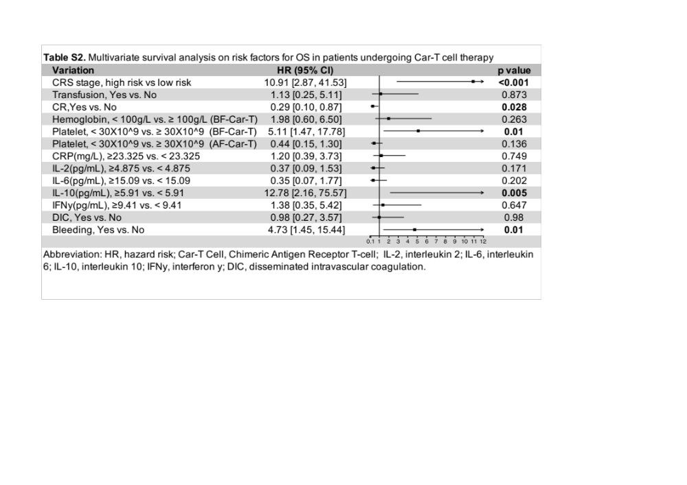

Figure Legends
Figure S1 Texture feature selection conducted via the selection operator (LASSO) binary logistic regression model and least absolute shrinkage. A. Tuning parameter selection was made by 10-fold cross-validation in the LASSO model via minimum criteria. The log(l) was plotted versus the area under the receiver operating characteristic curve (AUC). Dotted vertical lines were drawn at the optimal values by using the minimum criteria and the one standard error of the minimum criteria (the 1-SE criteria). A lambda value of 6.421 was chosen (1-SE criteria) according to 10-fold cross-validation. B. LASSO coefficient profiles of the 33 texture features. A coefficient profile plot was produced against the log (l) sequence. The vertical line was drawn at the value selected using 10-fold cross-validation, where optimal lambda resulted in 7 non-zero coefficients.
Figure S2 DCA and the visualisation of prediction accuracy for different models. A. DCA curve for our model compared with the Mobri model. B. DCA curve for our model compared with the HAS-BLED model.
Figure S3. Clinical Impact Curve of new bleeding model(A), HAS-BLED Model(B) and MOBRI Model(C).
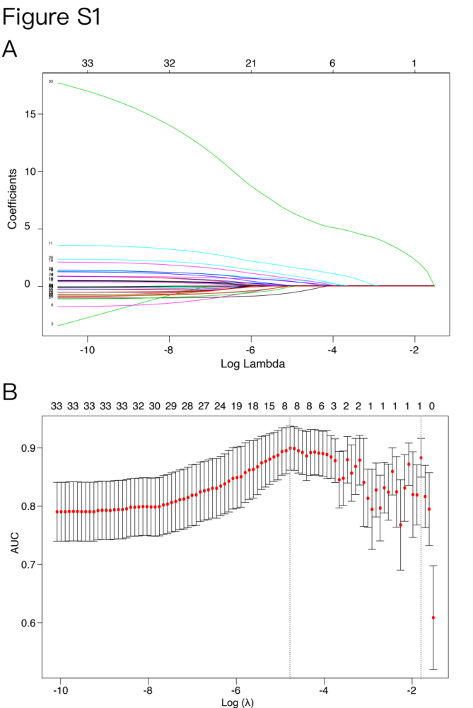
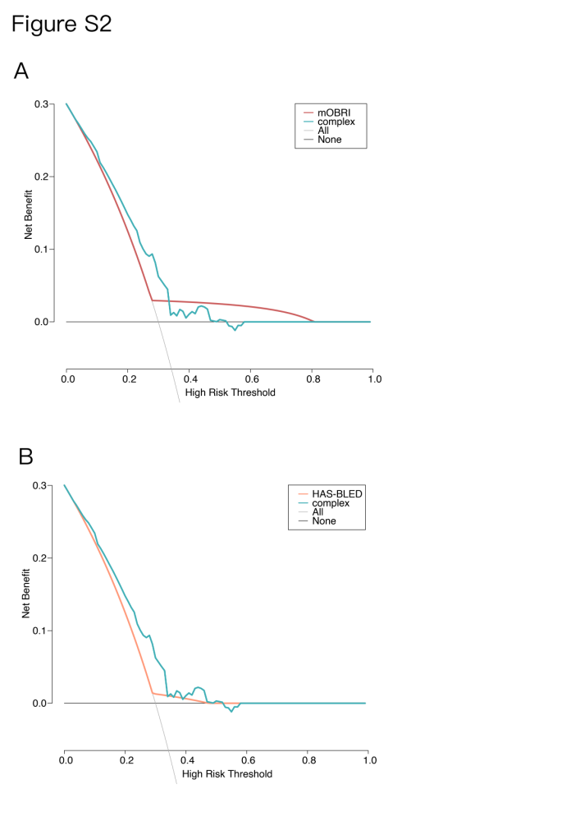
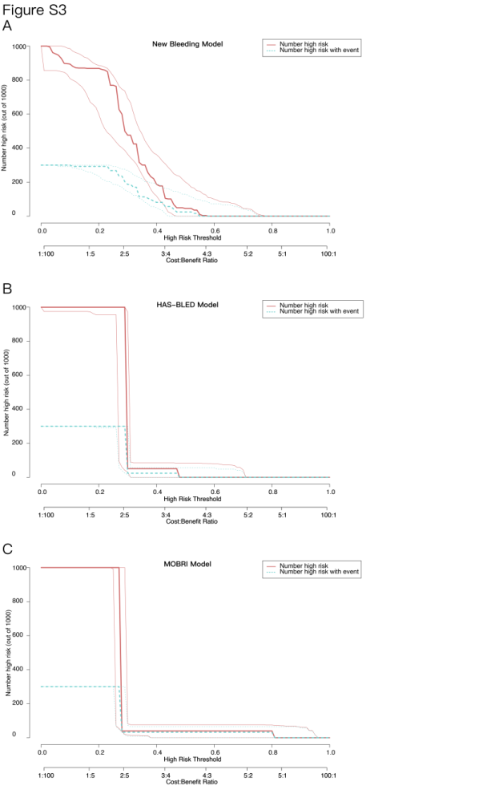
Part II. Report of sample size assessment.
PASS 15.0.5 1

Tests for Two Survival Curves Using Cox's Proportional Hazards Model

Numeric Results with Ha: HR ≠ 1

Total Control Trtmnt Prop'n Hazard Control Trtmnt
Sample Sample Sample Control Ratio Prob Prob Control Trtmnt
Size Size Size N1/N h2/h1 Event Event Events Events
Power N N1 N2 P1 HR Pev1 Pev2 E1 E2 Alpha Beta
0.9035 233 203 30 0.875 10.000 0.029 0.400 5.9 12.0 0.050 0.100

References
Chow, S.C., Shao, J., Wang, H. 2008. Sample Size Calculations in Clinical Research, 2nd Edition. Chapman &
Hall/CRC.
Schoenfeld, David A. 1983. 'Sample Size Formula for the Proportional-Hazards Regression Model', Biometrics,
Volume 39, Pages 499-503.

Report Definitions
Power is the probability of rejecting a false null hypothesis. Power should be close to one.
N is the total sample size.
N1 and N2 are the sample sizes of the control and treatment groups.
P1 is the proportion of the total sample that is in the control group, group 1.
HR is the hazard ratio: h2/h1.
Pev1 and Pev2 are the probabilities of an event in the control and the treatment groups.
E1 and E2 are the number of events required in the control and the treatment groups.
Alpha is the probability of a type one error: rejecting a true null hypothesis.
Beta is the probability of a type two error: failing to reject a false null hypothesis.

Summary Statements
A two-sided test of whether the hazard ratio is one with an overall sample size of 233 subjects
(of which 203 are in the control group and 30 are in the treatment group) achieves 90% power at
a 0.050 significance level when the hazard ratio is actually 10.000. The number of events
required to achieve this power is 17.9. It is anticipated that proportions of subjects having
the event during the study is 0.029 for the control group and 0.400 for the treatment group.
These results assume that the hazard ratio is constant throughout the study and that Cox
proportional hazards regression is used to analyze the data.

Procedure Input Settings

Autosaved Template File
\\Mac\Home\Documents\PASS 15\Procedure Templates\Autosave\Tests for Two Survival Curves Using Cox's Proportional Hazards Model - Autosaved 2020_1_17-18_2_4.t92

Design Tab
Solve For: Sample Size
Alternative Hypothesis: Ha: HR ≠ 1
Power: 0.90
Alpha: 0.05
Group Allocation: Enter R = N2/N1, solve for N1 and N2
R: 0.1428
Pev1 (Probability of a Control Event): 0.029
Pev2 (Probability of a Treatment Event): 0.4
HR (Actual Hazard Ratio = h2/h1): 10

Part III. Details of variants.
Patients’ age: The age of patients was based on the time of diagnosis of prostate cancer.

White blood cell counts, level of hemoglobin, platelet counts: All these indexes were extracted from blood routine examination to evaluate preoperative status of patients.

Diagnosis：
Acute Lymphoblastic Leukemia (ALL) was diagnosed by NCCN Clinical Practice Guidelines in Oncology
Acute Lymphoblastic Leukemia, Version 1.2015 NCCN Clinical Practice Guidelines in Oncology
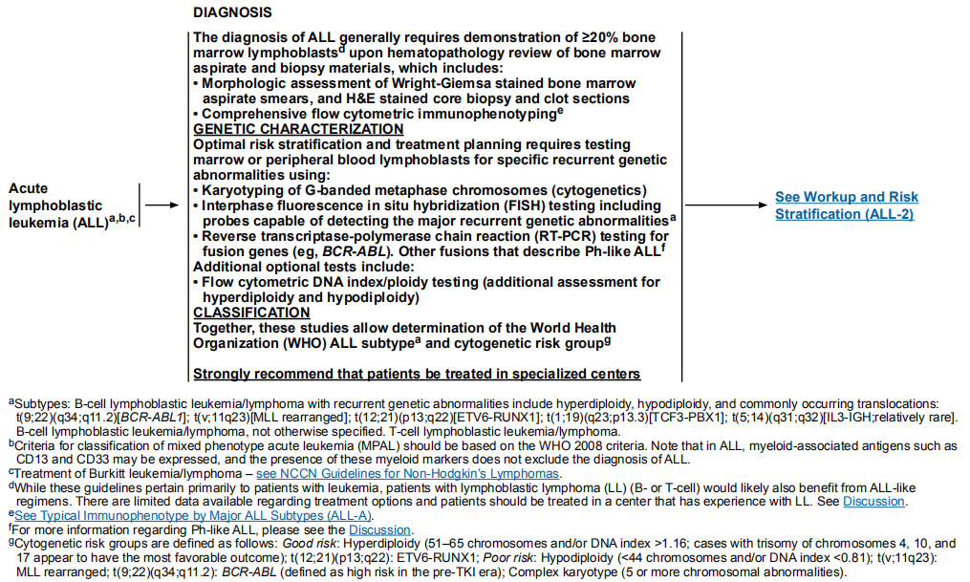

Acute myelocytic leukemia (AML) was diagnosed by World Health Organization classification of myeloid neoplasms and acute leukemia

The 2016 revision to the World Health Organization classification of myeloid neoplasms and acute leukemia.
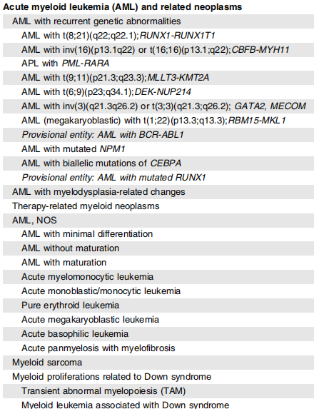

Blastic Plasmacytoid Dendritic Cell Neoplasm (BPDCN) was diagnosed by the World Health Organization (WHO) classification of myeloid neoplasms and acute leukemia
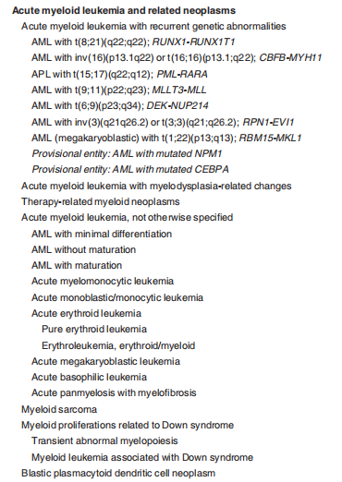
Arber DA, Orazi A, Hasserjian R, et al. The 2016 revision to the world health organization classification of myeloid neoplasms and acute leukemia. Blood 2016; 127: 2391–2405.
Vardiman JW, Thiele J, Arber DA, et al. The 2008 revision of the World Health Organization (WHO) classification of myeloid neoplasms and acute leukemia: rationale and important changes. Blood 2009; 114:937-51

Chronic lymphocytic leukemia (CLL) was diagnosed by 2017 NCCN Clinical Practice Guidelines in Oncology
Chronic Lymphocytic Leukemia/Small Lymphocytic Lymphoma,Version 1.2017 NCCN Clinical Practice Guidelines in Oncology
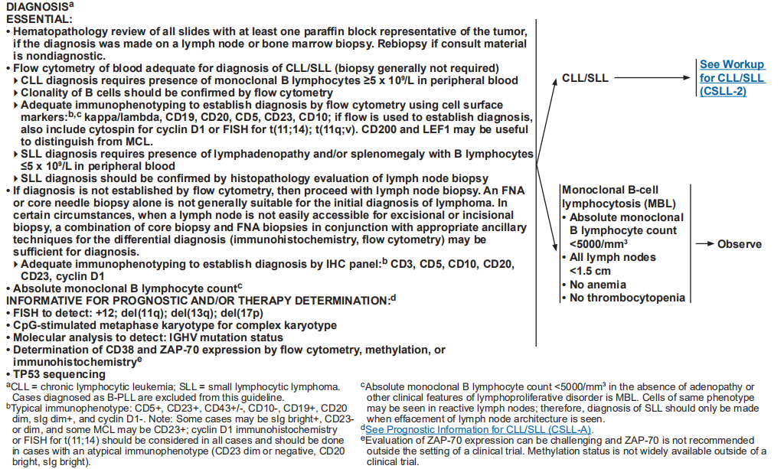

Chronic myeloid leukemia (CML) was diagnosed by World Health Organization classification of myeloid neoplasms and acute leukemia

The 2016 revision to the World Health Organization classification of myeloid neoplasms and acute leukemia.
The diagnosis of typical CML is simple and consists of documenting, in the setting of persistent unexplained leukocytosis (or occasionally thrombocytosis), the presence of the Ph chromosome abnormality, the t(9;22)(q34;q11), by routine cytogenetics, or the Phrelated molecular BCR-ABL abnormalities by fluorescent in situ hybridization (FISH) or by molecular studies.

Hybrid acute leukemia (HAL) was diagnosed by World Health Organization classification of myeloid neoplasms and acute leukemia
The 2016 revision to the World Health Organization classification of myeloid neoplasms and acute leukemia
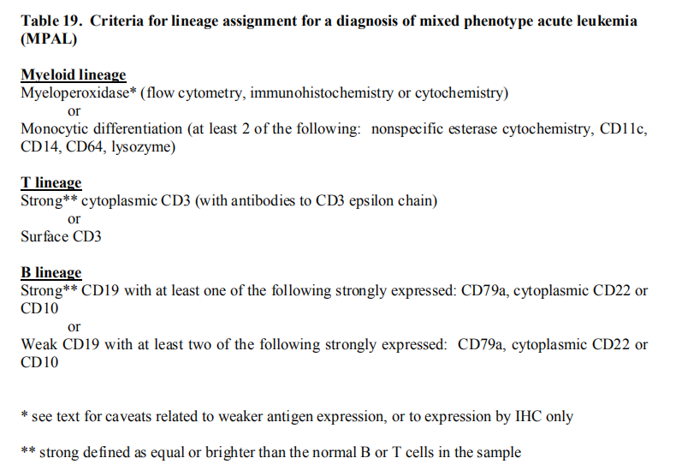

Hodgkin lymphoma (HD) was diagnosed by 2015 NCCN Clinical Practice Guidelines in Oncology
Hodgkin Lymphoma, Version 1.2015 NCCN Clinical Practice Guidelines in Oncology
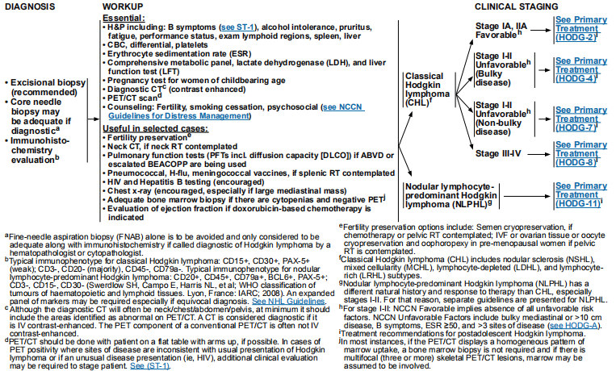

Multiple myeloma (MM) was diagnosed by 2017 NCCN Clinical Practice Guidelines in Oncology
Multiple Myeloma,Version 3. 2017 NCCN Clinical Practice Guidelines in Oncology
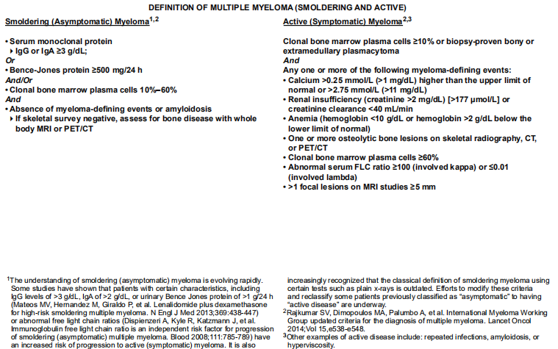

Non-hodgkin lymphoma (NHL) was diagnosed by 2015 NCCN Clinical Practice Guidelines in Oncology
Non-Hodgkin’s Lymphoma, Version 1.2015 NCCN Clinical Practice Guidelines in Oncology
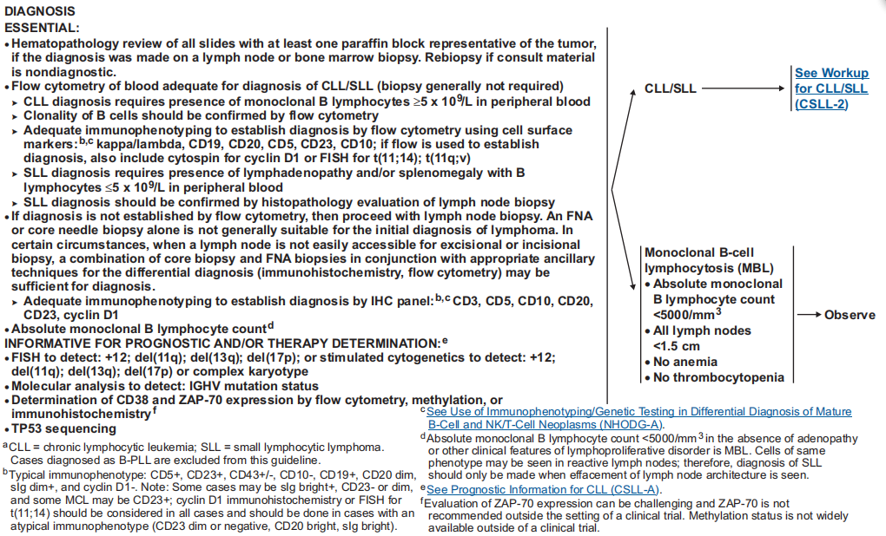

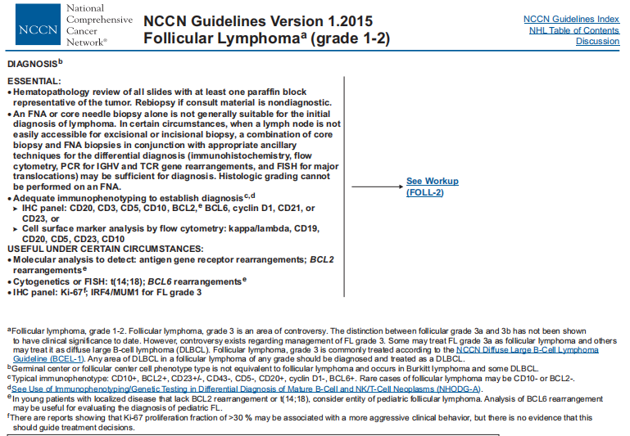

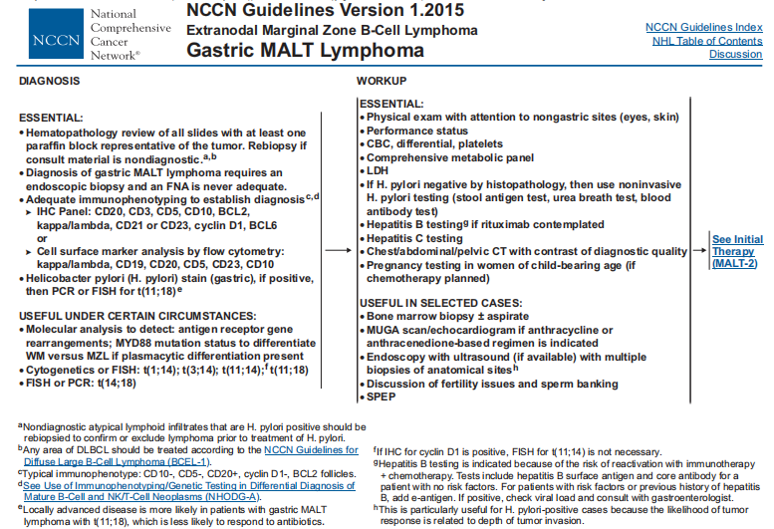
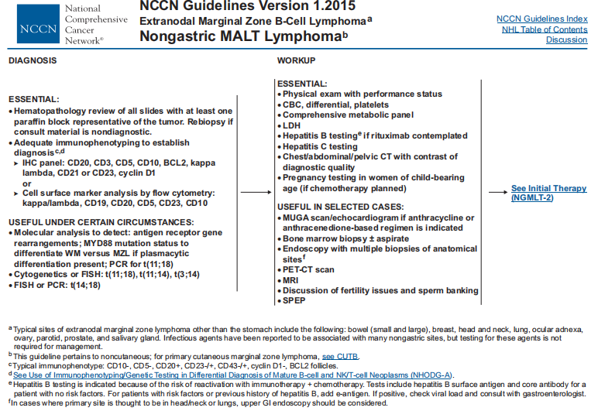

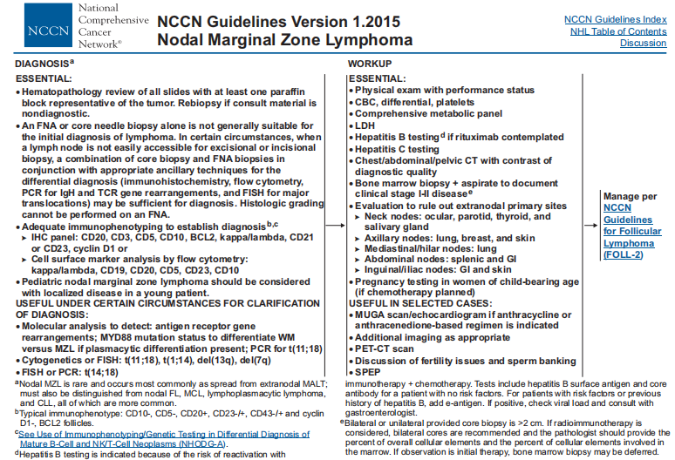

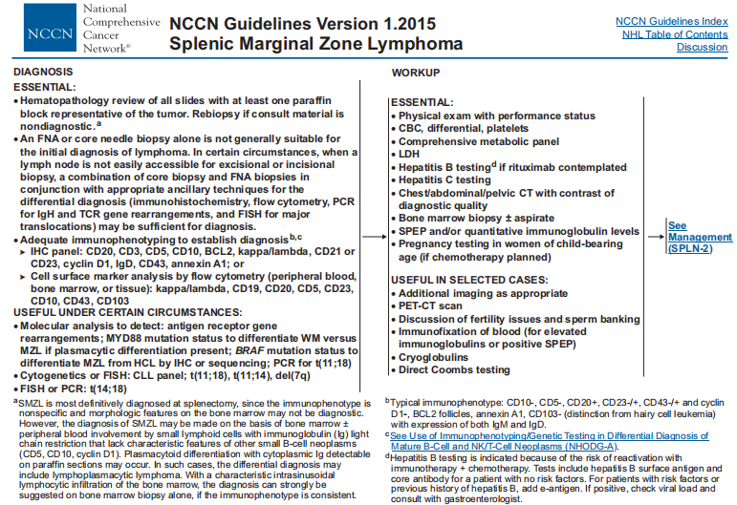

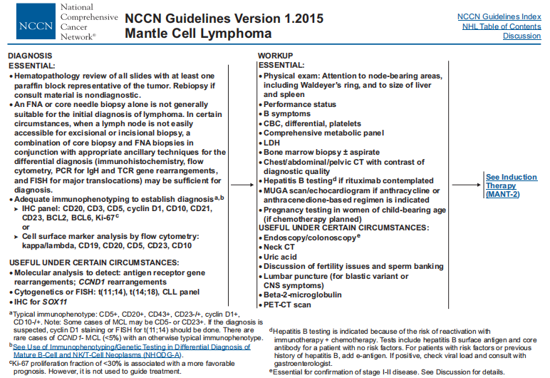

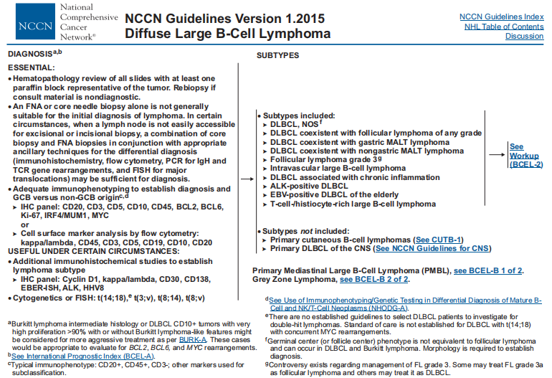

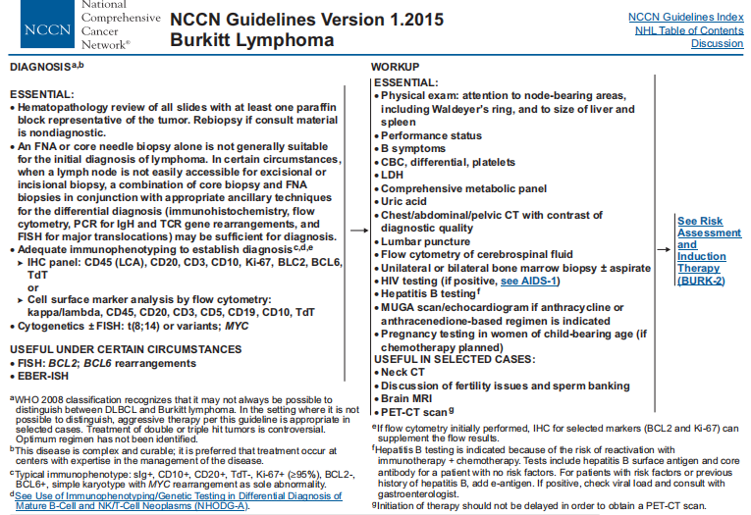

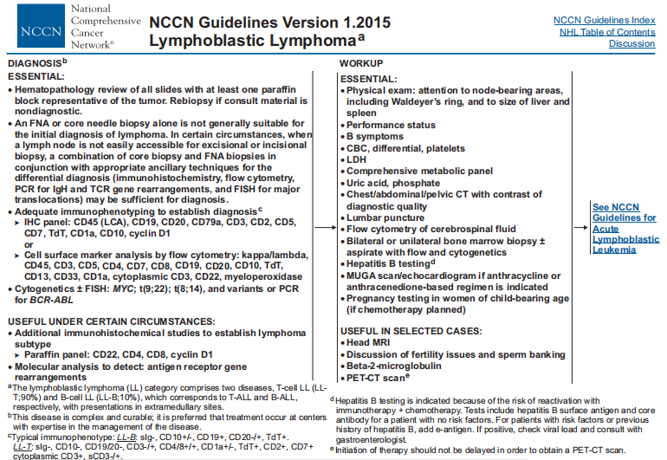

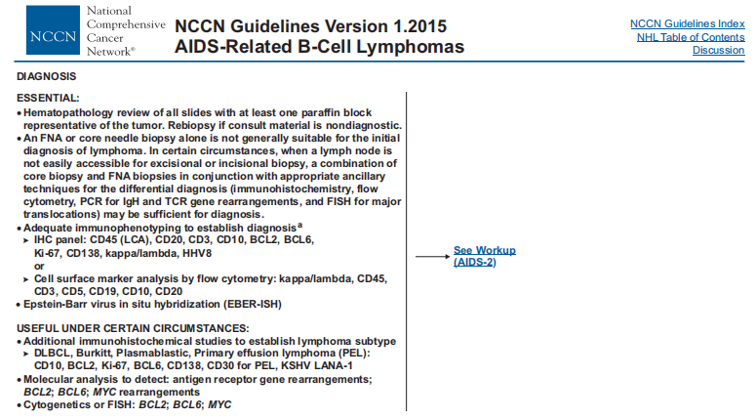

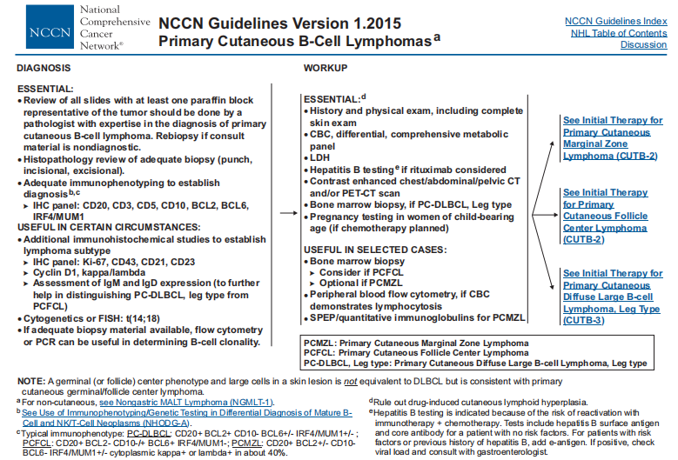

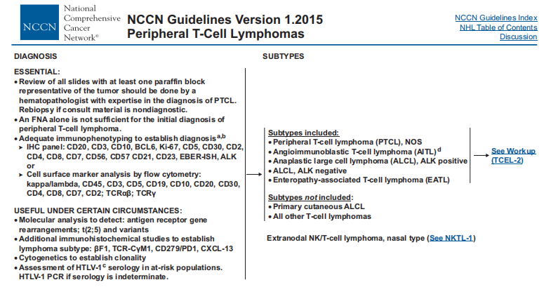
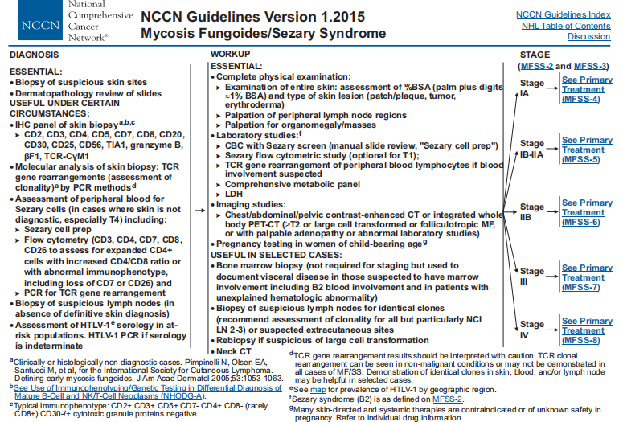

Plasma cell leukemia (PCL) was diagnosed by the recommendations of IMWG
De Larrea CF, Kyle RA, Durie BGM, Ludwig H, Usmani S, Vesole DH, et al. Plasma cell leukemia: consensus statement on diagnostic requirements, response criteria, and treatment recommendations by the International Myeloma Working Group (IMWG). Leukemia. 2013;27:780–91.
The original diagnostic criteria of PCL were established in 1974 by Noel and Kyle, requiring both more than 20% circulating plasma cells and an absolute count greater than 2*10^9/L plasma cells in peripheral blood.

POEMS was diagnosed by 2017 Update on diagnosis, risk stratification, and management of POEMS syndrome

POEMS syndrome: 2017 Update on diagnosis, risk stratification, and management. Am J Hematol. 2017 Aug;92(8):814-829.
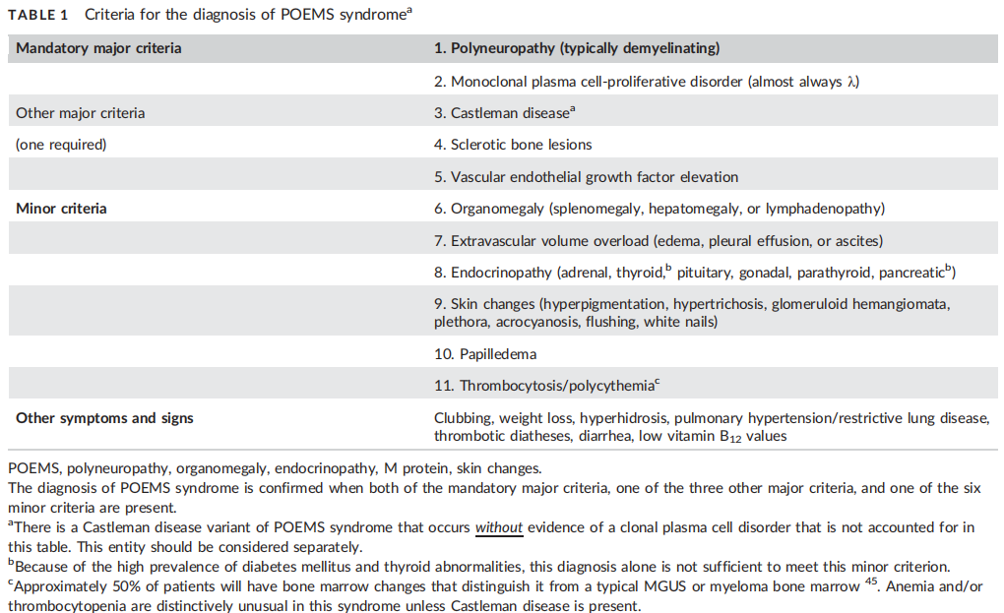

Waldenstrom macroglobulinemia (WM) was diagnosed by the latest Chinese guideline

The consensus of the diagnosis and treatment of lymphoplasmacytic lymphoma/Walderström macroglobulinemia in China (2016 version) Zhonghua Xue Ye Xue Za Zhi. 2016 Sep 14;37(9):729-734.
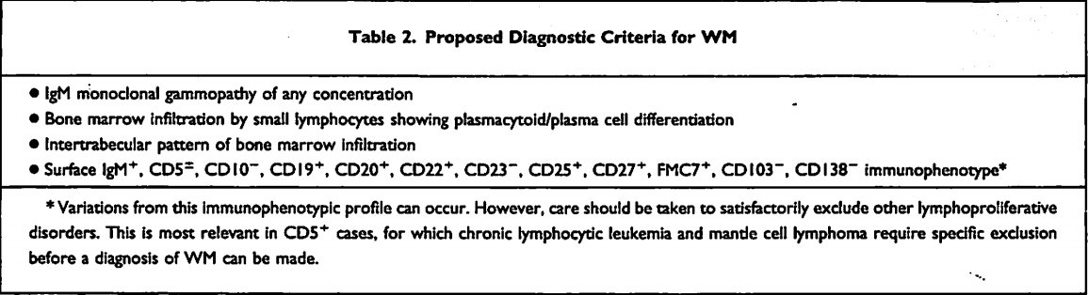

Percentage of blast in bone marrow：
proportion of blast cells in bone marrow after bone marrow aspiration when first diagnosed.

Type of Car-T cell therapy,
TCR part of CAR-T cell is replaced by CAR which includes two domains: an extracellular and an intracellular domain. The extracellular domain is typically an antibody single-chain fragment (scFv) specifically against a cell surface antigen, while the intracellular domain includes fused signaling domains from a natural TCR complex and costimulatory molecules. Different intracellular sections represent various CAR-T cell generations. The structure ranges from CD3z signaling domain alone in first generation CARs (lack of costimulatory signal) to those that possess the signaling endo-domains of costimulatory molecules, which are fused with CD3z, in second and third generation CARs. This structure imitates the costimulation signal when TCR combines with antigen-presenting cells to complete the process of activation.All of these generate CAR-T cell specificity for a certain type of cancer cell and leads to their elimination. Because a monoclonal antibody against a tumor antigen offers novel T cell specificity for certain types of cancer cells and bypasses the established antigen-presenting process, an important strength of this method is that the recognition is independent of the major histocompatibility complex.The most common target is CD19. Other targets such as CD20, CD30, CD138 are showing some success as well.

(Zhao Z, et al.The application of CAR-T cell therapy in hematological malignancies: advantages and challenges. Acta Pharm Sin B. 2018 Jul;8(4):539-551. )

Application of IL-6 knock-out,
Knock out IL-6 gene of CAR-T cells to reduce the release of IL-6 after Car-T cell transfusion.

Hypertension：
Patients with hypertension or isolated systolic hypertension
Joint Committee for Guideline Revision. 2018 Chinese Guidelines for Prevention and Treatment of Hypertension-A report of the Revision Committee of Chinese Guidelines for Prevention and Treatment of Hypertension. J Geriatr Cardiol. 2019 Mar;16(3):182-241.
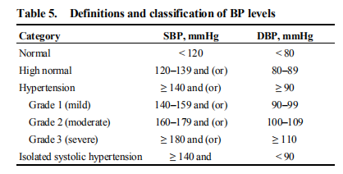

Diabetes：
Patients with diabetes which meets the guideline below
American Diabetes Association. Standards of Medical Care in Diabetes-2018[J]. Diabetes Care, 2018, 41(Suppl 1): S1-S153.
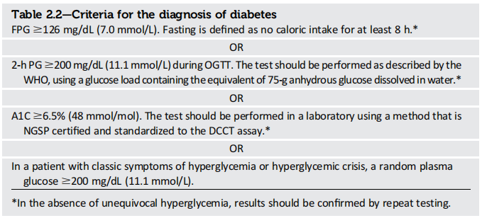

Car-T cell counts：
Cell volume per kg infused to patients

CRS stage：
CRS stage was according to the criteria below.
Lee, D. W. et al. Current concepts in the diagnosis and management of cytokine release syndrome. Blood 2014(124), 188–195
Neelapu SS, et al. Chimeric antigen receptor T-cell therapy - assessment and management of toxicities. Nat Rev Clin Oncol. 2018 Jan;15(1):47-62.
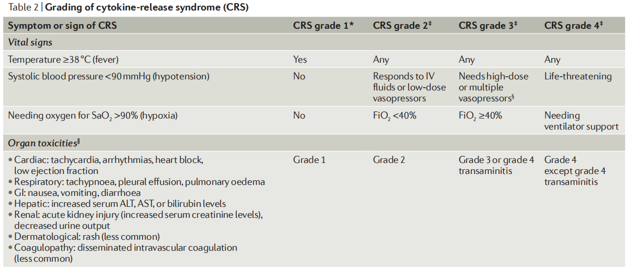
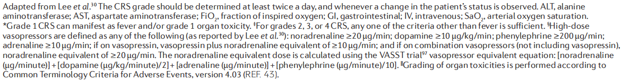

Application of hematopoietic stem cell transplant (HSCT)：
Before Car-T therapy，patients had had a hematopoietic stem cell transplant. We applied myeloablative conditioning (MAC) regimens in the majority of the MDS patients, while received reduced intensive conditioning (RIC) regimens were use in the remaining patients. For MSDT, MAC regimens comprised cytarabine (2g/m2/d, days −9 to −8), semustine (250mg/m2, day −10), cyclophosphamide (1.8g/m2/d, days −4 to −3) and busulfan (3.2 mg/kg/d, days −7 to −5). For MUDT and HIDT, patients received a MAC regimen identical to that for MSDT despite higher doses of cytarabine (4 g/m2/d, days −9 to −8). Patients receiving MUDT also received hydroxycarbamide (80mg/kg, day −10). Rabbit ATG (Thymoglobulin; ImtixSangstat, Lyon, France) was administered to patients receiving HIDT (10 mg/kg total dose, days −6 to −3) and MUDT (10 mg/kg total dose, days −5 to −2). The RIC comprised fludarabine (30 mg/m /d, 9 days −10 to −6), semustine (250 mg/m2, day −10), busulfan (3.2 mg/kg/d, 10 days −5 to −3) and cytarabine (1.5 g/m2/d, days −10 to −6). The regimens were as follows: ATG 2.5mg/kg/day, for four days; ATG-F 5mg/kg/day, for four days; ALG 15mg/kg/day, for four days. For a small part of patients who received MSDT, lower dose of ATG (2.5mg/kg/day, for two days) or ATG-F(5mg/kg/day, for two days) was used.

Efficacy of treatment (complete remission)：
Response criteria definitions for hematological diseases.
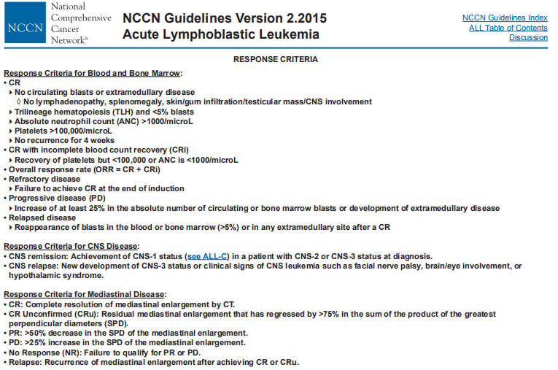

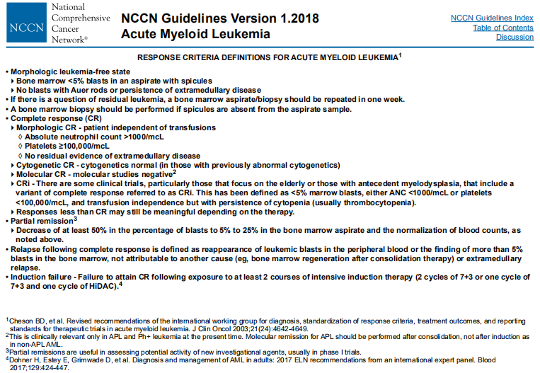

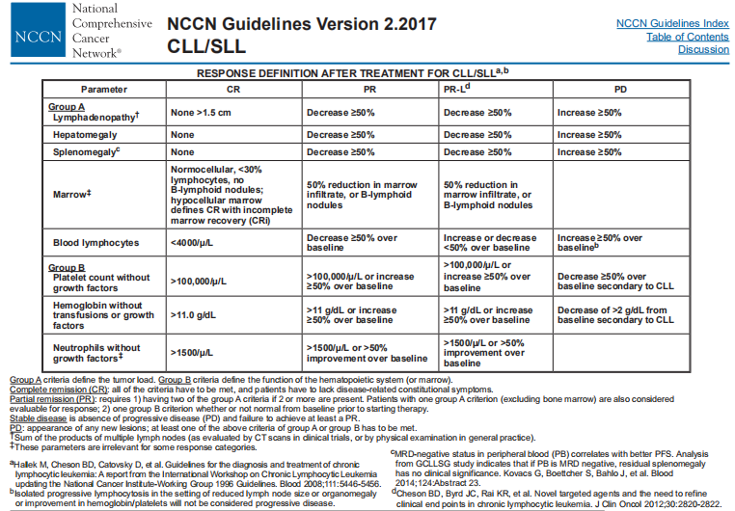

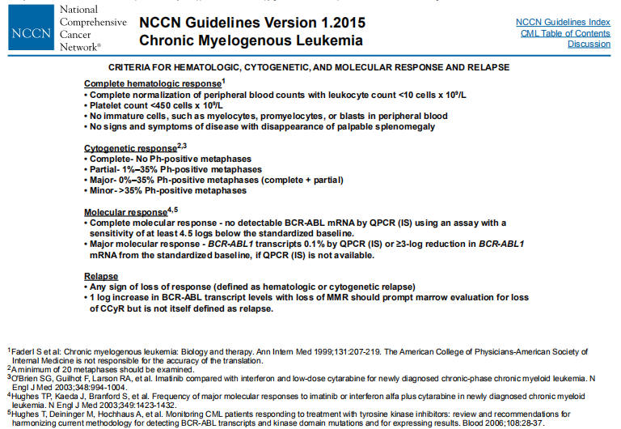

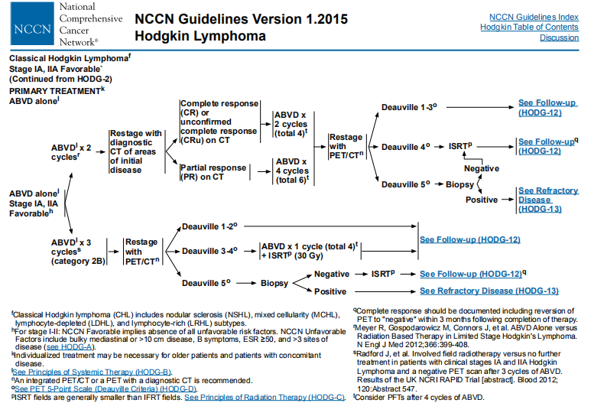

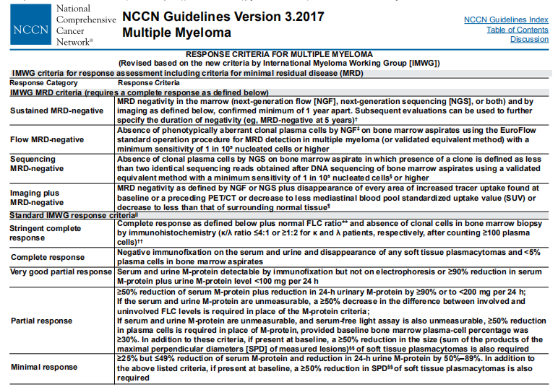
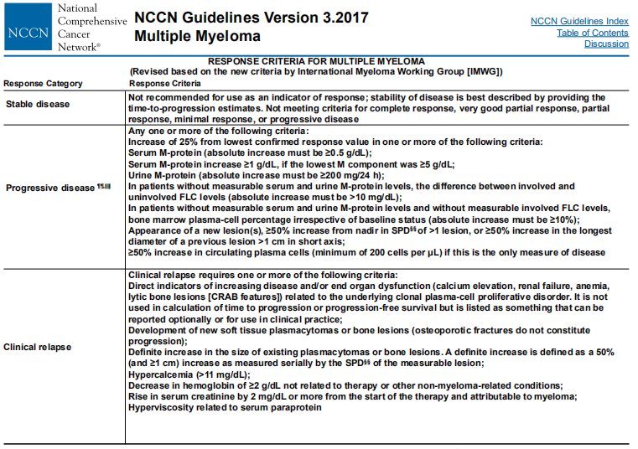
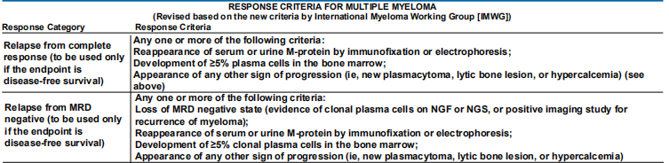
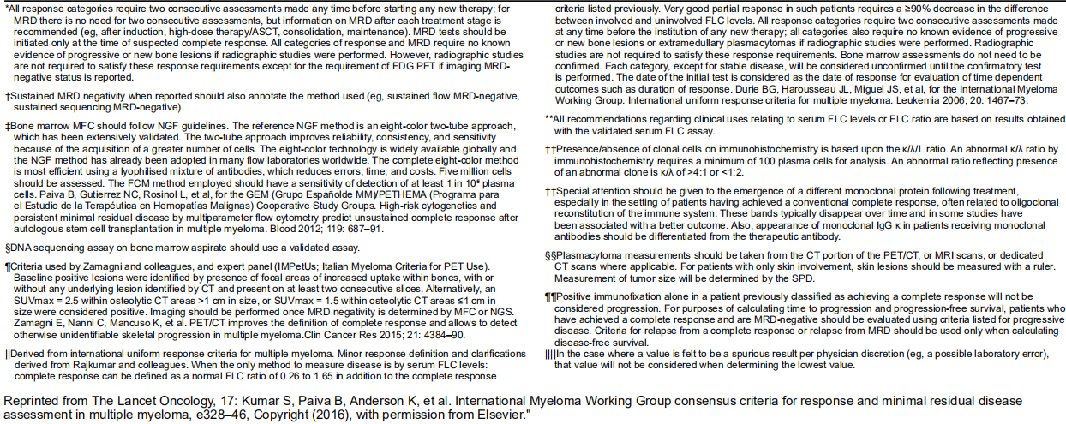

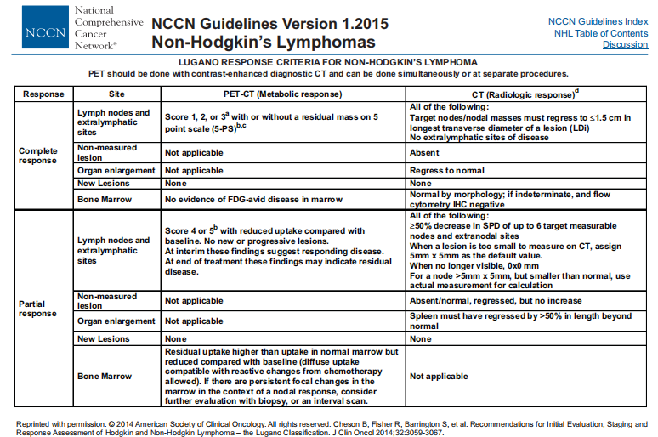

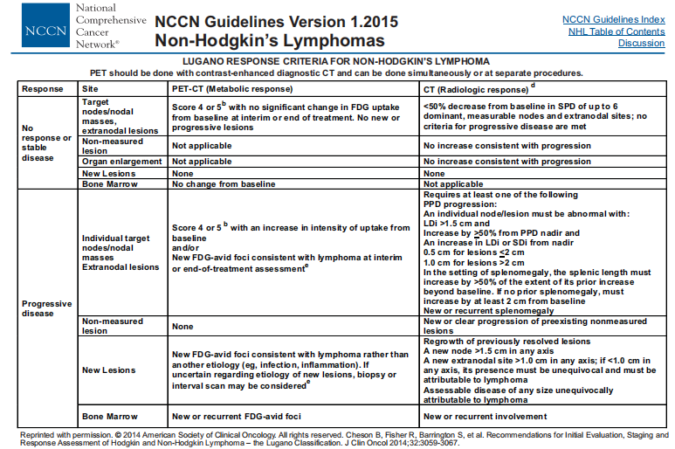

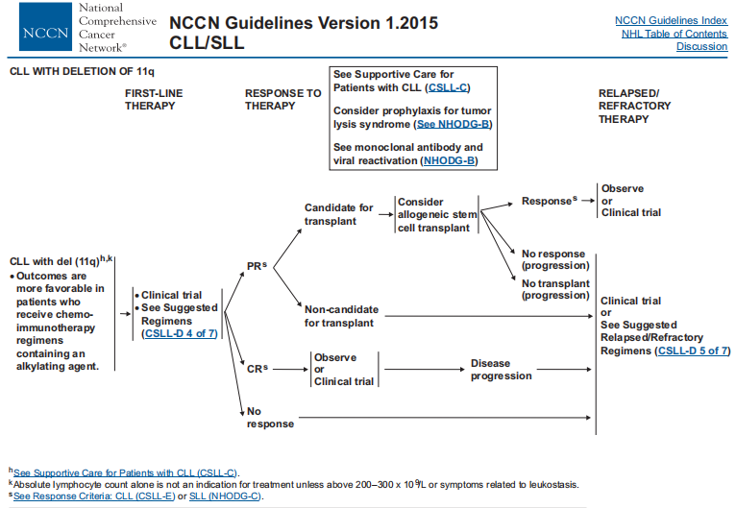

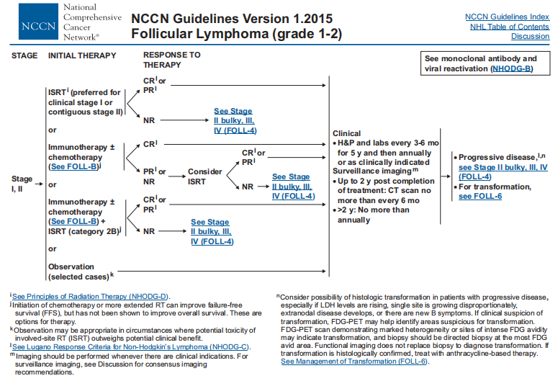

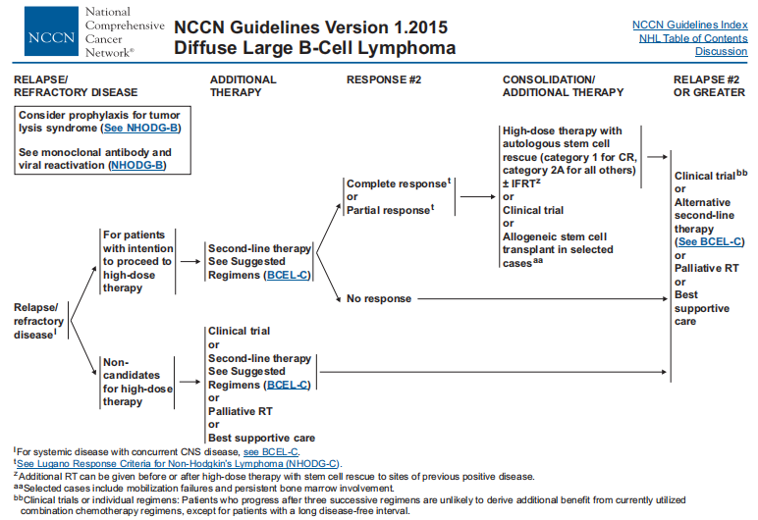

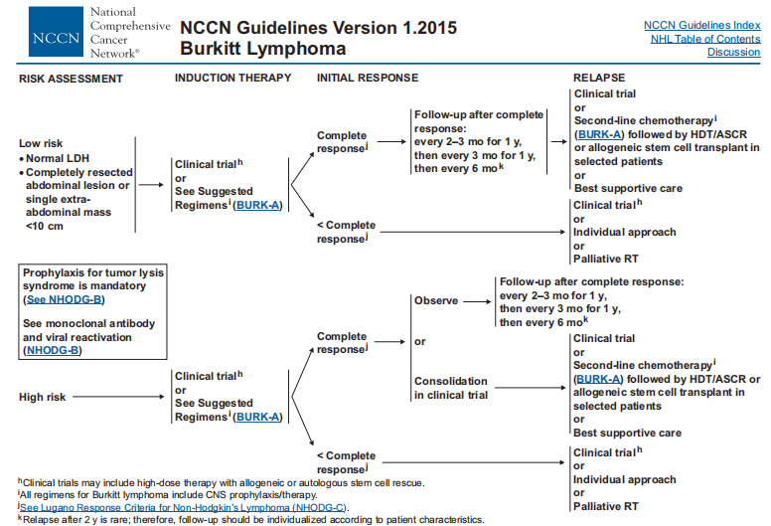

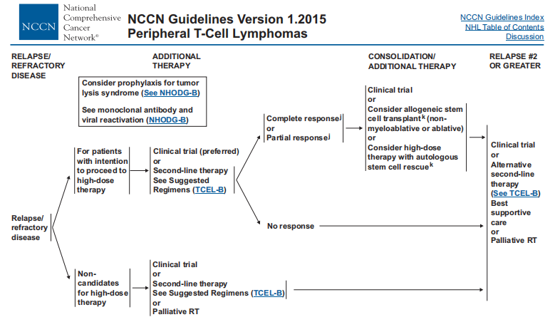
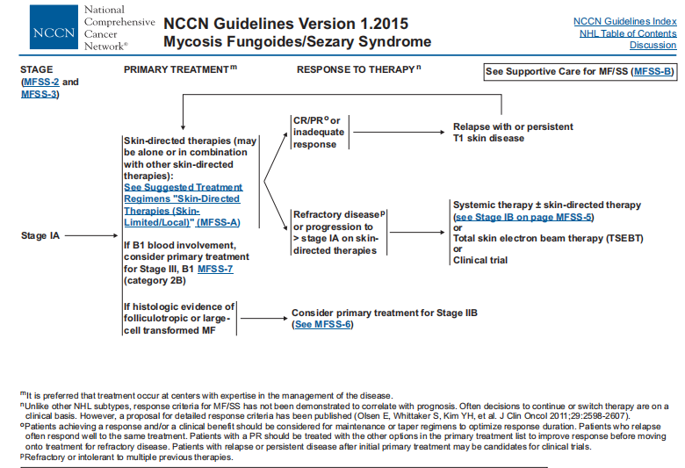

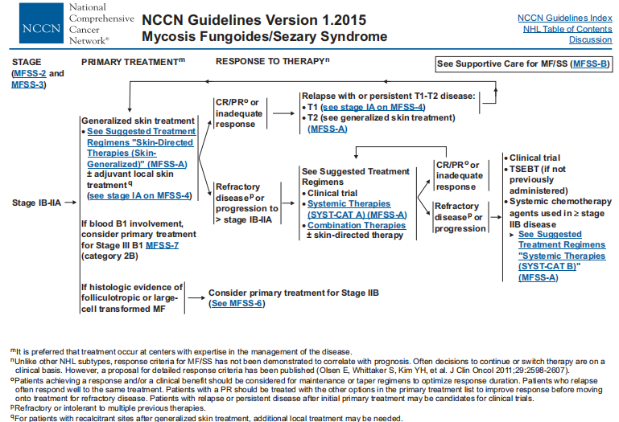

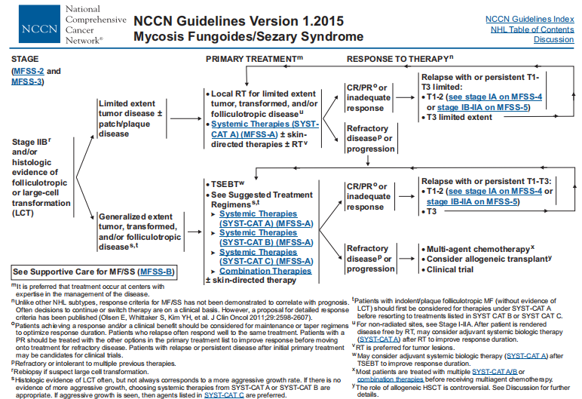

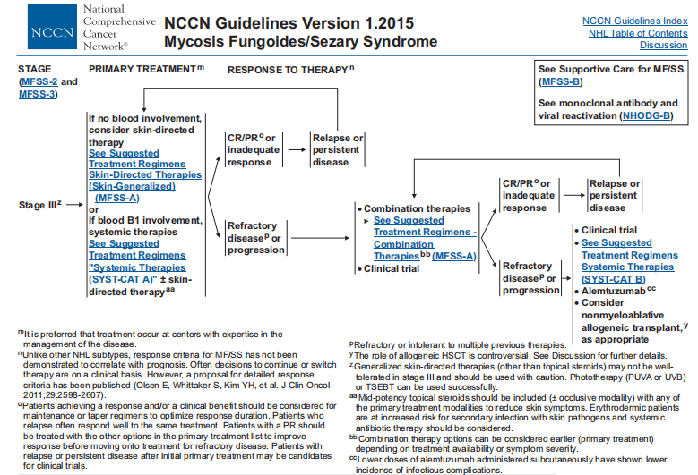

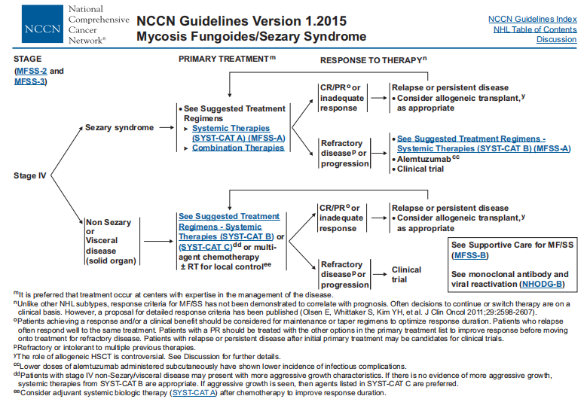

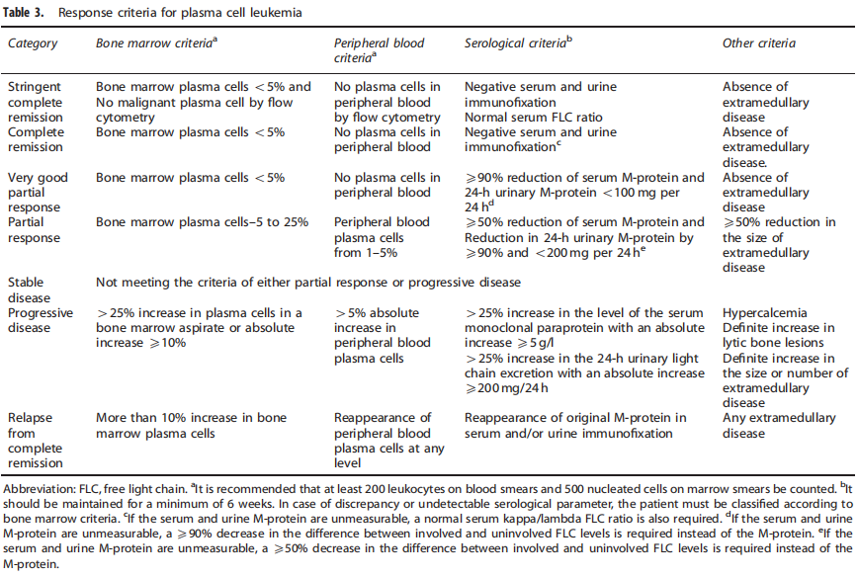

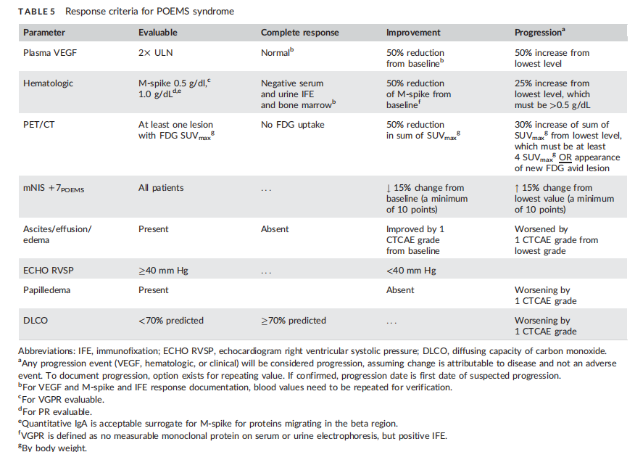

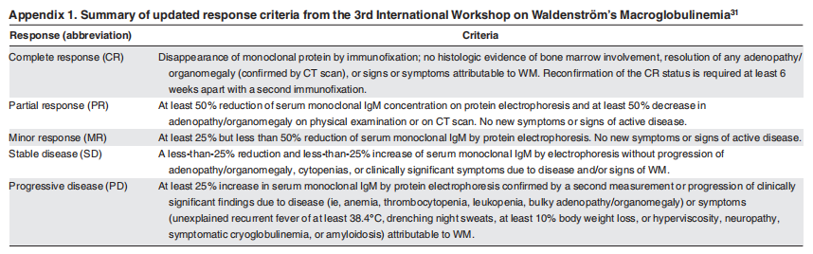

Application of blood transfusion:
After Car-T cell transfusion, blood transfusion was performed due to abnormal blood cell count or coagulation index, including blood products such as plasma, red blood cells, platelets, etc.
Blood Transfusion.National Clinical Guideline Centre (UK). London: National Institute for Health and Care Excellence (UK); 2015 Nov.

DIC occurrence:
Consensus of Chinese experts on diagnosis of disseminated intravascular coagulation (version2017). Zhonghua Xue Ye Xue Za Zhi. 2017 May 14;38(5):361-363.
Taylor FB Jr, Toh CH, Hoots WK, Wada H, Levi M; Towards definition, clinical and laboratory criteria, and a scoring system for disseminated intravascular coagulation. Scientific Subcommittee on Disseminated Intravascular Coagulation (DIC) of the International Society on Thrombosis and Haemostasis (ISTH).
Thromb Haemost. 2001 Nov;86(5):1327-30.

Fibrinogen (FIB)
It is a protein that can be dissolved in water. It is a protein with coagulation function synthesized by the liver. It is an important substance in the process of coagulation and thrombosis.

Activated partial thromboplastin time (APTT),
A more sensitive screening test for the endogenous coagulation system

Prothrombin time (PT),
It is an indicator of exogenous coagulation system function and an important monitoring indicator of clinical anticoagulation therapy.

Thrombin time (TT),
Time of blood clotting after adding standardized thrombin to the plasma

Level of Interleukin 2 (IL-2),
This is an interleukin, a type of cell growth factor in the immune system, which can regulate the cell activity of white blood cells in the immune system, promote the proliferation of Th0 and CTL, and also participate in antibody response, hematopoietic and tumor monitoring.

IL-4,
IL-4 is mainly produced by activated T cells and has immunoregulatory effects on B cells, T cells, mast cells, macrophages, and hematopoietic stem cells.
IL-6,
Lymphokines produced by activated T cells and fibroblasts

IL-10,
An immune medium secreted by Th2 cells can inhibit Th1 cell clone IL-2 and inhibit IFNr synthesis.

IL-17A,
Lymphocytes migrate to infected or injured parts of the body and secrete interleukin-17A.

TNF-α,
A pro-inflammatory cytokine produced mainly by macrophages and monocytes and is involved in normal inflammatory and immune responses.

Interferon gamma (IFN-γ),
A cytokine produced by activated T cells and natural killer cells (NK cells) and NKT cells

Risk of bleeding estimated by MOBRI:
Beyth RJ, et al. Prospective evaluation of an index for predicting the risk of major bleeding in outpatients treated with warfarin.Am J Med. 1998 Aug;105(2):91-9.
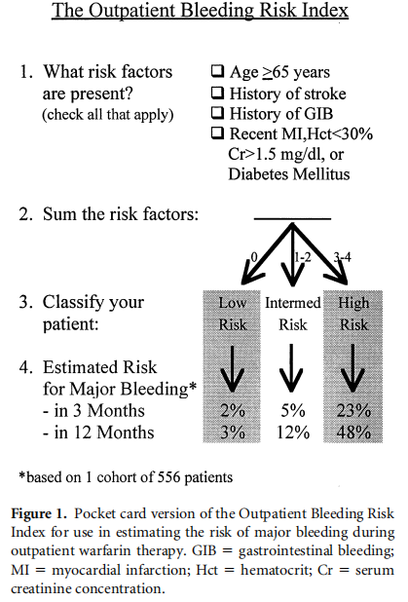

HAS-BLED:
Pisters R,et al. A novel user-friendly score (HAS-BLED) to assess 1-year risk of major bleeding in patients with atrial fibrillation: the Euro Heart Survey. Chest. 2010 Nov;138(5):1093-100.
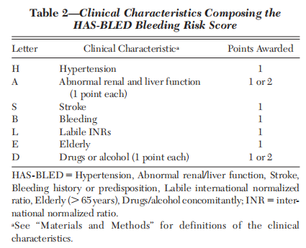

HEMORR2:
Gage BF, et al.Clinical classification schemes for predicting hemorrhage: results from the National Registry of Atrial Fibrillation (NRAF).Am Heart J. 2006 Mar;151(3):713-9.
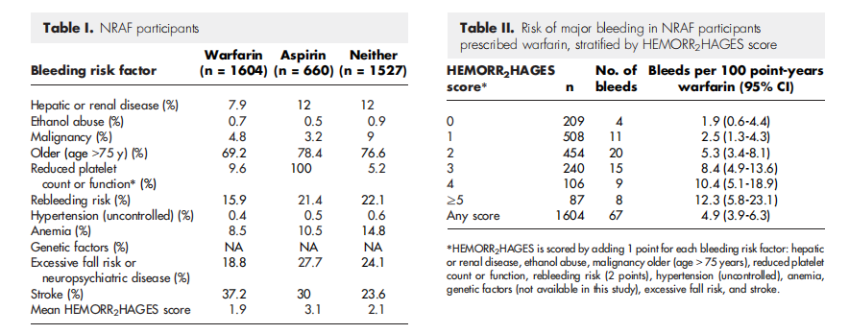

Bleeding class:
Stanworth SJ,et al. A no-prophylaxis platelet-transfusion strategy for hematologic cancers. N Engl J Med. 2013 May 9;368(19):1771-80.
