Supplementary Information for
Sensitivity of Cross-equatorial Propagation of Cold Surge to Sea Surface Temperature in the South China Sea

Narizka Nanda PURWADANI^{1,2}, Muhammad Rais ABDILLAH³, Erma YULIHASTIN², Nining Sari NINGSIH⁴, and Toshiki IWASAKI⁵
¹Doctoral Program in Earth Sciences, Faculty of Earth Sciences and Technology, Institut Teknologi Bandung, Bandung, Indonesia
²Research Center for Climate and Atmosphere, National Research and Innovation Agency, Bandung, Indonesia
³Atmospheric Science Research Group, Faculty of Earth Sciences and Technology, Institut Teknologi Bandung, Bandung, Indonesia
⁴Applied and Environmental Oceanography Research Group, Faculty of Earth Sciences and Technology, Institut Teknologi Bandung, Bandung, Indonesia
⁵Department of Geophysics, Graduate School of Science, Tohoku University, Sendai, Japan

Contents of this file
Figures S1 to S4
Table S1

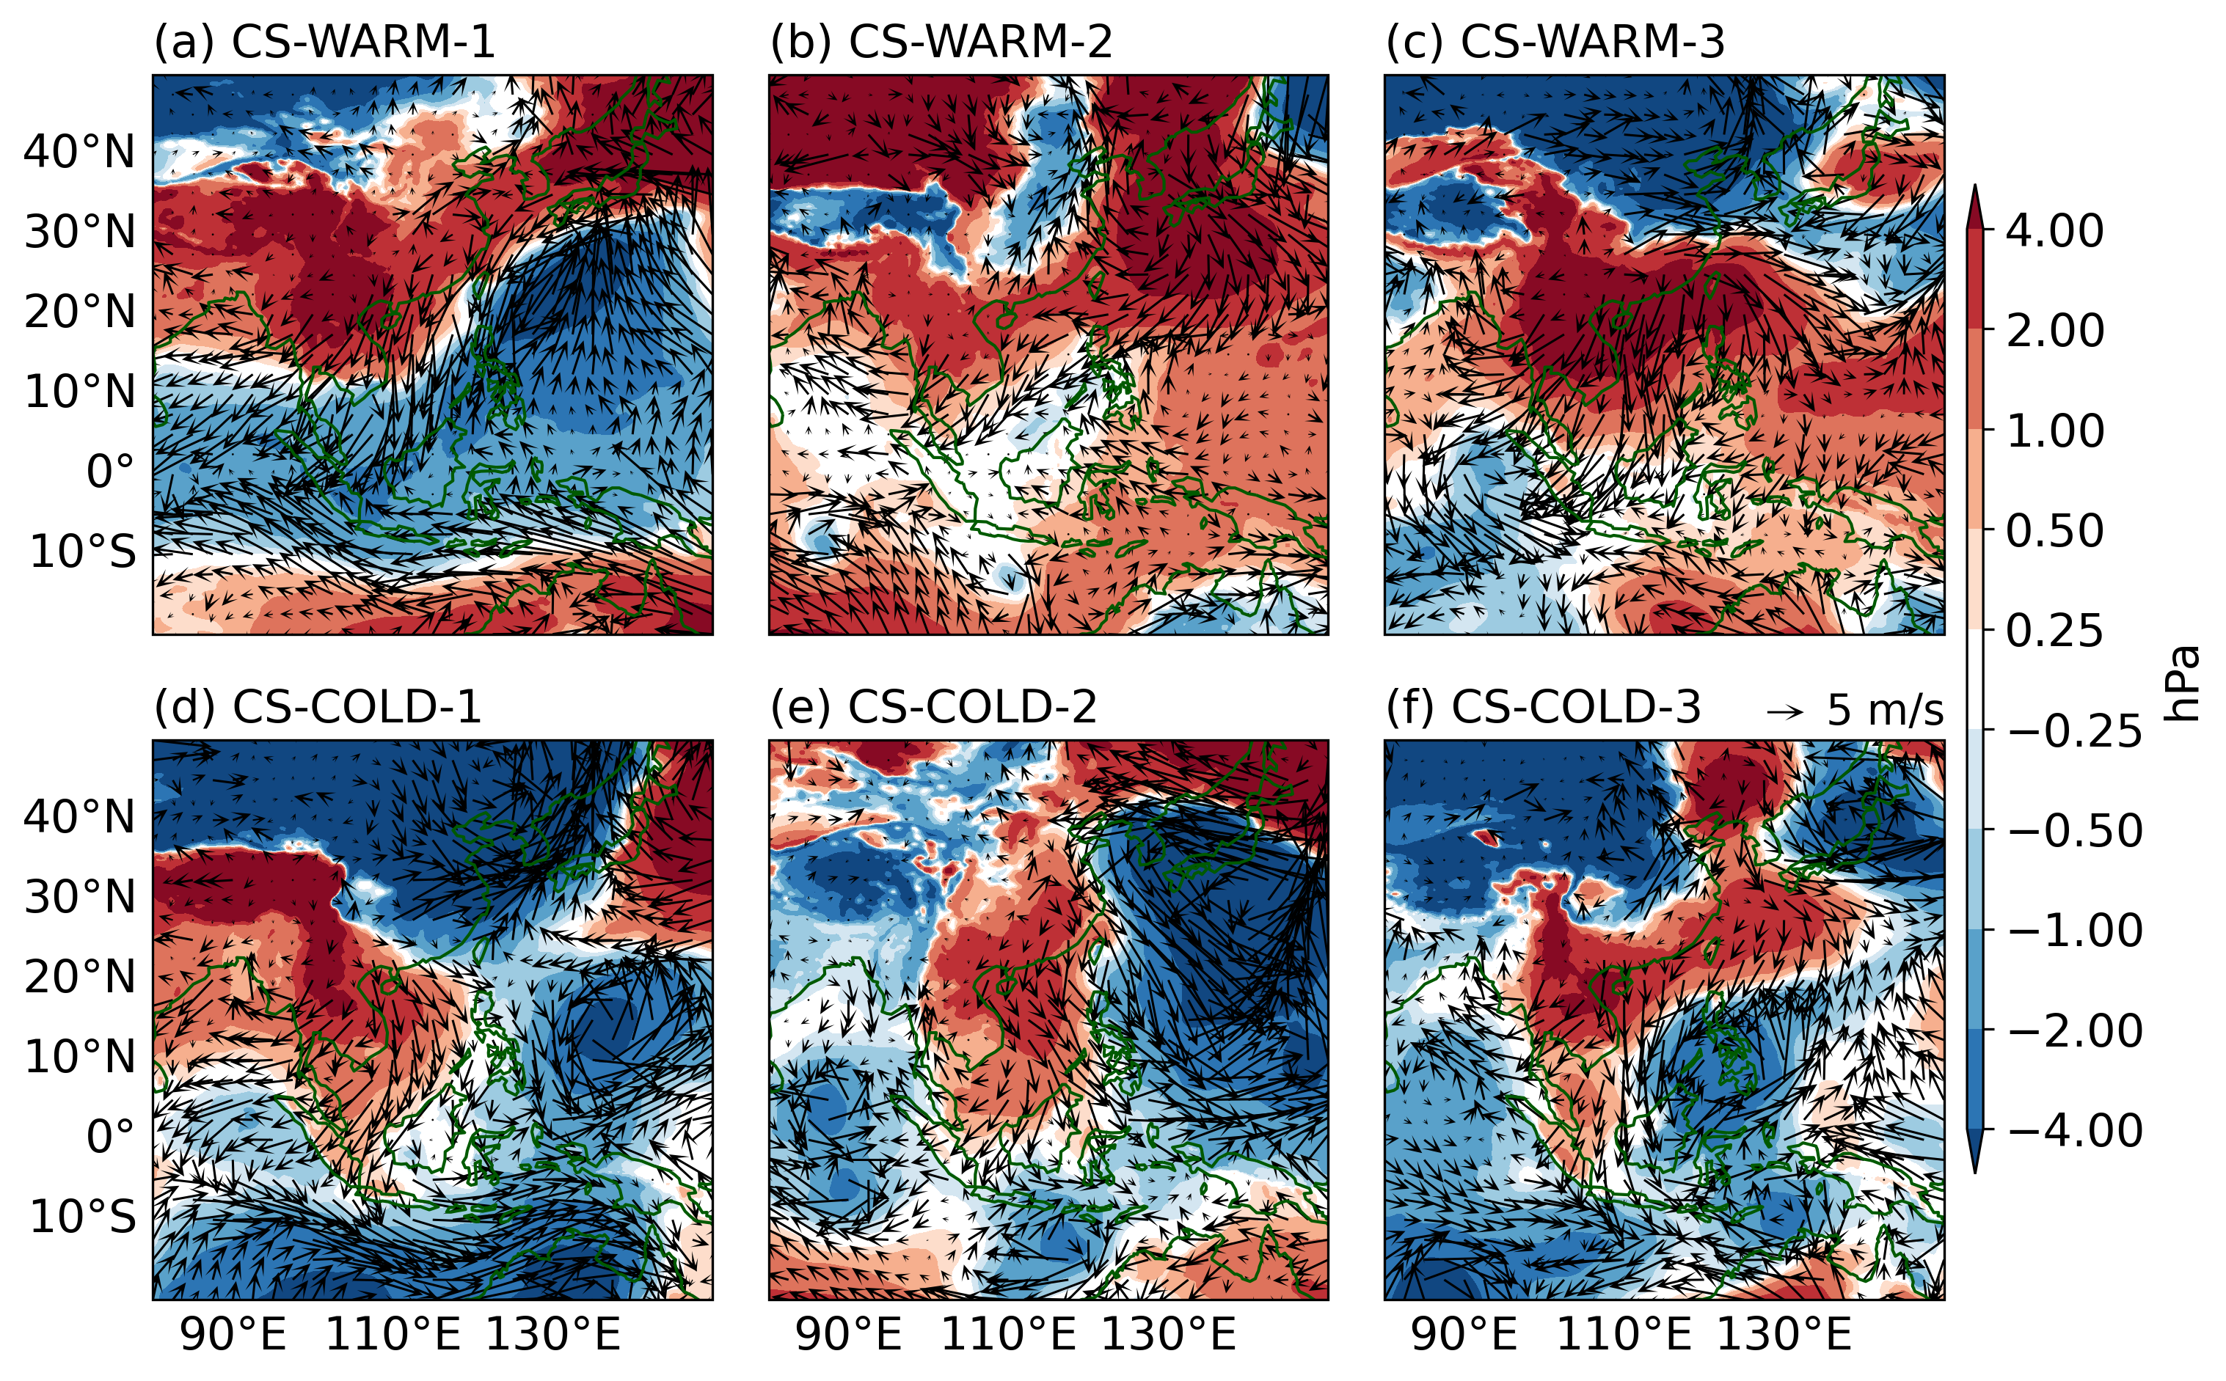
Figure S1. Spatial distribution of mean sea level pressure anomalies (hPa, shaded) and wind vectors (m/s) at Day 0 of the CS peak for the six selected cases in this study.

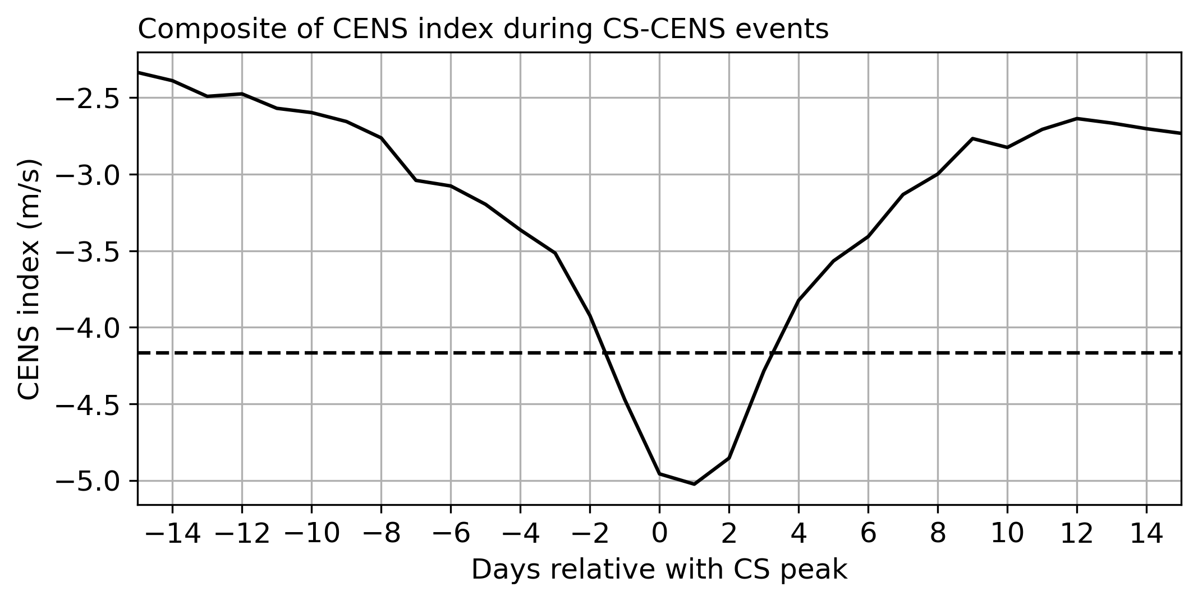
Figure S2. Time series composite of the CENS index (m/s) from 15 days before to 15 days after the peak of the CS. The CENS index is calculated using the 10-m meridional wind averaged over the CENS region shown in Figure 1 of the main text. The horizontal dashed line indicates the index threshold value for CENS events.

Table S1. Statistical evaluation metrics, including Correlation (Corr) and Root Mean Square Error (RMSE), for three planetary boundary layer schemes (YSU, MYNN, and QNSE) against observational data at the 1000–850 hPa pressure levels at three station locations (96237 Pangkal Pinang, Indonesia (PKP); 48698 Changi Airport, Singapore (SGP); 96413 Kuching, Malaysia (KCG)) for the CS-WARM-3 and CS-COLD-3 cases, along with the average performance rank of each parameterization.
 | Case CS-WARM-3 |  |  |  |  |  | Case CS-COLD-3
 | Corr |  |  | RMSE |  |  | Corr |  |  | RMSE
 | PKP | SGP | KCG | PKP | SGP | KCG | PKP | SGP | KCG | PKP | SGP | KCG
YSU | 0.62 | 0.73 | 0.47 | 3.22 | 3.03 | 4.76 | 0.38 | 0.81 | 0.72 | 4.30 | 2.71 | 2.78
MYNN | 0.73 | 0.55 | 0.47 | 2.66 | 3.93 | 4.84 | 0.55 | 0.80 | 0.72 | 3.18 | 2.96 | 3.24
QNSE | 0.74 | 0.68 | 0.49 | 2.55 | 3.38 | 5.13 | 0.64 | 0.81 | 0.68 | 3.56 | 2.93 | 3.50
 | RANK |  |  |  |  |  |  |  |  |  |  |  | AVG RANK
YSU | 3 | 1 | 2 | 3 | 1 | 1 | 3 | 2 | 2 | 3 | 1 | 1 | 1.92
MYNN | 2 | 3 | 3 | 2 | 3 | 2 | 2 | 3 | 1 | 1 | 3 | 2 | 2.25
QNSE | 1 | 2 | 1 | 1 | 2 | 3 | 1 | 1 | 3 | 2 | 2 | 3 | 1.83

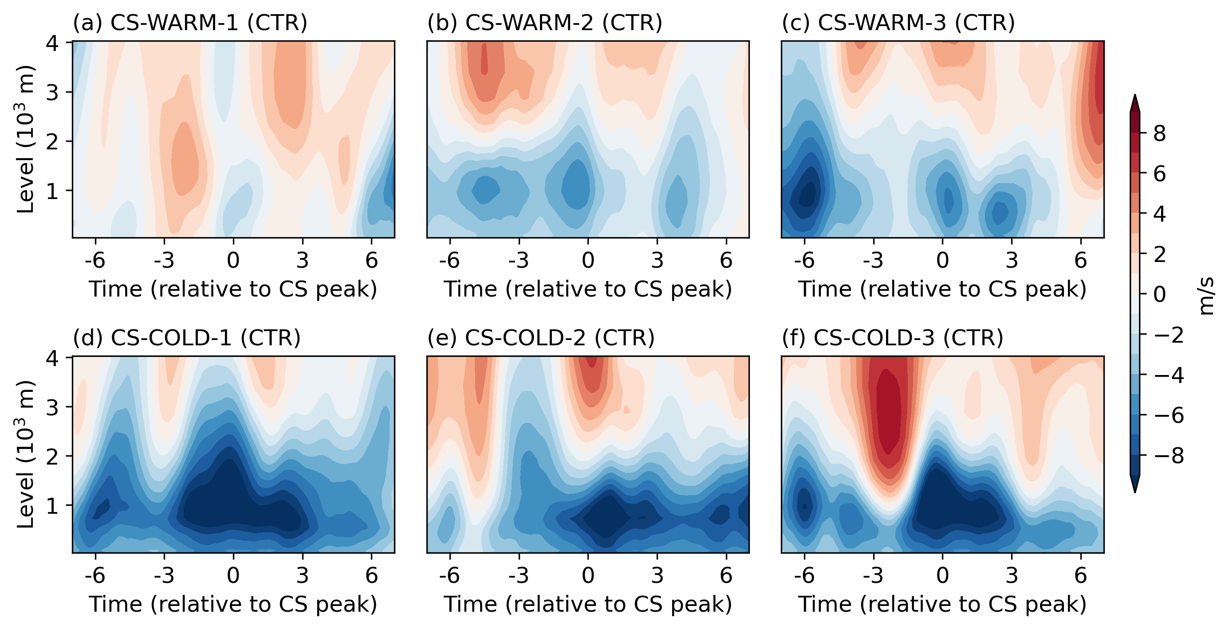
Figure S3. Vertical profiles of meridional wind speed from the CTL runs over the CENS region from day -7 to day +7 relative to the CS peak for each case study.

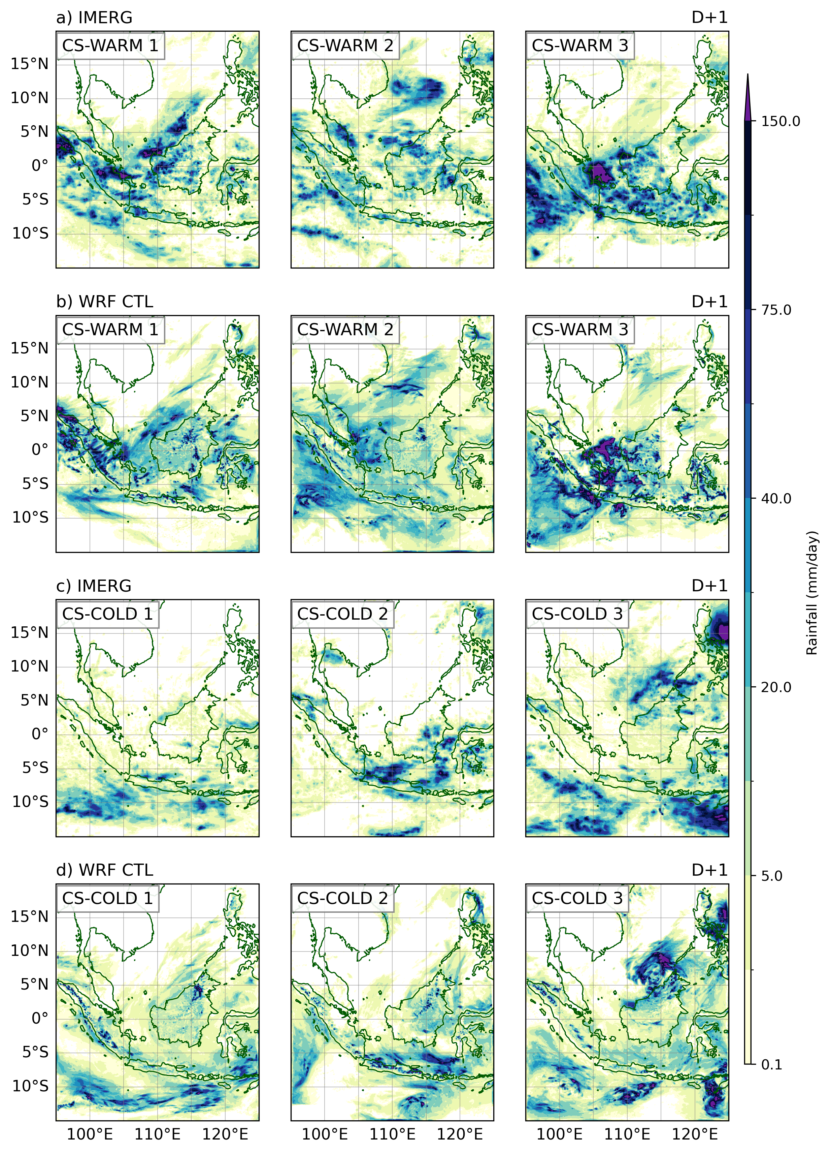
Figure S4. Spatial comparison of daily rainfall (mm/day) at day +1 of the peak CS events between GPM IMERG data and WRF CTL simulations. The top two rows display the CS-WARM cases derived from (a) IMERG and (b) WRF CTL. The bottom two rows display the CS-COLD cases derived from (c) IMERG and (d) WRF CTL.

