Supporting Information
Nanoparticulate selective emitters for effective radiative cooling in urban heat islands

Jiayu Song¹, Ahmad Alduweesh¹, Abdulkareem Alasli¹, Zhijie Xu¹, Albert Adibekyan², Christian Monte², Haoying Zhao³, Fei Guo⁴, Ivan P. Parkin⁴, Ioannis Papakonstantinou¹*
Affiliations:
¹ Department of Electronic and Electrical Engineering, Photonic Innovations Lab, University College London, WC1E 7JE, London, UK
² Physikalisch-Technische Bundesanstalt, Abbestrasse 2-12, 10587, Berlin, Germany.
³ Department of Chemical and Biological Engineering, the Hong Kong University of Science and Technology, Kowloon, HK
⁴ Department of Chemistry, Materials Chemistry Centre, University College London, WC1H 0AJ, London, UK

*Corresponding author email: i.papakonstantinou@ucl.ac.uk

Section S1 | Theoretical analysis of urban heat island effect on radiative cooling | 4
Figure S1 | Severity of urban heat island effect | 4
Figure S2 | Mid-infrared emissivity (ε) comparison of selective thermal emitters fabricated by SiO_{x}N_{y} and physical mixtures of SiO₂ and Si₃N₄ | 5
Figure S3 | View factor (VF) of representative urban scenarios | 6
Figure S4 | Calculated surface temperatures of emitters subjected to various heat fluxes from urban environment (Q_{urban}) and parasitic heat transfer coefficients h | 7
Figure S5 | Spectral radiation flux of blackbody at room temperature (300K) | 8
Figure S6 | Transmittance, reflectance, and absorptance spectra of LDPE and Nano-SEs/LDPE | 9
Figure S7 | Optical properties of Nano-SEs-based solar-transmissive selective thermal emitter | 10
Section S2 | Synthesis and characterization of Nano-SEs | 11
Figure S8 | N coordination of SiO_{x}N_{y} | 12
Figure S9 | Effects of reaction parameters on SiO_{x}N_{y} stoichiometry | 13
Figure S10 | Effects of particle morphology on SiO_{x}N_{y} stoichiometry | 14
Section S3 | Optimization of solar-reflective selective emitter (Nano-SEs/PDMS) | 15
Figure S11 | Measured FITR spectra of PDMS | 16
Figure S12 | Wettability of Nano-SEs/PDMS | 17
Figure S13 | Nano-SEs stoichiometry effect on the emissivity and selectivity of Nano-SEs/PDMS | 18
Figure S14 | Coating thickness effect on the emissivity and selectivity of Nano-SEs/PDMS | 19
Figure S15 | Nano-SEs loading ratio effect on the emissivity and selectivity of Nano-SEs/PDMS | 20
Figure S16 | Angular FTIR spectra of Nano-SEs/PDMS | 21
Figure S17 | Measured solar reflectance spectra of SiO_{1.4}N_{0.5}/PDMS and SiO_{1.2}N_{0.7}/PDMS | 22
Section S4 | Optimization of solar-transparent selective emitter (Nano-SEs/LDPE) | 23
Figure S18 | Measured FTIR spectra of LDPE films | 24
Figure S19 | Absorbance spectra mapping to characterize homogeneity of radiative cooling surfaces | 25
Figure S20 | Nano-SEs concentration effect on the emissivity and selectivity of Nano-SEs/LDPE | 26
Figure S21 | Film thickness and nanoparticle stoichiometry effects on the emissivity and selectivity of Nano-SEs/LDPE | 27
Figure S22 | Angular FTIR spectra of Nano-SEs/LDPE | 28
Section S5 | Radiative cooling performance under clear-sky conditions (SVF = 1) | 29
Figure S23 | Photo showing the setup for the outdoor radiative cooling test with SVF = 1 | 29
Figure S24 | Measured UV-Vis-NIR reflectivity spectra and optical images of solar-reflective selective emitter (SE) and broadband emitter (BE) | 30
Figure S25 | Relative humidity and wind speed during daytime on 20 August 2025 in London. | 31
Figure S26 | Nighttime performance of solar-reflective thermal emitters | 32
Figure S27 | Nighttime performance of solar-transparent thermal emitters without the LDPE covering layer | 33
Figure S28 | Nighttime performance of solar-transparent thermal emitters with the LDPE covering layer | 34
Section S6 | Radiative cooling performance in urban scenarios (0 < SVF < 1) | 35
Figure S29 | Experimental setup for radiative cooling tests in simulated urban scenarios | 35
Figure S30 | Thermal uniformity characterization of the heat source enclosure | 36
Figure S31 | Experimental setup for urban radiative cooling tests under a high-temperature heat source in simulated urban scenarios | 37
Figure S32 | Simulation methodology for city-scale radiative cooling potential of selective and broadband emitters. | 38
Figure S33 | City-scale radiative cooling potential simulation on the second zone in London. | 39
Figure S34 | Photograph and FTIR spectrum of the selective thermal emitter fabricated by incorporating Nano-SEs into a commercial polysiloxane | 40
Figure S35 | Photo showing the setup for emissivity measurement at PTB | 41
Figure S36 | Geometric configuration for calculating the radiative view factor between two perpendicular surfaces | 42
Supporting Note 1 | Sky View Factor (SVF) Calculation | 42
Supporting Note 2 | Calculation for Q_{urban} and surface temperature (T_{s}) of emitters under various Q_{urban} | 46
Supporting Note 3 | City Sky View Factor | 49
Table S1 | The weight-averaged optical properties of LDPE and Nano-SEs/LDPE films | 50
Supporting References |  | 51

Section S1. Theoretical analysis of urban heat island effect on radiative cooling
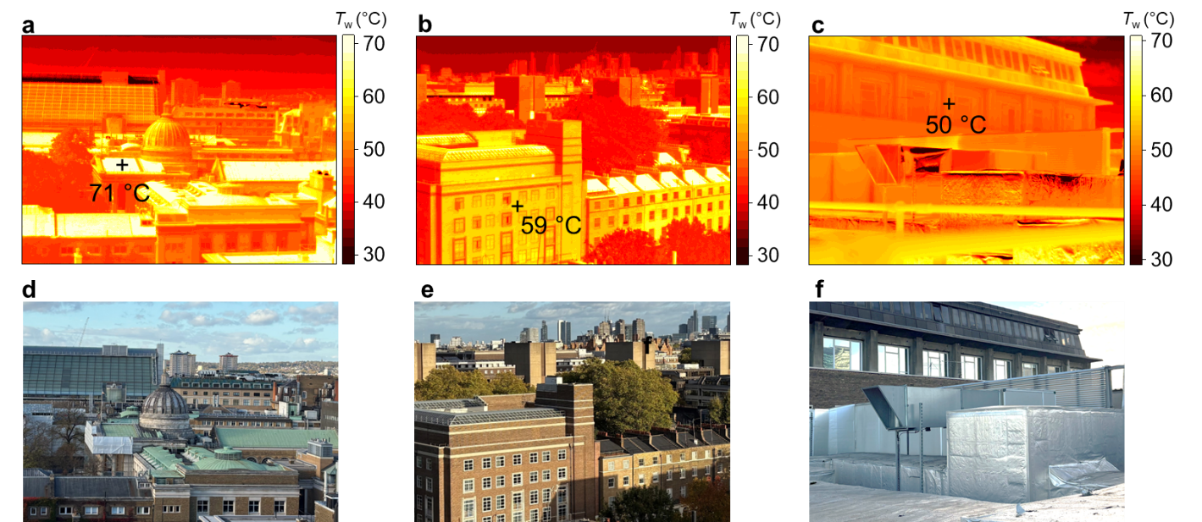
Figure S1. Severity of urban heat island effect. (a-c) IR images of representative urban scenarios in Bloomsbury, London, during summer daytime (June 30, 2025), and (d-f) their corresponding photographs.

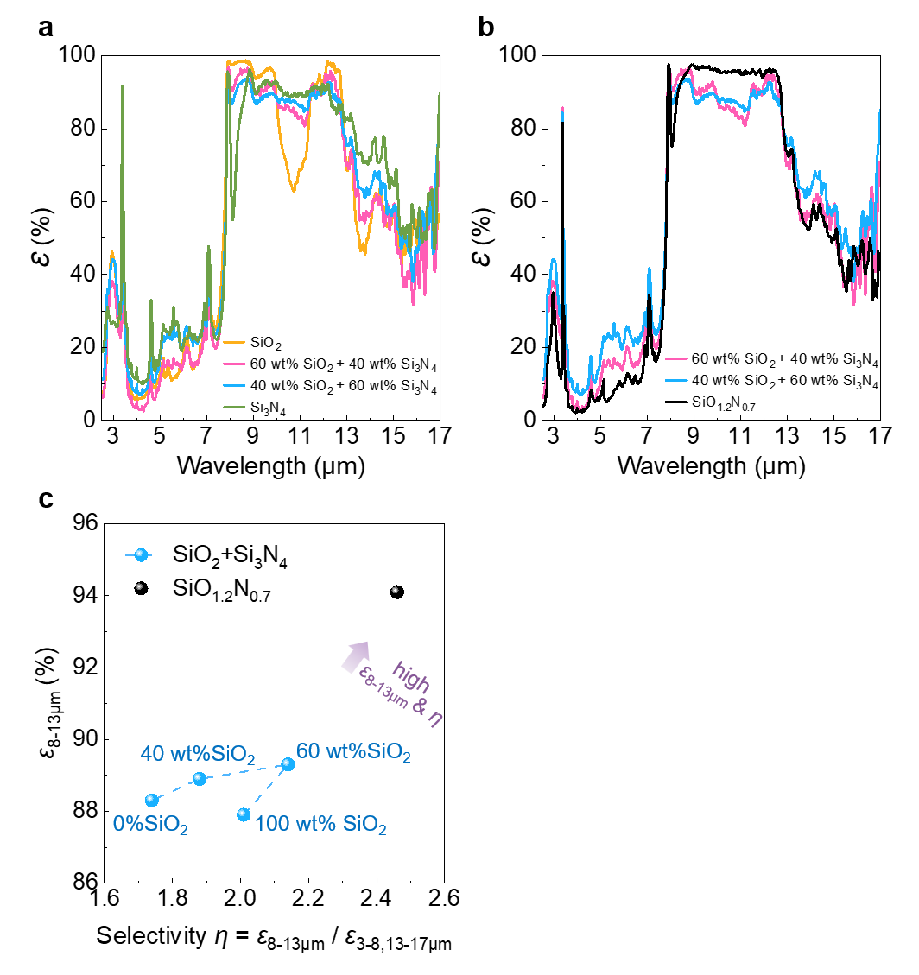
Figure S2. Mid-infrared emissivity (ε) comparison of selective thermal emitters fabricated by SiO_{x}N_{y} and physical mixtures of SiO₂ and Si₃N₄. (a) FTIR spectra of SiO₂/Si₃N₄ mixtures with different weight ratios. (b) Comparison of FTIR spectra of SiO₂/Si₃N₄ mixtures and SiO_{1.2}N_{0.7} with the same thickness. (c) Comparison of the atmospheric window emissivity (ε_{8-13µm}) and spectral selectivity (η) of selective emitters fabricated by SiO₂/Si₃N₄ mixtures with different weight ratios and SiO_{1.2}N_{0.7}. Polydimethylsiloxane (PDMS) was used as the polymer binder in the selective emitter fabrication.

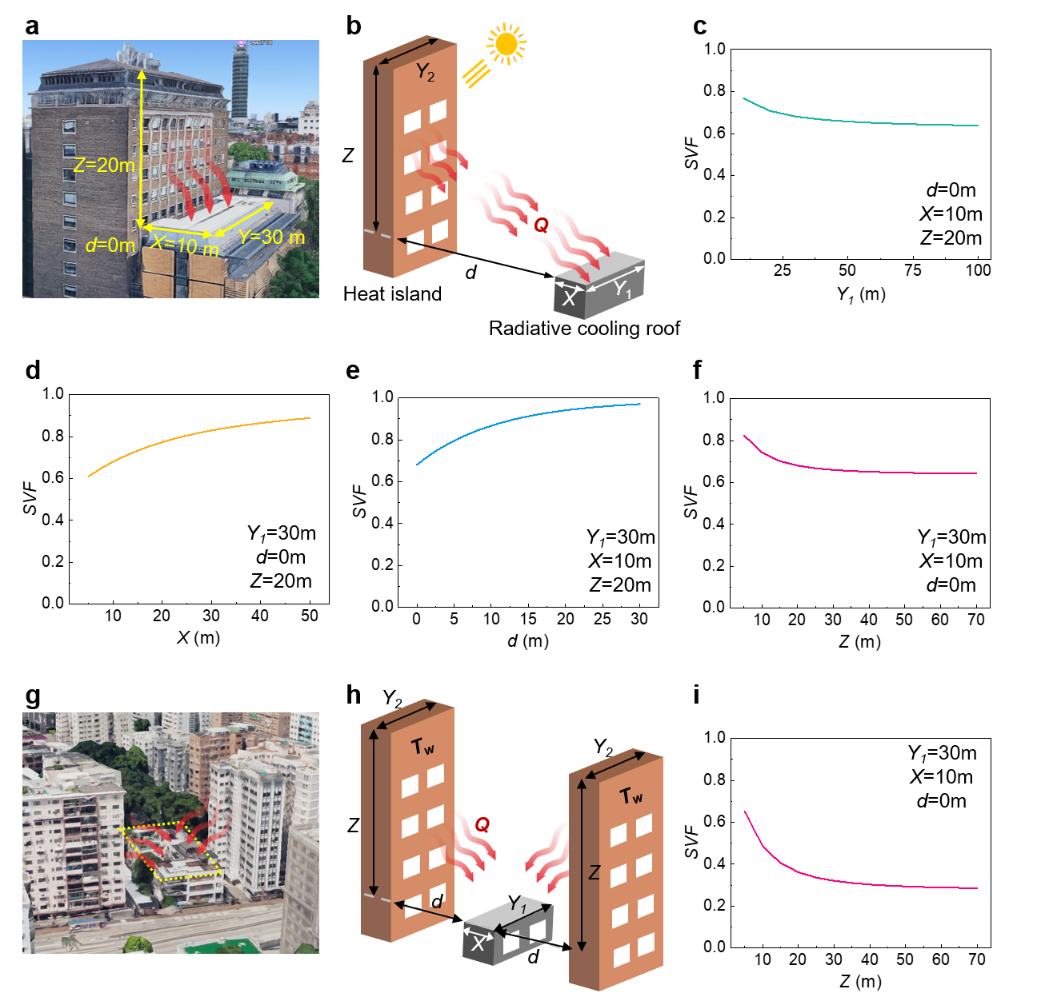
Figure S3. Sky view factor (SVF) of representative urban scenarios. (a) The image showing a real-world example of a horizontally placed rooftop subjected to a hot vertical surface of territorial objects (Roberts building, University College London, London). Reprinted from Google Maps. (b) Schematic demonstrating the geometric parameters for SVF calculation, assuming Y₁ = Y₂. (c-f) Calculated SVF as a function of individual geometric parameters X, Y₁, d, and Z, respectively, with all other variables held constant. The fixed parameter values were defined using the representative real-world building configuration as shown in (a), with X = 10 m, Y₁ = 30 m, Z = 20 m, and d = 0 m. (g) The image showing a real-world example of a horizontally placed rooftop subjected to two vertical surfaces of territorial objects (Hong Kong). Reprinted from Google Maps. (h) Schematic demonstrating the geometric parameters for SVF calculation. (i) An example of calculated SVF as a function of Z, assuming X = 10 m, Y₁ = 30 m, and d = 0 m.

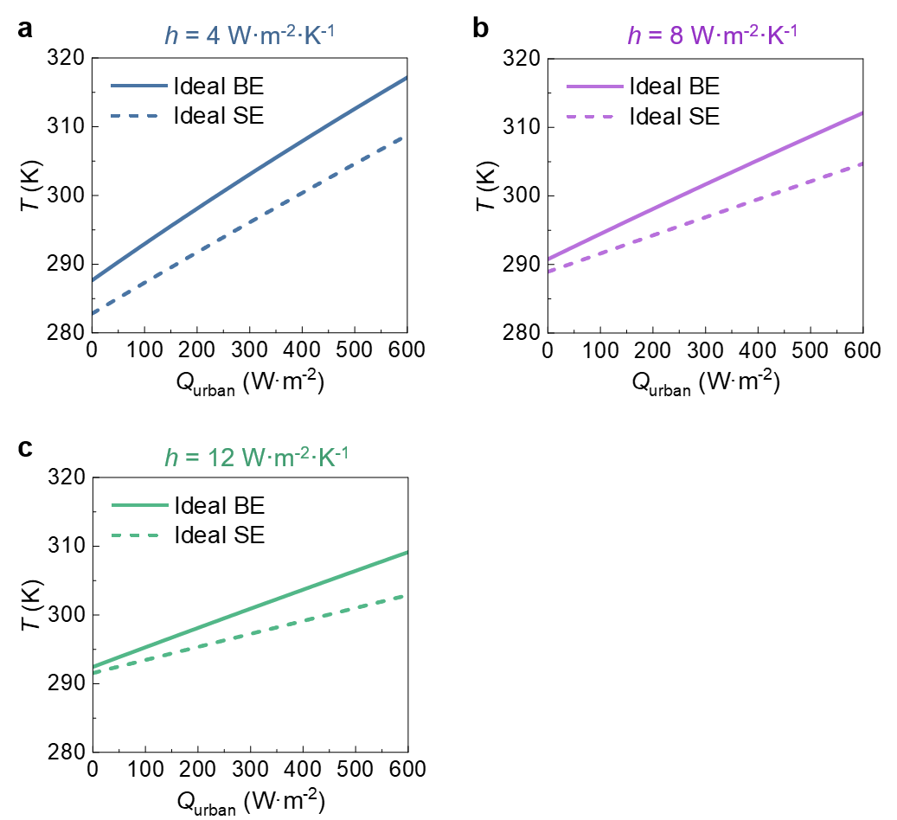
Figure S4. Calculated surface temperatures of ideal broadband emitter (BE) and selective emitter (SE) subjected to various heat fluxes from urban environment (Q_{urban}) under parasitic heat transfer coefficients h of (a) 4, (b) 8, and (c) 12 W·m⁻²·K⁻¹. Ambient temperature is 298K.

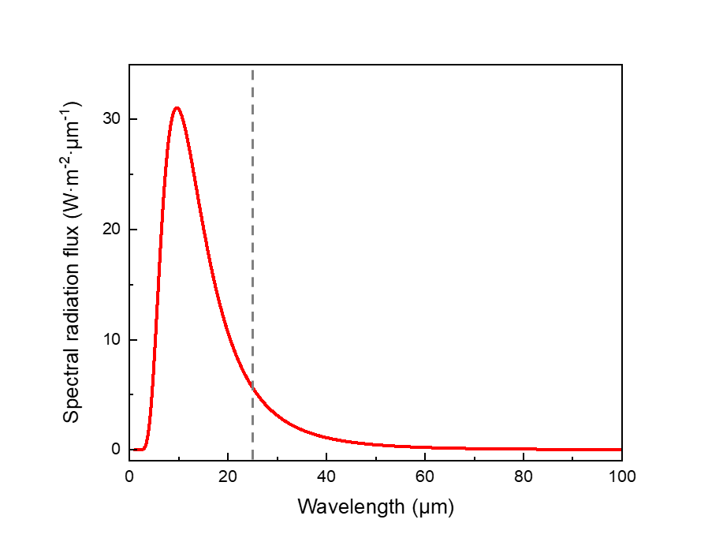
Figure S5. Spectral radiation flux of blackbody at room temperature (300K). The dashed line marks the 25 μm wavelength, the upper wavelength limit of reported emissivity in the literature.

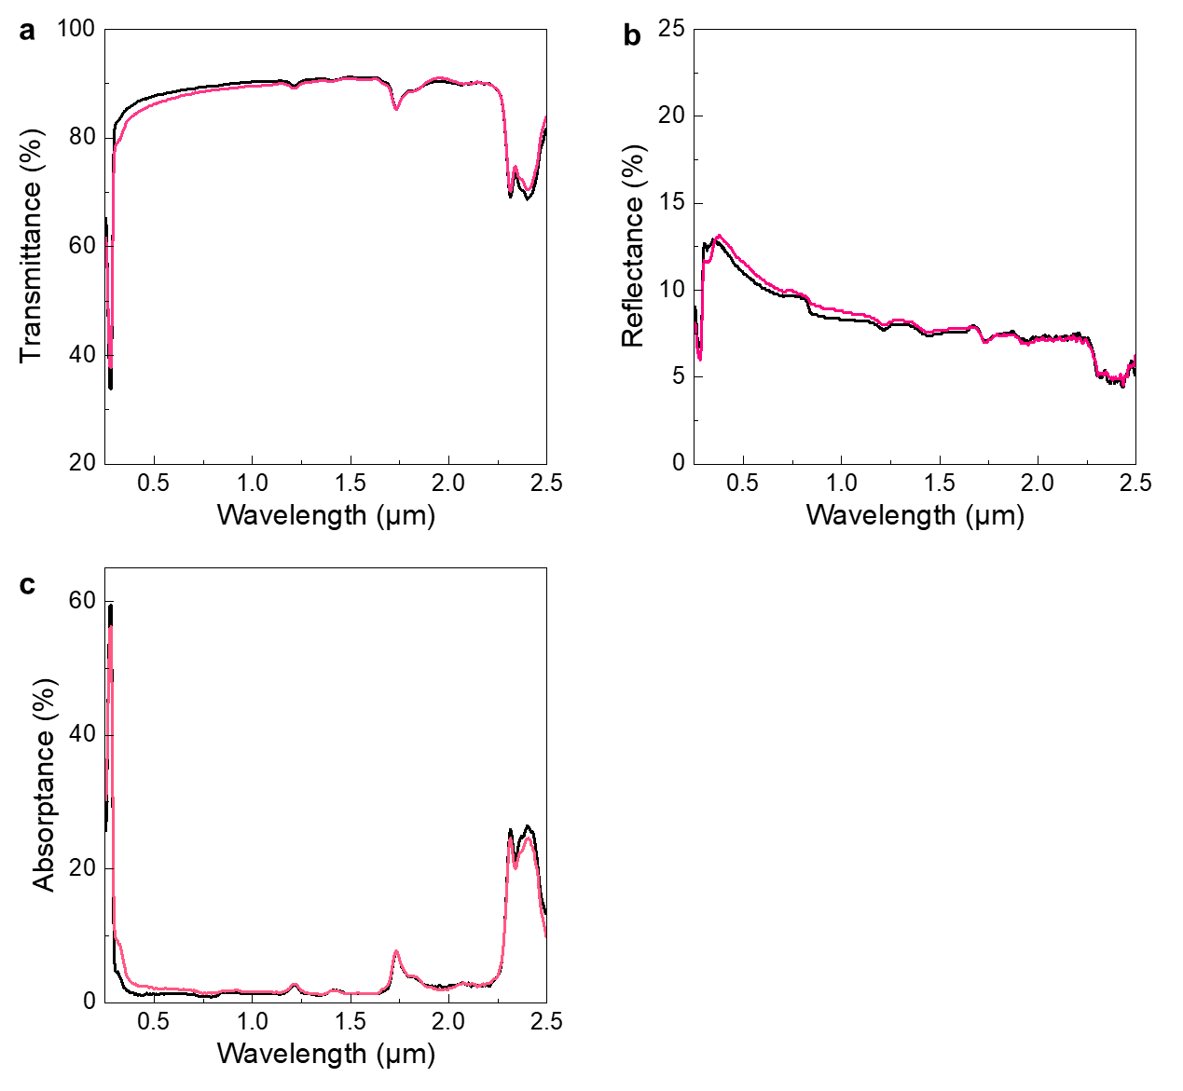
Figure S6. Measured (a) transmittance and (b) reflectance spectra in the UV-Vis-NIR range of LDPE (black line) and Nano-SEs/LDPE (red line) films with a thickness of 50 µm on 300-nm-Ag coated Si wafers. (c) The calculated absorptance of LDPE and Nano-SEs/LDPE according to the relationship Absorptance = 1 – Transmittance – Reflectance.

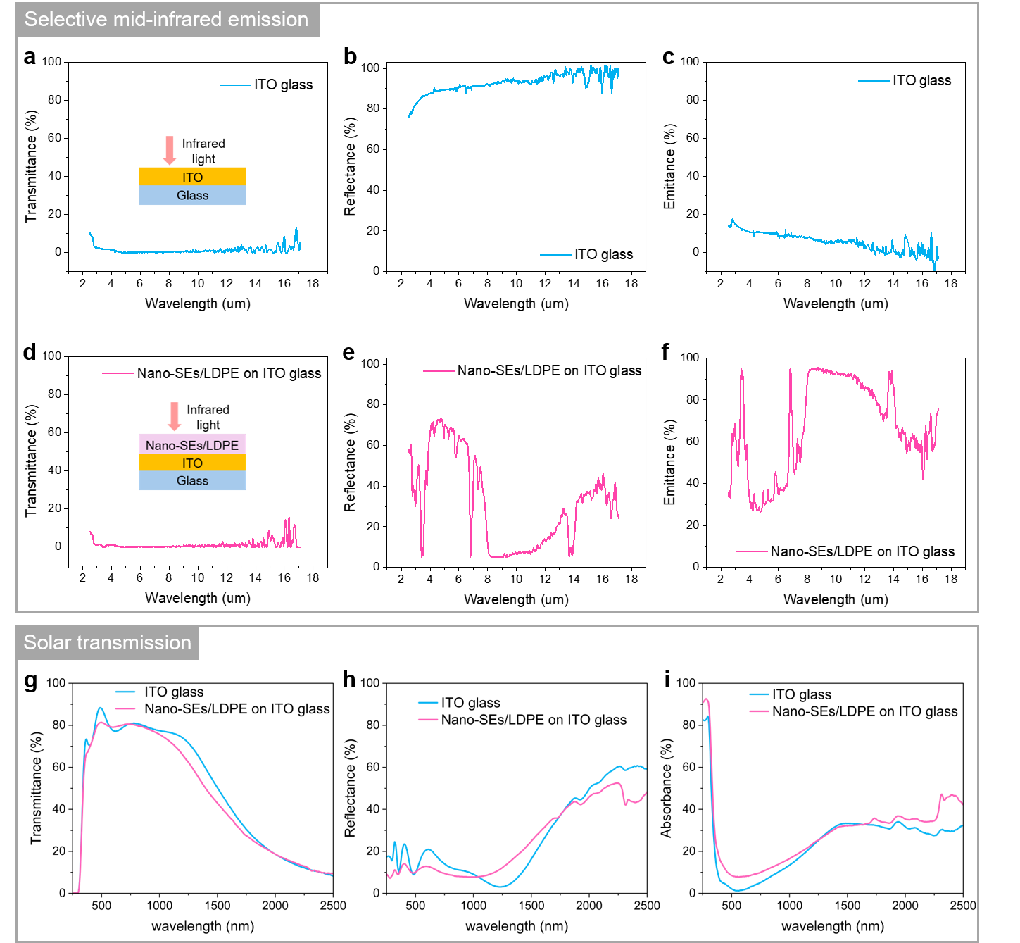
Figure S7. Optical properties of Nano-SEs-based solar-transmissive selective thermal emitter. (a-c) FTIR spectra of ITO glass showing its transmittance, reflectance and emittance in the mid-infrared region. (d-f) FTIR spectra showing the mid-infrared transmittance, reflectance, and emittance of ITO glass coated with Nano-SEs/LDPE. The surface functions as a selective thermal emitter, exhibiting high emittance within the 8-13 µm atmospheric transparent window while maintaining strong reflectance at wavelengths outside this band. (g-i) UV-Vis-NIR spectra showing the transmittance, reflectance, and absorbance of Nano-SEs-based selective emitter in the solar region. The ITO glass is fabricated by depositing an 185 nm ITO layer on a 1.1 mm glass. 15 wt% Nano-SEs/LDPE composite with a thickness of 50 µm was applied on the ITO glass using the blade-coating process.

Section S2. Synthesis and characterization of Nano-SEs
The stoichiometry of nanoparticulate SiO_{x}N_{y} was systematically controlled by adjusting particle morphology and thermal nitridation conditions.
(i) Under identical thermal conditions:
a. Nanoparticles with larger specific surface areas achieved higher nitrogen concentrations (Figure 2f-g).
(ii) With the same nanoparticle morphology (e.g., porous spheres):
a. Longer nitridation duration yielded red-shift of the mid-infrared (MIR) absorption spectrum measured by FTIR-ATR, indicating higher nitrogen content in SiO_{x}N_{y}. Nitridation beyond 10 hours did not result in a significant increase in nitrogen content (Figure S9a).
b. Nitridation temperatures below 1000 °C (e.g., 500 °C and 750 °C) were insufficient to initiate silica nitridation, while 1000 °C and 1150 °C enabled efficient nitridation with no apparent difference. We limited reactions to 1150 °C because common commercial furnaces have a maximum operating temperature of 1200 °C (Figure S9b).
c. Lower NH₃ gas flow rate resulted in a reduced nitrogen incorporation efficiency, while extended nitridation time compensated for this reduction (Figure S9c).

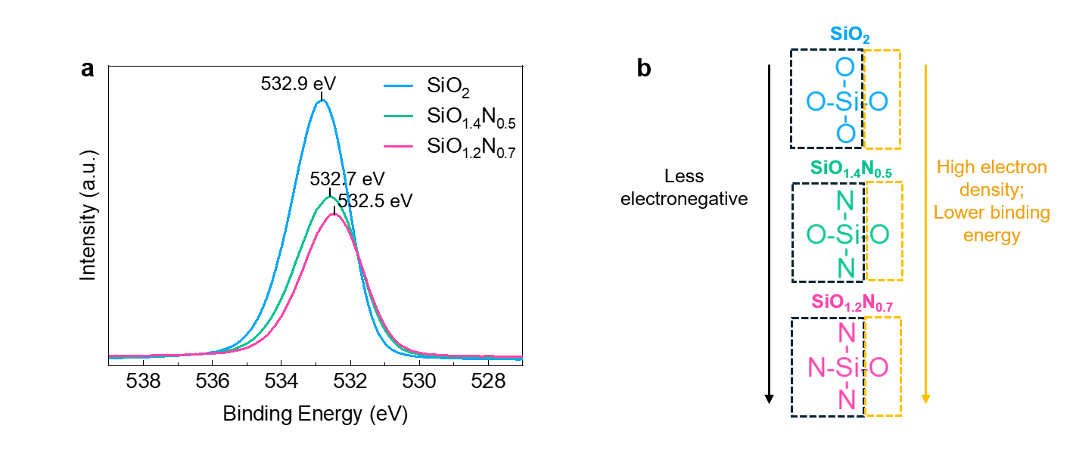
Figure S8. N coordination of SiO_{x}N_{y}. (a) High-resolution O 1s XPS spectra of SiO₂, SiO_{1.4}N_{0.5}, and SiO_{1.2}N_{0.7}, with peak position shifting to the lower binding energy. (b) Schematic illustrating that higher N content creates a less electronegative environment for O atoms, increasing local electron density and reducing the O 1s binding energy.

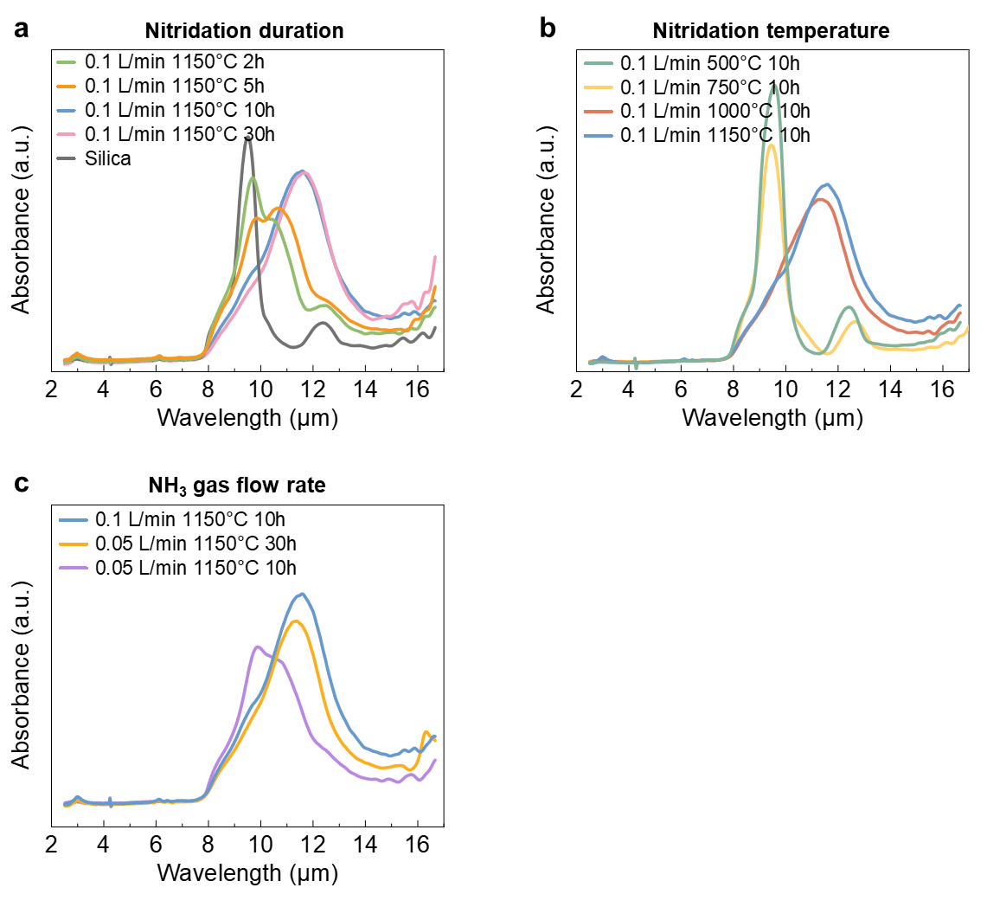
Figure S9. Effects of reaction parameters on SiO_{x}N_{y} stoichiometry. FTIR-ATR spectra of silica porous nanospheres after thermal nitridation with different (a) nitridation durations, (b) nitridation temperatures, and (c) ammonia (NH₃) gas flow rates.

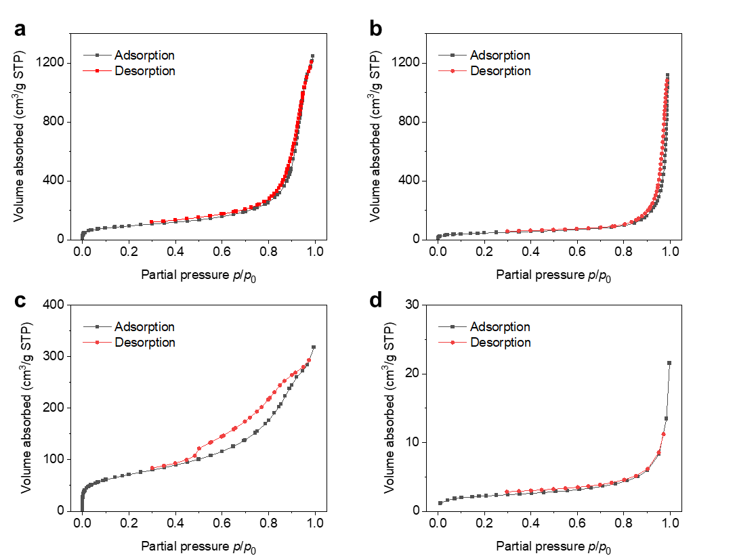
Figure S10. Effects of particle morphology on SiO_{x}N_{y} stoichiometry. N₂ adsorption and desorption isotherm plots of silica (a) porous nanospheres, (b) aerogel, (c) hollow nanospheres, and (d) solid nanospheres.

Section S3. Optimization of solar-reflective selective emitter (Nano-SEs/PDMS)
Optimization of Nano-SEs/PDMS involved systematic adjustment of Nano-SEs stoichiometry, coating thickness, and Nano-SEs concentration to simultaneously improve atmospheric window emissivity (ε_{8-13µm}) and selectivity (η).
a. The stoichiometry effect was examined by systematically varying nanoparticle nitrogen content while maintaining fixed coating thickness (10 μm) and concentration (50 wt%). Progressive nitrogen incorporation (from SiO₂ to SiO_{1.4}N_{0.5}) enhanced both ε_{8-13µm} and η, owing to the complementary emissivity of Si-N and Si-O bonds. Further nitrogen enrichment (SiO_{1.2}N_{0.7}) yielded no significant performance improvement relative to SiO_{1.4}N_{0.5}. However, when the Si-N bonds dominated the composition (Si₃N₄), both ε_{8-13µm} and η decreased substantially due to strong emissivity beyond 13 μm wavelength. (Figure S13 and Figure 3b)
b. Regarding coating thickness, increasing the thickness enhanced ε_{8-13µm} but simultaneously reduced η, as thicker coatings elevated emissivity both within and beyond the atmospheric window. Balancing ε_{8-13µm} and η, we identified 10 µm as the optimal coating thickness. (Figure S14)
c. Regarding Nano-SEs concentration, higher nanoparticle concentrations improved η by suppressing PDMS-induced emissivity outside the atmospheric window. However, excessive Nano-SEs compromised coating adhesion, resulting in poor substrate attachment and susceptibility to water-induced delamination. (Figure S15)
The optimized Nano-SEs/PDMS is SiO_{1.2}N_{0.7}/PDMS, with nanoparticle weight percentage of 50 wt% and thickness of 10µm.
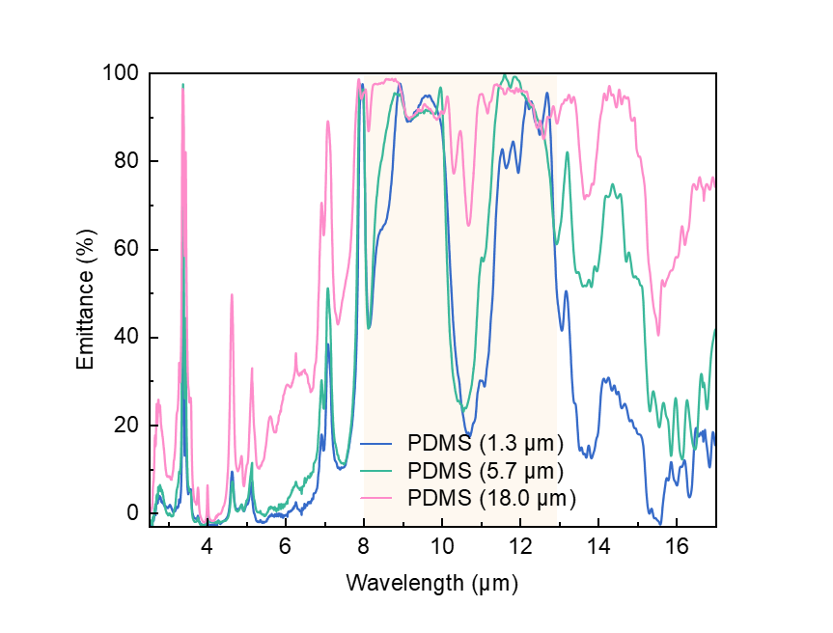
Figure S11. Measured FITR spectra of PDMS with thicknesses of 1.3 µm (blue), 5.7 µm (green), and 18.0 µm (pink) on a 300-nm-Ag coated Si wafer. The atmospheric window (8-13 μm) was highlighted in yellow.

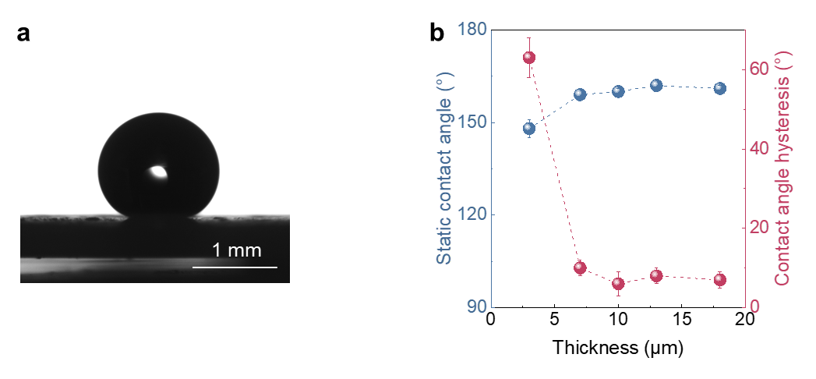
Figure S12. Wettability of Nano-SEs/PDMS. (a) The optical image showing the water contact angle (160 ± 1°) on the optimized Nano-SEs/PDMS surface. The water droplet volume is 8 µL. The contact angle hysteresis of this surface is 6 ± 3°. (b) The coating thickness effect on the surface wettability. Above a thickness of 7 μm, surfaces achieve superhydrophobicity with water contact angles exceeding 150° and contact angle hysteresis below 10°.

Figure S13. Nano-SEs stoichiometry effect on the emissivity and selectivity of Nano-SEs/PDMS. Measured FTIR spectra of SiO₂/PDMS, SiO_{1.4}N_{0.5}/PDMS, SiO_{1.2}N_{0.7}/PDMS, and Si₃N₄/PDMS at the same thickness of 10 µm.

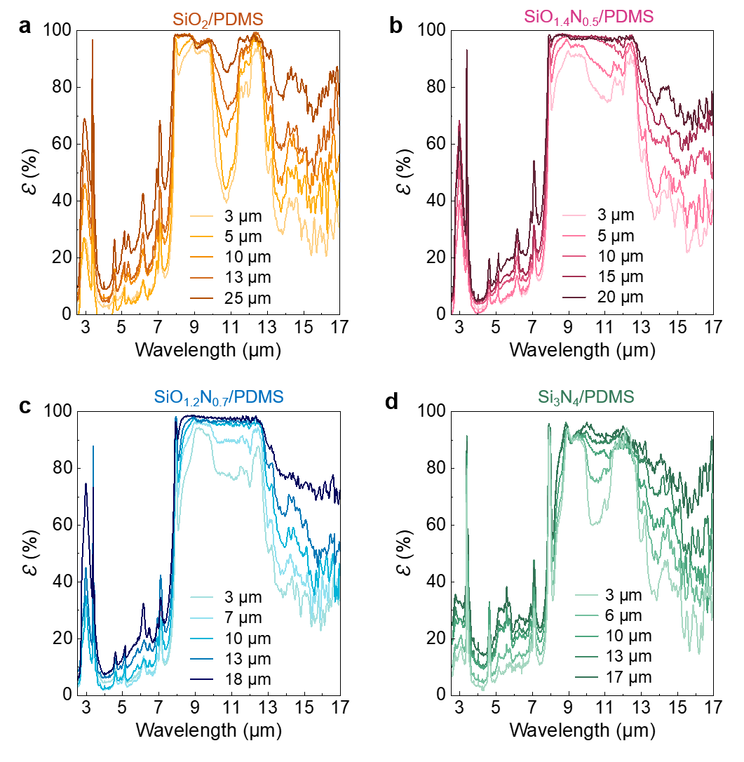
Figure S14. Coating thickness effect on the emissivity and selectivity of Nano-SEs/PDMS. Measured FTIR spectra of (a) SiO₂/PDMS, (b) SiO_{1.4}N_{0.5}/PDMS, (c) SiO_{1.2}N_{0.7}/PDMS, and (d) Si₃N₄/PDMS coatings with various thicknesses.

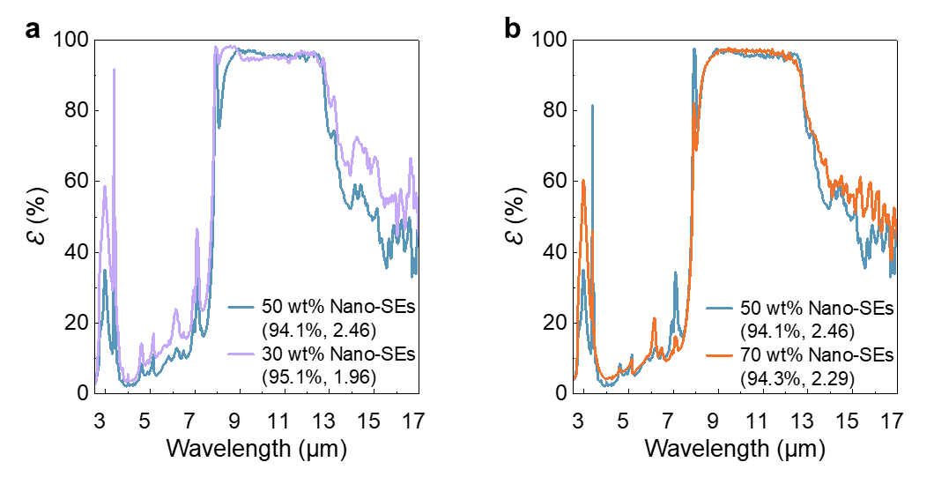
Figure S15. Nano-SEs concentration effect on the emissivity and selectivity of Nano-SEs/PDMS. (a) Measured FTIR spectra of Nano-SEs/PDMS with nanoparticle weight percentage of 30% and 50%. At suboptimal Nano-SEs concentration (30 wt% versus optimal 50 wt%), selectivity η decreased from 2.46 to 1.96 with similar ε_{8-13µm}, due to PDMS-induced out-of-window emission. (b) Measured FTIR spectra of Nano-SEs/PDMS with nanoparticle weight percentage of 50% and 70%. When the Nano-SEs concentration (70 wt%) was higher than the optimal, negligible performance gain was observed. However, the coating became hydrophilic, leading to water-induced detachment, which is unsuitable for practical outdoor applications. 50 wt% Nano-SEs (94.1%, 2.46) represents that Nano-SEs weight percentage in Nano-SEs/PDMS composite is 50%, and the resulting surface yields ε_{8-13µm} of 94.1% and η of 2.46.

Figure S16. Angular FTIR spectra of Nano-SEs/PDMS, showing the emissivity characteristics in the 5-100 µm region across zenith angles from 10° to 70°.

Figure S17. Measured solar reflectance spectra of SiO_{1.4}N_{0.5}/PDMS and SiO_{1.2}N_{0.7}/PDMS coatings with the same thickness (L = 10 µm). The weight-averaged reflectance (R_{solar}) was calculated with respect to the AM 1.5G solar spectrum.

Section S4. Optimization of solar-transparent selective emitter (Nano-SEs/LDPE)
Optimization of Nano-SEs/LDPE involved systematic adjustment of Nano-SEs stoichiometry, concentration, and coating thickness to simultaneously improve atmospheric window emissivity (ε_{8-13µm}) and selectivity (η).
a. Stoichiometry optimization in Nano-SEs/LDPE followed the same trend as observed in PDMS matrices. Nano-SEs (SiO_{1.4}N_{0.5} and SiO_{1.2}N_{0.7}) achieved significantly higher ε_{8-13µm} and η compared to SiO₂ and Si₃N₄, owing to the complementary emissivity from Si-N and Si-O bonds. (Figure S21)
b. Regarding coating thickness, increasing the thickness enhanced ε_{8-13µm} but simultaneously reduced η, as thicker coatings elevated emissivity both within and beyond the atmospheric window. Balancing ε_{8-13µm} and η, we identified 50 µm as the optimal coating thickness. (Figure S21)
c. Regarding Nano-SEs concentration, higher nanoparticle concentrations improved η by suppressing LDPE-induced emissivity outside the atmospheric window. However, excessive loading increased composite viscosity, rendering it unsuitable for the blade-coating process. (Figure S20)
The optimized Nano-SEs/LDPE is SiO_{1.2}N_{0.7}/LDPE, with nanoparticle weight percentage of 15 wt% and thickness of 50µm.
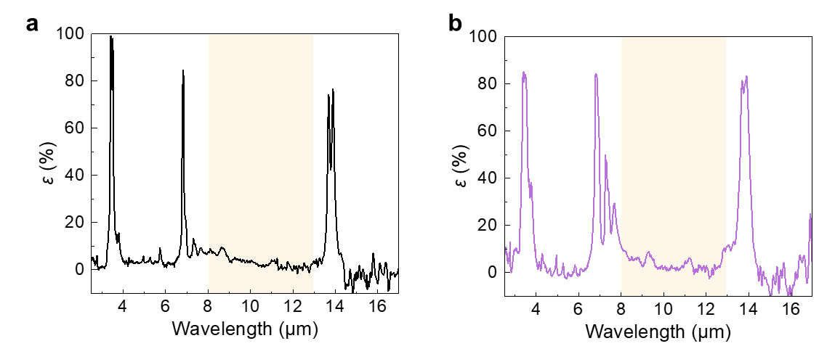
Figure S18. Measured FTIR spectra of LDPE films. (a) 50-μm-thick film with 1.5 wt% Irganox antioxidant used for solar-transparent sample preparation, and (b) 30-μm-thick commercial film for minimizing parasitic heat transfer during outdoor measurements. The atmospheric window (8-13μm) was highlighted in yellow.

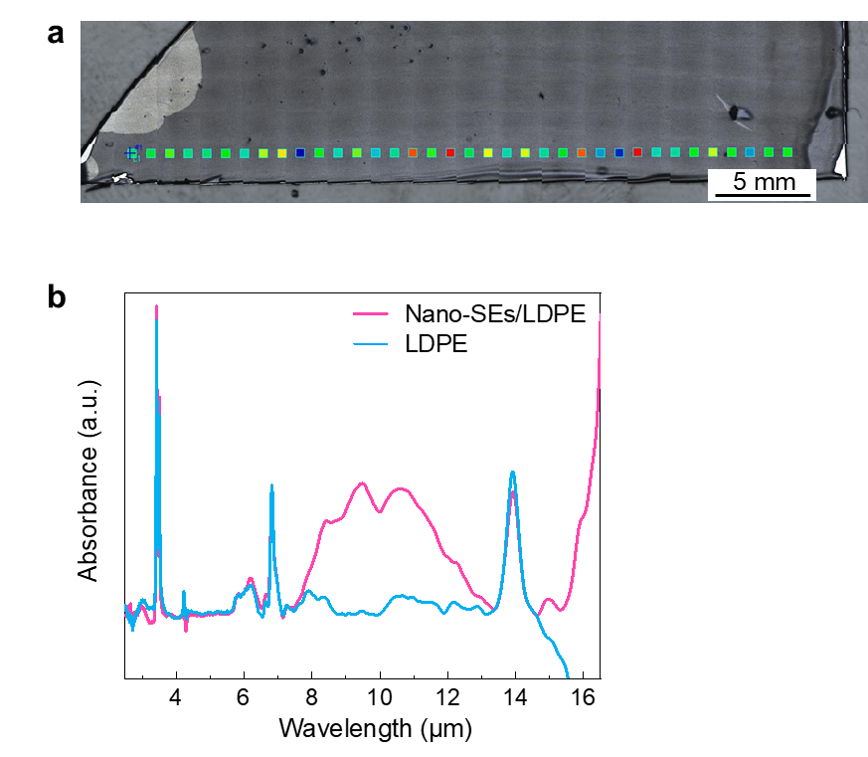
Figure S19. FTIR absorbance spectra mapping to characterize homogeneity of radiative cooling surfaces. (a) Optical image showing the scanning positions for the FTIR absorbance measurement on the Nano-SEs/LDPE film deposited on a silver-coated Si wafer. Each square represents an observation point with an aperture of 200 μm, spaced at 1000 μm. (b) Absorbance spectra of Nano-SEs/LDPE and LDPE.

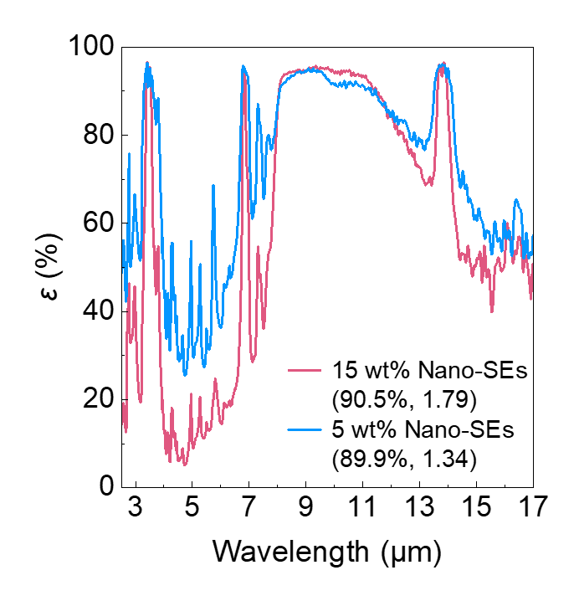
Figure S20. Nano-SEs concentration effect on the emissivity and selectivity of Nano-SEs/LDPE. Measured FTIR spectra of Nano-SEs/LDPE with nanoparticle weight percentage of 5% and 15%. The optimal Nano-SEs weight concentration is 15%. At suboptimal Nano-SEs concentration (5 wt%), selectivity η decreased from 1.79 to 1.34 with similar ε_{8-13µm}, due to LDPE-induced out-of-window emission. When the concentration was higher than the optimal, the Nano-SEs/LDPE mixture became too viscous for blade coating. 15 wt% Nano-SEs (90.5%, 1.79) represents that Nano-SEs weight percentage in Nano-SEs/LDPE composite is 15% and the resulting surface yields ε_{8-13µm} of 90.5% and η of 1.79.

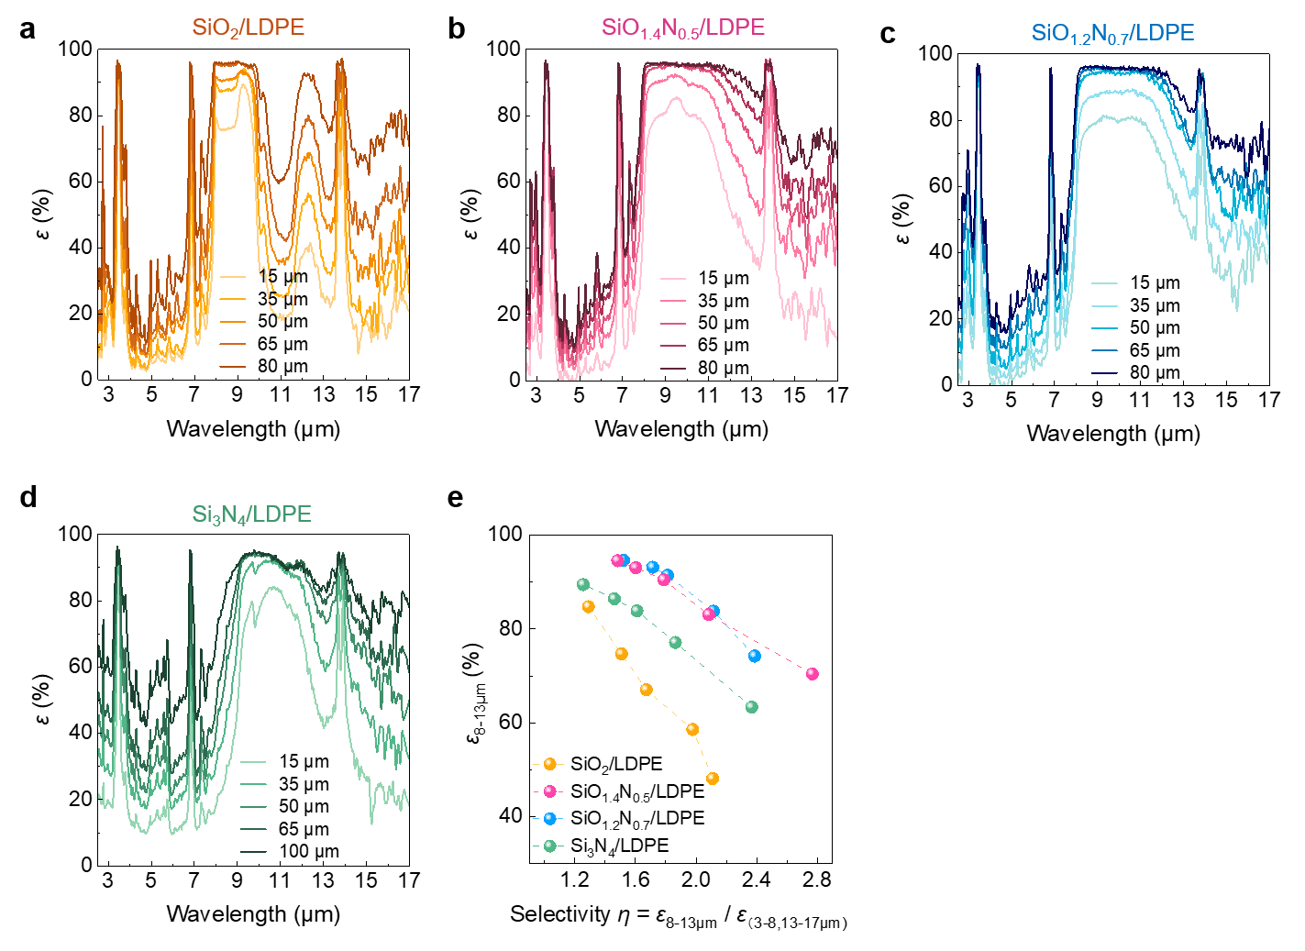
Figure S21. Film thickness and nanoparticle stoichiometry effects on the emissivity and selectivity of Nano-SEs/LDPE. Measured FTIR spectra of (a) SiO₂/LDPE, (b) SiO_{1.4}N_{0.5}/LDPE, (c) SiO_{1.2}N_{0.7}/LDPE, and (d) Si₃N₄/LDPE films with various thicknesses, and (e) their corresponding ε_{8-13µm} and η.

Figure S22. Angular FTIR spectra of Nano-SEs/LDPE, showing the emissivity characteristics in the 5-100 µm region across zenith angles from 10° to 70°.
The Physikalisch-Technische Bundesanstalt (PTB, Germany’s national metrology institute) conducted the angular-resolved measurements of directional spectral emissivity using the Emissivity Measurements in Air Facility (EMAF). In this setup, emissivity is determined by comparing the spectral radiance of the sample with those of two reference blackbodies maintained at different temperatures using an FTIR spectrometer, thereby ensuring that the results are validated and traceable to the ITS-90. The sample is mounted on a temperature-controlled heater and placed inside a thermally stabilized spherical enclosure. By applying an evaluation model that accounts for heat flux balance at the sample surface and multiple reflections within the enclosure, both the surface temperature and the directional spectral emissivity are accurately determined.
Section S5. Radiative cooling performance under clear-sky conditions (SVF = 1)
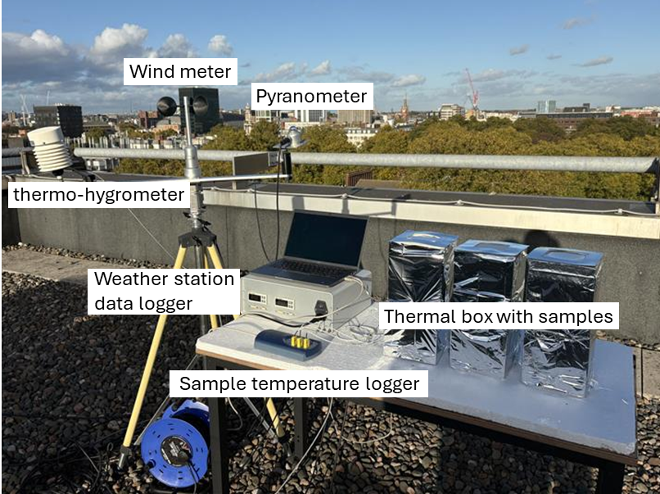
Figure S23. Photo showing the setup for the outdoor radiative cooling test with SVF = 1.

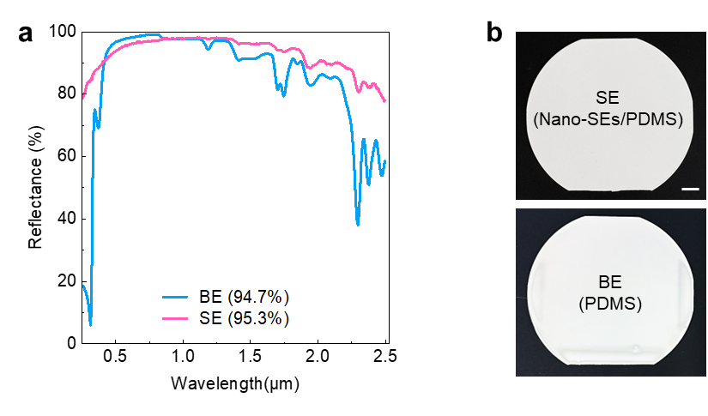
Figure S24. (a) Measured UV-Vis-NIR reflectivity spectra, and (b) optical images of solar-reflective selective emitter (SE) and broadband emitter (BE) for outdoor radiative cooling tests. The selective emitter was prepared by depositing 10-µm-thick Nano-SEs/PDMS on a silver-coated silicon wafer. The broadband emitter was prepared by depositing 150-µm-thick PDMS on a silver-coated silicon wafer. The scale bar represents 1 cm.

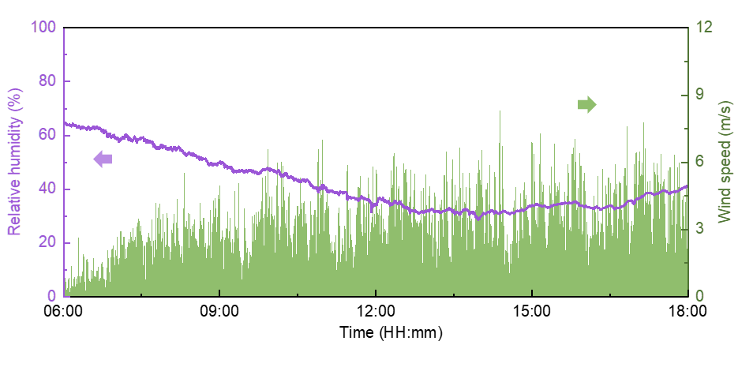
Figure S25. Relative humidity and wind speed during daytime on 20 August 2025 in London. The data was recorded every second.

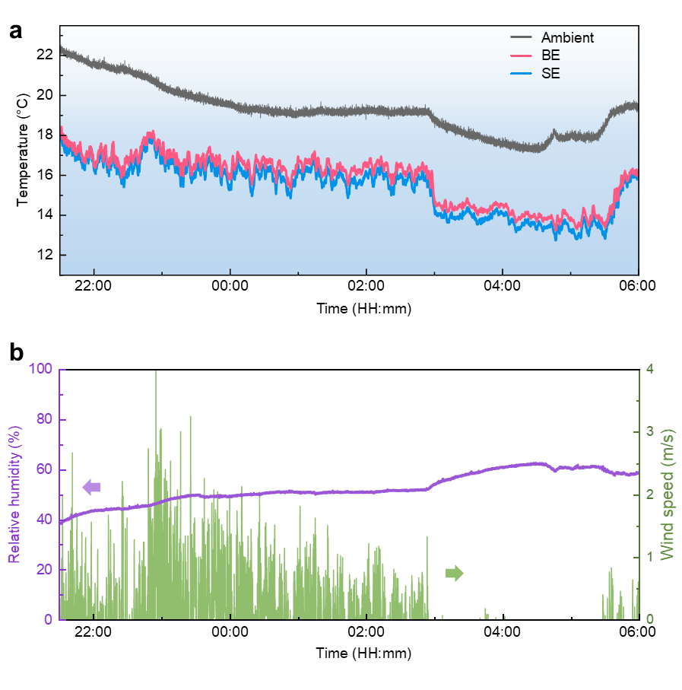
Figure S26. Nighttime performance of solar-reflective thermal emitters. (a) The temperature variations of selective emitter (SE) and broadband emitter (BE) with the ambient temperature, (b) relative humidity and wind speed during nighttime on 25-26 August 2025 in London.

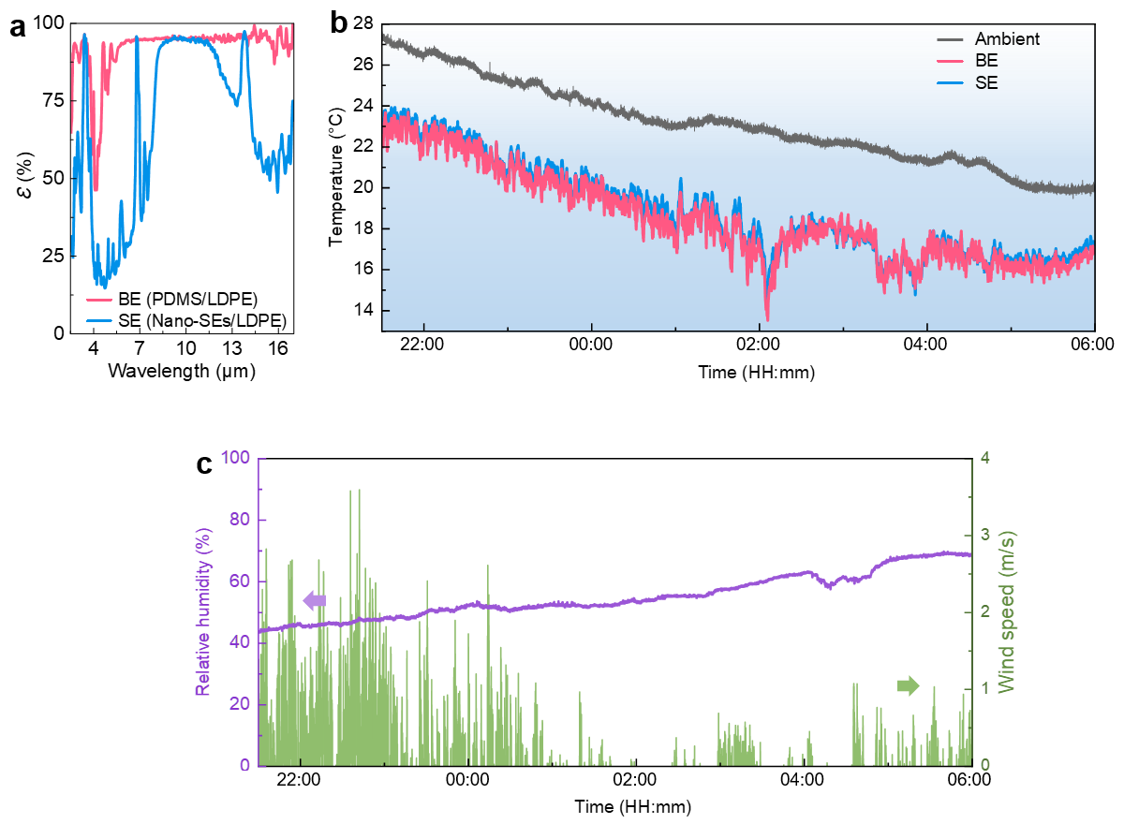
Figure S27. Nighttime performance of solar-transparent thermal emitters without the LDPE covering layer. (a) MIR emittance spectra of the solar-transparent selective emitter (SE) and broadband emitter (BE), (b) the temperature variations of SE and BE with the ambient temperature, and (c) the relative humidity and wind speed during nighttime on 11-12 July 2025 in London.

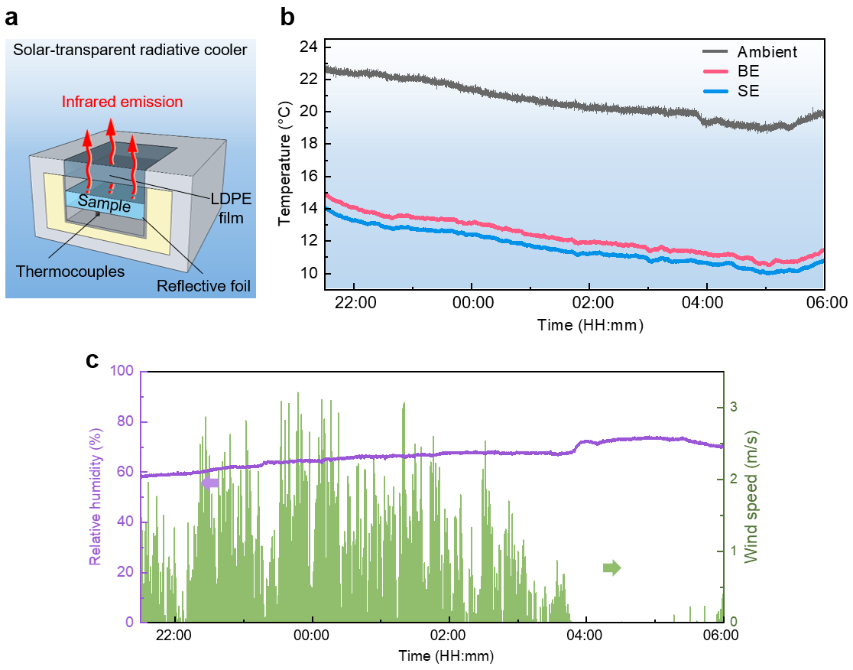
Figure S28. Nighttime performance of solar-transparent thermal emitters with the LDPE covering layer. (a) Schematic showing the experimental apparatus, (b) nighttime radiative cooling performance of the solar-transparent SE and BE, and (c) the relative humidity and wind speed during nighttime on 10-11 July 2025 in London.

Section S6. Radiative cooling performance in urban scenarios (0 < SVF < 1)
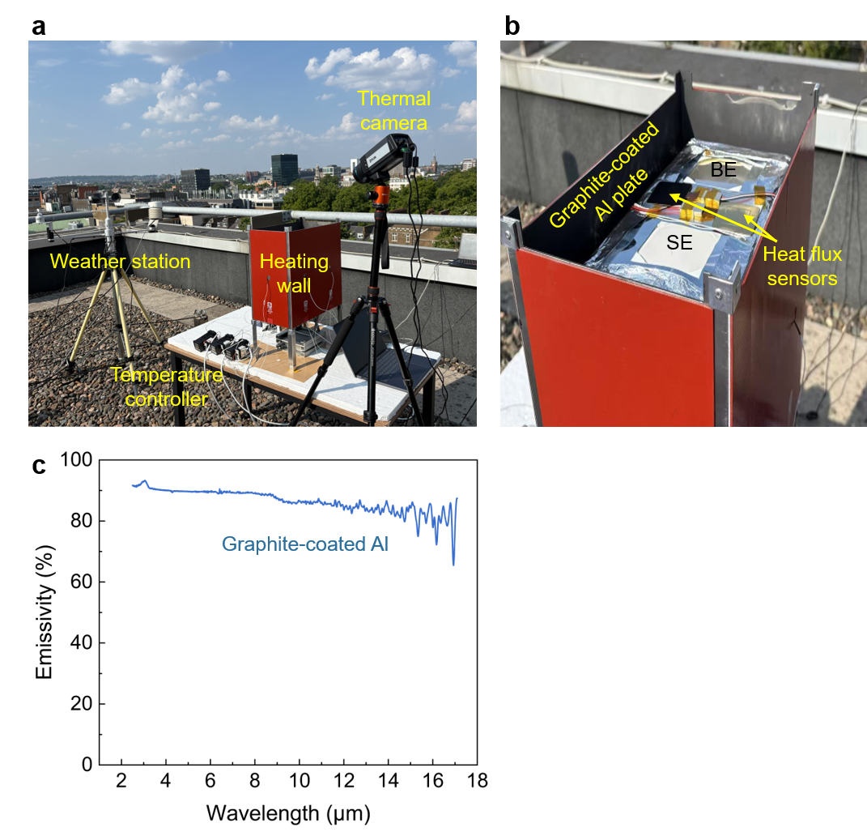
Figure S29. (a-b) Photos of the experimental setup for radiative cooling tests in simulated urban scenarios. (c) FTIR spectrum showing the emissivity of the inner surface of heating walls, graphite-coated Al. The temperature on each side is controlled by a proportional–integral–derivative (PID) controllers using thermocouples feedback.

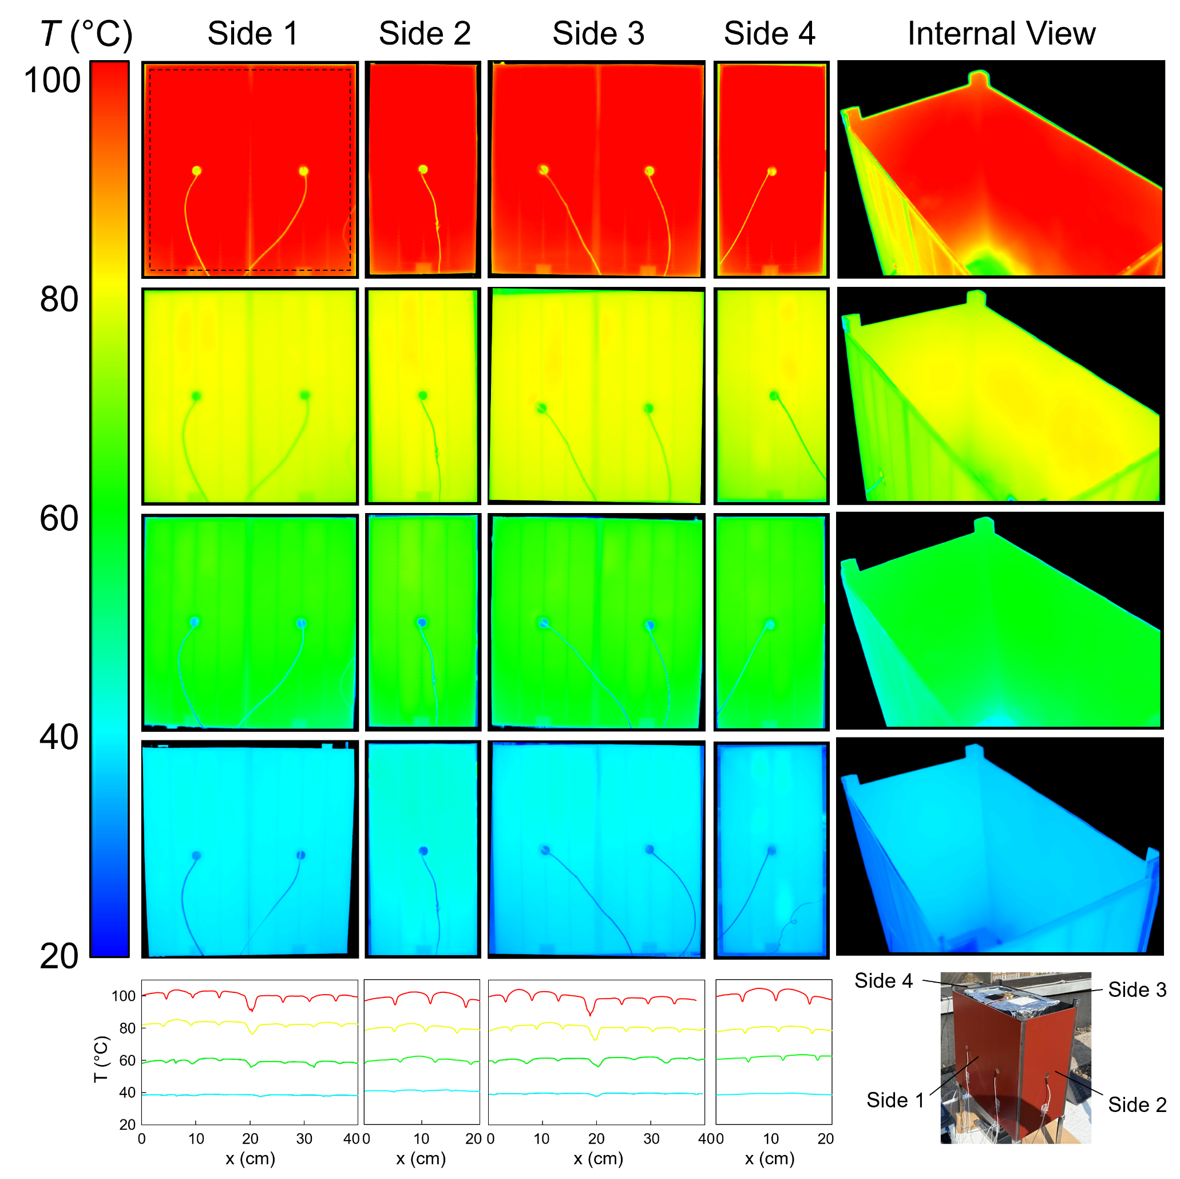
Figure S30. Thermal uniformity characterization of the heat source enclosure. Infrared thermal images of the four external sides (Side 1–4) and internal view of the box-shaped heat source, captured at four target temperatures (~40 °C, ~60 °C, ~80 °C, and ~100 °C, from bottom to top). Bottom row shows line profiles of surface temperature (T) as a function of lateral position (x) across each side, demonstrating relatively uniform temperature distribution across all faces of the enclosure.

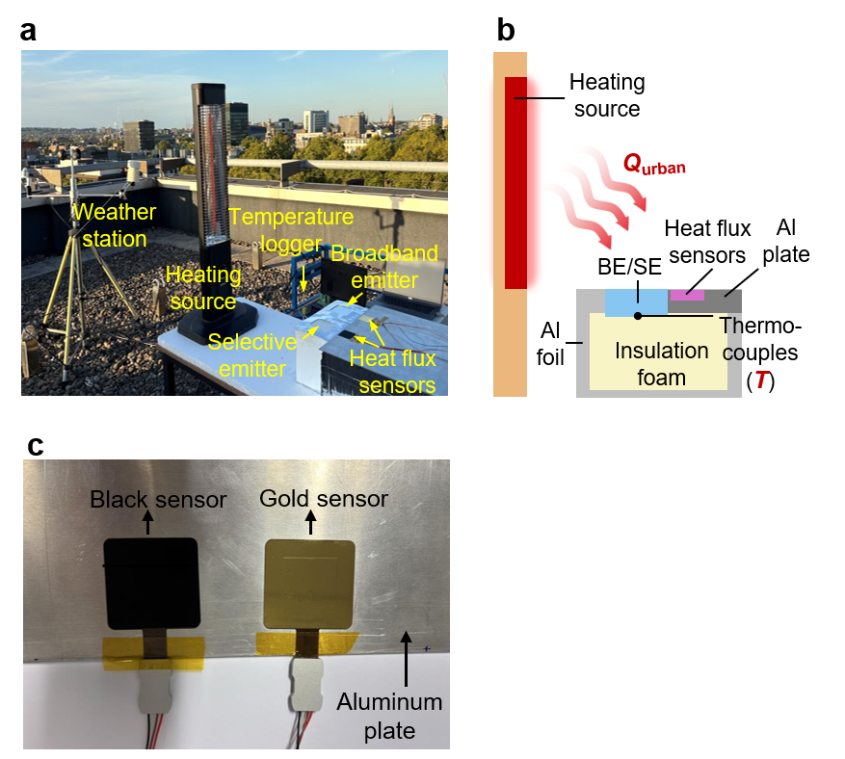
Figure S31. Experimental setup for urban radiative cooling tests under a high-temperature heat source in simulated urban scenarios. (a) Photo and (b) schematic of the setup, and (c) the sensors for measuring thermal radiative heat flux (Hukseflux, Netherlands). The black sensor with strong radiative absorption measures both convective and radiative heat flux. The gold sensor reflects all radiation, measuring only the convective heat flux. Therefore, the radiative heat flux (Q_{radiation}) equals the difference between the heat fluxes measured by the black and gold sensors, Q_{radiation} = Q_{black} - Q_{gold}. The surface area of the sensors is 5×5 cm². Sensors were affixed to a 5-mm-thick aluminum plate that reflected radiative heating from external sources, ensuring that the sensors' backside temperatures corresponded to ambient conditions.

Section S7. Urban radiative cooling potential
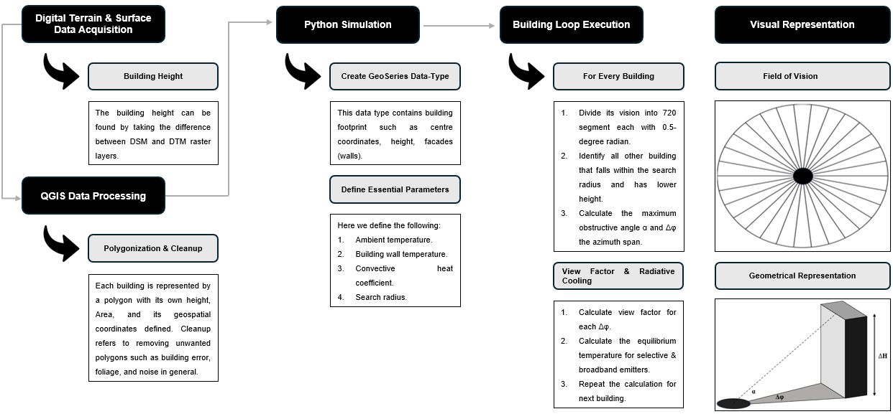
Figure S32. Simulation methodology for city-scale radiative cooling potential of selective and broadband emitters.

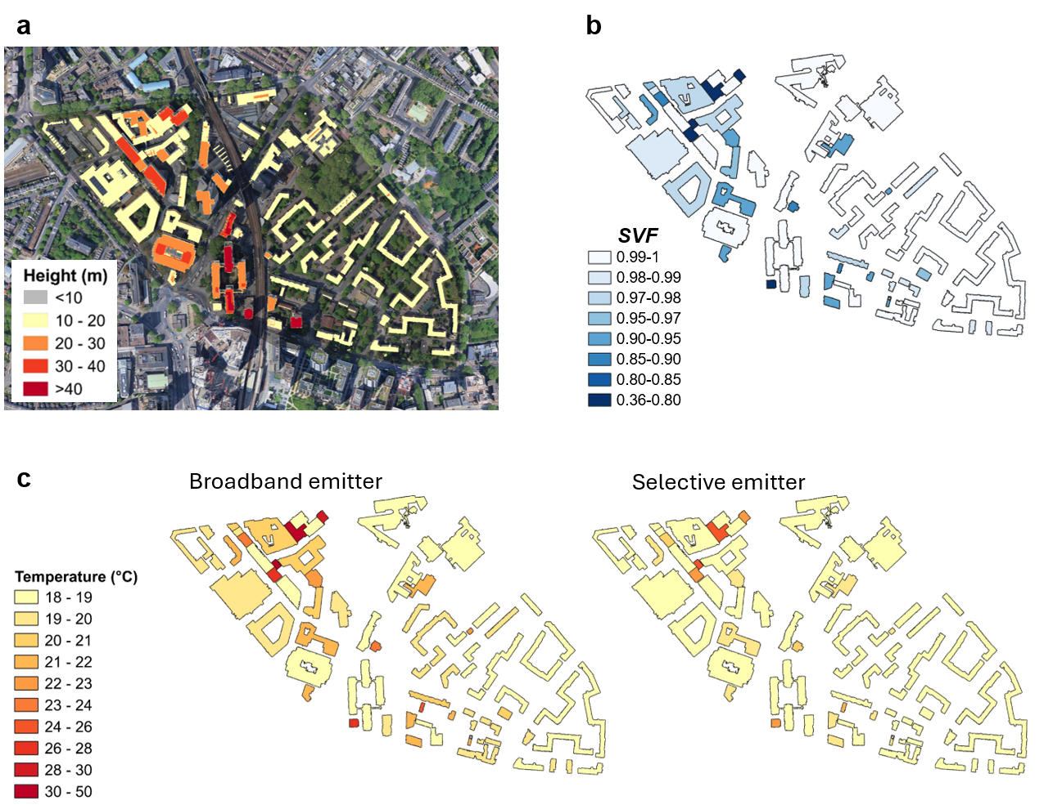
Figure S33. City-scale radiative cooling potential simulation on the second zone (Elephant and Castle area) in London. (a) Building height variations from LiDAR datasets, (b) calculated sky view factor (SVF) across the area, and (c) temperature distributions modeled for buildings equipped with broadband versus selective thermal emitters on rooftops, assuming environmental conditions of 25 °C ambient temperature, 60 °C wall temperatures, and the parasitic heat transfer coefficient of 8 W∙m⁻²∙K⁻¹.

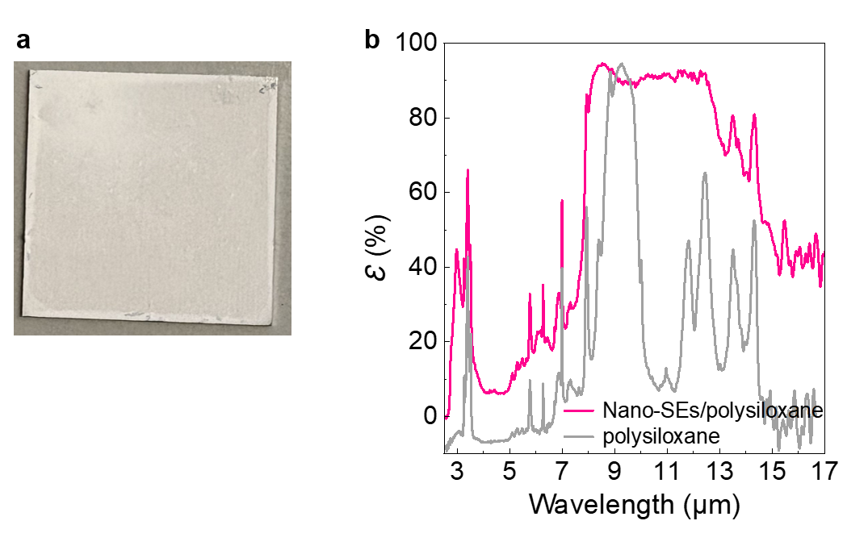
Figure S34. (a)Photograph and (b) FTIR spectrum of the selective thermal emitter fabricated by incorporating Nano-SEs into a commercial polysiloxane (PPG PSX 700, Industrial Coatings Company, UK), which provides the composite with stronger chemical and mechanical resistance than PDMS. The FTIR spectrum of polysiloxane (the gray line) is included for reference. The resulting selective emitter (the pink line) exhibits ε_{8-13µm} = 90.4% and η = ε_{8-13µm} / ε_{3-8, 13-17µm} = 2.05. The performance can be further optimized by varying Nano-SEs stoichiometry, Nano-SEs loading, and coating thickness.

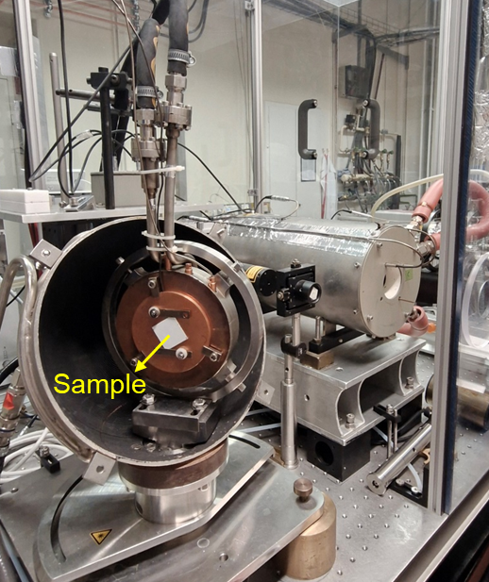
Figure S35. Photo showing the setup for emissivity measurement at PTB. One of the samples investigated in this article is mounted on the sample holder.

Supporting Note 1. Sky View Factor (SVF) Calculation
We analyze radiative heat transfer between two blackbody surfaces (schematic below). When net radiation exchange between differential areas dA₁ and dA₂ follows the Stefan-Boltzmann law, the corresponding view factor obeys:
$$F_{12}=\frac{1}{A_{1}}\iint{\frac{cos{β_{1}}cosβ_{2}}{{πS}^{2}}dA_{1}dA_{2}} (1)$$

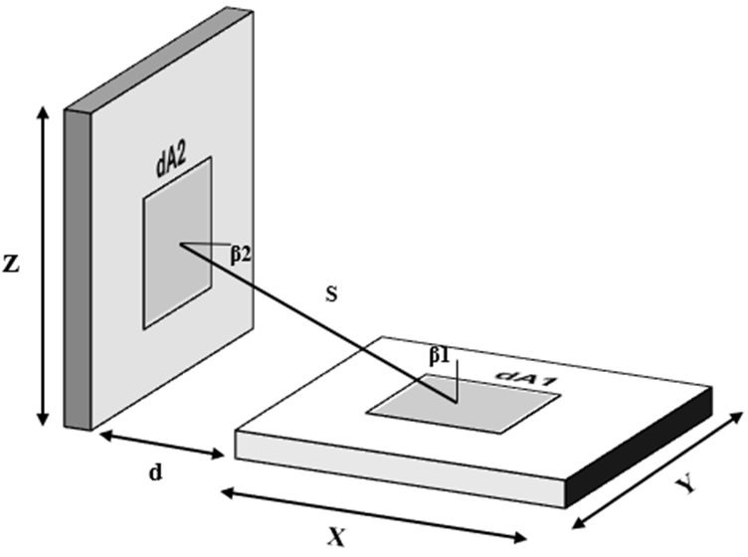
Figure S36. Geometric configuration for calculating the radiative view factor between two perpendicular surfaces.
When looking at city topography, one needs to consider the relative height of buildings and their orientation to one another. A common configuration setup is demonstrated in the figure above, where one building is taller than the other, with a distance $d$ separating the two. The boundaries of the two areas are defined as such:
$$A_{1}:\left(x,y,0\right) where 0≤x≤X and 0≤y≤Y$$
$$A_{2}:\left(-d,n,z\right) where 0≤z≤Z and 0≤n≤Y$$
Where the width is $Y$, the length is $X$, and height is $Z$. We then use Eq. (1) to find the view factor for such configurations. Starting with defining the cosines, the differential areas, and the distance between them.
$$\cos\left(β_{1}\right)=\frac{z}{S}: \cos\left(β_{2}\right)=\frac{x+d}{S}$$
$$S=\sqrt{{(x+d)}^{2}+z^{2}+{\left(n-y\right)}^{2}}$$
$$dA_{1}=dxdy$$
$$dA_{2}=dndz$$
Now that we have all the terms defined, Eq. (1) becomes:
$$F_{12}=\frac{1}{XY}\iint{\iint{\frac{z(x+d)}{π{\left({(x+d)}^{2}+z^{2}+{\left(n-y\right)}^{2}\right)}^{2}}dndydzdx}} (2)$$
Let’s rewrite Eq. (2) as follows:
$$F_{12}=\frac{1}{XY}\int_{0}^{X}{\int_{0}^{Z}{z(x+d)}}\left[\int_{0}^{Y}{\int_{0}^{Y}{\frac{1}{π{\left({\left(x+d\right)}^{2}+z^{2}+{\left(n-y\right)}^{2}\right)}^{2}}dndy}}\right]dzdx (3)$$
Define $a={\left(x+d\right)}^{2}+z^{2}$and $μ=n-y$ then the double integral inside the bracket becomes:
$$F_{12}=\frac{1}{XY}\int_{0}^{X}{\int_{0}^{Z}{z(x+d)}}\left[\int_{0}^{Y}{\int_{-y}^{Y-y}{\frac{1}{π{\left(a+μ^{2}\right)}^{2}}dμdy}}\right]dzdx (4)$$
Since $μ$ and $y$ overlap, we can use the following rule to further simplify the double integral.
$$\int_{0}^{Y}{\int_{0}^{Y}{f\left(n-y\right)dndy}= \int_{-Y}^{Y}{\left(Y-\left|μ\right|\right)f\left(μ\right)dμ}} (5)$$
And using symmetry since $f$ only appears on positive $μ$ we obtain:
$$\int_{-Y}^{Y}{\left(Y-\left|μ\right|\right)f\left(μ\right)dμ}=2\int_{0}^{Y}{\left(Y-μ\right)f\left(μ\right)dμ} (6)$$
Now we can rewrite the double integral inside the bracket in Eq. (4) as follows:
$$\frac{2}{π}\int_{0}^{Y}{\frac{Y-μ}{{\left(a+μ^{2}\right)}^{2}}dμ}= \frac{Y}{πa^{\frac{3}{2}}}\tan^{-1}\left(\frac{Y}{\sqrt{a}}\right)$$
Finally, we plug the solution back into Eq. (4)
$$F_{12}=\frac{1}{πX}\int_{0}^{X}{\int_{0}^{Z}{\frac{z(x+d)}{a^{\frac{3}{2}}}\tan^{-1}\left(\frac{Y}{\sqrt{a}}\right)}}dzdx (7)$$
Assume $R=\sqrt{{(x+d)}^{2}+z^{2}}$ and so $dz=(R/z)dR$, we can rewrite Eq. (7) as:
$$F_{12}=\frac{1}{πX}\int_{0}^{X}{\int_{R_{1}}^{R_{2}}{\frac{(x+d)}{R^{2}}\tan^{-1}\left(\frac{Y}{R}\right)}}dRdx (8)$$
Note that $R_{1}=x+d$ and $R_{2}=\sqrt{{(x+d)}^{2}+Z^{2}}$. The solution for the inner integral is:
$$I\left(R\right)=-\frac{1}{Y}\left[\frac{Y}{R}\tan^{-1}\left(\frac{Y}{R}\right)+ln\left(\frac{R}{\sqrt{R^{2}+Y^{2}}}\right)\right]+C (9)$$
Therefore, the view factor $F_{12}$ becomes:
$$F_{12}=\frac{1}{πX}\int_{0}^{X}{\left(x+d\right)\left[I\left(R_{2}\right)-I\left(R_{1}\right)\right]dx} (10)$$
Eq. (10) can be solved numerically using MATLAB code, however, if we desire an algebraic solution, we first start by defining the following nondimensional variables:
$$W=\frac{X}{Y}; H=\frac{Z}{Y}; D=\frac{d}{Y}; δ=\frac{x+d}{Y}; v=\frac{z}{Y}$$
The consequence of introducing the above variable is the following
$$x+d=Yδ: z=Yv$$
$$dx=Y dδ: dz=Y dv$$
Moreover, the ranges of the integral change to:
$$x=0⇒δ=\frac{0+d}{Y}=D$$
$$x=X⇒δ=\frac{X+d}{Y}=D+W$$
$$z=0⇒v=0$$
$$z=Z⇒v=\frac{Z}{Y}=H$$
We then start from Eq. (7) and here it is in its original form:
$$F_{12}=\frac{1}{πX}\int_{0}^{X}{\int_{0}^{Z}{\frac{z(x+d)}{{\left({\left(x+d\right)}^{2}+z^{2}\right)}^{\frac{3}{2}}}\tan^{-1}\left(\frac{Y}{\sqrt{{\left(x+d\right)}^{2}+z^{2}}}\right)}}dzdx (11)$$
$$F_{12}=\frac{1}{πX}\int_{δ=D}^{D+W}{\int_{v=0}^{H}{\frac{δv}{{Y\left(δ^{2}+v^{2}\right)}^{\frac{3}{2}}}\tan^{-1}\left(\frac{1}{\sqrt{δ^{2}+v^{2}}}\right)}}\left(Y.dv\right)\left(Y.dδ\right) (12)$$
$$F_{12}=\frac{1}{πW}\int_{δ=D}^{D+W}{\int_{v=0}^{H}{\frac{δv}{{\left(δ^{2}+v^{2}\right)}^{\frac{3}{2}}}\tan^{-1}\left(\frac{1}{\sqrt{δ^{2}+v^{2}}}\right)}}dvdδ (13)$$
Integrating the above will yield the final algebraic solution of the sky view factor
$$F_{12}\left(D\right)=\frac{1}{πW}\left[Φ\left(D+W;H\right)-Φ(D;H)\right] (14)$$
Where:
$$Φ\left(δ;H\right)=δ{.tan}^{-1}\left(\frac{1}{δ}\right)-C\left(δ\right){.tan}^{-1}\left(\frac{1}{C\left(δ\right)}\right)+\frac{1}{4}ln\left(\frac{\left(1+δ^{2}\right)\left(1+H^{2}\right)}{1+C{\left(δ\right)}^{2}}\right)+ \frac{δ^{2}}{4} \ln\left(\frac{δ^{2}\left(1+C{\left(δ\right)}^{2}\right)}{\left(1+δ^{2}\right)C{\left(δ\right)}^{2}}\right) + \frac{H^{2}}{4}ln\left(\frac{H^{2}(1+C{(δ)}^{2})}{(1+H^{2})C{(δ)}^{2}}\right)$$
$$C\left(δ\right)=\sqrt{δ^{2}+H^{2}}$$
$$SVF=1- F_{12} (15)$$

Supporting Note 2. Calculation for Q_{urban} and surface temperature (T_{s}) of emitters under various Q_{urban}
The heat absorbed from the adjacent tall building Q_{urban} is determined by SVF (a geometric scaler that describes the orientation and relative positioning of the two objects exchanging heat) and wall temperature (T_{w}). We treat the source of emission (high-rise buildings) as diffuse blackbody emitters. The adjacent wall is a blackbody with emissivity equal to one, therefore its radiated power can be calculated as follows¹:
$${Q_{urban}=(1-SVF)×P}_{wall}\left(T_{w}\right)=(1-SVF)×2π \int_{0}^{\frac{π}{2}}{\sin{θ}\cos{θ}\int_{0}^{∞}{I_{B}\left(T_{w},λ \right)ε_{s}\left(λ,θ\right)dθdλ}} (15)$$
where $ε_{s}\left(λ,θ\right)$ is the spectral directional emissivity of the surface, $I_{B}\left(T_{s},λ \right)$ is the blackbody spectral emissive power defined by Planck’s law.
$$I_{B}\left(T_{s},λ \right)=\frac{2{h_{p}c}^{2}}{λ^{5}\left(e^{\frac{h_{p}c}{λKT}}-1\right)} (16)$$
Planck’s constant is $h_{p}$, $c$ is the speed of light, and $K$ is Stefan-Boltzmann's constant.
To account for the heat absorbed from the adjacent tall building in radiative cooling, the heat exchange between a surface and its environment is described by the following equation:
$$P_{net}= P_{rad}\left(T_{s}\right)- P_{atm}\left(T_{a}\right)- P_{solar}- P_{nonrad}\left(T_{s}, T_{a}\right)-Q_{urban} (17)$$
Here $P_{rad}$ is the power radiated by the surface, $P_{atm}$ is the downward atmospheric radiation absorbed by the surface, $P_{solar}$ is the absorbed solar radiation, $P_{nonrad}$ represents heat transfer due to convection and conduction, T_{s} is the surface temperature of emitters, and T_{a} is the ambient temperature. The resulting $P_{net}$ is the net heat exchange between the environment and the surface.
$P_{rad}\left(T_{s}\right)=2π \int_{0}^{\frac{π}{2}}{\sin{θ}\cos{θ}\int_{0}^{∞}{I_{B}\left(T_{s},λ \right)ε_{s}\left(λ,θ\right)dθdλ}} (18)$
The spectral directional emissivity of the surface is $ε\left(λ,θ\right)$, and
$$P_{atm}\left(T_{a}\right)=SVF×2π\int_{0}^{\frac{π}{2}}{\sin{θ}\cos{θ}\int_{0}^{∞}{I_{B}\left(T_{a},λ \right)α\left(λ,θ\right)ε_{atm}\left(λ,θ\right)dθdλ}} (19)$$
$α\left(λ,θ\right)$ is the absorptivity of the surface and $ε_{atm}\left(λ,θ\right)$ is the emissivity of the atmosphere and it’s given by.
$$ε_{atm}\left(λ,θ\right)=1-t{\left(λ,θ=0\right)}^{\frac{1}{cosθ}} (20)$$
$t\left(λ,θ\right)$ is the spectral atmospheric transmittance in the zenith direction obtained from MODTRAN. Kirchhoff’s radiation law states that the total power absorbed under thermal equilibrium is equal to the total power emitted. Therefore, we can replace the absorptivity of the surface with its emissivity.
The incoming solar power absorbed by the surface is expressed as follows:
$$P_{solar}=\int_{0}^{∞}{I_{solar,1.5AM}\left(λ \right)α\left(λ\right)dλ} (21)$$
The conventional standard used in radiative cooling is 1.5AM solar irradiance which is approximately equal to 1000 W/m².
Finally, the heat loss power due to convection and conduction is also called parasitic heat loss, as expressed in Eq. (22), where h is the parasitic heat transfer coefficient.
$$P_{nonrad}\left(T_{s}, T_{a}\right)=h\left(T_{a}-T_{s}\right) (22)$$
Convective heat transfer coefficient used in the radiative heating experiments
The convective heat-transfer coefficient was evaluated separately for the two radiative-heating configurations. In the four-wall experiment, the heating walls substantially sheltered the horizontally oriented samples from the external wind. Convection from the upward-facing sample surface was therefore treated as natural convection. The thermophysical properties of air were evaluated at the film temperature: T_{f} =(T_{s}+T_{a})/2. The characteristic length was defined as L_{c} = A/P, where A and P are the exposed surface area and perimeter, respectively. The Rayleigh number was calculated from the temperature difference between the sample and ambient air:
${Ra}_{Lc} = \frac{gβ\left|T_{s} - T_{a}\right|L_{c}^{3}}{να}$ (23)
where g is gravitational acceleration, β is the volumetric thermal-expansion coefficient, ν is the kinematic viscosity, and α is the thermal diffusivity of air. For an upward-facing surface warmer than the ambient air, the average Nusselt number was calculated using the standard horizontal-plate correlations²:

${\overline{Nu}}_{Lc}=\left\{\begin{matrix}0.622 {Ra}_{Lc}^{1/4} for {3×10}^{2} ≤ {Ra}_{Lc} ≤ {4×10}^{6}, \\ 0.162 {Ra}_{Lc}^{1/3} for 4×{10}^{6} < {Ra}_{Lc} ≤ 1.7×{10}^{8}\end{matrix}\right.$ (24)
The natural convective heat-transfer coefficient was then obtained from Eq. 25 with k_{air} is the thermal conductivity of air at the film temperature.
$h_{ } =\frac{k_{air}{\overline{Nu}}_{Lc}}{L_{c}}$ (25)
In the high temperature radiative-heating experiment, the apparatus was exposed to environmental airflow, and convection was therefore treated as forced convection. The local convective heat-transfer coefficient h_{x} was evaluated using the generalized flat-plate model of Zhao et al.³, which accounts for the plate length L, measured ambient wind velocity v, streamwise position x, surface-to-air temperature difference ΔT = |T_{s} − T_{a}|, and the laminar, transitional, and turbulent regions of the boundary layer. Air properties were evaluated at the film temperature, and the surface-averaged forced-convection coefficient was obtained by spatially averaging the local values:
$h =\frac{1}{L} ∫h_{x}(L, v, x, ΔT) dx$ (26)
The samples and sample holders were surrounded by thermal insulation. Therefore, conduction through the holder was negligible and was not included as a separate term in the experimental surface-energy balance (Eq. 22).

Supplementary Note 3. City Sky View Factor
Implementing sky view factor analysis at the city scale is difficult, primarily because urban environments contain highly irregular and complex building geometry. Therefore, Johnson and Watson⁴ proposed a way to calculate the sky view factor by evaluating the radiation flux exchanged between an observer (radiative emitter) and the portion of the sky visible to it. In our analysis, we are primarily concerned with the portion of the sky blocked by the building adjacent to the observation point. Moreover, we approximate the view factor using the shadow that this building casts on the observer⁵.
Consider a building rooftop that absorbs heat from a tall adjacent building. The tall building acts as a heat emitter that obeys Planck’s blackbody radiation law. It adds excess heat to the rooftop, and the amount depends on the wall temperature and the view factor, which in this case represents the fraction of the sky obstructed by the tall building. We start with the total hemispherical diffuse irradiance:
$$\int_{0}^{2π}{\int_{0}^{π/2}{cos⁡(θ)sin⁡(θ)dθdϕ}=π} (27)$$
To calculate the fraction of the sky blocked by the tall building, one needs to determine the maximum obstruction angle, which lies within the azimuth span is $Δϕ$.
$$α=\tan^{-1}\left(\frac{∆H}{d}\right)$$
where $d$ is the distance from the rooftop’s centre to the wall of the tall building, and $∆H$ is the relative height between the two. Now we can compute the sky view factor SVF which is the irradiance-weighted solid angle of the sky region not blocked by the tall building and divide it by the total hemispherical irradiance.
$$SVF=1-\frac{1}{π}\int_{0}^{Δϕ}{\int_{\frac{π}{2}-α}^{π/2}{\cos\left(θ\right)sin⁡(θ)dθdϕ}=1-\frac{Δϕ}{2π}{\left(\sin{α}\right)}^{2}} (28)$$
This equation is used in the net radiative power equations, at equilibrium, to calculate the temperature for both selective and broadband emitters.
 | Transmittance | Reflectance | Absorptance
LDPE | 88.8% | 9.6% | 1.6%
Nano-SEs/LDPE | 87.8% | 10% | 2.2%

Table S1. The weight-averaged optical properties of LDPE and Nano-SEs/LDPE films (50 μm thickness) with respect to the AM 1.5G solar spectrum in the 0.25-2.5 μm range. The incorporation of Nano-SEs into the LDPE matrix increased solar absorptance from 1.6% to 2.2%, representing a 0.6% increment attributable to Nano-SEs.

Supporting References
1. Tang, H.; Chen, W.; Li, C., Experimental and Theoretical Study on Building Integrated Radiative Cooling with a Limited Sky-View Factor. J. Build. Eng. 2024, 97, 110948.
2. Yousef, W.; Tarasuk, J.; McKeen, W., Free Convection Heat Transfer from Upward-Facing Isothermal Horizontal Surfaces. 1982,104(3), 493-500.
3. Zhao, J.; Zhu, J.; Xu, Y.; Li, Y., New Generalized Expressions for Forced Convective Heat Transfer Coefficients across the Flat Plate. Appl. Therm. Eng. 2025, 258, 124688.
4. Johnson, G. T.; Watson, I. D., The Determination of View-Factors in Urban Canyons. Journal of Applied Meteorology and Climatology 1984, 23 (2), 329-335.
5. Matzarakis, A.; Matuschek, O., Sky View Factor as a Parameter in Applied Climatology-Rapid Estimation by the Skyhelios Model. Meteorol. Z. 2011, 20 (1), 39.

