Supporting Information

Flavin-containing monooxygenase acts as a metabolic signaling hub linking AhR - CYP transcriptional reprogramming to insecticide resistance

Cong Rao¹, Hailiang Guo¹, Kuitun Liu¹, Wangjin He¹, Bo Hu²*, and Jianya Su¹*

- State Key Laboratory of Agricultural and Forestry Biosecurity, College of Plant Protection, Nanjing Agricultural University, Nanjing 211800, China
- Jiangsu Key Laboratory of Sericultural and Animal Biotechnology, School of Biotechnology, Jiangsu University of Science and Technology, Zhenjiang, China

- Insect strains and rearing conditions
For the HZ21 and HZ24 field populations, the sampling area represents an intensively managed vegetable production region where insecticides are routinely applied approximately one to two times per month. Commonly used insecticides in this region include chlorantraniliprole, emamectin benzoate, lambda-cyhalothrin, and metaflumizone. Larvae of all S. exigua strains were reared on an artificial diet, whereas adults were supplied with a 10% sucrose solution. All insects were maintained at 27 ± 1°C, 60–70% relative humidity, and a 14:10 h light/dark photoperiod.
- Bioassays
For S. exigua diet-incorporation bioassays, artificial diet was melted, supplemented with 0.1% Triton X-100, and thoroughly mixed using a magnetic stir bar. After the diet cooled to approximately 40°C, equal volumes of serially diluted insecticide solutions were incorporated and mixed evenly. Diet containing the corresponding solvent was used as the negative control. The treated diet was dispensed into 6-cm Petri dishes, and ten early third-instar larvae were placed in each dish, with five biological replicates per treatment. Mortality was scored after 72 h for lambda-cyhalothrin and chlorpyrifos and after 96 h for the remaining insecticides. Larvae were considered dead when they showed no movement after gentle stimulation with a fine brush.
- Pharmacological manipulation of AHR-related signaling
KynA, Kyn, XA, and SR1 were incorporated into standard fly diet for compound treatment. KynA and XA were prepared as 50 mM stock solutions in DMSO and diluted 1:100 into the diet to final concentrations of 500 μM. Kyn and SR1 were prepared as 20 mM stock solutions in DMSO and diluted 1:100 to final concentrations of 200 μM. To prepare compound-containing diets, Triton X-100 was first added to melted standard diet to a final concentration of 0.2% and mixed thoroughly with magnetic stirring. After the diet cooled to approximately 40°C, compound stock solutions were added and mixed evenly. Corresponding solvent controls containing the same final concentrations of DMSO and Triton X-100 were included for all treatments.
- Real-Time Quantitative PCR.
For RT-qPCR analysis, total RNA was isolated from at least three biological replicates for each treatment. For S. exigua, each replicate consisted of pooled samples of five larvae, whereas each Drosophila replicate consisted of 10–15 adult male flies. Total RNA was extracted using TRIzol reagent (Invitrogen, USA) according to the manufacturer’s protocol, and cDNA was synthesized using HiScript III RT SuperMix with gDNA wiper (Vazyme, Nanjing, China). qPCR reactions were performed using AceQ qPCR SYBR Green Master Mix (Vazyme, Nanjing, China) on a QuantStudio 5 Real-Time PCR System (Applied Biosystems, USA). The amplification program was 95°C for 10 min, followed by 40 cycles of 95°C for 10 s and 60°C for 32 s. Melt curve analysis was performed at the end of each run to confirm amplification specificity. Actin5C was used as the internal reference gene for Drosophila. For S. exigua, β-Actin and GAPDH were used as internal reference genes, and expression levels were normalized to the geometric mean of the two reference genes. Relative gene expression was calculated using the 2−ΔΔCt method.
- Prokaryotic expression of SeFMO and in vitro metabolism assay
The enzymatic reaction was performed in a total volume of 500 μL using 1× PBS as the reaction buffer. The reaction mixture contained 160 μg of SeFMO protein, an NADPH regeneration system (0.25 mM NADP⁺, 2.5 mM glucose-6-phosphate, and 1 U glucose-6-phosphate dehydrogenase), and 10 μM metaflumizone. Reactions were incubated at 37°C for 12 h, after incubation, reactions were terminated by adding 4 mL ethyl acetate to extract reaction products. Samples were vortexed thoroughly for 10 min and sonicated for 5 min. An appropriate amount of sodium chloride was then added to promote phase separation, followed by vortexing for another 2 min and centrifugation at 12,000 × g for 10 min. The upper organic phase (3 mL) was collected and dried under nitrogen gas. The residue was re-dissolved in 500 μL methanol, filtered through a 0.22 μm organic-phase membrane filter, and subjected to HPLC analysis. HPLC analysis was performed using an Agilent 1260 high-performance liquid chromatography system equipped with a ZORBAX Eclipse XDB-C18 column (4.6 × 250 mm, 5 μm) and a DAD UV detector. The injection volume was 50 μL, and the column temperature was maintained at 25°C. Metaflumizone was detected using acetonitrile:water (80:20, v/v) as the mobile phase at a detection wavelength of 285 nm. Metaflumizone standard dissolved in methanol was used for peak identification, with a retention time of 5.73 min. Metaflumizone content was estimated based on peak area, which was calculated by automatic integration using the HPLC software.
- Transcriptome library preparation and sequencing
RNA integrity and quality were assessed before library construction. Qualified RNA samples were used for library preparation with the Illumina TruSeq RNA Sample Preparation Kit. Briefly, mRNA was enriched using oligo(dT) magnetic beads, followed by fragmentation, cDNA synthesis, end repair, A-tailing, adapter ligation, and PCR amplification. After library quality control, paired-end 150 bp sequencing was performed on an Illumina NovaSeq 6000 platform, generating at least 6 Gb of raw data per sample. Raw reads were filtered using fastp to remove adapter sequences and low-quality reads, and the resulting clean reads were used for downstream transcriptome analysis.
- Homology Modeling and Molecular Docking.
The amino acid sequence SeAHR (GenBank: AYI99241.1) was used to generate a predicted three-dimensional structure with ProteinX. The initial model was further optimized using Rosetta Relax to improve local geometry and overall stereochemical quality. The refined structure was prepared in PyMOL by removing nonprotein molecules and adding hydrogen atoms. Ligand structures were obtained from PubChem in SMILES format, converted into three-dimensional conformers using RDKit, and energy-minimized with the MMFF94 force field. Potential ligand-binding regions were first searched by blind docking with CB-Dock2 (Eberhardt et al., 2021), and the candidate binding pockets were subsequently used for docking refinement with AutoDock Vina. Docking poses were ranked according to the predicted binding affinity, and the lowest-energy conformation was selected for downstream analysis. Protein-ligand interactions were analyzed using the PLIP server and visualized in PyMOL. The selected docking complex was further evaluated by molecular dynamics simulations.
Molecular dynamics simulations were performed using GROMACS 2023.3. The protein and ligand were parameterized using the AMBER14SB and GAFF force fields, respectively (Maier et al., 2015; Wang et al., 2004). Hydrogen atoms were added with pdb2gmx, and the protein-ligand complex was placed in a cubic TIP3P water box with a 10 Å buffer distance. Na+ and Cl- ions were added to neutralize the system. Energy minimization was performed using the steepest descent algorithm with a maximum force threshold of 1000 kJ mol-1 nm-1 and a step size of 0.01 nm. The minimized system was then subjected to 100 ps NVT equilibration with heating from 0 to 310.15 K, followed by 100 ps NPT equilibration at 310.15 K and 1 bar using the Berendsen barostat. A 100 ns production simulation was performed under isothermal-isobaric conditions. Bonds involving hydrogen atoms were constrained using the LINCS algorithm with a 2 fs time step. Long-range electrostatic interactions were calculated using the particle mesh Ewald method with a 1.2 nm cutoff, and van der Waals interactions were truncated at 10 Å. Trajectories were processed to remove periodic boundary effects. Complex stability was evaluated using RMSD and radius of gyration analyses, and binding free energy was calculated from trajectory frames extracted from the final 10 ns of the simulation.
Supporting Information

Table S1. Drosophila lines and transgenic constructs used in this study
Category | Fly line / genotype | Source / provider
FMO overexpression line | UAS-DmFMO1 | Previously described in Wei et al. (2025)
FMO overexpression line | UAS-DmFMO2 | Previously described in Wei et al. (2025)
FMO knockdown line | UAS-DmFMO1-RNAi | Vienna Drosophila Resource Center, #v38146
FMO knockdown line | UAS-DmFMO2-RNAi | Vienna Drosophila Resource Center, #v42829
CYP transgenic line | UAS-DmCyp4p2 | Zhuhai United Huayi Technology Co., Ltd.
CYP transgenic line | UAS-DmCyp6d2 | Zhuhai United Huayi Technology Co., Ltd.
CYP transgenic line | UAS-DmCyp6a14 | Zhuhai United Huayi Technology Co., Ltd.
CYP transgenic line | UAS-SeCYP321A16 | Zhuhai United Huayi Technology Co., Ltd.
CYP transgenic line | UAS-SeCYP321A8 | Zhuhai United Huayi Technology Co., Ltd.
Ubiquitous driver | Actin5C-Gal4/CyO | Bloomington Drosophila Stock Center, #25374
Malpighian tubule driver | c42-Gal4 | Bloomington Drosophila Stock Center, #30835
Fat body driver | Lsp-Gal4 | Bloomington Drosophila Stock Center, #6357
Temporal driver line | w−; actin-Gal4; tub-Gal80ts | Constructed from BDSC #7017 and #25374

Table S2 Chemicals including Insecticides used in this study
Chemical | Purity | Source | Working concentration in fly assay
Methimazole | 99% | Sigma-Aldrich Co. LLC., USA | 30 mM
Chlorantraniliprole | 97% | DuPont Agricultural Chemicals Ltd., China | —
Chlorpyrifos | 97% | Nanjing Red Sun Co., Ltd., China | 0.1 mg/L
Emamectin benzoate | 95.2% | Nanjing Keweibang Chemical Co., Ltd., China | —
Lambda-cyhalothrin | 95.8% | Jiangsu Yangnong Co., Ltd., China | —
Metaflumizone | 97.7% | BASF Chemical Co., Ltd., China | 350–450 mg/L
Cartap | 98% | Yueyang Anda Chemical Co., Ltd., China | 60–80 mg/L
Indoxacarb | 96% | Jiangsu Kesheng Group Co., Ltd., China | 10 mg/L
StemRegenin 1 | 98% | MedChemExpress (MCE), USA | 200 μM
Kynurenic acid | 98% | Sigma-Aldrich Co. LLC., USA | 500 μM
Kynurenine | 98% | Sigma-Aldrich Co. LLC., USA | 200 μM
Xanthurenic acid | 98% | Sigma-Aldrich Co. LLC., USA | 500 μM

Table S3 Resistance of S. exigua to insecticides and the synergistic effects of MMI treatment.
Strain | Insecticides | Slope | LC₅₀ (95%FL), mg/L | χ2(df) | RR | SRª
Lab-Sus | Chlorpyrifos | 1.227 | 32.834 (17.774-50.180) | 1.370 (4)
 | Lambda-cyhalothrin | 1.442 | 11.900 (7.987-17.210) | 0.722 (4)
 | Chlorantraniliprole | 1.676 | 0.503 (0.346-0.684) | 3.245 (5)
 | Metaflumizone | 1.839 | 3.332 (2.435-4.531) | 0.262 (4)
 | Emamectin benzoate | 1.123 | 1.423 (0.940-2.206) | 0.373 (5)
HZ21 | Chlorpyrifos | 1.843 | 7860.1 (6209.4-10819.0) | 1.199 (3) | 239.4
 | Lambda-cyhalothrin | 2.149 | 762.7 (503.8-1300.9) | 4.214 (3) | 64.1
 | Chlorantraniliprole | 2.327 | 6.107 (4.813-7.857) | 1.912 (3) | 12.1
 | Metaflumizone | 2.450 | 693.0 (549.8-907.7) | 0.783 (3) | 208.0
 | Emamectin benzoate | 1.772 | 47.909 (23.085-126.474) | 1.721 (3) | 33.7
HZ24 | Chlorpyrifos | 1.804 | 966.5 (701.4-1301.1) | 3.071 (5) | 29.4
 | Lambda-cyhalothrin | 2.459 | 768.8 (643.2-915.9) | 1.565 (4) | 64.6
 | Chlorantraniliprole | 2.271 | 17.024 (13.037-22.237) | 1.263 (4) | 33.8
 | Metaflumizone | 1.862 | 1892.2 (1451.9-2645.2) | 1.391 (4) | 567.9
 | Emamectin benzoate | 2.671 | 390.1 (261.7-571.2) | 8.001 (4) | 274.2
HZ24+MMI | Chlorpyrifos+MMI | 2.382 | 717.1 (600.3-862.3) | 0.805(4) |  | 1.3
HZ24+MMI | Lambda-cyhalothrin+MMI | 2.213 | 986.5 (659.5-1633.0) | 1.433 (4) |  | 0.8
 | Chlorantraniliprole+MMI | 1.686 | 17.290 (10.738-31.583) | 1.423 (5) |  | 1.0
 | Metaflumizone+MMI | 1.803 | 383.1 (277.1-536.9) | 1.082 (4) |  | 4.9
 | Emamectin benzoate+MMI | 1.582 | 288.2 (145.1-921.2) | 2.126 (4) |  | 1.4
ª SR (synergism ratio) = LC₅₀ of a strain treated with insecticide alone divided by LC₅₀ of the same strain treated with insecticide and a synergist.

Table S4. Primers used for RT-qPCR analysis in this study.
Genes | Forword sequences (5’-3’) | Reverse sequences (5’-3’)
Acting5c | CACACCAAATCTTACAAAATGTGTGA | AATCCGGCCTTGCACATG
Dmfmo1 | GAACCTACGAACCAACCTGC | GCCACTTTGTTTTCCTCTGC
Dmfmo2 | ACGAGGTGATAAGAGTGCGT | TGTTGCCCTCGAACAGATCT
DmCyp4p2 | TGCTGGACACCTTGATTTGC | GTGCTCCTGGATCTCTTGGT
DmCyp6a14 | ACAGTCTCCAGGATCCAAGC | GTCAAATCATCGGGGAGCAC
DmCyp6d2 | GATTTCGCCAGTTTCCACGA | GTGCCGAACATGCCCTTAAT
DmCyp6a17 | CTACGGACGAAGGAAAAGCG | TTGCCAATCTCCTCCCTGAG
DmCyp4e1 | GGCCTCCTCACCAGTACTG | GAAGATGTTGCCTCCGTCTG
DmCyp6a19 | TTTGGTGGTCGGTGTCCTTA | CATAGAGGTAGAAGCCCGCA
DmCyp4g1 | TAGTTCAGGAGACGCTGCAA | GGATCTCGGCATTGCTCAAG
DmCyp4d21 | TGCGTGATTTTCTTGGCGAT | CTTGAATAGGTCCACGCACG
Spineless | CAGCAGAACCAACCACAGAC | TATAGATTGTCCGCGGCACT
β-Actin | AAGCCTTCGATGCCACCGGGTA | TTCGGGCGTGTTTAGTGGAGGC
GAPDH | CTGAGGAACAGGTCGTGTCATC | GATCGATAACGCGGTTGGAGTA
SeFMO1 | ATACTCCACGCCAGACGATG | GTGTCACCAGACTCCGCAAT
SeFMO2 | TTCCTCCACAATGTCCTCCT | CTTCTCCAGGTATGTTAGGC
SeFMO3 | TTTATACCGCAAATACCAGG | TTTTCGATACAGTCGTCAGTTC
SeAHR | CAATGGCTGCAGACCTCTTC | GGTCTCCGAGAAGTAGAGGC
CYP6AE70 | ATCTCACGCCTCTGTTCTC | GTCAAAGTCCTCGTATCAA
CYP321A8 | AAACAACCCCAAGACGCATG | CCAATGCCAAAGATAGCCCC
CYP321A16 | GCCGTCGGTATAGGTCAGTT | CAATGCTTTCCACTCCTCGG
GSTo2 | TCTATCACCGATCCACACCG | AGGGCCAGATCATGTAGTCG
GSTe6 | GTCAACGTAAAGGCTGGTGA | CGTCAGAATTGCATGGCTGT

Table S5. Effects of SR1 and MMI on the susceptibility of susceptible and HZ24 S. exigua populations to metaflumizone and chlorpyrifos.
Strain / Insecticides | Slope (S.E.) | χ²(df) | LC₅₀ (95%FL), mg/L | SR
HZ24
Metaflumizone only | 1.089 (0.209) | 0.789 (4) | 2818.300 (1841.419-5026.749) | -
Metaflumizone +SR1 | 1.484 (0.229) | 2.231 (4) | 716.066 (301.916-1742.490)* | 3.9
Metaflumizone + MMI | 1.686 (0.231) | 0.329 (4) | 521.748 (382.741- 692.337)* | 5.4
Metaflumizone + MMI + SR1 | 1.389 (0.215) | 0.850 (4) | 371.769 (244.799- 518.716)* | 7.6
Chlorpyrifos only | 1.940 (0.318) | 1.267 (3) | 765.111 (458.110-1740.834) | -
Chlorpyrifos + SR1 | 2.213 (0.280) | 1.433 (4) | 986.462 (659.523-1633.022)^{ns} | 1.1
Sus strain
Metaflumizone only | 1.648 (0.281) | 0.637 (3) | 2.370 (1.703- 3.259) | -
Metaflumizone + SR1 | 2.255 (0.330) | 2.645 (3) | 1.775 (1.360- 2.263)^{ns} | 1.3
Metaflumizone + MMI | 2.195 (0.330) | 2.134 (3) | 2.569 (2.082- 3.356)^{ns} | 0.9
Metaflumizone + SR1 + MMI | 1.647 (0.276) | 0.160 (3) | 1.945 (1.371- 2.638)^{ns} | 1.2
LC₅₀ marked with * or ns mean significant or no difference compared with insecticide only

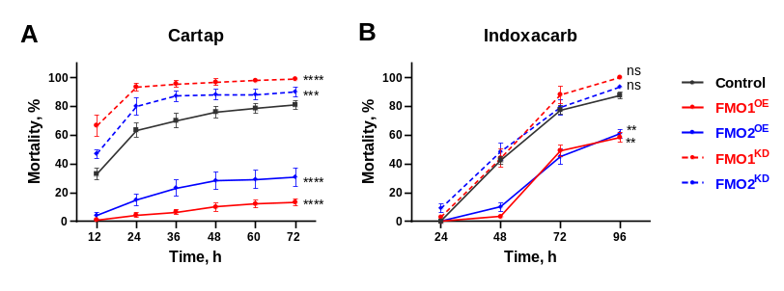
Fig S1. DmFMO modulates susceptibility to indoxacarb and cartap in Drosophila. Statistical analyses were performed using repeated-measures ANOVA followed by Dunnett’s multiple-comparison test, with each treatment group compared with the control. ns, not significant, *p < 0.05，**p < 0.01，***p < 0.001，****p < 0.0001.
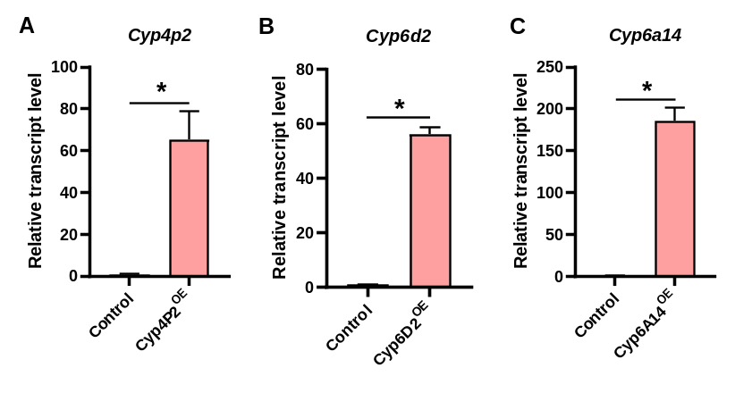
Fig S2 RT-qPCR validation of Cyp4p2, Cyp6d2, and Cyp6a14 overexpression in Drosophila. Statistical analyses were performed using two-tailed unpaired t-tests, *p < 0.05.

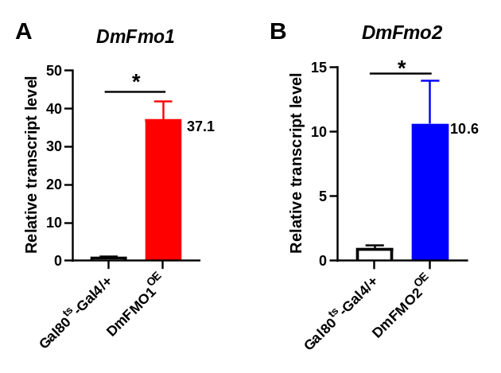
Fig S3 Quantitative validation of heat-induced transient overexpression of DmFmo1 and DmFmo2. Two-tailed unpaired t-test, p < 0.05, numbers above the bars indicate statistically significant fold changes in expression.
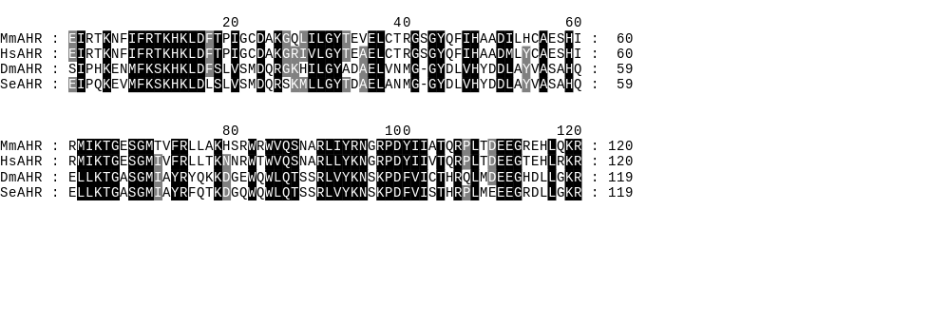
Fig S4 Multiple sequence alignment of the AHR PAS-B domain among representative species. Mm, Mus musculus; Hs, Homo sapiens; Dm, Drosophila melanogaster; Se, Spodoptera exigua.

