Supplementary material
Functional beverages based on herbal and tea extracts: evaluation of bioactive phytochemical properties, nutritional value and effects on α-amylase and glucosidase inhibition.
Joanna Ziętala ª, Grażyna Budryn ª, and Joanna Grzelczyk ^{a,}*

ªInstitute of Food Technology and Analysis, Faculty of Biotechnology and Food Sciences, Lodz University of Technology, 90-537, Lodz, Poland; joanna.zietala@edu.p.lodz.pl; grazyna.budryn@p.lodz.pl; joan-na.grzelczyk@p.lodz.pl
*Correspondence: joanna.grzelczyk@p.lodz.pl
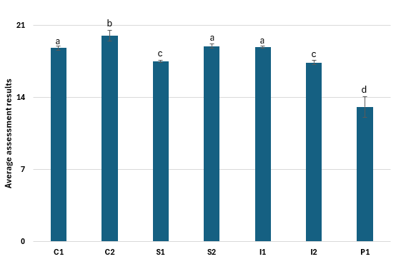
Figure S1. Organoleptic evaluation of beverages in terms of consumer acceptability. Different letters above the bars indicate statistically significant differences between variants. Values are expressed as mean ± SD; n = 4.
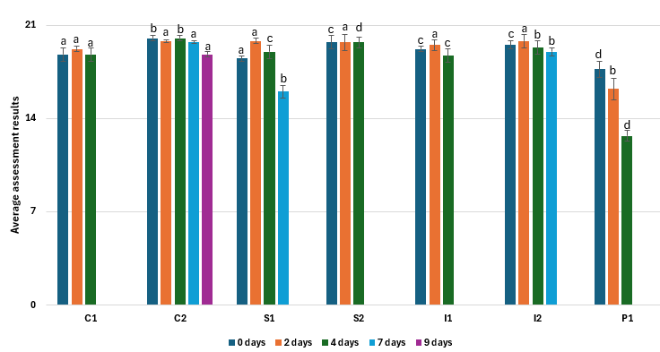
Figure S2. Organoleptic evaluation of beverages in terms of consumer acceptability subjected to ultrafiltration during storage. Different letters above the bars indicate statistically significant differences between variants. Values are expressed as mean ± SD; n = 4.
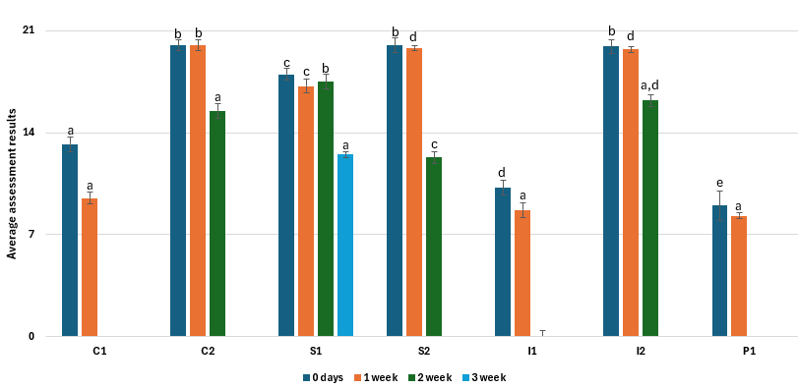
Figure S3. Organoleptic evaluation of beverages in terms of consumer acceptability subjected to a pasteurization process during storage. Different letters above the bars indicate statistically significant differences between variants. Values are expressed as mean ± SD; n = 4.
(Table S1).
Table S1. Total phenolic compounds, tannins and anthocyanin content in pasteurization beverages.
Beverage variant | Total Phenols  [mg GAE/100 mL] | Tannin content [g TAE/100 mL] | Total anthocyanins [g C3GE/100 mL]
Pasteurization – “0” day
C1 | 109.55 ± 1.19ª | 0.11 ± 0.03ª | 0.15 ± 0.03ª
C2 | 140.23 ± 1.24^{b} | 0.10 ± 0.02ª | 0.18 ± 0.03^{b}
S1 | 157.66 ± 1.05^{c} | 0.14 ± 0.04^{b} | 0.17 ± 0.02^{b}
S2 | 191.88 ± 1.15^{d} | 0.15 ± 0.03^{c} | 0.20 ± 0.02^{c}
I1 | 170.94 ± 1.24e | 0.13 ± 0.02^{b} | 0.09 ± 0.05^{d}
I2 | 181.37 ± 1.35^{f} | 0.12 ± 0.02^{d} | 0.13 ± 0.01^{f}
P1 | 51.91 ± 1.45^{g} | 0.10 ± 0.02^{d} | 0.04 ± 0.01^{g}
Pasteurization – 1 week
C1 | 105.22 ± 1.12ª | 0.11 ± 0.03ª | 0.13 ± 0.02^{f}
C2 | 136.84 ± 1.15^{h} | 0.10 ± 0.01ª | 0.17 ± 0.03^{b}
S1 | 151.68 ± 1.10^{c} | 0.14 ± 0.02^{b} | 0.16 ± 0.02ª
S2 | 184.15 ± 1.05^{f} | 0.15 ± 0.02^{c} | 0.19 ± 0.03^{c}
I1 | 163.22 ± 1.09^{i} | 0.13 ± 0.02^{b} | 0.06 ± 0.03^{g}
I2 | 172.36 ± 1.33e | 0.12 ± 0.02^{d} | 0.11 ± 0.02^{f}
P1 | 46.88 ± 1.16^{j} | 0.10 ± 0.01^{d} | 0.01 ± 0.01^{h}
Pasteurization – 2 week
C2 | 122.69 ± 1.45^{j} | 0.09 ± 0.03e | 0.12 ± 0.03^{f}
S1 | 142.52 ± 1.89^{b} | 0.13 ± 0.02^{b} | 0.15 ± 0.02ª
S2 | 164.97 ± 1.24^{i} | 0.08 ± 0.02e | 0.16 ± 0.02ª
I2 | 151.78 ± 1.03^{c} | 0.02 ± 0.01^{f} | 0.08 ± 0.03^{d}
Pasteurization – 3 week
S1 | 137.33 ± 0.43^{k} | 0.12 ± 0.02^{d} | 0.14 ± 0.03ª

Different letters a-k within columns indicate statistically significant differences between variants (p < 0.05). Values are expressed as mean ± SD; n = 4.
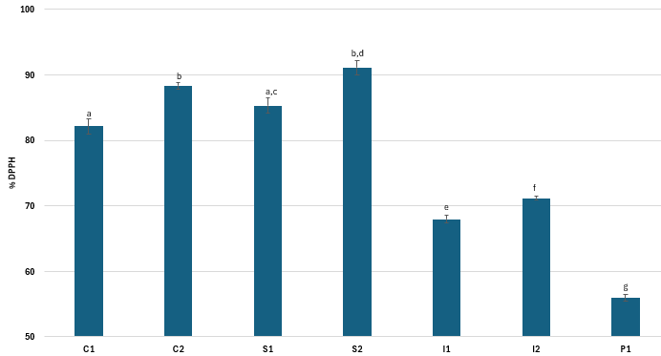
Figure S4. Values of antioxidant potential of beverages in %. Different letters above the bars indicate statistically significant differences between variants. Values are expressed as mean ± SD; n = 4.
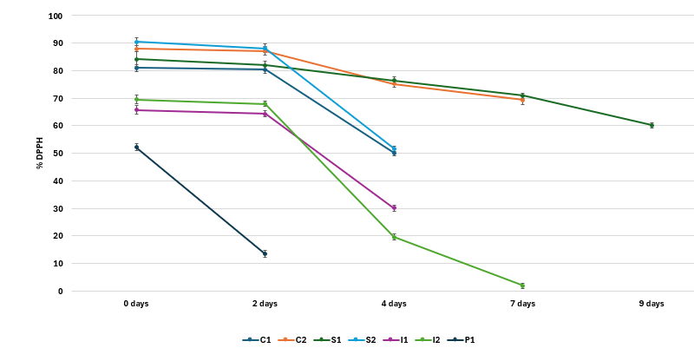
Figure S5. Values of antioxidant potential of beverages in %, subjected to ultrafiltration, during storage. Values are expressed as mean ± SD; n = 4.
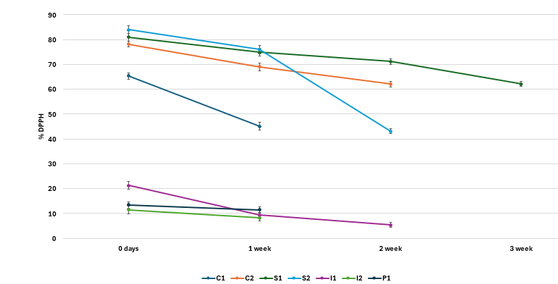
Figure S6. Values of antioxidant potential of beverages in %, subjected to a pasteurization process, during storage. Values are expressed as mean ± SD; n = 4.
Table S2. α-glucosidase and α-amylase inhibition.
Beverage variant |  | Inhibition of α-amylase activity [%] | Inhibition of α-glucosidase activity [%]
Fresh beverage
 | Store-bought beverage | 21.05 ± 0.45ª | 51.55 ± 2.11ª
C1 |  | 49.31± 1.02^{b} | 77.70 ± 2.18^{b}
C2 |  | 59.82± 1.54^{c} | 85.13 ± 2.98^{c}
S1 |  | 49.25± 1.25^{b} | 79.50 ± 2.09^{b}
S2 |  | 54.12± 1.39^{d} | 83.84 ± 2.49^{d}
I1 |  | 55.18± 1.26^{c} | 80.22 ± 1.55^{d}
I2 |  | 55.97± 1.45^{c} | 82.11± 2.39^{d}
P1 |  | 33.12± 1.55e | 65.45 ± 1.98e
Ultrafiltered – “0” day
C1 |  | 52.31± 1.15^{d} | 79.11 ± 2.08^{b}
C2 |  | 60.14± 1.65^{f} | 88.14 ± 2.01^{c}
S1 |  | 51.18± 1.23^{d} | 80.25 ± 2.06^{d}
S2 |  | 55.48± 1.87^{c} | 86.39 ± 2.06^{c}
I1 |  | 57.13± 1.34^{c} | 82.26 ± 1.02^{d}
I2 |  | 56.85± 1.98^{c} | 87.55± 2.02^{c}
P1 |  | 34.98± 1.59e | 68.33 ± 1.03e
Ultrafiltered – 2 days
C1 |  | 51.01 ± 1.05^{d} | 75.32 ± 2.01^{b}
C2 |  | 59.58 ± 1.05^{c} | 84.78 ± 2.05^{d}
S1 |  | 50.08 ± 1.09^{d} | 78.45 ± 2.01^{b}
S2 |  | 54.69 ± 1.55^{d} | 83.11 ± 2.12^{d}
I1 |  | 56.36 ± 1.19^{c} | 80.61 ± 1.09^{d}
I2 |  | 55.12 ± 1.49^{c} | 85.23± 2.48^{c}
P1 |  | 33.05 ± 1.35e | 62.46 ± 1.55^{f}
Ultrafiltered – 4 days
C1 |  | 48.35 ± 1.29^{b} | 70.15 ± 1.55^{g}
C2 |  | 59.11 ± 1.09^{c} | 83.47 ± 2.98^{d}
S1 |  | 49.55 ± 1.16^{b} | 77.13 ± 1.95 ^{b}
S2 |  | 50.01 ± 1.45^{d} | 80.12 ± 2.05^{d}
I1 |  | 49.85 ± 1.55^{b} | 72.11 ± 1.56^{g}
I2 |  | 53.10 ± 1.26^{d} | 84.74± 2.01^{d}
P1 |  | 20.19 ± 1.23ª | 50.13 ± 0.52ª
Ultrafiltered – 7 days
C2 |  | 57.05 ± 1.15^{c} | 80.11 ± 1.09^{d}
S1 |  | 45.03 ± 1.55^{b} | 71.59 ± 1.03^{g}
I2 |  | 50.98 ± 1.39^{d} | 79.88 ± 1.15^{b}
Ultrafiltered – 9 days
C2 |  | 52.03 ± 0.98^{d} | 77.31 ± 1.05^{b}
Pasteurization – “0” day
C1 |  | 50.87 ± 1.55^{d} | 76.34 ± 1.08^{b}
C2 |  | 58.64 ± 1.09^{c} | 84.15 ± 1.15^{d}
S1 |  | 50.56 ± 1.35^{d} | 79.84 ± 1.50^{b}
S2 |  | 53.57 ± 1.45^{d} | 82.63 ± 1.16^{d}
I1 |  | 54.64 ± 1.13^{d} | 76.25 ± 1.03^{b}
I2 |  | 53.11 ± 1.97^{d} | 81.49± 1.04^{d}
P1 |  | 31.55 ± 1.45e | 64.95 ± 1.05^{f}
Pasteurization – 1 week
C1 |  | 47.69 ± 0.55^{b} | 75.36 ± 1.15^{b}
C2 |  | 56.49 ± 1.11^{c} | 83.16 ± 1.82^{d}
S1 |  | 48.78 ± 0.29^{b} | 78.55 ± 1.03^{b}
S2 |  | 53.34 ± 1.98^{d} | 81.34 ± 1.11^{d}
I1 |  | 53.58 ± 1.26^{d} | 75.97 ± 1.05^{b}
I2 |  | 52.16 ± 1.55^{d} | 80.58± 1.26^{d}
P1 |  | 30.02 ± 1.33e | 63.22 ± 1.02^{f}
Pasteurization – 2 week
C2 |  | 52.05 ± 1.55^{d} | 80.36 ± 2.29^{d}
S1 |  | 47.11 ± 1.05^{b} | 76.11 ± 1.45^{b}
S2 |  | 51.18 ± 1.98^{d} | 77.78 ± 2.22^{b}
I2 |  | 50.33 ± 2.11^{d} | 80.26± 2.05^{d}
Pasteurization – 3 week
S1 |  | 44.14 ± 0.15^{b} | 72.15 ± 0.58^{g}

Different letters a-g within columns indicate statistically significant differences between variants (p < 0.05). Values are expressed as mean ± SD; n = 4.

Table S3. Contains vitamins C, E, B2 and B9.
Beverage variant |  | Vitamin C  [mg/100 ml] | Vitamin E  [mg/100 ml] | Vitamin B₂  [mg/100 ml] | Vitamin B₉  [µg/100 ml]
Fresh beverage
 | Store-bought beverage | nd | nd | nd | nd
C1 |  | 2.55 ± 0.45ª | 0.01 ± 0.00ª | 0.01 ± 0.00ª | 30.22 ± 0.00ª
C2 |  | 6.56 ± 0.53^{b} | nd | 0.02 ± 0.01^{b} | 45.35 ± 0.01^{b}
S1 |  | 2.46 ± 0.25^{c} | 0.55 ± 0.03^{b} | 0.01 ± 0.00ª | 10.15 ± 0.00^{c}
S2 |  | 3.12 ± 0.56^{d} | 0.52 ± 0.05^{b} | 0.01 ± 0.01ª | 10.49 ± 0.01^{c}
I1 |  | 2.58 ± 0.48ª | 0.48 ± 0.02^{c} | 0.01 ± 0.01ª | 2.55 ± 0.01^{d}
I2 |  | 3.97 ± 0.69e | 0.44 ± 0.01^{c} | 0.01 ± 0.01ª | 1.43 ± 0.01e
P1 |  | 2.12 ± 0.22^{c} | 0.36 ± 0.01^{d} | 0.01 ± 0.01ª | 9.83 ± 0.01^{f}
Ultrafiltered – “0” day
C1 |  | 2.07 ± 0.55^{c} | nd | 0.01 ± 0.01ª | 28.87 ± 0.45^{g}
C2 |  | 6.23 ± 0.46^{f} | nd | 0.02 ± 0.01^{b} | 43.39 ± 0.55^{h}
S1 |  | 2.11 ± 0.54^{c} | 0.51 ± 0.05^{b} | 0.01 ± 0.01ª | 8.55 ± 0.59^{i}
S2 |  | 2.81 ± 0.32ª | 0.47 ± 0.03^{c} | 0.01 ± 0.01ª | 9.19 ± 0.43^{f}
I1 |  | 2.01 ± 0.39^{c} | 0.45 ± 0.02^{c} | 0.01 ± 0.01ª | 1.11 ± 0.45e
I2 |  | 3.52 ± 0.14e | 0.42 ± 0.05^{c} | 0.01 ± 0.01ª | 0.26 ± 0.05^{j}
P1 |  | 1.36 ± 0.15^{g} | 0.31 ± 0.02^{d} | 0.01 ± 0.01ª | 8.12 ± 0.59^{k}
Ultrafiltered – 2 days
C1 |  | 2.05 ± 0.23^{c} | nd | nd | 23.55 ± 0.28^{g}
C2 |  | 6.21 ± 0.11^{f} | nd | 0.02 ± 0.01^{b} | 43.02 ± 0.24^{h}
S1 |  | 2.08 ± 0.14^{c} | 0.50 ± 0.03^{b} | 0.01 ± 0.01ª | 8.01 ± 0.35^{k}
S2 |  | 2.74 ± 0.18ª | 0.46 ± 0.01^{c} | 0.01 ± 0.01ª | 9.02 ± 0.28^{f}
I1 |  | 2.00 ± 0.13^{c} | 0.42 ± 0.01^{c} | 0.01 ± 0.01ª | 0.81 ± 0.26^{j}
I2 |  | 3.43 ± 0.24^{d} | 0.39 ± 0.02^{d} | 0.01 ± 0.01ª | nd
P1 |  | 1.31 ± 0.05^{g} | 0.25 ± 0.03e | nd | 4.98 ± 0.15ª
Ultrafiltered – 4 days
C1 |  | 1.12 ± 0.05^{g} | nd | nd | 20.03 ± 0.59^{g}
C2 |  | 5.33 ± 0.09^{h} | nd | 0.02 ± 0.01^{b} | 41.25 ± 0.55^{h}
S1 |  | 1.85 ± 0.15^{i} | 0.33 ± 0.02^{d} | 0.01 ± 0.01ª | 7.98 ± 0.29^{l}
S2 |  | 1.64 ± 0.03^{i} | 0.40 ± 0.02^{c} | nd | 8.55 ± 0.25^{k}
I1 |  | 1.06 ± 0.05^{g} | 0.35 ± 0.02^{d} | nd | nd
I2 |  | 2.18 ± 0.16^{c} | 0.25 ± 0.03e | nd | nd
P1 |  | 0.45 ± 0.02^{j} | 0.11 ± 0.03^{f} | nd | 4.01 ± 0.39^{m}
Ultrafiltered – 7 days
C2 |  | 5.02 ± 0.15^{h} | nd | 0.02 ± 0.01^{b} | 40.19 ± 0.22^{h}
S1 |  | 0.52 ± 0.06^{k} | 0.30 ± 0.03^{d} | 0.01 ± 0.01ª | 7.32 ± 0.35^{l}
I2 |  | 1.31 ± 0.14^{g} | 0.38 ± 0.05^{d} | nd | nd
Ultrafiltered – 9 days
C2 |  | 3.18 ± 0.55^{d} | nd | 0.02 ± 0.01^{b} | 39.26 ± 0.55^{n}
Pasteurization – “0” day
C1 |  | 1.22 ± 0.09^{g} | nd | 0.01 ± 0.00ª | 15.02 ± 0.98^{c}
C2 |  | 3.87 ± 0.05e | nd | 0.01 ± 0.01ª | 22.65 ± 0.12^{g}
S1 |  | 1.31 ± 0.03^{g} | 0.31 ± 0.03^{d} | 0.01 ± 0.00ª | 6.23 ± 0.55^{l}
S2 |  | 0.81 ± 0.02^{k} | 0.22 ± 0.05e | 0.01 ± 0.01ª | 5.26 ± 0.35º
I1 |  | 1.37 ± 0.06^{g} | 0.31 ± 0.02^{d} | 0.01 ± 0.01ª | 1.31 ± 0.12e
I2 |  | 2.03 ± 0.05^{c} | 0.29 ± 0.01e | 0.01 ± 0.01ª | 0.48 ± 0.02^{j}
P1 |  | 0.92 ± 0.09^{k} | 0.15 ± 0.01^{f} | 0.01 ± 0.01ª | 4.97 ± 0.23^{m}
Pasteurization – 1 week
C1 |  | 1.11 ± 0.03^{g} | nd | nd | 13.00 ± 0.55^{c}
C2 |  | 3.35 ± 0.02^{d} | nd | 0.01 ± 0.01ª | 20.10 ± 0.38^{g}
S1 |  | 0.95 ± 0.05^{k} | 0.29 ± 0.02e | 0.01 ± 0.01ª | 6.06 ± 0.21^{l}
S2 |  | 0.45 ± 0.04^{j} | 0.18 ± 0.01^{f} | 0.01 ± 0.01ª | 4.01 ± 0.25^{m}
I1 |  | 0.87 ± 0.03^{k} | 0.25 ± 0.01e | nd | 0.05 ± 0.01^{p}
I2 |  | 1.22 ± 0.09^{g} | 0.26 ± 0.02e | 0.01 ± 0.01ª | 0.23 ± 0.06^{j}
P1 |  | 0.22 ± 0.03^{j} | 0.11 ± 0.01^{f} | nd | 2.12 ± 0.05e
Pasteurization – 2 week
C2 |  | 1.11 ± 0.15^{g} | 0.15 ± 0.01^{f} | 0.01 ± 0.00ª | 16.36 ± 0.46^{c}
S1 |  | 0.85 ± 0.03^{k} | 0.22 ± 0.02e | 0.01 ± 0.01ª | 5.12 ± 0.55º
S2 |  | 0.21 ± 0.03^{j} | 0.15 ± 0.02^{f} | 0.01 ± 0.01ª | 3.23 ± 0.05^{d}
I2 |  | 0.33 ± 0.05^{j} | 0.21 ± 0.03e | 0.01 ± 0.01ª | nd
Pasteurization – 3 week
S1 |  | 0.83 ± 0.02^{k} | 0.18 ± 0.02^{f} | 0.01 ± 0.01ª | 5.02 ± 0.29º

Different letters a-o within columns indicate statistically significant differences between variants (p < 0.05). Values are expressed as mean ± SD; n = 4,nd - not detected.

