A widespread W-linked reservoir of masculinizing-gene homologs underlies recurrent evolution of feminizing piRNA loci in Lepidoptera
Suijie Kuang¹, Zhuotian Yao¹, Yue Li¹, Yatao Zhu¹, Youwei Gong¹, Yuan Qiu¹, Wenbing Ding^{2,3}, Hualiang He¹, Hongshuai Gao¹, Qiao Gao¹, Dong Jing¹, Youzhi Li^{1,3,4,*}, Lin Qiu^{1,4,*}
¹ Hunan Provincial Key Laboratory for Biology and Control of Plant Diseases and Insect Pests, College of Plant Protection, Hunan Agricultural University, Changsha 410128, China
² National Research Center of Engineering & Technology for Utilization of Botanical Functional Ingredients, Hunan Agricultural University, Changsha 410128, China
³ Hunan Provincial Engineering & Technology Research Center for Biopesticide and Formulation Processing, Hunan Agricultural University, Changsha 410128, China
⁴ Yuelushan Laboratory, Changsha 410128, China
* Co-corresponding authors: Youzhi Li (liyouzhi@hunau.edu.cn), Lin Qiu (qiulin@hunau.edu.cn)

Additional file 1: supplementary figures
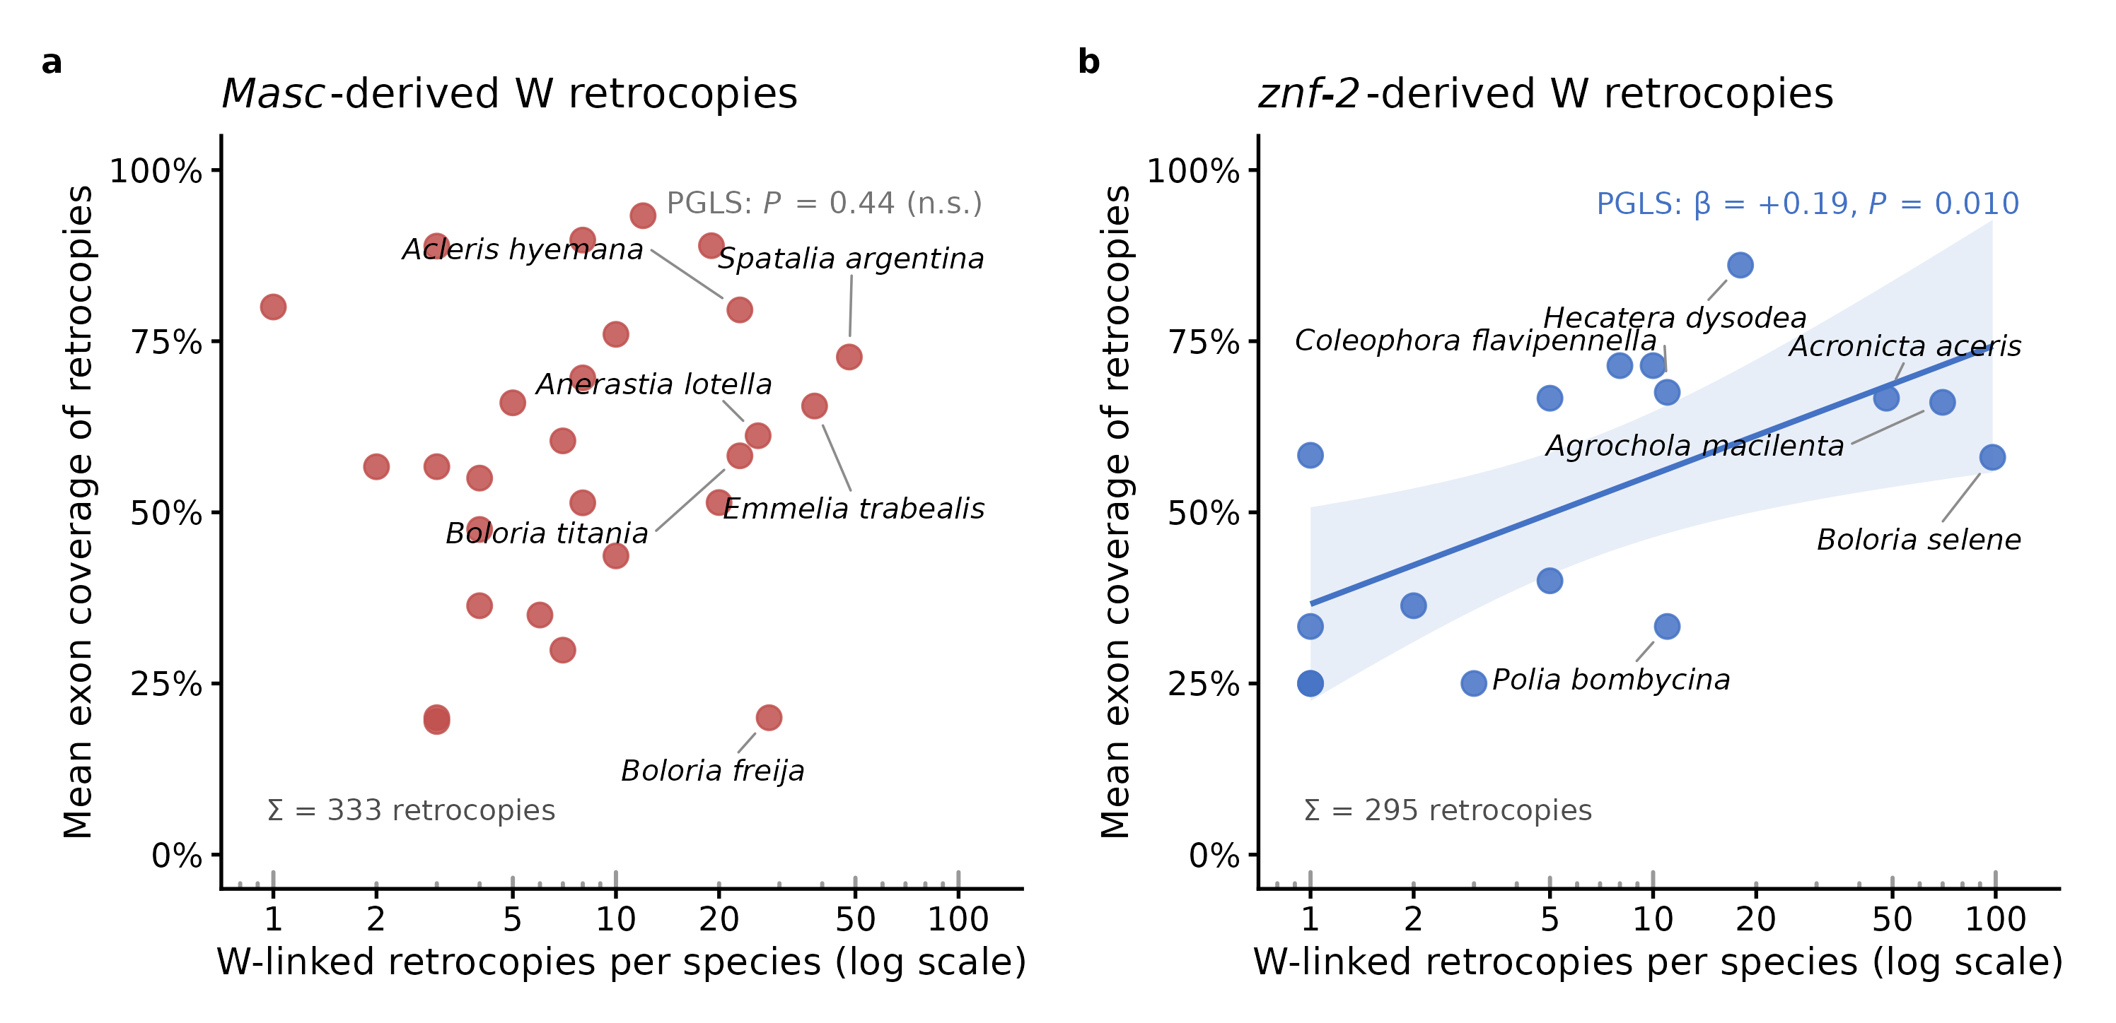
Figure S1. Per-species-gene W-linked intronless-copy counts and exon coverage.
Each point is one species-gene call carrying W-linked intronless copies, plotted separately for (a) Masc-derived and (b) znf-2-derived copies. The x-axis gives the number of W-linked copies (log scale), and the y-axis gives the mean exon coverage. Per-copy genomic coordinates are in Additional file 2 (Dataset S1). Fitted lines and statistics are phylogenetic generalized least squares (PGLS): for (b) znf-2, β = +0.19, P = 0.010, with a shaded 95% confidence band. For (a) Masc the relationship is not significant (P = 0.44).
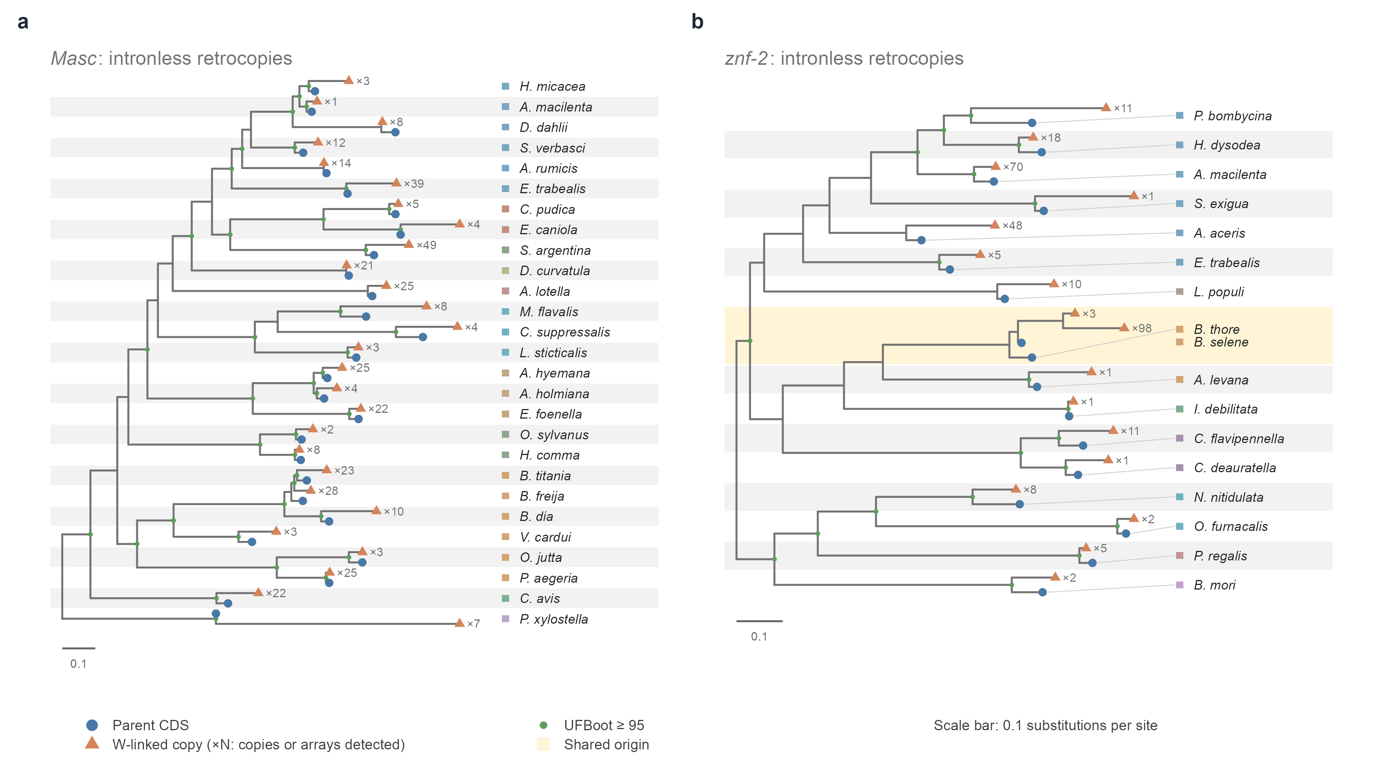
Figure S2. Gene trees of W-linked intronless retrocopies with species labels.
Expanded version of Figure 2a,d. (a) Masc, (b) znf-2. Blue circles, parental coding sequences. Orange triangles, the representative W-linked copy of each species-level cluster, with ×N giving the number of copies in that cluster. Green node circles, ultrafast bootstrap ≥ 95. Amber shading marks a clade shared by two species. These two trees are midpoint-rooted. Tip colours give the family. Scale bar, 0.1 substitutions per site.
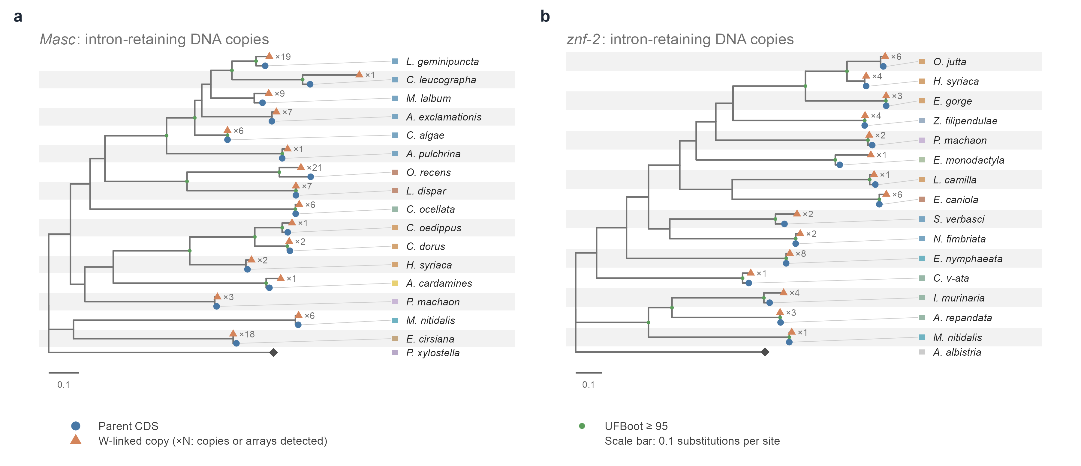
Figure S3. Gene trees of W-linked intron-retaining DNA-level copies with species labels.
Expanded version of Figure 2b,e. (a) Masc, (b) znf-2. Copies were projected onto exon sequence before alignment (Methods). Symbols as in Figure S2, with the outgroup shown as a black diamond. In both trees every species with W-linked copies forms a clade with its own parental sequence.
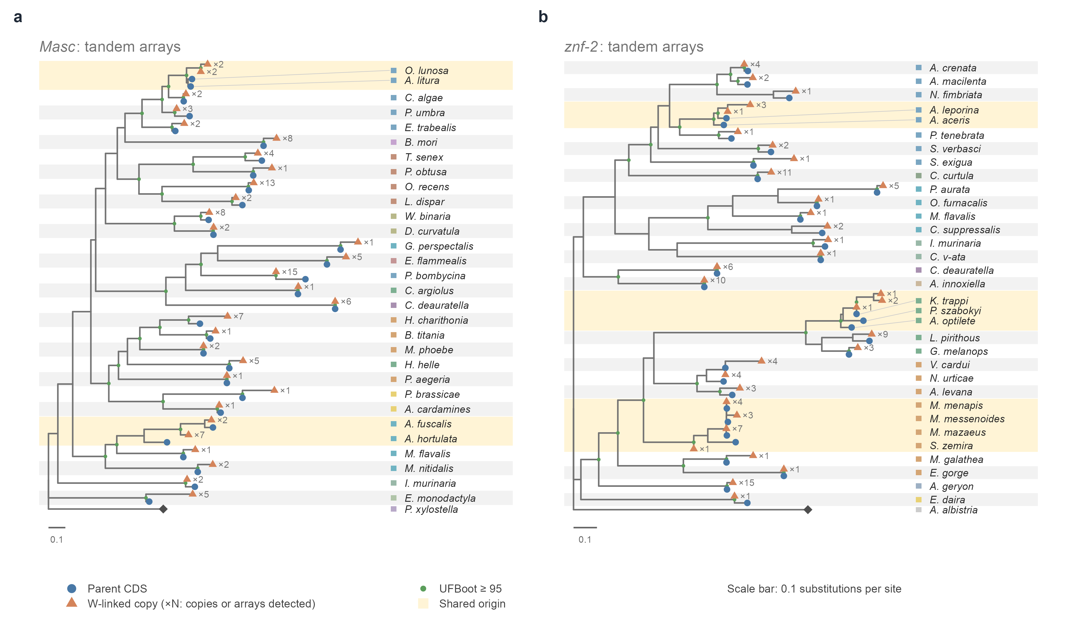
Figure S4. Gene trees of W-linked tandem-array units with species labels.
Expanded version of Figure 2c,f. (a) Masc, (b) znf-2. Array units were extracted with the parameters of the array screen and verified against the parental coding sequence (Methods). Symbols as in Figure S2. Amber shading marks clades shared by two or more species, which correspond to the shared capture events described in the Results.
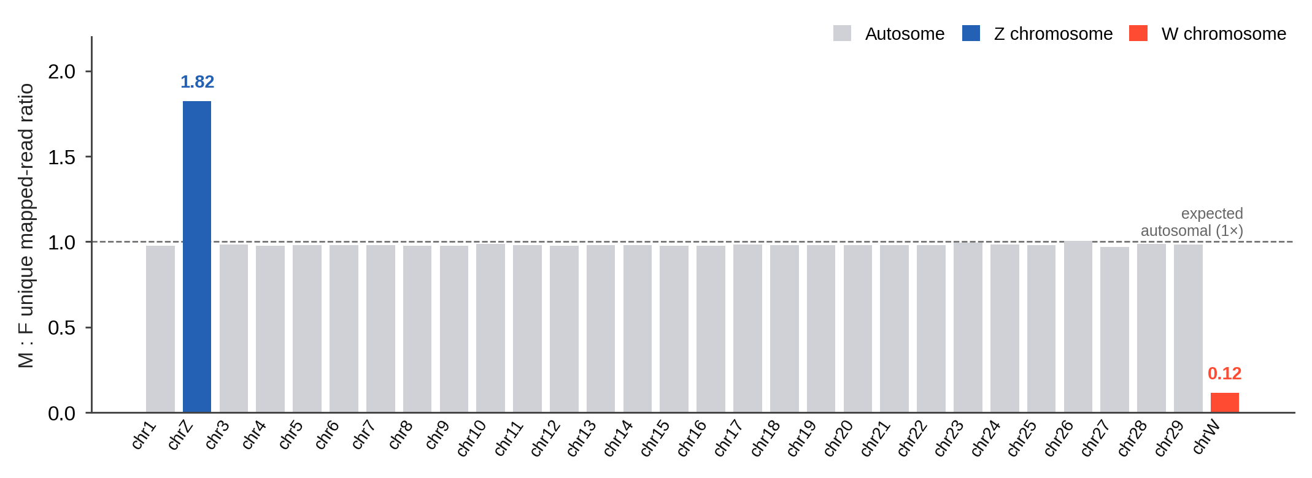
Figure S5. Chromosome quotient analysis identifies the C. suppressalis W chromosome.
Chromosome quotient (CQ) values were calculated as the male-to-female normalized read-depth ratio for each C. suppressalis chromosome. Autosomes cluster near 1.0, the Z chromosome is elevated (CQ = 1.82), and the W chromosome is depleted (CQ = 0.12), supporting W-chromosomal assignment for the assembly used to identify CsFem.
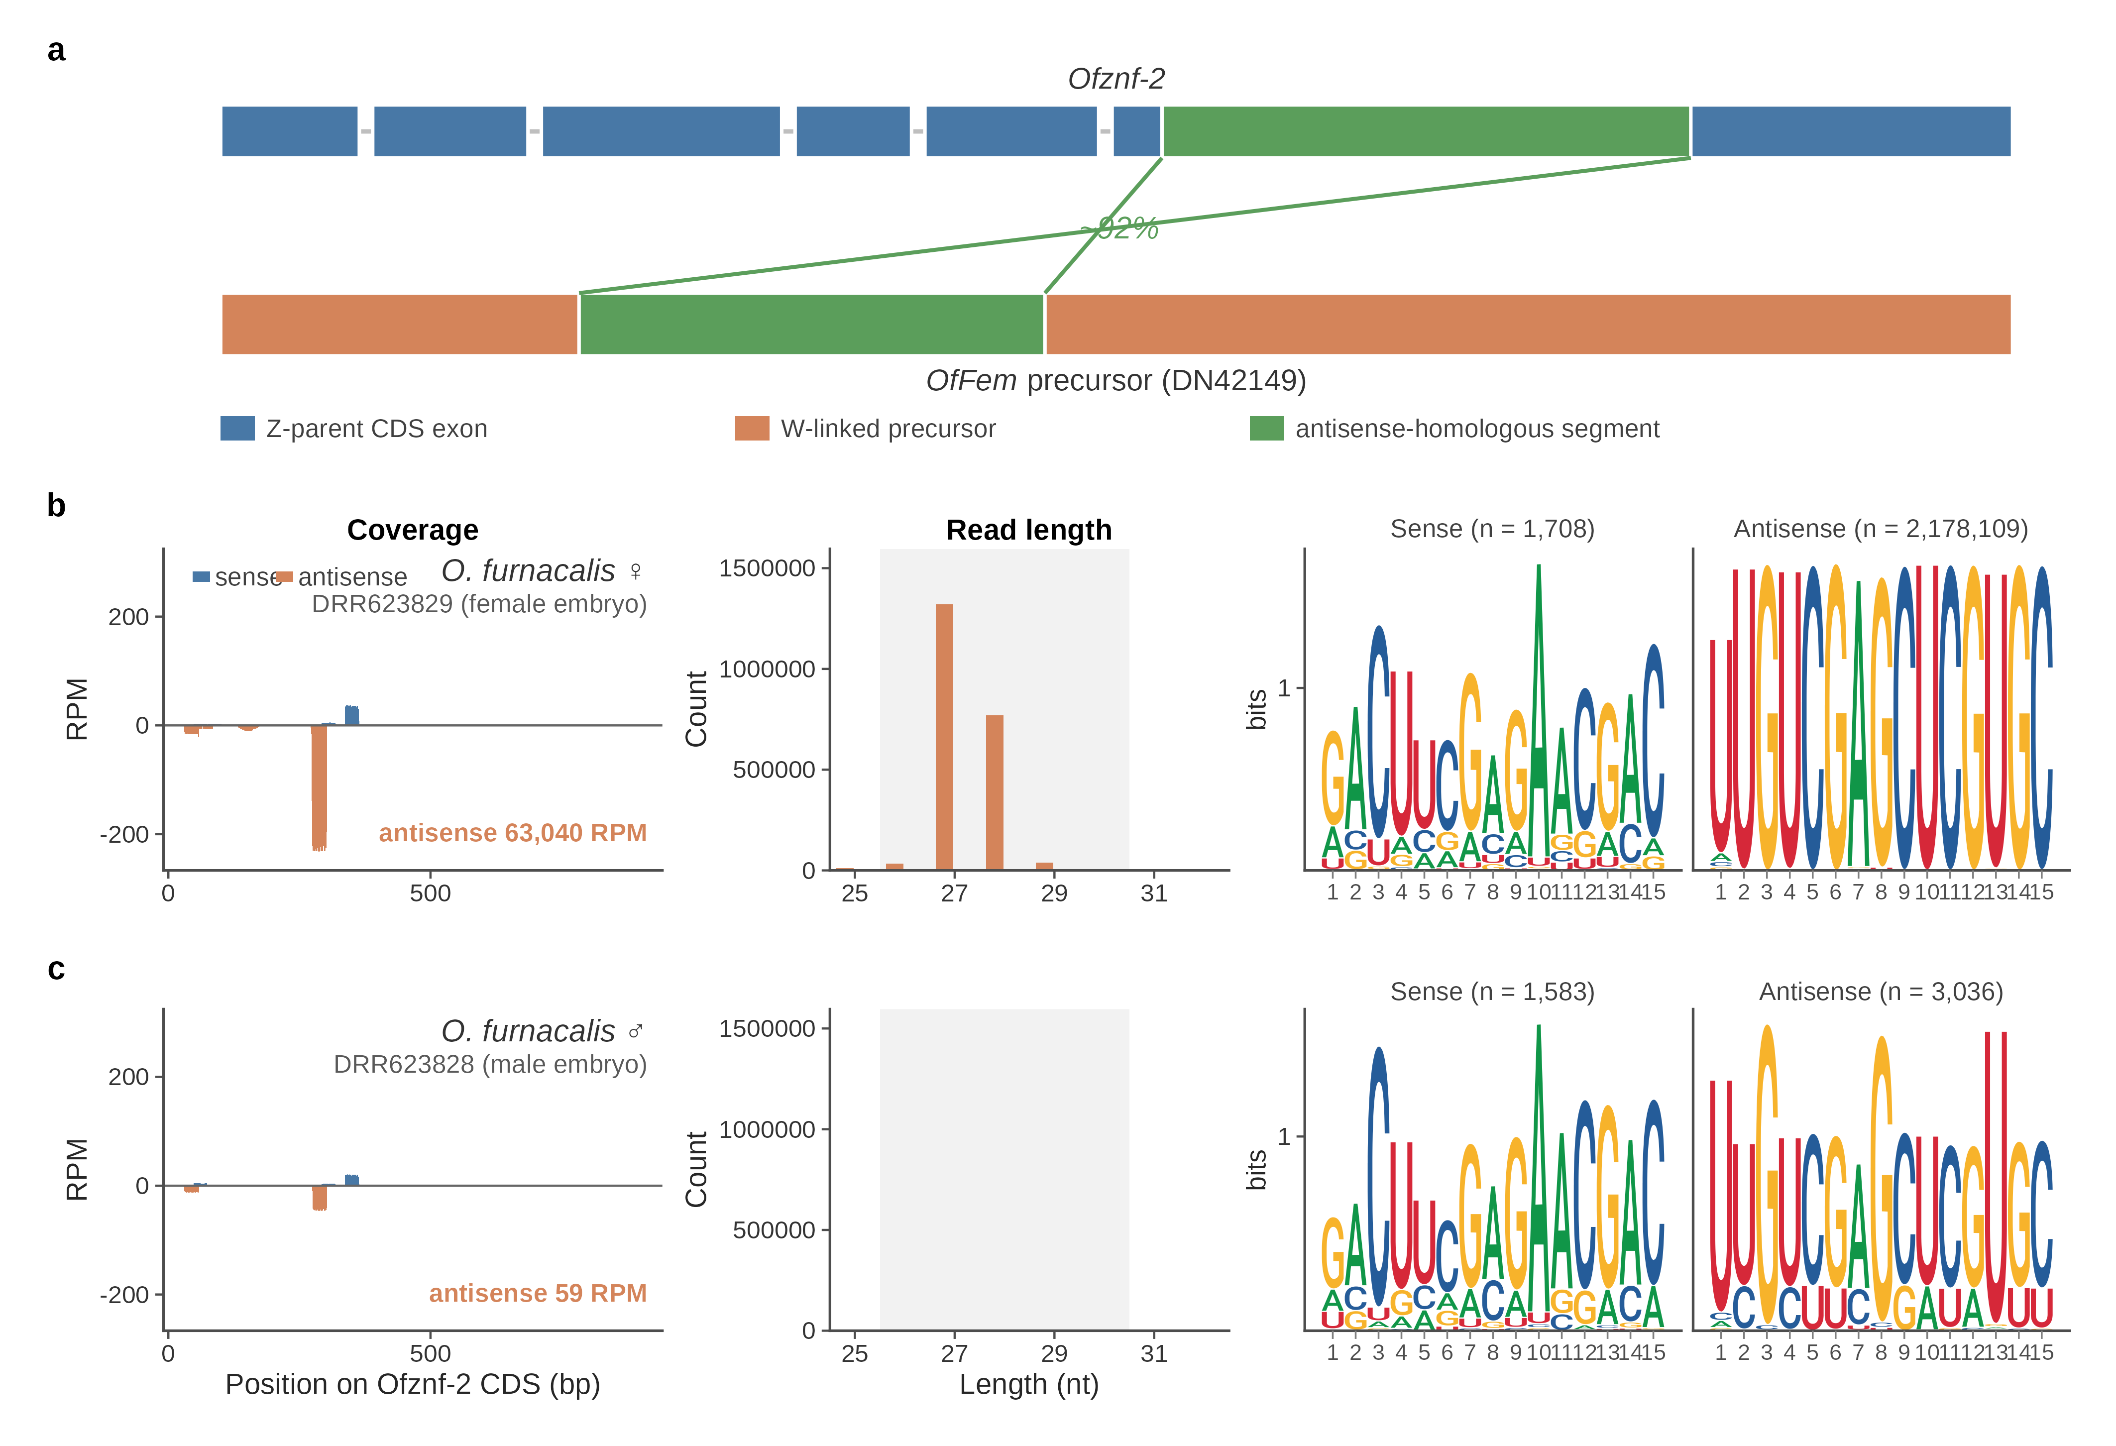
Figure S6. The W-linked OfFem locus produces female-specific antisense piRNAs against Ofznf-2 in Ostrinia furnacalis.
Validation of the piRNA-precursor miner on the previously characterized OfFem locus (public data, NCBI BioProject PRJDB19674, Fukui et al., Nat. Commun. 2026, 17, 104).
(a) Homology of the miner-recovered OfFem precursor transcript (DN42149) to the parental Ofznf-2 coding sequence (gene Ofur01G000050, linkage group 1 (LG1), the Z chromosome, seven exons). The precursor carries a single antisense-homologous block to exon 6 (CDS ~27–313, ~92% identity), shown in green. At the locus, OfFem comprises ~17 tandem repeats (162–197 bp each). The same W chromosome separately carries two Ofznf-2 intronless copies (W1/W2, ~400 kb apart, intron-loss confirmed by splice-aware alignment, not drawn). Ofznf-2 lies on the minus strand, so its exons are numbered in genomic order from the right of the diagram.
(b,c) Strand-resolved piRNA features at the Ofznf-2 CDS in (b) female (DRR623829) and (c) male (DRR623828) embryos, each shown in the three-column Coverage / Read-length / 5′-motif layout of Figure 4c. Antisense piRNAs are overwhelmingly female-biased (~1,070-fold sex bias). Female antisense reads show a 26–31 nt piRNA size mode (27 nt dominant) and a 5′-uridine (1U) bias, with the complementary tenth-position adenine (10A) bias on sense reads. Together these are diagnostic of ping-pong amplification.
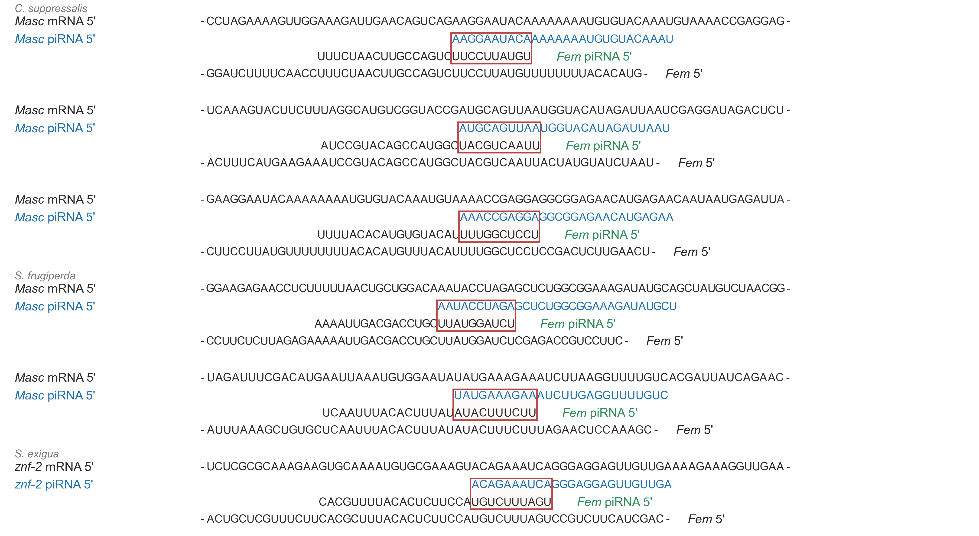
Figure S7. Base-resolution ping-pong loops between masculinizing-gene piRNAs and Fem-precursor piRNAs.
Representative ping-pong pairs at the three piRNA-producing loci, grouped by species: C. suppressalis (CsMasc, three hotspots), S. frugiperda (SfMasc, two hotspots) and S. exigua (Seznf-2, one hotspot). For each hotspot, four aligned sequences are shown top to bottom: the parental masculinizing mRNA (Masc or znf-2), the sense piRNA derived from the masculinizing gene (blue), the antisense Fem piRNA (labelled in green), and the Fem precursor. The red box marks the 10-nt ping-pong overlap shared by the sense and antisense piRNA 5′ ends, sense piRNAs carry a tenth-position adenine (10A) bias and antisense piRNAs a 5′-uridine (1U) bias, quantified in Figure 4c. Ping-pong pairs were defined as sense and antisense 5′ ends offset by 10 nt with reciprocal 10-nt seed complementarity, on 25–32 nt reads (Methods). Plotted hotspots are dominant representatives selected per species-target (≤ 3 per locus, supported by ≥ 2 independent pairs, both 10A and 1U present, precursor match exact or ≤ 1 mismatch), the complete candidate list is available from the corresponding authors on request.
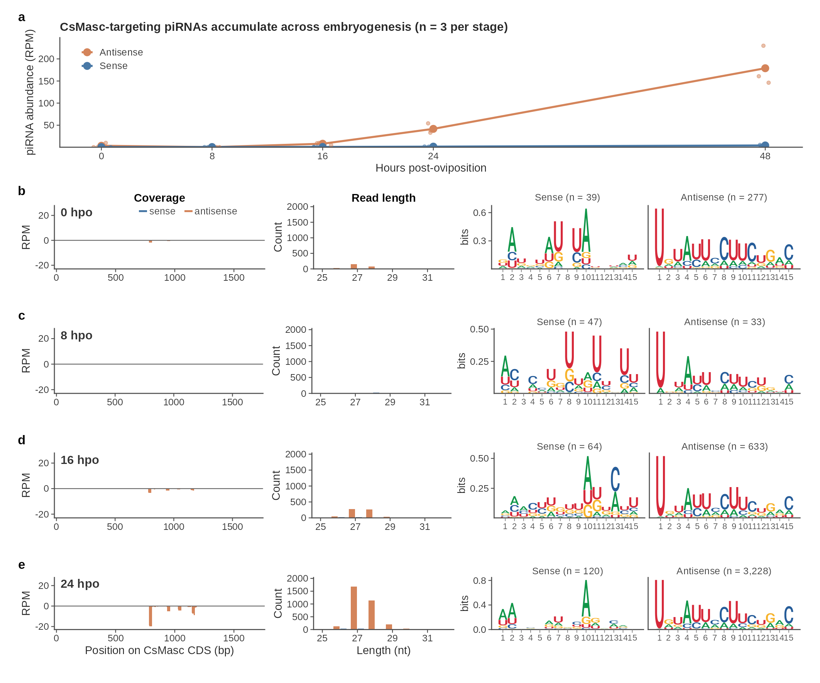
Figure S8. Zygotic accumulation of CsMasc-targeting antisense piRNAs across C. suppressalis embryogenesis.
Strand-resolved small-RNA profiling of pooled C. suppressalis embryo libraries at 0, 8, 16, 24 and 48 hpo, mapped to the CsMasc CDS.
(a) Locus-level piRNA abundance versus developmental time, across 0, 8, 16, 24 and 48 hpo. Points show replicate-level antisense RPM, the line shows the stage mean, which rises from 3.6 at 0 hpo to 179 at 48 hpo.
(b–e) Per-stage piRNA features at 0, 8, 16 and 24 hpo in the three-column layout of Figure 4c (Coverage / Read length / 5′ sequence-motif logo, sense blue and positive y, antisense orange and negative y). From 16 hpo onward the antisense population shows canonical piRNA features: a 26–30 nt size mode, a 5′-uridine (1U) bias, and antisense-strand dominance (antisense:sense ~42:1 at 48 hpo).
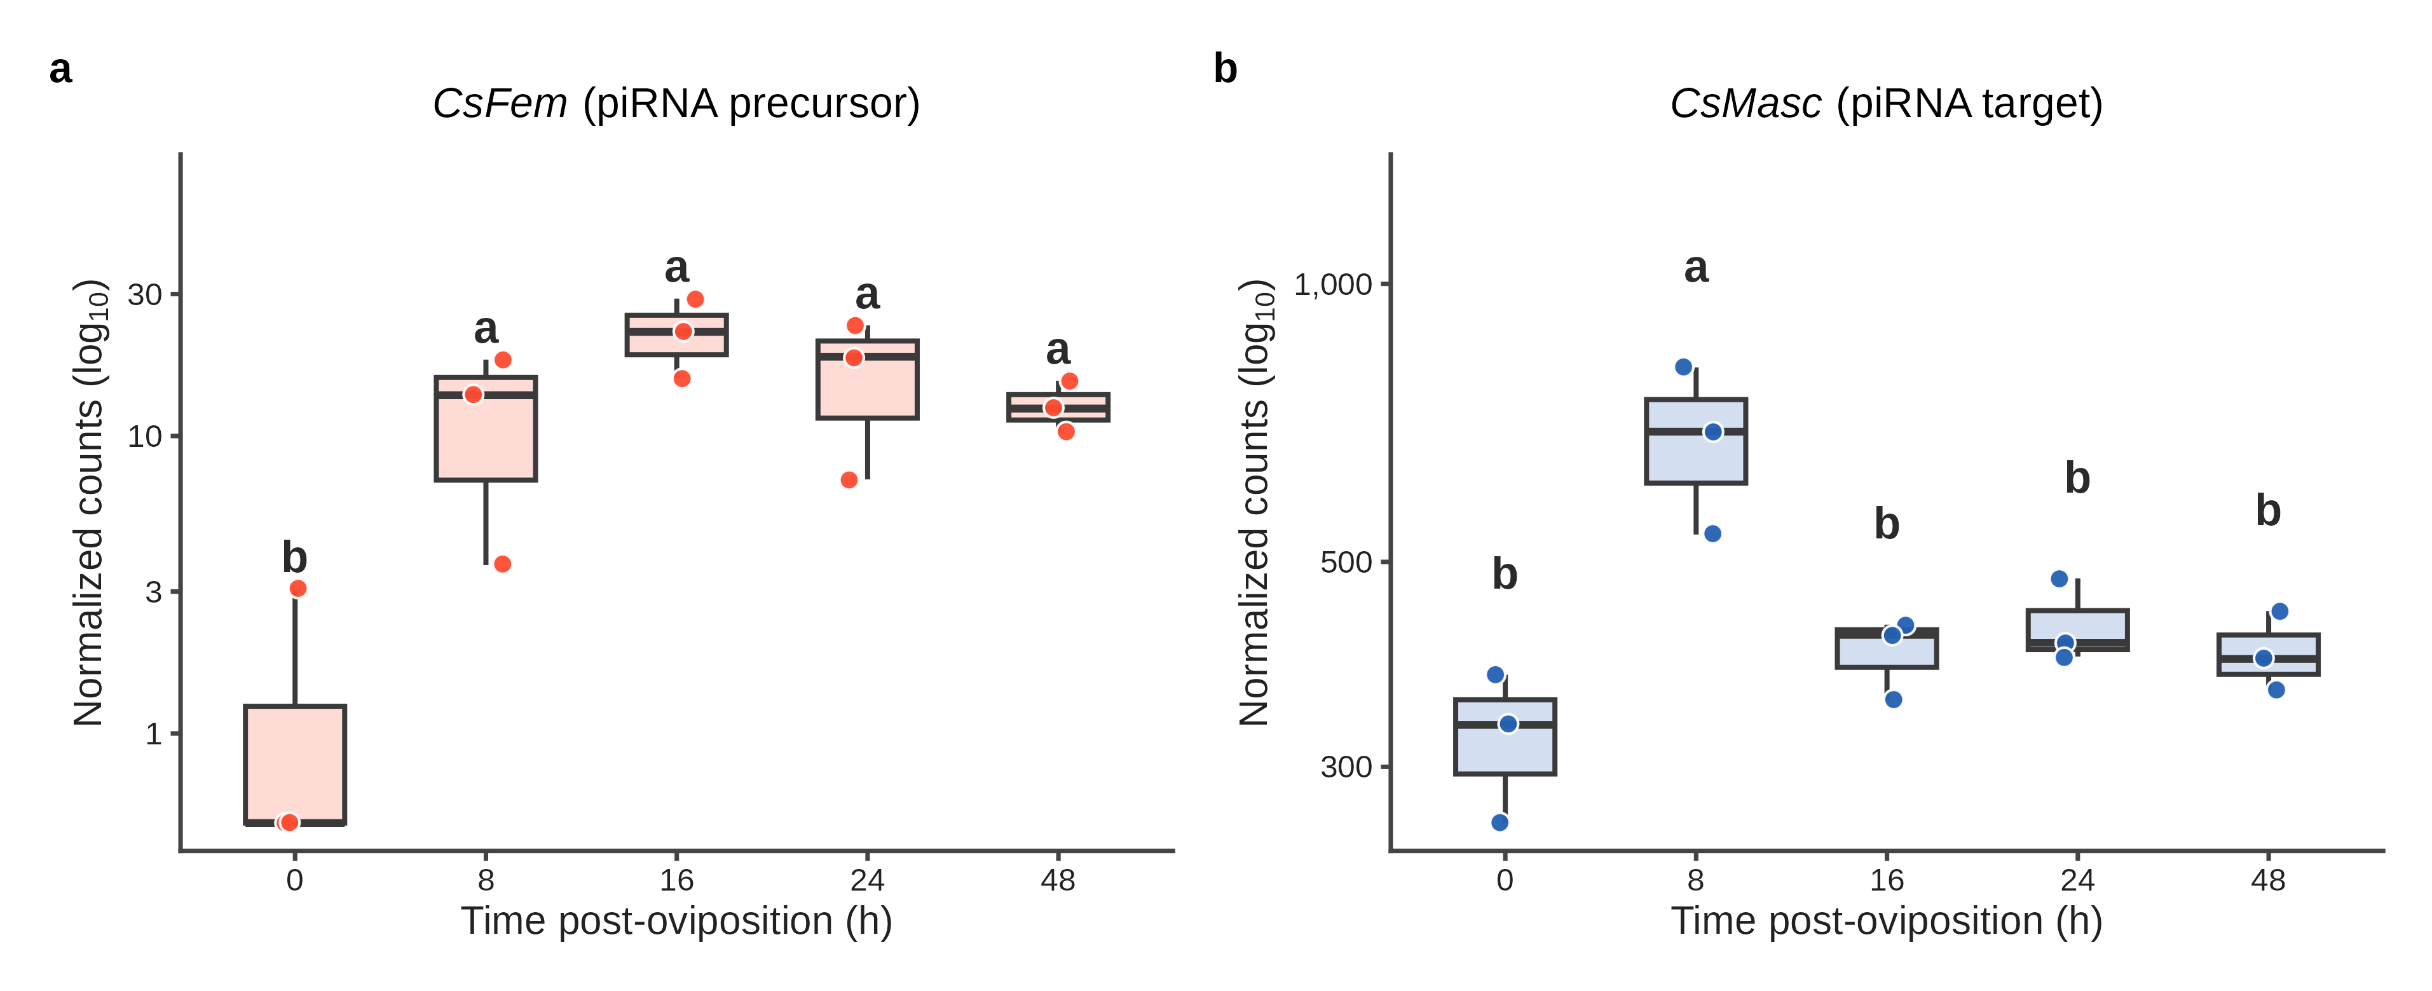
Figure S9. CsFem precursor accumulates across the sex-determination window.
Bulk mRNA-seq of triplicate pooled C. suppressalis embryo libraries at 0, 8, 16, 24 and 48 hpo, quantified against a de novo Trinity assembly with Salmon.
(a) CsFem, the W-linked piRNA precursor, and (b) CsMasc, its Z-linked silencing target, per sample, Salmon counts were summed over the BLAST-confirmed isoforms of each, and the y axis shows DESeq2-normalized counts (log₁₀). Points are individual libraries, boxes show median and interquartile range. Letters are a compact letter display from a negative-binomial GLM (MASS::glm.nb) with a TMM library-size offset, with all-pairwise comparisons among stages multiplicity-adjusted (emmeans): stages not sharing a letter differ at P < 0.05. CsFem is low at 0 hpo and elevated at every later stage, CsMasc differs only at a transient 8 hpo peak. DESeq2 and edgeR are concordant.
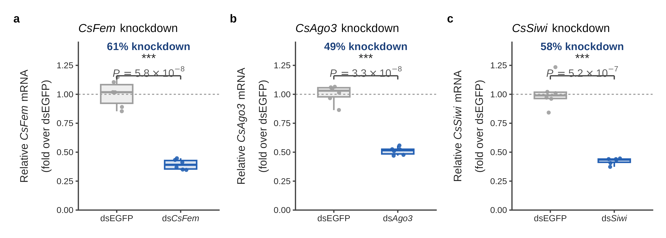
Figure S10. dsRNA knockdown efficiency for the C. suppressalis RNAi experiments.
Relative transcript levels of the targeted genes in genetic-female embryos 48 h after injection of (a) dsCsFem, (b) dsAgo3 or (c) dsSiwi, each versus dsEGFP, by qRT-PCR (n = 6 individual embryos per group, two technical replicates each). Relative expression was computed by the 2^{−ΔΔCt} method against the geometric mean of CsUbc and CsRpl32 and calibrated to dsEGFP. Each dsRNA reduced its target by 49–61% (CsFem 61%, CsAgo3 49%, CsSiwi 58%, Welch’s two-sided t-test on ΔCt, P = 5.8 × 10⁻⁸, 3.3 × 10⁻⁸ and 5.2 × 10⁻⁷, respectively). Boxes show median and interquartile range, points are individual embryos. Asterisks denote P < 0.001.
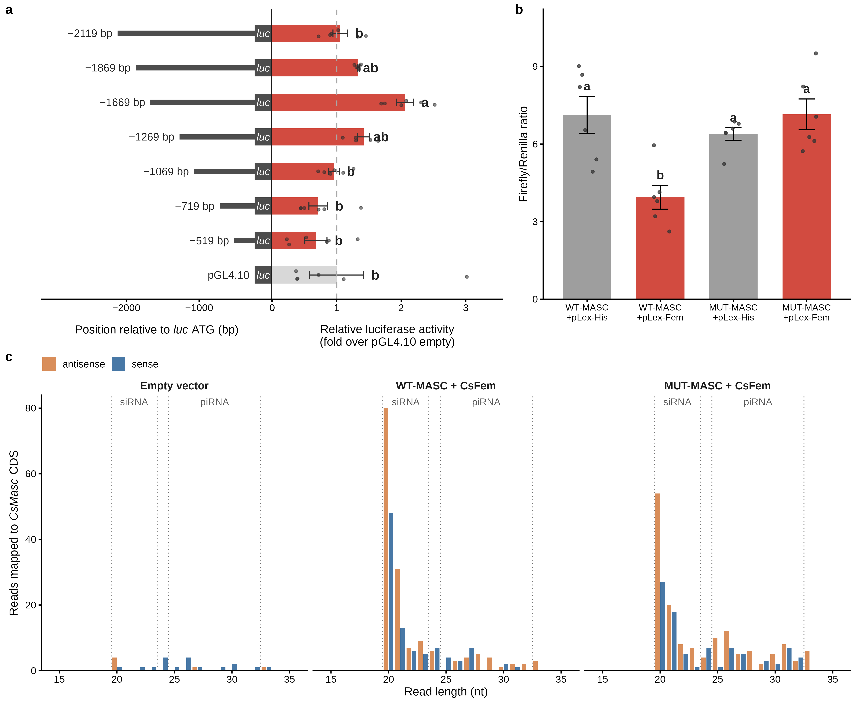
Figure S11. CsFem silencing mechanism and promoter analysis in Sf9 cells.
(a) Promoter truncation analysis. Left, deletion-ladder schematic of CsFem upstream truncations (−2,119 to −519 bp relative to the luc ATG) driving a luciferase reporter, right, relative luciferase activity as fold over the pGL4.10 empty-vector backbone (dashed line, empty-vector level = 1). Bars, mean ± SEM, points, individual replicates (n = 6 per construct). Bars not sharing a letter differ significantly (Tukey HSD, P < 0.05), only the −1,669 bp construct (a) rises above the empty vector and most truncations (b), with the −1,269 and −1,869 bp constructs intermediate (ab), indicating no coherent promoter-truncation pattern.
(b) Dual-luciferase reporter assay. Relative Firefly/Renilla luciferase ratios across four conditions (n = 6 replicates, bars, mean ± SEM): WT-Masc + pLex-His (7.13 ± 0.71), WT-Masc + pLex-Fem (3.94 ± 0.46, 44.7% reduction), MUT-Masc + pLex-His (6.39 ± 0.24) and MUT-Masc + pLex-Fem (7.15 ± 0.59). Bars not sharing a letter differ significantly (Tukey HSD, P < 0.05): WT-Masc + pLex-Fem (b) is reduced relative to WT-Masc + pLex-His (a), whereas the four-site mutant is unaffected (MUT-Masc + pLex-His and MUT-Masc + pLex-Fem both a, key contrast WT-Masc + pLex-Fem vs WT-Masc + pLex-His, adjusted P = 0.0021). The MUT-Masc construct carries point mutations at all four predicted piRNA target sites.
(c) Small-RNA read-length distribution of reads mapping to the CsMasc CDS across three sequenced transfection pools: empty vector, WT-Masc + pLex-Fem, and MUT-Masc + pLex-Fem. Antisense (orange) and sense (blue) reads are dodged, the 20–21 nt siRNA and 25–32 nt piRNA windows are marked. WT-Masc + pLex-Fem yielded reads sharply peaked at 20–21 nt within the siRNA range, with only a handful in the canonical piRNA window (25–32 nt). In this heterologous Sf9 assay, CsFem-associated silencing therefore produced siRNA-sized rather than piRNA-sized small RNAs.
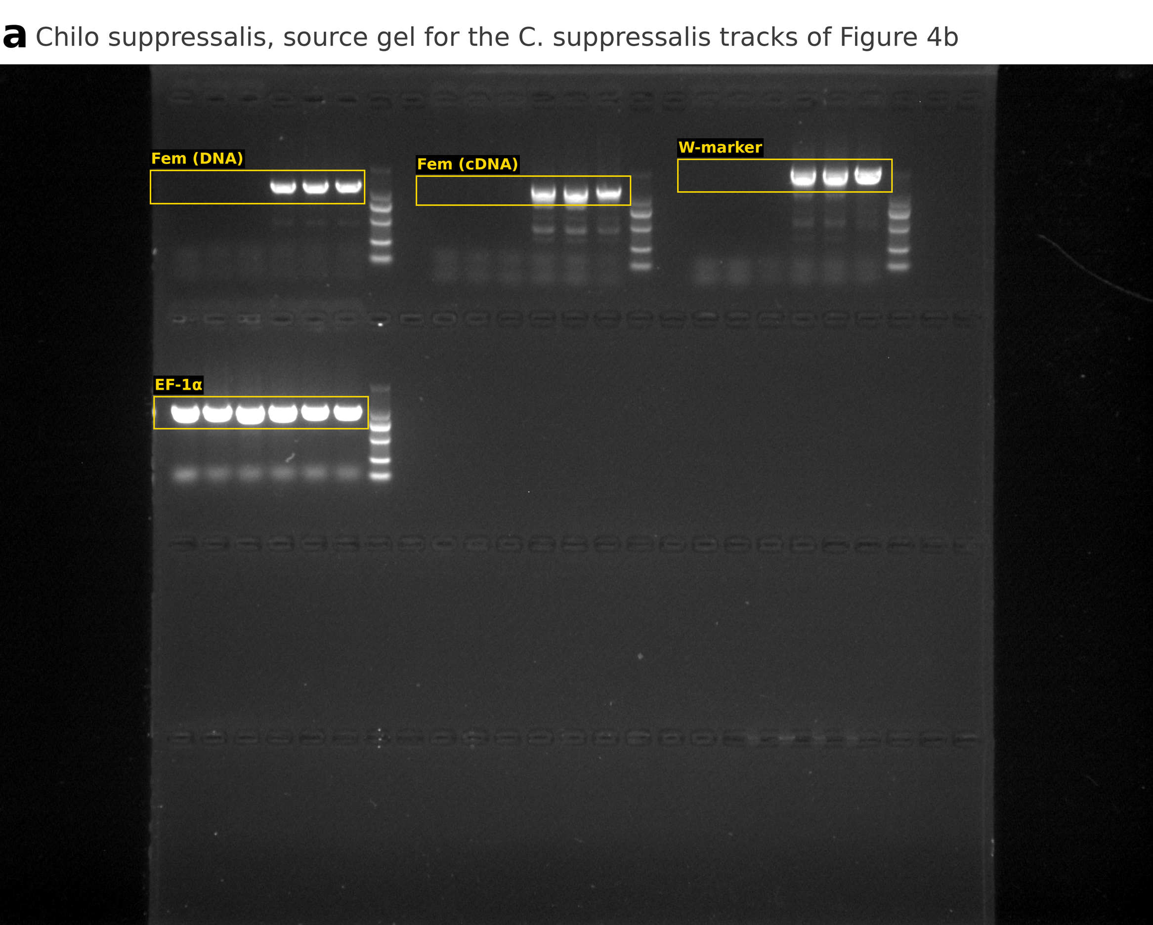
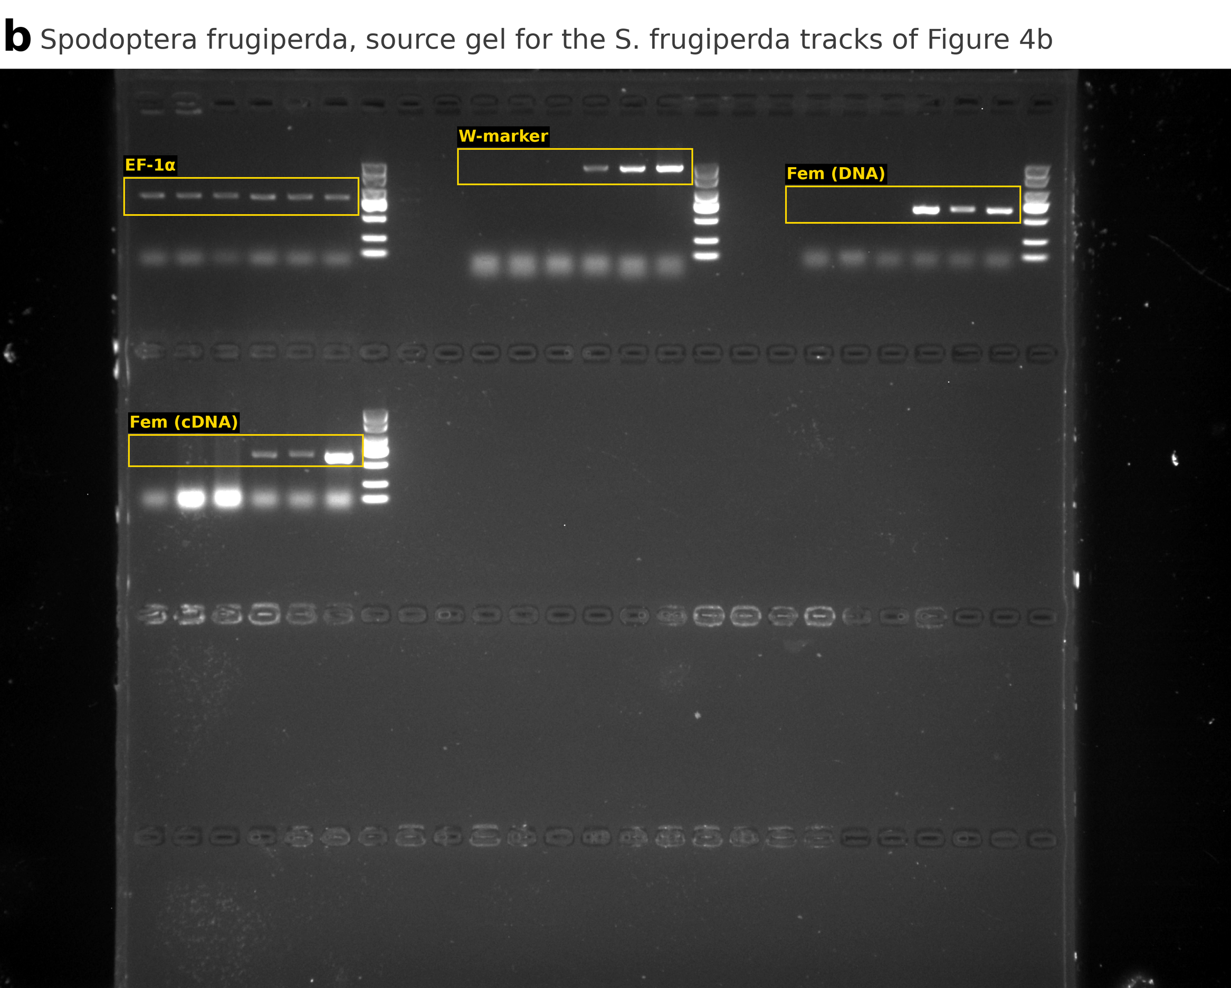
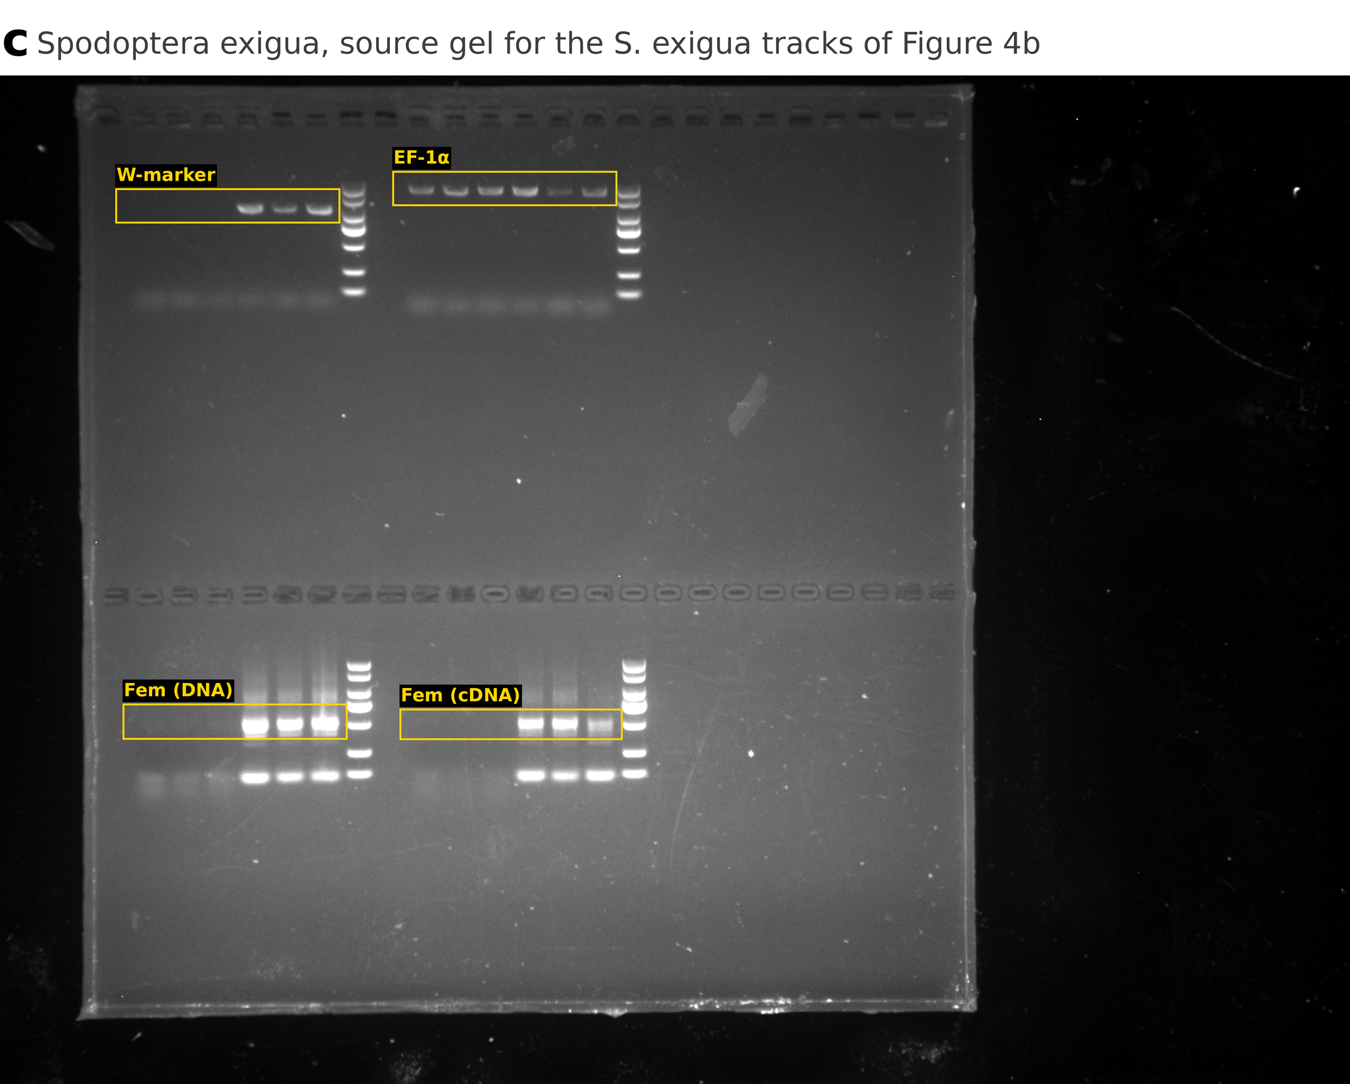
Figure S12. Uncropped source gels for Figure 4b.
Full images of the agarose gels used for the W-linkage and transcription validation in Figure 4b. (a) Chilo suppressalis. (b) Spodoptera frugiperda. (c) Spodoptera exigua. Yellow boxes mark the regions reproduced in Figure 4b, labelled by track. Within each species all four tracks derive from a single gel. Brightness and contrast were adjusted linearly across each whole image, with no local adjustment, gamma correction or lane rearrangement.
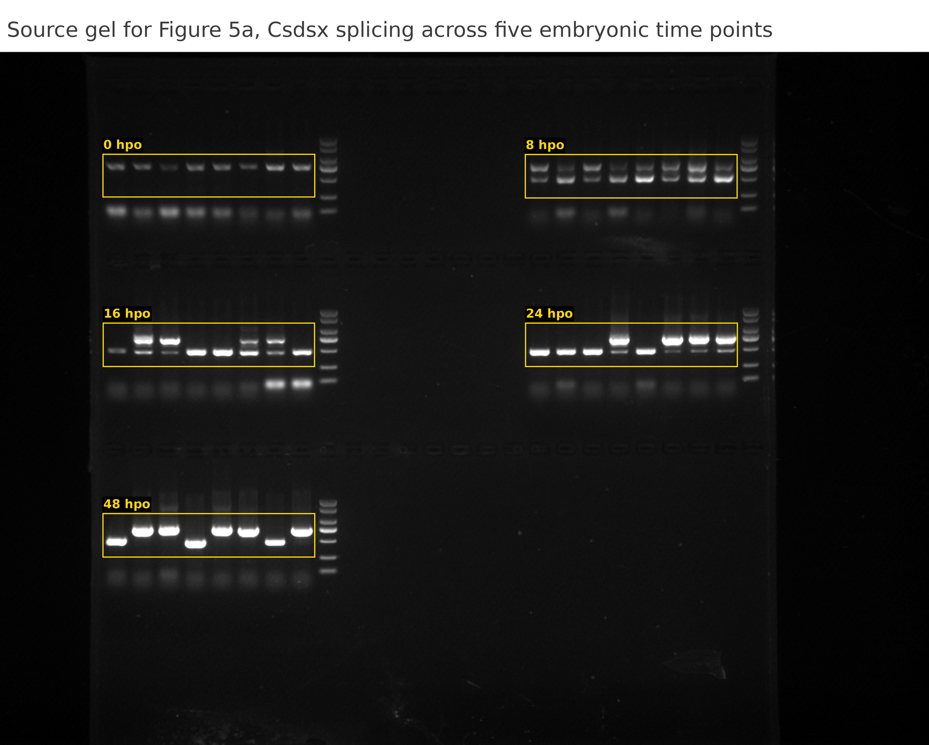
Figure S13. Uncropped source gel for Figure 5a.
Full image of the agarose gel used for the Csdsx splicing time course in Figure 5a. Yellow boxes mark the regions reproduced in Figure 5a, labelled by time point. All five time points derive from a single gel. Brightness and contrast were adjusted linearly across the whole image, with no local adjustment, gamma correction or lane rearrangement.
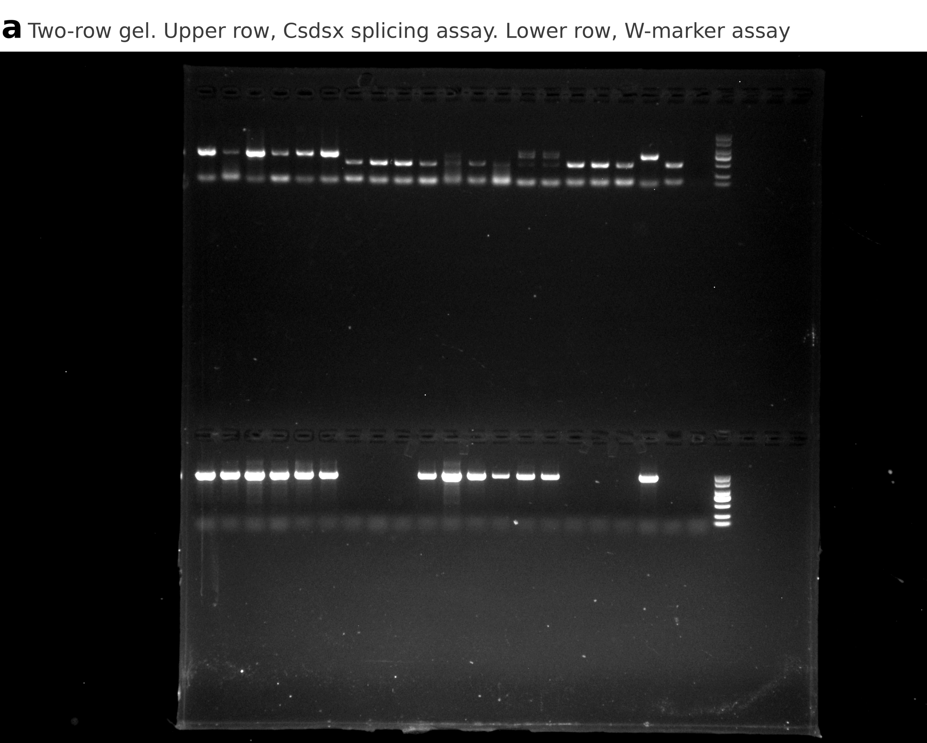
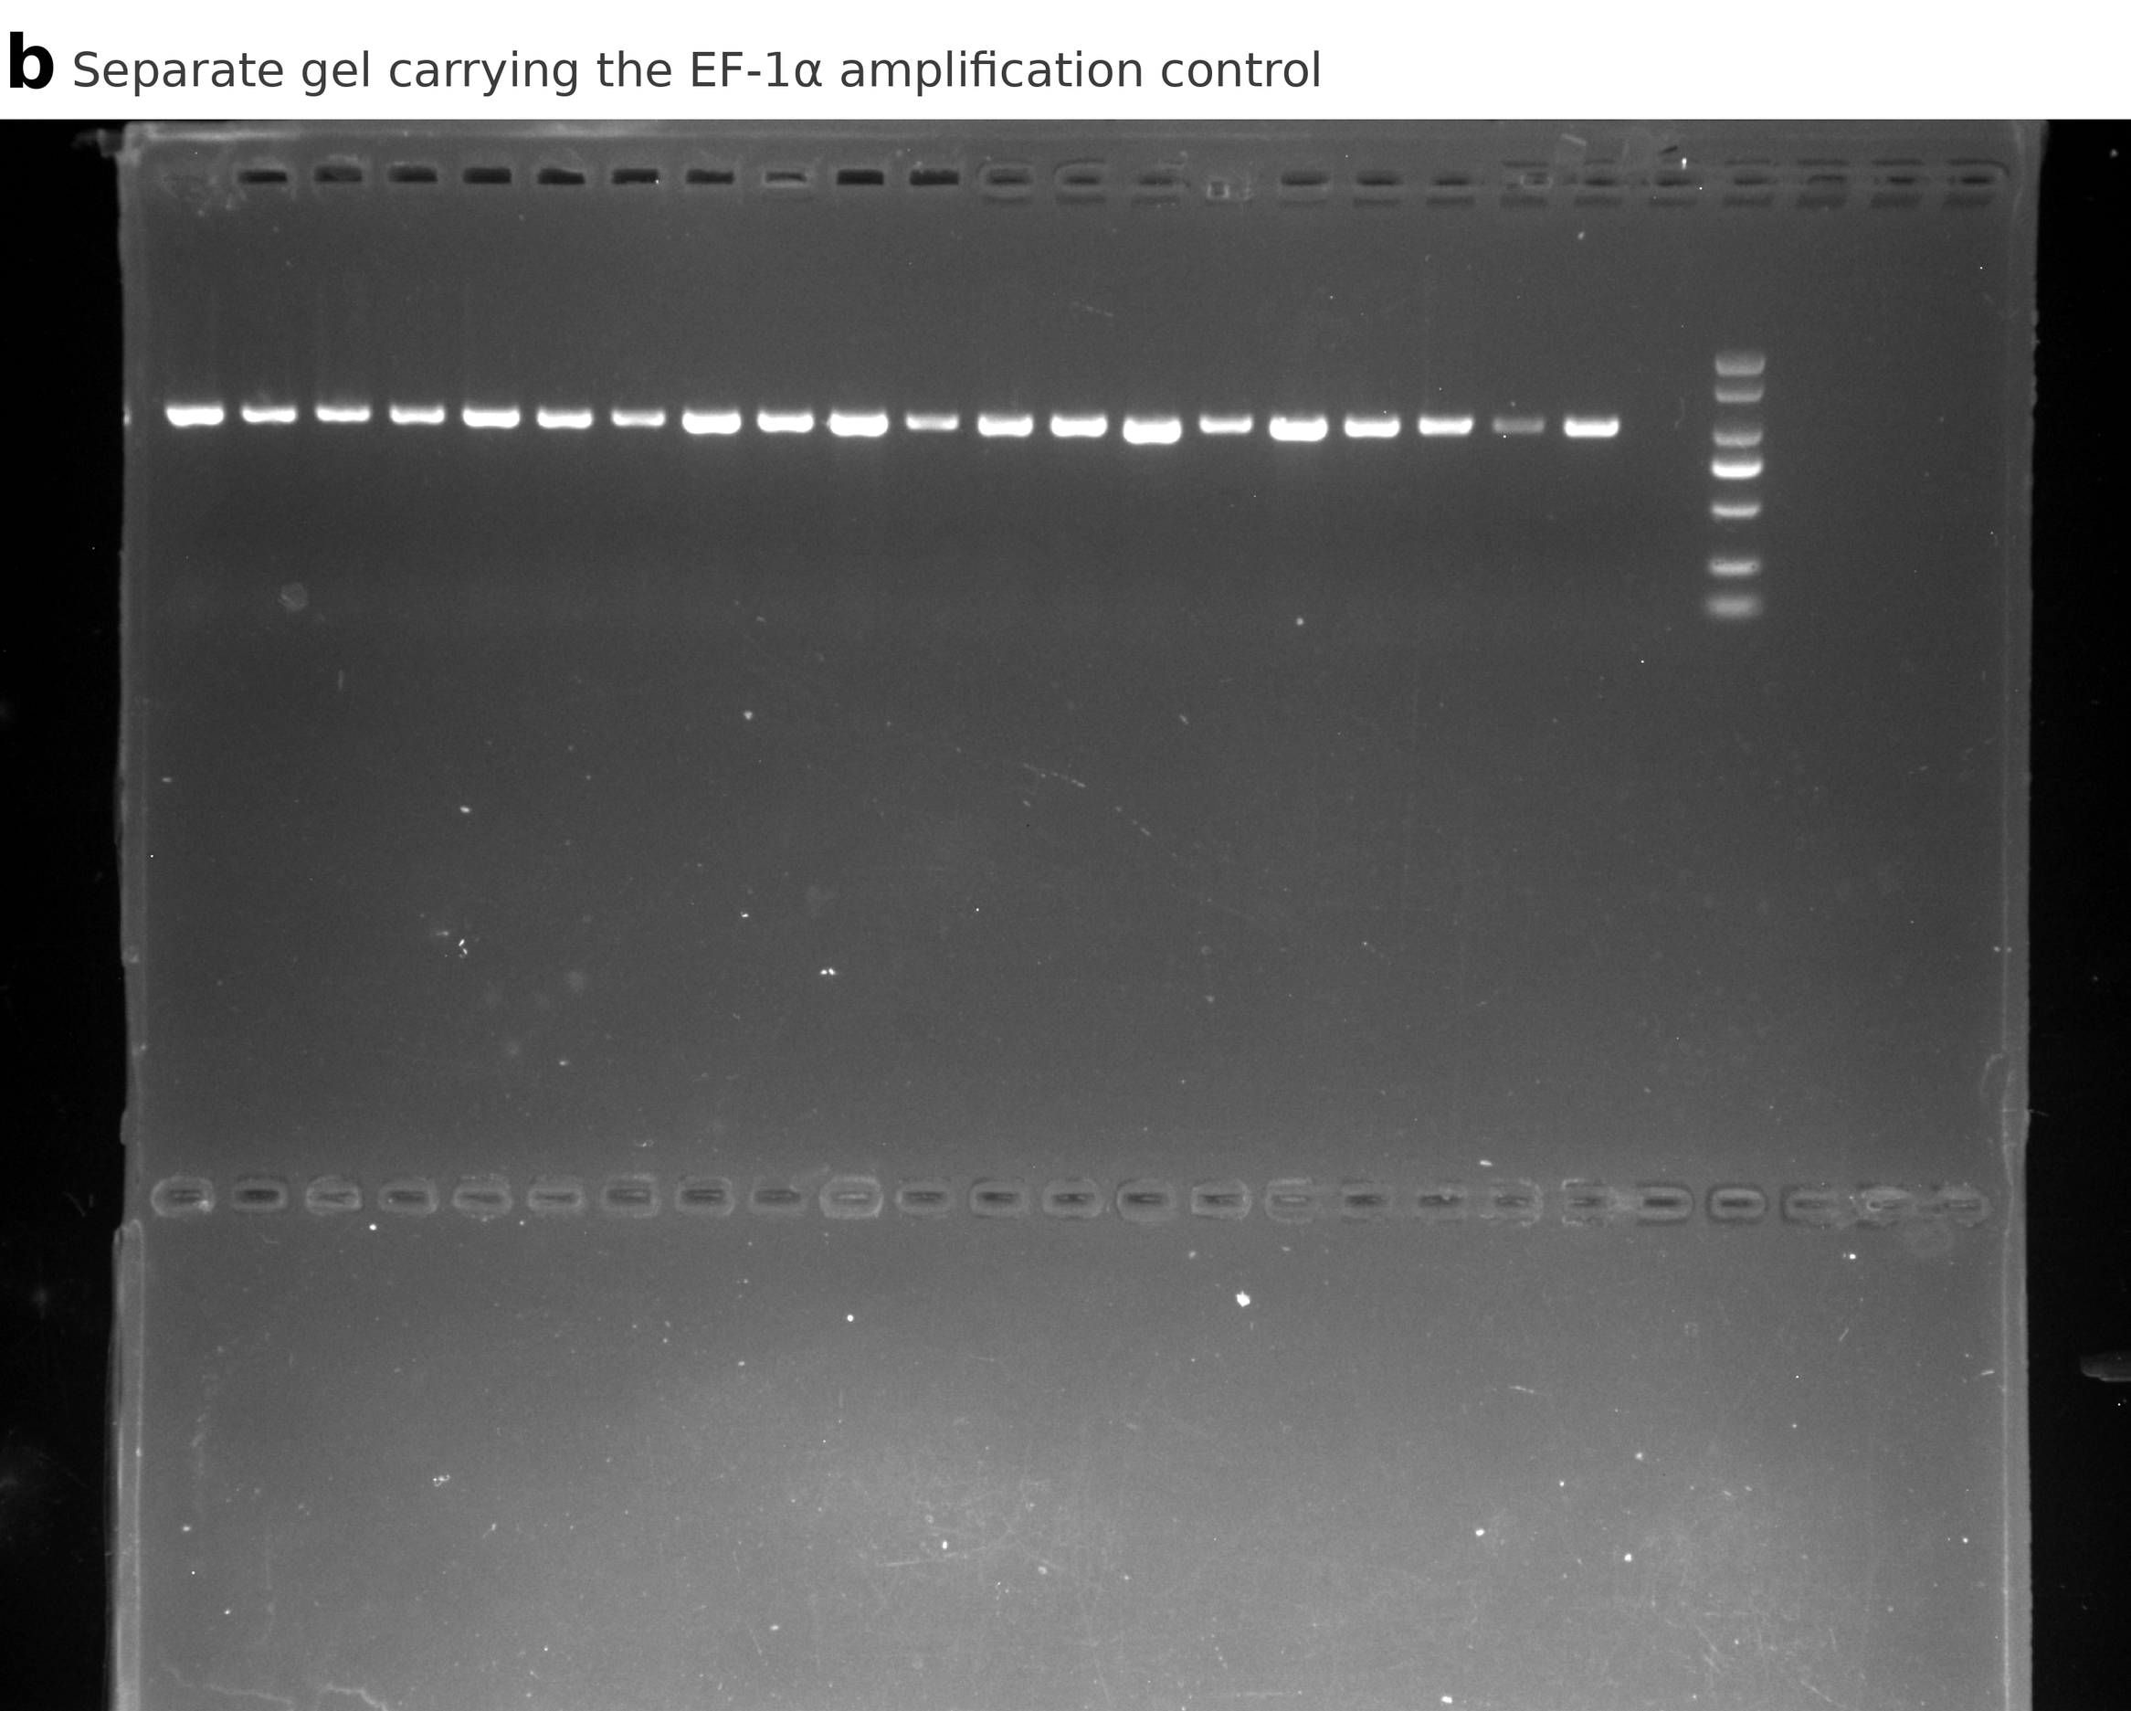
Figure S14. Uncropped source gels for Figure 6b.
Full images of the two gels used for Figure 6b. (a) Two-row gel. The upper row carries the Csdsx splicing assay and the lower row carries the W-marker assay. The Csdsx track of Figure 6b was recorded from this gel at a longer exposure. (b) Separate gel carrying the EF-1α amplification control. Within each track all lanes are contiguous on the source gel and appear in their original order, and the vertical rules in Figure 6b separate treatment groups. Brightness and contrast were adjusted linearly across each whole image, with no local adjustment, gamma correction or lane rearrangement.

Legends for Additional files 2 to 5

Additional file 2 (Dataset S1). Genome-screening calls, W-linked copy coordinates and W-assembly metrics.
This workbook contains five data sheets: S1a_screening_calls, per-species screening calls for W-linked Masc/znf-2 copies across the 266 assemblies, including the three structural classes (intronless retrocopy, intron-retaining DNA-level copy and tandem array) and union membership. S1b_retrocopy_coords, per-copy coordinates for W-linked retrocopies. S1c_DNA_copy_coords, per-copy coordinates for intron-retaining DNA-level W-linked copies. S1d_W_assembly_metrics, per-species W/Z/autosome assembly metrics. S1e_tandem_array_criteria, per-candidate tandem-array screening criteria.

Additional file 3 (Dataset S2). Target specificity and mismatch-sensitivity analysis.
This table summarizes Masc and znf-2 small-RNA target recovery, precursor assignment and BWA mismatch-setting sensitivity for the four profiled pest species.

Additional file 4 (Dataset S3). Primers, guide RNAs and dsRNA-template oligonucleotides.
This table lists PCR, RT-PCR, qRT-PCR, dsRNA and CRISPR guide sequences, with target, assay purpose and specificity-check information.

Additional file 5 (Dataset S4). W-copy transcription screen across 61 species.
W-copy transcription screen across all 61 species assessed, comprising the 37 candidate species shown in Figure 3 and 24 further screened species. For each species the dataset gives the W-copy gene (Masc, znf-2 or both), structural form, transcription call and evidence tier, the sex of the screened public library, and the public sequencing accession(s) used, the screening run and, where applicable, the female and male sex-control arms, with source study. Of the 24 further species, 23 yielded no W-array transcript and one (G. perspectalis) was assessable only on a male library and is marked not assessable, so transcription was detected in 12/61 species across the full set (20%). This screened cohort spans W-copy candidates across all structural forms, including tandem-array candidates that fell below the final structural-screen threshold. A few screened species are therefore not among the 106 W-positive species, and this transcription-screen set of 61 is not the same set as the 61 species with a confirmed tandem array.

