Reality-anchored generative gating enables robust morphological classification and metacognitive triage of leukemia
Shah Faisal^{1, #}, Hui Zhao^{2, #}, Zhangyue Wu¹, Shiqing Zhang¹, Jia Liu⁴, Yi Zou¹, Yi Ye³, Ziyan Zhang¹, Zhihui Huang¹, Kaiwen Yang¹, Meishi Wu¹, Qingyun Ye¹, Wenxuan Ye¹, Yizhe Wang¹, Abdulkadir Zaheer Abdulkadir¹, Jiarong Lian¹, Gengwen Chen^{3,} *, and Zhigang Yang^{1,} *
¹ Key Laboratory of Optoelectronic Devices and Systems of Ministry of Education and Guangdong Province, College of Physics and Optoelectronic Engineering, Shenzhen University, Shenzhen, 518060, China
² Department of Hematology, South China Hospital, Medical school, Shenzhen University, Shenzhen, 518116, China
³Hematology Product Development Department, Shenzhen Mindray Bio-Medical Electronics Co. Ltd., Shenzhen, Guangdong 518055, China
⁴Department of Laboratory Medicine, Jiangxi Maternal and Child Health Hospital, Nanchang, 330108, China
#These authors contributed equally to this work.
*Corresponding Email: chengengwen@mindray.com; zhgyang@szu.edu.cn

- Sample Collection, Staining, and Image Acquisition
Supplementary Note 1: Extended Clinical and Data Acquisition Protocols
Sample Collection and Preparation
This prospective study was conducted under the ethical approval of the Institutional Review Board of South China Hospital, Shenzhen, adhering to the principles of the Declaration of Helsinki¹. Written informed consent was obtained from all participants. Venous blood samples, (approximately 2 mL), were collected into EDTA-K₂ anticoagulant tubes (1.5–2.2 mg/mL) and processed strictly within four hours of acquisition to prevent morphological degradation. Peripheral blood smears were prepared using a standardized thin-film methodology² and subjected to immediate air-drying to mitigate artifactual distortion prior to staining.
Staining and Optical Standardization
Cellular visualization was achieved utilizing a standardized Wright-Giemsa protocol² (Zhuhai Baisuo, China). To ensure optimal chromosomal and cytoplasmic differentiation, a critical prerequisite for downstream computational analysis, peripheral smears were incubated for 10–15 minutes, while bone marrow preparations underwent an extended 30-minute reaction period utilizing a pH 6.8 phosphate buffer.
Digital image acquisition was executed using a Leica DM750 biological microscope equipped with a 100×10 oil immersion objective. To guarantee longitudinal consistency for the deep learning pipeline, image capture was localized within a standardized optical environment managed by the Beion V4.90 professional medical imaging system. The microscope diaphragm and exposure parameters were rigidly calibrated against baseline staining intensity to ensure uniform chromatic fidelity across all samples (Supplementary Figure S1). Multiple non-overlapping microscopic fields were recorded per slide to capture a representative distribution of the leukocyte population. All microscopic scans were exported into high-resolution PNG format, explicitly preserving the high-frequency structural details such as complex nuclear contours, chromatin density, and delicate cytoplasmic granularity required for robust latent space encoding.
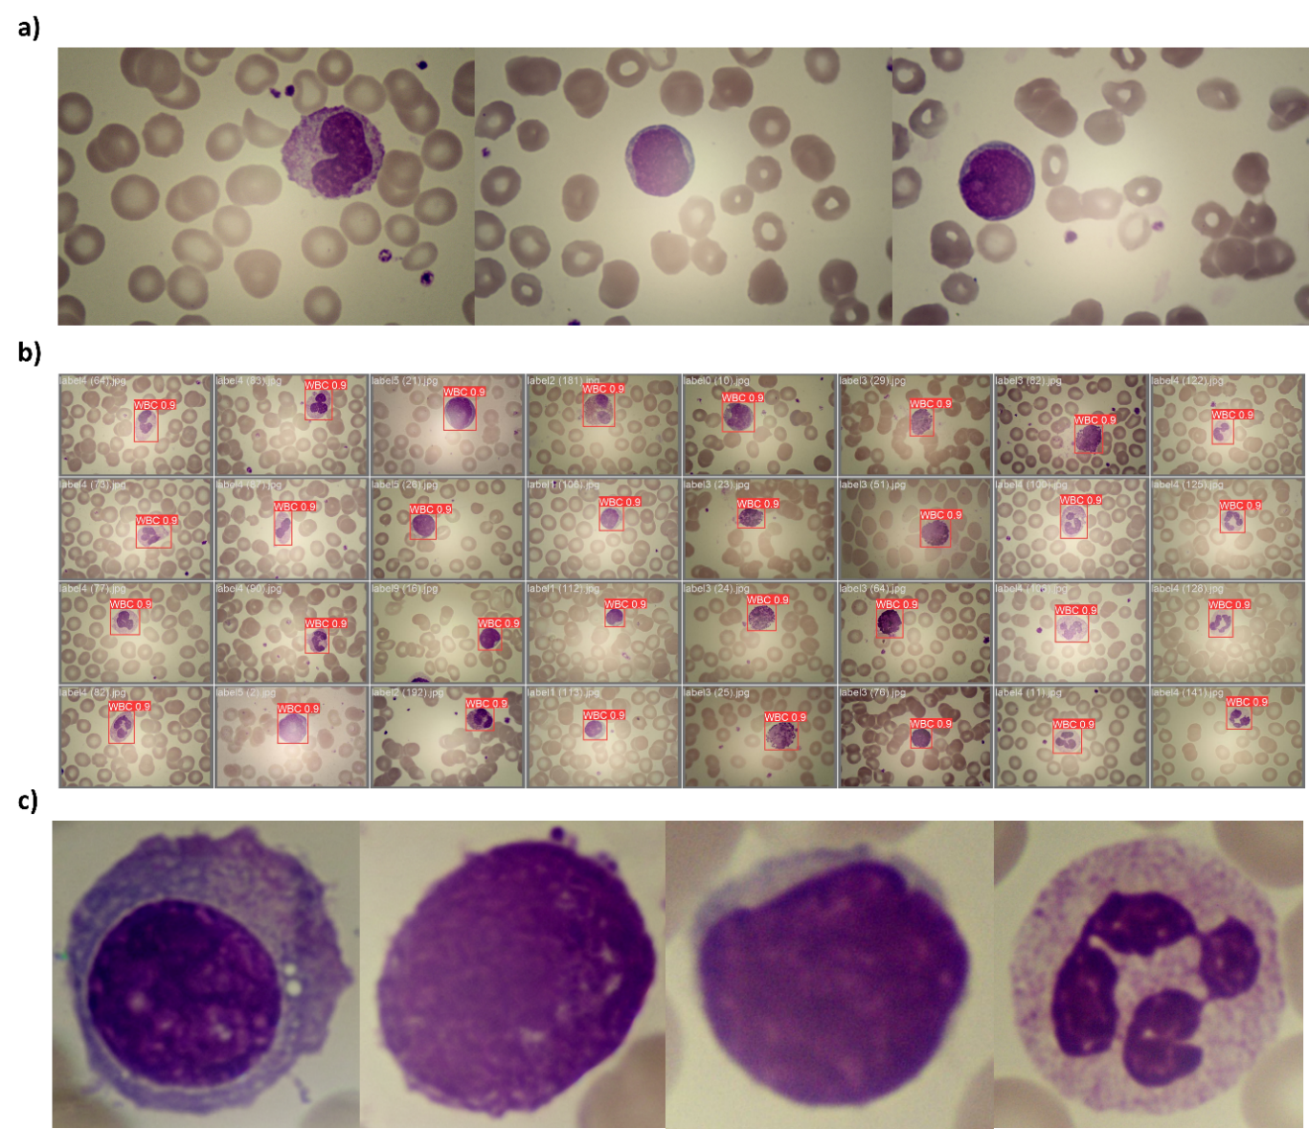Supplementary Figure S1: Optical Standardization and Data Preprocessing Pipeline. (a) Raw, uncropped microscopic fields of Wright-Giemsa-stained peripheral blood smears acquired at 1000x magnification. These initial captures demonstrate the natural clinical variance in illumination, staining intensity, and erythrocyte density inherent to real-world hematology workflows. (b) Automated cell segmentation and localization masks. This intermediate processing step precisely isolates the target normal and malignant leukocytes from the background and surrounding red blood cells, ensuring the diagnostic network does not overfit to spurious contextual optical artifacts. (c) Final, standardized single-cell crops extracted for model input. The localized cells are spatially centered and normalized to a uniform resolution, explicitly preserving the high-frequency cytological features, such as delicate cytoplasmic granularity, Auer rods, and complex nuclear chromatin contours strictly required for robust multi-level feature fusion and generative latent space encoding.
Supplementary Note 2: Generative Augmentation Implementation Details
LoRA-Conditioned Latent Diffusion Architecture
To address the extreme class imbalance of the clinical cohort without inducing traditional oversampling artifacts, the foundational dataset was systematically expanded using a highly controlled Latent Diffusion Model (LDM)³. Rather than synthesizing samples from pure Gaussian noise, the framework was configured in a structurally conditioned image-to-image (img2img) modality⁴. This approach leveraged the preprocessed, cropped clinical images as structural priors, ensuring that the global geometry and baseline nucleocytoplasmic ratios of the synthesized cells remained biologically plausible.
The generative trajectory was governed by a dual-conditioning mechanism comprising Textual Inversion and Low-Rank Adaptation (LoRA). Textual Inversion was employed to embed class-specific pathological tokens⁵ into the model's text encoder, providing exact semantic definitions for rare morphotypes (e.g., Auer rods or nuclear clefting). Concurrently, learned LoRA weights were integrated directly into the cross-attention layers of the U-Net⁶. This adaptation constrained the network to strictly adhere to the textural properties and specific Wright-Giemsa chromatic profiles characteristic of our hospital’s standardized imaging system.
Optimization Strategy and Hyperparameter Tuning
To achieve precise domain adaptation while remaining memory-efficient, the LoRA structural capacity was defined by a network dimension (rank)⁶ and an alpha scaling factor both set to 16. This specific dimensionality provided sufficient parameter space to capture high-frequency leukemic morphologies while mitigating the risk of overfitting on the highly scarce minority classes (e.g., AML-M5 Promonocytes).
To ensure semantic stability during adaptation, a differential learning rate strategy was enforced. The cross-attention layers of the U-Net were updated at a primary learning rate of 1x10⁻⁴, whereas the CLIP text encoder was fine-tuned⁷ at a significantly reduced rate of 1x10⁻⁷. This uncoupling prevented catastrophic forgetting of foundational semantic concepts within the text encoder while allowing the U-Net to rapidly assimilate the unique visual characteristics of hematological smears. The optimization trajectory was driven by the Lion optimizer⁸, significantly reducing the VRAM footprint without compromising weight update precision. Furthermore, a CLIP skip value of 2 was utilized to extract feature representations from the penultimate layer of the text encoder. This bypassed the final, highly abstracted layer, capturing the richer, more granular semantic embeddings required for non-photographic, microscopic cellular pathology.
Sampling Dynamics
During inference, latent representations were decoded to a standardized spatial resolution of 512x512 pixels using dynamic aspect ratio bucketing. To iteratively denoise the latent space, we employed the DPM++ 2M Karras sampling algorithm over 20 discrete steps^{9,10}. This specific differential equation solver was selected for its superior convergence properties in rendering high-frequency biological details. Crucially, the denoising strength was fixed at 0.75; empirical evaluation determined this threshold optimally preserved the fundamental geometric footprint of the original source cell while granting the U-Net sufficient generative freedom to mutate internal pathological features according to the LoRA constraints and specific text prompts (Supplementary Table S1).
Table S1: Textual Inversion and LoRA Conditioning Parameters Used for Generative Cohort Expansion.
Label | Leukocyte type | Text prompt
00 | Monocytes | Monocytes with oval or kidney-shaped nucleus, loose chromatin, without nucleoli, abundant pale blue cytoplasm, irregular shape, smooth edges, well-defined boundaries, microscope-style.
01 | Lymphocytes | Lymphocytes with round nucleus, dense chromatin, minimal cytoplasm, pale blue cytoplasm, small size, smooth edges, well-defined boundaries, microscope-style.
02 | Eosinophils | Eosinophils with bilobed nuclei, coarse chromatin, prominent cytoplasmic granules, without nucleoli, abundant cytoplasm, bright eosinophilic (pink/red) granules, granules evenly distributed, background of pale staining, round or slightly oval shape, cells with well-defined boundaries, soft and smooth edges, microscope-style
03 | Basophils | Basophils nucleus is often unsegmented or bilobed (which looks like two raindrops connected by a thin thread), coarse chromatin, abundant cytoplasm, dark purple/blue granules, granules densely packed, round/oval shape, spherical in shape, smooth edges, microscope-style.
04 | Neutrophils | Neutrophils with multilobed nucleus, coarse chromatin, fine pinkish cytoplasm, prominent granules, irregular shape, smooth edges, well-defined boundaries, microscope-style.
05 | Myeloblast: From AML-M1 OR AML-M2² | Myeloblast-dominant marrow, uniform blasts, fine chromatin, nucleoli, scant cytoplasm, rare granules, rare Auer rods, no maturation, microscopy.
06 | Abnormally Promyelocyte: From AML M3² | Abnormal promyelocyte, abundant coarse azurophilic granules, heavy cytoplasmic granulation, multiple Auer rods, faggot cells with rod bundles, folded or bilobed nuclei, hypergranular cells, high-detail marrow smear, hematopathology style.
07 | Promonocyte: from AML-M5² | Promonocytes, large highly folded and convoluted nuclei, cerebriform nuclear contours, inconspicuous nucleoli, gray-blue cytoplasm with fine azurophilic granules, numerous cytoplasmic vacuoles, pseudopodia, monocytic differentiation, high-detail bone marrow smear, Wright-Giemsa stain, 100x oil immersion brightfield microscopy
08 | Monoblast: from AML-M5² | Monoblasts, round to slightly folded nuclei, prominent nucleoli, pale gray-blue agranular cytoplasm, pseudopodia, monocytic differentiation, high-detail single cell smear, Wright-Giemsa stain, 100x oil immersion brightfield microscopy.
09 | Lymphoblast: from ALL² | Lymphoblasts; high N:C ratio; round to slightly irregular nuclei; fine stippled chromatin with inconspicuous nucleoli; scant basophilic agranular cytoplasm; lymphoid lineage features; hypercellular bone marrow smear; Wright-Giemsa stain; 100x oil immersion brightfield microscopy; high-detail hematopathology image.
10 | Plasma_cell_leukemia_rare | Plasma cells with eccentric nuclei, clumped chromatin, basophilic cytoplasm; pleomorphism; plasmablast forms; marrow infiltration by atypical plasma cell clusters; high-detail hematopathology image.
The text labeling system constructed in this study strictly follows the standardized descriptions of leukocyte morphology in international authoritative medical textbooks¹¹, and adopts a two-layer heterogeneous design to define the cross-category shared labels describing the basic structure of the cells, and the specific differentiation labels describing the specific features of leukocytes of different categories. Meanwhile, this study adheres to the closed-loop logic of generation, comparison, and correction by independently training the LoRA adapter on each class of leukocytes and generating images as shown in Supplementary Figure S2, which are then manually compared with the real captured images, thus modifying the misdescribed labels, adding missing feature labels, and deleting ambiguous and negative labels in the textual labels.

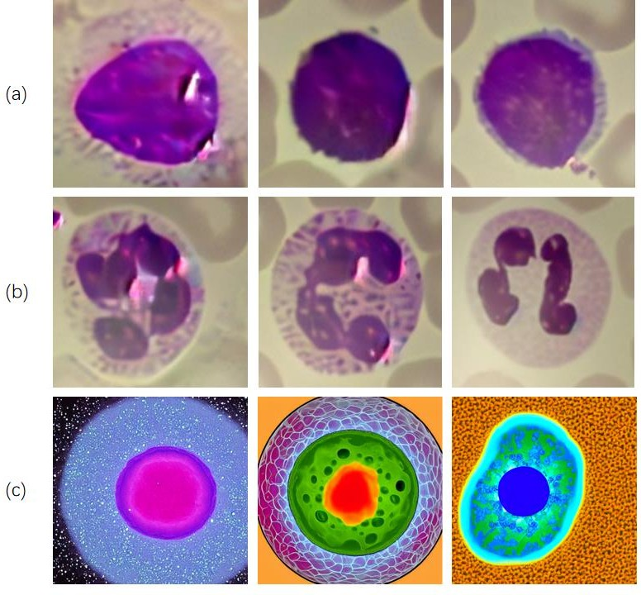
(a) Lymphocyte (b) Neutrophils (c) Directly generated leukocyte images
Supplementary Figure S2: Structural conditioning and generative ablation for high-fidelity morphological synthesis. (a, b) Demonstration of precise phenotypic control using structurally conditioned image-to-image (img2img) generation. By systematically modulating the textual conditioning prompts, our LoRA-adapted framework successfully generates and directs the morphological transition between (a) lymphocytic and (b) neutrophilic lineages, maintaining rigid structural constraints, delicate chromatin patterns, and authentic cytoplasmic granularity. (c) Comparative generative ablation explicitly validating the necessity of this architectural approach. This row displays synthetic outputs generated by the foundational, unadapted Stable Diffusion model using identical text prompts showing the baseline model produces overly smoothed, artifactual representations and fundamentally fails to capture specialized hematological textures, conclusively proving that LoRA fine-tuning is strictly required to cross the domain gap into high-fidelity pathological generation.
Supplementary Note 3: Deep Feature Similarity Distribution Analysis
To rigorously validate the generative data pipeline and rule out the presence of synthetic mode collapse, deep feature extraction and pairwise similarity analyses were performed on a per-class basis. Following spatial standardization (224 x 224 center-crop) and ImageNet channel normalization¹², input tensors were mapped into a high-dimensional latent space utilizing a pre-trained ResNet-18 architecture¹³, with the terminal fully connected classification layer explicitly removed to isolate generalized morphological features.
The pairwise cosine similarity was computed using the standard dot product formulation for $L_{2}$-normalized vectors¹⁴:
$$S_{cosine}\left(A, B\right)= \frac{A.B}{{\left\|A\right\|}_{2}{\left\|B\right\|}_{2}}$$
This metric was evaluated across three distinct matrices for every leukocyte sub-lineage: internal authentic hospital data (A x A), internal synthetic data (B x B), and the cross-manifold comparison (A x B). (Figure 3c, Quantitative deep feature cosine similarity analysis) and confirmed a negligible domain gap, to explicitly demonstrate the absence of generative mode collapse.
In a collapsed generative model, the synthetic intra-class variance (B x B) would present as an artificially narrow spike approaching a similarity of 1.0, indicating the network is simply memorizing and reproducing a single "average" cell. Conversely, our framework generated distinct, diverse cellular morphologies, maintaining a broad interquartile range highly analogous to the authentic clinical samples. The exact minimum, maximum, and mean values for the cross-similarity of all 11 hematological classes are fully detailed in Supplementary Table S3.
Clinical Blinded Validation and Visual Turing Test To rigorously assess the domain gap between authentic clinical smears and the synthetic generative manifold, a blinded Visual Turing Test was conducted. Three independent, board-certified hematopathologists were tasked with evaluating a randomized, balanced subset of 220 images (110 authentic, 110 synthetic). The experts were instructed to flag any image presenting with synthetic artifacts, unnatural chromatic distributions, or biologically implausible morphometrics. Furthermore, diagnostic feature preservation was assessed on a separate 200-image synthetic subset. The full concordance metrics and synthetic identification rates are detailed in Supplementary Table S2.
Supplementary Table S2: Expert Concordance and Visual Turing Test Results Blinded clinical validation evaluating diagnostic feature preservation and the domain gap between authentic and synthetic leukocyte manifolds.
Evaluation Metric | Expert 1 | Expert 2 | Expert 3
Phase 1: Diagnostic Feature Preservation
Total Images Reviewed | 200 | 200 | 200
Correct Lineage Diagnoses | 194 | 154 | 159
Diagnostic Accuracy (%) | 97.0% | 77.0% | 79.5%
Phase 2: Visual Turing Test (Domain Gap Analysis)
Total Images Reviewed | 220 | 220 | 220
Authentic Clinical Samples | 110 | 110 | 110
Synthetic Generated Samples | 110 | 110 | 110
Real Images Correctly Identified | 25 | 98 | 55
Synthetic Images Correctly Flagged | 10 | 10 | 87
Synthetic Identification Rate (%) | 9.1% | 9.1% | 79.1%
Phase 3: Generative Quality Control
Images Rejected (Morphological Artifacts) | 0 | 0 | 0

Supplementary Table S3: Quantitative Deep Feature Cosine Similarity Distributions Pairwise cosine similarity metrics across internal hospital data (Real * Real), synthetic data (Syn * Syn), and cross-manifold validation (Real * Syn) to explicitly demonstrate the absence of generative mode collapse
Cell Class | Real × Real (Mean) | Syn × Syn (Mean) | Real × Syn (Mean)
Monocyte | 0.7894 | 0.7974 | 0.7769
Lymphocyte | 0.8291 | 0.8318 | 0.8201
Eosinophil | 0.8149 | 0.8374 | 0.811
Basophil | 0.7918 | 0.7956 | 0.7866
Neutrophil | 0.8141 | 0.8214 | 0.7963
Myeloblast | 0.8335 | 0.835 | 0.8222
Promyelocyte | 0.8021 | 0.8201 | 0.8056
Promonocyte | 0.7529 | 0.815 | 0.7622
Monoblast | 0.7591 | 0.7802 | 0.7447
Lymphoblast | 0.854 | 0.851 | 0.8372
Plasma Leukemia | 0.8229 | 0.8176 | 0.8136

Supplementary Note 4: In-Domain Morphological Regression and Uncertainty Calibration
Morphological Trait Calibration and Generalization
To explicitly verify that the diagnostic network successfully mapped latent representations to physical biological realities, we evaluated the auxiliary morphological regression head across the internal holdout validation set (n = 3,174). The network demonstrated robust morphological grounding, achieving an overall macro-averaged Mean Absolute Error (MAE) of 0.1974 across all normalized phenotypic constraints (Supplementary Table S4). Crucially, to prove that the framework did not overfit to the generative manifold and could safely generalize to real-world clinical variance, this identical regression head was deployed on the independent external clinical cohort. The network maintained a highly stable external macro-averaged MAE of 0.1092 (Supplementary Table S5). This negligible generalization gap confirms that the multi-level feature fusion architecture successfully learned invariant cytological rules rather than memorizing domain-specific optical artifacts.
Baseline Metacognitive Uncertainty
To establish a quantitative baseline for the model's metacognitive calibration and diagnostic performance, predictive variance was initially assessed on the internal validation cohort (n = 3,174). Because this cohort comprises data drawn directly from the expanded generative manifold and the primary training domain, the network demonstrated exceptional baseline metrics, achieving an overall initial accuracy of 99.56% (3,160 correct predictions). The architecture established highly robust decision boundaries even for rare pathological precursors, yielding an F1-score of 0.98 for myeloblasts, 0.99 for promonocytes, and 0.99 for monoblasts. Furthermore, the model maintained perfect 1.00 precision, recall, and F1-scores across all mature leukocyte classes and specific critical malignancies, including promyelocytes, lymphoblasts, and plasma leukemia. Applying the identical predictive variance threshold utilized for the external clinical cohort, the model flagged only a single boundary-case cell for human review (Supplementary Figure S3). Applying the identical predictive variance threshold utilized for the internal clinical cohort, the model flagged 14 boundary-case cells for human review (a 0.44% deferral rate). Upon independent expert confirmation, it was determined that 4 of these deferred images were actually classified correctly by the model's primary head, 2 represented genuinely atypical cellular presentations, and the remaining 8 were true misclassifications safely intercepted. The highly saturated confidence distribution on this internal dataset confirms that the architecture appropriately scales its epistemic uncertainty to halt predictions when exposed to highly transitionary or ambiguous clinical variance.
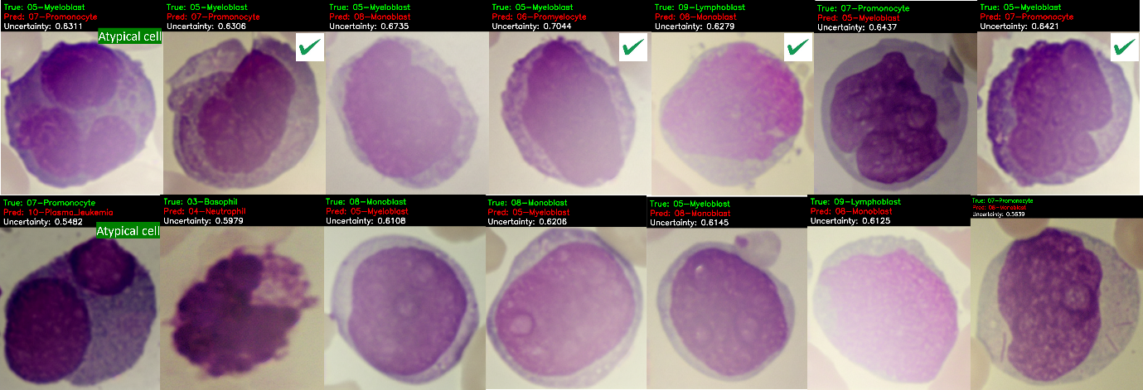
Supplementary Figure S3: Uncertainty-driven deferral of a morphologically ambiguous leukocyte. This panel details the single cellular instance (n = 14 out of 3,174) autonomously flagged for expert review during the internal holdout validation. While the primary diagnostic head misclassified the cell as a myeloblast, the GUR-Gate's auxiliary variance head successfully detected significant out-of-distribution feature conflict. This yielded a predictive uncertainty score ($σ^{2}$ = 0.5482 – 0.7044) that explicitly crossed the established threshold, triggering the margin penalty and halting the autonomous prediction. The ground truth of this specimen is a promyelocyte. Biologically, this cell exhibits extreme phenotypic overlap; specifically, it presents with an unusually high nucleocytoplasmic ratio and relatively sparse primary azurophilic granulation, features that closely mimic the preceding myeloblast stage and obscure the cell's true maturation status. The successful isolation of this boundary-case presentation demonstrates that the framework's heteroscedastic uncertainty calibration effectively prevents silent algorithmic failures, establishing a robust, clinical-grade safety net
Supplementary Table S4: Morphological Regression Calibration
Mean absolute error (MAE) of the explicitly modeled phenotypic traits evaluated across the internal holdout validation cohort (n = 3174).
Phenotypic Trait | Mean Absolute Error (MAE)
Relative Nuclear Area | 0.1081
Logarithmic N:C Ratio | 0.2728
Normalized Nuclear Contour | 0.8780
Nuclear Sphericity | 0.0923
Nuclear Eccentricity | 0.1029
Mean Chromatin Density | 0.0863
Chromatin Heterogeneity | 0.0085
Chromatin Entropy | 0.0308
Overall Calibration Error | 0.1974

Supplementary Table S5: External Cohort Morphological Regression Calibration Mean absolute error (MAE) of the explicitly modeled phenotypic traits evaluated across the independent external clinical cohort, demonstrating robust out-of-distribution morphological grounding.
Phenotypic Trait | Mean Absolute Error (MAE)
Relative Nuclear Area | 0.0669
Logarithmic N:C Ratio | 0.2407
Normalized Nuclear Contour | 0.4318
Nuclear Sphericity | 0.0512
Nuclear Eccentricity | 0.0195
Mean Chromatin Density | 0.0459
Chromatin Heterogeneity | 0.0048
Chromatin Entropy | 0.0130
Overall External Calibration Error | 0.1092

Supplementary Note 5: Architectural Specifications of the GUR-Gate Framework
Hierarchical Feature Extraction via Adapted ResNet-50
The foundational diagnostic backbone of the Generative Uncertainty-anchored Retrieval Gate (GUR-Gate) utilizes an adapted ResNet-50 architecture¹³ engineered for multi-level feature fusion¹⁵. Standard deep convolutional networks typically suffer from spatial information loss at deeper, highly abstracted layers. To successfully differentiate highly ambiguous leukemic sub-lineages, it is imperative to preserve high-frequency cytological textures (e.g., azurophilic granulation and Auer rods) while simultaneously capturing global morphometrics (e.g., the overall nucleocytoplasmic ratio). Consequently, our architecture bypasses standard terminal pooling by extracting intermediate activation maps across multiple residual blocks. These multi-scale feature embeddings are concatenated and passed through a custom projection head, ensuring that the final latent representation is deeply grounded in physical, biologically interpretable morphology rather than spurious background artifacts.
Heteroscedastic Uncertainty Calibration and Metacognitive Triage
The core algorithmic safety mechanism of the framework is its metacognitive triage capability, driven by heteroscedastic uncertainty calibration. Rather than relying on raw softmax probabilities, which are notoriously overconfident when exposed to out-of-distribution (OOD) hematological presentations¹⁶, the GUR-Gate explicitly models predictive variance.
During inference, the network outputs both a discrete class prediction and an associated continuous uncertainty scalar ($σ^{2}$) for every detected leukocyte. This variance acts as a mathematical proxy for the model's epistemic (lack of knowledge) and aleatoric (data noise) uncertainty¹⁷. A strict margin penalty is enforced: if the predictive variance for a given cell exceeds a rigorously calibrated threshold, the GUR-Gate autonomously halts the prediction process. Instead of forcing a potentially fatal misclassification, the framework isolates and defers the specific anomalous cell to a human hematopathologist. This uncertainty-driven gating explicitly anchors the model to the known clinical manifold, ensuring safe deployment in long-tail, real-world hospital environments.
Multi-Objective Optimization Strategy
To enforce this morphological grounding and calibrated uncertainty, the network was trained using a joint multi-objective loss function. The primary diagnostic loss was governed by a standard Cross-Entropy ($L_{CE}$) formulation to optimize categorical sub-lineage classification. Simultaneously, an auxiliary Mean Squared Error ($L_{MSE}$) The regression head was utilized to continuously predict the explicitly modeled phenotypic traits (as detailed in Supplementary Tables S4 and S5). This dual-optimization strategy forces the network to learn latent features that are highly predictive of both the abstract disease state and the measurable physical geometry of the cell.
Supplementary Note 6: Spatial Interpretability via Gradient-Weighted Class Activation Mapping (Grad-CAM)
To rigorously validate the spatial attention of the diagnostic network, Grad-CAM was applied to the terminal residual block (Layer 4) of the adapted ResNet-50 backbone¹⁸. Because the framework utilizes multi-level feature fusion, targeting this specific deep convolutional layer allows for the visualization of the maximum spatial receptive field immediately prior to the continuous features being flattened and routed through the Margin-Penalized Retrieval Feature Gate (GUR-Gate).
During inference, the gradients of the predicted sub-lineage logit were computed with respect to these terminal activation maps, globally averaged, and passed through a ReLU activation. This mathematical isolation ensures that only the spatial features that positively contributed to the final diagnostic classification¹⁹ are highlighted. As shown in Supplementary Figure S4, the resulting heatmaps confirm robust spatial localization on diagnostic cellular structures (nucleus and cytoplasm) while actively suppressing irrelevant background noise.
Supplementary Figure S4: Spatial interpretability and saliency mapping across leukocyte sub-lineages. A comprehensive Grad-CAM analysis evaluating the network's visual attention across the 11 normal and malignant hematological classes. For each sub-lineage, the authentic clinical input image is displayed alongside its corresponding gradient-weighted heatmap overlay. The dense, high-activation regions (red/yellow) demonstrate that the network consistently localizes its predictive focus onto critical cytological structures, specifically the nuclear chromatin and granular cytoplasm. Crucially, the network exhibits no focal attention on the surrounding erythrocytes, plasma boundaries, or slide-preparation artifacts, confirming that the diagnostic decision-making is firmly grounded in biologically valid hematopathology rather than spurious environmental noise.
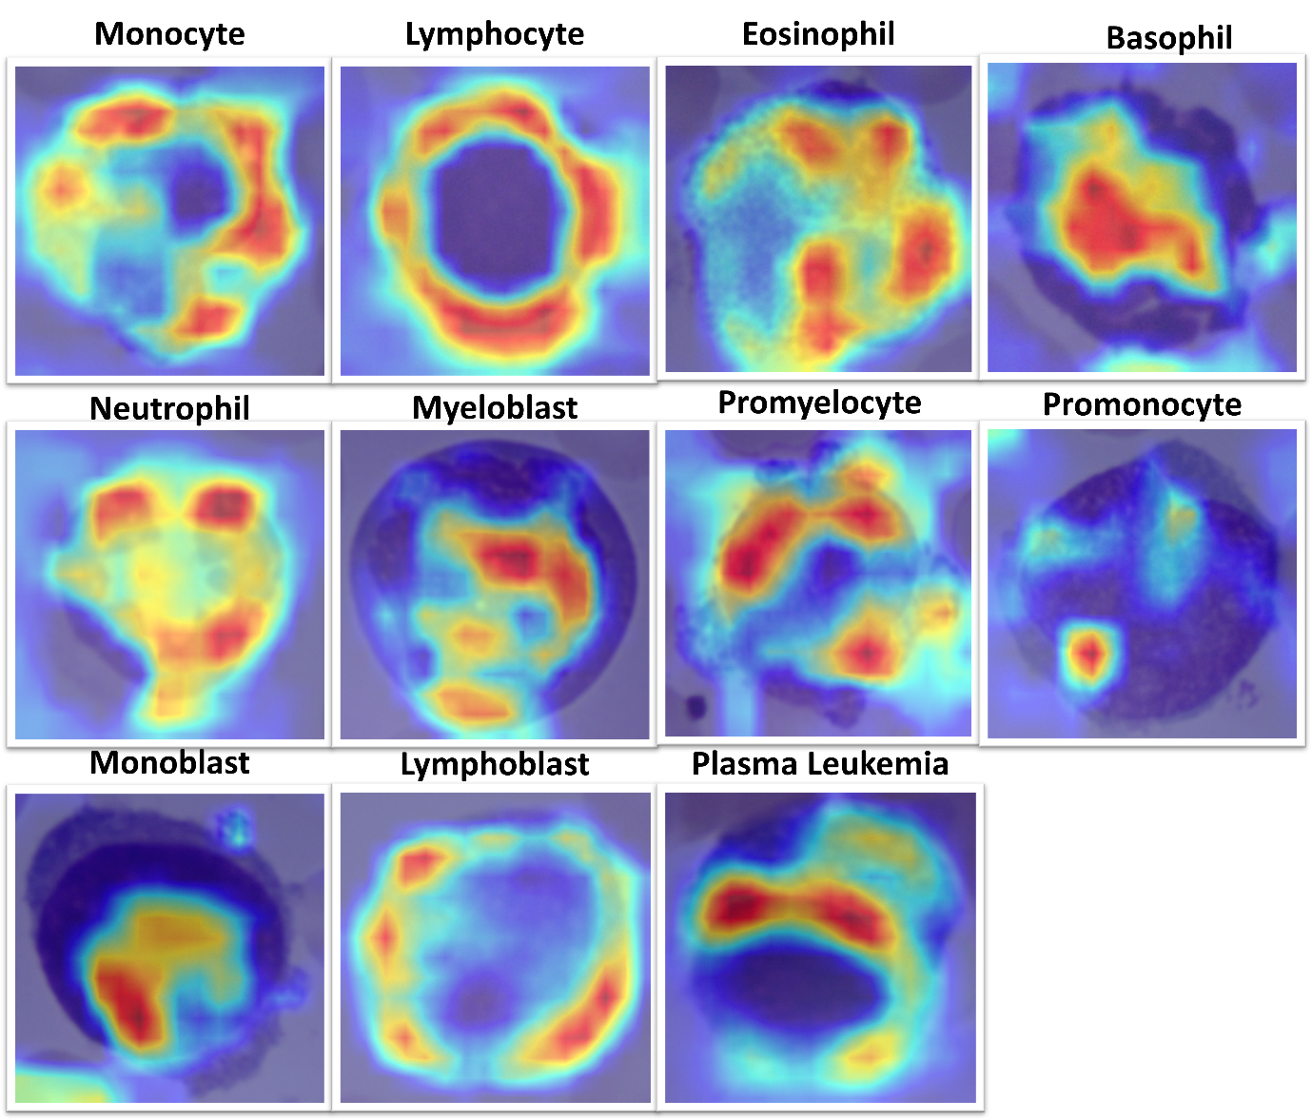Supplementary Figure S4: Comprehensive spatial interpretability grid across all evaluated leukocyte lineages. This 5x5 grid presents representative image pairs for each of the major normal and malignant leukocyte classes and subtypes classified by the GUR-Gate framework. For each cell type, the authentic microscopic input image is shown on the left, and its corresponding gradient-weighted heatmap overlay is displayed on the right. The dense, localized high-activation regions (red/yellow) demonstrate that the network consistently localizes its predictive attention to canonical pathological features, such as nuclear chromatin architecture, lobulation patterns, and cytoplasmic granulation textures across the diverse hematological spectrum. The rigorous exclusion of background artifacts and non-target cells from the visual attention underscores the successful morphological grounding of the deep feature fusion architecture and its alignment with canonical human hematopathology.
Supplementary Note 7: Prospective Clinical Cohort Validation
To support the prospective clinical findings detailed in the main text, we conducted a comprehensive evaluation of the GUR-Gate framework on an expanded clinical cohort (N=968). This cohort notably included a morphologically complex, relapsed case of AML-M5 (promonocytic leukemia). Supplementary Figure S5 visualizes the framework's robust discriminative capacity and metacognitive safety mechanisms when challenged with the severe morphological distortions typical of relapsed malignancies. The latent space projection confirms that the architecture maintains strict inter-class separability, while the predictive variance distribution demonstrates the model's ability to safely isolate ambiguous cells by assigning higher uncertainty scores to erroneous or highly degraded presentations. To explicitly verify the triage mechanism on the expanded prospective cohort, the 22 cells autonomously flagged by the predictive variance head were evaluated by a clinical specialist. The expert confirmed that 8 of the deferred instances were ultimately classified correctly by the diagnostic head, while the remaining 14 were true misclassifications. This mathematically demonstrates the network's robust capacity to safely intercept its own errors prior to clinical output when evaluating severely distorted relapsed malignancies.
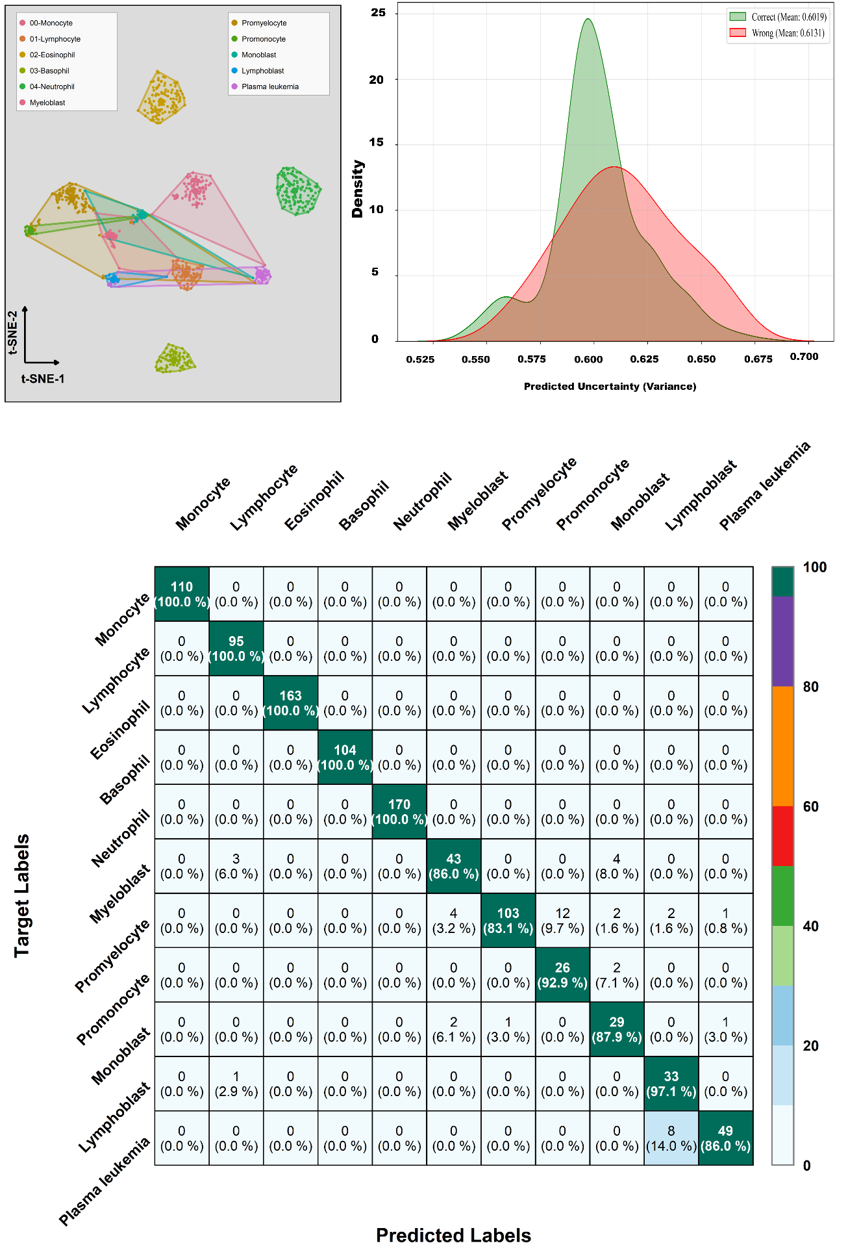
Supplementary Figure S5: Diagnostic performance, latent clustering, and metacognitive calibration on the expanded prospective clinical cohort (N=968). (a) A 2D t-SNE projection of the contrastive latent space, demonstrating that the framework maintains robust feature clustering and strict topological separability across 11 leukocyte lineages, despite the heavy disease burden and morphological distortions of the relapsed cohort. (b) Predictive variance (uncertainty) distributions for correct versus incorrect predictions. The GUR-Gate’s heteroscedastic variance head effectively separates confident, accurate predictions (0.6019) from erroneous or highly ambiguous out-of-distribution cells (0.6131) enabling safe, automated clinical triage. (c) Comprehensive diagnostic confusion matrix detailing absolute predictive performance. The architecture exhibits strict diagonal dominance, notably achieving a 92.9% sensitivity and 98.7% specificity for the critical relapsed promonocyte (AML-M5) sub-lineage without degrading baseline performance on normal leukocyte populations.
Extended Data Table 1 | Summary of evaluated clinical and synthetic cohorts
Dataset Partition | # Images | # Classes | Image Composition | Expert Validated | Uncertainty Triage
Baseline Clinical Manifold | 1,333 | 11 | 100% Real | ✓ | ✗
Expanded Generative Dataset | 15,881 | 11 | Real + Synthetic | ✓ | ✗
Internal Holdout Set | 3,174 | 11 | Real + Synthetic | ✓ | ✓
External Validation Cohort | 715 | 11 | 100% Real | ✓ | ✓
Expanded Prospective Cohort | 968 | 11 | 100% Real | ✓ | ✓

References
1. Association WM. World Medical Association Declaration of Helsinki: ethical principles for medical research involving human subjects. Jama. 2013;310(20):2191-2194.
2. Palmer L, Briggs C, McFadden S, et al. ICSH recommendations for the standardization of nomenclature and grading of peripheral blood cell morphological features. International journal of laboratory hematology. 2015;37(3):287-303.
3. Rombach R, Blattmann A, Lorenz D, Esser P, Ommer B. High-resolution image synthesis with latent diffusion models. Proceedings of the IEEE/CVF conference on computer vision and pattern recognition; 2022:10684-10695.
4. Meng C, He Y, Song Y, et al. Sdedit: Guided image synthesis and editing with stochastic differential equations. arXiv preprint arXiv:210801073. 2021.
5. Gal R, Alaluf Y, Atzmon Y, et al. An image is worth one word: Personalizing text-to-image generation using textual inversion. arXiv preprint arXiv:220801618. 2022.
6. Hu EJ, Shen Y, Wallis P, et al. Lora: Low-rank adaptation of large language models. Iclr. 2022;1(2):3.
7. Radford A, Kim JW, Hallacy C, et al. Learning transferable visual models from natural language supervision. International conference on machine learning: PmLR; 2021:8748-8763.
8. Chen X, Liang C, Huang D, et al. Symbolic discovery of optimization algorithms. Advances in neural information processing systems. 2023;36:49205-49233.
9. Lu C, Zhou Y, Bao F, Chen J, Li C, Zhu J. Dpm-solver++: Fast solver for guided sampling of diffusion probabilistic models. Machine Intelligence Research. 2025;22(4):730-751.
10. Karras T, Aittala M, Aila T, Laine S. Elucidating the design space of diffusion-based generative models. Advances in neural information processing systems. 2022;35:26565-26577.
11. Khoury JD, Solary E, Abla O, et al. The 5th edition of the World Health Organization classification of haematolymphoid tumours: myeloid and histiocytic/dendritic neoplasms. leukemia. 2022;36(7):1703-1719.
12. Deng J, Dong W, Socher R, Li L-J, Li K, Fei-Fei L. Imagenet: A large-scale hierarchical image database. 2009 IEEE conference on computer vision and pattern recognition: Ieee; 2009:248-255.
13. He K, Zhang X, Ren S, Sun J. Deep residual learning for image recognition. Proceedings of the IEEE conference on computer vision and pattern recognition; 2016:770-778.
14. Zhang R, Isola P, Efros AA, Shechtman E, Wang O. The unreasonable effectiveness of deep features as a perceptual metric. Proceedings of the IEEE conference on computer vision and pattern recognition; 2018:586-595.
15. Lin T-Y, Dollár P, Girshick R, He K, Hariharan B, Belongie S. Feature pyramid networks for object detection. Proceedings of the IEEE conference on computer vision and pattern recognition; 2017:2117-2125.
16. Hendrycks D, Gimpel K. A baseline for detecting misclassified and out-of-distribution examples in neural networks. arXiv preprint arXiv:161002136. 2016.
17. Kendall A, Gal Y. What uncertainties do we need in bayesian deep learning for computer vision? Advances in neural information processing systems. 2017;30.
18. Selvaraju RR, Cogswell M, Das A, Vedantam R, Parikh D, Batra D. Grad-CAM: visual explanations from deep networks via gradient-based localization. International journal of computer vision. 2020;128(2):336-359.
19. Simonyan K, Vedaldi A, Zisserman A. Deep inside convolutional networks: Visualising image classification models and saliency maps. arXiv preprint arXiv:13126034. 2013.

