Supplementary Information

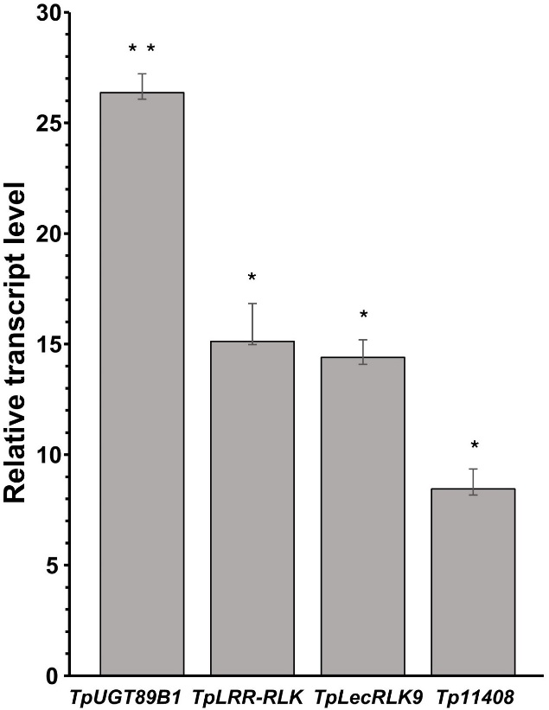
Figure S1. Relative transcript levels of the TpUGT89B1, TpLRR-RLK, TpLecRLK9 and Tp11408 genes in the roots of the resistant red clover accession Formica in response to F. avenaceum infection. The data are relative to those of mock-treated Formica plants at 7 dpi (value =1). The bar chart represents the means ± SDs (n=3 biological replicates). Real-time quantitative PCR was performed using the 2^{−ΔΔCT} method. All the transcript data were normalized to those of EIF-4α. Asterisks indicate significant differences according to Student’s t test (*P ≤ 0.05, ** P ≤ 0.01, *** P ≤ 0.001).

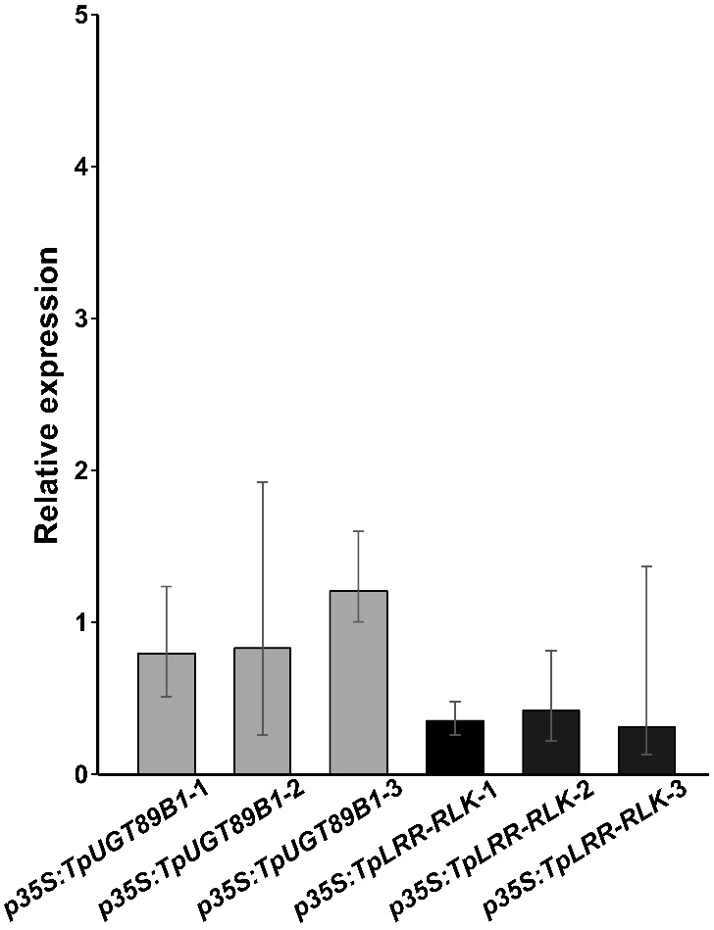
Figure S2. Relative expression levels of TpUGT89B1 and TpLRR-RLK in independent OE lines (p35S:TpUGT89B1-1, 2, 3 and p35S:TpLRR-RLK-1, 2, 3) determined by RT‒qPCR using the 2^{−ΔΔCT} method, with normalization to EIF-4α. The data are relative to those of resistant red clover Formica roots at 7 dpi with F. avenaceum (value =1). The bar chart shows the means ± SDs (n=3 biological replicates). No statistically significant differences were detected (Student’s t test, P > 0.05).

Figure S3. Predicted hydrophobic acceptor binding pocket of TpUGT89B1. Surface representation of the TpUGT89B1 ligand-binding cavity generated in UCSF ChimeraX version 1.3 and colored according to hydrophobicity. The docked trichothecene scaffold 7E0 (green color) is shown to occupy the predicted acceptor pocket. Amino acid residues (Ser137, Ser174, Ala376 and Asp377) lining the binding cavity are highlighted, and the distances between these residues and the docked ligand are indicated (Å). The protein structure was predicted using Protenix-v0.5.0.

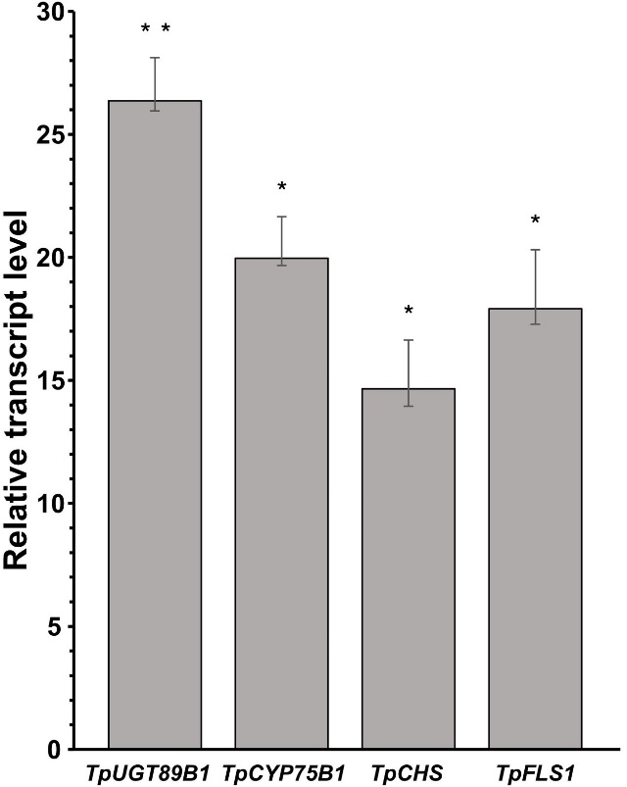
Figure S4. Relative transcript levels of the TpUGT89B1, TpCYP75B1, TpCHS and TpFLS1 genes in the roots of the resistant red clover accession Formica in response to F. avenaceum infection. The data are relative to those of mock-treated Formica plants at 7 dpi (value =1). The bar chart shows the means ± SDs (n=3 biological replicates). Real-time quantitative PCR was performed using the 2^{−ΔΔCT} method. All the transcript data were normalized to those of EIF-4α. Asterisks indicate significant differences according to Student’s t test (*P ≤ 0.05, ** P ≤ 0.01, *** P ≤ 0.001).

Table S1 The 50 highly upregulated genes unique to F. avenaceum-infected resistant Formica red clover (Trifolium pratense) compared with infected susceptible SW 1678002 plants (RP vs. SP; RP = pathogen infected resistant plants; SP = pathogen infected susceptible plants; log₂foldchange > 1; P < 0.01; adjusted P < 0.05).
Gene name | Chromosomal location | Start  position | End position | Log2  fold  change | P value | p adj  value | Gene description
Tp57577_TGAC_v2_gene36361 | Contig FKJA01001704.1 | 11216 | 13738 | 25 | 3E-05 | 0.002028 | Flavonol 3-O-glucosyltransferase UGT89B1-like At1g73880
Tp57577_TGAC_v2_gene10948 | Contig FKJA01004574.1 | 1 | 1094 | 22 | 0.00018 | 0.006913 | Cysteine-rich receptor-like protein kinase
Tp57577_TGAC_v2_gene8161 | LG2 | 21480619 | 21490551 | 19 | 1.6E-08 | 5.89E-06 | Retrovirus-related Pol polyprotein from transposon TNT 1-94
Tp57577_TGAC_v2_gene1814 | LG1 | 15307231 | 15313947 | 15 | 3.1E-07 | 6.51E-05 | Cytochrome P450 71D9-like
Tp57577_TGAC_v2_gene35402 | Contig FKJA01020006.1 | 1 | 852 | 9.3 | 0.00027 | 0.008968 | Myb DNA-binding 3 domain-containing protein
Tp57577_TGAC_v2_gene8001 | LG4 | 1358626 | 1366623 | 9 | 5.7E-05 | 0.003182 | Hypothetical protein
Tp57577_TGAC_v2_gene1430 | LG4 | 23307726 | 23308660 | 7.2 | 1.4E-05 | 0.001188 | LRR receptor-like serine/threonine-protein kinase At4g29180  Root hair specific 16
Tp57577_TGAC_v2_gene29843 | Contig FKJA01000491.1 | 16943 | 18433 | 6.7 | 7.6E-05 | 0.00396 | L-type lectin-domain containing receptor kinase IX.1-like protein
Tp57577_TGAC_v2_gene11408 | Contig FKJA01007680.1 | 1 | 1446 | 5.6 | 3E-07 | 6.39E-05 | Uncharacterized
Tp57577_TGAC_v2_gene35971 | Contig FKJA01001509.1 | 12127 | 13731 | 5.2 | 0.00013 | 0.005495 | DUF975 family protein
Tp57577_TGAC_v2_gene30147 | LG7 | 22166799 | 22168391 | 4.8 | 0.00029 | 0.00946 | Uncharacterized protein
Tp57577_TGAC_v2_gene28041 | Contig FKJA01000870.1 | 69485 | 87040 | 4 | 1.4E-06 | 0.000217 | Uncharacterized protein
Tp57577_TGAC_v2_gene31561 | Contig FKJA01000737.1 | 55891 | 58237 | 3.7 | 7.2E-05 | 0.003778 | MLP-like protein 43
Tp57577_TGAC_v2_gene14107 | LG6 | 13047694 | 13062737 | 3.7 | 3.8E-05 | 0.002433 | Uncharacterized protein
Tp57577_TGAC_v2_gene37543 | LG5 | 7059655 | 7063659 | 3.7 | 0.00011 | 0.00511 | WAT1-related protein At4g30420-like
Tp57577_TGAC_v2_gene33461 | LG6 | 19737468 | 19745986 | 3.6 | 1E-07 | 2.66E-05 | Cyclic nucleotide-gated ion channel 2
Tp57577_TGAC_v2_gene38331 | LG2 | 19446921 | 19452303 | 3.5 | 4E-06 | 0.00047 | MDIS1-interacting receptor like kinase 2-like
Tp57577_TGAC_v2_gene16180 | LG2 | 4225593 | 4229877 | 3.5 | 0.00013 | 0.005621 | Leucine-rich repeat receptor-like kinase MDIS1-INTERACTING RECEPTOR-LIKE KINASE 2
Tp57577_TGAC_v2_gene36213 | Contig FKJA01029292.1 | 42 | 447 | 3.4 | 4E-05 | 0.002525 | Uncharacterized protein
Tp57577_TGAC_v2_gene10688 | Contig FKJA01000221.1 | 315523 | 317345 | 3.4 | 0.0002 | 0.007546 | G-type lectin S-receptor-like serine/threonine-protein kinase LECRK1
Tp57577_TGAC_v2_gene28317 | Contig FKJA01030852.1 | 254 | 689 | 3.1 | 0.00018 | 0.006872 | Uncharacterized protein
Tp57577_TGAC_v2_gene24968 | Contig FKJA01000186.1 | 309893 | 322250 | 2.7 | 0.00025 | 0.008704 | Uncharacterized protein
Tp57577_TGAC_v2_gene27252 | Contig FKJA01001064.1 | 32579 | 33939 | 2.7 | 0.00031 | 0.009902 | Receptor-like protein kinase
Tp57577_TGAC_v2_gene34391 | Contig FKJA01004189.1 | 1 | 3036 | 2.6 | 6.7E-05 | 0.003642 | Leucine-rich receptor-like kinase family protein/receptor-like protein EIX2
Tp57577_TGAC_v2_gene2888 | LG3 | 13555864 | 13558181 | 2.5 | 2.6E-05 | 0.001872 | Leucine-rich repeat extensin-like protein 4
Tp57577_TGAC_v2_gene29567 | Contig FKJA01001195.1 | 1 | 9545 | 2.5 | 0.00028 | 0.009373 | Probable LRR receptor-like serine/threonine-protein kinase At3g47570 isoform X1
Tp57577_TGAC_v2_gene36676 | LG2 | 1644103 | 1651767 | 2.4 | 8.5E-05 | 0.004235 | Cytochrome P450 family protein/abscisic acid 8'-hydroxylase 3-like
Tp57577_TGAC_v2_gene39140 | LG6 | 18673607 | 18678863 | 2.4 | 0.00031 | 0.009895 | Leucine-rich repeat receptor-like protein kinase resistance protein
Tp57577_TGAC_v2_gene28594 | LG4 | 10432259 | 10448604 | 2.4 | 4.4E-05 | 0.002648 | Uncharacterized protein
Tp57577_TGAC_v2_gene20889 | Contig FKJA01014618.1 | 1 | 1508 | 2.4 | 1.1E-05 | 0.000996 | Cytochrome P450 family 71 protein
Tp57577_TGAC_v2_gene40257 | Contig FKJA01006920.1 | 1633 | 2305 | 2.4 | 8.9E-05 | 0.004388 | RNase H type-1 domain-containing protein
Tp57577_TGAC_v2_gene29758 | Contig FKJA01000776.1 | 99510 | 101172 | 2.4 | 4.1E-05 | 0.002561 | Nicotianamine synthase-like protein
Tp57577_TGAC_v2_gene35358 | Contig FKJA01000658.1 | 42807 | 44053 | 2.3 | 6.8E-06 | 0.000698 | Disease resistance protein At4g27190-like
Tp57577_TGAC_v2_gene33029 | Contig FKJA01002362.1 | 210 | 1242 | 2.2 | 0.00015 | 0.006012 | Pleiotropic drug resistance protein 1-like
Tp57577_TGAC_v2_gene22389 | Contig FKJA01000686.1 | 51863 | 53073 | 2.2 | 9.8E-05 | 0.004641 | Cytochrome P450 family protein/Geraniol 8-hydroxylase-like
Tp57577_TGAC_v2_gene32555 | LG2 | 7417454 | 7418624 | 2.2 | 6.8E-05 | 0.003654 | Solute carrier family 25 member 39-like protein
Tp57577_TGAC_v2_gene12645 | LG2 | 24654394 | 24662571 | 2.1 | 1.5E-08 | 5.48E-06 | ABC transporter B family member 11-like protein
Tp57577_TGAC_v2_gene25111 | LG2 | 12785024 | 12787326 | 2.1 | 0.00025 | 0.008725 | Peroxidase 64-like protein
Tp57577_TGAC_v2_gene4471 | LG7 | 4012901 | 4017356 | 2.1 | 1.3E-06 | 0.000207 | Leucine-rich receptor-like kinase resistance protein/receptor-like protein EIX2
Tp57577_TGAC_v2_gene29367 | Contig FKJA01001168.1 | 3975 | 5461 | 2 | 6.8E-05 | 0.003671 | Glycosyltransferase/UDP-glucuronosyl/UDP-glucosyltransferase/7-deoxyloganetin glucosyltransferase-like/UDP-glucosyl transferase 85A2 At1g22360
Tp57577_TGAC_v2_gene15260 | Contig FKJA01000598.1 | 4794 | 7891 | 2 | 1.5E-08 | 5.46E-06 | L-type lectin-domain containing receptor kinase IX.1-like
Tp57577_TGAC_v2_gene4970 | LG4 | 28839574 | 28840878 | 1.9 | 2.5E-07 | 5.52E-05 | Flowering-promoting factor 1-like protein
Tp57577_TGAC_v2_gene6936 | LG6 | 3572883 | 3575119 | 1.9 | 6E-06 | 0.000636 | Putative N-acetyltransferase
Tp57577_TGAC_v2_gene12062 | LG1 | 22710085 | 22711199 | 1.9 | 0.00022 | 0.007919 | Flowering-promoting factor 1-like protein 2
Tp57577_TGAC_v2_gene14883 | Contig FKJA01000604.1 | 1 | 22605 | 1.8 | 6E-05 | 0.003343 | Wall-associated receptor kinase 2-like At1g21270
Tp57577_TGAC_v2_gene3556 | LG7 | 7482669 | 7487233 | 1.8 | 8.9E-05 | 0.004365 | Mechanosensitive ion channel protein 10-like
Tp57577_TGAC_v2_gene5150 | LG3 | 24488187 | 24495300 | 1.8 | 1.4E-05 | 0.001135 | Disease resistance protein RPM1-like
Tp57577_TGAC_v2_gene34750 | Contig FKJA01032725.1 | 1 | 637 | 1.8 | 0.0003 | 0.009624 | UDP-glucosyl transferase 85A7 At1g22340/7-deoxyloganetin glucosyltransferase-like
Tp57577_TGAC_v2_gene20644 | Contig FKJA01001214.1 | 16271 | 21269 | 1.7 | 0.00013 | 0.005457 | Uncharacterized protein
Tp57577_TGAC_v2_gene32291 | LG6 | 7666614 | 7668444 | 1.7 | 9.1E-05 | 0.004418 | MATH domain and coiled-coil domain-containing protein At3g58210-like/Ubiquitin carboxyl-terminal hydrolase family protein
Bold indicates the candidates selected for functional analysis. Grey highlighted are the putative uridine diphosphate (UDP)- glycosyltransferases (UGTs) identified in this dataset.

Table S2 Primers and vectors used in this study.
Construct design | Construct | Primer sequence (5'-3') | Entry vector | Destination vector
 | p35S:TpUGT89B1-GFP | F: ATGTCCATACCACAAACCCACC  R: TTAGTCATTCTTAAGTTCATTA | pDONR/Zeo | pGWB406ª
 | p35S:TpLRR-RLK-GFP | F: ATGAATATGATCAACATAGGAT  R: TGGAAGATCCTCAGTTCGAAAT | pDONR/Zeo | pGWB405ª
 | p35S:TpLecRLK9-GFP | F: ATGGCTCCCATTTTCTATACCA  R: CTACCATAGTTTTGTCTCTTTT | pDONR/Zeo | pGWB406ª
 | p35S:Tp11408-GFP | F: ATGAAGAACATCTTCAAAAAAT  R: TTCCGGAGCTTGTGGCATGTCA | pDONR/Zeo | pGWB406ª
Transgene confirmation | Primer name | Sequence (5'-3')
 | NPTII-F | GCTATTCGGCTATGACTGGGC
 | NPTII-R | CCACCATGATATTCGGCAAGC
Fungal biomass | EF-1F^{b} | ATG GGT AAG GAR GAC AAG AC
 | EF-2R^{b} | GGA RGT ACC AGT SAT CAT G
Gene expression | EIF-4αF^{c} | GACCTGTTGGCTCGTGGTAT
 | EIF-4αR^{c} | TCAGGTTGGGTAGGCAAATC
 | TpUGT89B1-F | ACGAGTGAGGGAAAGAGGGT
 | TpUGT89B1-R | ATTGATCGGCACCCATAGGC
 | TpLRR-RLK-F | GCAACTTTGAACTGGTCATTGGG
 | TpLRR-RLK-R | TGTCATCAATAGTTCAGCCTCAGTT
 | TpLecRLK9-F | TGGGAGAGGTGTGTGGTACA
 | TpLecRLK9-R | AGCCGAATGTTCCTGCTAACC
 | Tp11408-F | ATGAAGTGCCACAGGCTCC
 | Tp11408-R | AATATGCCGGGACTTGCTCC
 | TpF3´H-F | ACGGTCCTTTGATGCACCTC
 | TpF3´H-R | TCGAAGCAATCGCCATCGAC
 | TpCHS-F | CAAACGTTGCTAAGTCATCAACCA
 | TpCHS-R | GATTGCCAACACAGTGGCAG
 | TpFLS1-F | GTCAATTGGGCTTGGGCTTG
 | TpFLS1-R | AGACCCTGCACATCATTGGG
ªNakagawa T, Kurose T, Hino T, et al (2007) Development of a series of Gateway binary vectors, pGWBs, for realizing efficient construction of fusion genes for plant transformation. J Biosci Bioeng 104:34–41. https://doi.org/10.1263/jbb.104.34
^{b}Pollard AT, Okubara PA (2019) Real-time PCR quantification of Fusarium avenaceum in soil and seeds. J Microbiol Methods 157:21–30. https://doi.org/10.1016/j.mimet.2018.12.009
^{c}Mehdi Khanlou K, Van Bockstaele E (2012) A critique of widely used normalization software tools and an alternative method to identify reliable reference genes in red clover (Trifolium pratense L.). Planta 236:1381–1393. https://doi.org/10.1007/s00425-012-1682-2

Table S3 Tissue culture media used for Trifolium pratense transformation.
Medium | Ingredient | Company
M1 (pH = 5.8) | 1x MS including vitamins | Duchefa Biochemie B.V, Haarlem, North Holland, NL
 | Sucrose (5 g/l) | Duchefa Biochemie B.V, Haarlem, North Holland, NL
 | Phytagel (2.5g/l) | Sigma-Aldrich, Germany
CCM liquid  (pH = 5.4) | 1/10X Gamborg B5 including vitamins | Duchefa Biochemie B.V, Haarlem, North Holland, NL
 | MES monohydrate (3.9 g/l) | Duchefa Biochemie B.V, Haarlem, North Holland, NL
 | Sucrose (30 g/l) | Duchefa Biochemie B.V, Haarlem, North Holland, NL
 | 6-BA (1.67 mg/l) | Sigma-Aldrich, Germany
 | GA₃ (0.25 mg/l) | Sigma-Aldrich, Germany
 | Acetosyringone (40 mg/l) | Sigma-Aldrich, Germany
 | Dithiothreitol (DTT) (154.2 mg/l) | Sigma-Aldrich, Germany
CCM solid  (pH = 5.4) | 1/10X Gamborg B5 including vitamins | Duchefa Biochemie B.V, Haarlem, North Holland, NL
 | MES monohydrate (3.9 g/l) | Duchefa Biochemie B.V, Haarlem, North Holland, NL
 | Sucrose (30 g/l) | Duchefa Biochemie B.V, Haarlem, North Holland, NL
 | 6-BA (1.67 mg/l) | Sigma-Aldrich, Germany
 | GA₃ (0.25 mg/l) | Sigma-Aldrich, Germany
 | Acetosyringone (40 mg/l) | Sigma-Aldrich, Germany
 | Dithiothreitol (DTT) (154.2 mg/l) | Sigma-Aldrich, Germany
 | L-cys (400 mg/l) | Duchefa Biochemie B.V, Haarlem, North Holland, NL
 | Sodium thiosulfate (158 mg/l) | Sigma-Aldrich, Germany
 | Agarose (5 g/l) | Biowest, Spain
SIM  (pH 5.6) | 1x Gamborg B5 including vitamins | Duchefa Biochemie B.V, Haarlem, North Holland, NL
 | Sucrose (30 g/l) | Duchefa Biochemie B.V, Haarlem, North Holland, NL
 | MES monohydrate (0.58 g/l) | Duchefa Biochemie B.V, Haarlem, North Holland, NL
 | 6-BA (1.67 mg/l) | Sigma-Aldrich, Germany
 | Cefotaxime (200 mg/l) | Duchefa Biochemie B.V, Haarlem, North Holland, NL
 | Timentin (100 mg/l) | Duchefa Biochemie B.V, Haarlem, North Holland, NL
 | Kanamycin (50 mg/l) | Duchefa Biochemie B.V, Haarlem, North Holland, NL
 | Phytagel (2.5g/l) | Sigma-Aldrich, Germany
M2 (pH = 5.8) | 1x MS including vitamins | Duchefa Biochemie B.V, Haarlem, North Holland, NL
 | Sucrose (20 g/l) | Duchefa Biochemie B.V, Haarlem, North Holland, NL
 | Phytagel (2.5g/l) | Sigma-Aldrich, Germany

Table S4 Transformation efficiency in red clover.
Construct | No. of hypocotyls co-cultivated | PCR confirmed transgenic plants | Transformation efficiency (%)
p35S:TpUGT89B1-GFP | 500 | 23 | 4.6
p35S:TpLRR-RLK-GFP | 500 | 33 | 6.6
Transformation efficiency is expressed as percentage of PCR-confirmed independent transgenic plants
per 100 inoculated hypocotyl explants.

Table S5 STRING-based predicted protein interaction partners of the Medicago truncatula ortholog A0A072UML8 (bitscore 206.5; 31.4% identity to TpUGT89B1) associated with the phenylpropanoid and flavonoid biosynthesis pathway.
Protein Partners | Function | Confidence  score | Evidence type
ANS | Leucoanthocyanidin dioxygenase-like protein; Belongs to the iron/ascorbate-dependent oxidoreductase family | 0.727 | Text mining
G7I515_MEDTR | Phenylalanine ammonia-lyase | 0.656 | Co-expression
G7IBI3_MEDTR | Phenylalanine ammonia-lyase | 0.620 | Co-expression
A0A072U4G3 | Phenylalanine ammonia-lyase | 0.620 | Co-expression
A0A072VD63 | Phenylalanine ammonia-lyase-like protein; Belongs to the PAL/histidase family | 0.620 | Co-expression
G7K0Q0_MEDTR | Phenylalanine ammonia-lyase | 0.620 | Co-expression
A0A072U2U7 | Phenylalanine ammonia-lyase | 0.620 | Co-expression
lar | Putative leucoanthocyanidin reductase | 0.601 | Text mining
G7K8W9_MEDTR | Flavonol synthase/flavanone 3-hydroxylase; Belongs to the iron/ascorbate-dependent oxidoreductase family | 0.502 | Text mining
G7J3J7_MEDTR | Flavonol synthase/flavanone 3-hydroxylase; Belongs to the iron/ascorbate-dependent oxidoreductase family | 0.502 | Text mining
D2DFB1_MEDTR | Naringenin 3-dioxygenase (Flavanone-3-hydroxylase); Belongs to the iron/ascorbate-dependent oxidoreductase family | 0.502 | Text mining
G7J3J8_MEDTR | Flavonol synthase/flavanone 3-hydroxylase; Belongs to the iron/ascorbate-dependent oxidoreductase family | 0.502 | Text mining
G7K8X0_MEDTR | Flavonol synthase/flavanone 3-hydroxylase; Belongs to the iron/ascorbate-dependent oxidoreductase family | 0.502 | Text mining
A0A072TWS3 | Putative phosphoglycerate mutase (2,3-diphosphoglycerate-independent) | 0.501 | Text mining
Q6TQT1_MEDTR | Putative dihydroflavanol 4-reductase | 0.464 | Text mining

Table S6 STRING-based predicted protein interaction partners of the Arabidopsis thaliana UGT89 orthologs (bitscore 252.3; 36.4% identity to TpUGT89B1) associated with the flavonoid biosynthesis pathway.
Protein Partners | Function | Confidence score | Evidence type
FLS1 | Flavonol synthase/flavanone 3-hydroxylase; Catalyzes the formation of flavonols from dihydroflavonols | 0.797 | Co-expression
CHI1 | Chalcone--flavonone isomerase 1; Catalyzes the intramolecular cyclization of bicyclic chalcones into tricyclic (S)-flavanones | 0.791 | Co-expression
CHS | Chalcone synthase | 0.768 | Co-expression
CYP75B1 | Flavonoid 3'-monooxygenase; Catalyzes the 3'-hydroxylation of the flavonoid B-ring to the 3',4'-hydroxylated state | 0.722 | Co-expression
RHM1 | Rhamnose synthase; Trifunctional enzyme involved in UDP-beta-L-rhamnose biosynthesis | 0.737 | Co-expression
F3H | Flavanone 3′-hydroxylase | 0.657 | Co-expression
MYB75 | Transcription factor MYB75; Transcription activator, when associated with BHLH12/MYC1, EGL3, or GL3 | 0.566 | Co-expression/ Text-mining
MYB111 | Transcription factor MYB111; Flavonol-specific transcription activator | 0.559 | Co-expression/ Text-mining
DFRA | Dihydroflavonol 4-reductase; Bifunctional enzyme involved in flavonoid metabolism. | 0.488 | Co-expression

Table S7 The 50 highly upregulated genes unique to F. avenaceum-infected resistant Formica red clover (Trifolium pratense) compared with non-infected control Formica plants (RP vs. RC; RP = pathogen infected resistant plants; RC = non-infected resistant control plants; log₂foldchange > 1; P < 0.01; adjusted P < 0.05).
Gene name | Chromosomal location | Start  position | End position | Log2  fold  change | P value | p adj  value | Gene description
Tp57577_TGAC_v2_gene39680 | LG5 | 4434449 | 4443398 | 23.8 | 3.8E-11 | 1.3E-09 | Transposase-associated domain-containing protein
Tp57577_TGAC_v2_gene19856 | Contig FKJA01000331.1 | 21021 | 27075 | 23.3 | 5.6E-23 | 1.1E-20 | LRR receptor-like serine/threonine-protein kinase At3g47570
Tp57577_TGAC_v2_gene1746 | Contig FKJA01001927.1 | 3728 | 6174 | 22.8 | 6.8E-10 | 1.8E-08 | Mariner transposase
Tp57577_TGAC_v2_gene40047 | Contig FKJA01017513.1 | 1 | 1303 | 21.9 | 2.1E-12 | 9.1E-11 | probable RNA-dependent RNA polymerase 5
Tp57577_TGAC_v2_gene3812 | LG1 | 20852314 | 20854225 | 20.9 | 2E-17 | 1.8E-15 | Uncharacterized
Tp57577_TGAC_v2_gene17089 | LG3 | 8973189 | 8975799 | 20.8 | 1.1E-12 | 4.9E-11 | Pentatricopeptide repeat-containing protein At3g02650
Tp57577_TGAC_v2_gene26507 | Contig FKJA01000910.1 | 73841 | 74487 | 19.8 | 5.9E-09 | 1.3E-07 | Pentatricopeptide repeat-containing protein
Tp57577_TGAC_v2_gene31350 | Contig FKJA01000748.1 | 104578 | 108273 | 19.5 | 1.7E-06 | 2E-05 | Putative aquaporin TIP-type alpha
Tp57577_TGAC_v2_gene31541 | LG5 | 12198700 | 12199462 | 19.5 | 1.1E-09 | 2.9E-08 | Cysteine desulfurase mitochondrial-like
Tp57577_TGAC_v2_gene3212 | LG1 | 24682843 | 24685261 | 19.4 | 3E-20 | 4.3E-18 | Transcription termination factor MTERF protein
Tp57577_TGAC_v2_gene24437 | LG2 | 18464814 | 18467847 | 19.4 | 4.4E-09 | 9.7E-08 | WRKY DNA-binding domain protein
Tp57577_TGAC_v2_gene16314 | LG7 | 19421924 | 19424395 | 19.4 | 3.3E-08 | 5.9E-07 | Zinc finger BED domain-containing protein DAYSLEEPER-like
Tp57577_TGAC_v2_gene33714 | LG7 | 15714874 | 15729182 | 19.3 | 5.8E-22 | 1E-19 | Cation/H(+) antiporter 15-like
Tp57577_TGAC_v2_gene5324 | LG2 | 23879894 | 23889408 | 19.2 | 6E-12 | 2.4E-10 | E3 ubiquitin-protein ligase SINA (Seven-in-absentia protein)-like
Tp57577_TGAC_v2_gene14648 | Contig FKJA01000474.1 | 175133 | 178723 | 19.2 | 1.4E-10 | 4.3E-09 | Probable serine/threonine-protein kinase PBL25
Tp57577_TGAC_v2_gene6006 | LG2 | 21888137 | 21892779 | 19.2 | 1.6E-06 | 1.9E-05 | RNA-dependent RNA polymerase 5-like protein
Tp57577_TGAC_v2_gene2296 | LG2 | 8431656 | 8439023 | 18.8 | 2.5E-15 | 1.7E-13 | Methyl-CpG binding domain-containing protein 9-like
Tp57577_TGAC_v2_gene40450 | Contig FKJA01029250.1 | 1 | 742 | 18.5 | 5.9E-07 | 7.8E-06 | Uncharacterized protein
Tp57577_TGAC_v2_gene22876 | LG5 | 3084334 | 3086289 | 18.4 | 2.1E-11 | 7.5E-10 | Ribonuclease H
Tp57577_TGAC_v2_gene22878 | LG5 | 3083364 | 3084666 | 17.9 | 5.8E-12 | 2.3E-10 | DUF6598 domain-containing protein
Tp57577_TGAC_v2_gene18004 | Contig FKJA01011641.1 | 1 | 1767 | 16.1 | 3.3E-08 | 5.9E-07 | DUF6598 domain-containing protein
Tp57577_TGAC_v2_gene15449 | Contig FKJA01004668.1 | 1365 | 2773 | 15.7 | 1.5E-07 | 2.4E-06 | Uncharacterized protein
Tp57577_TGAC_v2_gene1193 | LG4 | 671634 | 677131 | 14.7 | 1.3E-06 | 1.6E-05 | Cysteine-rich RECEPTOR-like kinase
Tp57577_TGAC_v2_gene9693 | Contig FKJA01000213.1 | 292825 | 299484 | 13.5 | 3.7E-06 | 4E-05 | Ty3/gypsy retrotransposon protein
Tp57577_TGAC_v2_gene39000 | LG7 | 8357215 | 8360493 | 13.1 | 7.3E-08 | 1.2E-06 | Uncharacterized protein
Tp57577_TGAC_v2_gene1702 | LG3 | 13020395 | 13026023 | 12.3 | 0.00023 | 0.00141 | Probable disease resistance protein At5g66900 (CC-NBS-LRR class family)
Tp57577_TGAC_v2_gene40580 | Contig FKJA01015918.1 | 245 | 1416 | 12.2 | 5.6E-05 | 0.00042 | Putative pectinesterase 10
Tp57577_TGAC_v2_gene30420 | Contig FKJA01000484.1 | 56114 | 57109 | 12.2 | 8.4E-05 | 0.00059 | Histone H4
Tp57577_TGAC_v2_gene22922 | Contig FKJA01010312.1 | 108 | 1871 | 12.1 | 0.00044 | 0.00243 | Hypothetical protein L195_g016577
Tp57577_TGAC_v2_gene38069 | Contig FKJA01028157.1 | 1 | 541 | 10.8 | 3.4E-13 | 1.7E-11 | Pentatricopeptide repeat-containing protein
Tp57577_TGAC_v2_gene563 | Contig FKJA01031643.1 | 1 | 666 | 10.6 | 1.8E-07 | 2.7E-06 | Cystatin domain-containing protein
Tp57577_TGAC_v2_gene39325 | LG5 | 9562324 | 9563402 | 9.46 | 3.4E-14 | 2E-12 | Leucine-rich receptor-like protein 9a
Tp57577_TGAC_v2_gene12214 | LG3 | 28967271 | 28967935 | 9.4 | 8.8E-11 | 2.8E-09 | Flavonoid 3'-hydroxylase
Tp57577_TGAC_v2_gene7012 | LG6 | 3770796 | 3772190 | 9.15 | 9.2E-14 | 5.1E-12 | Calmodulin-2/4-like
Tp57577_TGAC_v2_gene39467 | Contig FKJA01002902.1 | 1 | 1476 | 9.13 | 4.3E-06 | 4.5E-05 | Zinc finger MYM-type protein 1-like
Tp57577_TGAC_v2_gene20829 | Contig FKJA01011790.1 | 1 | 489 | 9 | 1.8E-05 | 0.00015 | BED zinc finger and HAT family dimerization domain-containing protein
Tp57577_TGAC_v2_gene16816 | Contig FKJA01000264.1 | 233014 | 237238 | 8.94 | 7.1E-07 | 9.2E-06 | F-box/RNI/FBD/LRR-repeat protein At3g14710
Tp57577_TGAC_v2_gene10715 | Contig FKJA01000221.1 | 339206 | 343267 | 8.93 | 3.1E-06 | 3.4E-05 | G-type lectin S-receptor-like serine/threonine-protein kinase LECRK1
Tp57577_TGAC_v2_gene17629 | Contig FKJA01002309.1 | 1518 | 5539 | 8.79 | 1.4E-07 | 2.1E-06 | Uncharacterized protein
Tp57577_TGAC_v2_gene14710 | Contig FKJA01000476.1 | 102422 | 104759 | 8.7 | 2.1E-08 | 4E-07 | Chalcone/stilbene synthase
Tp57577_TGAC_v2_gene27661 | Contig FKJA01008725.1 | 29 | 1249 | 8.7 | 1.9E-05 | 0.00016 | Uncharacterized protein
Tp57577_TGAC_v2_gene24908 | LG3 | 27866221 | 27883778 | 8.67 | 1.5E-07 | 2.3E-06 | SPX domain-containing protein 1-like
Tp57577_TGAC_v2_gene23293 | Contig FKJA01000139.1 | 185506 | 187360 | 8.6 | 0.00184 | 0.00817 | F-box/LRR-repeat protein
Tp57577_TGAC_v2_gene33845 | LG7 | 2302267 | 2304237 | 8.48 | 3.5E-08 | 6.3E-07 | Isoflavone reductase-like protein
Tp57577_TGAC_v2_gene18100 | LG2 | 10639453 | 10643163 | 8.44 | 0.00155 | 0.00708 | Ribonuclease H
Tp57577_TGAC_v2_gene23732 | LG3 | 18378692 | 18383857 | 8.38 | 0.00051 | 0.00277 | PI-PLC X domain-containing protein At5g67130-like
Tp57577_TGAC_v2_gene8465 | Contig FKJA01000308.1 | 225169 | 225794 | 8.35 | 1.9E-06 | 2.2E-05 | Uncharacterized protein
Tp57577_TGAC_v2_gene30588 | LG1 | 15986689 | 16000208 | 8.35 | 0.00027 | 0.00164 | Uncharacterized protein
Tp57577_TGAC_v2_gene30439 | LG3 | 26159492 | 26160388 | 8.31 | 1E-06 | 1.3E-05 | Pectinesterase inhibitor 2-like protein
Tp57577_TGAC_v2_gene6952 | LG6 | 3762235 | 3765602 | 8.28 | 2.4E-22 | 4.3E-20 | Probable aldo-keto reductase 1
Grey highlighted are the flavonoid biosynthesis pathway genes identified in this dataset.

