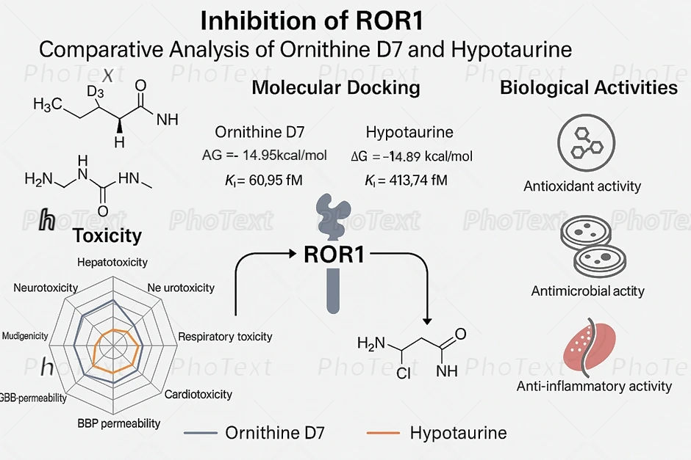
Molecular docking visualization and binding affinity analysis of selected ligands (Ornithine D7 and Hypotaurine) against ROR1 and other immune checkpoints. The diagram illustrates the computational interaction of Hypotaurine and Ornithine D7 derived from Curcuma zedoaria and Curcuma caesia, respectively, showing significant binding affinity toward ROR1 receptor tyrosine kinase. The estimated binding energies and inhibition constants indicate strong inhibitory potential, with Hypotaurine showing a ΔG of –14.89 kcal/mol and Ki of 413.74 fM .Structural visualization revealed that Hypotaurine occupies the active binding pocket of ROR1, forming multiple hydrogen bonds and electrostatic interactions with key amino acid residues responsible for receptor activation Figure 3(a-b). These interactions suggest that Hypotaurine may sterically block Wnt5a binding, thereby preventing ROR1 dimerization and suppressing downstream PI3K/AKT and MAPK signaling pathways associated with cancer progression.

Comparative Bar Graph of Binding Energy (ΔG): Shows that Hypotaurine–ROR1 (–14.89 kcal/mol) has the highest binding affinity, followed closely by GPER.
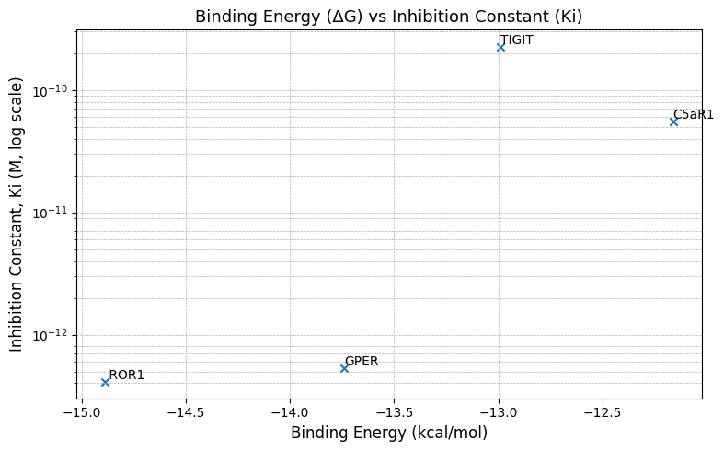
Shows ΔG vs Ki Scatter Plot (log scale): Illustrates the inverse relationship between ΔG and Ki, with ROR1 and GPER clustering in the femtomolar range, confirming their strong interaction potential.

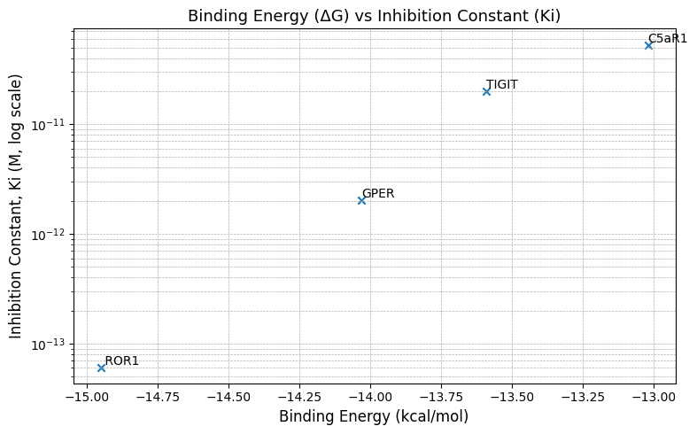Correlation between binding energy (ΔG) and inhibition constant (Ki) of ligand–target complexes. A scatter plot (log-scale Ki) demonstrating the inverse relationship between ΔG and Ki. Ornithine D7–ROR1 lies in the femtomolar range, confirming high-affinity binding.

combination could be explored for future anticancer strategies.
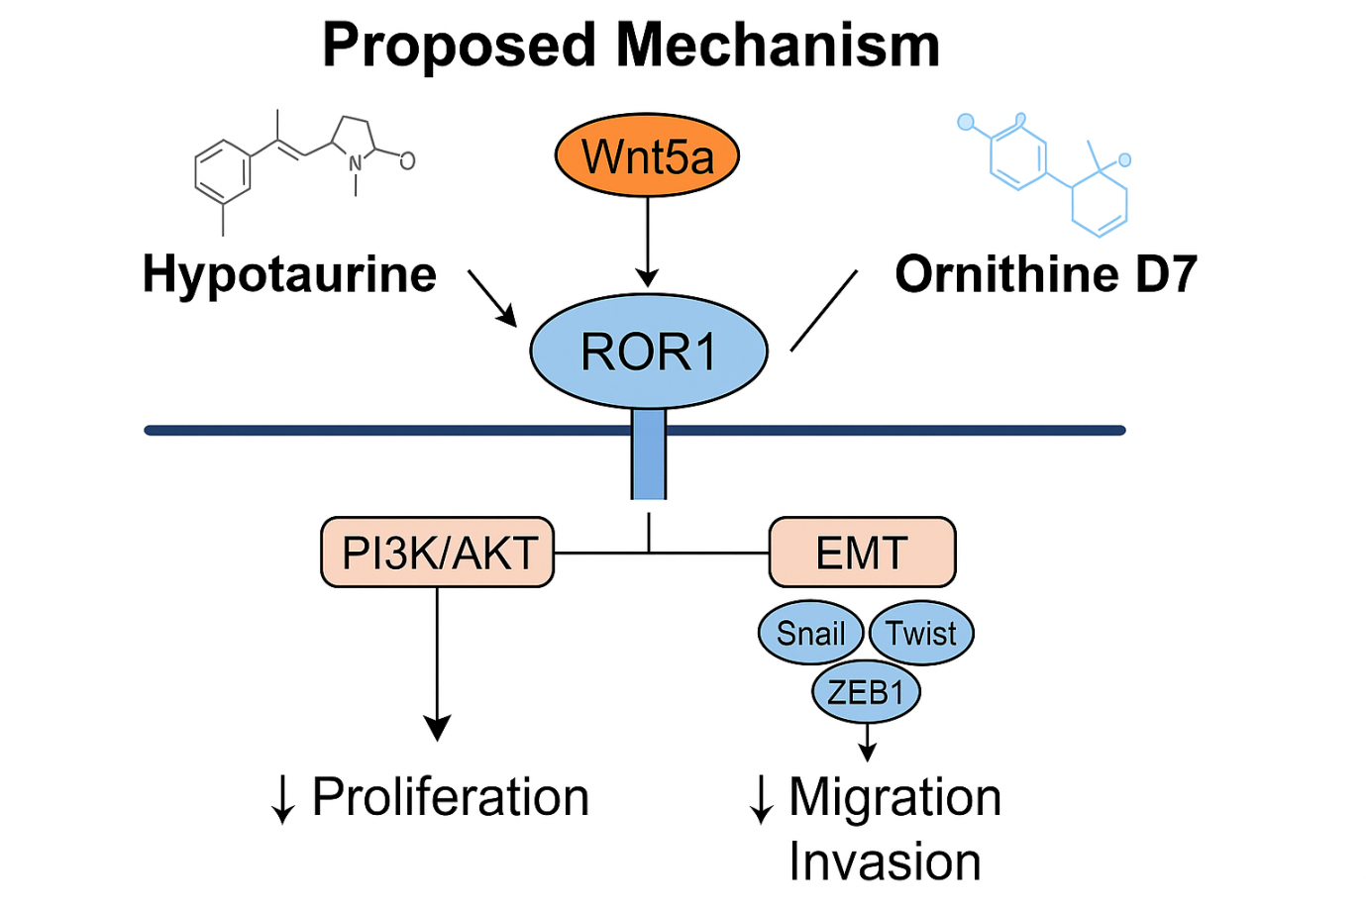
Proposed comparative mechanism of Hypotaurine and Ornithine D7 in inhibiting ROR1 signaling.

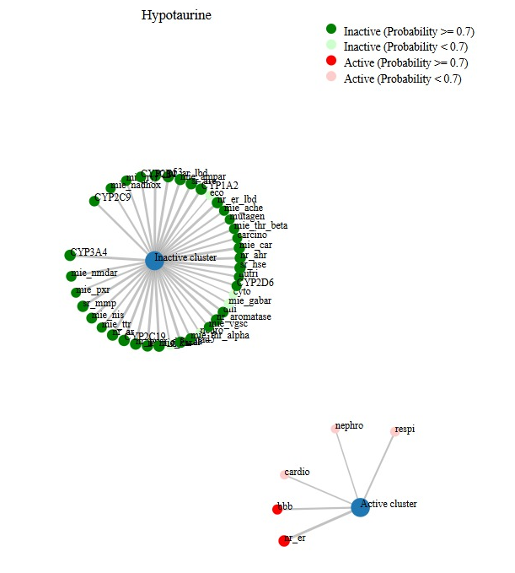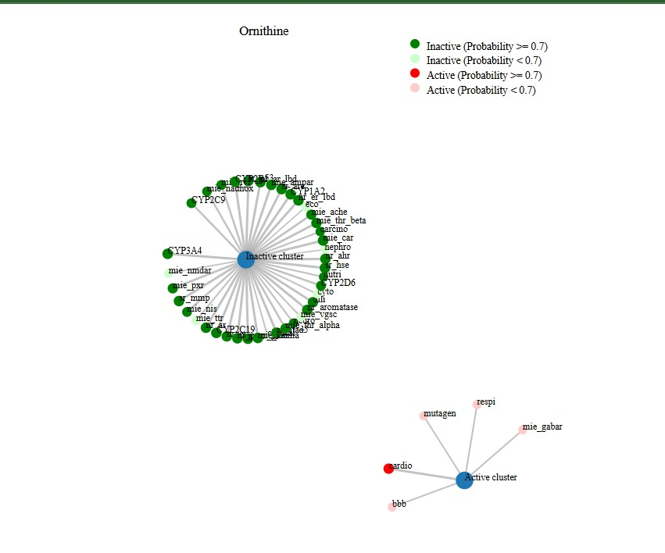
b)
a)
Network-based prediction of biological activity was performed to identify potential molecular interactions of selected bioactive compounds from Curcuma caesia and Curcuma zedoaria. • Panel A illustrates the predicted interaction profile of Hypotaurine, showing a dominant inactive cluster (green nodes), indicating minimal biological activity. A small active cluster suggests weak interactions with cardiovascular (cardio), nephrotoxicity (nephro), respiratory (respi), blood-brain barrier (bbb), and estrogen receptor (ER) pathways.• Panel B presents Ornithine, which also shows mostly inactive targets, but with slight predicted activity in cardio, bbb, respiratory (respi), GABA receptor modulation (mie_gabar), and mutagenicity (mutagen), indicating limited but specific biological engagement.

Proposed comparative mechanism of Hypotaurine and Ornithine D7 in inhibiting ROR1 signaling.

