Supplementary Information for
Polarization-coupled complete operators in sliding ferroelectric semiconductors for native in-memory attention computing
Di Wang et al.
*Corresponding authors. E-mail addresses: hkxlwu@nju.edu.cn (Xinglong Wu); zhangjinlei@mail.usts.edu.cn (Jinlei Zhang); wuhyi@connect.hku.hk (Hongyi Wu); zouynn@nju.edu.cn (Yinuo Zou)

The PDF file includes:
Supplementary Note 1
Supplementary Figures 1 to 10
References

Supplementary Note 1: Simulation methods
Device-level simulations were performed using experimentally measured I–V characteristics and resistance-state distributions as input parameters. A numerical framework based on a dual-barrier ferroelectric-coupling model was constructed to fit the dependence of device resistance on pulse amplitude and polarization state. All simulations were conducted in Python using SciPy for parameter regression. A Monte Carlo device model was further established using experimentally extracted high/low resistance ranges, exponential-mapping relations, and state-noise statistics.
For array-level simulations, the actual (9×3)×9 topology was implemented, incorporating non-idealities such as row/column addressing delays, parasitic coupling, readout resistance, and pulse attenuation to closely match hardware behavior. The inference procedure mirrors the hardware workflow: quantized weights are first written into the virtual array, followed by sequential row readout, linear accumulation, exponential mapping, and normalization.
System-level simulations were carried out by constructing a lightweight generative-model framework in Python, using the simulated array output conductance as intermediate network features. The effects of device noise, weight perturbation, and pulse errors on generation accuracy were statistically analyzed. All simulations were repeated at least 20 times under a fixed random seed to ensure statistical stability.
The first-principles calculation was based on the pseudo-potential density-functional-theory (DFT) code Vienna Ab initio Simulation Package (VASP) with the projected augmented wave (PAW) method. The generalized-gradient-approximation (GGA) was adopted using the Perdew–Burke–Ernzerhof (PBE) exchange-correlation functional. The lattice constants were set as 6.41 and 6.54 Å for the a and b axes, respectively, and the angle between the a and b axes was set as 119.3°. Meanwhile, the height of the vacuum layer was set as 20 Å to prevent interlayer interactions. In the relaxations, the convergence criteria were set to be 0.001 eV/Å and 10−5 eV/atom, respectively, with a 5×5×1 Monkhorst-Pack k-point grid and a 550 eV energy cutoff. The van der Waals (vdW) interactions were semi-empirically described by the DFT-D3 correction method of Grimme. The electric polarization was calculated by the evaluation of the Berry phase expressions according to the modern theory of polarization.
The 1T monolayer ReS₂ is known to undergo a spontaneous lattice distortion to the 1T’ structure where the Re atoms form characteristic in-plane Re–Re zigzag chains. The 1T′ monolayer ReS₂ has the inversion symmetry, which prohibits the emergence of polarization. To study the sliding ferroelectricity of bilayer ReS₂, we first stack two monolayers according to the xy-plane mirror symmetry, then slide the upper layer along the a and b axes with the sliding distance $\left(l_{a},l_{b}\right)$. The method is the same as that in ref. 27.
For in-plane transport through the FeS-FET channel, the carrier densities in monolayer or few-layer ReS₂ are described by Fermi–Dirac statistics as
$n=\frac{g_{c}}{t_{L}}k_{B}T\log\left(1+\text{exp}\left(\frac{E_{F}-E_{C}-eV}{k_{B}T}\right)\right)$
$p=\frac{g_{V}}{t_{L}}k_{B}T\log\left(1+\text{exp}\left(\frac{E_{V}+eV-E_{F}}{k_{B}T}\right)\right)$
respectively, with $g_{c(V)}=\frac{2m_{C(V)}}{πℏ^{2}}$ the 2D electronic (hole) density of states (DOS), where the electronic (hole) effective mass $m_{C(V)}$ is obtained from the curvature of the conduction (valence) band in the vicinity of its minimum (maximum). $t_{L}$ is the layer thickness. The resistance of FeS-FET devices can be written as $R=\frac{1}{σ_{C}+σ_{V}}∙\frac{L_{ch}}{S_{ch}}$ where the electronic and hole conductivities are $σ_{C}=enμ$ and $σ_{V}=epμ$, respectively, with $μ$ the carrier mobility, which was taken as 16 cm²V⁻¹s⁻¹ (ref. 41). Here, $L_{ch}$ and $S_{ch}$ are the length and section area of the channel. In experiment, the majority carriers of a monolayer or few-layer ReS₂ FeS-FET device are electrons, which dominate the contribution to the resistance.
For out-of-plane transport across the FTJ, the electronic conductivity along the z-axis was calculated using the semi-empirical Boltzmann transport theory⁴², which adopts a constant relaxation time $τ$, irrelevant with the band index and the wave vector. In our calculation, it is set as 10⁻¹⁶ s.
According to the Wentzel-Kramers-Brillouin (WKB) approximation, the transmission through the FTJ is $T≈\text{exp}\left(-2t_{L}\frac{\sqrt{2m_{C}\left(E_{C}+eV-E\right)}}{ℏ}\right)$. Here, the FTJ is simplified as a 1D square barrier, with $t_{L}$ the barrier width. In the linear response regime, $R_{FTJ}=\frac{h}{e^{2}}\text{exp}\left(2t_{L}\frac{\sqrt{2m_{C}\left(E_{C}+eV-E_{F}\right)}}{ℏ}\right)=α_{1}\text{exp}\left(c_{1}\sqrt{E_{C}+eV-E_{F}}\right)$ with $α_{1}=\frac{h}{e^{2}}$ and $c_{1}=2t_{L}\frac{\sqrt{2m_{C}}}{ℏ}$. On the other hand, the electronic density in the ReS₂ FeS-FET device is approximately $n\sim \text{exp}\left(\frac{E_{F}-E_{C}-eV}{k_{B}T}\right)$, and the resistance $R_{FeS-FET}=\frac{L_{ch}}{eμS_{ch}}{\left(\frac{g_{C}k_{B}T}{t_{L}}\right)}^{-1}\text{exp}\left(\frac{E_{C}+eV-E_{F}}{k_{B}T}\right)=α_{2}\text{exp}\left[c_{2}\left(E_{C}+eV-E_{F}\right)\right]$. As a result, we can obtain the relation $R_{FeS-FET}=α_{2}{\left(\frac{R_{FTJ}}{α_{1}}\right)}^{\frac{c_{2}}{{c_{1}}^{2}}ln\left({R_{FTJ}}/{α_{1}}\right)}$, where $\frac{c_{2}}{{c_{1}}^{2}}=\frac{ℏ^{2}}{8k_{B}T{t_{L}}^{2}m_{C}}$, yielding:
$$\ln{R_{FeS-FET}}∝{\ln{R_{FTJ}}}^{ }$$
For high-field operation, the out-of-plane transport across the FTJ can be further described by the Fowler–Nordheim tunneling model:
$J_{FTJ}=AE^{2}exp⁡\left(-\frac{Bϕ_{B}^{3/2}}{E}\right)$ (3)
where E is the effective electric field and $ϕ_{B}^{ }$ is the polarization-modulated tunneling barrier. The tunnel resistance satisfies $\ln{R_{FTJ}}$ $∝$ $ϕ_{B}^{3/2}$. Since both transport channels are controlled by the same sliding-ferroelectric polarization state, eliminating the intermediate barrier term gives:
$\ln{R_{FeS-FET}}∝{\left(\ln{R_{FTJ}}\right)}^{\frac{2}{3}}$ (4)
This indicates an intrinsic nonlinear coupling between the vertical tunneling resistance and the lateral channel resistance under the FN regime, thereby expanding the accessible nonlinear operating space of the coupled ferroelectric architecture. This relationship accounts for the results shown in Fig. 1c.

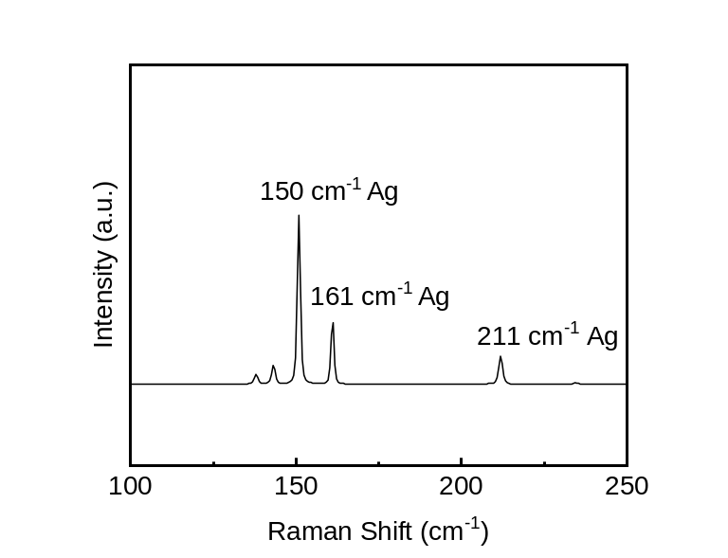
Supplementary Figure S1 | Raman spectroscopy of ReS₂. The representative Raman spectrum of exfoliated ReS₂ shows three characteristic in-plane vibrational modes at approximately ~150, ~161, and ~211 cm⁻¹, corresponding to the Ag phonon modes. The presence and relative intensity of these peaks confirm both the crystallographic phase and the high crystalline quality of the ReS₂ flakes.

Supplementary Figure S2 | Atomic force microscopy (AFM) topography. AFM height image of a representative ReS₂ flake deposited on the substrate. The dashed line indicates the position where the height profile is extracted.

Supplementary Figure S3 | Long-term retention of the resistive states measured over more than one year. a-b, Retention characteristics of representative HRS and LRS in the FeS-FET (a) and the FTJ (b). The resistance states were measure up to 10⁵ s and remeasured at 10⁷ s, confirming that both states remain well separated after long-term storage.

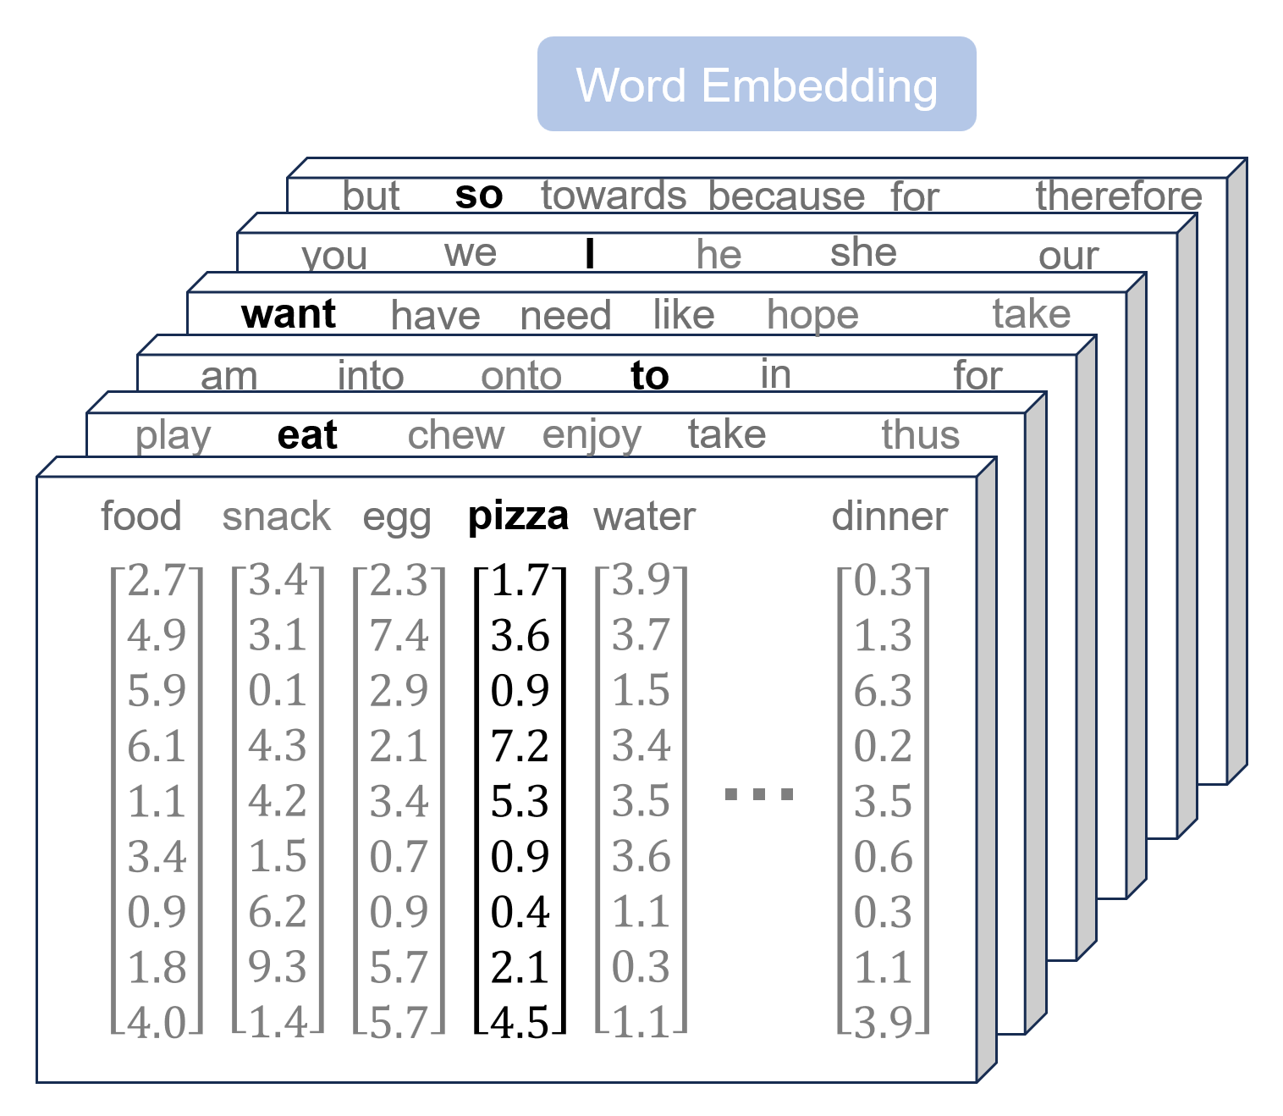
Supplementary Figure 4 | Schematic illustration of the nine-dimensional word embedding representation used in the hardware-based generative task. Each word in the vocabulary is encoded as a 9-element numerical vector, corresponding directly to the nine input channels of the COA array. Representative embedding vectors for selected tokens (e.g., “want”, “eat”, “pizza”) illustrate how semantic information is distributed across the nine dimensions.

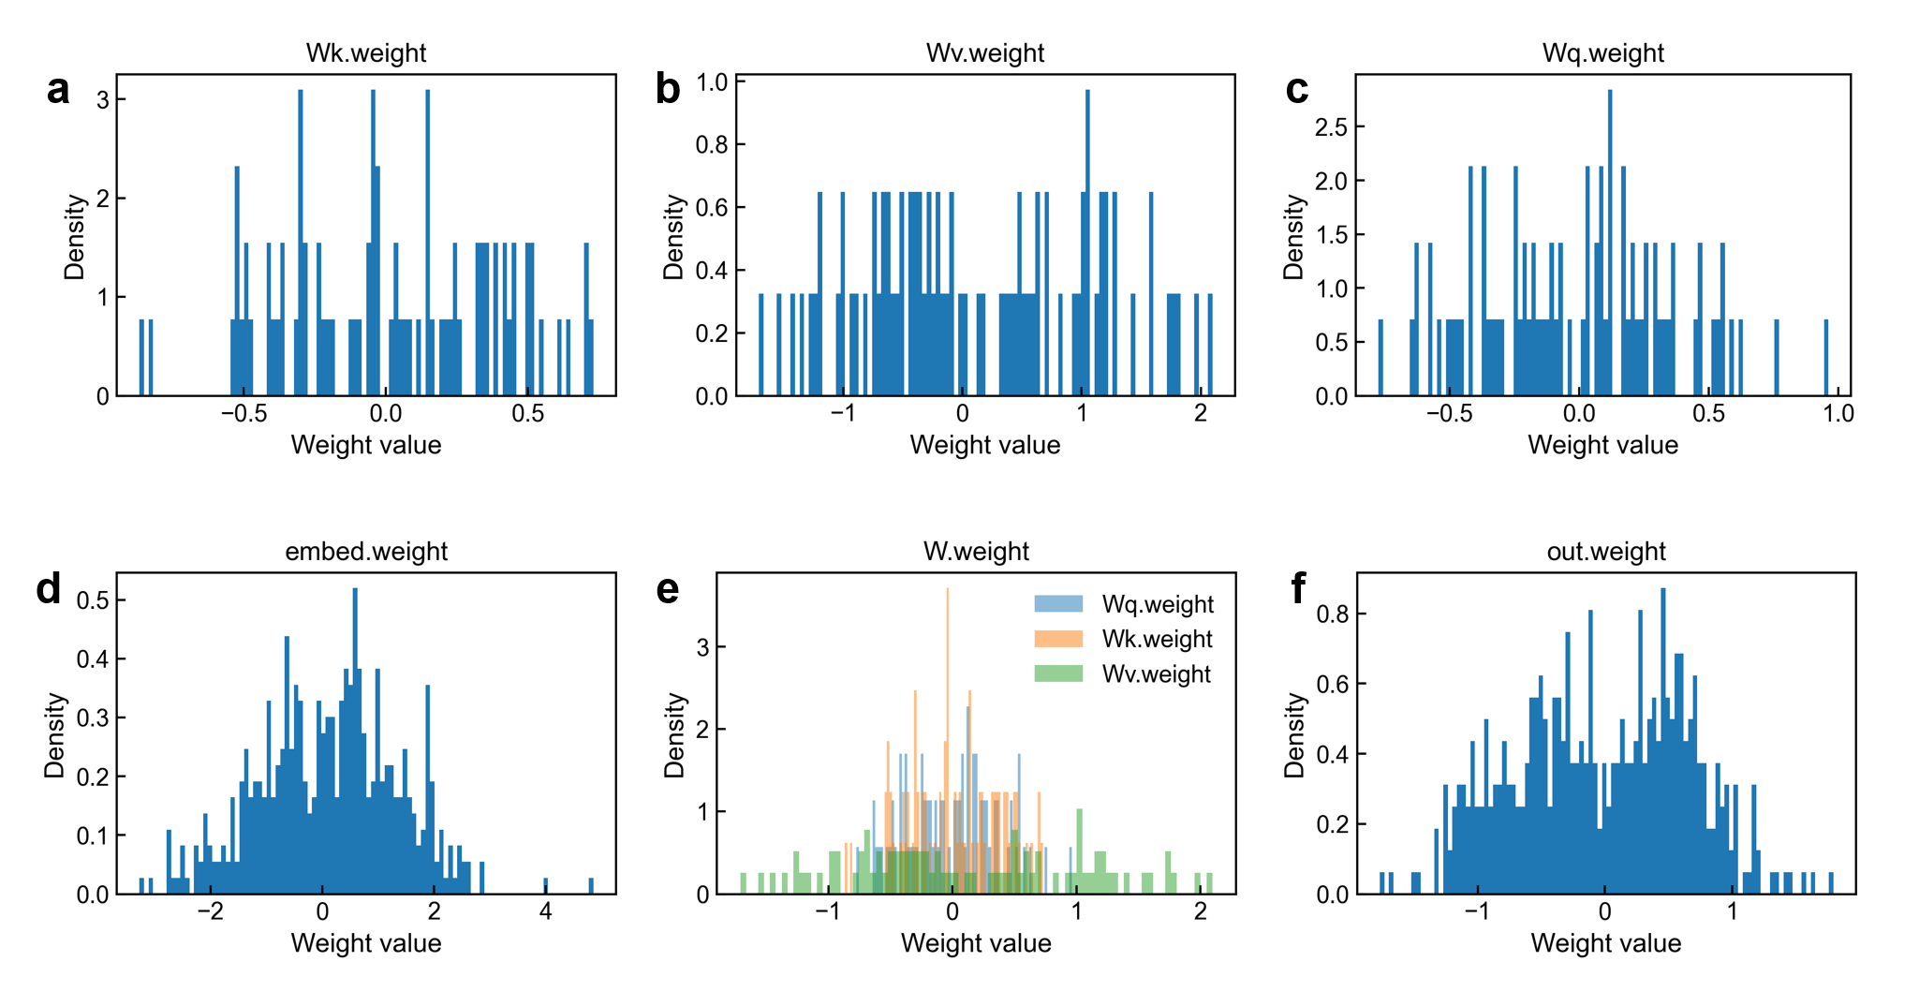
Supplementary Figure 5 | Distributions and comparison of projection weights. a, Distribution of the trained key projection weights (W_{k}). b, Distribution of the trained value projection weights (W_{v}). c, Distribution of the trained query projection weights (W_{q}). d, Distribution of the learned word embedding weights, reflecting the numerical range of the nine-dimensional input representations. e, Combined comparison of the weight distributions for W_{q}, and Wv, highlighting their relative scales and overlap. f, Distribution of the output projection weights (W_{out}). These statistical results confirm that all weight matrices stay within a bounded and hardware-compatible numerical range after training.

Supplementary Figure 6 | Estimated latency and energy comparison with conventional CIM. (a) Estimated latency and energy consumption for transformer attention executed by the hardware COA array, compared with a conventional analog CIM implementation. (b) Estimated latency and energy consumption for the large-scale measured-parameter generative simulation using measured device parameters, compared with a conventional analog CIM implementation.

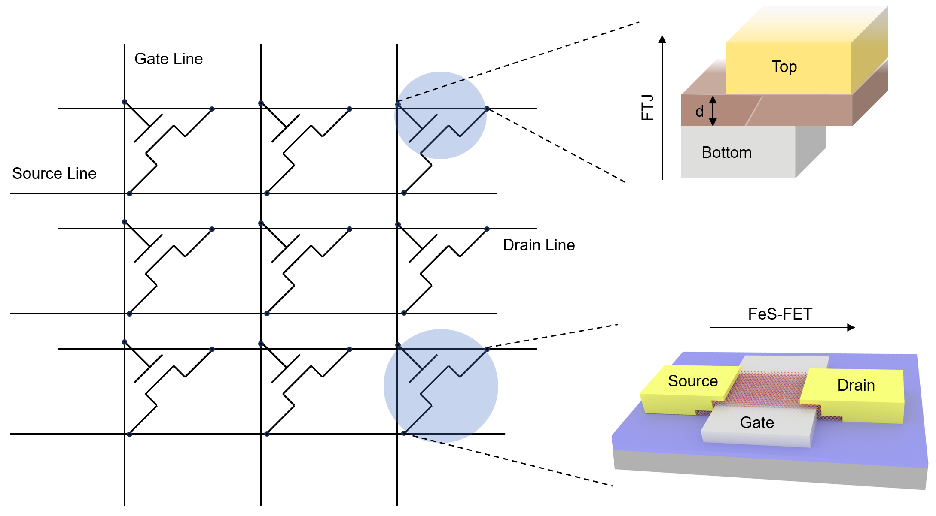
Supplementary Figure 7 | Schematic illustration of the three-terminal COA unit cell and its arrangement in an array architecture. Each unit cell integrates a lateral FeS-FET and a vertical FTJ sharing a common source line. The gate, source, and drain lines are orthogonally organized to enable independent addressing of in-plane transport and out-of-plane tunneling within the same physical unit. Enlarged schematic views highlight the vertical FTJ structure, defined by top and bottom electrodes with a ferroelectric barrier of thickness d, as well as the lateral FeS-FET structure with source, drain, and gate electrodes, illustrating the dual-channel configuration enabled by the shared ferroelectric medium.

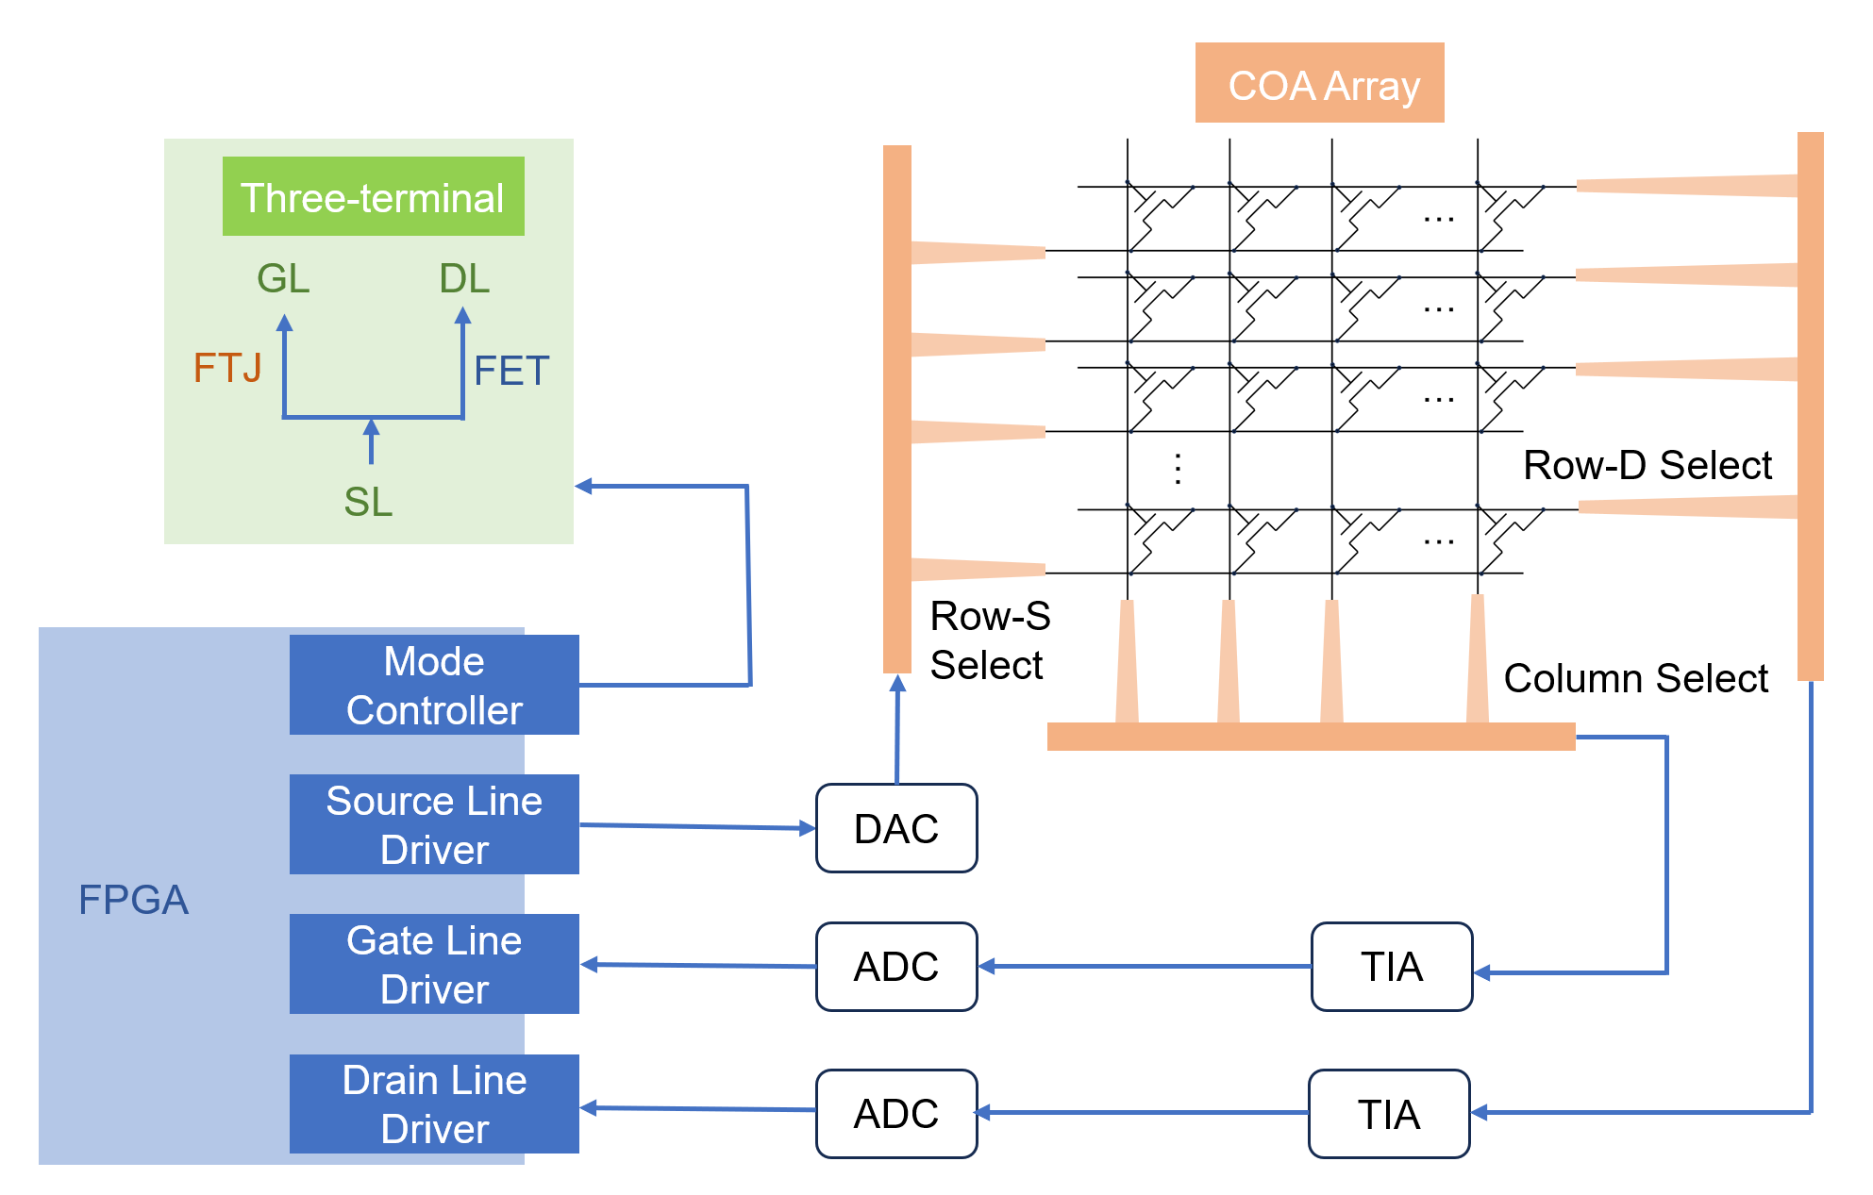
Supplementary Figure 8 | Block diagram of the experimental measurement and control system for the COA array. This scheme illustrates the three-terminal addressing using gate line (GL), source line (SL), and drain line (DL). The system-level architecture integrates the COA array with FPGA-based control electronics, including row-source (Row-S), row-drain (Row-D), and column selection, along with peripheral digital-to-analog converters (DACs), analog-to-digital converters (ADCs), and transimpedance amplifiers (TIAs), enabling programmable write–read operations and parallel array-level measurements.

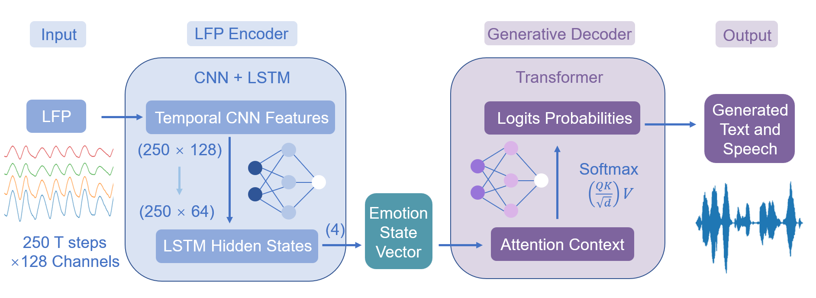
Supplementary Figure 9 | Detailed algorithmic structure and layer-wise parameters of the generative model used in the simulations. The LFP encoder takes preprocessed LFP signals of shape 250×128 (time steps × channels) as input. A one-dimensional temporal convolution layer is applied first, with 128 input channels, 64 output channels, a kernel size of 3, and a padding of 1. This is followed by batch normalization, ReLU activation, and a dropout rate of 0.3. The resulting feature map retains the temporal length of 250 and is reshaped into a sequence of 250 feature vectors, each with 64 dimensions. These features are then processed by a two-layer LSTM with a hidden size of 64, operating in batch-first mode. The hidden state at the final time step is extracted and passed through a fully connected classifier, which consists of a 64-unit linear layer, ReLU activation, dropout (0.3), and a final linear projection to 4 output classes, resulting in a compact emotion state representation. The generative decoder is implemented as a lightweight Transformer model with a vocabulary size of 256 and an embedding dimension of 9. Each input token is mapped to a 9-dimensional embedding vector, which is then linearly projected into query (Q), key (K), and value (V) representations using three independent linear layers of size 9×9, all without bias. The context is then passed through a final linear layer of size 9×256 to produce token logits, which are normalized by Softmax during inference to generate probabilistic text outputs.
Supplementary Figure 10 | Emotion-intensity-dependent semantic controllability in COA-based generation. a, Emotion-intensity–dependent spectrograms and generated sentences, illustrating the tunability of semantic strength. As hunger intensity gradually increases, the model generates sentences that smoothly transition from mild intent (“I feel a little hungry, I want to look for a snack”) to urgent necessity (“I am starving! I must eat something immediately”). b, Probability evolution of key intention verbs (“want,” “need,” “must”) as a function of emotion intensity.

References
- Vaswani, A. et al. Attention is all you need. In Proc. 31st International Conference on Neural Information Processing Systems, NIPS’ 17 6000-6010 (Curran Associates, 2017).
- Leroux, N., Manea, PP., Sudarshan, C. et al. Analog in-memory computing attention mechanism for fast and energy-efficient large language models. Nat. Comput. Sci. 5, 813-824 (2025).
- Xia, Q., Yang, J. J. Memristive crossbar arrays for brain-inspired computing. Nat. Mater. 18, 309-323 (2019).
- Singh, A., Le Gallo, M., Vasilopoulos, A. et al. The design of analogue in-memory computing tiles. Nat Electron 8, 1156–1169 (2025).
- Huang, Y., Ando, T., Sebastian, A. et al. Memristor-based hardware accelerators for artificial intelligence. Nat. Rev. Electr. Eng. 1, 286-299 (2024).
- Yao, P., Wu, H., Gao, B. et al. Fully hardware-implemented memristor convolutional neural network. Nature 577, 641-646 (2020).
- Aguirre, F., Sebastian, A., Le Gallo, M. et al. Hardware implementation of memristor-based artificial neural networks. Nat. Commun. 15, 1974 (2024).
- Rasch, M. J., Carta, F., Fagbohungbe, O. et al. Fast and robust analog in-memory deep neural network training. Nat. Commun. 15, 7133 (2024).
- Ning, H., Yu, Z., Zhang, Q. et al. An in-memory computing architecture based on a duplex two-dimensional material structure for in situ machine learning. Nat. Nanotechnol. 18, 493-500 (2023).
- Sebastian, A., Le Gallo, M., Khaddam-Aljameh, R. et al. Memory devices and applications for in-memory computing. Nat. Nanotechnol. 15, 529-544 (2020).
- Lanza, M., Pazos, S., Aguirre, F. et al. The growing memristor industry. Nature 640, 613-622 (2025).
- Zhou, J., Li, W., Chen, Y. et al. Optoelectronic polymer memristors with dynamic control for power-efficient in-sensor edge computing. Light Sci. Appl. 14, 309 (2025).
- Choi, Y., Jeong, S., Jeong, H. et al. Advanced AI computing enabled by 2D material-based neuromorphic devices. npj Unconv. Comput. 2, 8 (2025).
- Jain, S., Li, S., Zheng, H. et al. Heterogeneous integration of 2D memristor arrays and silicon selectors for compute-in-memory hardware in convolutional neural networks. Nat. Commun. 16, 2719 (2025).
- Hong, H., Du, Z., Jiang, M. et al. Memristor-based adaptive analog-to-digital conversion for efficient and accurate compute-in-memory. Nat. Commun. 16, 9749 (2025).
- Schranghamer, T. F., Pannone, A., Kumar, J. M. et al. Large-scale crossbar arrays based on three-terminal MoS₂ memtransistors. Nat. Commun. 16, 9518 (2025).
- Du, N., Polian, I., Bengel, C. et al. Mixed-mode in-memory computing: towards high-performance logic processing in a memristive crossbar array. Commun. Eng. 4, 163 (2025).
- Martemucci, M., Rummens, F., Malot, Y. et al. A ferroelectric–memristor memory for both training and inference. Nat. Electron. 8, 921-933 (2025).
- Zolfagharinejad, M., Büchel, J., Cassola, L. et al. Analogue speech recognition based on physical computing. Nature 645, 886-892 (2025).
- Li, S., Li, B., Feng, X. et al. Electron-beam-irradiated rhenium disulfide memristors with low variability for neuromorphic computing. npj 2D Mater Appl 5, 1 (2021).
- Yang, J., Mao, R., Jiang, M. et al. Efficient nonlinear function approximation in analog resistive crossbars for recurrent neural networks. Nat. Commun. 16, 1136 (2025).
- Liu, Y., Tang, W., Zeng, J. et al. Ferroelectric-based neuromorphic memory devices for bio-inspired computing. Nat. Rev Electr. Eng. 2, 773-787 (2025).
- Pantel, D., Alexe, M. Electroresistance effects in ferroelectric tunnel barriers. Phys. Rev. B 82, 134105 (2010).
- Maksymovych, P. et al., Polarization control of electron tunneling into ferroelectric surfaces. Science 324, pp.1421−1425 (2009).
- Si, M., Saha, A.K., Gao, S. et al. A ferroelectric semiconductor field-effect transistor. Nat. Electron. 2, 580-586 (2019).
- Wang, S., Liu, L., Gan, L. et al. Two-dimensional ferroelectric channel transistors integrating ultra-fast memory and neural computing. Nat. Commun. 12, 53 (2021).
- Wan, Y., Hu, T., Mao, X. et al. Room-Temperature Ferroelectricity in 1T′-ReS₂ Multilayers. Phys. Rev. Lett. 128, 067601 (2022).
- Zhang, Q., Fan, A., Wang, Y. et al. Emerging frontiers in two-dimensional sliding ferroelectrics. npj 2D Mater. Appl. 9, 76 (2025).
- Zhong, T.-T., Wu, M.-H. Research progress of two-dimensional interlayer-sliding ferroelectricity. Acta Phys. Sin. 69, 217707 (2020).
- HuangFu, C., Zhou, Y., Ke, C. et al. Out-of-plane ferroelectricity in two-dimensional 1T-MoS₂ above room temperature. ACS Nano 18, 14708-14715 (2024).
- Cui, C., Hu, W.-J., Yan, X. et al. Intercorrelated in-plane and out-of-plane ferroelectricity in ultrathin two-dimensional layered semiconductor In₂Se₃. Nano Lett. 18, 1253-1258 (2018).
- Kaiser, M. A. A., Adebunmi, K. O., You, H. et al. Multi-functional polymorphic memory based on 2D ferroelectric tunnel junctions. npj 2D Mater. Appl. 9, 85 (2025).
- Berdan, R., Marukame, T., Ota, K. et al. Low-power linear computation using nonlinear ferroelectric tunnel junction memristors. Nat. Electron. 3, 259-266 (2020).
- Luo, Z., Wang, Z., Guan, Z. et al. High-precision and linear weight updates by subnanosecond pulses in ferroelectric tunnel junction for neuro-inspired computing. Nat. Commun. 13, 699 (2022).
- Xu, Y. X. et al. Ferroelectric FET-based context-switching FPGA enabling dynamic reconfiguration for adaptive deep learning machines. Sci. Adv. 10, eadk1525 (2024).
- Liu, Z., Mei, J., Tang, J. et al. A memristor-based adaptive neuromorphic decoder for brain–computer interfaces. Nat. Electron. 8, 362-372 (2025).
- Wairagkar, M., Card, N. S., Singer-Clark, T. et al. An instantaneous voice-synthesis neuroprosthesis. Nature 644, 145-152 (2025).
- Anderson, A. J., Fernandino, L., Gross, W. L.et al. Neural decoding of autobiographical mental image features with a general semantic model. Nat. Commun. 16, 11208 (2025).
- Adikari, A., Alahakoon, D., Pallewela, N. et al. Reconstructing impaired language using generative AI for people with aphasia. Sci. Rep. 15, 40877 (2025).
- Jin, S., Li, J. Z., Jiang, L. Y. et al. Instant noninvasive near-infrared deep brain stimulation using optoelectronic nanoparticles without genetic modification, Sci. Adv. 11, eadt4771 (2025).
- Liu, E., Fu, Y., Wang, Y. et al. Integrated digital inverters based on two-dimensional anisotropic ReS₂ field-effect transistors. Nat. Commun. 6, 6991 (2015).
- Wang, V., Xu, N., Liu, J. C., Tang, G. et al. VASPKIT: A user-friendly interface facilitating high-throughput computing and analysis using VASP code. Comp. Phys. Comm. 175, 67 (2006).

