Extended Data Fig. 1 | PFM characterization of sliding ferroelectricity in different ReS₂ samples. a, Local piezoresponse hysteresis loop measured from a non-twisted bilayer ReS₂ flake, showing a butterfly-shaped amplitude response and a clear phase reversal under sweeping DC bias. b, PFM phase image of the same non-twisted bilayer ReS₂ sample after local polarization writing, displaying a well-defined ferroelectric domain pattern. Scale bar, 2 μm. c, PFM hysteresis loop measured from few-layer ReS₂, also showing pronounced amplitude switching and phase reversal.
Extended Data Fig. 2 | Coupled FeS-FET/FTJ device enabling tunneling–conduction correlation. a, Optical micrograph of the fabricated coupled device based on a ReS₂ ferroelectric layer, where the vertical FTJ and lateral FeS-FET are integrated within the same unit cell. b, Schematic illustration of the coupled operation mechanism: vertical transport is governed by polarization-modulated tunneling between the top and bottom electrodes, while lateral transport relies on polarization-controlled channel conduction between the source and drain. The shared ferroelectric polarization intrinsically links the tunneling resistance of the FTJ to the channel resistance of the FeS-FET, giving rise to an exponential correlation between the two transport modes.

Extended Data Fig. 3 | Switching cycles under ultrafast polarization pulses. a-c. Time-resolved resistance evolution under repeated ±3 V polarization pulses with 600 ps (a), 20 ns (b), and 100 ns (c) of durations. Stable and repeatable resistance switching is preserved across all pulse durations, demonstrating reliable endurance even under sub-nanosecond polarization excitation.
Extended Data Fig. 4 | Switching cycles under different thickness of the ReS₂ layer. a-c, Corresponding resistance evolution under cyclic polarization pulses (±3 V) for devices with ReS₂ thicknesses of 1.62 nm (a), 7.79 nm (b), and 17.45 nm (c), demonstrating stable and repeatable switching behavior in both FeS-FET and FTJ channels.

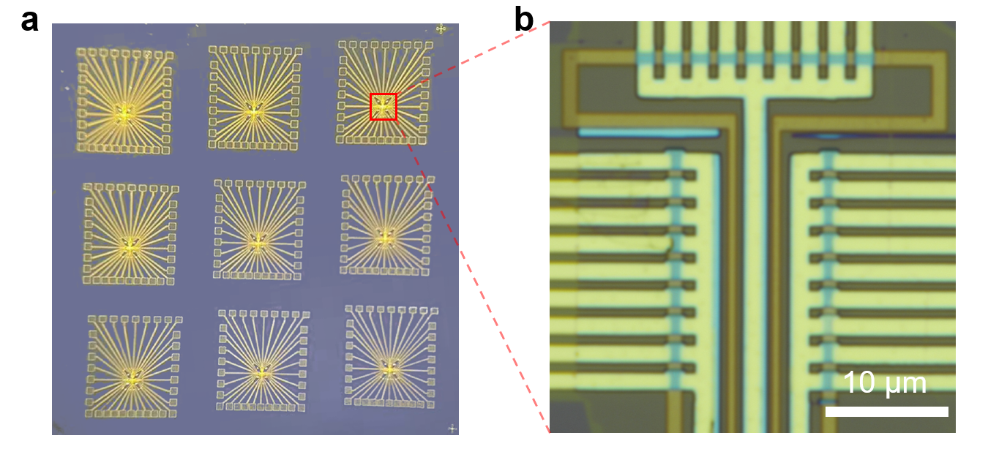
Extended Data Fig. 5 | Optical micrograph of device arrays. a, Optical micrograph of the fabricated (9×3)×9 device array, Comprising nine identical sub-arrays, each consisting of a 9×3 configuration of FeS-FET/FTJ coupled cells. The uniform layout and well-defined electrode geometry facilitate independent electrical addressing of individual devices across the array. b, Magnified optical image of a representative array unit highlighted in a, showing the detailed electrode routing and intersection geometry. The clearly separated source, drain, and gate lines define the multi-terminal structure required for lateral FeS-FET operation and vertical FTJ tunneling within the same physical cell.

Extended Data Fig. 6 | Uniform high-speed response and cycling endurance of the coupled FeS-FET/FTJ array. a-b, Cycle-dependent resistance evolution of nine representative array cells measured through in the FeS-FET (a) and FTJ (b) terminals of the COA array. Both terminals exhibit stable resistance modulation with small cell-to-cell variation and well-maintained resistance windows over 10⁵ cycles, demonstrating excellent array-level response uniformity and cycling endurance.

Extended Data Fig. 7 | Scaling behavior of array-level error with increasing cell number. Average array error as a function of the number of array cells. The mean error of individual cells was experimentally measured to be 4.6%. The red curve represents the theoretical error reduction expected from statistical averaging, while the blue bars show the experimentally extracted array errors. The decrease in error with increasing cell number indicates that cell-to-cell fluctuations are partially averaged out in larger arrays, thereby improving the array-level accuracy.
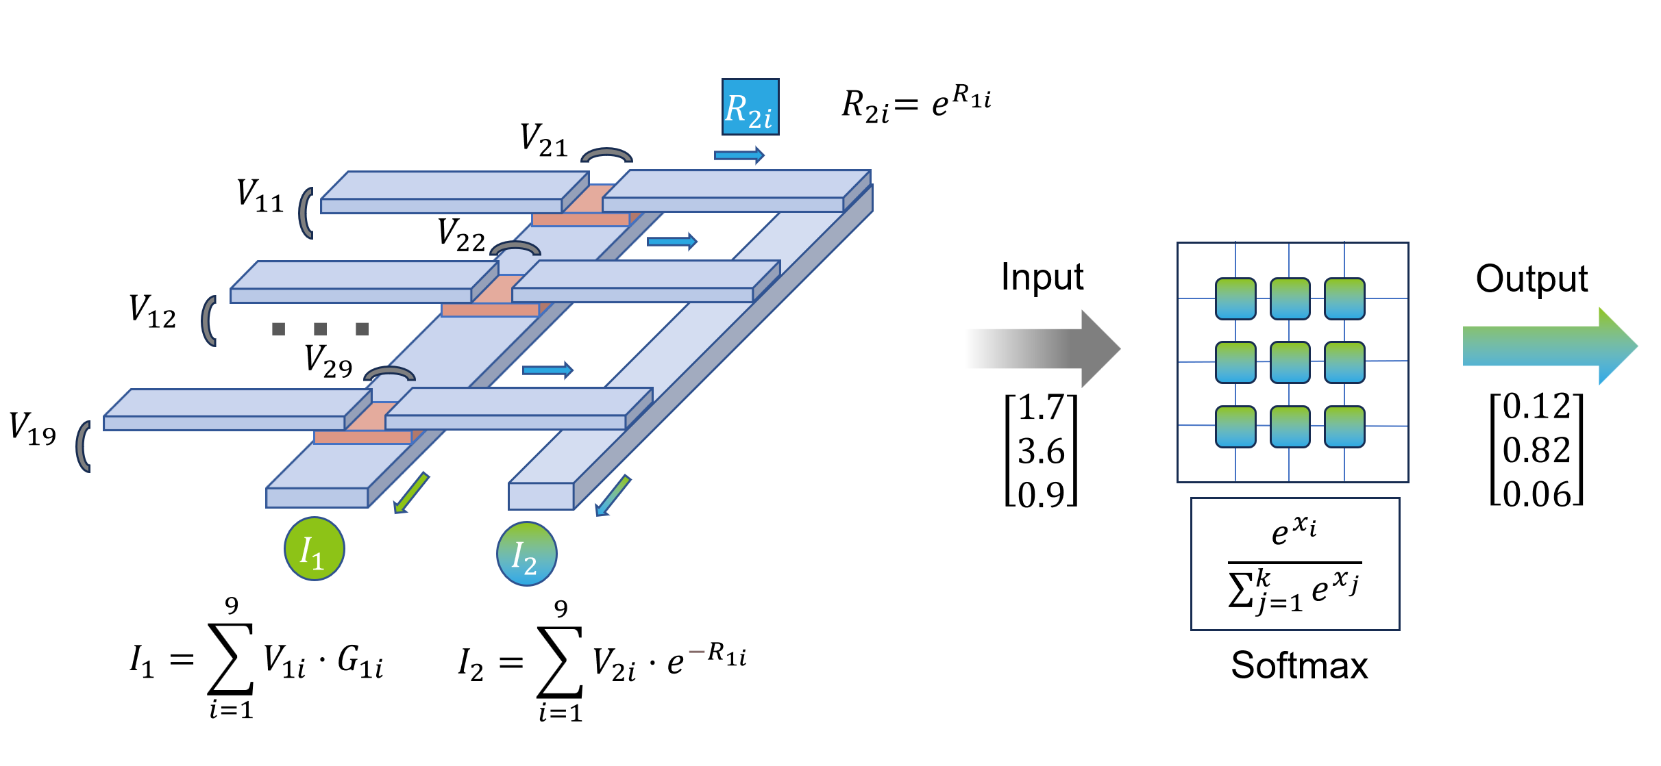
Extended Data Fig. 8 | Schematic illustration of in-memory Softmax computation realized by the COA array. Input voltages $V_{1i}$ and $V_{2i}$ are applied through polarization-controlled write–read operations to generate two current paths in situ within the same physical unit: a linear accumulation current $I_{1}=\sum_{i=1}^{9}{V_{1i}}⋅G_{1i}$ and an exponential-mapped current $I_{2}=\sum_{i=1}^{9}{V_{2i}}⋅e^{{-R}_{1i}}$, where the resistance state $R_{2i}=e^{R_{1i}}$ encodes the exponential mapping. The normalization inherent to the ratio between these currents enables the Softmax operation to be implemented directly within the array, without the need for external digital computation.
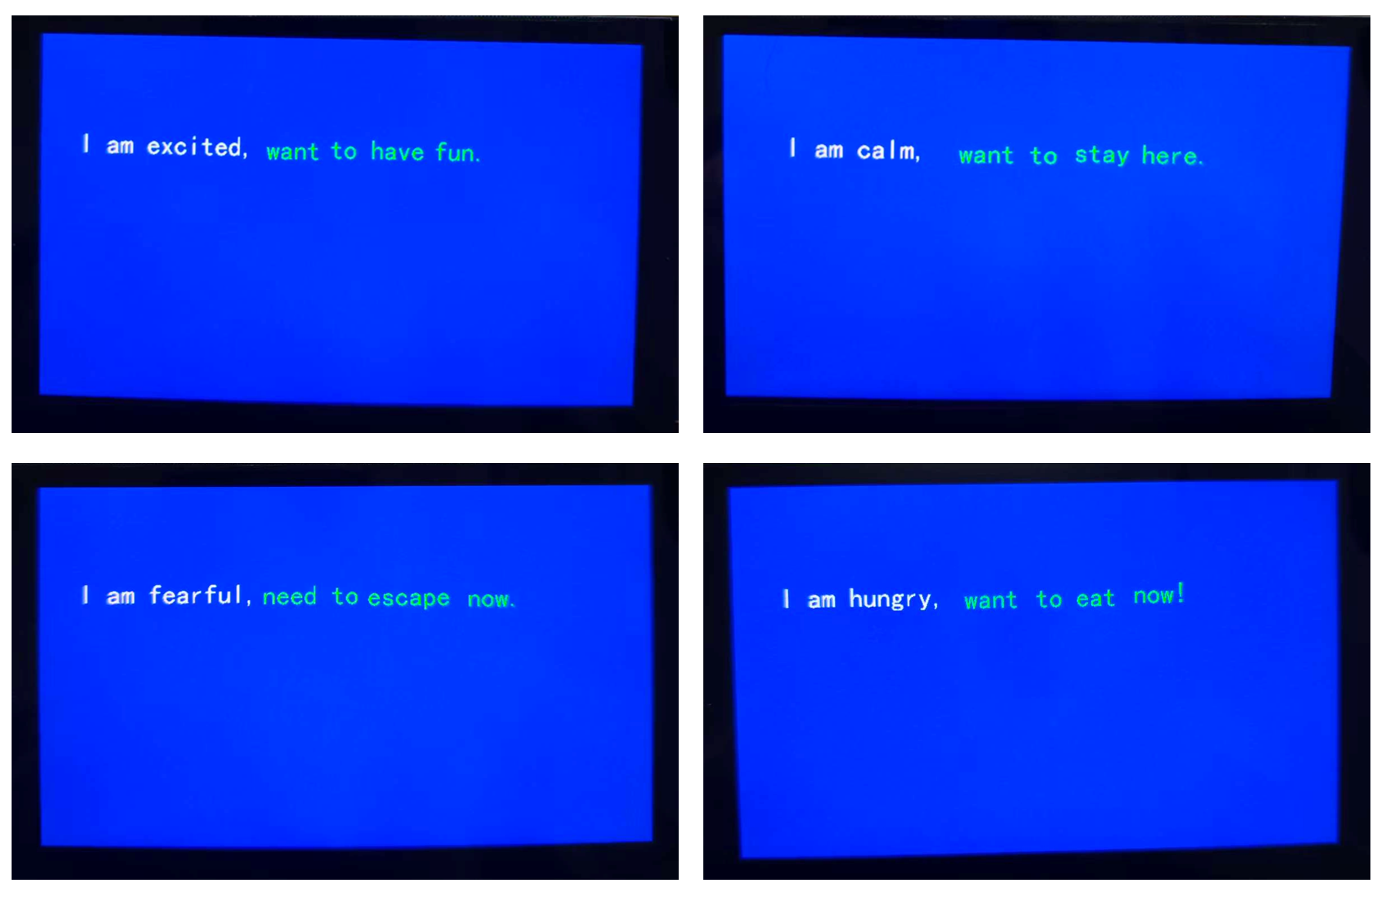
Extended Data Fig. 9 | Representative text generation results produced by the COA hardware system under different input emotional states, including excited, calm, fearful, and hungry. Each sentence is generated directly by the on-chip array and displayed in real time via the external interface.
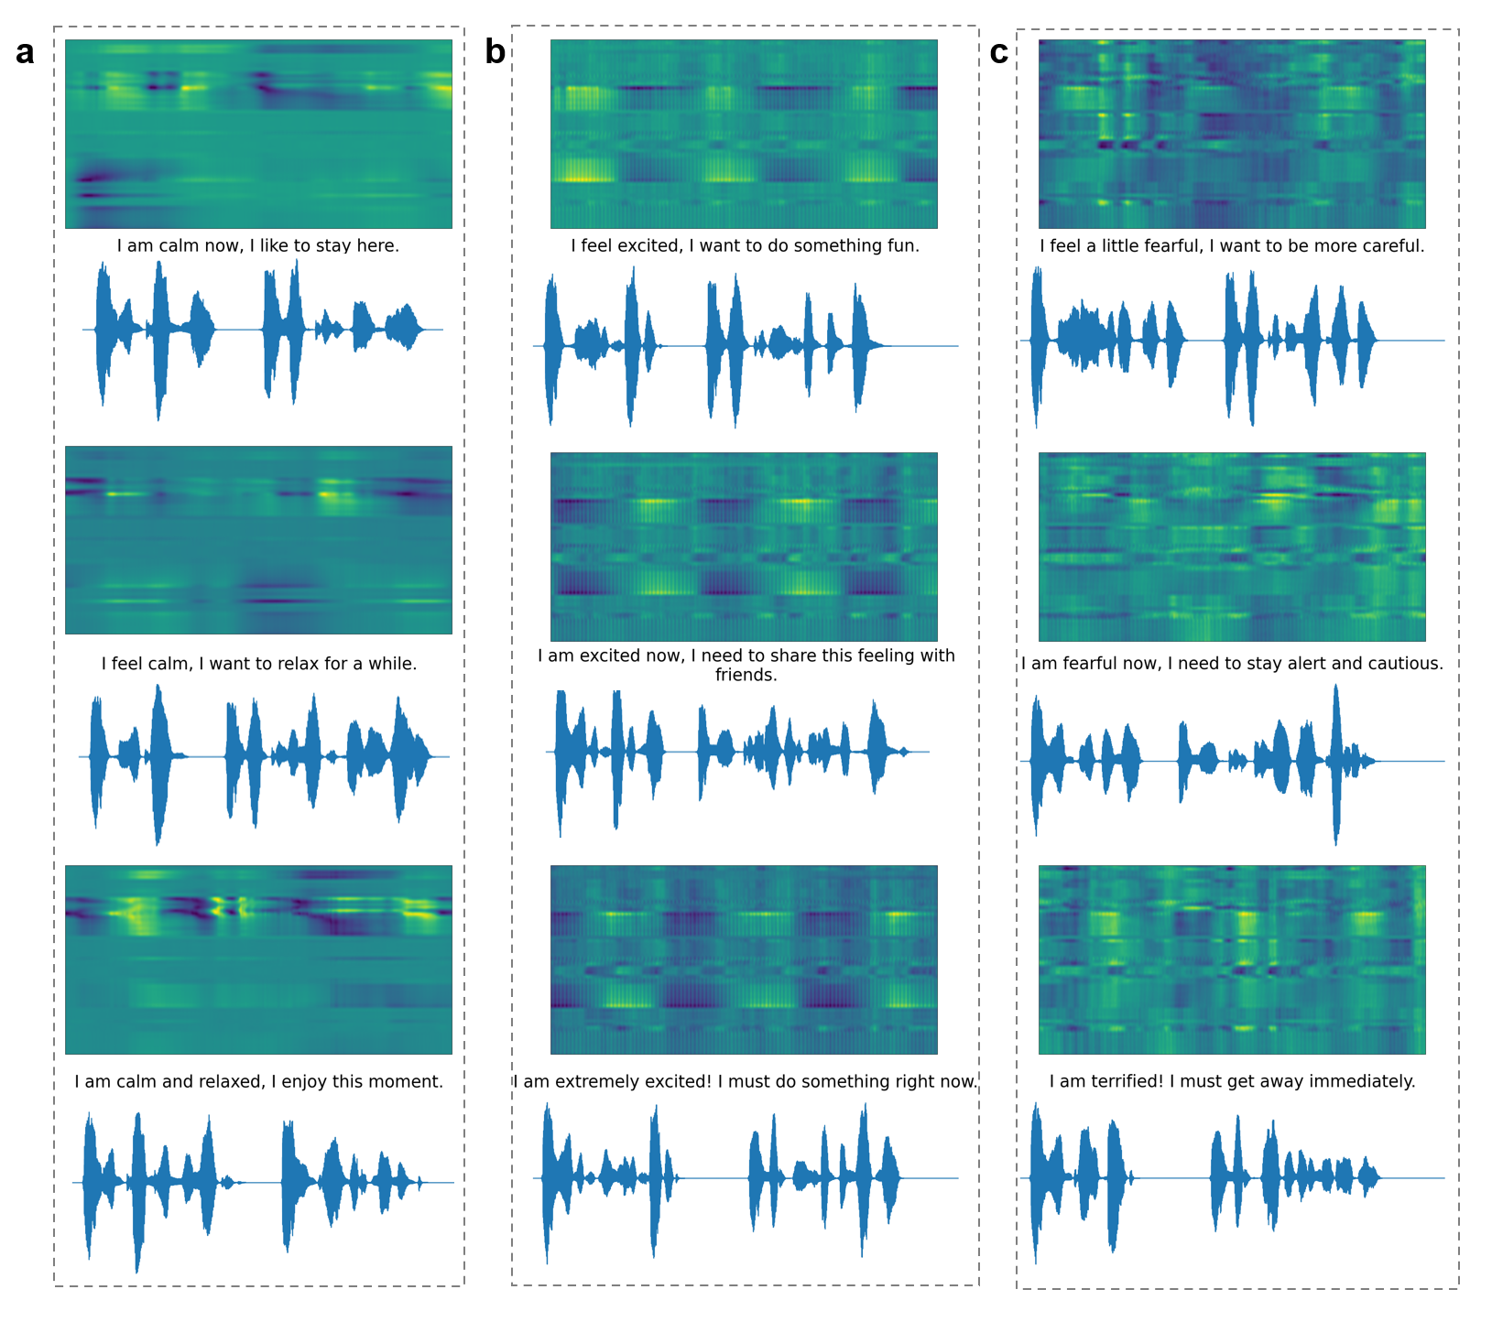
Extended Data Fig. 10 | Supplementary generation results under the calm, excited, and fearful emotional state. a, Supplementary generation results under the calm emotional state across different intensity levels show observable variations in the generated sentences. However, the overall semantic content and acoustic patterns remain relatively stable, suggesting that the calm emotion exhibits limited sensitivity to changes in emotional intensity. b, Supplementary generation results under the excited emotional state at different intensity levels reveal that as emotional intensity increases, the generated sentences exhibit progressively stronger expressive wording, along with more dynamic speech waveforms and heightened spectral activity. c, Supplementary generation results under the fearful emotional state at varying intensity levels show that higher emotional intensity leads to more urgent or cautious linguistic expressions, along with pronounced temporal and spectral variations in the synthesized speech. These supplementary results further demonstrate that the model captures emotion-dependent generation behaviors, with distinct sensitivities across different emotional categories.

