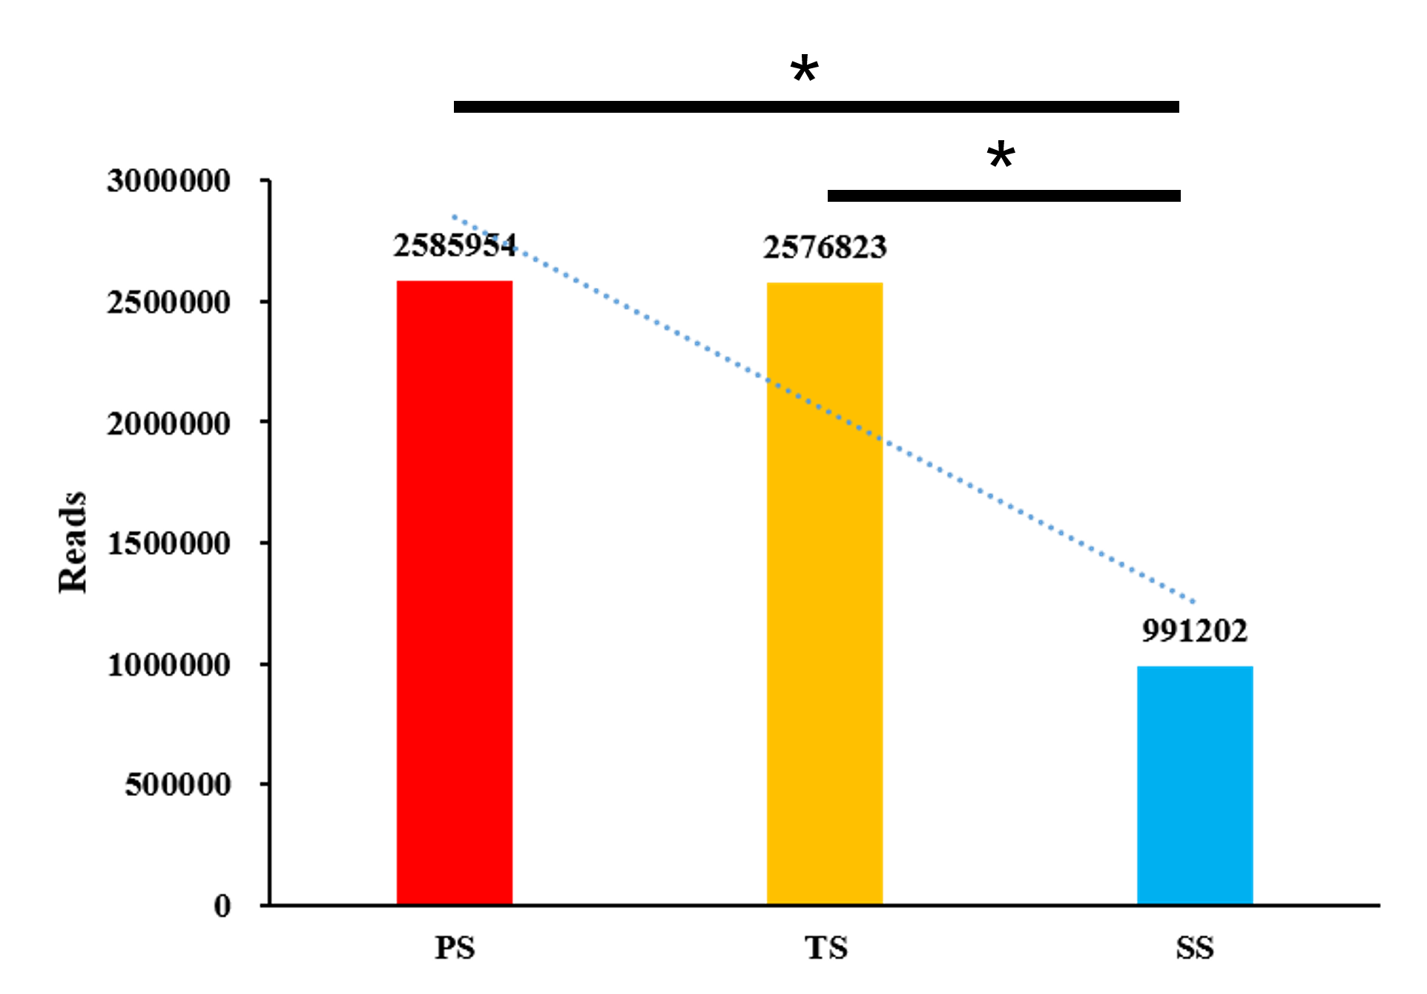

Fig S1 Reads of 24 nt sRNA in different development stage. The dotted blue line represents the trend line.

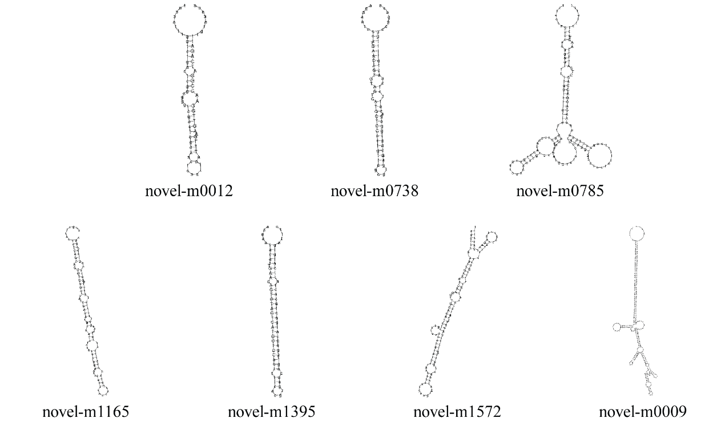

Fig S2 Stem–loop structure of selected novel miRNAs.

