Supplementary materials

Supplementary movie captions

Supplementary Movie S1: Hot steam condensation test. In a room temperature environment, the water vapor generated by boiling water impacts the surface of the coating and continuously condenses into tiny droplets on the STC surface. When the small droplets increase, they merge into large droplets and roll off.

Supplementary Movie S2: Large-scale ice removing test. In the refrigeration cycle tester, water was poured on the surface of pristine Al sheet and STC-Al sheet at -70 ºC for freezing treatment. After freezing for more than 1 hour, the two samples were taken out and immediately hit with a hammer to test the ice adhesion and deicing performance. The ice on the pristine Al sheet was difficult to remove after being impact by a hammer. In contrast, the ice fell in large chunks after lightly hitting the edge with a hammer, indicating the extremely low adhesion of the coating surface to the ice. The original audio of the video has been preserved.

Supplementary Movie S3: Long-term copper accelerated acetic acid salt spray test (CASS). Pristine Al sheet, Control 1-Al sheet, Control 2-Al sheet and STC-Al sheet were placed in salt spray box for corrosion resistance testing. After 300 hours of corrosion test, the corrosion state of the coating surface was observed. The STC-Al sheet reveals slightly corrosion products, while very thick corrosion products and deep pits appear on the other samples.

Supplementary Movie S4: Taber abrasion mechanical durability test of STC under 750 g load and 250 g load, respectively. After 1200 cycles of 750 g load test and 3000 cycles of 250 g load test, although dents caused by abrasive wheels appeared in the STC, the samples still have superhydrophocity. The original audio of the video has been preserved.

Supplementary Movie S5: Taber abrasion mechanical durability test of Control 1 under 250 g load. After 300 test cycles, the coating was irreversibly destroyed, losing its superhydrophobicity. This shows that the adhesion of Control 1 to the glass substrate is poor. The original audio of the video has been preserved.

Supplementary Movie S6: Taber abrasion mechanical durability test of Control 2 under 250 g load. After 1000 test cycles, the Control 2 was worn out, the glass substrate was exposed, and the damaged area of the coating completely lost its hydrophobicity. This shows that with the special structural design, Control 2 has improved its adhesion to the substrate, but it still needs improvement. The original audio of the video has been preserved.

Supplementary Movie S7: Sharp objects scratching and abrasion test of STC-Al sample (dimension = 11 inches). The test sample can still remain superhydrophobicity after steel-wool abrasion, screwdriver scratch, steel-blade scratch, utility knife scratch and even vicious hammer attack. The original audio of the video has been preserved.

Supplementary Movie S8: Flame resistance test of STC coated wooden model. Pristine wooden model was as control sample. The two samples were ignited with an alcohol blowtorch for 30 seconds and then the fire source was removed. The pristine wooden model has been ignited, while the STC coated wooden model only showed black areas due to high temperature carbonization, and no open flames appeared. Ignition tests were performed on different positions of the STC coated wooden model. After a long period of burning, open flames appeared in some areas, but they extinguished immediately. In comparison, the main frame of the pristine wooden model has been swallowed by flames when the test was carried out for 180 seconds.

Supplementary Movie S9: Large scale fire resistance test of STC coated wooden house. The customized wooden house (1.2 m×1.2 m×1.4 m) was sprayed indoors, and the fire test was conducted outdoors after 18 hours of room temperature curing. Multi-point ignition test was performed on pristine wooden house and STC coated wooden house. After 25 min, the pristine house became a pile of ash. However, the STC wooden house showed excellent flame retardant performance after ignition tested at multiple points.

Supplementary Movie S10: Fire resistance test of STC coated supercapacitor (SC) in closed circuit. A closed circuit is formed with twelve SCs connected in series with customized LED lights. The pristine SC was ignited with a lighter, and the circuit was broke with the LED light extinguished. In contrast, the STC coated SC was ignited with a lighter. After 10 s of continuous igniting, the SC still works properly.

Materials and Methods
Materials
Silicon dioxide (15 nm), α-cellulose (25 μm), tetraethyl orthosilicate (TEOS) were supplied by Shanghai Macklin Biochemical Co., Ltd. (China). Silicon dioxide (50 nm), 9,10-dihydro-9-oxa-10-phosphaph-enanthrene-10-oxide (DOPO), 3-(2-aminoethylamino) propyl trimethoxysilane (AS), fluorescein isothiocyanate (FITC), dibutyltindilaurate (DBTDL), N, N’-Dimethylformamide (DMF) were received from Aladdin Reagent Co., Ltd. (China). 1H, 1H, 2H, 2H-Perfluorodecyltrimethoxysilane (FAS) was purchased from Jinan Guochen Taifu Chemical Co., Ltd. (China). Bisphenol-A-based epoxy resin (ER) was supplied by Nantong Xingchen Synthetic Material Co., Ltd. (China). Absolute ethanol, ammonia, HCl, NaOH were all provided by Sinopharm Chemical Reagent Co., Ltd. (China). Slide glass, aluminum sheet (11 inches, 22.5 inches), stainless steel sheet (3.4 inches), wooden house model was purchased from a local store. Aluminum sheet, steel sheet was purged with acetone and distilled water and polished before use. All chemicals were analytical grade and used as received without any further purification.

Preparation of Control 1
First, 15 nm SiO₂ (0.45 g), 50 nm SiO₂ (0.45 g) and 25 μm α-cellulose (0.45 g) were dispersed in the mixed solution containing absolute ethanol (30 mL) and aqueous ammonia (10 mL) by stirred and sonicated for 30 min in the water bath at 60 °C. And then TEOS (3 mL) and FAS (0.9 mL) were added drop-wise to the above solution and continuously stirred for 4 h, named solution A. Second, ER (7.0 g) was dissolved in the absolute ethanol (35 mL) solution by ultrasonic oscillation for 1 h, named solution B. Next, solution B was added to solution A in the water bath at 60 °C for 1 h. After fully blended, 0.6 mL of TEOS and 0.6 mL of FAS and 2 g of DOPO were added drop-wise to above mixed solution and stirred for 1 h, named solution C. At the same time, 2.8 mL AS was added into 10 mL absolute ethanol at 60 °C in another flask followed by dropwising 0.3 mL FAS and reacting for 1 h, as curing agent. Finally, the curing agent was added into solution C after reaction for 15 mins, resulting in the final homogeneous solution. From a distance of 15 cm vertically, 5 mL of the suspension was sprayed onto the surface of the horizontal substrates, such as slide glass, Al sheet, stainless steel sheet and so on by using a spray gun (ET4000, STAT, Germany), then drying in a 120 °C oven for 6h. Finally, the Control 1 coated materials were obtained.

Preparation of Control 2
Top layer. 15 nm SiO₂ (0.45 g), 50 nm SiO₂ (0.45 g) and 25 μm α-cellulose (0.45 g) were dispersed in the mixed solution containing absolute ethanol (30 mL) and aqueous ammonia (10 mL) by stirred and sonicated for 30 min in the water bath at 60 °C. And then TEOS (3 mL) and FAS (0.9 mL) were added drop-wise to the above solution and continuously stirred for 4 h, named solution A. Second, ER (5.0 g) was dissolved in the absolute ethanol (25 mL) solution by ultrasonic oscillation for 1 h, named solution B. Next, solution B was added to solution A in the water bath at 60 °C for 1 h. After fully blended, 0.6 mL of TEOS and 0.6 mL of FAS were added drop-wise to above mixed solution and stirred for 1 h, named solution C. At the same time, 2.8 mL AS was added into 10 mL absolute ethanol at 60 °C in another flask followed by dropwising 0.3 mL FAS and reacting for 1 h, as curing agent. Finally, the curing agent was added into solution C after reaction for 15 mins, resulting in the final homogeneous solution.
Bottom layer. ER (2.0 g) was dissolved in the absolute ethanol (10 mL) solution by ultrasonic oscillation for 1 h. Then 0.8 mL AS as curing agent was added into above solution and reacted for 15 mins in 60 °C water bath.
From a distance of 15 cm vertically, 3 mL of bottom layer solution was sprayed onto the surface of the horizontal substrates, such as slide glass, Al sheet, stainless steel sheet and so on by using a spray gun, then 3 mL of top layer solution was sprayed onto the surface in the same way. The Control 2 coated materials were obtained by drying in a 120 °C oven for 6h.

Preparation of STC
Top layer. 15 nm SiO₂ (0.3 g), 50 nm SiO₂ (0.3 g) and 25 μm α-cellulose (0.3 g) were dispersed in the mixed solution containing absolute ethanol (30 mL) and aqueous ammonia (10 mL) by stirred and sonicated for 30 min in the water bath at 60 °C. And then TEOS (2 mL) and FAS (0.6 mL) were added drop-wise to the above solution and continue stirred for 4 h, named solution A. Second, ER (2.0 g) was dissolved in the absolute ethanol (10 mL) solution by ultrasonic oscillation for 1 h, named solution B. Next, solution B was added to solution A in the water bath at 60 °C for 1 h. After fully blended, 0.3 mL of TEOS and 0.3 mL of FAS were added drop-wise to above mixed solution and stirred for 1 h, named solution C. At the same time, 0.8 mL AS was added into 10 mL absolute ethanol at 60 °C in another flask followed by dropwising 0.3 mL FAS and reacting for 1 h, as curing agent. Finally, the curing agent was added into solution C after reacting for 15 mins, resulting in the final homogeneous solution.
Middle layer. 15 nm SiO₂ (0.15 g), 50 nm SiO₂ (0.15 g) and 25 μm α-cellulose (0.15 g) were dispersed in the mixed solution containing absolute ethanol (30 mL) and aqueous ammonia (10 mL) by stirred and sonicated for 30 min in the water bath at 60 °C. And then TEOS (1 mL) and FAS (0.3 mL) were added drop-wise to the above solution and continuously stirred for 4 h, named solution A. Second, ER (3.0 g) was dissolved in the absolute ethanol (15 mL) solution by ultrasonic oscillation for 1 h, named solution B. Next, solution B was added to solution A in the water bath at 60 °C for 1 h. After fully blended, 0.3 mL of TEOS and 0.3 mL of FAS were added drop-wise to above mixed solution and stirred for 1 h, named solution C. At the same time, 1.2 mL AS was added into 10 mL absolute ethanol at 60 °C in another flask followed by dropwising 0.3 mL FAS and reacting for 1 h, as curing agent. Finally, the curing agent was added into solution C after reaction for 15 mins, resulting in the final homogeneous solution.
Bottom layer. ER (2.0 g) was dissolved in the absolute ethanol (10 mL) solution by ultrasonic oscillation for 1 h. Then, 0.8 mL AS as curing agent and 2 g DOPO as flame retardant were added into above solution and reacted for 15 min in 60 °C water bath.
From a distance of 15 cm vertically, 3 mL of bottom layer solution was sprayed onto the surface of the horizontal substrates, such as slide glass, Al sheet, stainless steel sheet and so on by using a spray gun, then 3 mL of middle layer solution was sprayed onto the surface in the same way. After dying at 45 °C for 30 mins, the top layer solution was sprayed onto the semi-cured state surface. Finally, the sprayed STC coated materials were obtained after drying in a 120 °C oven for 6h.

Characterization
Electron microprobe (EM). EM results are obtained with JXA-8530F PLUS (JEOL, Japan) electron probe analysis system. After spraying Control 1, Control 2 and STC on the glass substrate (thickness ~0.17 mm) and curing, the sample was quenched by liquid nitrogen, and then the cross-sectional sample was characterized. A finely focused electron beam with a kinetic energy of 10 to 30 kV is used as a probe to detect the section of the sample. The distribution of elements in the sample section can be observed through the exported images to verify the rationality and feasibility of our layered design. Each sample is scanned in three different areas to verify its homogeneity.

3D cellulose frame characterization. To confirm the frame structure of cellulose embedded into the coating, the cellulose in the STC preparation process was replaced with fluorescently labeled cellulose (FITC-labeled cellulose), and the rest of the preparation steps remain unchanged. Then the prepared coating was sprayed on the glass substrate in a three-step spraying manner. After curing, the cross-sectional structure of the coating was scanned with a Nikon A1MP⁺ confocal microscope (Nikon, Japan). The FITC-labeled cellulose showed bright green fluorescence. The distribution of cellulose on different depth levels was characterized by layer-by-layer scanning.

Wetting characterization. The water contact angle and roll-off angle measurements were performed using KRüSS DSA25S (KRüSS, Germany) contact angle system. For static contact angle measurement, a water droplet (~ 4 μL) was dispensed onto the sample surface through a motor-controlled syringe. The side-view image was captured with the camera when the droplet was stabilized. For roll-off angle measurement, a motor-controlled rotatable test platform is used to tilt the sample, and the rotated angle will be fed back in real time on the computer connected to the motor. The initial inclination angle of the platform was kept at 0 º. After dripping the water droplet (~ 4 μL) on the surface through the syringe, the platform was rotated to one side. When the droplet starts to roll on the surface, the rotation was stopped. The rotation angle as roll-off angle was recorded. Each sample is measured at three different positions to reduce data errors.

Scanning Electron Micrography. The SEM observation was conducted on SUPRA™ 55 Thermal Field Emission Scanning Electron Microscopy (Zeiss, Germany). After spraying Control 1, Control 2 and STC on the glass substrate (thickness ~0.17 mm) and curing, the samples were quenched by liquid nitrogen, and then different surface and cross-sectional area of the samples were characterized.

Thermal infrared photography. The infrared thermal image observation was conducted on handheld UTI160H thermal infrared imager (UNI-T, China). The thermal infrared images are all obtained from continuous shooting under the condition of a fixed distance. In the wooden house model combustion experiment, the emissivity of the thermal infrared imager was set as 0.85. In the steel sheet heating experiment, the emissivity of the thermal infrared imager was set as 0.81.

X-ray Photoelectron Spectroscopy (XPS). The XPS observation was conducted on EscaLab Xi+ X-ray photoelectron spectrometer (Thermo Fisher Scientific, USA).

Mechanical abrasion test
Taber abrasion test. Taber abrasion tester was used to evaluate robustness according to ASTM standard test (D4060 standard). Two loaded grinding wheels (CALIBRASE® Cs-10 from TABER® Industries) with two different loads of 250 g and 750 g were utilized. The abrasion test was carried out on the coated glass substrate with a size of 10 cm diameter. STC can still remain superhydrophobicity after 3000 cycles abrasion tests under 250 g load. Even under 750 g load for 1000 cycles abrasion, which is a unprecedented weight that never used, STC can still keep superhydrophobic (θ_{CA} ~ 150.9° and θ_{roll-off} ~ 6.1°).

Sharp object destruction test. All of sharp objects used in destruction test such as steel ball, steel blade, utility knife, bolt driver and hammer are purchased from local shop. As shown in Supplementary Movie S7, all wear tests are performed continuously on the same test sample, after being worn by sharp objects, the tested sample was tilt up (~ 30º) and water was dropped on the surface of the sample. Water droplets can easily roll off the surface, which indicate great water repellent performance.

Adhesion test
The adhesion strengths were carried out according to ASTM D3359 standard. All tested samples are cross-cut by QHF cutting knife with an interval of 1 mm. By using 3MTM 600 tape to firmly stick the small grid, and a 2 kg loading was pressed to fully contact with the tested area. After 90 seconds resting, the tape was quickly pulled off in the vertical direction (90º). The same area was tested twice. Then the left of the coating on the substrate was observed to evaluate the adhesion of the coating.

Flame retardancy test
Cone calorimeter tests were carried out on cone calorimeter (FTT0007, UK) with sample dimension of 10 cm×10 cm×1 cm at heat flux of 50 kW·m-2 following the standard ISO 5660. The limiting oxygen index test was measured by oxygen index measuring instrument (FTT0077, UK) with dimensions of 10 cm×1 cm×1 cm based on standard ASTM D2863, In order to ensure the accuracy of the data, more than three parallel experiments were done.

Electrochemical measurements
Electrochemical measurements of the coating were conducted in a neutral salt mist (ASTM B117) environment. A salt mist corrosion tester (Dongguan LESTEST Equipment Co., Ltd.) was used. The sample was exposed to salt mist containing 5 wt％ NaCl for continuous 30 min under 35 ºC. The electrochemical measurements of the coating were conducted by using CHI 660D electrochemical workstation (Chenhua, Shanghai, China) under steady open-circuit voltage. The working electrode was a 2 cm×2 cm sample-coated metal. The counter electrode was a carbon rod. The scanning rate of the polarization curve was 1 mV s⁻¹, the electrochemical impedance spectroscopy was conducted within the frequency scope of 10-2 Hz〜105 Hz, and the sine signal disturbance was 5 mV. Each test was repeated for more than three times to guarantee the accuracy of the experiment result.

Copper-accelerated acetic acid salt spray (CASS)
5 wt% sodium chloride solution and a proper quantity of glacial acetic acid were added in the salt mist corrosion tester to make the PH value be around 3. A proper amount of anhydrous cupric chloride (concentration: 0.26 g L⁻¹) (ASTM B368) was added to induce strong corrosion. The test temperature was 50 ℃. Under the CASS test, the corrosion speed is 2~3 times faster than that of the acetic acid salt mist test. This is an extremely rigorous environment. The changes of the tested sample were measured under different time. Furthermore, to quantitatively assess the corrosion resistance of the coating, the mass loss rate per unit area (△K_{MLR}, △K_{MLR}=$\frac{\left|m_{t}-m_{0}\right|}{TS}$, where m_{t} corresponds to the mass of sample under different test times, m₀ is the initial mass of the sample, T represents the test time, and S represents the area of the sample) was calculated.

Anti-icing performance test
The whole test process is carried out in the refrigeration cycle machine. Pristine Al sheet and STC-Al sheet were placed in refrigeration cycle machine at an inclination angle of 1 º. The initial temperature is 0 ºC, and 2 mL of water is dripped on the tested sample for every 10 ºC drop until the temperature reaches -70 ºC. At every temperature, 30 minutes were left, making fully icing of the deionized water. The ice on the surface was weighed.

Deicing performance test
The deicing test is carried out on 22-inch STC-Al sheet and pristine Al sheet is used as a control. A certain amount of water was added on the pristine Al sheet and STC-Al sheet. Standing for 60 minutes at -70 ºC makes the water fully frozen. The iced samples were taken out immediately and impacted by hammer to test the deicing ability.

Hot stream condensation
The hot steam condensation experiment adopts the home-made device set up as shown in Supplementary Fig. S11. Deionized water in an oil bath was heated until it boils. A condenser tube was used to export the hot steam. The condenser tube is wrapped with tin foil for heat preservation. The tested sample is inclined at 60º. The condensation state of hot steam on the tested sample surface is photographed with a camera.

Supplementary Figures
Epoxy resin fluorination
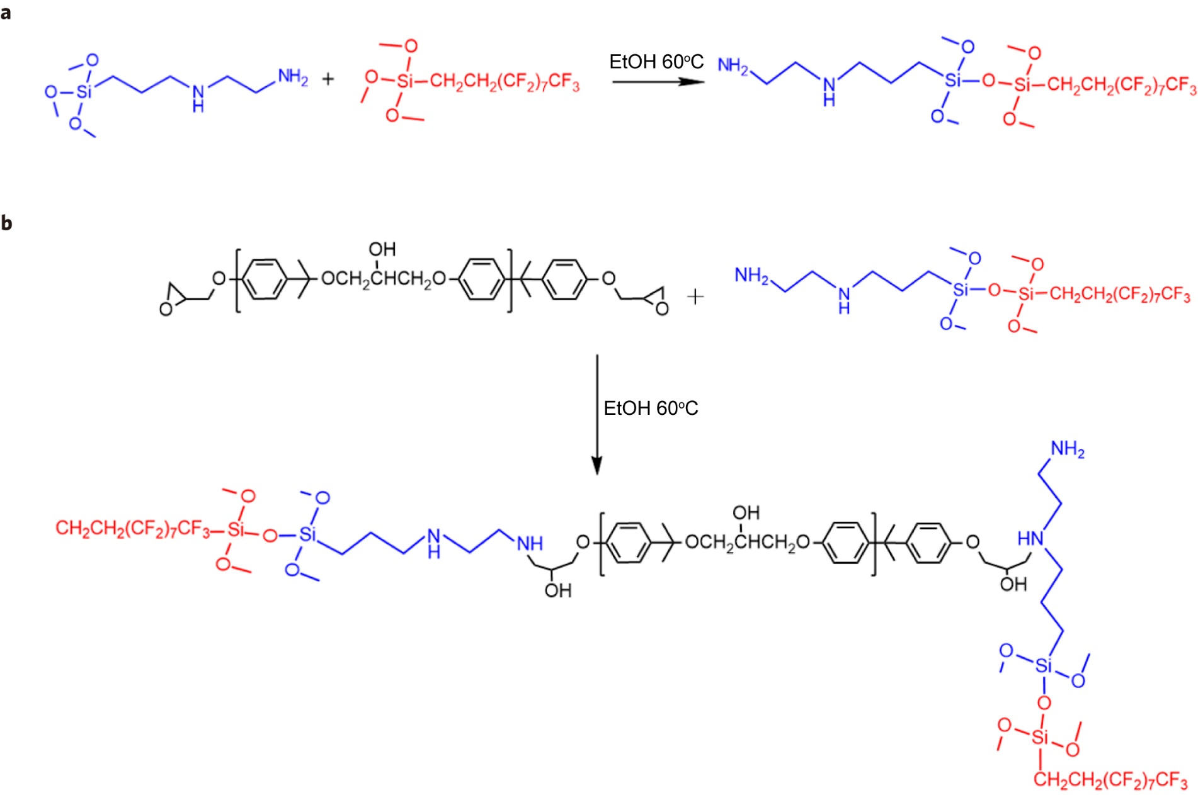
Fig. S1 | Epoxy resin fluorination. a, Synthesis of fluorinated aminosilane curing agent. b, Fabrication of fluorinated epoxy resin.

Aminosilane curing agent fluorination. AS and FAS in a molar ratio of 1:1 was dissolved into the ethanol followed by reacting continuously for 1 h at 60 °C (Supplementary Fig. S1a). The prepared fluorinated aminosiloxane curing agent is abbreviated as FAS-AS.

Epoxy resin fluorination. The dosage is calculated according to the epoxy value of the epoxy resin. The amount of FAS-AS required for curing of 1 g epoxy resin is added to the reaction system for curing and fluorination of the epoxy resin (Supplementary Fig. S1b).

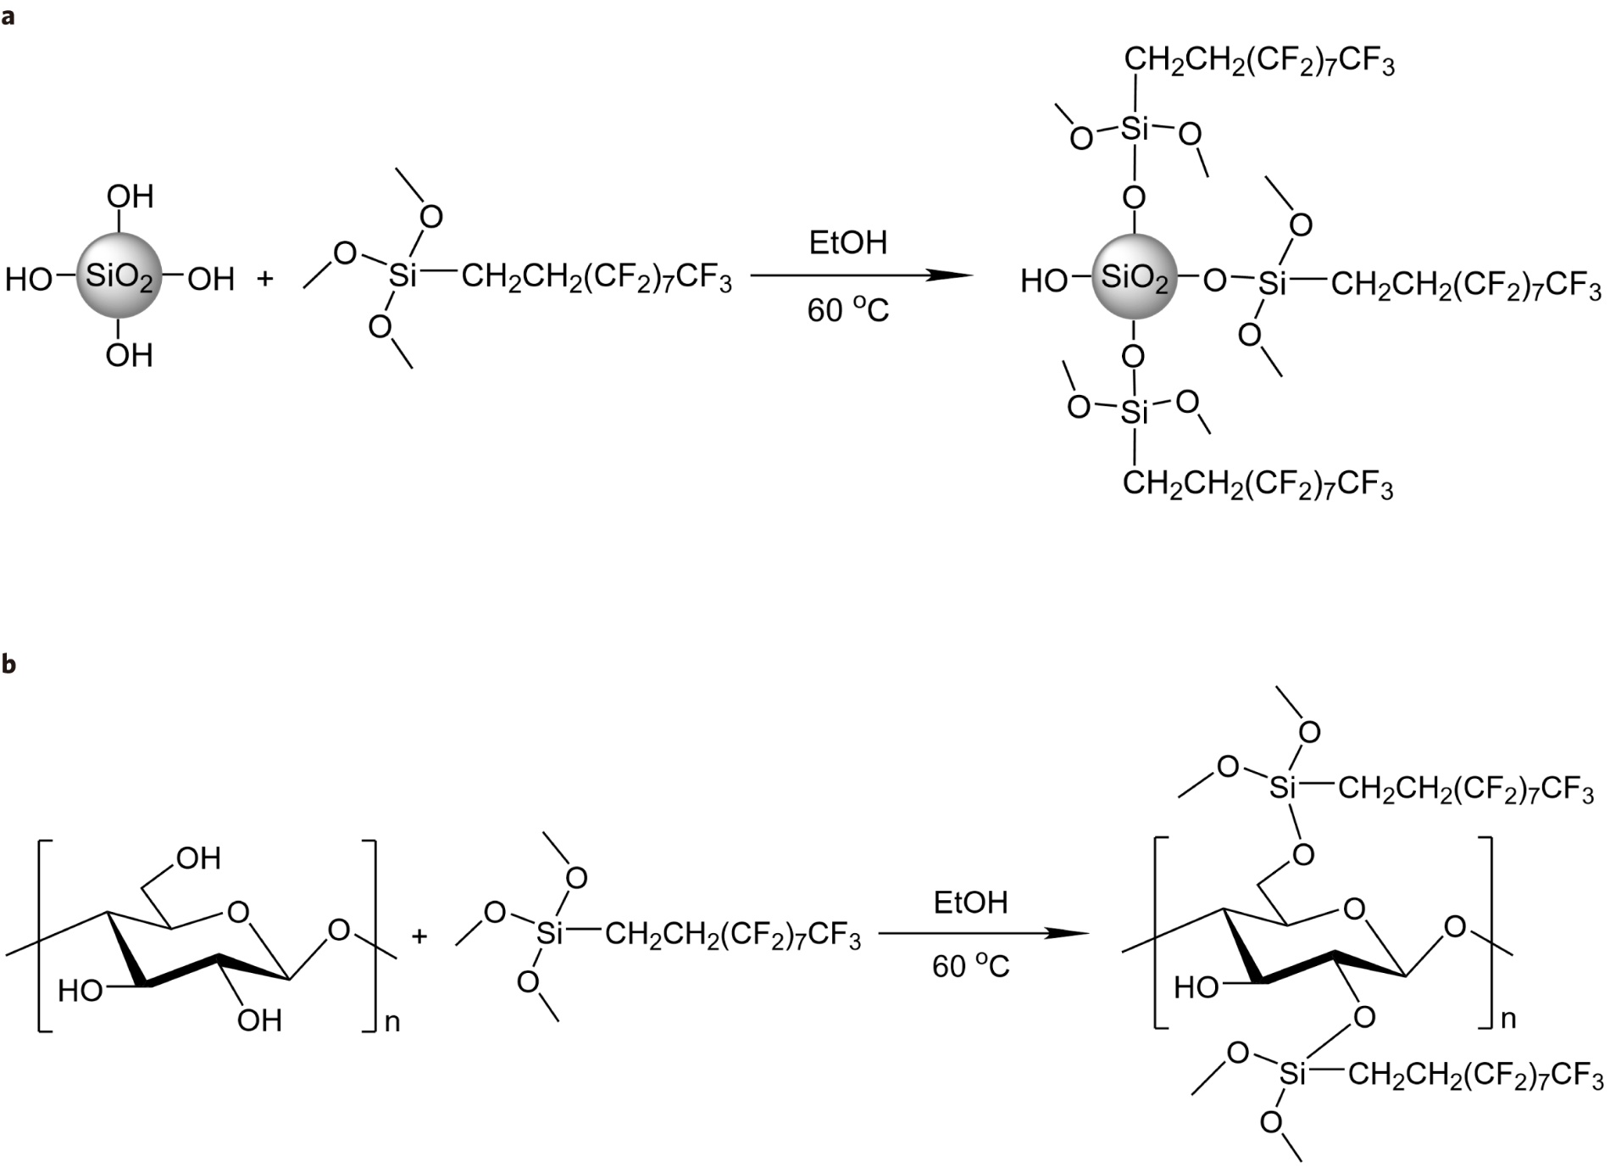

Fig. S2 | Fluorination of SiO₂ (a) and epoxy resin (b) in the middle layer and top layer.

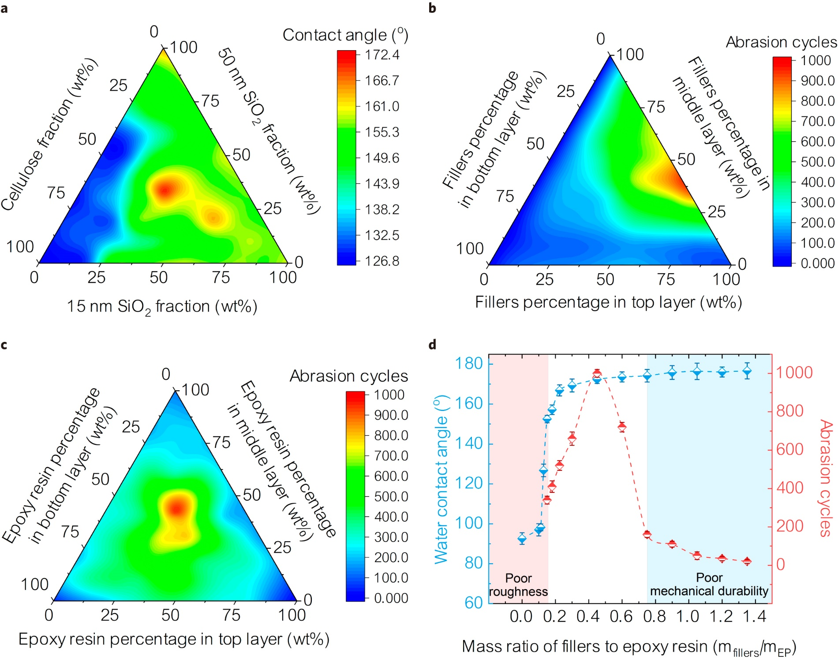

Fig. S3 | The effect of various components on the on the superhydrophobicity and mechanical robustness. a, The effect of cellulose and SiO₂ fraction on the superhydrophobicity. b, The effect of fillers (cellulose and SiO₂) percentage in each layer on the mechanical robustness. c, The effect of epoxy resin percentage on the mechanical robustness. d, The effect of mass ratio of fillers to epoxy on the superhydrophobicity and mechanical robustness.

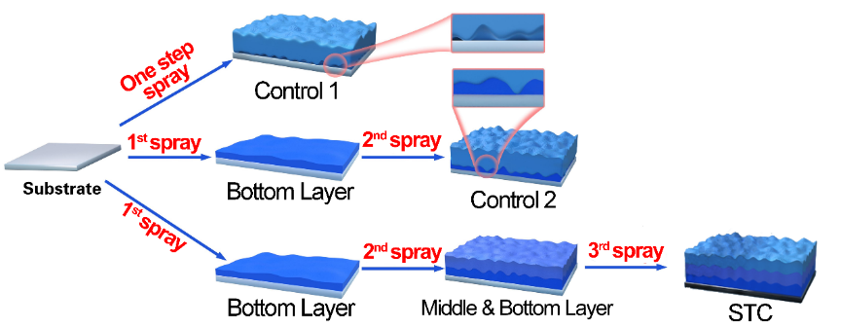
Fig. S4 | Preparation of three samples. Schematic procedure of one-step monolayer coating (Control 1), two-step bilayer coating (Control 2) and STC.

Cellulose fluorescent label
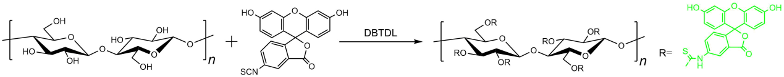
Fig. S5 | The reaction of cellulose by fluorescent labeling.

The synthesis was performed in the Schlenk line¹. Firstly, 3 mmol cellulose acetate was dissolved in 20 mL of DMF at 80 ℃ to get a homogeneous solution. Then, 0.1 mmol FITC and 1.5 mmol DBTDL as catalyst were added into the cellulose acetate solution followed by stirring at 100 ℃ for 4 h. The product was precipitated in the mixed solvent of methanol and water (v/v = 1/1). The generated precipitation was filtered and further washed three times followed by drying in the vacuum oven at 80 ℃ for 24 h to offer a yellow powder.

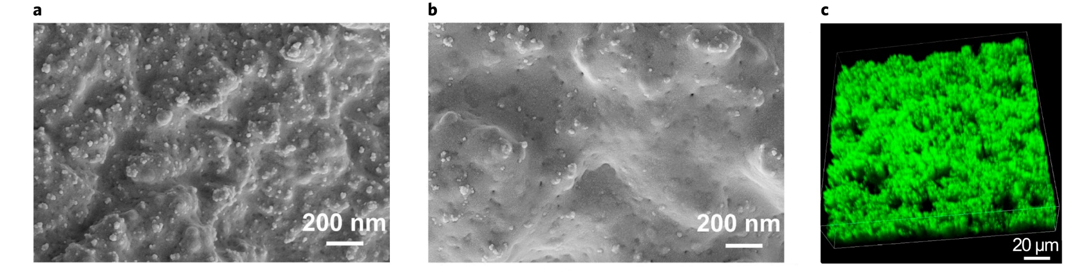
Fig. S6 | Characterization of cellulose framework structure. a, Surface SEM image of STC with cellulose. b, Surface SEM image of STC without cellulose. c, 3D map of confocal microscopy of fluorescently labeled cellulose.
The surface of STC with cellulose indicates the rough structures, while the surface of STC without cellulose is relatively smooth, which is caused by the lack of cellulose frame structure. The confocal microscopy images show that the fluorescently labeled celluloses are existed in the overall coating. It can be clearly seen that the celluloses construct a 3D frame structure, which can support and reinforce the coating, providing excellent mechanical properties.

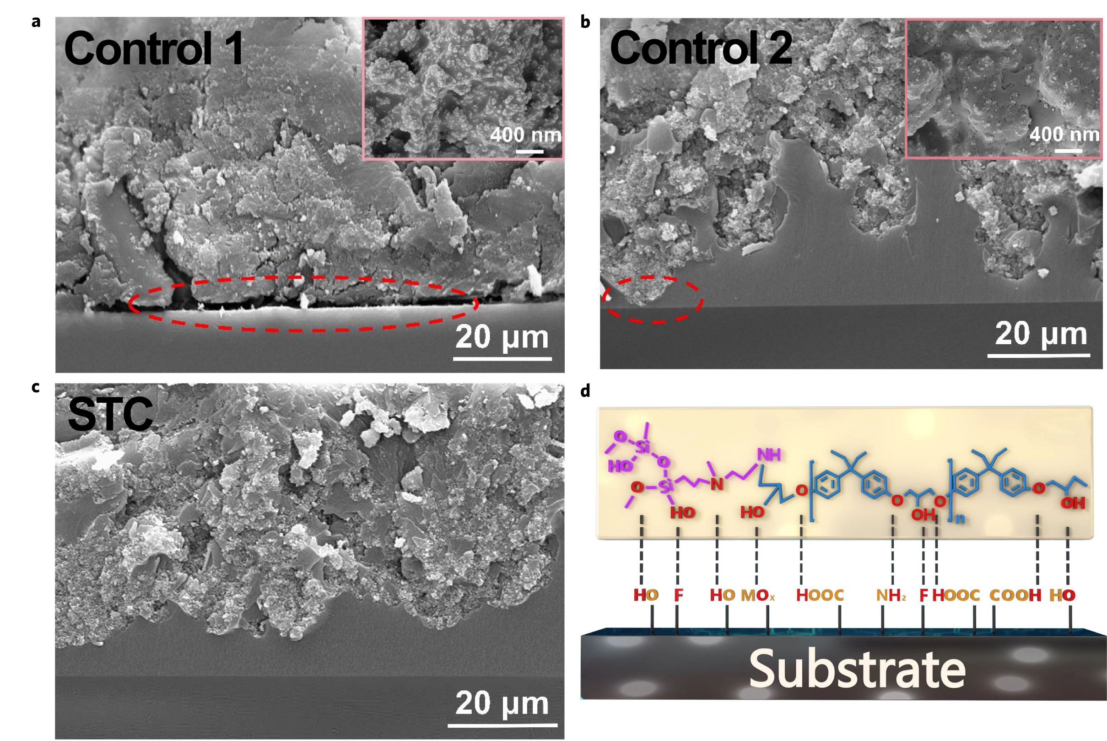
Fig. S7 | Structure analysis. a, The cross-sectional SEM images and surface image (inset) of Control 1. Large gaps between the coating and the substrate as marked by the red circle. b, The cross-sectional SEM images and surface image (inset) of Control 2. The upper layer with micro/nano particles partially contacts with the substrate as marked by the red circle. c, The cross-sectional SEM image of STC. d, The illustration of chemical bond between the bottom layer and the substrate.

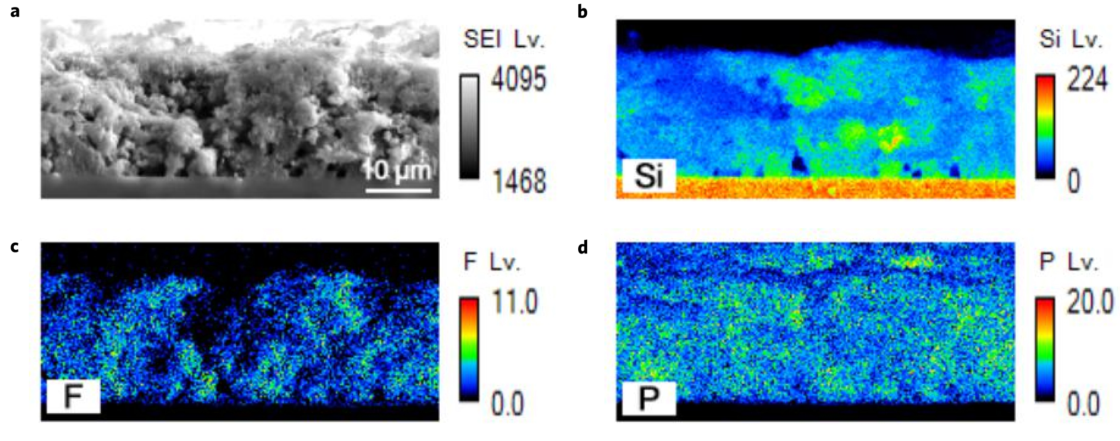
Fig. S8 | Cross-sectional structure of Control 1. a, EM image of Control 1. Elemental mapping of the EM image of the cross-sectional Control 1: b, Si element distribution. c, F element distribution. d, P element distribution.
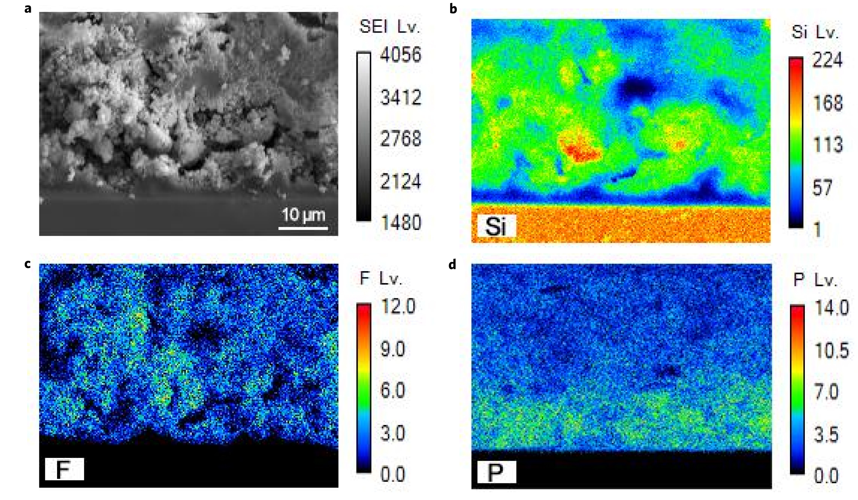
Fig. S9 | Cross-sectional structure of Control 2. a, EM image of Control 2. Elemental mapping of the EM image of the cross-sectional Control 2: b, Si element distribution. c, F element distribution. d, P element distribution.

For traditional one-step spraying coating such as Control 1, the adhesion strength is poor due to the weak contact between the micro/nanoparticles necessary for the superhydrophobicity and the substrate. The SEM images of the cross-section of Control 1 indicate that the presence of several gaps (Supplementary Fig. S7a and Fig. S8) between the coating and the substrate. These gaps cause the coating easier to be fallen off. In contrast to Control 2, although the upper layer in Control 2 is evenly spread on the bottom layer, the large amount of micro/nanoparticles used in the upper layer locally comes into contact with the substrate (Supplementary Fig. S7b and Fig. S9), causing the decrease in the adhesion and wear resistance of Control 2. In addition, in our STC design, introducing the polar phosphorous flame retardant DOPO into the bottom layer not only avoids adversely affecting the superhydrophobic performance but also enables the coating to possess flame retardancy performance.

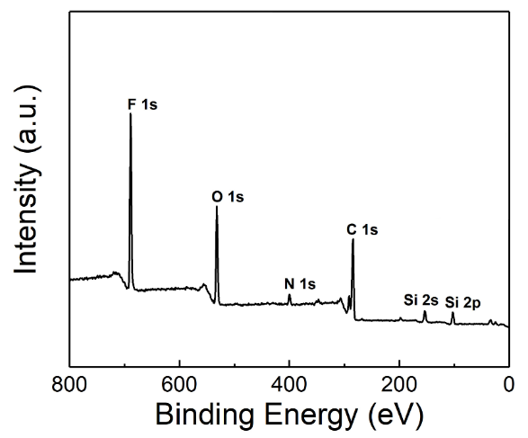
Fig. S10 | XPS spectra of the STC surface.

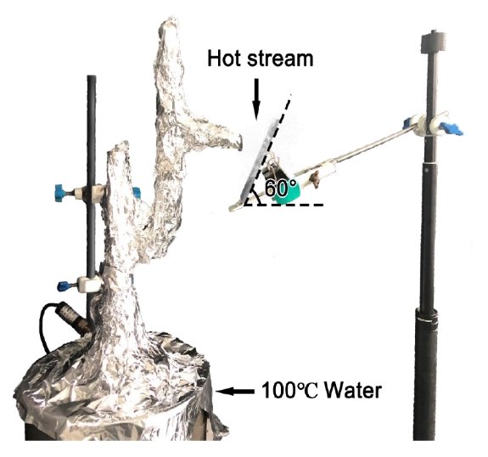
Fig. S11 | Photograph of hot stream condensation test setup.

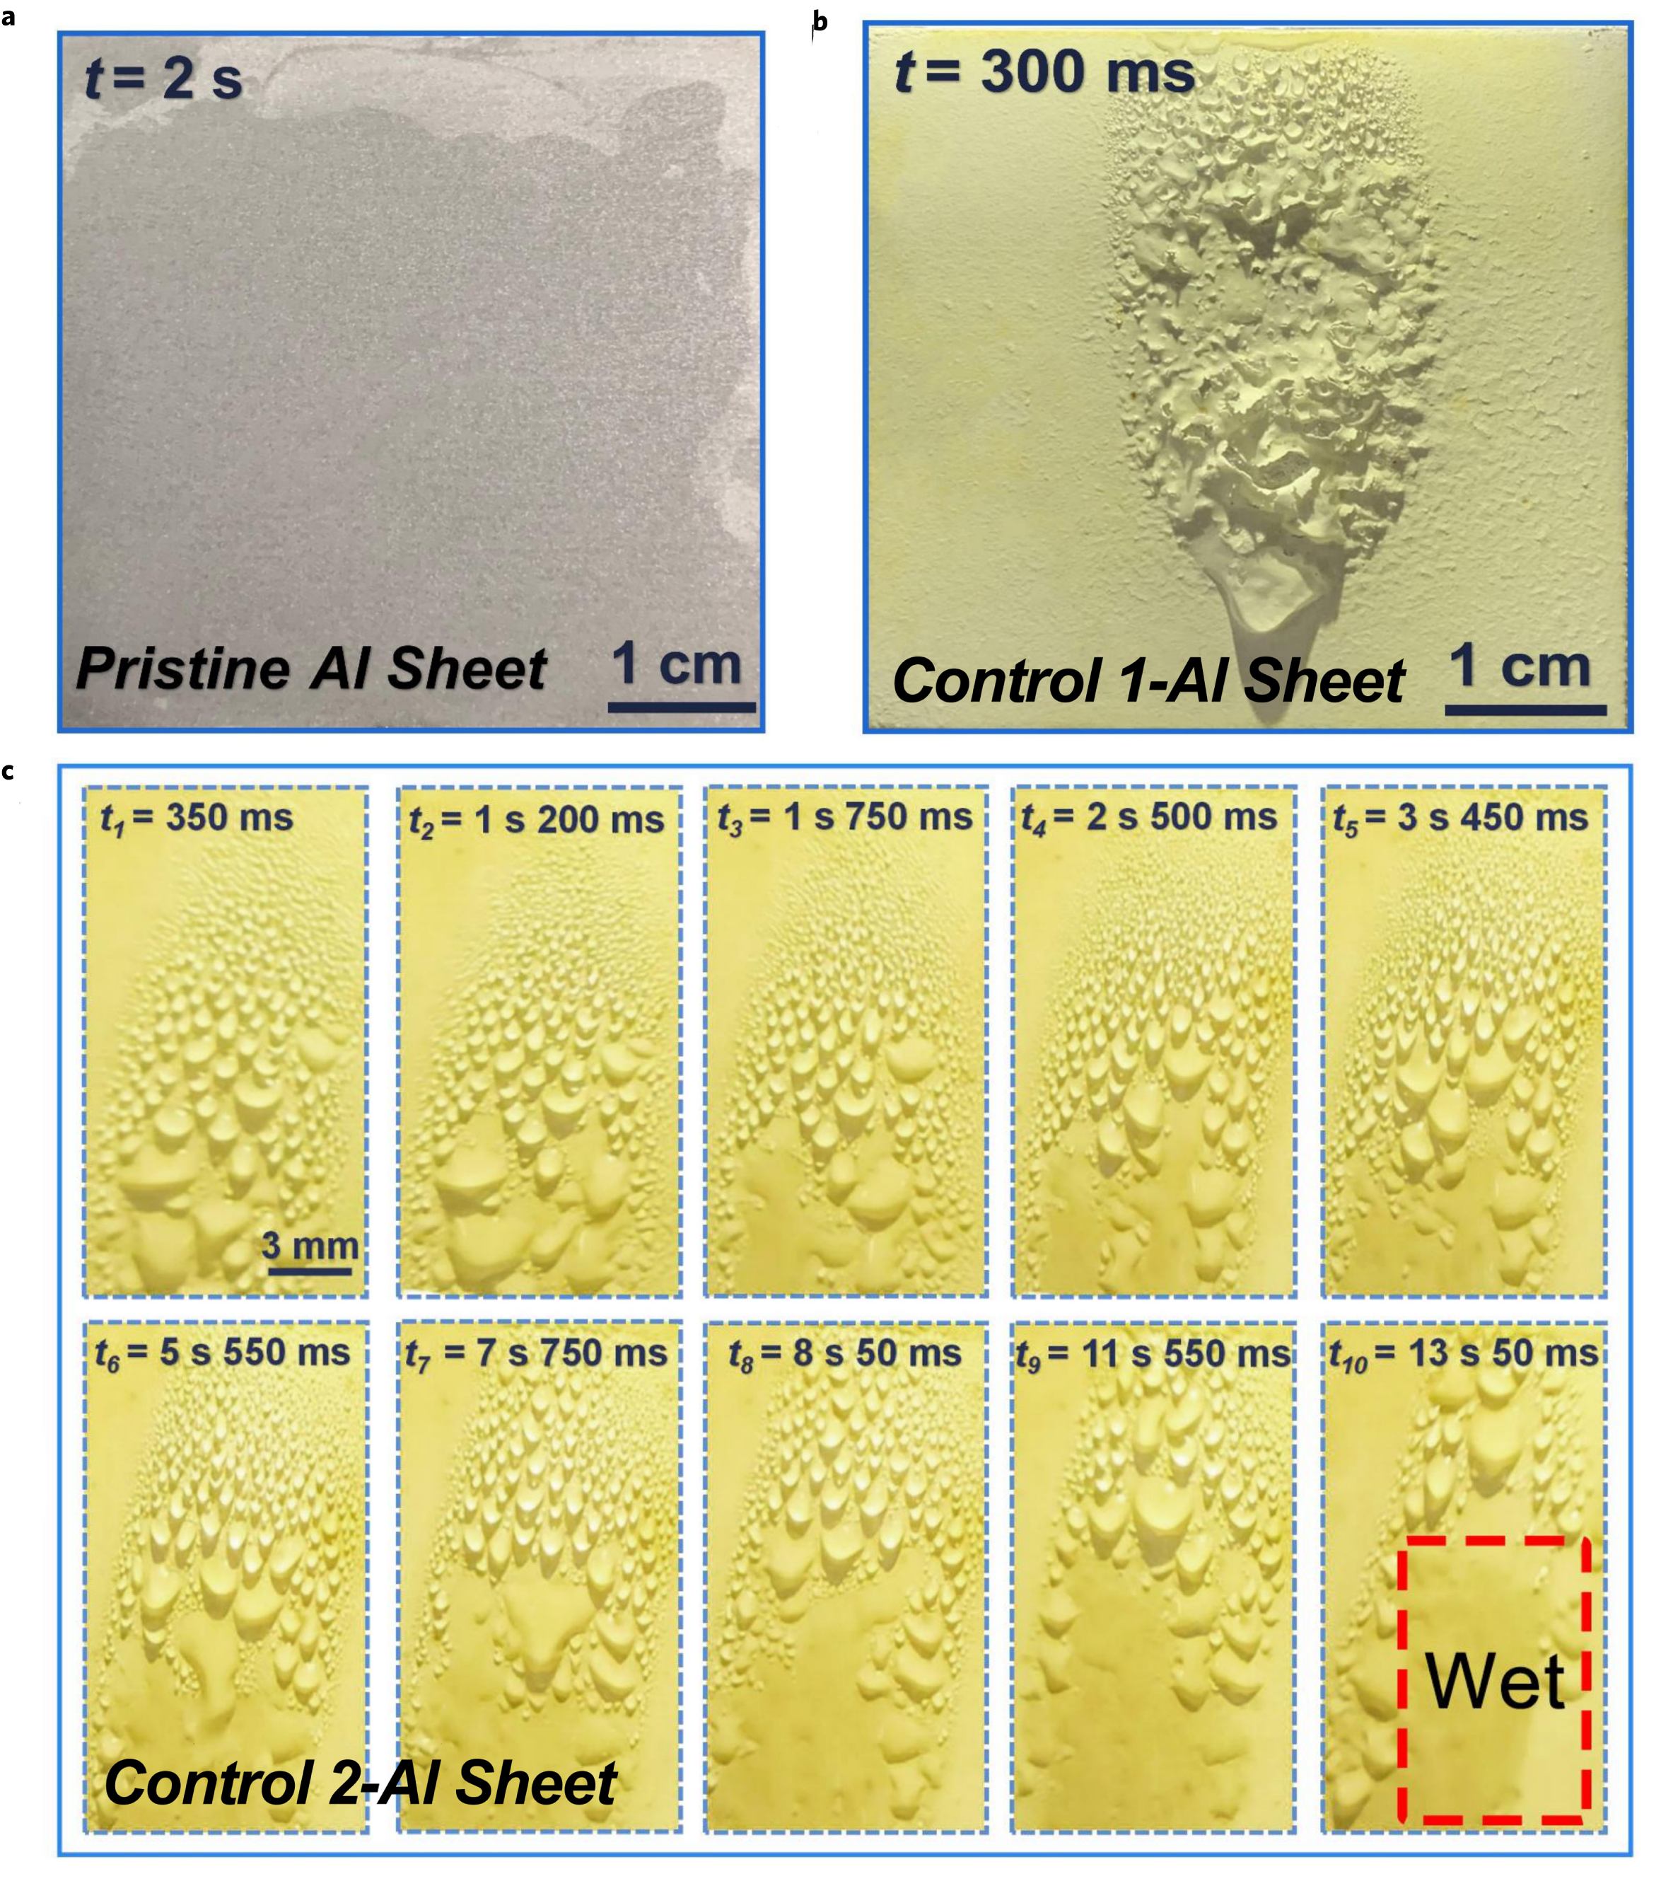
Fig. S12 | a, Pristine Al sheet after hot stream spraying for 2 s. b, Control 1-Al sheet after hot stream spraying for 300 ms, the coating has been destroyed. c, Serial photographs of Control 2-Al sheet during 13 s 50 ms. The coating was not damaged, but lost superhydrophobicity.

The hot steam condensation experiment can be used to assess the hydrophobicity of the coating. The hot stream will penetrate into the micro/nano structure of the superhydrophobic surface. The air in the micro/nano structure is squeezed out, which leads to the failure of superhydrophobic properties. In addition, continuous high-temperature steam impact will destroy the coating structure, and the surface tension of water will decrease as the temperature rises. The high-temperature steam will infiltrate after contacting the surface, forming a liquid layer. In the test of Control 1, due to the weak adhesion between the Control 1 and the substrate, after the thermal steam impact, the coating is completely destroyed and separated from the substrate. For Control 2 and STC, although the coatings are not destroyed, there is a significant difference in their hydrophobic properties. The hot steam will wet the coating after touching the surface of Control 2, resulting in loss of hydrophobicity. In contrast, STC-Al sheet still maintains excellent superhydrophobicity after being exposed to high-temperature steam. As shown in Fig. 2A, the high-temperature water vapor condenses on the surface and many small droplets merge large droplets (~400 μm diameter), and then the merged droplets roll off the surface by gravity (Movie S1).

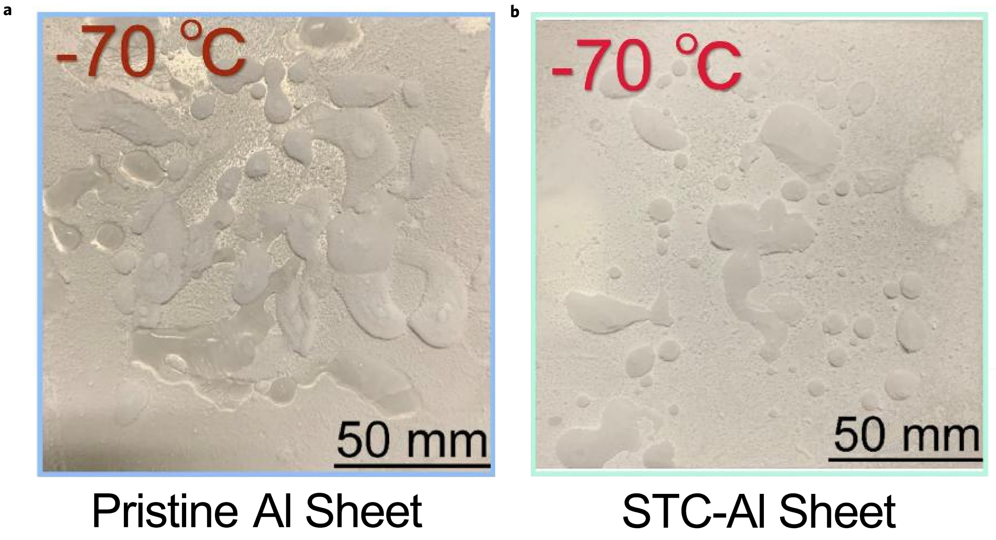
Fig. S13 | Extreme temperature adaptability of Control 1, Control 2 and STC. Icing reduction experiment of pristine Al sheet (a) and STC-Al sheet (b).

The STC can maintain anti-icing and easy deicing properties in extreme low temperature environments. Ice will be formed under subzero temperature because of heterogeneous nucleation of supercooled water on the surface and result in the loss of superhydrophobicity. In addition, once the ice has formed, it is difficult to be removed due to the mechanical interlocking effect². The hierarchal micro/nano structures are key to surface ice resistance³. Our STC shows perfect anti-icing and deicing ability.

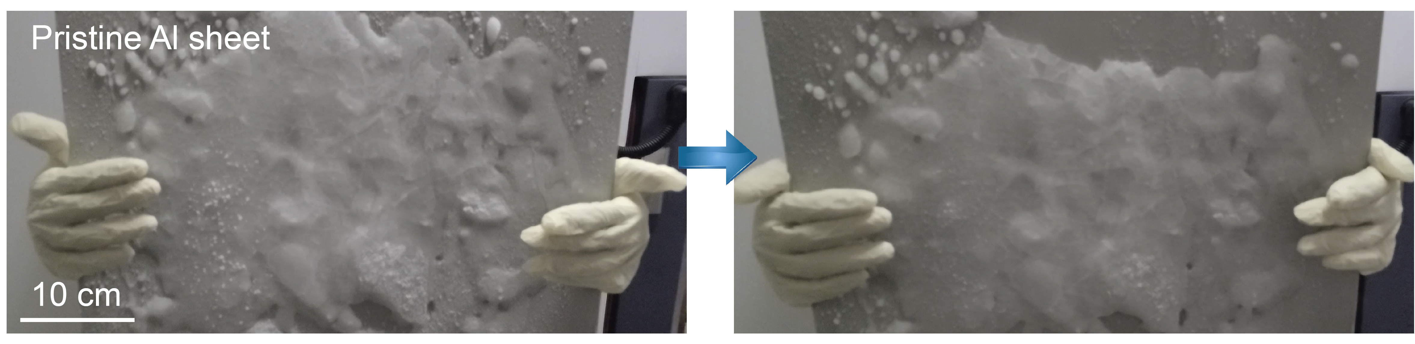
Fig. S14 | Photograph of deicing experiment on pristine Al sheet.

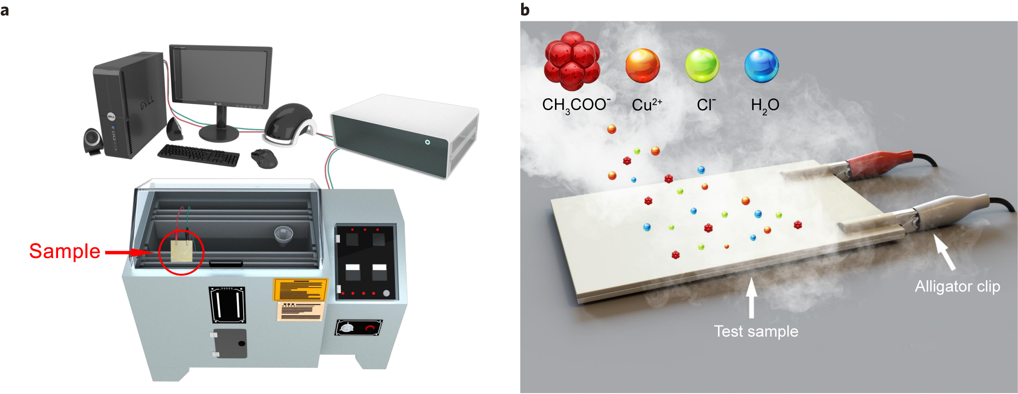
Fig. S15 | a, Illustration of the setup of copper-accelerated acetic acid salt spray (CASS) test connected with electrochemical measurement. b, Schematic of electrochemical measurement of the coated-Al sheet during CASS test

Usually, the superhydrophobic coating can capture a layer of air at the interface between the coating and corrosive medium, thus reducing the contact area of the coating with the corrosive medium and providing the anti-corrosion ability⁴⁻⁶. The STC coated Al sheets and other samples were put into the salt-spray cabinet. This rigorous test has been used for the first time for superhydrophobic corrosion resistance. After the samples are continuously exposed to the salt spray with 5 wt % NaCl for 30 min at 35 °C, the Tafel polarization curves were obtained. The lower the corrosion potential (E_{corr}) and the larger corrosion current (I_{corr}) indicate the easier the corrosion possibility. The CASS has a significant effect on the corrosion of metals.

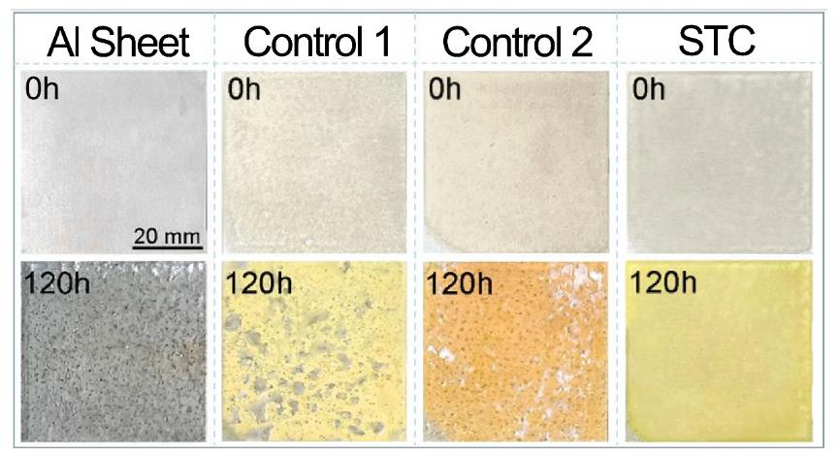
Fig. S16 | Photographs of corrosion degree of pristine Al sheet and different coating coated samples after 0 h and 120 h, respectively.

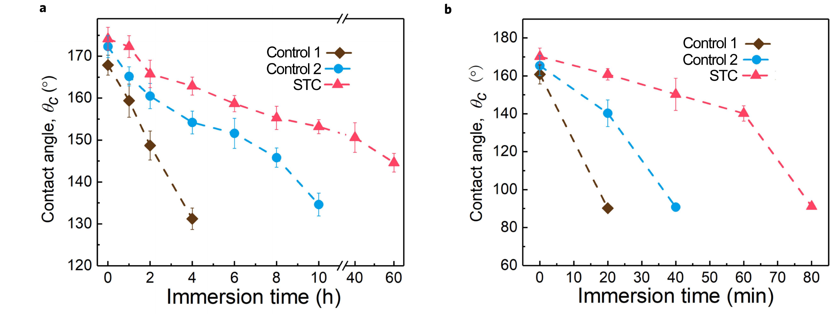
Fig. S17 | Chemical resistance test. a, Changes of water contact angle after immersing in aqua regia for different time. b, Changes of water contact angle after immersing in 12M NaOH for different time.
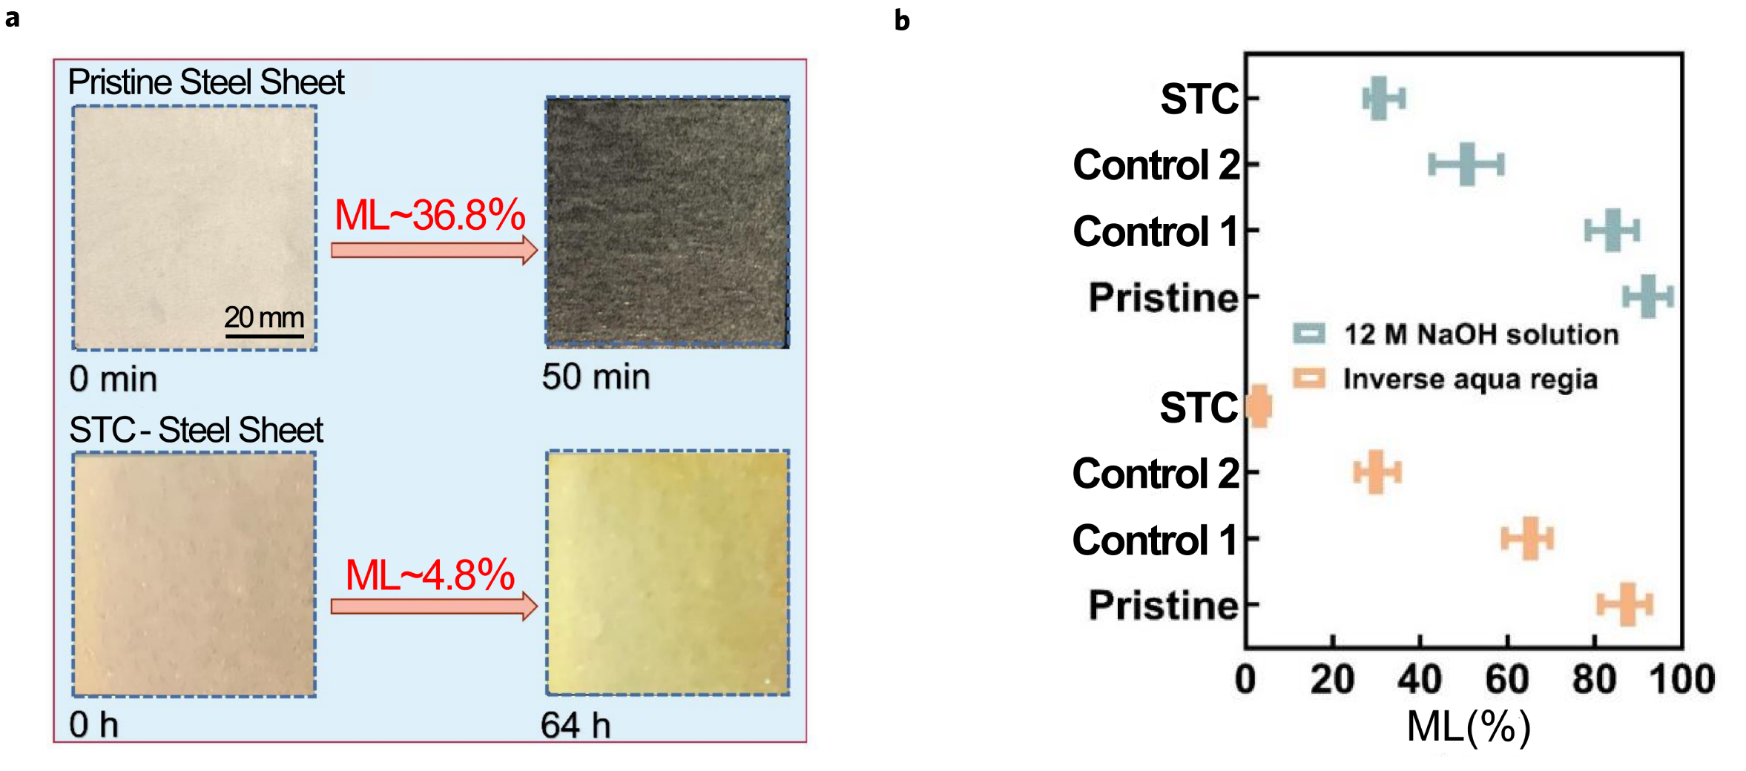
Fig. S18 | Corrosion resistance test. a, Photograph and mass loss (ML, ML=$\frac{\left|m_{t}-m_{0}\right|}{m_{0}}$ x100%, where m_{t} corresponds to the mass of sample under different test times, m₀ is the initial mass of the sample) of pristine-steel sheet and STC-steel sheet after soaking in aqua regia for different time. b, ML of different samples after soaking in 12 M NaOH and inverse aqua regia for 125 min, respectively. The dimensions of all samples are 6 cm × 6 cm.

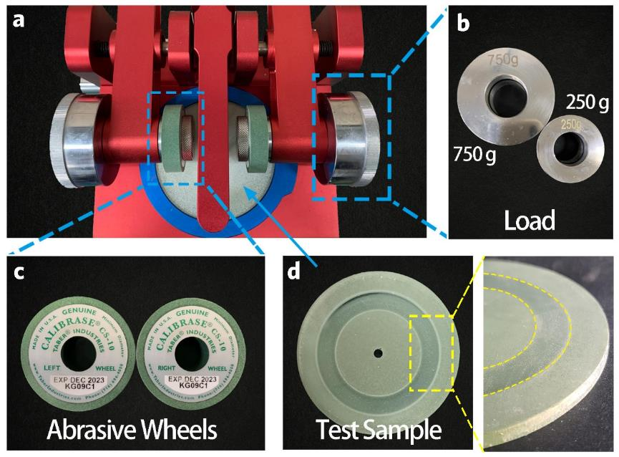
Fig. S19 | Taber abrasion test setup. a, Taber abrasion tester. b, Ring load of 750g and 250g, respectively. c, Abrasive wheels. d, The coated STC after abrasion test and partially enlarged image (right side).
The abrasion tests were performed following ASTM D4060 standard. Two loads of 250 g and 750 g were used in the Taber abrasion test. The sample-coated glass substrates were fixed on the rotation platform. After abrasion, the water contact angle of the coated glass substrate was measured. It was found that STC remained superhydrophobic after 1,000 cycles under 750 g load and also maintained excellent superhydrophobicity after 3,000 cycles under 250 g load.

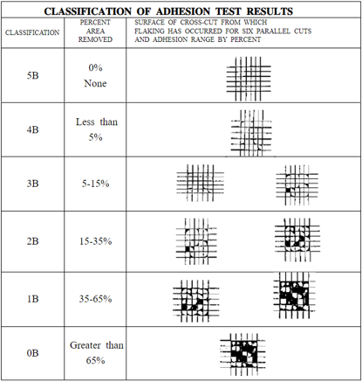
Fig. S20 | Classification of adhesion test according ASTM D3359.
The adhesion tests were performed according to ASTM D3359 standard. First, a neat grid was cut on the surface of the coating using multiple tap cutters with an interval of 1 mm for each cutter edge, and then the 3M tape was compacted under a load of 2 kg to get a uniform pressure. After 90 seconds, the 3M tape was peeled off rapidly. Then the left of the coating on the substrate was observed to evaluate the adhesion strength.

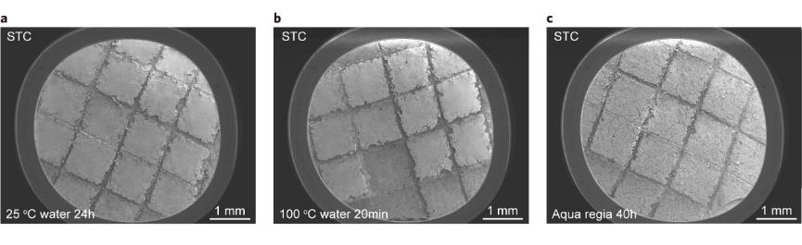
Fig. S21 | SEM images of STC adhesion test with different pre-treatment. SEM image of STC after cutting and immersing into (a) water at room temperature for 24 h, (b) boiling water for 20 min and (c) aqua regia for 40 h, respectively, followed by peeling-off using 3 M tape.

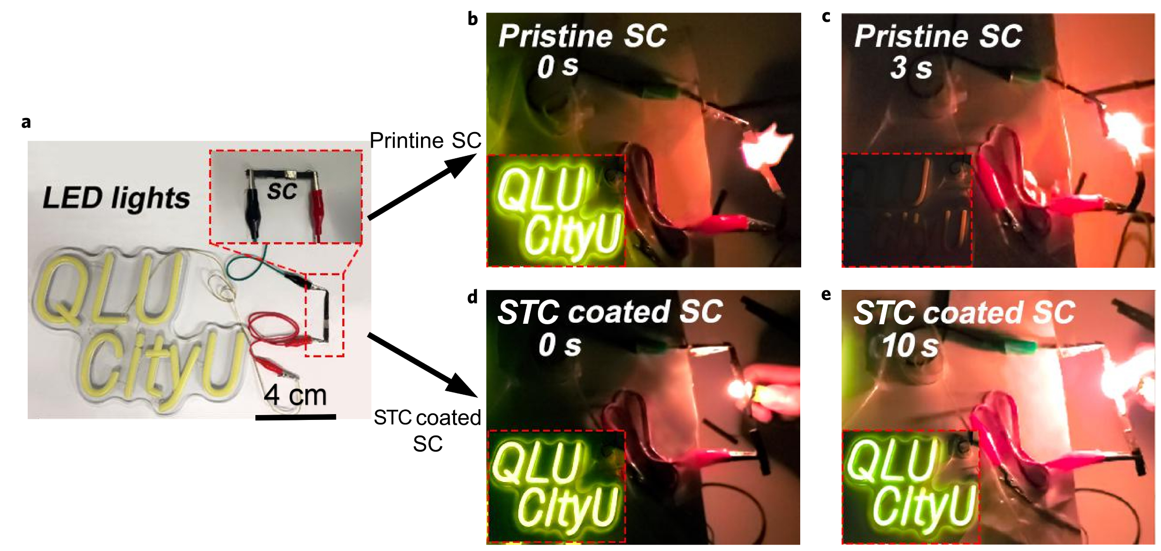
Fig. S22 | Flame retardant test of circuit. a, Photograph of circuit flame retardant test devices. Photograph of pristine supercapacitor (SC) ignited for 0 seconds (b) and 3 seconds (c). Photograph of STC-coated SC during igniting for 0 seconds (d) and 10 seconds (e).
The SC used in the test was commercially supported in local store. The SC connects with LED light in series to form a closed loop. Before igniting, the device can work normally. When the pristine SC is ignited by a lighter, it burns immediately and the SC is destroyed, the LED light is extinguished after 3 seconds. In contrast, the STC coated SC can still work normally after 10 s igniting, which shows that the STC has the role of protecting electrical components from flame damage.

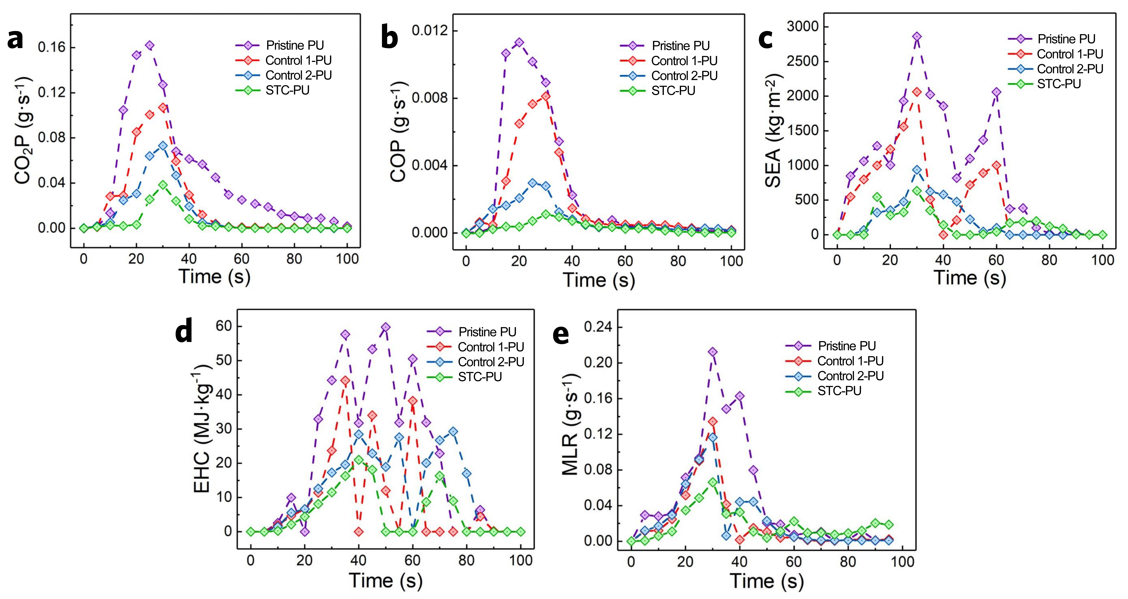
Fig. S23 | PU foam burning test. a, Graph of CO₂ release over time. b, Graph of CO release over time. c, Graph of SEA release over time. d, Graph of EHC release over time. e, Graph of MLR release over time.

During the combustion process, the release rate of CO₂ and CO approaches the highest level within about 30 seconds and then declines. Compared with that of pristine PU, the release rate of CO₂ and CO of STC-PU decreases by about 76.3% and 90.2%, respectively (Supplementary Fig. S23a and S23b). Simultaneously, the specific extinction area (SEA) is used as a parameter to measure and monitor the amount of smoke arising from combustion. The amount of smoke generated by STC-PU has been kept at a low level (Supplementary Fig. S23c). The effective heat of combustion (EHC) reflects the combustion degree of volatile gas in the gas flame. The peak EHC of the pristine-PU is 59.8 MJ·kg⁻¹, while the EHC of STC-PU foam is 21 MJ·kg⁻¹ (Supplementary Fig. S23d), which is reduced by about 65%. This may be caused by pyrolysis during the combustion process. Phosphoric oxygen radicals and phosphoric acid can inhibit the mass loss rate (MLR) of flame combustion in the condensed phase (Supplementary Fig. S23e). A lower MLR indicates that there is more residual carbon after combustion, forming a continuous dense carbon layer. Its barrier effect can effectively inhibit heat transfer, and delay or even prevent combustion, demonstrating strong fire resistance. The MLR of STC-PU is significantly reduced, which means that the supply of combustibles is reduced during the combustion process of the STC-PU, resulting in the reduction in heat radiation and release of harmful gases.

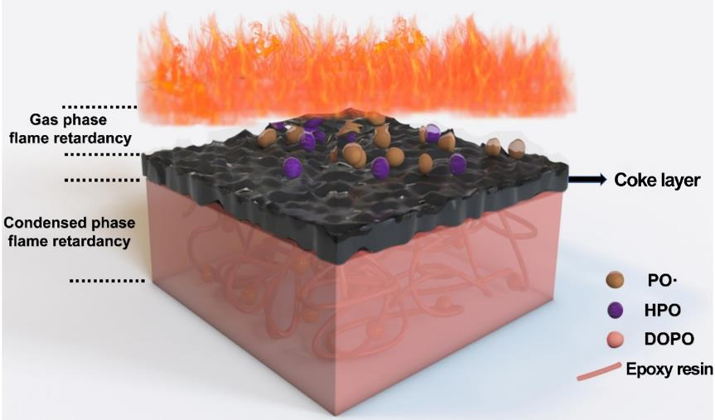
Fig. S24 | Proposed flame-retardant mechanism of coating.

When the STC coated sample is kindled, the bottom layer of epoxy with DOPO flame retardant is decomposed by heat to generate orthophosphoric acid, and the dehydration of orthophosphoric acid will generate a coke layer⁷. The coke layer is flame retardant and insulates heat and oxygen, which can effectively hamper the combustion reaction. In addition, the PO• free radicals produced in combustion process can capture H• and HO• free radicals in gas phase as shown below⁸, achieving the effect of flame retardancy in the gas phase.

PO•+H•→HPO
HPO+H•→H₂+PO•
PO•+OH•→HPO+O•
OH•+PO•+H₂→HPO+H₂O

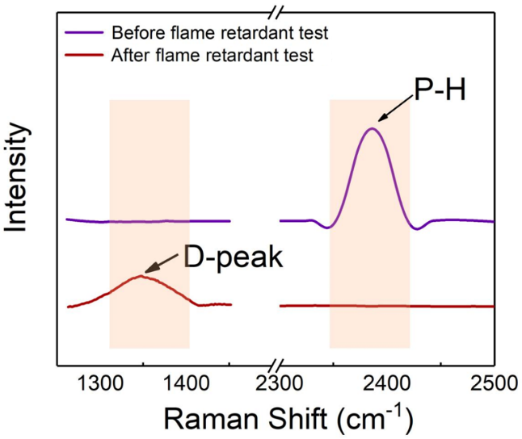
Fig. S25 | Raman shift of the sample before and after the combustion test.
Before the combustion test, due to the existence of the P-H bond in DOPO, a strong absorption peak appears at 2400 cm⁻¹. After combustion, DOPO will splits through the P-H bond releasing free radicals containing P during combustion, such as PO•, which can capture a lot of free radicals of H• and HO• produced in reaction of the combustion⁸. The absorption peak at 1360 cm⁻¹ corresponds to the carbon atom in the disordered graphite structure, which is the Raman characteristic absorption peak of the residual carbon residue after combustion, called D peak. The residual carbon reduces the amount of combustible gas generated, and the generated coke layer has the effect of isolating heat and oxygen transfer.

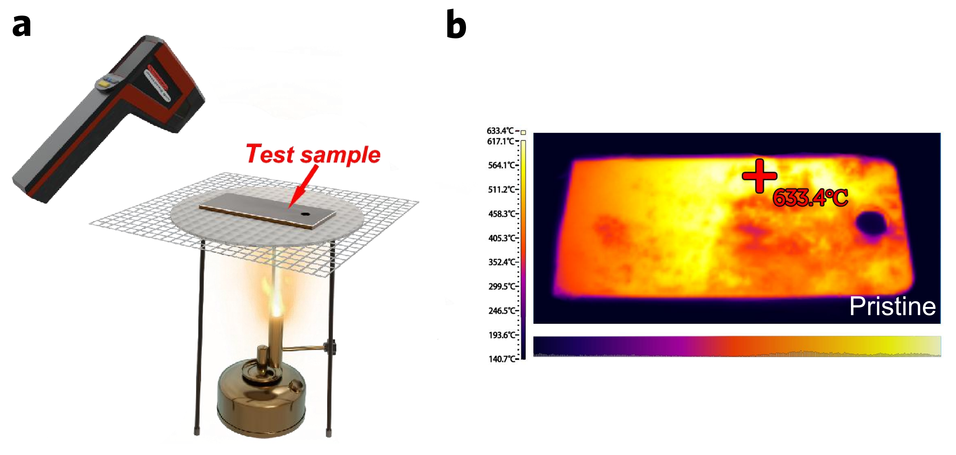
Fig. S26 | Thermal infrared imaging assisted burning test. a, Illustration of burning test setup. b, Thermal infrared imaging temperature map of pristine steel sheet.
The Control 1, Control 2 and STC coated steel sheets with 100 mm×100 mm×50 mm are put onto the sample stage. One side of the steel sheet was faced an alcohol blowtorch and the temperature of the coating coated side was measured with an infrared thermometer. The sample stage height is adjusted to make the sample contact with the outer flame of the alcohol blowtorch. The infrared thermal imager is 10 cm above the sample. After 60 s, the temperature of the samples is almost invariable. The maximum stable temperature of the pristine steel sheet is 633.4 ℃, the temperature of the Control 1 steel sheet is 389.4 ℃, the temperature of the Control 2 steel sheet is 414.7 ℃. Especially, the maximum stable temperature of the STC-steel sheet is the lowest (only 306 ℃), showing the excellent thermal insulation properties of the coating and the advantages of three-layer structure.

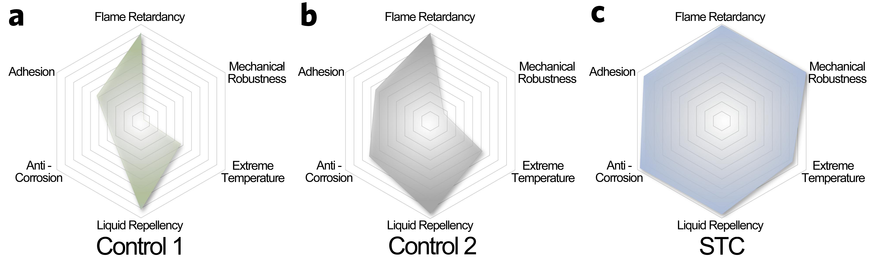
Fig. S27 | Performance comparison. The performance of Control 1, Control 2 and STC is displayed through the hexagonal radar chart. Each indicator starts from 0 to a maximum index of 10 (details of each indicator are detailed in the following parts). Besides the liquid repellency and flame retardancy, STC possesses other super performances than Control 1 and Control 2, proving the importance of triple-layer structure design concept.

Definition of Radar Chart
The performance of Control 1, Control 2 and STC is measured through the hexagonal radar chart. The six vertexes correspond to six different performance indicators. Each indicator starts from 0 to a maximum index of 10.

Liquid repellency. Make no less than 5 times static contact angle measurements for each sample, then take the average value, and record the value as θ_{CA}*. Liquid repellency index is calculated by the following formula:
$$\text{LRI}\text{=}\frac{{{\text{θ}}_{\text{CA}}}^{\text{*}}}{\text{18}{\text{0}}^{\text{°}}}\text{×10}$$
The obtained value is used as an index to measure the liquid repellent performance of the sample, and the corresponding point is taken on the hexagonal radar chart.

Mechanical robustness. Since the mechanical performance of STC has reached the best level under taber abrasion test method, the STC is tentatively set to 10 (Set 250 g load abrasion 3000 cycles and 750 g load abrasion 1000 cycles as perfect marks). The number of abrasion cycles that the tested sample can withstand under a load of 250 g is recorded as n₂₅₀. The number of abrasion cycles that the tested sample can withstand under a load of 750 g is recorded as n₇₅₀. Mechanical robust index (MRI) is calculated by the following formula. Taking the average values of MRI₂₅₀ and MRI₇₅₀ are as the final index to define the mechanical robustness.

$\text{MR}{\text{I}}_{\text{250}}\text{=}\frac{{\text{n}}_{\text{250}}}{\text{3000}}\text{×10}$ and $\text{MR}{\text{I}}_{\text{750}}\text{=}\frac{{\text{n}}_{\text{750}}}{\text{1000}}\text{×10}$

Flame Retardancy. Limiting oxygen index (LOI) refers to the minimum concentration of oxygen in a mixture gas of oxygen and nitrogen that it is needed to support the flaming combustion of a material. Materials with LOI values less than 21 % are classified as combustible, but those with LOI greater than 27 are classed as non-flammable. LOI of 27 was defined as critical flammable index. The LOI of different samples obtained by the combustion test is recorded as LOI_{r}. Flame retardant index (FRI) is calculated by the following formula:
$$\text{FRI}\text{=}\frac{\text{LO}{\text{I}}_{\text{r}}}{\text{27}}\text{×10}$$
The obtained value is used as an index to measure the flame resistance performance of the sample, and the corresponding point is taken on the hexagonal radar chart.

Adhesion. The coating adhesion test was measured according to ASTM D3359 standard. After processing the sample with a multitip cutter, the surface of the sample was captured. The pixel points of the tested coating (excluding the groove after cutting) were calculated and recorded as PPI_{in} (initial pixel point index). After 3M tape was compacted and peeled off, the surface of the tested sample was captured. The pixel points of the measured surface area were calculated as PPI_{fin} (final pixel point index). Adhesion index (AI) is calculated by the following formula:
$\text{AI}\text{=}\frac{PPI_{fin}}{PPI_{in}}\text{×10}$
The obtained value is used as an index to measure the coating adhesion performance of the sample, and the corresponding point is taken on the hexagonal radar chart.

Anti-corrosion. The calculation of the corrosion resistance index is mainly based on the quality change of CASS corrosion test (△K_{MLR}, Fig. 2f). Mass lose rate of pristine Al sheet, Control 1-Al sheet, Control 2-Al sheet and STC-Al sheet was defined as △K*, △K_{MLR}, △K_{MLR} and △K_{MLR} respectively. Anti-corrosion index (ACI) is calculated by the following formula (taking Control 1 as an example).
$$\text{ACI}\text{=}\frac{\text{△}\text{K}\text{*}\text{-}\text{△}\text{K}\text{MLR}}{\text{△}\text{K}\text{*}}\text{×10}$$

Extreme temperature. Since the test results of hot steam condensation are difficult to be quantified, the calculation of extreme temperature index (ETI) is only based on the test results at low temperatures.
The theoretical mass of the dropped water on the measured sample is calculated as m*. The actual mass of the ice after freezing is recorded as m_{r}. Then the decreased mass between the initial water and formed ice is calculated as m_{de}.
$${\text{m}}_{\text{de}}\text{=}{\text{m}}^{\text{*}}\text{-}{\text{m}}_{\text{r}}$$
Extreme temperature index (ETI) is calculated by the following formula:
$$\text{ETI}\text{=}\frac{{\text{m}}_{\text{de}}}{{\text{m}}^{\text{*}}}\text{×10}$$

References
- Jia, R. et al. Amine-responsive cellulose-based ratiometric fluorescent materials for real-time and visual detection of shrimp and crab freshness. Nat Commun. 10, 795 (2019).
- Makkonen, L. Ice adhesion -theory, measurements and countermeasures. J. Adhes. Sci. Technol. 26, 413 (2012).
- Wang, N. Xiong, D. Deng, Y. Shi, Y. & Wang, K. Mechanically robust superhydrophobic steel surface with anti-icing, UV-durability, and corrosion resistance properties. ACS Appl. Mater. Interfaces. 7, 6260 (2015).
- Zang, D. et al. Corrosion-resistant superhydrophobic coatings on Mg alloy surfaces inspired by lotus seedpod. Adv. Funct. Mater. 27, 1605446 (2017).
- Gomaa, H. Tembely, M. Esmail, N. & Dolatabadi, A. Bouncing of cloud-sized microdroplets on superhydrophobic surfaces. Physics of Fluids 32, 122118 (2020).
- Wei, J. et al. Efficient protection of Mg alloy enabled by combination of a conventional anti-corrosion coating and a superamphiphobic coating. Chemical Engineering Journal 390, 124562 (2020).
- Gaan, S. et al. Flame retardant flexible polyurethane foams from novel DOPO-phosphonamidate additives. Polymer Degradation and Stability 113, 180-188 (2015).
- Schäfer, A. Seibold, S. Lohstroh, W. Walter, O. & Döring, M. Synthesis and properties of flame-retardant epoxy resins based on DOPO and one of its analog DPPO. Journal of Applied Polymer Science 105, 685–696 (2007).

