Supplementary Materials
Table S1 | Researcher-Selected Song List
 |  |  | Title | Artist/Composer | Music Selection
 |  |  | Adagio for Strings | Barber | Well-Known
 |  |  | Symphony No. 2, Finale | Mahler | Well-Known
 |  |  | Cavatina Op. 130 | Beethoven | Well-Known
 |  |  | John Wayne Gacy Jr. | Sufjan Stevens | Well-Known
 |  |  | Hurt | Johnny Cash | Well-Known
 |  |  | Sound of Silence | Simon and Garfunkel | Well-Known
 |  |  | Reckoner | Radiohead | Well-Known
 |  |  | Nocturne in C Sharp Minor | Chopin | Well-Known
 |  |  | Nessun Dorma | Andrea Bocelli | Well-Known
 |  |  | Symphony No. 6, movement 1 | Tchaikovsky | Well-Known
 |  |  | Bohlen-Pierce Pan Flute Folk Tune | Arturo Grolimund | Novel
 |  |  | Hoquetus II | Johannes Kretz | Novel
 |  |  | Reminiscences | Steven Yi | Novel
 |  |  | Beyond The Horizon | Georg Hajdu | Novel
 |  |  | When the Moon Casts Shadows | Hubert Ho | Novel
 |  |  | Simmer | Hubert Ho | Novel
 |  |  | Vertigo Temporum | Hubert Ho | Novel
 |  |  | Manual Labor | Hubert Ho | Novel
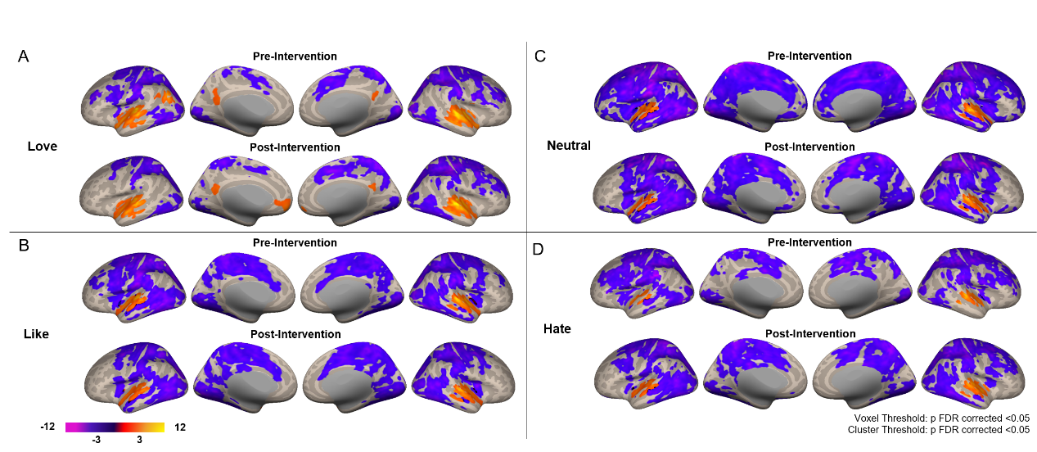
Figure S1. Univariate whole-brain analyses for different levels of liking. (A) Love. Auditory and DMN regions showed activity both pre- and post-intervention, with the TPJ showing pre-intervention activity only. Motor areas showed deactivation both pre- and post-intervention. (B) Like. Auditory regions showed activity both pre- and post-intervention. Regions spanning the motor and DMN areas showed deactivation both pre- and post-intervention. (C) Neutral. Auditory regions showed activity both pre- and post-intervention. Regions spanning the motor and DMN areas showed deactivation both pre- and post-intervention. (D) Hate. Auditory regions showed activity both pre- and post-intervention. Regions spanning the motor and DMN areas showed deactivation both pre- and post-intervention. All images are results of second-level analyses showing significant clusters at the p < .05 FDR-corrected level.
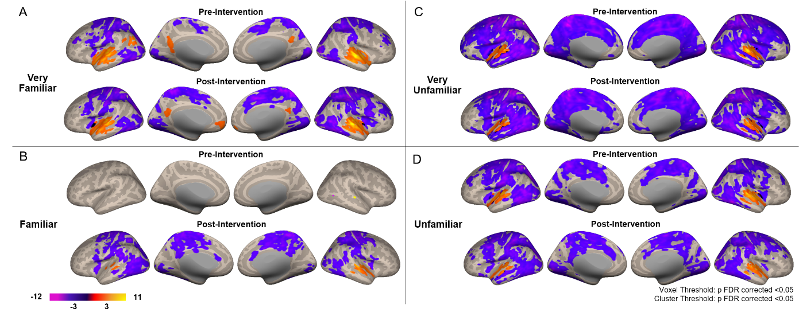
Figure S2. Univariate whole-brain analyses for different levels of familiarity. (A) Very Familiar. Auditory and DMN regions showed activity both pre- and post-intervention, with the TPJ showing pre-intervention activity only. Motor areas showed deactivation both pre- and post-intervention. (B) Familiar. Auditory regions showed activity both pre- and post-intervention, post-intervention to a greater extent. Motor regions showed deactivation only for post-intervention. (C) Very Unfamiliar. Auditory regions showed activity both pre- and post-intervention. Regions spanning the motor and DMN areas showed deactivation both pre- and post-intervention. (D) Unfamiliar. Auditory regions showed activity both pre- and post-intervention. Regions spanning the motor and DMN areas showed deactivation both pre- and post-intervention. All images are results of second-level analyses showing significant clusters at the p < .05 FDR-corrected level.
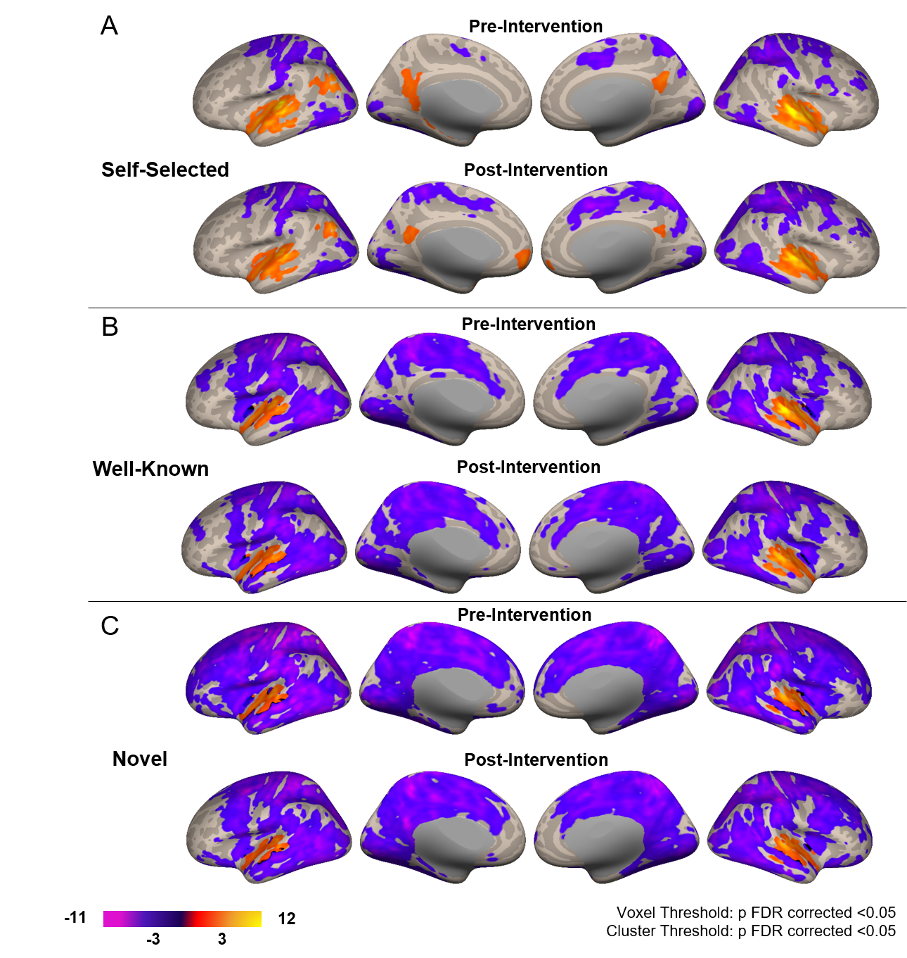
Figure S3. Univariate whole-brain analyses for music selection. (A) Self-Selected. Auditory and DMN regions showed activity both pre- and post-intervention. Motor areas showed deactivation both pre- and post-intervention. (B) Well-Known. Auditory regions showed activity both pre- and post-intervention. Regions spanning the motor and DMN areas showed deactivation both pre- and post-intervention. (C) Novel. Auditory regions showed activity both pre- and post-intervention. Regions spanning the motor and DMN areas showed deactivation both pre- and post-intervention. All images are results of second-level analyses showing significant clusters at the p < .05 FDR-corrected level.
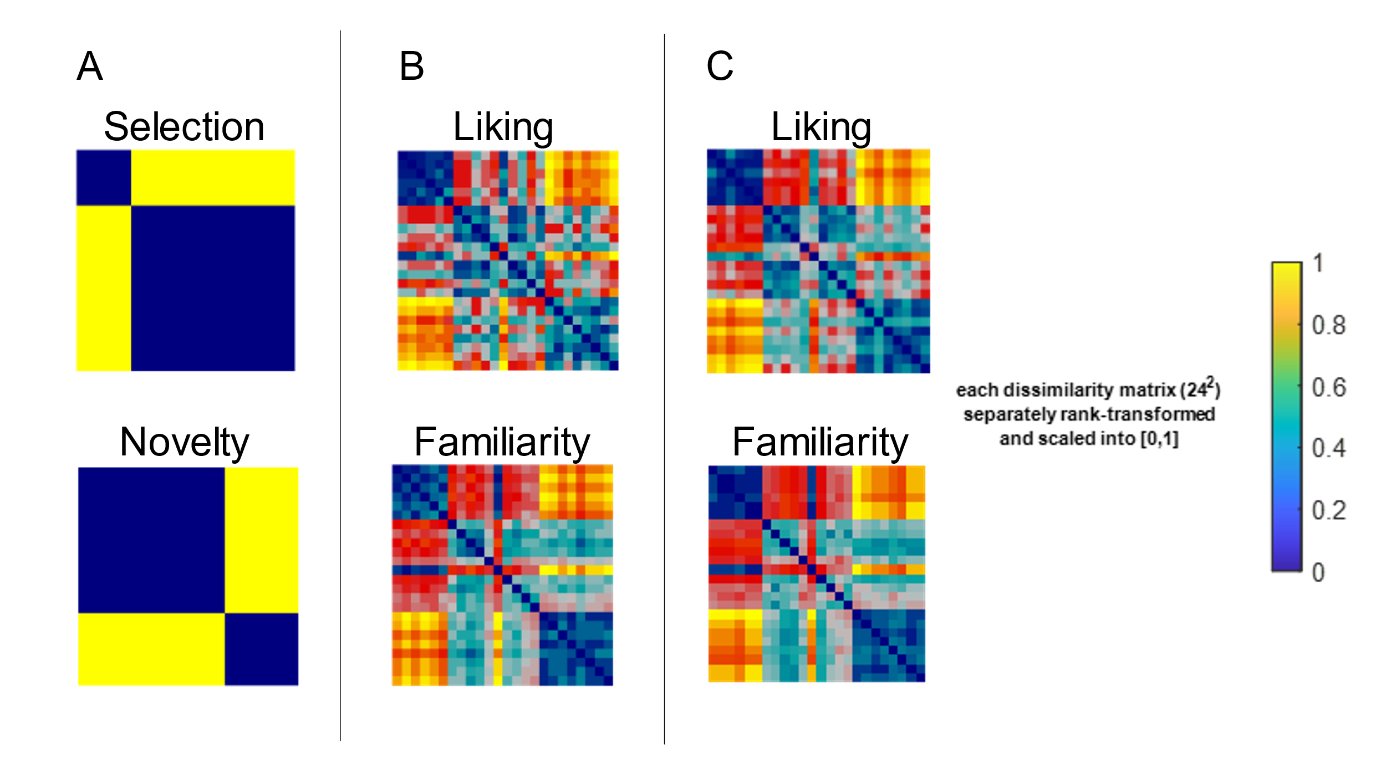
Figure S4: Second Level Model RDMs. (A) Time invariant binary RDMs representing stimulus selection (top) and novelty (bottom). (B) subject-averaged RDMs representing stimulus liking (top) and familiarity (bottom) ratings at the pre-intervention timepoint. (C) subject-averaged RDMs representing stimulus liking (top) and familiarity (bottom) ratings at the post-intervention timepoint.

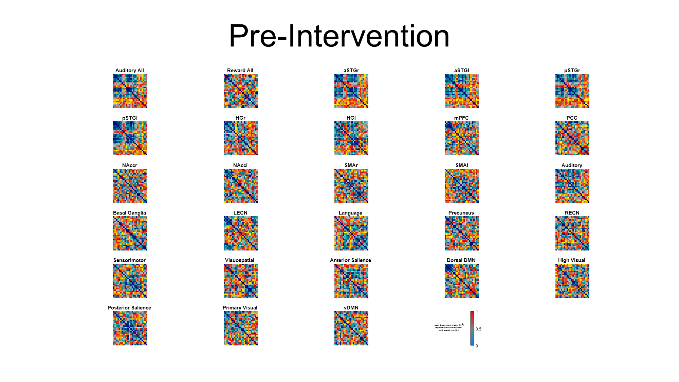
Figure S5: Pre-intervention fMRI-Derived RDMs. Participant-averaged RDMs representing differences in cortical responses to stimuli at the pre-intervention timepoint.

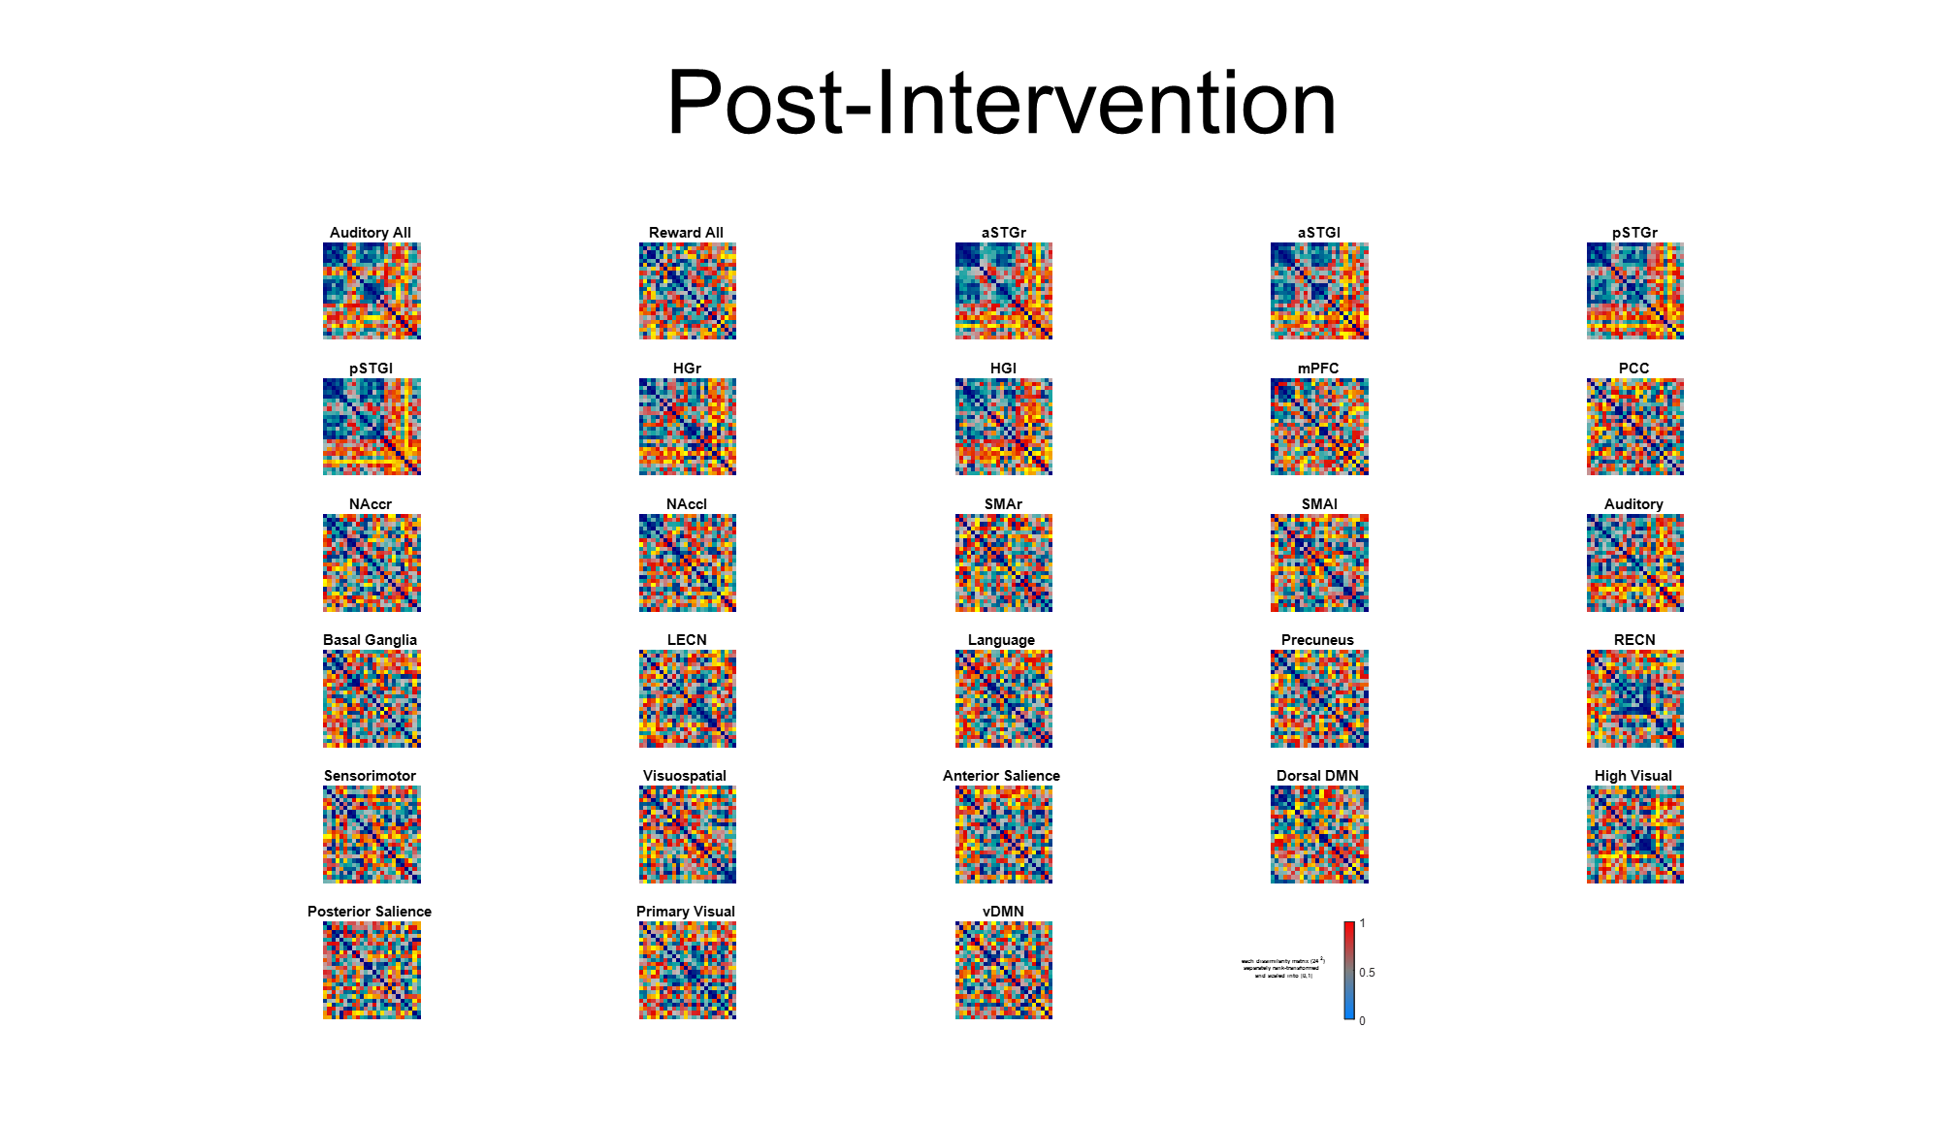
Figure S6: Post-intervention fMRI-Derived RDMs. Participant-averaged RDMs representing differences in cortical responses to stimuli at the post-intervention timepoint.

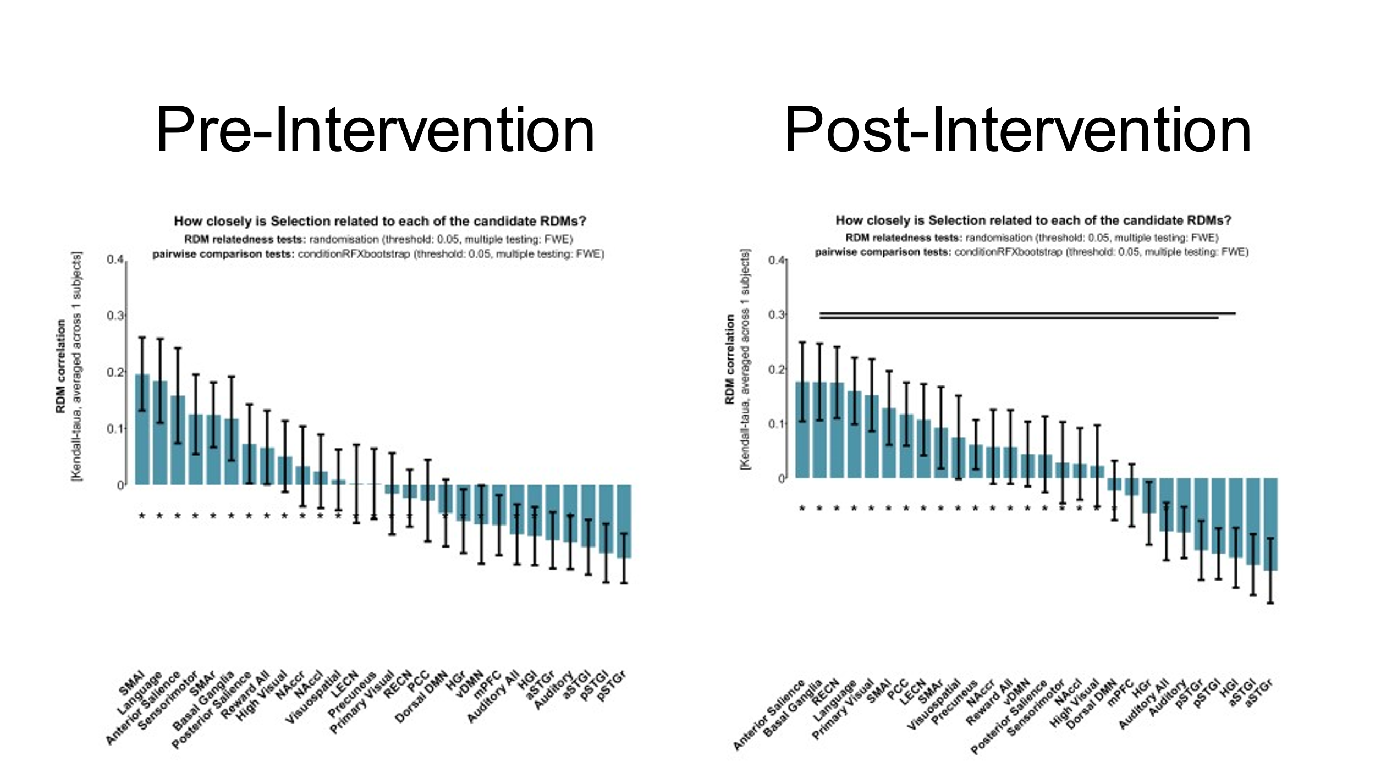
Figure S7: Bootstrap Comparisons of Selection RDM. results of 10,000-fold bootstrap comparisons of selection RDM to second level fMRI-derived RDMs at pre-intervention (left) and post-intervention (right) time points. Asterisk (*) represents a significant correlation between selection and a given fMRI-derived RDM (p <0.05, FWE corrected), and Black bars represent a significant difference between fMRI-derived RDMs (p <0.05, FWE corrected)

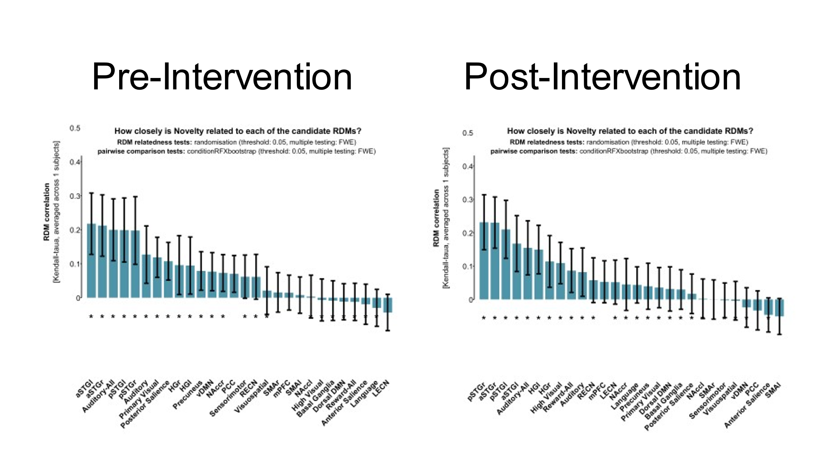
Figure S8: Bootstrap Comparisons of Novelty RDM. results of 10,000-fold bootstrap comparisons of novelty RDM to second level fMRI-derived RDMs at pre-intervention (left) and post-intervention (right) time points. Asterisk (*) represents a significant correlation between novelty and a given fMRI-derived RDM (p <0.05, FWE corrected).

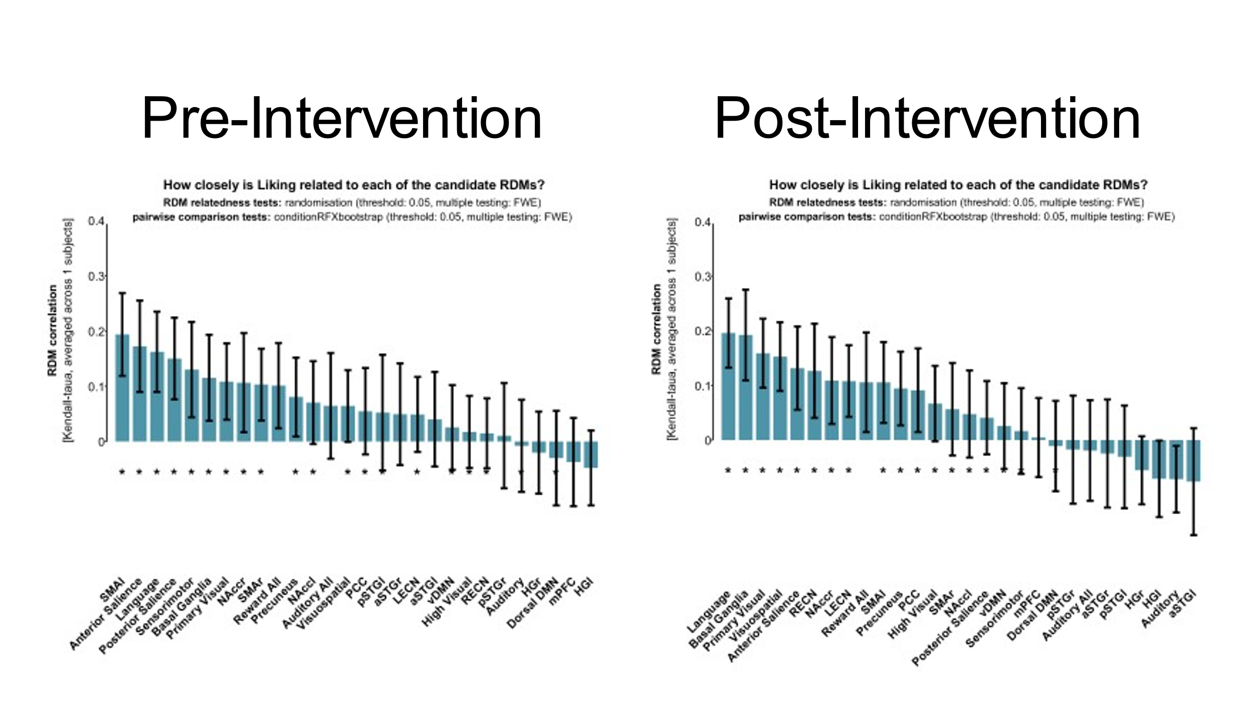
Figure S9: Bootstrap Comparisons of Liking RDM. results of 10,000-fold bootstrap comparisons of second-level liking RDM to second level fMRI-derived RDMs at pre-intervention (left) and post-intervention (right) time points. Asterisk (*) represents a significant correlation between liking and a given fMRI-derived RDM (p <0.05, FWE corrected).

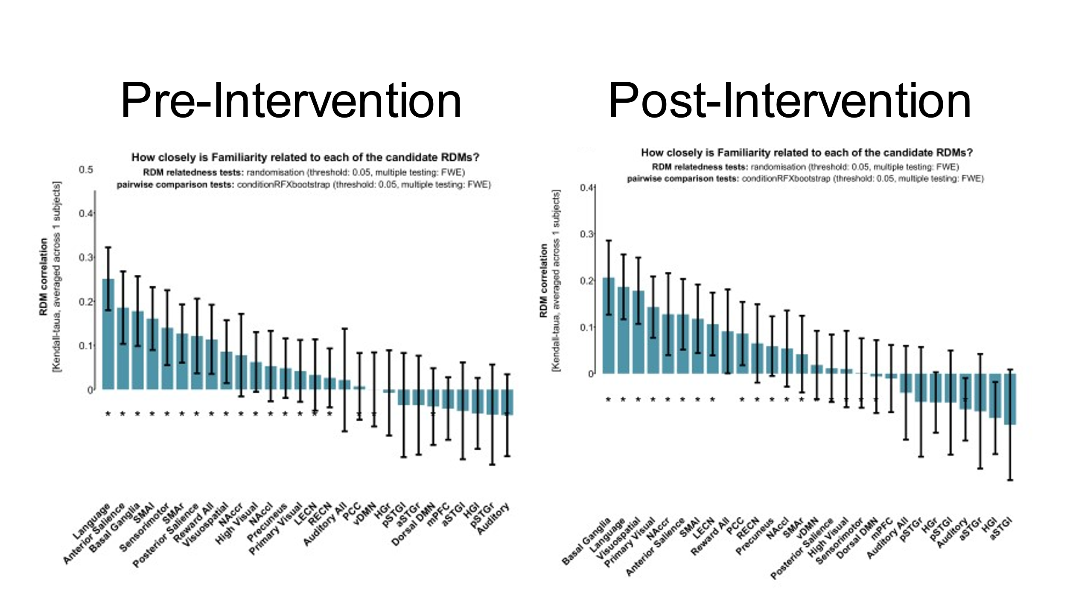
Figure S10: Bootstrap Comparisons of Familiarity RDM. results of 10,000-fold bootstrap comparisons of second-level familiarity RDM to second level fMRI-derived RDMs at pre-intervention (left) and post-intervention (right) time points. Asterisk (*) represents a significant correlation between liking and a given fMRI-derived RDM (p <0.05, FWE corrected).

