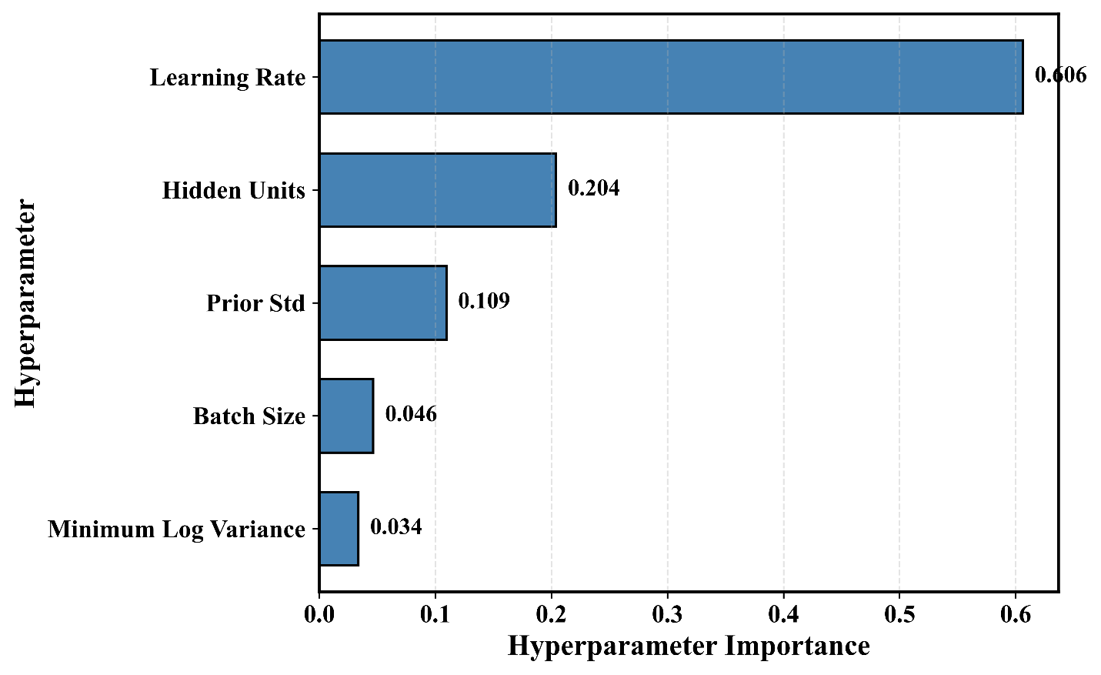
Supplementary Figure S1. Relative contribution of each hyperparameter to validation RMSE variance across optimization trials, computed using functional ANOVA.

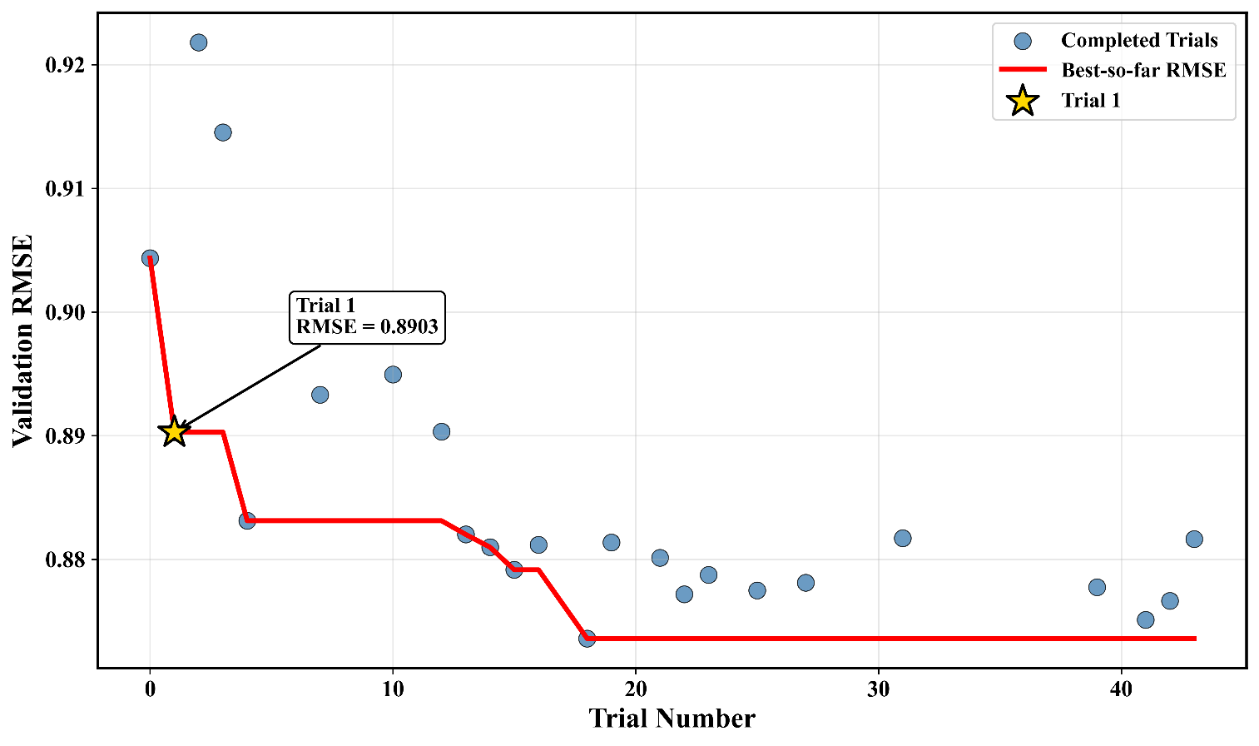
Supplementary Figure S2. Validation RMSE across completed optimization trials and the corresponding best-so-far RMSE; Trial 1 is marked.
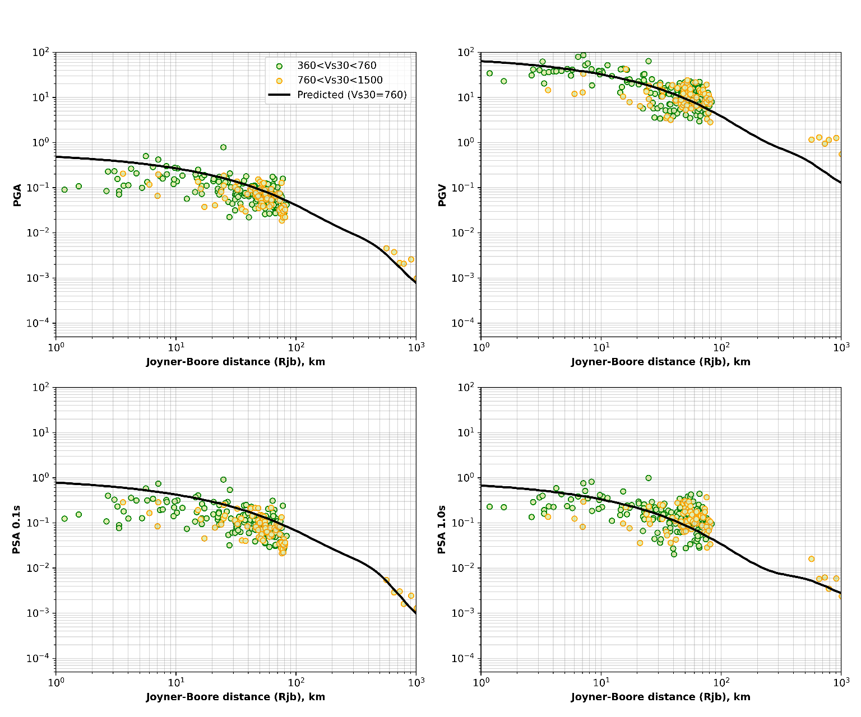
Supplementary Figure S3. Observed and predicted ground motions grouped by Vs30 range as functions of Joyner-Boore distance for the Mw = 7.5 magnitude bin.

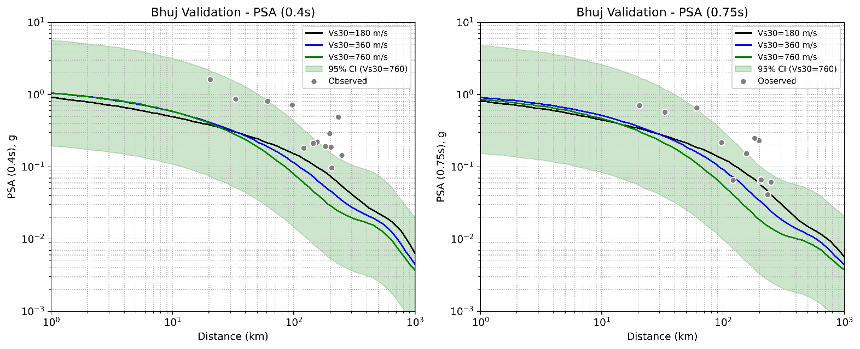
Supplementary Figure S4. Comparison of recorded Bhuj earthquake PSA at 0.4 s and 0.75 s with BNN-GMM predictions and 95% predictive intervals.
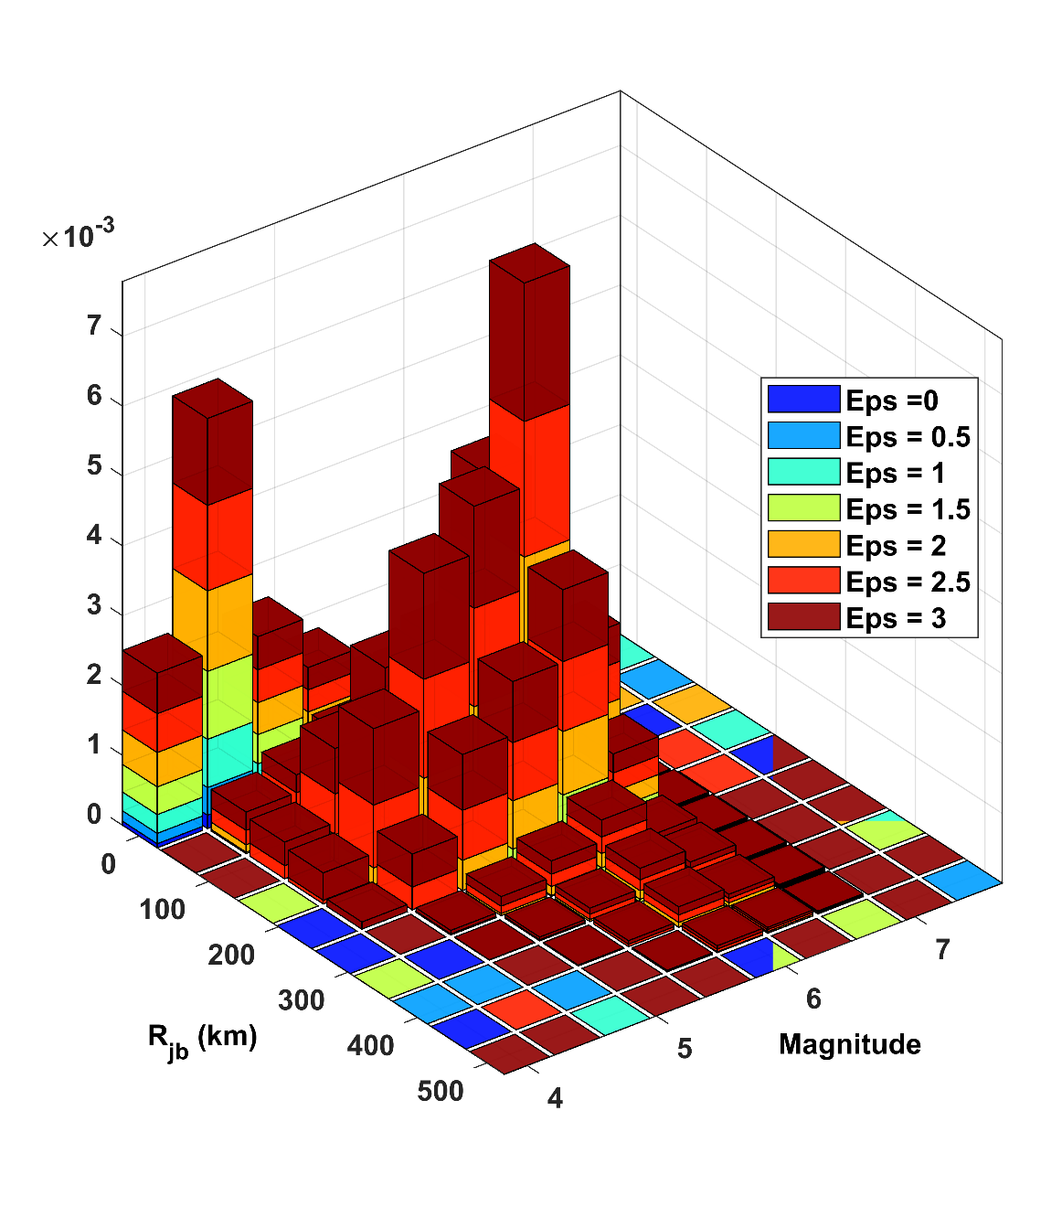
Supplementary Figure S5. Hazard deaggregation by magnitude, Joyner-Boore distance, and epsilon for the controlling earthquake scenario.

