Trait-mediated nutrient resorption reveals element-specific conservation strategies in mangroves
Zuo Xu^{1,2}, Tao Nie^{1,2}, Dalong Jiang^{1,2}*, Shiwei Wang^{1,2}, Wenyi Zi^{1,2}, Erhui Feng³, Qing Ye⁴

¹Ministry of Education Key Laboratory for Ecology of Tropical Islands, Key Laboratory of Tropical Animal and Plant Ecology of Hainan Province, College of Life Sciences, Hainan Normal University, Haikou, 571158, China
²Hainan Dongzhaigang Mangrove Ecosystem Provincial Observation and Research Station, Haikou, 571129, China
³Hainan Dongzhaigang National Nature Reserve Authority, Haikou, 571129, China
⁴Guangdong Provincial Key Laboratory of Applied Botany, and Key Laboratory of National Forestry and Grassland Administration on Plant Conservation and Utilization in Southern China, South China Botanical Garden, Chinese Academy of Sciences, Guangzhou, 510650, China

*Corresponding author:
Associate Professor Dalong Jiang
Email: djiang@hainnu.edu.cn
Tel: +86-186-8986-4779
Postal address: No. 99, Longkun South Road, Qiongshan District, Haikou, 571158, China
Supplementary material
Table S1. Species information in this study, including the salt regulation strategy and the nutrient resorption efficiencies (mean ± SE) of nitrogen (N), phosphorus (P), potassium (K), calcium (Ca), magnesium (Mg), iron (Fe), manganese (Mn), copper (Cu), zinc (Zn), boron (B), sodium (Na), and aluminum (Al) for each species.
Species | Salt regulation strategy |  | Nutrient resorption efficiency (%)
Species | Salt regulation strategy |  | N | P | K | Ca | Mg | Fe | Mn | Cu | Zn | B | Na | Al
Aegiceras corniculatum | secretor |  | 51.40 ± 6.23 | 54.11 ± 6.81 | 16.44 ± 5.21 | ‒59.34 ± 19.31 | ‒51.97 ± 18.52 | ‒84.70 ± 29.13 | ‒132.39 ± 55.01 | 46.76 ± 19.24 | 1.41 ± 10.27 | 19.23 ± 24.70 | 14.18 ± 10.49 | ‒35.71 ± 34.76
Avicennia marina | secretor |  | 54.57 ± 7.06 | 52.06 ± 6.71 | 43.91 ± 6.60 | ‒10.31 ± 16.82 | ‒46.01 ± 14.96 | ‒110.41 ± 50.09 | ‒125.93 ± 37.10 | 64.72 ± 8.19 | 25.09 ± 14.34 | ‒80.34 ± 48.90 | ‒17.94 ± 22.20 | ‒142.60 ± 62.56
Bruguiera gymnorrhiza | non-secretor |  | 65.29 ± 2.23 | 39.48 ± 6.49 | 32.16 ± 6.44 | ‒30.38 ± 13.65 | ‒25.40 ± 11.00 | ‒80.48 ± 36.96 | ‒39.83 ± 19.14 | 67.29 ± 6.11 | 26.69 ± 8.58 | ‒90.37 ± 32.08 | ‒31.46 ± 10.31 | ‒76.21 ± 77.74
Bruguiera sexangula | non-secretor |  | 69.10 ± 3.27 | 47.80 ± 10.24 | 34.74 ± 8.60 | 8.71 ± 8.43 | 9.62 ± 7.26 | ‒44.32 ± 41.98 | ‒31.29 ± 24.49 | 73.04 ± 4.00 | 29.87 ± 6.02 | ‒34.12 ± 16.56 | ‒8.93 ± 10.61 | ‒84.52 ± 61.37
Ceriops tagal | non-secretor |  | 50.95 ± 4.87 | 35.02 ± 6.24 | 45.42 ± 5.44 | ‒21.76 ± 12.62 | ‒7.82 ± 8.86 | ‒262.17 ± 98.42 | ‒94.46 ± 41.66 | 48.05 ± 16.57 | ‒1.26 ± 12.04 | ‒88.79 ± 28.52 | ‒5.69 ± 5.57 | ‒185.86 ± 80.68
Kandelia obovata | non-secretor |  | 63.74 ± 1.73 | 38.01 ± 6.79 | 46.09 ± 6.80 | ‒39.33 ± 18.41 | ‒15.63 ± 11.88 | ‒62.81 ± 40.32 | ‒112.73 ± 57.06 | 72.14 ± 5.76 | 6.21 ± 11.45 | ‒163.88 ± 42.63 | ‒11.82 ± 12.31 | ‒154.91 ± 86.17
Lumnitzera racemosa | non-secretor |  | 56.70 ± 5.88 | 62.62 ± 5.65 | 43.10 ± 10.44 | ‒47.72 ± 22.48 | ‒13.66 ± 14.95 | ‒147.46 ± 57.98 | ‒49.02 ± 31.50 | 52.30 ± 9.58 | 26.16 ± 14.68 | ‒15.76 ± 39.45 | ‒91.59 ± 22.42 | ‒295.85 ± 161.35
Rhizophora stylosa | non-secretor |  | 54.66 ± 4.08 | 38.09 ± 8.63 | 34.25 ± 7.54 | ‒34.23 ± 15.64 | ‒23.10 ± 10.22 | ‒267.28 ± 69.55 | ‒96.14 ± 18.32 | 32.91 ± 12.08 | 33.41 ± 11.62 | ‒160.41 ± 43.41 | ‒19.57 ± 9.97 | ‒226.05 ± 150.56
Sonneratia apetala | non-secretor |  | 70.88 ± 3.20 | 49.90 ± 7.37 | 51.10 ± 4.53 | ‒16.54 ± 21.28 | ‒1.87 ± 15.88 | ‒95.98 ± 21.73 | ‒36.83 ± 31.52 | 57.78 ± 8.93 | ‒1.41 ± 14.47 | ‒182.97 ± 75.45 | ‒65.39 ± 37.47 | ‒97.95 ± 63.58
Sonneratia caseolaris | non-secretor |  | 68.95 ± 4.18 | 66.28 ± 5.36 | 59.35 ± 4.41 | ‒2.13 ± 19.33 | 17.98 ± 8.08 | ‒80.66 ± 44.09 | ‒8.51 ± 21.71 | 63.04 ± 7.56 | 27.78 ± 17.08 | 23.85 ± 18.51 | ‒52.40 ± 31.95 | ‒349.43 ± 172.51
Average |  |  | 60.62 ± 1.60 | 48.34 ± 2.42 | 40.66 ± 2.40 | ‒25.30 ± 5.61 | ‒15.79 ± 4.45 | ‒123.63 ± 18.00 | ‒72.71 ± 11.80 | 57.80 ± 3.50 | 17.39 ± 4.00 | ‒77.36 ± 14.5 | ‒29.06 ± 6.87 | ‒164.91 ± 33.2

Table S2. Comparison of Akaike information criterion (AIC) values between linear and log‒linear models for leaf nutrient and anatomical traits. Bold values indicate the model with the lowest AIC.
Resorption efficiency |  | Nu_{gr} | P:S ratio | ET | GCL | SD | LV_{diameter} | LV_{density}
N | Linear model | 51.61 | 52.95 | 52.97 | 49.30 | 52.55 | 51.81 | 52.67
 | Log–linear model | 51.66 | 52.99 | 52.96 | 48.42 | 52.61 | 52.53 | 52.68
P | Linear model | 196.37 | 197.71 | 193.76 | 193.77 | 192.64 | 197.71 | 192.73
 | Log–linear model | 196.82 | 197.67 | 193.62 | 193.19 | 192.56 | 197.63 | 192.72
K | Linear model | 231.24 | 233.76 | 233.80 | 233.95 | 231.62 | 228.91 | 232.22
 | Log–linear model | 231.02 | 233.60 | 233.58 | 233.39 | 231.92 | 230.43 | 232.76
Ca | Linear model | 451.98 | 454.22 | 450.91 | 453.24 | 452.28 | 454.19 | 450.90
 | Log–linear model | 453.16 | 454.33 | 450.41 | 451.90 | 453.02 | 454.57 | 451.82
Mg | Linear model | 448.03 | 448.47 | 448.04 | 445.95 | 446.81 | 448.15 | 447.71
 | Log–linear model | 448.09 | 448.47 | 448.06 | 444.34 | 447.17 | 448.22 | 448.06
Fe | Linear model | 451.99 | 452.51 | 452.80 | 452.95 | 450.73 | 452.13 | 452.91
 | Log–linear model | 451.37 | 452.32 | 452.62 | 452.90 | 450.35 | 451.22 | 452.80
Mn | Linear model | 444.71 | 444.19 | 444.75 | 439.48 | 444.73 | 444.57 | 444.23
 | Log–linear model | 444.69 | 444.18 | 444.76 | 438.19 | 444.68 | 444.64 | 444.48
Cu | Linear model | 330.95 | 334.34 | 334.23 | 325.55 | 334.34 | 334.15 | 334.00
 | Log–linear model | 330.40 | 334.31 | 334.10 | 327.78 | 334.34 | 334.32 | 334.14
Zn | Linear model | 438.60 | 435.47 | 438.20 | 438.45 | 438.24 | 438.59 | 437.73
 | Log–linear model | 438.64 | 435.70 | 438.42 | 438.19 | 438.23 | 438.65 | 437.62
B | Linear model | 473.06 | 472.17 | 466.35 | 468.10 | 473.02 | 472.59 | 469.68
 | Log–linear model | 473.05 | 472.66 | 465.78 | 469.21 | 473.03 | 472.99 | 468.53
Na | Linear model | 456.58 | 456.79 | 456.04 | 456.54 | 456.91 | 445.31 | 456.14
 | Log–linear model | 456.57 | 456.96 | 455.94 | 456.87 | 456.60 | 445.30 | 456.37
Al | Linear model | 479.25 | 479.02 | 478.45 | 478.90 | 477.49 | 473.66 | 478.89
 | Log–linear model | 479.26 | 479.16 | 478.42 | 478.37 | 477.92 | 473.60 | 478.93
Nu_{gr}: green leaf nutrient concentration, including nitrogen (N), phosphorus (P), potassium (K), calcium (Ca), magnesium (Mg), iron (Fe), manganese (Mn), copper (Cu), zinc (Zn), boron (B), sodium (Na), and aluminum (Al). P:S ratio: palisade to spongy mesophyll ratio, ET: epidermal thickness, GCL: guard cell length, SD: stomatal density, LV_{diameter}: leaf vein diameter, LV_{density}: leaf vein density.
Table S3. Parameter estimates from the best‒supported model (based on AICc) explaining the variation in multinutrient resorption efficiency. Estimates (± SE), degrees of freedom (df), t‒values and P‒values are shown for all fixed effects. Significant effects (P < 0.05) are shown in bold. Abbreviations are consistent with those used in Table S2.
Resorption efficiency | Fixed term | Estimate ± SE | df | t value | P
N | GCL | ‒0.08 ± 0.04 | 54.17 | ‒2.04 | 0.046
P | ET | 0.20 ± 0.12 | 64.09 | 1.66 | 0.10
 | P_{gr} | 0.52 ± 0.09 | 71.06 | 5.67 | <0.001
 | P:S ratio | ‒0.19 ± 0.09 | 59.12 | ‒2.14 | 0.037
 | SD | ‒0.45 ± 0.11 | 68.18 | ‒4.26 | <0.001
 | LV_{diameter} | 0.18 ± 0.09 | 55.55 | 1.91 | 0.06
K | K_{gr} | 0.22 ± 0.13 | 79.36 | 1.73 | 0.088
 | LV_{diameter} | ‒0.27 ± 0.15 | 68.17 | ‒1.81 | 0.075
Ca | ET | ‒1.51 ± 0.49 | 80.00 | ‒3.10 | 0.003
 | P:S ratio | ‒1.19 ± 0.49 | 80.00 | ‒2.45 | 0.017
Mg | Mg_{gr} | 1.04 ± 0.40 | 51.53 | 2.62 | 0.012
 | GCL | ‒0.80 ± 0.42 | 50.99 | ‒1.91 | 0.061
Fe | Fe_{gr} | 2.54 ± 0.33 | 75.21 | 7.81 | <0.001
 | SD | 0.88 ± 0.37 | 58.02 | 2.39 | 0.020
Mn | ET | 0.90 ± 0.39 | 47.26 | 2.32 | 0.025
 | Mn_{gr} | 2.10 ± 0.36 | 79.79 | 5.77 | <0.001
 | GCL | ‒0.81 ± 0.37 | 57.43 | ‒2.17 | 0.035
Cu | GCL | ‒0.60 ± 0.20 | 80.00 | ‒3.05 | 0.003
Zn | ET | 0.91 ± 0.53 | 80.00 | 1.71 | 0.091
 | Zn_{gr} | 0.91 ± 0.39 | 80.00 | 2.36 | 0.021
 | P:S ratio | ‒0.83 ± 0.44 | 80.00 | ‒1.86 | 0.066
 | LV_{density} | 1.22 ± 0.52 | 80.00 | 2.38 | 0.020
B | ET | ‒2.65 ± 0.53 | 80.00 | ‒4.97 | <0.001
 | GCL | ‒1.46 ± 0.44 | 80.00 | ‒3.30 | 0.001
 | P:S ratio | ‒1.95 ± 0.50 | 80.00 | ‒3.94 | <0.001
 | LV_{diameter} | 1.77 ± 0.48 | 80.00 | 3.72 | <0.001
Na | ET | ‒1.15 ± 0.52 | 80.00 | ‒2.22 | 0.029
 | Na_{gr} | 1.25 ± 0.36 | 80.00 | 3.46 | <0.001
 | P:S ratio | ‒1.17 ± 0.44 | 80.00 | ‒2.67 | 0.009
 | LV_{density} | 1.06 ± 0.52 | 80.00 | 2.06 | 0.043
 | LV_{diameter} | 2.53 ± 0.41 | 80.00 | 6.23 | <0.001
Al | Al_{gr} | 2.36 ± 0.45 | 80.00 | 5.30 | <0.001

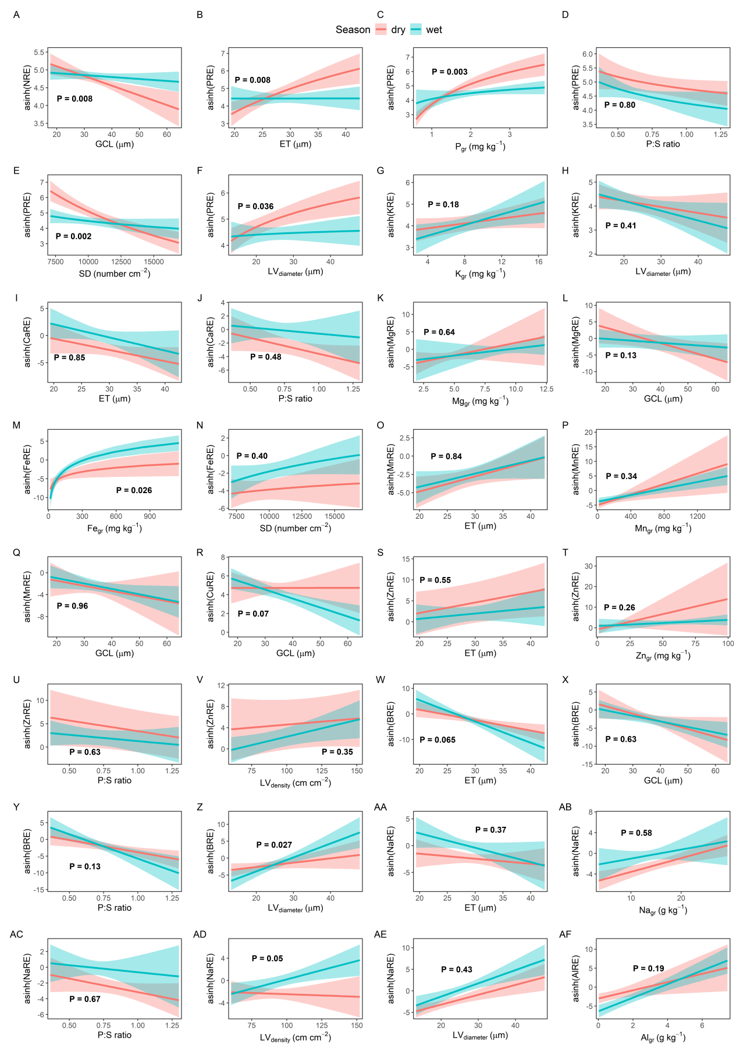
Fig. S1. Partial effects of green-leaf nutrient concentrations and leaf anatomical traits on nutrient resorption efficiency across season groups. Lines represent model predictions from linear mixed-effects models, with shaded areas indicating 95% confidence intervals. All the predictors were standardized, and the response variables were arcsinh-transformed; plots were included as random effects. P values indicate the significance of the interaction between season and the focal leaf trait. Abbreviations of the explanatory variables are as defined in Table S2.
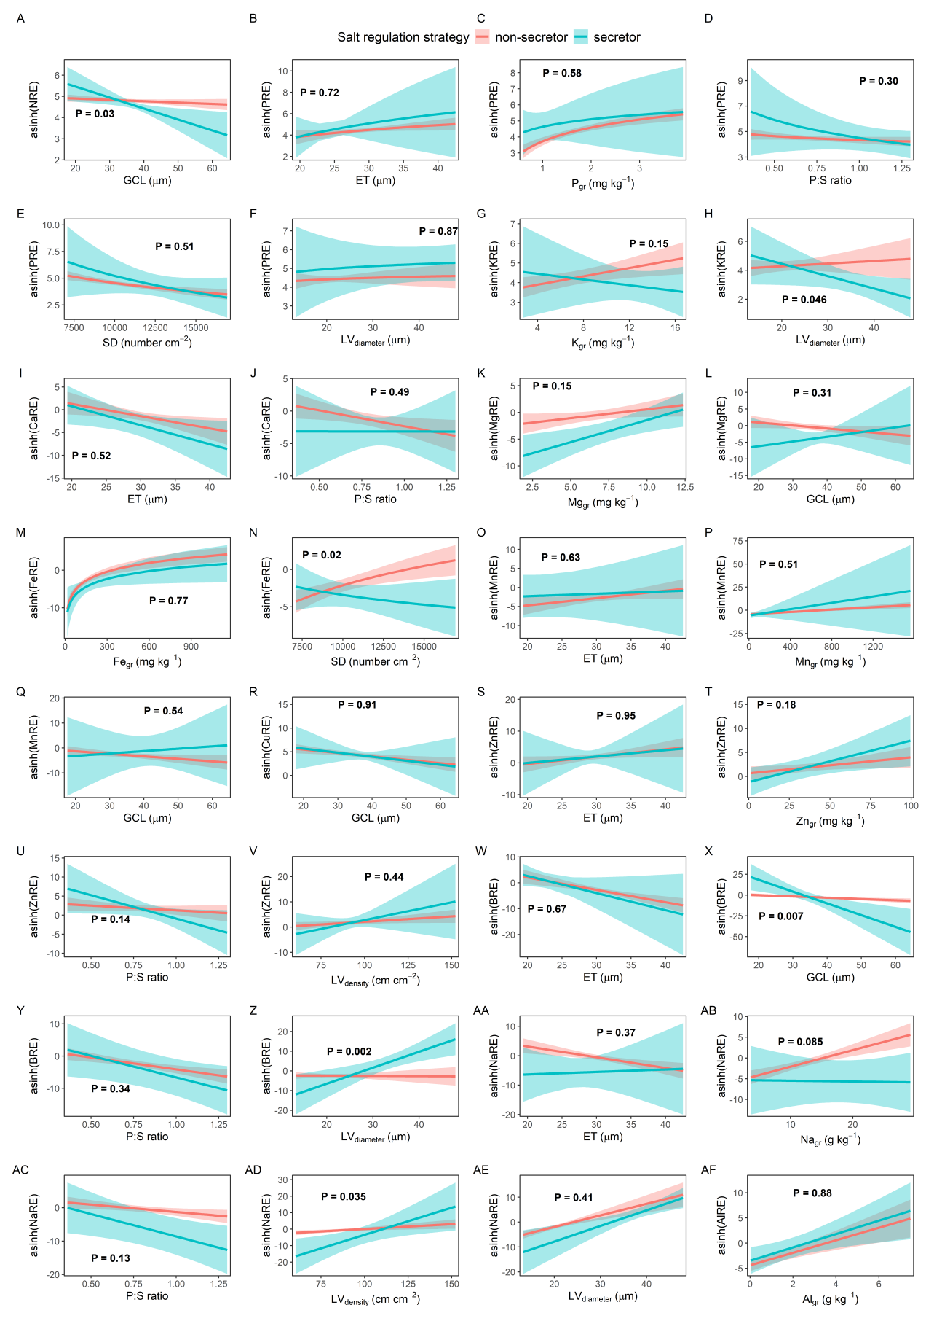
Fig. S2. Partial effects of green-leaf nutrient concentrations and leaf anatomical traits on nutrient resorption efficiency across salt regulation strategy groups. Lines represent model predictions from linear mixed-effects models, with shaded areas indicating 95% confidence intervals. All the predictors were standardized, and the response variables were arcsinh-transformed; plots were included as random effects. P values indicate the significance of the interaction between the salt regulation strategy and the focal leaf trait. Abbreviations of the explanatory variables are as defined in Table S2.

