Supplementary Information
In silico design and physicochemical characterisation of a dual-action intranasal nanoparticle formulation for Alzheimer’s disease
Table S1. Per-complex molecular dynamics stability metrics for all twelve protein–ligand pairs (single 20 ns trajectory each).
Compound | Target | Backbone RMSD (Å) | Ligand RMSD (Å) | Mean H-bonds | Stable binding
7,8-Dihydroxyflavone | TrkB | 2.1 | 2.2 | 3.2 | Yes
7,8-Dihydroxyflavone | Tau | 3.4 | 3.7 | 1.3 | Borderline
7,8-Dihydroxyflavone | GSK-3β | 2.2 | 2.8 | 2.1 | Yes
EF24 | TrkB | 2.3 | 3.3 | 1.6 | Yes
EF24 | Tau | 3.0 | 2.6 | 2.4 | Yes
EF24 | GSK-3β | 2.0 | 3.1 | 3.1 | Yes
Donepezil | TrkB | 2.2 | 3.8 | 1.6 | Borderline
Donepezil | Tau | 3.6 | 4.6 | 1.0 | No
Donepezil | GSK-3β | 2.4 | 4.8 | 1.9 | No
Memantine | TrkB | 2.2 | 5.1 | 0.6 | No
Memantine | Tau | 3.8 | 5.8 | 0.4 | No
Memantine | GSK-3β | 2.6 | 4.2 | 1.1 | No
Ligand RMSD < 4 Å was taken as the stability threshold; “Borderline” denotes values within ~0.3 Å of that threshold. Backbone RMSD values above 3 Å for tau reflect its intrinsic disorder. Each value derives from a single 20 ns trajectory.
Table S2. Full predicted physicochemical, ADME and toxicity profiles for all four compounds.
Compound | BBB permeant | LogP | Solubility (log S) | Drug-like | Ames | LD50 (mg kg⁻¹)
7,8-Dihydroxyflavone | Yes | 2.35 | −4.52 | Yes | Negative | 2,200
EF24 | Yes | 3.87 | −3.39 | Yes | Positive (mild) | 2,000
Donepezil | Yes | 4.00 | −2.50 | Yes | Positive | 45
Memantine | Yes | 2.85 | −2.52 | Yes | Negative | 370
BBB permeability, consensus LogP, aqueous solubility (log S) and drug-likeness predicted with SwissADME; Ames mutagenicity and rat oral LD50 predicted with admetSAR 2.0. Values are the consensus of three independent submissions per compound.
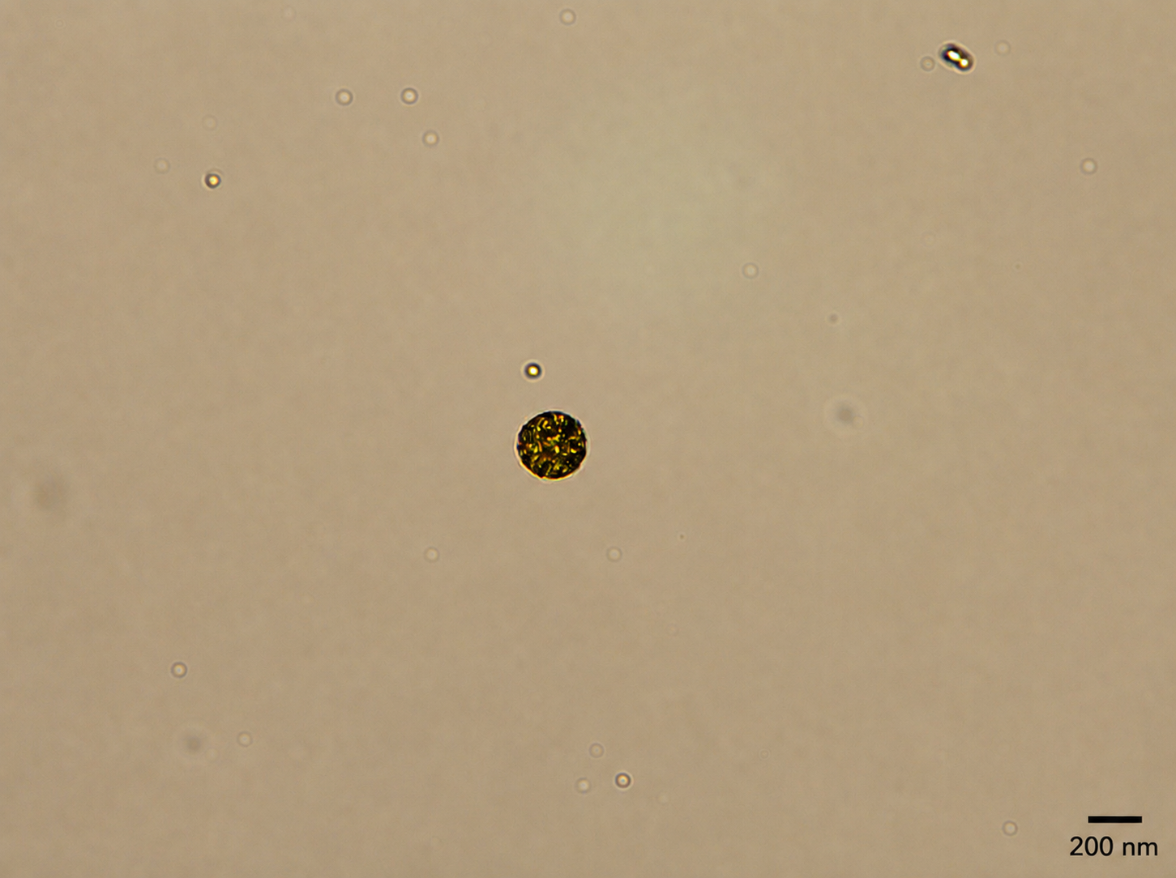
Figure S1. Optical micrograph of a synthesised nanoparticle co-loading EF24 and 7,8-dihydroxyflavone.
Brightfield optical micrograph of a PLGA nanoparticle co-loading EF24 and 7,8-dihydroxyflavone in aqueous suspension. Scale bar, 200 nm.
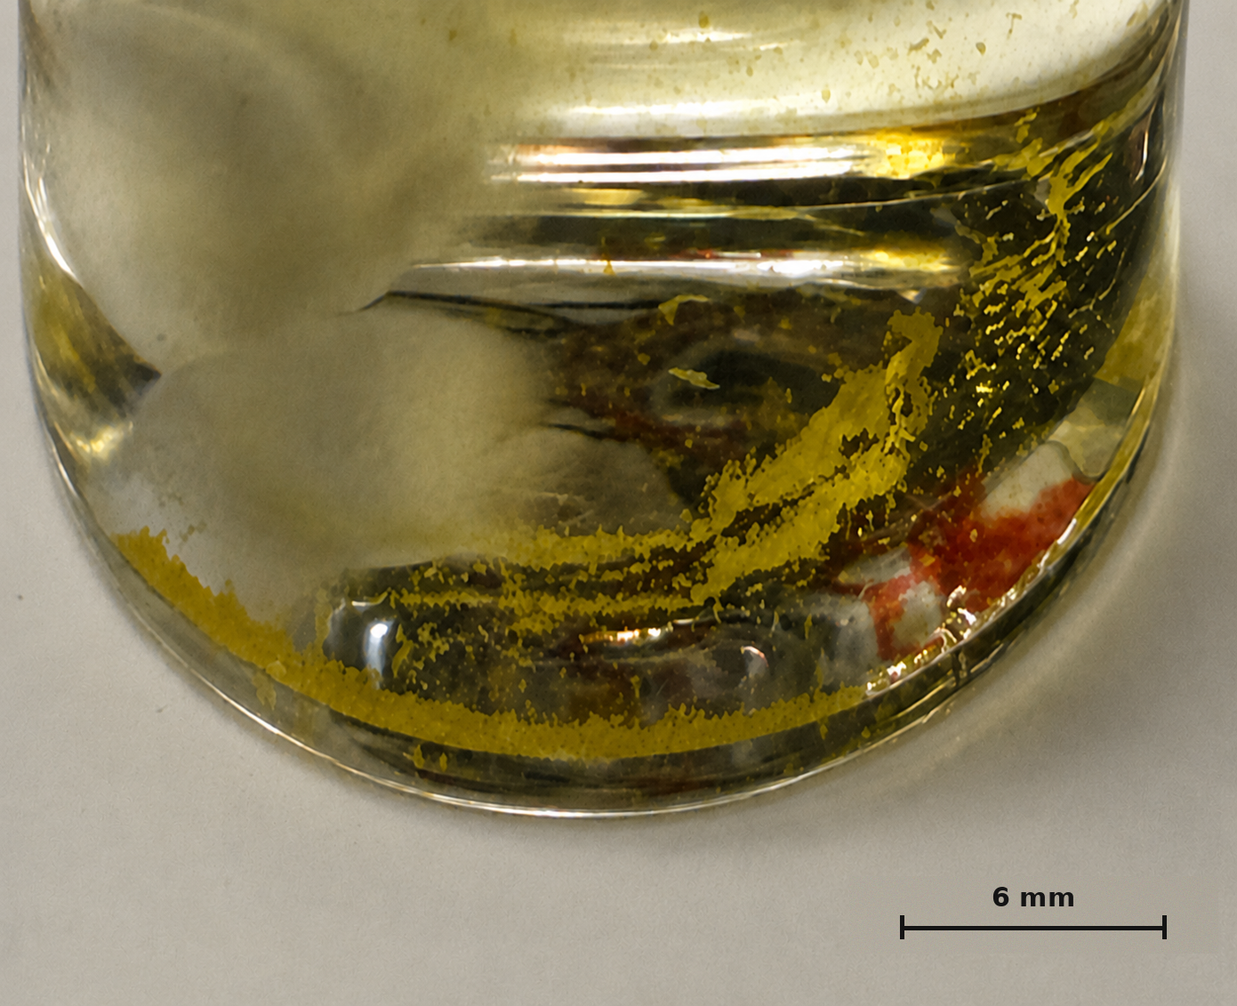
Figure S2. Nanoparticle formation during oil-in-water emulsion–solvent evaporation.
Photograph of the reaction vial during synthesis. The yellow EF24/7,8-dihydroxyflavone-loaded organic phase (PLGA dissolved in dichloromethane) disperses through the aqueous polyvinyl alcohol solution as nanoparticles form during solvent evaporation.

