Integrated analysis of Helicobacter pylori-related prognostic gene modification patterns in the tumour microenvironment of gastric cancer
Ye Wang^{1#}, Kaitian Zheng^{1#}, Jiancheng Wang¹, Congjun Wang¹, Junqiang Chen^{2*}

- Guangxi Medical University, No.6, Shuangyong Road, Qingxiu District, Nanning City, Guangxi Zhuang Autonomous Region, China.
- Department of Gastrointestinal Gland Surgery, The First Affiliated Hospital of Guangxi Medical University, Nanning City, Guangxi Zhuang Autonomous Region, 530021, China.
# Ye Wang and Kaitian Zheng contributed equally to this work.
* Correspondence:
Junqiang Chen
chenjunqiang@gxmu.edu.cn

Fig. S1: Data preprocessing steps.
Fig. S2: The expression pattern and correlation analysis of HP-related prognostic genes.
Fig. S3: External data sets verify the application value of prognostic risk models.
Fig. S4: Basic mode and mixture coefficients of Non-negative matrix factorization (NMF).
Fig. S5: The construction of HPscore and the association among HPscore, Age, and Gender.
Fig. S6: Analysis of the relationship of HPscore with fibroblast and the value in immunotherapy.

Fig. S1: Data preprocessing steps. (a) ROC curves to compare the diagnostic accuracy in GSE61433, GSE60642, and 27411 data sets. (b) Overall survival of the gastric cancer data sets. (c) Removal of batch effect. (d) Principal component analysis of combined data sets before and after batch effect correction.
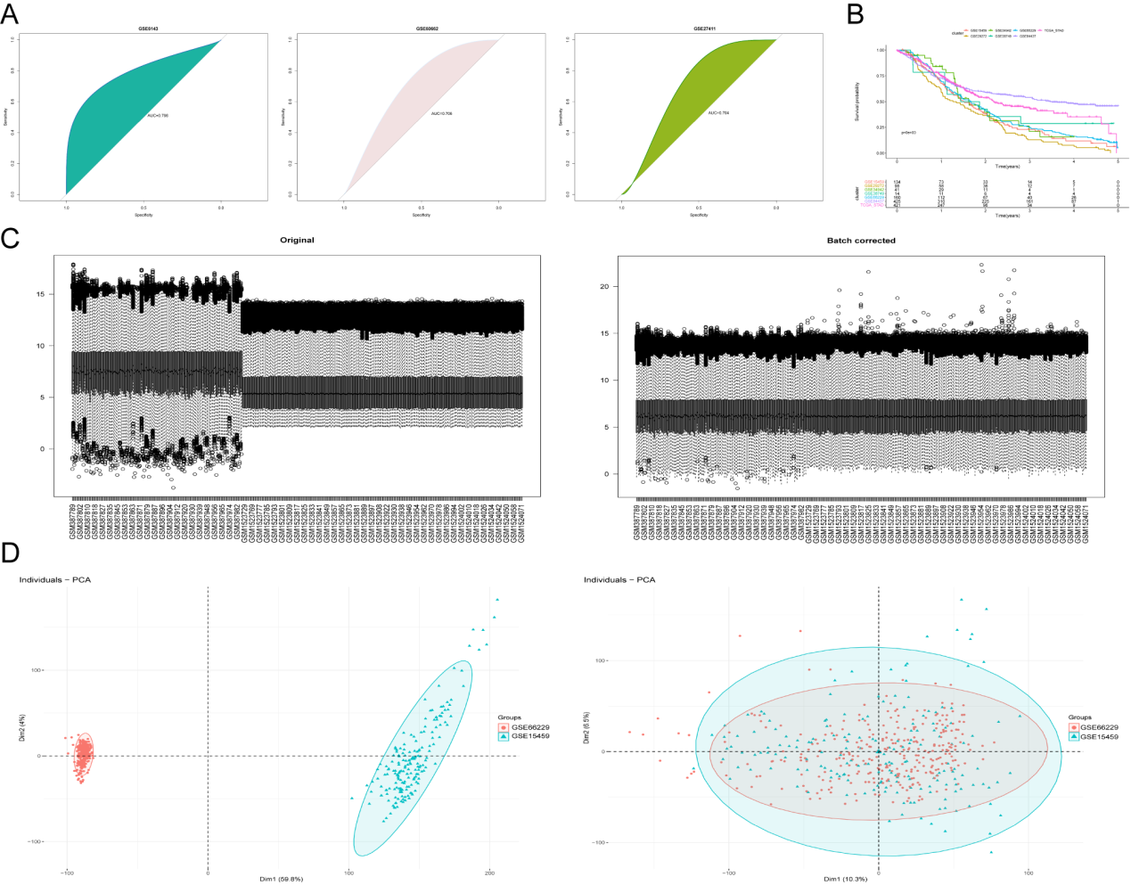
Fig. S2: The expression pattern and correlation analysis of HP-related prognostic genes. (a) Upset diagram displaying the overlap of differential gene expression profiles. (b) Chart of the expression correlation between 28 HP-related prognostic genes. (c) Immunohistochemistry analysis for IFFO1 in gastric cancer (HPA database).
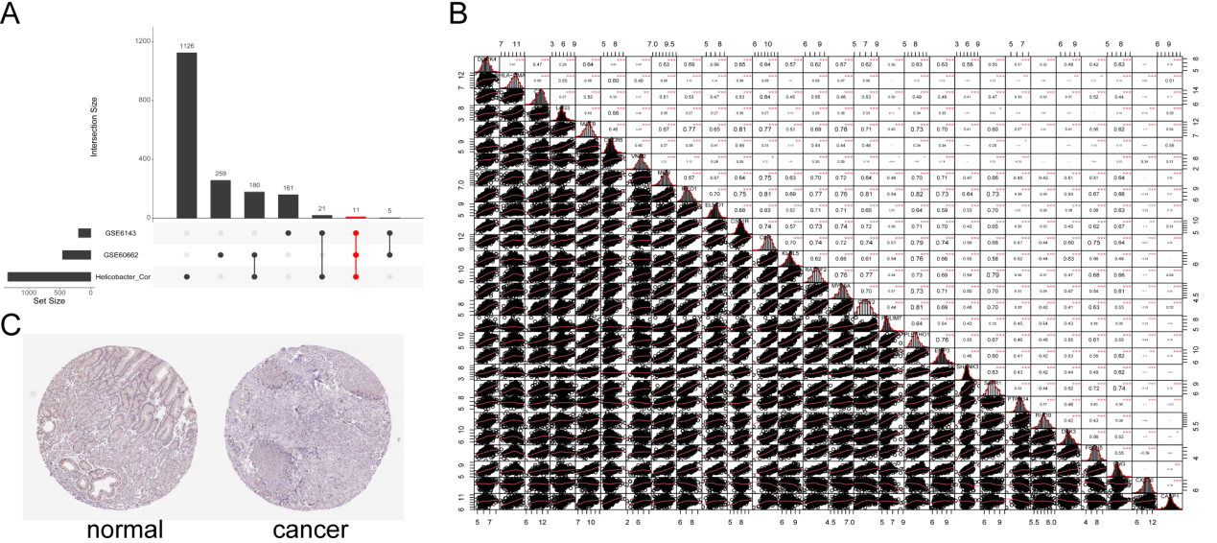

Fig. S3: External data sets verify the application value of prognostic risk models.
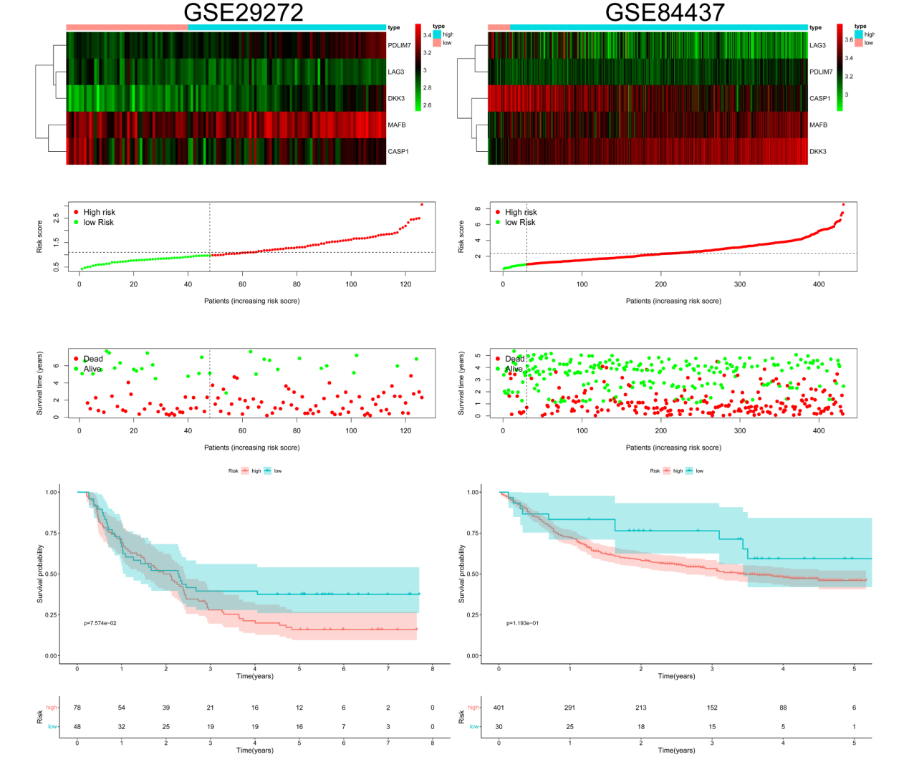
Fig. S4: Basic mode and mixture coefficients of Non-negative matrix factorization (NMF).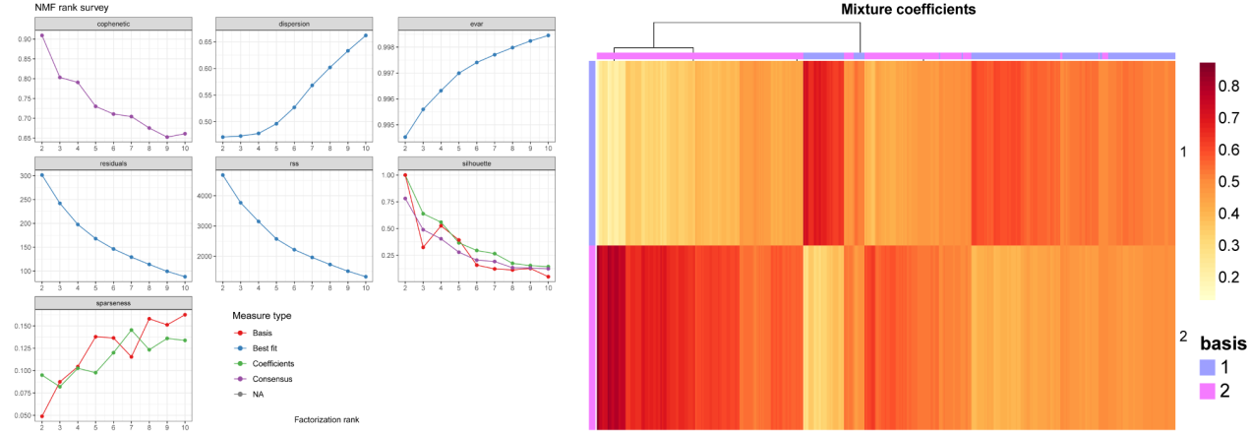
Fig. S5: The construction of HPscore and the association among HPscore, Age, and Gender. (a) Scree plot based on the principal component analysis. (b) Difference of HPscores with internal datasets (GSE66229, GSE15459). (c) and (d) Relationship among HPscore, Age, and Gender. (e) and (f) The HPscore difference analysis in the risk groups and cluster groups.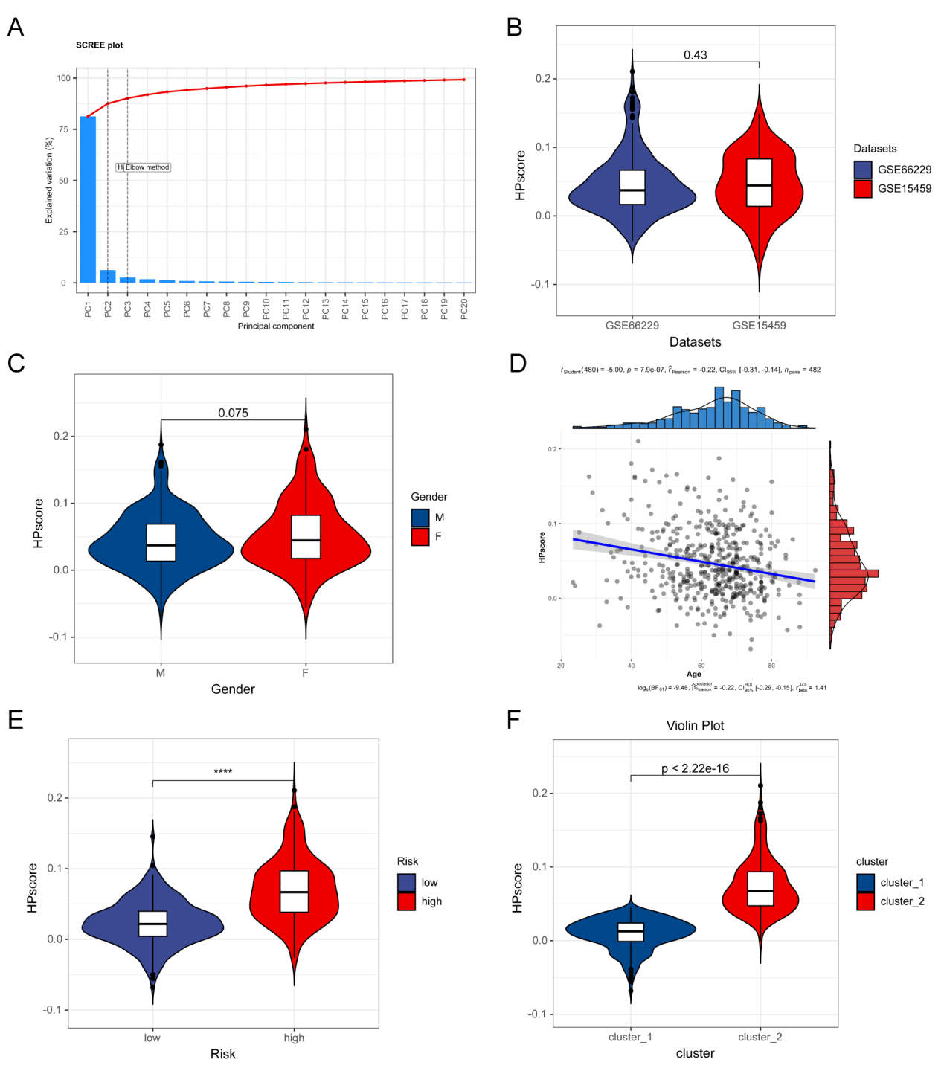
Fig. S6: Analysis of the relationship of HPscore with fibroblast and the value in immunotherapy. (a) The differences of HPscore between Normal fibroblasts (NF) and Carcinoma-associated fibroblasts (CAF). (b) The differences expression of CD274 between two Hp_Score groups in IMvigor210. (c) Bar plots of each patient response to PD-L1 treatment in two Hp_Score groups. (d) The Kaplan–Meier curves of OS between two Hp_Score groups in IMvigor210.
