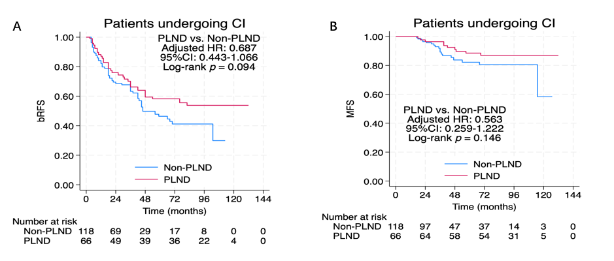
Supplementary fig 2. Kaplan-Meier curves of bRFS (A) and MFS (B) stratified by pelvic lymph node dissection (PLND) status in CI cohort: patients receiving PLND (red line) versus those without PLND (Non-PLND, blue line). A：Adjusted hazard ratio (HR) = 0.687, 95% confidence interval (CI): 0.443–1.066, lo g-rank p=0.094. B：Adjusted hazard ratio (HR) = 0.563, 95% confidence interval (CI): 0.259–1.222, log-rank p=0.146. bRFS, biochemical recurrence-free survival; MFS, metastatic-free survival; PLND, pelvic lymph node dissection; CI, conventional imaging; HR, hazard ratio; CI, confidence interval.

