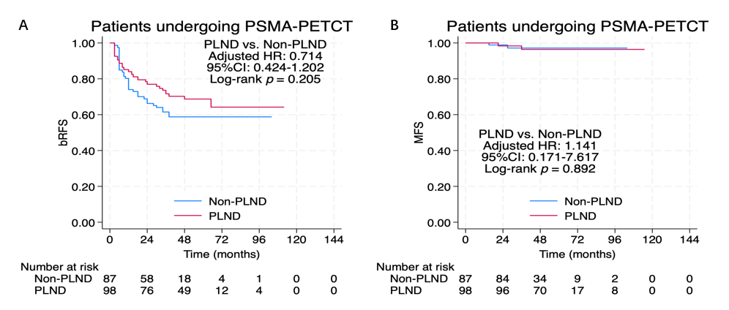
Supplementary fig 1. Kaplan-Meier curves of bRFS (A) and MFS (B) stratified by pelvic lymph node dissection (PLND) status in PSMA PET-CT cohort: patients receiving PLND (red line) versus those without PLND (Non-PLND, blue line). A：Adjusted hazard ratio (HR) = 0.714, 95% confidence interval (CI): 0.424–1.202, log-rank p=0.205. B：Adjusted hazard ratio (HR) = 1.141, 95% confidence interval (CI): 0.171–7.617, log-rank p=0.892. bRFS, biochemical recurrence-free survival; MFS, metastatic-free survival; PLND, pelvic lymph node dissection; PSMA-PETCT, prostate-specific membrane antigen positron emission tomography combined with computed tomography; HR, hazard ratio; CI, confidence interval.

