TAG-lite: a pre-training task-affinity workflow for multi-task ADMET learning with disjoint datasets
Seoyoon Koo^{1,2}, Sungmin Ko¹, Seung-Yong Seong^{1,3,*}
Supplementary Tables and Figures

Figure legends
Supplementary Fig. S1. Hierarchical clustering dendrograms under four linkage criteria. Ward, complete, average and single linkage applied to the same distance matrix D = 1 − A derived from the affinity matrix of Figure 1. The vertical axis is merge distance; each panel is annotated with the size of the largest cluster and the number of singletons it produces. Average and single linkage do not merely underperform: they collapse 14 and 16 of the 27 tasks respectively into one cluster, so that no usable partition is produced in this narrow-affinity regime. Complete linkage limits the largest cluster to eight but still converges on two or three large clusters without a useful task-level partition. Ward is the only criterion that resists chaining, and it also attains the highest mean within-cluster affinity (Supplementary Table S2).
Supplementary Fig. S2. Relative gain of equal-weighting multi-task learning over the single-task baseline. Per-endpoint relative gain Δrel (%) for the 26 non-singleton endpoints, sign-unified so that positive values denote improvement, ordered by the mean affinity ā of the group to which each endpoint was assigned. Bars are coloured by the sign of transfer; dashed lines separate groups, each annotated with its ā. Half_Life is omitted because within-group affinity is undefined for a singleton. Eleven endpoints gained and 15 lost, with a mean relative change of −1.47% and a median of −0.39%; per-task values are given in Supplementary Table S3. The panel is ordered by the predictor and not by the outcome, so the quantity of interest is the trend across groups rather than the aggregate mean: the two highest-affinity groups improved on most of their members while the five lower-affinity groups deteriorated on most of theirs.
Supplementary Fig. S3. Discrimination of positive transfer by within-group mean affinity. (a) ROC curve obtained with positive transfer (ΔP > 0; 11 positives, 15 negatives) as the binary outcome and within-group mean affinity as the discriminant score, with the Youden-optimal operating point marked. (b) Youden index J as a function of the affinity threshold; the shaded band spans the convergence interval of the three independent threshold estimates. Area under the curve 0.745 (Mann–Whitney U = 123, P = 0.018; permutation P = 0.016; bootstrap 95% CI [0.509, 0.955]). The Youden optimum is τ* = 0.151 (J = 0.615) at sensitivity 0.73 and false-positive rate 0.20; the zero-crossings of the task-level and group-level regressions are 0.167 and 0.164, which together give the recommended operating point τ* ≈ 0.16. J becomes negative below 0.121.
Supplementary Table S1. Single-task AttentiveFP baselines for the 27 endpoints. Mean ± s.d. over seeds 42, 123 and 777 on the official TDC scaffold split, reported in the official TDC metric for each endpoint.
Category | Endpoint | Metric | Performance
Absorption | HIA_Hou | AUROC | 0.9798 ± 0.004
Absorption | Pgp_Broccatelli | AUROC | 0.8922 ± 0.021
Absorption | Bioavailability_Ma | AUROC | 0.5996 ± 0.044
Absorption | Caco2_Wang | MAE | 0.3343 ± 0.007
Absorption | Lipophilicity_AZ | MAE | 0.4641 ± 0.073
Absorption | Solubility_AqSolDB | MAE | 0.7448 ± 0.025
Absorption | HydrationFreeEnergy | MAE | 0.7501 ± 0.104
Distribution | BBB_Martins | AUROC | 0.8136 ± 0.091
Distribution | PPBR_AZ | MAE | 7.2944 ± 0.016
Distribution | VDss_Lombardo | Spearman | 0.7104 ± 0.052
Metabolism | CYP1A2_Veith | AUPRC | 0.9295 ± 0.067
Metabolism | CYP2C9_Veith | AUPRC | 0.7647 ± 0.048
Metabolism | CYP2C19_Veith | AUPRC | 0.8722 ± 0.012
Metabolism | CYP2D6_Veith | AUPRC | 0.7461 ± 0.020
Metabolism | CYP3A4_Veith | AUPRC | 0.8629 ± 0.063
Metabolism | CYP2C9_Substrate | AUPRC | 0.3627 ± 0.091
Metabolism | CYP2D6_Substrate | AUPRC | 0.6015 ± 0.082
Metabolism | CYP3A4_Substrate | AUROC | 0.6247 ± 0.032
Excretion | Half_Life_Obach | Spearman | 0.5012 ± 0.112
Excretion | Clearance_Hepatocyte | Spearman | 0.3593 ± 0.033
Excretion | Clearance_Microsome | Spearman | 0.5210 ± 0.023
Toxicity | hERG | AUROC | 0.8031 ± 0.071
Toxicity | AMES | AUROC | 0.8509 ± 0.003
Toxicity | DILI | AUROC | 0.8865 ± 0.056
Toxicity | Carcinogens_Lagunin | AUROC | 0.7828 ± 0.047
Toxicity | Skin_Reaction | AUROC | 0.7295 ± 0.028
Toxicity | LD50_Zhu | MAE | 0.5723 ± 0.097
Note. The large absolute value for PPBR_AZ (MAE 7.2944) reflects its 0–100% target range rather than poorer prediction. Bioavailability_Ma (AUROC 0.5996) and CYP2C9_Substrate (AUPRC 0.3627) combine small datasets with severe class imbalance, and the Spearman-evaluated excretion endpoints are the weakest of the regression tasks, so it is there that transfer has the most headroom.

Supplementary Table S2. Comparison of four hierarchical linkage criteria. Mean within-cluster affinity, size of the largest cluster and qualitative outcome for Ward, complete, average and single linkage applied to the same distance matrix D = 1 − A (Supplementary Fig. S1).
Linkage | Within-cluster affinity | Max cluster size | Outcome
Ward | 0.1590 | 5 | Balanced clusters of 2–5 tasks; selected
Complete | 0.1517 | 8 | 2–3 large clusters, 3 singletons
Average | 0.1360 | 14 | Severe chaining; no usable partition
Single | 0.1274 | 16 | Severe chaining; no usable partition
Note. Because affinities are uniformly low and narrowly distributed, criteria that expand a cluster on the minimum pairwise distance merge dissimilar tasks through intermediates. Chaining, not incremental performance, is therefore the decisive criterion, and in this regime the choice of linkage is a necessary component of the algorithm rather than a refinement: a negative result obtained without varying it would be uninterpretable.

Supplementary Table S3. Equal-weighting multi-task results against the single-task baseline. Per-task single-task and multi-task performance in the official TDC metric, with Δ sign-unified so that positive values denote improvement, for all seven groups.
Group | Task | Metric | STL | MTL (EW) | Δ
Group 1 (ā = 0.223) | PPBR | MAE ↓ | 7.2944 ± 0.016 | 7.2418± 0.053 | +0.053
 | CL_Hep | Spearman ↑ | 0.3593 ± 0.033 | 0.4684± 0.054 | +0.109
 | CL_Mic | Spearman ↑ | 0.5210 ± 0.023 | 0.6068± 0.049 | +0.086
 | HydFE | MAE ↓ | 0.7501 ± 0.104 | 0.8700± 0.023 | −0.120
Group 2 (ā = 0.175) | HIA | AUROC ↑ | 0.9798 ± 0.004 | 0.9867 ± 0.006 | +0.007
 | Pgp | AUROC ↑ | 0.8922 ± 0.021 | 0.8893 ± 0.010 | −0.003
 | Bioavail | AUROC ↑ | 0.5996 ± 0.044 | 0.6114 ± 0.023 | +0.012
 | BBB | AUROC ↑ | 0.8136 ± 0.091 | 0.8631 ± 0.009 | +0.050
 | A4Sub | AUROC ↑ | 0.6247 ± 0.032 | 0.6321 ± 0.022 | +0.007
Group 3 (ā = 0.155) | Caco2 | MAE ↓ | 0.3343 ± 0.007 | 0.3063 ± 0.019 | +0.028
 | Sol | MAE ↓ | 0.7448 ± 0.025 | 0.7611 ± 0.018 | −0.016
Group 4 (ā = 0.151) | Lipo | MAE ↓ | 0.4641 ± 0.073 | 0.5114 ± 0.004 | −0.047
 | DILI | AUROC ↑ | 0.8865 ± 0.056 | 0.8828 ± 0.023 | −0.004
 | Carcin | AUROC ↑ | 0.7828 ± 0.047 | 0.7929 ± 0.042 | +0.010
Group 5 (ā = 0.145) | 1A2 | AUPRC ↑ | 0.9295 ± 0.067 | 0.9261 ± 0.002 | −0.003
 | 3A4 | AUPRC ↑ | 0.8629 ± 0.063 | 0.8544 ± 0.003 | −0.009
 | D6Sub | AUPRC ↑ | 0.6015 ± 0.082 | 0.5687 ± 0.046 | −0.033
 | hERG | AUROC ↑ | 0.8031 ± 0.071 | 0.7530 ± 0.003 | −0.050
 | Skin | AUROC ↑ | 0.7295 ± 0.028 | 0.5601 ± 0.051 | −0.169
Group 6 (ā = 0.121) | C9Sub | AUPRC ↑ | 0.3627 ± 0.091 | 0.3402 ± 0.032 | −0.023
 | AMES | AUROC ↑ | 0.8509 ± 0.003 | 0.8306 ± 0.005 | −0.020
 | LD50 | MAE ↓ | 0.5723 ± 0.097 | 0.6224 ± 0.020 | −0.050
Group 7 (ā = 0.116) | VDss | Spearman ↑ | 0.7104 ± 0.052 | 0.6464 ± 0.004 | −0.064
 | 2C9 | AUPRC ↑ | 0.7647 ± 0.048 | 0.7862 ± 0.005 | +0.022
 | 2C19 | AUPRC ↑ | 0.8722 ± 0.012 | 0.8819 ± 0.003 | +0.010
 | 2D6 | AUPRC ↑ | 0.7461 ± 0.020 | 0.6157 ± 0.004 | −0.130
Note. Overall, 11 of 26 tasks showed positive transfer and 15 negative, with a mean relative change of −1.47% and a median of −0.39%. Group 5 declined on all five members, Skin most severely (AUROC 0.7295 to 0.5601, −23.2%), and Group 7 was net negative despite small gains in CYP2C9 and CYP2C19. Under the framing adopted here the aggregate negative mean is not a failure but the observation sample the predictive-validity analysis requires.

Supplementary Table S4. Optimiser comparison on the two groups admitted by the affinity screen. Equal weighting, PCGrad, CAGrad and GradNorm compared against the single-task baseline. Group 1 is the three-task configuration obtained after the post-hoc removal of HydFE; Group 2 is unmodified. GradNorm values are the better of α = 1.0 and α = 1.5.
Group | Task | Metric | STL | EW | PCGrad | CAGrad | GradNorm
Group 1 (ā = 0.223) | PPBR | MAE ↓ | 7.2944 ± 0.016 | 7.2418 ± 0.053 | 7.1493 ± 0.044 | 7.3176 ± 0.088 | 7.0397 ± 0.190
 | CL_Hep | Spearman ↑ | 0.3593 ± 0.033 | 0.4684 ± 0.054 | 0.4738 ± 0.017 | 0.4039 ± 0.033 | 0.4583 ± 0.051
 | CL_Mic | Spearman ↑ | 0.5210 ± 0.023 | 0.6068 ± 0.049 | 0.6565 ± 0.036 | 0.6115 ± 0.049 | 0.6089 ± 0.027
Group 2 (ā = 0.175) | HIA | AUROC ↑ | 0.9798 ± 0.004 | 0.9867 ± 0.006 | 0.9881 ± 0.004 | 0.9848 ± 0.004 | 0.9920 ± 0.001
 | Pgp | AUROC ↑ | 0.8922 ± 0.021 | 0.8893 ± 0.010 | 0.8954 ± 0.002 | 0.8957 ± 0.008 | 0.8825 ± 0.010
 | Bioavail | AUROC ↑ | 0.5996 ± 0.044 | 0.6114 ± 0.023 | 0.6423 ± 0.071 | 0.6914 ± 0.027 | 0.6663 ± 0.030
 | BBB | AUROC ↑ | 0.8136 ± 0.091 | 0.8631 ± 0.009 | 0.8691 ± 0.013 | 0.8655 ± 0.009 | 0.8733 ± 0.022
 | A4Sub | AUROC ↑ | 0.6247 ± 0.032 | 0.6321 ± 0.022 | 0.6256 ± 0.021 | 0.6087 ± 0.038 | 0.6009 ± 0.012
Note. PCGrad is the only method that improves every task in both groups over its single-task baseline and was selected for both. GradNorm at α = 1.5 achieves the lowest PPBR error of any configuration (7.0397) but loses on both clearance endpoints; CAGrad reaches the highest Bioavailability score of any method (0.6914) while degrading PPBR below the single-task baseline and losing on CYP3A4_Substrate. The comparison was not run on the rejected Groups 3–7 (Supplementary Table S8), so it does not establish that gradient surgery would fail to rescue a low-affinity group.

Supplementary Table S5. Multiple regression of relative gain on within-group mean affinity with covariates (n = 26). Coefficients, standard errors, t statistics, P values, 95% confidence intervals and variance inflation factors for affinity, log₁₀ training-set size, a classification indicator, group size and within-group mean overlap.
Regressor | Coefficient | SE | t | P | 95% CI | VIF
Within-group mean affinity | +188.10 | 79.84 | 2.356 | 0.029 | [21.56, 354.64] | 2.28
log₁₀ training-set size | −0.93 | — | — | 0.849 | — | 2.22
Classification indicator | +4.09 | — | — | 0.497 | — | 2.41
Group size | −3.58 | — | — | 0.180 | — | 1.86
Within-group mean overlap | +28.87 | — | — | 0.123 | — | 1.77
Constant | −19.54 | — | — | — | — | —
Note. Affinity remains significant at +188.10 (P = 0.029), no covariate approaches significance and all variance inflation factors are below 2.5; R² = 0.377 (adjusted 0.222) with an omnibus F-test P = 0.072, which is why the inference rests on the partial coefficient rather than on the omnibus statistic. The partial correlation of affinity with relative gain, controlling for log₁₀ N, task type and group size, is +0.518 (P = 0.0067, df = 22) — larger than the zero-order correlation, so the covariates were suppressing the association rather than generating it.

Supplementary Table S6. Two-condition screening rule over the 26 non-singleton endpoints. Confusion matrix, sensitivity, false-positive rate, precision and Youden index for four threshold combinations of within-group mean affinity and within-group mean compound overlap, evaluated on the equal-weighting outcome.
Rule | TP | FP | FN | TN | TPR | FPR | Precision | Youden J
Affinity ≥ 0.155 only | 8 | 3 | 3 | 12 | 0.73 | 0.20 | 0.73 | +0.527
Affinity ≥ 0.155 & overlap ≥ 0.5% | 8 | 2 | 3 | 13 | 0.73 | 0.13 | 0.80 | +0.594
Affinity ≥ 0.155 & overlap ≥ 2.0% | 7 | 1 | 4 | 14 | 0.64 | 0.07 | 0.88 | +0.570
Affinity ≥ 0.175 & overlap ≥ 0.5% | 7 | 1 | 4 | 14 | 0.64 | 0.07 | 0.88 | +0.570
Note. Discrimination by score is 0.745 for affinity alone, 0.761 for overlap alone and 0.852 in sample for their logistic combination, falling to 0.758 under leave-one-out validation against 0.661 for affinity alone. The two conditions catch different failures: HydFE sits in the highest-affinity group and is removed only by the overlap condition, whereas CYP2D6 clears any overlap threshold and is caught only by affinity. Both thresholds were optimised on the same 26 observations used to evaluate them, so the reported operating characteristics are optimistic.

Supplementary Table S7. Re-analysis of the present data under the evaluation protocols of ten prior studies. Each protocol as extracted from its primary source, as applied here, the resulting figure and the reading it supports. The same 26 grouped endpoints, the same affinity estimates and the same multi-task results were used throughout, with no additional model training. Because no prior protocol contains an overlap term, the panel evaluates within-group mean affinity alone rather than the two-condition rule.
Protocol | As applied here | Result | Reading
Du et al. [10]: admit if cosine > 0 | Applied verbatim to within-group mean affinity | Admits 26 of 26; Youden J = 0; mean gain of admitted set −1.47% | Sign threshold carries no information in this affinity range
Zhang & Cheng [21]: admit if G > 0.05 | Applied verbatim | Admits 26 of 26 | Same conclusion; published cut-offs are not transportable
Azorin et al. [12]: correlate score with measured gain | Pearson, Kendall, Spearman against Δrel | r = +0.469; ρ = +0.462 | Comparable to their best score (Pearson 0.47) at 1% rather than 100% overlap
Azorin et al. [12]: score comparison on one outcome | Four candidate scores, same outcome | Affinity ρ +0.500 / AUC 0.745; overlap +0.473 / 0.761; log₁₀ N −0.026 / 0.424; group size +0.050 / 0.542 | Mechanistic scores carry signal; size covariates do not
Azorin et al. [12]: best-partner identification | — | Not performed (requires the 351-pair MTL oracle) | See Supplementary Table S8
Standley et al. [8]: grouping under a network budget | Admit the b highest-affinity groups; remainder single-task | +1.21% (b = 1) / +1.58% (2) / +1.82% (3) / +1.46% (4) / +0.07% (5) / −0.60% (6) / −1.47% (7) | Affinity ordering yields a usable efficiency frontier peaking at three groups
Standley et al. [8]: proxy-versus-outcome correlation | Four proxies against Δrel | Affinity +0.392 (P = 0.048); overlap +0.261 (0.198); log₁₀ N −0.058 (0.778); group size −0.048 (0.815) | Only affinity is significant, unlike the proxies in their study
TAG [9]: improvement rate and cost | Count of improved tasks; training runs | 11 of 26 (42.3%); 1 run × 3 seeds vs 351 pairwise runs | Unfavourable on rate, favourable on cost
MolGroup [14]: mean per-target improvement | Mean Δrel over endpoints | All 26: −1.47% (median −0.39%); classification −2.82% (7 of 17); regression +1.09% (4 of 9); τ*-admitted +4.31% (8 of 11) | Their +4.41% is matched only on the in-sample admitted subset
MTGL-ADMET [13]: per-endpoint win count | Count of endpoints beating single-task | 11 of 26 vs their 20 of 24 | Not like-for-like: partition vs per-task auxiliaries; scaffold vs random split; different endpoint set
MTG-Net [26]: predict the gain of a combination | Leave-one-out prediction of Δrel from affinity | MAE 6.98 pp vs 6.90 pp for the median baseline; r = +0.206 (P = 0.312); sign accuracy 76.9% | Magnitude prediction fails; direction survives
Sarafianos et al. [17]: top-50% rank rule | Split at the median affinity (0.151) | Strong half +4.31% (8 of 11); weak half −5.70% (3 of 15); U = 134, two-sided P = 0.008 | Separation replicates; on this dataset the rank split coincides with τ*
Zhang & Cheng [21]: overlap floor | Fraction of pairs and groups meeting their thresholds | 14 of 351 pairs (4.0%) ≥ 40%; 15 (4.3%) ≥ 30%; 0 of 7 groups ≥ 40%, 1 of 7 ≥ 30% | The whole analysis sits below their stated floor; the one group clearing 30% is the worst-performing
Zhang & Cheng [21]: band contrast and F₁ | Reported in their format at τ* | High band +4.31% (73% positive), low band −5.70% (20% positive); retains 73%, avoids 80%, F₁ = 0.727 | Comparable to their +2.3% / −1.8% and F₁ = 0.81 obtained above 40% overlap
Li et al. [19]: higher-order subset affinity | — | Not performed (thousands of subset trainings; requires the full 27 × 27 matrix) | See Supplementary Table S8
Note. The panel separates into three bands, and the separation is itself the result. Protocols that ask affinity to order or classify are favourable; protocols that ask it to forecast an absolute magnitude are unfavourable, most sharply the gain-prediction protocol of MTG-Net, under which the instrument loses to a median baseline that uses no affinity information (MAE 6.98 against 6.90 percentage points) while retaining 76.9% sign accuracy. The third band comprises published cut-offs that admit every endpoint here, which is a failure of threshold transport rather than of these data. Two protocols could not be applied at all and are recorded in Supplementary Table S8.
Supplementary Table S8. Audit of planned analyses, performed and not performed. Every analysis specified in the study design, with its status and, where it was not executed, the reason and the compute it would require.
Analysis | Status | Basis or reason
Pairwise compound overlap, 351 pairs | Performed | RDKit canonical SMILES; Table 2
Single-task baselines, 27 endpoints, 3 seeds | Performed | Supplementary Table S1
Linkage comparison, four criteria | Performed | Supplementary Fig. S1, Supplementary Table S2
Equal-weighting MTL, all seven groups | Performed | Supplementary Table S3
PCGrad / CAGrad / GradNorm comparison | Performed | Tables 7 and 8; restricted to the two admitted groups
HydFE exclusion sensitivity (3-task vs 4-task) | Performed | Post-hoc; r = 0.800 at n = 25
Task- and group-level correlation | Performed | Figure 3
Multiple regression with four covariates | Performed | Supplementary Table S5
Permutation null, task-level r | Performed | 100,000 replicates; P = 0.047
Permutation null, area under the curve | Performed | 100,000 replicates; P = 0.016
Permutation null, group-level r, sizes preserved | Performed | 100,000 replicates; P = 0.006
Overlap-stratified validity | Performed | Figure 4b
Two-variable rule with leave-one-out validation | Performed | Supplementary Table S6
Gradient-level label-permutation test | Not performed | Requires 1,000 additional multi-task training runs
Across-seed reproducibility, Spearman and Mantel | Not performed | The three seed-specific matrices were not retained
Overlap versus across-seed variability | Not performed | Depends on the same unavailable seed-specific matrices
Minimum pairwise affinity / affinity variance criteria | Not performed | Requires the full 27 × 27 matrix at pair level; superseded by the overlap condition
C1 random grouping, retrained | Not performed | Approximated by the group-level permutation test only
C2 anti-affinity grouping | Not performed | Requires 7 MTL runs; highest-priority missing experiment
C3 A/D/M/E/T grouping | Not performed | Requires 5 MTL runs
C4 undivided co-training | Not performed | Requires 2 MTL runs
Optimiser comparison on the rejected groups 3–7 | Not performed | Requires 15 further MTL runs; not attempted after the HydFE result
Magnitude-weighted affinity variant | Not performed | Proposed repair for the HydFE failure mode; untested
Replication on D-MPNN and GIN encoders | Not performed | Full pipeline per architecture; determines whether τ* is encoder-invariant
Attention-based structural interpretation | Not performed | Would test whether co-grouped endpoints read the same substructures
Best-partner identification (Azorin et al.¹²) | Not performed | Requires the 351-pair MTL oracle
Higher-order subset affinity (Li et al.¹⁹) | Not performed | Requires thousands of subset trainings and the full matrix
Per-task summed-affinity statistic (Sarafianos et al.¹⁷) | Not computable | Full pairwise matrix not retained; approximated by the top-50% rank rule
Measured GPU-hours | Not performed | Utilisation logs were not retained
Note. The audit is reported so that no claim rests on an analysis that was not run. The anti-affinity control (C2) is the single most informative missing experiment, being the only design that tests the directionality of the affinity signal while holding group size fixed, and it would require seven MTL runs. Until it is performed, the claim supported by this study is that affinity predicts transfer, not that affinity-based grouping causes better transfer than another grouping of the same shape.

Supplementary Table S9. Training runs required for task grouping over 27 tasks. Number of training runs demanded by exhaustive search, pairwise co-training, MTGL-ADMET, TAG and TAG-lite at T = 27, with the applicability of each to disjoint datasets.
Method | Runs required | At T = 27 | Note
Exhaustive search | One per partition | Infeasible | Bell number
Pairwise co-training⁸ | One per task combination | ≥ 351 | Pairwise minimum
MTGL-ADMET¹³ | O(T²) pairwise | 351 | Plus one single-task run
TAG⁹ | 1 (requires shared batches) | 1 | Not applicable to disjoint data
TAG-lite (this work) | 1 | 1 | Warm-up plus measurement phases; overlap computed without training
Note. The comparison is analytical, in units of training runs; measured GPU-hours are not reported because wall-clock and device-utilisation logs were not retained (Supplementary Table S8). TAG-lite delivers discrimination of 0.745, rising to 0.758 under cross-validation when combined with compound overlap, from a single run, whereas transference-based methods measure realised performance change and are correspondingly more reliable but require 351 pairwise runs.

Supplementary Table S10. Positioning relative to the closest prior work. For each of the seven most closely related studies: what it establishes, what it leaves open in the disjoint-input setting, and the increment contributed here.
Prior work | What it establishes | What remains open | Increment of this work
Du et al.¹⁰; PCGrad¹¹ | Gradient cosine similarity is a meaningful measure of task relatedness | Validity when the two gradients come from disjoint input distributions | Predictive validity demonstrated at a measured median 0.99% Jaccard overlap
Azorin et al.¹² | Unified benchmark of six affinity scores | Benchmarked on shared-input settings; no decision threshold | Predictive-validity statistics and a cross-validated two-variable decision rule
TAG⁹ | Loss-based lookahead affinity with strong theoretical grounding | Structurally inapplicable to disjoint datasets | TAG-lite: establishes what is recoverable when a common batch is unavailable
MTGL-ADMET¹³ | Data-driven auxiliary-task selection for ADMET using measured transfer | O(T²) cost; yields main plus auxiliary sets, not a partition | Single-run screening; two-stage combination proposed
MolGroup¹⁴ | Cosine affinity from independently sampled batches | Reports selection performance, not validity of the score itself | Score validated as an instrument, with permutation nulls and covariate adjustment
Sarafianos et al.¹⁷ | Ward clustering of a task-correlation matrix | Behaviour of linkage criteria in a narrow-affinity regime | Qualitative collapse of average and single linkage demonstrated
Zhang & Cheng²¹ | Argues gradient affinity requires ≥ 30% sample overlap; places TDC at 8–14% | Claim untested against a full ADMET grouping pipeline | Overlap figure confirmed; magnitude prediction confirmed to fail below 5% overlap; sign discrimination shown to survive; proposed distributional mechanism unsupported (r = −0.097)
Note. The components that are not new are named explicitly: the affinity definition, its measurement from independently sampled per-task batches, Ward clustering of an affinity matrix, and the observation that MTL benefit depends on grouping. The increment claimed is their operational integration into a pre-training decision procedure for disjoint molecular assay panels.

Supplementary Table S11. Quantities to report when extending the analysis to new endpoint panels. Reporting specification along five axes — scalability, matrix stability, threshold transfer, group assimilation and optimisation — giving for each the quantity to report, its reference value in the present study and the interpretation if it diverges.
Axis | Quantity to report | Reference value here | Interpretation if it diverges
Scalability | Training runs required for the extended panel of 27 + m endpoints | 1 run, against 351 pairwise runs at T = 27 | None expected; the run count is constant by construction
Scalability | Wall-clock and data volume of the single run | Not reported here (logs not retained) | Establishes that a constant run count does not mean constant cost
Scalability | Measurement batches B before and after extension | Set by the smallest task in the panel | A fall in B degrades the estimate for every task; lengthen the measurement phase by repeated passes
Matrix stability | Spearman and Mantel statistics between the 351 base-panel entries before and after extension | Published matrix (this study) | High agreement supports affinity as a property of the endpoint pair; low agreement makes it panel-conditional
Matrix stability | Adjusted Rand index between base-panel partitions before and after extension | Ward partition at k = 8 (Table 3) | Indicates whether existing groups survive the addition of new endpoints
Threshold | Youden-optimal τ*, and the two regression zero-crossings | 0.151; 0.167 and 0.164 | Agreement supports a transferable operating point; divergence requires recalibration
Threshold | τ* expressed as a percentile of the within-group affinity distribution | To be reported alongside the absolute value | Agreement on percentile but not absolute value indicates a scale shift rather than a moved decision boundary
Threshold | Overlap condition re-derived on the new panel | 0.5% within-group mean Jaccard | The 0.5% figure was optimised in sample here and is not assumed to transfer
Threshold | Thresholds fitted on a subset and evaluated on held-out endpoints | Not performed here | Supplies the out-of-sample validation this study lacks
Assimilation | Merge distance and assigned group for each new endpoint, with its within-group affinity and overlap | Seven groups, affinity 0.116–0.223 (Table 3) | Locates the new endpoint relative to the established structure
Assimilation | Attention-profile similarity between the new endpoint and its assigned group, by Mantel test | Not performed here | Tests whether assimilation on gradient affinity corresponds to shared substructure attention; a mismatch is the informative negative case
Optimisation | Best optimiser per admitted group, against equal weighting | PCGrad on both admitted groups (Supplementary Table S4) | A different winner indicates that the choice is panel- or architecture-dependent rather than general
Note. The specification is implemented by the three commands of the released pipeline (affinity, group and screen). Quantities marked as not reported here are those the present study specifies but did not execute (Supplementary Table S8); a panel extension obtains several of them as a by-product, in particular the Mantel comparison that determines whether affinity is a property of the endpoint pair or of the panel.

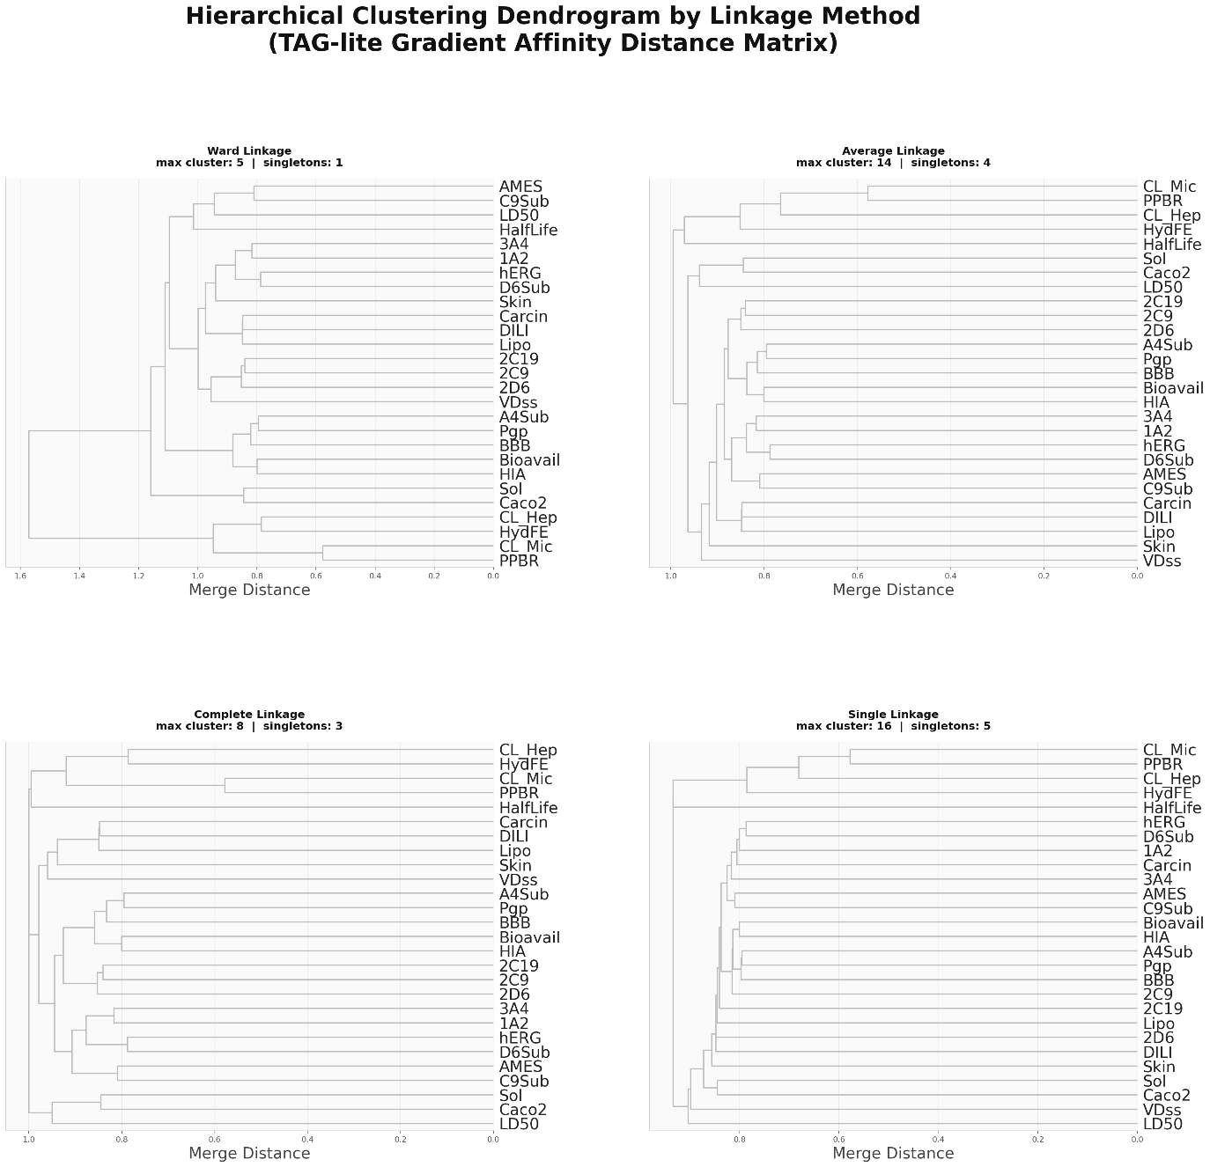
Supplementary Fig. S1
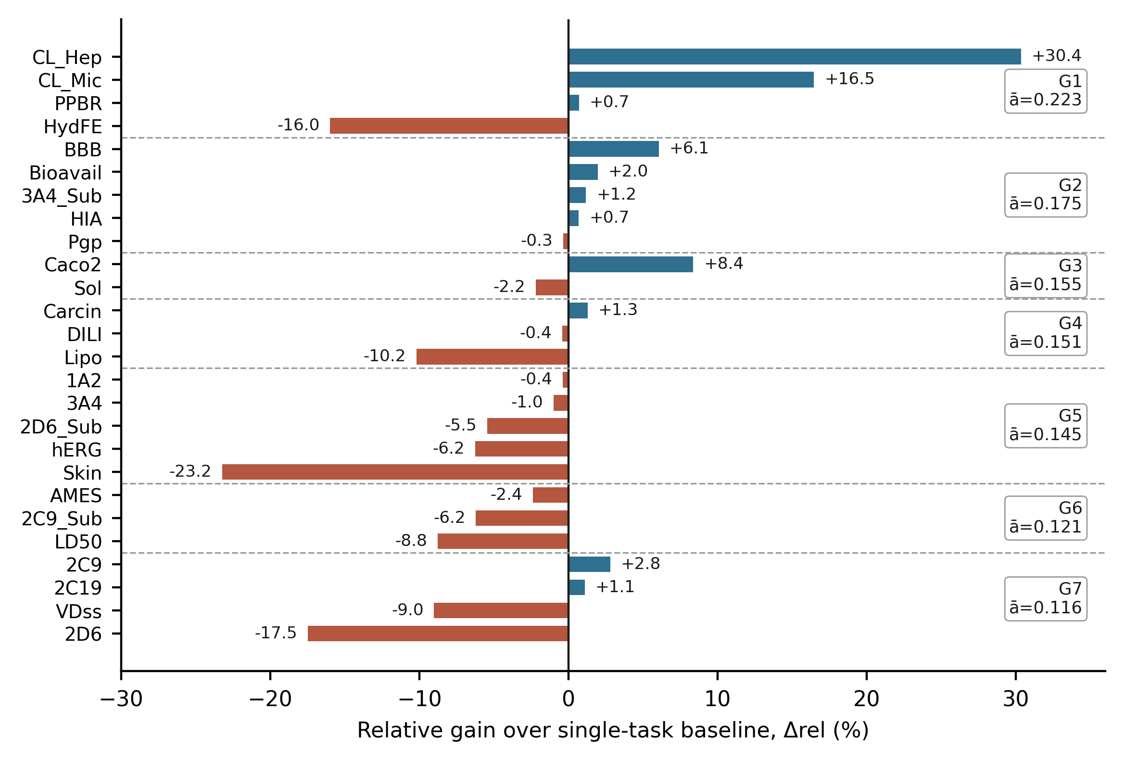
Supplementary Fig. S2

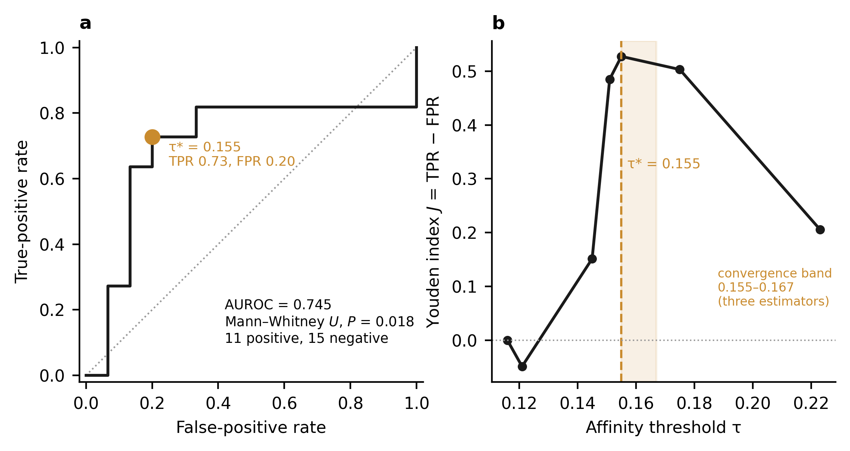
Supplementary Fig. S3

