Supplementary Fig. S3
This file is the single supplementary file containing the gel and blot images used in the main manuscript. In accordance with the journal’s Editorial Policies, the membrane/gel edges are clearly marked, each image is labelled with its corresponding main-text figure number and the relevant descriptor, and molecular-weight markers (ladders) are provided where applicable. Full-length, original, unprocessed versions are provided for all panels except Supplementary Figure S3-1, for which the original full-length unprocessed image could no longer be located (details are provided in the response letter); the available image for this panel is shown.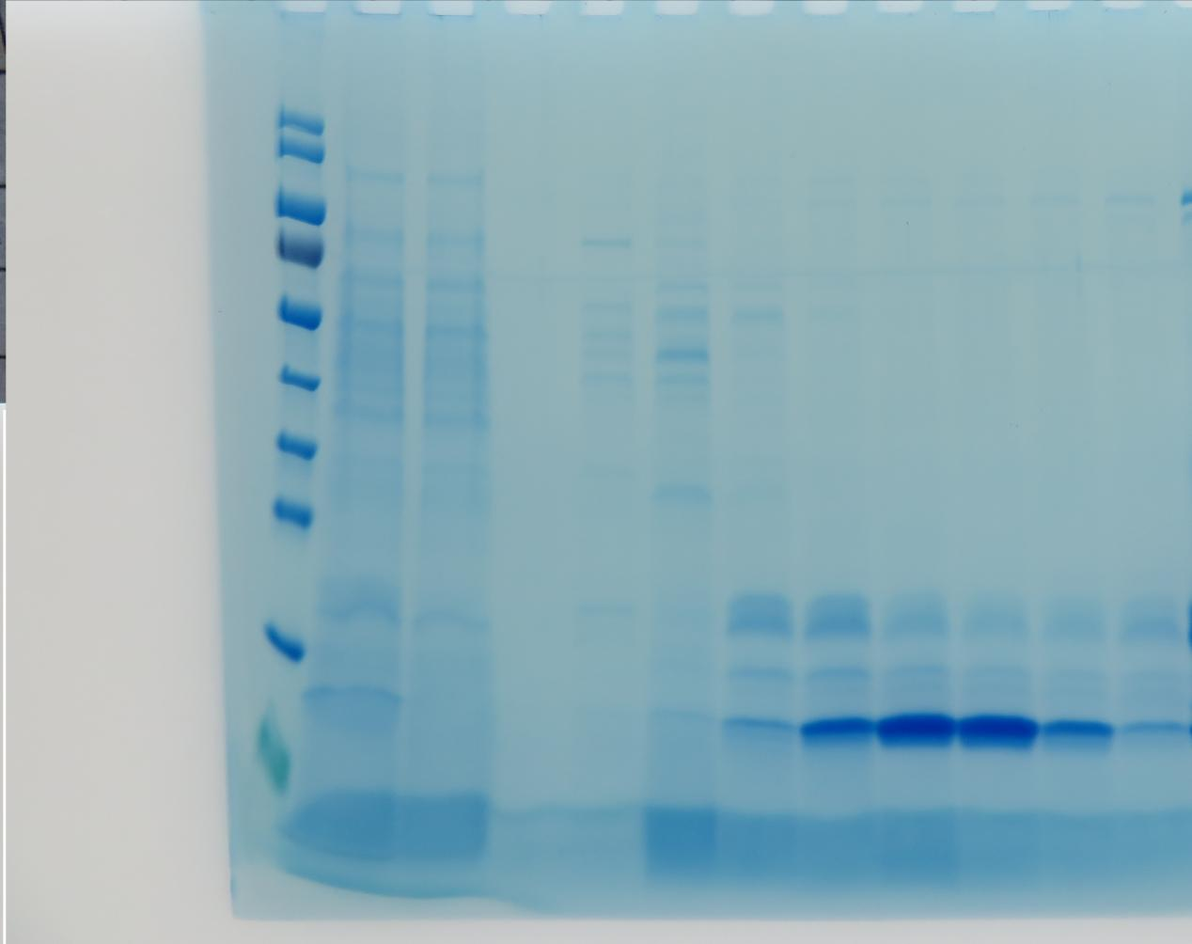
M 1 2 3 4 5 6 7 8 9 10 11
Supplementary Figure S3-1. SDS–PAGE analysis (Coomassie Brilliant Blue staining) of the Ni–NTA affinity purification of recombinant giant panda calprotectin subunits, corresponding to Figure 2C of the main manuscript. Lane M, protein molecular-weight marker; lane 1, culture supernatant (load); lane 2, flow-through (effluent); lane 3, wash fraction; lane 4, elution fraction; lanes 5–11, eluted peak fractions. The target bands at approximately 15 kDa (S100A8) and 18 kDa (S100A9) are progressively enriched. Please note: the original full-length, unprocessed gel image for this panel could no longer be located after the figure panel was prepared and is therefore not available for upload; the available image is provided here, and this is detailed in the response letter. The gel edges shown are clearly marked, and the image is labelled as corresponding to Figure 2C.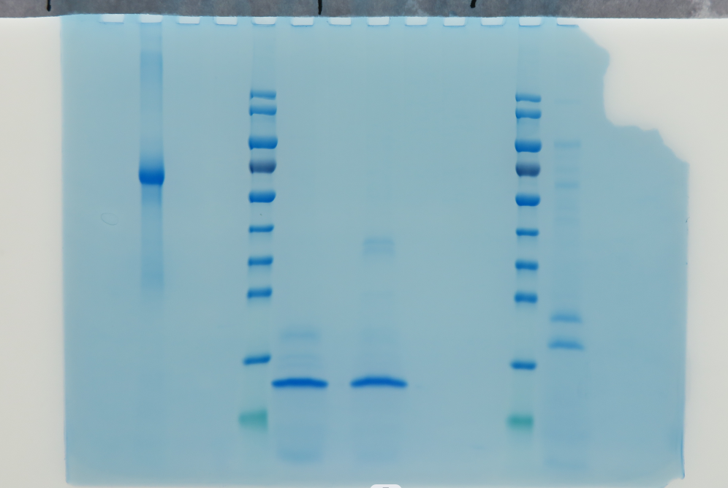

M 1 2
Supplementary Figure S3-2. Full-length, unprocessed SDS–PAGE gel (Coomassie Brilliant Blue staining) of purified recombinant giant panda S100A8 and S100A9 subunits, corresponding to Figure 2A of the main manuscript. Lane M, protein molecular-weight marker; lane 1, purified protein under reducing conditions (SDS sample buffer containing β-mercaptoethanol); lane 2, purified protein under non-reducing conditions. Target bands at approximately 15 kDa and 18 kDa. Unprocessed original; gel edges retained. Gel edges are clearly marked, and the image is labelled as corresponding to Figure 2A with the protein molecular-weight marker (lane M) as the ladder; the full-length, uncropped gel is shown.
+ - M 1 2 3 4 5 6 7 8 9 10 11 12 13 14 15 16 17 18 19 20
+ - M 1 2 3 4 5 6 7 8 9 10 11 12 13 14 15 16 17 18 19 20
Supplementary Figure S3-3. Full-length, unprocessed 1% agarose gel (UV transillumination) of colony PCR identification of recombinant Pichia pastoris transformants, corresponding to Figure 1 of the main manuscript. Upper panel: 5′AOX / 102667-1-R products (~550–600 bp); lower panel: 102667-2-F / 3′AOX products (~450–500 bp). Lane M, DL5000 DNA marker (100–5000 bp); the lane immediately to the left of the marker in each panel is the positive control; subsequent lanes, individual Zeocin-resistant colonies; the negative control (nuclease-free water) showed no amplification. Unprocessed original; gel edges retained. Gel edges are clearly marked, and the image is labelled as corresponding to Figure 1 with the DL5000 DNA marker (lane M) as the size ladder; the full-length, uncropped agarose gel is shown.
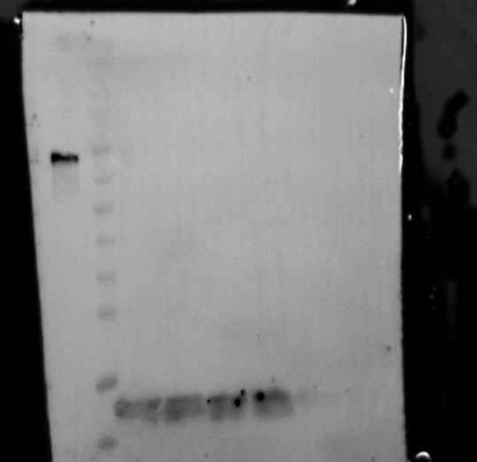

M 1
Supplementary Figure S3-4. Full-length, unprocessed Western blot corresponding to Figure 2B of the main manuscript. Recombinant giant panda calprotectin subunits were probed with anti-His tag monoclonal antibody (Abcam, ab18184) followed by HRP-conjugated goat anti-mouse IgG (Abcam, ab205719). Lane M, prestained protein molecular-weight marker; remaining lanes, eluted/purified recombinant protein fractions. Specific immunoreactive bands are visible at the expected molecular sizes (~15–18 kDa), confirming tag integrity. Chemiluminescent detection; unprocessed original, blot edges retained. This blot is the unprocessed source for the anti-His panel of Figure 2B. The blot edges are clearly marked, and the image is labelled as corresponding to Figure 2B with the anti-His descriptor; a prestained protein molecular-weight marker (lane M) is included as the ladder; the full-length, uncropped blot is shown.
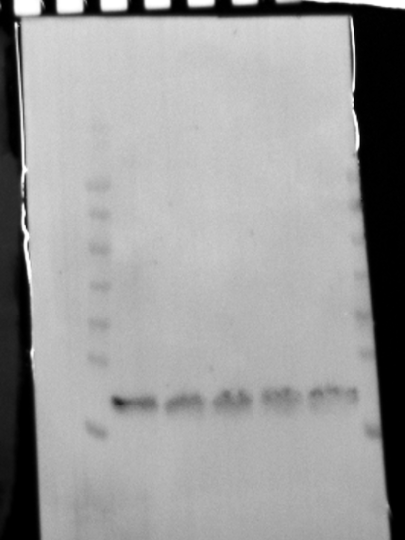

M 1
Supplementary Figure S3-5. Full-length, unprocessed Western blot corresponding to Figure 2B of the main manuscript. Recombinant giant panda calprotectin subunits were probed with anti-FLAG tag antibody (Sigma-Aldrich, F1804) followed by HRP-conjugated goat anti-mouse IgG. Lane M, prestained protein molecular-weight marker; remaining lanes, eluted/purified recombinant protein fractions. Specific immunoreactive bands at ~15–18 kDa confirm FLAG-tag expression. Chemiluminescent detection; unprocessed original, blot edges retained. This blot is the unprocessed source for the anti-FLAG panel of Figure 2B. The blot edges are clearly marked, and the image is labelled as corresponding to Figure 2B with the anti-FLAG descriptor; a prestained protein molecular-weight marker (lane M) is included as the ladder; the full-length, uncropped blot is shown.

