Supplementary Information for Robust and Single-Mode Flexible Perovskite Lasers via 3D Printing
Kai Feng^{1,2,#}, Daqian Wu^{1,#}, Zijun Zhan^{1,#}, Ning Zhou¹, Sihao Huang², Fengxian Zhou^{1,2}, Xinyi Kuang¹, Caisong Yan¹, Zhengzheng Liu^{2,*}, Zeyu Zhang¹, Hongzhi Zhou¹, Jinghui Li¹, Zhiping Hu^{1,*}, Juan Du^{1,*}

1 School of Physics and Optoelectronic Engineering, Hangzhou Institute for Advanced Study, University of Chinese Academy of Sciences, Hangzhou, 310024, China
2 State Key Laboratory of Ultra-intense Laser Science and Technology, Shanghai Institute of Optics and Fine Mechanics (SIOM), Chinese Academy of Sciences (CAS), Shanghai 201800, China
# These authors contributed equally to this work.
*Correspondence: Zhengzheng Liu (liuzhengzheng@siom.ac.cn) or Zhiping Hu (huzhiping@ucas.ac.cn) or Juan Du (du@ucas.ac.cn)
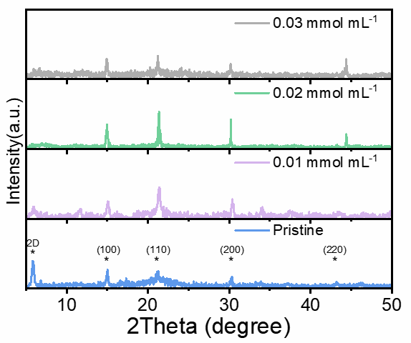
Fig. S1. XRD patterns of pristine and TBPO-treated perovskite films with varying TBPO concentrations.
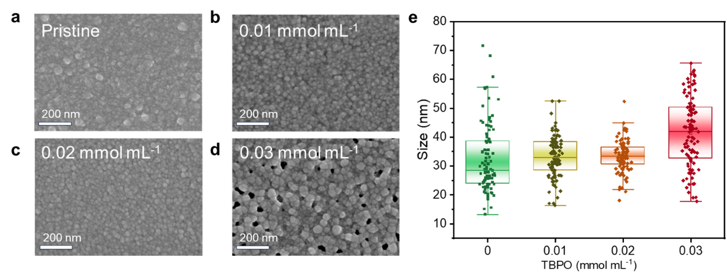
Fig. S2. Top-view SEM images of (a) pristine perovskite and (b), (c), (d) TBPO-treated film with varied TBPO concentration. (e) Statistics of the corresponding crystal size distribution with varied TBPO concentration.
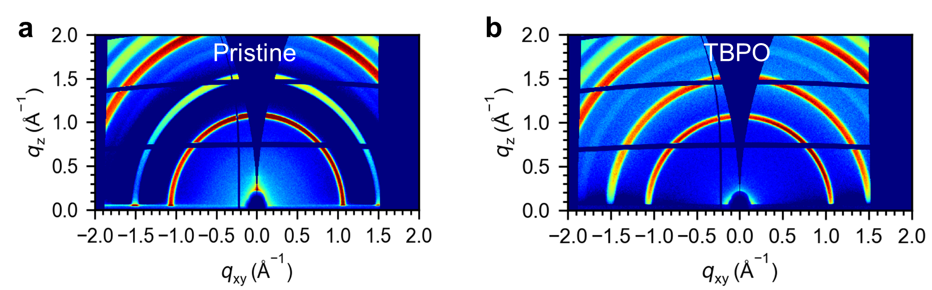
Fig. S3. GIWAXS pattern of pristine and TBPO-treated perovskite films.
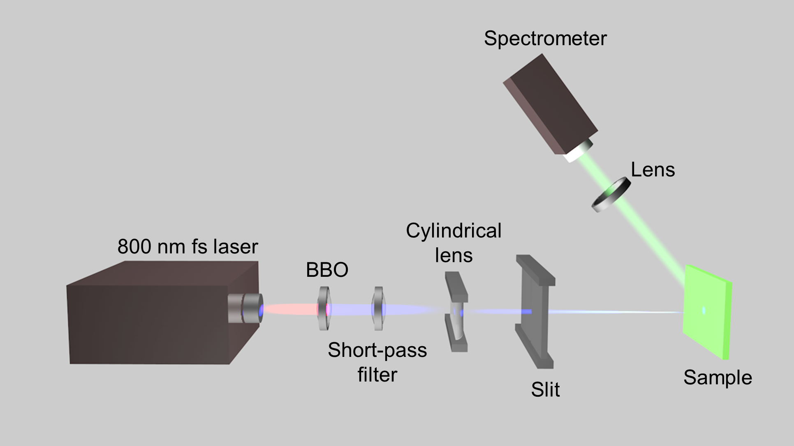
Fig. S4. Diagram of optical gain characteristic measurement.
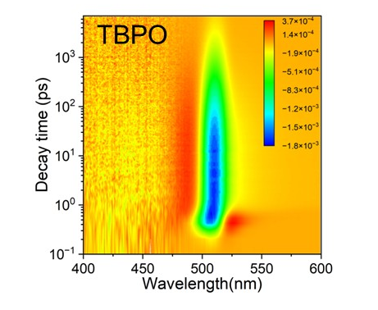
Fig. S5. Two-dimensional pseudo-color contour map of TA spectra for TBPO-treated perovskite films at 2.47 μJ cm⁻².
Fig. S6. TRPL₀ as a function of laser power density for pristine and TBPO-treated films, respectively.
Fig. S7. Absorption spectrum of the 3D printed WGM micro-ring array.
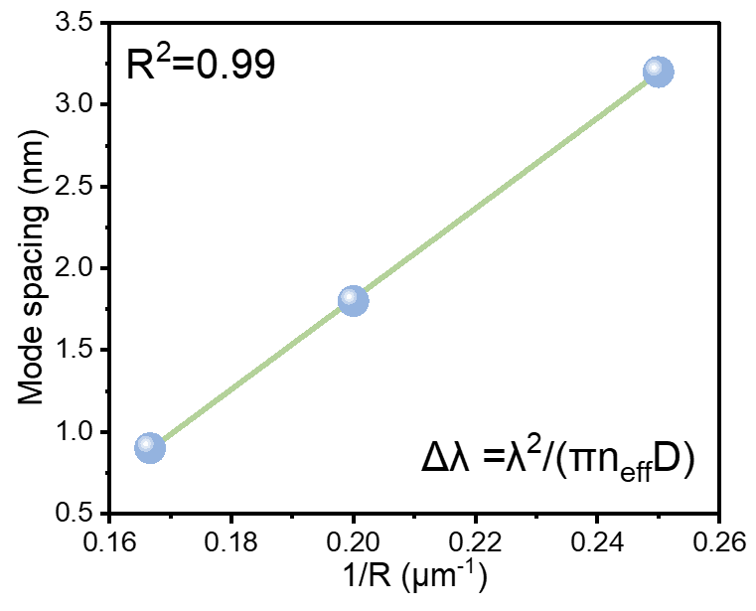
Fig. S8. Extracted mode spacing as a function of the inverse of the ring radius.
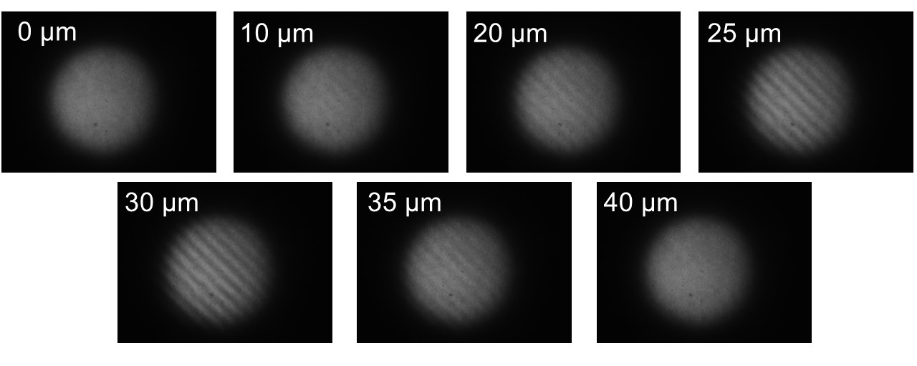
Fig. S9. The interferogram of the lasing output using a Michelson interferometer at different positions of the delay line.
Fig. S10. Environmental stability of the WGM micro-ring laser under ambient conditions.
Fig. S11. Lorentzian fit of the lasing with varying bending radii (from 2 to 0.1 mm).
Fig. S12. Evolution of the normalized lasing intensity and FWHM after repeated bending-release cycles.
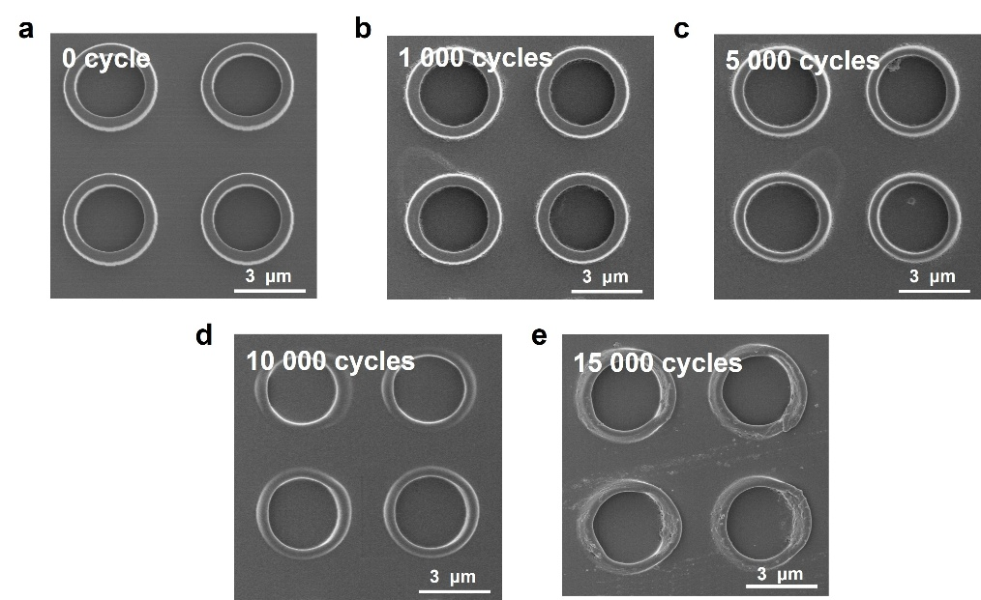
Fig. S13. SEM images of the flexible micro-ring cavities after 0, 1000, 5000, 10000, and 15000 bending-release cycles, respectively.

Supplementary Note S1. Temperature-dependent PL
The intensity of the PL spectra as a function of inverse temperature is extracted in Fig. 2i, which can be fitted using the Arrhenius equation¹⁻³:
$$I\left(t\right)=\frac{I_{0}}{1+A_{e}^{-E_{b}/K_{B}T}}$$
where I₀ is the PL intensity at 0 K, A is a constant, and K_{B} is the Boltzmann constant.

Supplementary Note S2. Global fits of carrier recombination kinetics
The absorption coefficient of perovskite can be quantified in terms of the optical density (OD), sometimes called absorbance. Hence the absorption coefficient can be calculated as follows:
$$α=\log_{e}{10\frac{OD}{l}}=0.434*\frac{OD}{l}$$
OD is the absorbance obtained via a UV-vis spectrometer.
Carrier density calculation:
$$n=\frac{P_{ave}/(f_{laser}∙πr^{2})∙(1-R)}{hυ∙l}∙[1-exp⁡(-α∙l)]$$
Where Pave is the pump power, flaser is the repetition rate of the pulsed laser, r is the radius of the laser spot, R is the reflection coefficient of D-J perovskite film , l is the thickness of perovskite films, α is the absorption coefficient.
Here, the carrier recombination kinetics can be fitted by the following equation:
$$\frac{dn}{dt}=-k_{1}n-k_{2}n^{2}-k_{3}n^{3}$$
The photobleaching kinetics is chosen for analyzing. The maximum of the photobleaching kinetics can be denoted to be excited carrier density n(t). n(t) shows a linear relationship with ΔA(t) as following⁴:
$$n\left(t\right)=C∙∆A(t)$$
Where $C=\frac{n_{0}}{∆A_{0}}$is the proportionality factor between the initial absorption change ∆A₀.
Firstly, the monomolecular recombination constant k₁ can be derived from the TRPL measurements at ultralow pump density (Fig. 2c), where the trap-assisted recombination dominates and high-order recombination (k₂ and k₃) is negligible. The monomolecular recombination constant k₁ can be derived from the equation$τ_{1/e}=1/(k_{1}+k_{2}∙n/2+k_{3}*{n^{2}}/3))$. Considering the above conditions, the bimolecular k₂ and trimolecular recombination constant k₃ can be extracted through a global fitting procedure. The fitting results are summarized in Table S3.

Table S1. Fast decay component (τ₁), slow decay component (τ₂) of pristine perovskite and TBPO-treated film respectively.
Sample | τ₁ (ns) | A₁ | τ₂ (ns) | A₂ | τ_{ave} (ns)
Pristine | 19.66 | 0.247 | 100.42 | 0.753 | 95.55
TBPO | 36.69 | 0.178 | 181.31 | 0.824 | 175.25

Table S2. Comparison of the D-J perovskite thin-film ASE performance.
Gain media | Pump source | ASE wavelength | Threshold | Gain coefficient | Year^{Ref}
D-J film | 0.5 ns, 355 nm | 535 nm | 25 μJ cm⁻² | 383 cm⁻¹ | 2023⁵
D-J film | 35 fs, 400 nm | 538 nm | 8.8 μJ cm⁻² | / | 2024⁶
D-J film | 35 fs, 400 nm | 534 nm | 28.5 μJ cm⁻² | / | 2024⁷
D-J film | 35 fs, 400 nm | 520 nm | 4.8 μJ cm⁻² | 1559 cm⁻¹ | 2024⁸
D-J film | 10 ns, 532 nm | 676 nm | 61 μJ cm⁻² | / | 2024⁹
D-J film | 500 ps, 355 nm | 541 nm | 18.6 μJ cm⁻² | 190 cm⁻¹ | 2025¹⁰
D-J film | fs, 400 nm | 540 nm | 8.5 μJ cm⁻² | 601.4 cm⁻¹ | 2025¹¹
D-J film | 400 nm | 528 nm | 8.2 μJ cm⁻² | 368 cm⁻¹ | 2025¹²
D-J film | 35 fs, 400 nm | 539 nm | 3.2 μJ cm⁻² | 1948 cm⁻¹ | This work

Table S3. Recombination decay constant of pristine and TBPO-treated film.
Sample | k₁ (s⁻¹) | k₂ (cm³ s⁻¹) | k₃ (cm⁶ s⁻¹)
Pristine | 1.243*10 ⁷ | 0.43*10⁻⁹ | 12*10⁻²⁸
TBPO | 6.459*10 ⁶ | 0.82*10⁻⁹ | 2.3*10⁻²⁸

Table S4. Summary of representative perovskite WGM lasers based on various cavity geometry
Cavity geometry | Gain medium | Characteristic size | Substrate | Mode feature | Threshold | Linewidth | Year^{ref}
Microring WGM laser array | 2D R-P perovskite (BA)₂(MA)₅Pb₆Br₁₉ | D = 12, 19, and 29 µm | glass | Multi-mode WGM | 12.2 µJ cm⁻² | ~0.21 nm | 2018¹³
Imprinted microdisk WGM cavity | MAPbBr_{x}I_{y} thin film | D=2.1,3.8,5.65,8.3 µm | glass | Single-mode WGM | 0.3 mJ cm⁻² | ~0.2-0.3 nm | 2019¹⁴
Micron hemisphere WGM cavity | CsPbBr₃ hemispheres | Several to dozens of micrometers | Si | Multi–mode WGM | 36.1 µJ cm⁻² | ~0.22 nm | 2020¹⁵
microdisk | MAPbBr₃ | Circular microdisk D = 20 µm; | ITO | Multi-mode WGM | 20.5 µJ cm⁻²; | ~0.5 nm | 2021¹⁶
microdisk WGM array | Single-crystal CsPbX₃ thin film, mainly CsPbBr₃ | D = 3,4,5,6 µm | mica | Single-mode WGM | 5.1 µJ cm⁻² | ~0.09 nm | 2023¹⁷
3D-printed flexible WGM cavity | D-J quasi-2D perovskite | R = 3,4 5,6 µm microring; | flexible substrate | Single-mode flexible WGM | 11.2 µJ cm⁻² | ~0.20 nm | This work

Table S5. Characteristics of perovskite flexible lasers from the literature.
Device | Cavity construction | Gain medium | Threshold | Linewidth | Stability | Year^{ref}
Single-mode laser | DBR | FAPbBr₃ | 40.6 μJ cm⁻² | 0.6 nm | 20 h lifetime (rigid) | 2017¹⁸
Random laser | / | MAPbBr₃ | 10 μJ cm⁻² | 0.4 nm | Stable lasing after 200 cycles of 90% strain–release deformation. | 2017¹⁹
Random laser | / | MAPbBr₃ | 2.5 mJ cm⁻² | 1.8 nm | Similar lasing intensity retained after >2000 bending cycles. | 2019²⁰
Random laser | / | CsPbBr₃ | 52.1 μJ cm⁻² | / | Threshold remained stable after 100 cycles of 50% stretching and 0.12 mm⁻¹ bending. | 2021²¹
Random laser | / | CsPbBr₃ | 190 μJ cm⁻² | 1 nm | Stable lasing intensity after 1000 cycles of 45° bending and release. | 2021²²
Random laser | / | MAPbBr₃ | 14.6 μJ cm⁻² | 0.3 nm | Retained >95% initial lasing intensity after 10000 bending cycles at R=3.5 mm. | 2023²³
Single-mode laser | WGM resonator | D-J perovskite | 11.2 μJ cm⁻² | 0.2 nm | Retained >86% initial lasing intensity after 15000 bending cycles | This work

References
1. Zhang, L.; Xia, M. Z.; Zhang, Y.; Song, L.; Guo, X. W.; Zhang, Y.; Wang, Y. L.; Xia, Y. Q., The Effect of Organic Spacer Cations with Different Chain Lengths on Quasi-Two-Dimensional Perovskite Properties. INORGANICS 2024, 12 (1).
2. Cui, Y. H.; Zhu, D. L.; Chen, J. W.; Dong, S. Y.; Cheng, Y. Z.; Liu, X. Y.; Yan, X. H.; Jin, Z. C.; Duan, L.; Xu, J.; Ma, D. X., Ion-pair pinning on perovskite quantum dots for high-efficiency air-processed light-emitting diodes with Rec. 2020 compliance. LIGHT-SCIENCE & APPLICATIONS 2026, 15 (1).
3. Lee, S.; Kim, J.; Kim, H.; Kim, C.; Kim, S.; Kim, C.; Lee, H.; Choi, B.; Muthu, C.; Kim, T.; Lee, J.; Lee, S.; Ihee, H.; Lee, J. Y., Brightening deep-blue perovskite light-emitting diodes: A path to Rec. 2020. SCIENCE ADVANCES 2024, 10 (20).
4. Zhong, Y. G.; Liao, K.; Du, W. N.; Zhu, J. R.; Shang, Q. Y.; Zhou, F.; Wu, X. X.; Sui, X. Y.; Shi, J. W.; Yue, S.; Wang, Q.; Zhang, Y. F.; Zhang, Q.; Hu, X. Y.; Liu, X. F., Large-Scale Thin CsPbBr3 Single-Crystal Film Grown on Sapphire via Chemical Vapor Deposition: Toward Laser Array Application. ACS Nano 2020, 14 (11), 15605-15615.
5. Wang, X. Z.; Jin, L.; Sergeev, A.; Liu, W.; Gu, S. Y.; Li, N.; Fan, K. Z.; Chen, S. C.; Wong, K. S.; Sun, X. K.; Zhao, N., Quasi-2D Dion-Jacobson phase perovskites as a promising material platform for stable and high-performance lasers. SCIENCE ADVANCES 2023, 9 (43).
6. Qin, C. C.; Huang, Q. X.; Zhang, S. C.; Song, J.; Jiao, Z. Y.; Ma, S. H.; Zheng, S. W.; Song, P.; Wang, H. Y.; Zhang, J. C.; Jia, G. R.; Jiang, Y. H.; Zhou, Z. P., Effect of phase distribution and defect passivation on amplified spontaneous emission of quasi-2D Dion-Jacobson perovskite. Appl. Phys. Lett. 2024, 124 (8).
7. Qin, C. C.; Dong, Y. X.; Cui, M. H.; Zheng, S. W.; Song, P.; Wang, H. Y.; Zhang, J. C.; Song, J.; Ma, S. H.; Jiao, Z. Y.; Jia, G. R.; Jiang, Y. H.; Zhou, Z. P., Promoting energy transfer via manipulation of crystallization kinetics of quasi-2D Dion-Jacobson phase perovskites for high-performance green lasers. Appl. Phys. Lett. 2024, 125 (2).
8. Zhang, Y.; Dong, Z. W.; Guo, X. W.; Hu, Y. S.; Zhang, Z. B.; Deng, Y. Y.; Zhang, Y.; Men, Z.; Geng, C.; Wang, Y. L.; Chen, Z. D.; Jiang, Y. G.; Song, L.; Xia, Y. Q., Enhanced performance of amplified spontaneous emission in Dion-Jacobson phase quasi-2D perovskite by facilitating carrier co-radiation. Opt. Express 2024, 32 (15), 26306-26317.
9. Wang, L.; Zhang, Y.; Yan, M.; Zhang, J.; Lu, H.; Lyu, M.; Zhu, J., Low‐Threshold Amplified Spontaneous Emission of Dion–Jacobson‐Phase Perovskite Films Achieved by Tuning Diamine Cation Size. physica status solidi (RRL) – Rapid Research Letters 2024, 18 (12).
10. Jin, L.; Wang, X.; Zeng, L.; Feng, Z.; Zhao, N.; Sun, X., Etchless Dion–Jacobson-Phase Perovskite Surface-Emitting Circular Bragg Lasers with an Ultrahigh Q Factor. ACS Photonics 2024, 12 (1), 53-61.
11. Jia, G.; Huang, X.; Zhang, X.; Zhou, Z.; Qin, C., Effect of additives on amplified spontaneous emission of quasi-2D Dion–Jacobson perovskite. Appl. Phys. Lett. 2025, 127 (21).
12. Dong, Y.; Cui, M.; Zheng, S.; Song, P.; Wang, H.; Zhang, J.; Song, J.; Ma, S.; Jiao, Z.; Jia, G.; Zhou, Z.; Jiang, Y.; Qin, C., Ionic liquid tailoring defect/interface-induced recombination loss toward enhanced Dion–Jacobson perovskite lasing. Appl. Phys. Lett. 2025, 127 (22).
13. Zhang, H.; Liao, Q.; Wu, Y.; Zhang, Z.; Gao, Q.; Liu, P.; Li, M.; Yao, J.; Fu, H., 2D Ruddlesden-Popper Perovskites Microring Laser Array. Adv. Mater. 2018, 30 (15), e1706186.
14. Zhizhchenko, A.; Syubaev, S.; Berestennikov, A.; Yulin, A. V.; Porfirev, A.; Pushkarev, A.; Shishkin, I.; Golokhvast, K.; Bogdanov, A. A.; Zakhidov, A. A.; Kuchmizhak, A. A.; Kivshar, Y. S.; Makarov, S. V., Single-Mode Lasing from Imprinted Halide-Perovskite Microdisks. ACS Nano 2019, 13 (4), 4140-4147.
15. Zhang, H.; Zhao, C.; Chen, S.; Tian, J.; Yan, J.; Weng, G.; Hu, X.; Tao, J.; Pan, Y.; Chen, S.; Akiyama, H.; Chu, J., Lasing operation in the CsPbBr3 perovskite micron hemisphere cavity grown by chemical vapor deposition. Chem. Eng. J. 2020, 389.
16. Wang, K.; Liang, J.; Chen, R.; Gao, Z.; Zhang, C.; Yan, Y.; Yao, J.; Zhao, Y. S., Geometry-Programmable Perovskite Microlaser Patterns for Two-Dimensional Optical Encryption. Nano Letters 2021, 21 (16), 6792-6799.
17. Mao, W.; Li, H.; Tang, B.; Zhang, C.; Liu, L.; Wang, P.; Dong, H.; Zhang, L., Laser patterning of large-scale perovskite single-crystal-based arrays for single-mode laser displays. International Journal of Extreme Manufacturing 2023, 5 (4).
18. Chen, S.; Nurmikko, A., Stable Green Perovskite Vertical-Cavity Surface-Emitting Lasers on Rigid and Flexible Substrates. ACS Photonics 2017, 4 (10), 2486-2494.
19. Hu, H. W.; Haider, G.; Liao, Y. M.; Roy, P. K.; Ravindranath, R.; Chang, H. T.; Lu, C. H.; Tseng, C. Y.; Lin, T. Y.; Shih, W. H.; Chen, Y. F., Wrinkled 2D Materials: A Versatile Platform for Low‐Threshold Stretchable Random Lasers. Adv. Mater. 2017, 29 (43).
20. Wang, Y.-C.; Li, H.; Hong, Y.-H.; Hong, K.-B.; Chen, F.-C.; Hsu, C.-H.; Lee, R.-K.; Conti, C.; Kao, T. S.; Lu, T.-C., Flexible Organometal–Halide Perovskite Lasers for Speckle Reduction in Imaging Projection. ACS Nano 2019, 13 (5), 5421-5429.
21. Hou, Y.; Zhou, Z.; Zhang, C.; Tang, J.; Fan, Y.; Xu, F.-F.; Zhao, Y. S., Full-color flexible laser displays based on random laser arrays. Science China Materials 2021, 64 (11), 2805-2812.
22. Gao, W.; Wang, T.; Xu, J.; Zeng, P.; Zhang, W.; Yao, Y.; Chen, C.; Li, M.; Yu, S. F., Robust and Flexible Random Lasers Using Perovskite Quantum Dots Coated Nickel Foam for Speckle‐Free Laser Imaging. Small 2021, 17 (39).
23. Cao, X.; Xing, S.; Lai, R.; Lian, Y.; Wang, Y.; Xu, J.; Zou, C.; Zhao, B.; Di, D., Low‐Threshold, External‐Cavity‐Free Flexible Perovskite Lasers. Adv. Funct. Mater. 2023, 33 (19).

