Dear Editor,

Thank you for your request for the full uncropped gels and blots.

We would like to clarify that, for some of our Western blot experiments, the membranes were physically cut into sections after protein transfer and before antibody incubation, in order to incubate different membrane sections with the corresponding antibodies. Therefore, complete uncropped membranes following antibody detection are unfortunately not available for these experiments.

However, we have retained the original white-light images of the membranes obtained before membrane cutting and antibody incubation. These images represent the original, uncropped membrane records and have been provided as supplementary files for transparency and verification of the experimental data. Where available, we have also included the corresponding original gel images.

We apologize for any inconvenience and hope that these original images will be acceptable for the purpose of documenting the uncropped experimental data.

Best regards,
liu peisen

The following are the images generated by combining the blot results with the white-light images of the membranes taken during the detection process. The images show the bands for Vinculin, TP63, and DLX5, respectively. The protein molecular weight marker used was Thermo Fisher Scientific 26616.

26616 marker
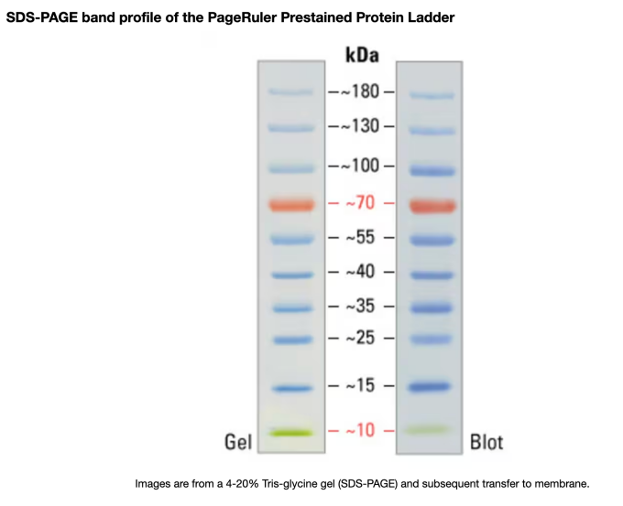

KONG FOR EMPTY VECTOR
VINCULIN

TP63

DLX5

