Supplementary material
Regional morphometric variation and phenotypic structure of Moorish zebu cows (Bos indicus) in Mauritania
Youssouf El Hadj et al.

Supplementary tables
Table S1. Full descriptive body and udder measurements of the three candidate groups
Trait | Group 1 (n=154) | Group 2 (n=80) | Group 3 (n=117) | P
Head length (cm) | 53.56±0.2ª | 57.33±0.33^{b} | 52.81±0.23ª | <0.001
Head width (cm) | 18.32±0.12ª | 20.57±0.28^{b} | 18.35±0.12ª | <0.001
Neck length (cm) | 42.40±0.43ª | 45.06±0.60^{b} | 45.91±0.53^{b} | <0.001
Neck circumference (cm) | 66.90±0.49ª | 74.09±0.75^{c} | 68.99±0.56^{b} | <0.001
Withers height (cm) | 122.93±0.35ª | 128.47±0.59^{b} | 131.00±0.50^{c} | <0.001
Heart girth (cm) | 148.45±0.53ª | 156.54±1.03^{b} | 158.96±0.71^{b} | <0.001
Chest width (cm) | 47.21±0.51ª | 49.09±0.69ª | 58.25±0.70^{b} | <0.001
Chest depth (cm) | 59.62±0.34ª | 62.45±0.54^{b} | 66.41±0.49^{c} | <0.001
Body length (cm) | 130.55±0.52ª | 138.51±0.95^{c} | 135.96±0.58^{b} | <0.001
Pelvis length (cm) | 42.36±0.21ª | 45.70±0.28^{c} | 43.97±0.19^{b} | <0.001
Pelvis width (cm) | 37.12±0.23ª | 40.17±0.36^{c} | 38.70±0.21^{b} | <0.001
Abdominal girth (cm) | 161.67±0.89ª | 173.32±1.21^{b} | 174.82±0.82^{b} | <0.001
Estimated live weight (kg) | 268.92±2.93ª | 316.78±6.99^{b} | 330.49±4.61^{b} | <0.001
Teat length (cm) | 5.04±0.11ª | 5.83±0.18^{b} | 5.04±0.13ª | <0.001
Teat diameter (cm) | 2.62±0.12^{b} | 2.95±0.20^{b} | 2.14±0.06ª | <0.001
Posterior inter-teat distance (cm) | 4.44±0.15ª | 4.95±0.25ª | 4.35±0.16ª | 0.077
Anterior inter-teat distance (cm) | 8.81±0.21ª | 9.99±0.35^{b} | 9.59±0.27ª | 0.006

Table S2. Full zoometric indices of the three candidate groups
Zoometric index | Group 1 (n=154) | Group 2 (n=80) | Group 3 (n=117) | P
Body index | 88.13±0.50^{b} | 88.72±0.75^{b} | 85.71±0.51ª | <0.001
Estimated body weight index | 218.79±2.32ª | 247.40±5.98^{b} | 252.53±3.53^{b} | <0.001
Cephalic index | 34.30±0.25ª | 35.98±0.55^{b} | 34.83±0.28ª | 0.003
Compactness index | 2.19±0.02ª | 2.47±0.06^{b} | 2.53±0.04^{b} | <0.001
Length index 1 | 1.063±0.005^{b} | 1.080±0.008^{b} | 1.040±0.006ª | <0.001
Height index | 94.39±0.46ª | 93.05±0.70ª | 96.56±0.55^{b} | <0.001
Thoracic index | 79.45±0.92ª | 78.88±1.17ª | 88.35±1.34^{b} | <0.001
Anamorphosis index | 179.72±1.28ª | 191.90±3.05^{b} | 193.56±1.82^{b} | <0.001
Pelvic index | 87.86±0.61ª | 88.06±0.81ª | 88.14±0.54ª | 0.943
Transverse pelvic index | 30.24±0.21ª | 31.28±0.25^{b} | 29.58±0.18ª | <0.001
Rump length index | 32.51±0.18ª | 33.09±0.27ª | 32.41±0.19ª | 0.086
Over-increase index | 34.49±0.17^{b} | 35.63±0.28^{c} | 33.63±0.20ª | <0.001
Depth index | 0.486±0.003ª | 0.487±0.005ª | 0.508±0.004^{b} | <0.001
Balance | 0.578±0.013^{b} | 0.615±0.014^{b} | 0.450±0.007ª | <0.001
Body ratio | 2.912±0.016^{b} | 2.819±0.020ª | 2.986±0.017^{c} | <0.001
Length index 2 | 2.201±0.016^{b} | 2.232±0.025^{b} | 2.060±0.017ª | <0.001
Table S3. Qualitative trait frequencies of the three candidate groups
Trait | Category | Group 1, n (%) | Group 2, n (%) | Group 3, n (%) | P
Coat pattern | Unicolor | 116 (75.3) | 49 (61.3) | 80 (68.4) | 0.099
Coat pattern | Multicolor | 38 (24.7) | 30 (37.5) | 37 (31.6) | 0.099
Hump position | Thoracic | 130 (84.4) | 65 (81.3) | 63 (53.8) | <0.001
Hump position | Cervico-thoracic | 24 (15.6) | 15 (18.8) | 54 (46.2) | <0.001
Horn shape | Lyre-shaped | 55 (35.7) | 27 (33.8) | 45 (38.5) | 0.343
Horn shape | Crescent-shaped | 47 (30.5) | 30 (37.5) | 39 (33.3) | 0.343
Horn shape | Cup-shaped | 41 (26.6) | 16 (20.0) | 25 (21.4) | 0.343
Horn shape | Wheel-shaped | 1 (0.6) | 3 (3.8) | 0 (0.0) | 0.343
Horn shape | Other shapes | 10 (6.5) | 4 (5.0) | 7 (6.0) | 0.343
Coat color | Red | 69 (44.8) | 35 (43.8) | 52 (44.4) | 0.192
Coat color | Pied-red | 27 (17.5) | 23 (28.8) | 26 (22.2) | 0.192
Coat color | Yellow | 23 (14.9) | 11 (13.8) | 14 (12.0) | 0.192
Coat color | White | 10 (6.5) | 1 (1.3) | 11 (9.4) | 0.192
Coat color | Black | 10 (6.5) | 1 (1.3) | 2 (1.7) | 0.192
Coat color | Pied-black | 7 (4.5) | 2 (2.5) | 5 (4.3) | 0.192
Coat color | Grey | 2 (1.3) | 0 (0.0) | 1 (0.9) | 0.192
Coat color | Other colors | 6 (3.9) | 7 (8.8) | 6 (5.1) | 0.192
Table S4. Provisional phenotypic reference values for adult, multiparous, lactating Moorish zebu cows in the sampled regions.
Trait | Mean ± SD | Median | 5th-95th percentile | CV (%)
Withers height (cm) | 126.9 ± 6.1 | 127.0 | 117.0 - 136.5 | 4.8
Body length (cm) | 134.2 ± 7.6 | 134.0 | 122.0 - 145.0 | 5.7
Heart girth (cm) | 153.8 ± 9.0 | 152.0 | 140.6 - 170.0 | 5.9
Pelvis length (cm) | 43.7 ± 2.7 | 44.0 | 40.0 - 48.0 | 6.3
Head length (cm) | 54.2 ± 3.5 | 54.0 | 49.0 - 60.0 | 6.4
Abdominal girth (cm) | 168.7 ± 12.0 | 170.0 | 150.0 - 186.5 | 7.1
Pelvis width (cm) | 38.3 ± 3.0 | 38.0 | 34.0 - 43.0 | 7.8
Chest depth (cm) | 62.5 ± 5.6 | 62.0 | 53.6 - 72.0 | 8.9
Neck circumference (cm) | 69.2 ± 6.8 | 70.0 | 58.6 - 79.0 | 9.8
Head width (cm) | 18.9 ± 2.0 | 19.0 | 16.0 - 22.0 | 10.6
Neck length (cm) | 44.2 ± 5.7 | 44.0 | 34.6 - 53.0 | 12.9
Chest width (cm) | 51.3 ± 8.3 | 51.0 | 39.0 - 66.0 | 16.2
Estimated body weight (kg) | 300.3 ± 55.5 | 287.0 | 226.9 - 401.4 | 18.5
Teat length (cm) | 5.2 ± 1.5 | 5.0 | 3.0 - 8.0 | 28.3
Teat diameter (cm) | 2.5 ± 1.4 | 2.0 | 1.5 - 6.0 | 54.8
These intervals describe the sampled class of cows and are not formal breed-standard limits.
Table S5. Reference intervals for the first two principal-component scores.
Component | Mean | SD | Mean ± 1 SD
Dim1 (overall size, 26.2% of variance) | 0.00 | 1.77 | [-1.77 ; 1.77]
Dim2 (cephalic dimensions, 14.4% of variance) | 0.00 | 1.32 | [-1.32 ; 1.32]
Table S6. Random Forest importances and standardized LASSO coefficients used for candidate predictor screening.
Predictor | RF importance | LASSO coefficient | Retained
Teat diameter (cm) | 0.163 | 0.113 | Yes
Teat length (cm) | 0.154 | 0.324 | Yes
Body length (cm) | 0.107 | 0.138 | Yes
Abdominal girth (cm) | 0.093 | 0.000 | No
Withers height (cm) | 0.068 | 0.000 | No
Chest width (cm) | 0.059 | -0.000 | No
Predictor screening was conducted in the full sample before cross-validation; performance estimates are therefore optimistic.
Table S7. Sensitivity analysis of AUC at alternative daily-yield thresholds.
Dichotomization threshold | AUC
Lower quartile (threshold = 2.0 L/d; 317 vs. 32) | 0.641
Median / lower tertile (threshold = 3.0 L/d; 235 vs. 114) | 0.614
Upper tertile / upper quartile (threshold = 4.0 L/d; 127 vs. 222) | 0.715
Table S8. Cross-tabulation of sample-tertile MZ-DSPS class of the three candidate groups
Candidate group | Low, n (%) | Medium, n (%) | High, n (%)
Group 1 (n=154) | 63 (40.9) | 51 (33.1) | 40 (26.0)
Group 2 (n=80) | 10 (12.5) | 24 (30.0) | 46 (57.5)
Group 3 (n=117) | 41 (35.0) | 44 (37.6) | 32 (27.4)
Cross-tabulation of MZ-DSPS tertile class by candidate groups (Chi²=31.92; df=4; P<0.001; Cramer's V=0.213). Group 2 (largest teats) is markedly enriched for High MZ-DSPS (57.5%, vs 26-27% in Groups 1 and 3), consistent with teat length being the dominant contributor to the score (Section 3.10). Mean MZ-DSPS score: Group 1=36.7±1.4 (a), Group 2=52.7±2.1 (b), Group 3=40.0±1.4 (a); ANOVA F=22.92, P<0.001. This association is descriptive because the score and clustering share morphometric inputs.
Table S9. Principal component analysis (PCA) loadings of the 12 non-redundant standardized core morphometric traits (estimated body weight excluded) on the three retained components (eigenvalue>1), with eigenvalues and explained variance. Loadings correspond to Fig. 3a; values are Pearson correlations between each standardized trait and the component score.
Variable | PC1 | PC2 | PC3
Head length | 0.223 | 0.680 | 0.213
Head width | 0.271 | 0.557 | 0.208
Neck length | 0.270 | -0.074 | 0.767
Neck circumference | 0.397 | 0.320 | -0.490
Withers height | 0.656 | -0.198 | 0.306
Heart girth | 0.679 | -0.199 | -0.267
Chest width | 0.506 | -0.605 | -0.066
Chest depth | 0.532 | -0.388 | 0.159
Body length | 0.576 | 0.173 | 0.024
Pelvis length | 0.577 | 0.371 | -0.031
Pelvis width | 0.548 | 0.263 | -0.136
Abdominal girth | 0.632 | -0.143 | -0.174
Eigenvalue | 3.148 | 1.733 | 1.162
% Variance explained | 26.23 | 14.44 | 9.69
Cumulative % variance | 26.23 | 40.68 | 50.36

Supplementary figures

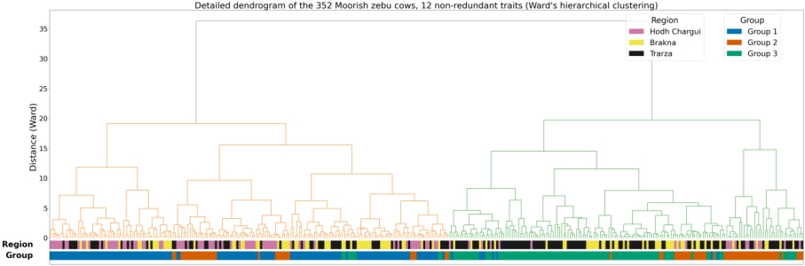 Figure S1. Ward hierarchical clustering of all 352 cows on the first four principal components. Color bands denote region and K-means the three candidate groups
.
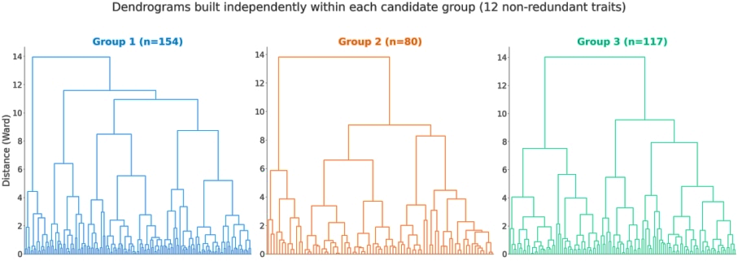
Figure S2. Ward dendrograms computed separately within each candidate group. These plots visualize within-group heterogeneity and are not independent validation of the K-means partition.
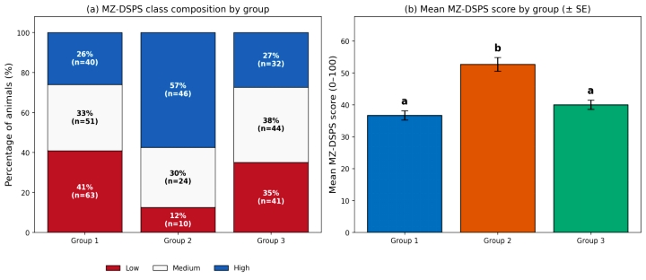
Figure S3. Descriptive correspondence between MZ-DSPS class and candidate group
Descriptive correspondence between MZ-DSPS sample-tertile class and (12-trait) candidate group. (a) Percentage composition of Low/Medium/High MZ-DSPS classes within each group; (b) mean MZ-DSPS score by group (± SD); bars not sharing a letter differ significantly (Tukey's HSD, P<0.05). As in Table S8, Group 2 stands out with the highest proportion of High-MZ-DSPS animals and the highest mean score.

