Supplementary Material

Candidate plasma lipidomic alterations associated with recurrent leg-ulcer phenotype in Sickle Cell Disease

Sheila O. G. Mateos^{1,13} *, Marcos E. S. Abreu¹*, Fábio E. Leal¹, Felipe C. C. Santos^{1,3}, André R. Belisário⁴, Brian S. Custer^{5,6}, Carla L. Dinardo⁷, Luiz M. A. Filho⁸, Scott A. Bowler^{9,} Lishomwa C. Ndhlovu^{9,}, Paula F. B. Caselli¹⁴, Hebert Culler², Luís A. P. C. Lage², Juliana Pereira², Cadiele O. Reichertv², Dahra Teles^{10,11}, Monica Conde Tilli¹ , Shannon Kelly^{5,12}, Alex Ap. R. Silva^{1†}, Ester C. Sabino^{1,13†}

¹Universidade Municipal de São Caetano do Sul (USCS), São Caetano do Sul, Brazil;
²Laboratory of Pathogenesis and Directed Therapy in Onco-Immuno-Hematology (LIM-31), Department of Hematology, Hemotherapy, and Cell Therapy, Faculty of Medicine, University of Sao Paulo (FM-USP), Sao Paulo, Brazil;
³National Institute of Science and Technology of Bioanalytics Lauro Kubota (INCTBio-LK), Institute of Chemistry, Universidade Estadual de Campinas (UNICAMP), Campinas, São Paulo, Brazil
⁴Gerência de Desenvolvimento Técnico-Científico, Fundação Hemominas, Belo Horizonte, Brazil;
⁵Vitalant Research Institute, San Francisco, CA, USA;
⁶Department of Laboratory Medicine, University of California San Francisco, San Francisco, CA, USA;
⁷Fundação Pró-sangue — Immunohematology Division, São Paulo, Brazil;
⁸Instituto Estadual de Hematologia Arthur de Siqueira Cavalcanti, Rio de Janeiro, Brazil;
⁹Division of Infectious Diseases, Department of Medicine, Weill Cornell Medicine, New York City, NY, USA;
¹⁰Fundação HEMOPE, Recife, Pernambuco, Brazil;
¹¹Universidade de Pernambuco, Recife, Pernambuco, Brazil;
¹²UCSF Benioff Children's Hospital, Oakland, CA, USA;
¹³Infectious Diseases and Global Health Programme, Faculty of Medicine, University of Sao Paulo (FM-USP), Sao Paulo, Brazil.
¹⁴Faculdade Israelita de Ciências da Saúde Albert Einstein (FICSAE), São Paulo, Brazil

Correspondence: Sheila O. G. Mateos (sheila.mateos@online.uscs.edu.br)
*The authors contributed equally to this study. †A.A.R.S. and E.C.S. are joint senior authors.

Supplementary Methodology
Sample Preparation and Metabolite Extraction
For the lipidomic analysis, initially, the samples were centrifuged at 12,000 rpm for 10 minutes at 4 °C. Subsequently, 200 μL of the supernatant was transferred to a clean microtube and combined with 800 μL of a cold methanol:chloroform:tert-Butyl methyl ether (1.33:1:1, v/v/v) solution. The mixture was vortexed vigorously for 30 seconds and centrifuged at 12,000 x g for 10 minutes at 4 °C to pellet debris. The supernatant was carefully transferred to a clean cryotube or Eppendorf tube (without a sealing ring), avoiding any disturbance of the pellet. From the organic (lower) phase, 450 μL were collected and dried. The dried extracts were stored at –80 °C until analysis. Prior to LC analysis, samples were resuspended in the same initial proportion of the mobile phase (200 μL) used in the chromatographic system.
Liquid chromatography coupled to mass spectrometry analysis
Untargeted metabolomics analyses were performed using LC-MS as previously reported. A Waters Acquity UPLC system coupled with a SYNAPT XS mass spectrometer equipped with an electrospray ionization source (ESI) was used. The samples were separated by an ACQUITY UPLC and eluted through a CSH C18 column (1.7 µm × 100 mm × 2.1 mm) (Waters Ltd., Elstree, UK), and analysis was acquired in negative mode. The column oven was maintained at 40 °C throughout the chromatographic run.
For the analysis, mobile phase A was employed using an ACN/H₂O solution (60:40, v/v) and 10 mM ammonium formate + 0.1% formic acid, and mobile phase B, comprising isopropanol/ACN (90:10, v/v) with 10 mM ammonium formate + 0.1% formic acid. The flow rate was 0.400 mL/min. The method started with 10% of solvent A, followed by an 18-minute ramp-up to 70% of B, which was then held for 1.5 minutes. Shortly after, the system returned to the initial value of 10% of A, maintaining this condition for an additional 3.5 minutes for re-equilibration. The total run time was 22 minutes, with an injection volume of 2 μL.
Data was obtained in MS^{E} mode employing 6 V for low collision energy and a ramp of 20–50 V for high collision energy. The range was set from 50 to 1200 Da, with a scan duration of 0.5 s. Leucine enkephalin (molecular weight = 555.62; 200 pg L⁻¹ in 1:1 ACN:H₂O, v/v) was used as the lock mass, and calibration was performed using 0.5 mM sodium formate solution. Additional settings included a source temperature of 140°C, a desolvation temperature of 550°C, a desolvation gas flow rate of 900 L h⁻¹, a capillary voltage of 2.5 kV, and a cone voltage of 40 V.
Pooled quality control (QC) samples were prepared by combining aliquots from all study samples and injected every 10 runs throughout the analytical sequence to monitor extraction reproducibility and instrument stability. Sample injection order was randomized to minimize technical bias, and solvent blanks were analyzed to monitor background and carryover.

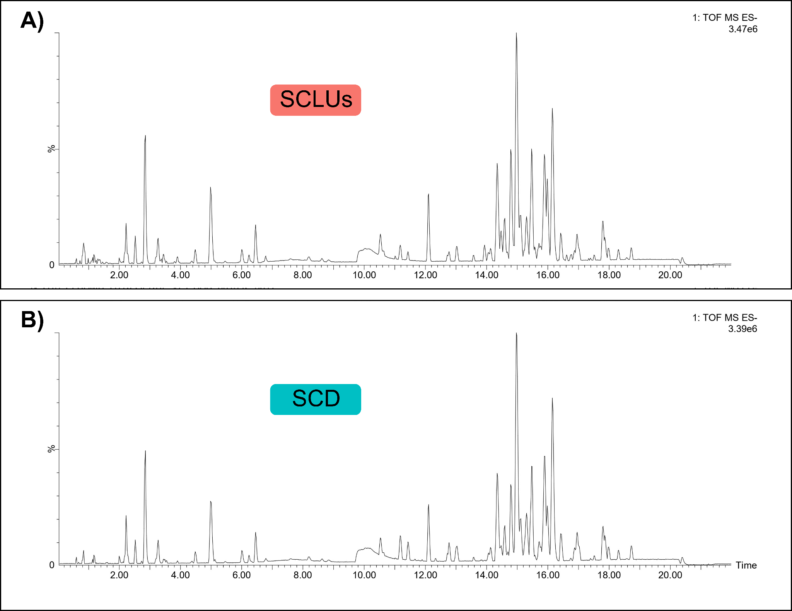
Supplementary Results
Figure S1. Representative chromatograms from untargeted LC–MS analysis in negative ionization mode. (A) Plasma sample from a patient with leg ulcers due to sickle cell disease (SCLU). (B) Plasma sample from a control subject without leg ulcer.

