Appendix B: GAM Formula

### GAM using number of individual Ji’kaw detected per month, with added zeros showing which receivers did not detect any Ji’kaw in a given month ###

library(mgcv)

mgcv::bam(count ~ te(utm_easting, utm_northing, month,
d = c(2,1),
k=c(25, 5),
bs=c('tp','cc')),
knots=list(week=c(0.5, 12.5)),
data =.,
family = 'nb',
method = 'fREML',
discrete = T))

Appendix C: Tagged Ji’kaw Length Frequency

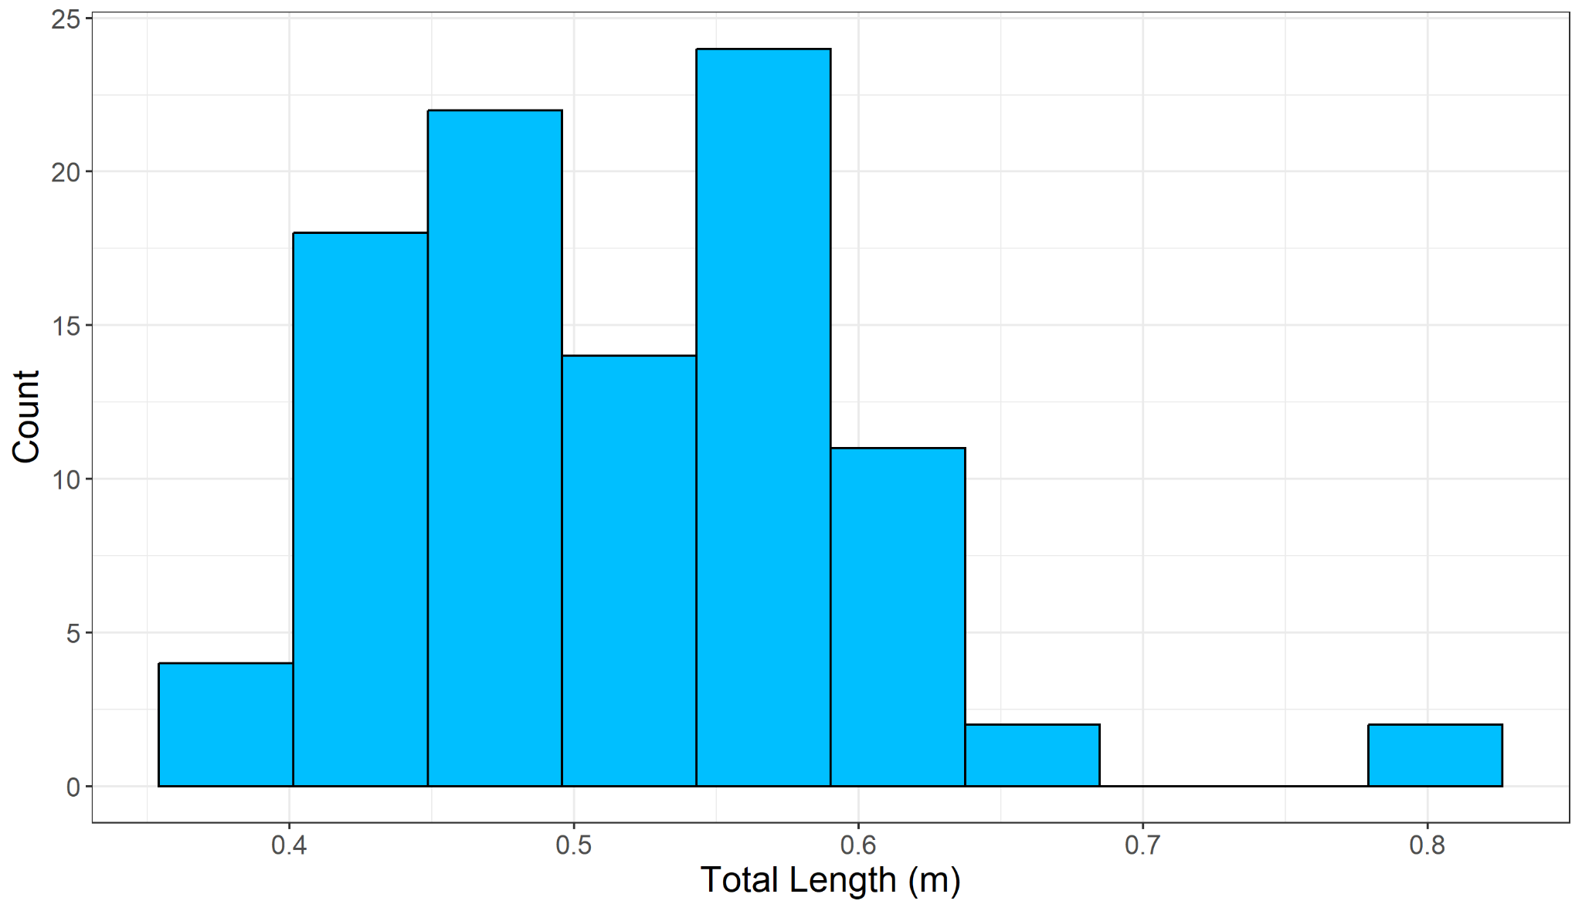
Figure C1: Length frequency of tagged Ji’kaw.

