Supplementary Figures:
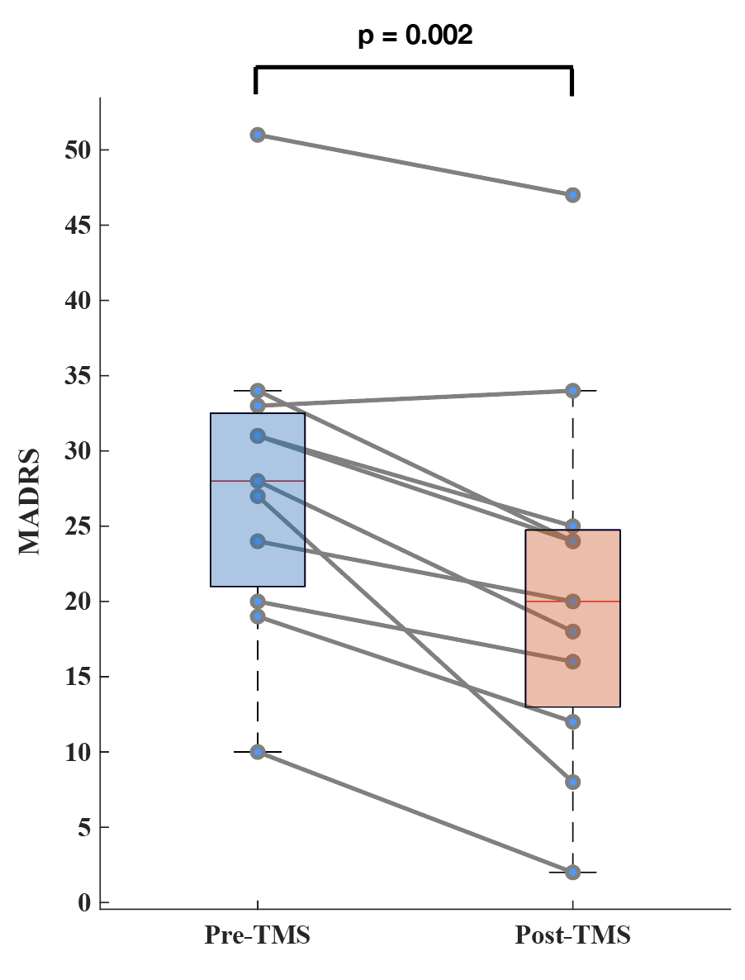
Supplementary Figure 1: Reduction in MADRS pre-/post-TMS. Significance evaluated using sign-rank test

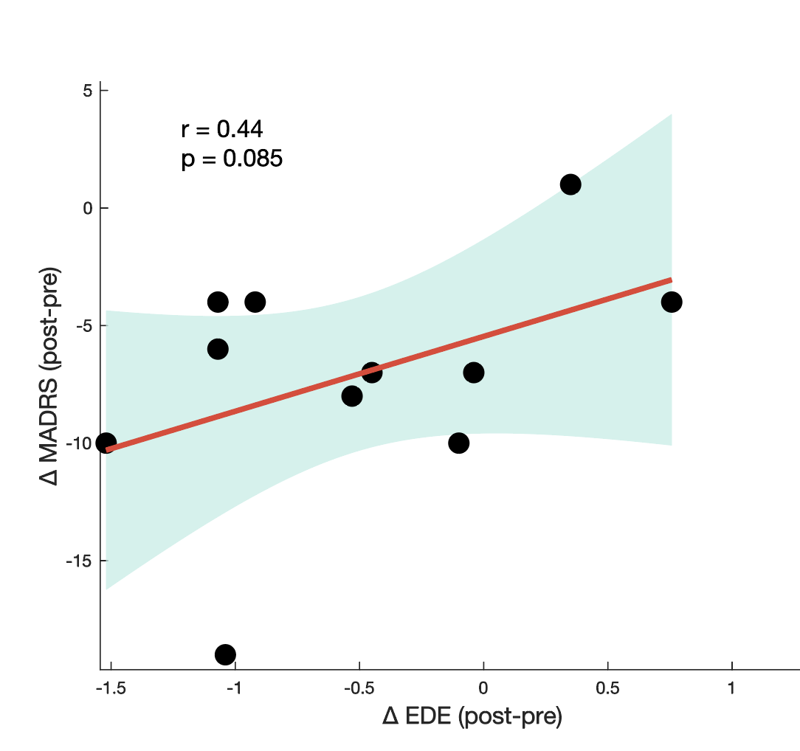
Supplementary Figure 2: Correlation between Change in MADRS and EDE with TMS treatment. Significance evaluated using permutation test.

