Alignment Between Child Health Research and Disease Burden in Canada: A National Bibliometric Analysis

June 30, 2026

Masoumeh Dehghani Ph.D. 0000-0003-2494-2724¹, Matthew P. Adams Ph.D. 0000-0001-7144-9751¹, Christina L. Hirota Ph.D 0000-0003-0799-2041¹, Daniel Helldén M.D. 0000-0001-8969-2194^{1,2,3}, Quynh Doan M.D. 0000-0002-8435-7837^{4,5}, Evdokia Anagnostou M.D. 0000-0002-3455-9887^{6,7}, Bruno Piedboeuf M.D. 0000-0003-0369-6018^{8,9}, Victor K.M. Han M.D. 0000-0003-3479-9132^{10,11,12,13}, Jason N. Berman M.D. 0000-0002-4053-6067^{14,15}, Jacques L Michaud M.D. 0000-0002-9912-0293^{16,17}, Soren Gantt M.D., Ph.D 0000-0001-5743-3606¹⁸, Jennifer L.P. Protudjer 0000-0002-3888-8688^{19,20}, Frank MacMaster M.D. 0000-0002-7159-7583^{21,22}, Stephen Lye M.D. 0000-0002-3305-4406^{23,24,25}, Gita Wahi M.D. 0000-0001-5943-9702²⁶, M. Constantine Samaan M.D. 0000-0002-6403-4715^{27,28}, Indra Gupta M.D. 0000-0002-2460-746X^{29,30,31}, Frédéric Dallaire MD, PhD 0000-0002-0489-2523³², Darryl Adamko M.D. 0000-0002-9619-2048³³, Sandra Davidge PhD 0000-0002-5559-4905^{34,35}, Joanne L. Weninger M.B.A.¹, Padmaja Subbarao M.D 0000-0003-0394-1933^{36,37,38,39}, Stephen W. Scherer PhD 0000-0002-8326-1999^{40,41,42,43}, One Child Every Child⁴⁴, William A. Ghali M.D. 0000-0002-2836-5365^{45,46,47}, Kathryn E.R. Graham PhD 0000-0003-3277-8987^{47,1}, *Susanne M. Benseler M.D. 0000-0001-5756-3638^{48,49,50,51,52}, *Francois P. Bernier M.D. 0000-0001-7063-4269^{53,1}, *Benedikt Hallgrimsson PhD 0000-0002-7192-9103^{54,1,55}

Affiliations:
¹Alberta Children's Hospital Research Institute, University of Calgary, Calgary, Alberta, Canada
²Institute for Transdisciplinary Scholarship, University of Calgary, Calgary, Alberta, Canada
³Department of Pediatrics, Cumming School of Medicine, University of Calgary, Calgary, Alberta, Canada
⁴Department of Pediatrics, Faculty of Medicine, University of British Columbia, Vancouver, British Columbia, Canada
⁵British Columbia Children's Hospital Research Institute, University of British Columbia, Vancouver, British Columbia, Canada
⁶Department of Pediatrics, Faculty of Medicine, University of Toronto, Toronto, Ontario, Canada
⁷Holland Bloorview Kids Rehabilitation Hospital, Toronto, Ontario, Canada
⁸Department of Pediatrics, Faculty of Medicine, Université Laval, Québec, Québec, Canada
⁹CHU de Québec, Université Laval, Québec, Québec, Canada
¹⁰Children’s Health Research Institute, Western University, London, Ontario, Canada
¹¹Department of Biochemistry, Schulich School of Medicine & Dentistry, Western University, London, Ontario, Canada
¹²Department of Anatomy and Cell Biology, Schulich School of Medicine & Dentistry, Western University, London, Ontario, Canada
¹³Department of Paediatrics, Schulich School of Medicine & Dentistry, Western University, London, Ontario
¹⁴Children's Hospital of Eastern Ontario, University of Ottawa, Ottawa, Ontario, Canada
¹⁵Department of Cellular and Molecular Medicine, University of Ottawa, Ottawa, Ontario, Canada
¹⁶Centre de recherche Azrieli du CHU Sainte-Justine, CHU Saint Justine, Montreal, Québec, Canada
¹⁷Departments of Pediatrics and Neurosciences, Université de Montréal,, Montreal, Québec, Canada
¹⁸Département de Microbiologie, Infectiologie et Immunologie, Université de Montréal,, Montreal, Québec, Canada
¹⁹Department of Pediatrics and Child Health, , University of Manitoba, Winnipeg, Manitoba, Canada
²⁰The Children's Hospital Research Institute of Manitoba, , University of Manitoba, Winnipeg, Manitoba, Canada
²¹IWK Health Centre, Halifax, Nova Scotia, Canada
²²Department of Psychiatry, Dalhousie School of Medicine, Dalhousie University, Halifax, Nova Scotia, Canada
²³Lunenfeld Tanenbaum Research Institute, Sinai Health, Toronto, Ontario, Canada
²⁴Department of Physiology, University of Toronto, Toronto, Ontario, Canada
²⁵Department of Obstetrics & Gynecology, University of Toronto, Toronto, Ontario, Canada
²⁶Department of Pediatrics, Michale G. DeGroote School of Medicine, McMaster University, Hamilton, Ontario, Canada
²⁷Department of Pediatrics, School of Medicine, Queens University, Kingston, Ontario, Canada
²⁸Division of Pediatric Endocrinology, Department of Pediatrics, Kingston Health Sciences Center, Kingston, Ontario, Canada
²⁹Research Institute of the McGill University Health Centre, McGill University, Montreal, Québec, Canada
³⁰Department of Pediatrics, Faculty of Medicine and Health Sciences, McGill University, Montreal, Québec, Canada
³¹Child Health and Human Development Program, Center for Translational Biology, McGill University, Montreal, Québec, Canada
³²Département de pédiatrie, Faculté de médecine et des sciences de la santé, Université de Sherbrooke, Sherbrooke, Québec, Canada
³³Canada
³⁴Women and Children’s Health Research Institute, University of Alberta, Edmonton, Alberta, Canada
³⁵Department of Obstetrics & Gynaecology, University of Alberta, Edmonton, Alberta, Canada
³⁶Department of Paediatrics, Temerty Faculty of Medicine, University of Toronto, Toronto, Ontario, Canada
³⁷Dalla Lana School of Public Health, Temerty Faculty of Medicine, University of Toronto, Toronto, Ontario, Canada
³⁸Department of Physiology, Temerty Faculty of Medicine, University of Toronto, Toronto, Ontario, Canada
³⁹Program in Translational Medicine, SickKids Research Institute, The Hospital for Sick Children, Toronto, Ontario, Canada
⁴⁰Genetics and Genome Biology, The Hospital for Sick Children, Toronto, Ontario, Canada
⁴¹The Centre for Applied Genomics, The Hospital for Sick Children, Toronto, Ontario, Canada
⁴²Department of Molecular Genetics, University of Toronto, Toronto, Ontario, Canada
⁴³McLaughlin Centre, Temerty Faculty of Medicine, University of Toronto, Toronto, Ontario, Canada
⁴⁴University of Calgary, Calgary, Alberta, Canada
⁴⁵Office of the Vice President Research, University of Calgary, Calgary, Alberta, Canada
⁴⁶O'Brien Institute for Public Health, University of Calgary, Calgary, Alberta, Canada
⁴⁷Department of Community Health Sciences, University of Calgary, Calgary, Alberta, Canada
⁴⁸Children's Health, Ireland, Dublin, Ireland
⁴⁹University College Dublin, Dublin, Ireland
⁵⁰Department of Paediatrics, School of Medicine, Trinity College Dublin, Dublin, Ireland
⁵¹Royal College of Physicians of Ireland and Dublin, Dublin, Ireland
⁵²Dublin City University, Dublin, Ireland
⁵³Department of Medical Genetics, Cumming School of Medicine, University of Calgary, Calgary, Alberta, Canada
⁵⁴Department of Cell Biology & Anatomy, Cumming School of Medicine, University of Calgary, Calgary, Alberta, Canada
⁵⁵McCaig Institute for Bone Health, University of Calgary, Calgary, Alberta, Canada

*Corresponding authors: bhallgri@ucalgary.ca; Susa.Benseler@childrenshealthireland.ie; Francois.Bernier@albertahealthservices.ca

Supplementary Methods

Text Processing pipeline
We developed a preprocessing pipeline which standardized abstracts and titles before further analysis to achieve text data consistency and enhance quality. The pipeline started with abbreviation handling followed by tokenization, stop word removal, normalization and n-gram detection.
Abbreviation Handling: Our system used an in-house automated system to transform abbreviations into their full forms while maintaining unique mappings for each abstract. Abbreviation-full term pairs were identified by detecting patterns where an abbreviation appeared in parentheses after the full term (e.g., Magnetic Resonance Imaging (MRI)). A dictionary was built for each abstract to translate its abbreviations into their complete forms. The abbreviation dictionaries were refined by resolving inconsistencies and filtering invalid pairs to ensure the best possible mapping across the dataset. To preserve the relationship between abbreviations and their full terms we employed the following scheme.
- The full terms in abstracts and titles were initially replaced with their corresponding abbreviations according to the predefined abbreviation dictionary for each abstract.
- During preprocessing, all abbreviations were replaced with placeholders to prevent unintended modifications.
- After completing other preprocessing steps, placeholders were mapped back to their respective full terms.
Stop Word Removal: A unified set of stop-words was generated by combining stop-words from the NLTK and SPACY libraries to filter common and non-informative words.
Normalization: The text was standardized through lowercasing characters, handling improperly concatenated words, removing possessive markers, punctuation and symbols.
Tokenization and Lemmatization: The text was tokenized and lemmatized based on their part of speech (POS) through NLTK's POS tagging process.
Frequent N-Gram: frequent n-grams (3-5 tokens) occurring at least three times were identified. These frequent n-grams were treated as individual tokens to maintain their semantic meaning.
Non-informative Tokens: Numeric values, decimal-only, or single-character tokens were removed to analyze text-based information only.
The text preprocessing pipeline reduced the token count from 800,000 tokens to 125,000.

Hyperparameter Tunning of CHW classifier
To assess whether model performance could be improved beyond the default XGBoost configuration, we performed hyperparameter optimisation using a Randomized SearchCV procedure with 100 sampled configurations across a predefined search space including n_estimators from 100 to 650 in increments of 50; max_depth from 3 to 8 in increments of 1; learning_rate values of 0.01, 0.05, 0.1, 0.2, and 0.3; subsample values of 0.8, 0.9, and 1.0; and colsample_bytree ranging from 0.7 to 1.0 in increments of 0.1.
The best hyperparameter combination identified by the random search achieved an F1 score comparable to, but not higher than, the default XGBoost configuration. This indicates that the model was relatively robust to hyperparameter variation. We proceeded with the default XGBoost settings for subsequent analyses.

Supplementary Results

Topic Coherence and Prevalence in CHW Publications
Figure 5 shows the normalized weight by topic. Highly coherent topics include Athlete Training and Sport Psychology, Epilepsy and Seizures Disorder (coherence score = 0.88) and Diet, Nutrition, and Metabolism, Language Development, Surgery, Postoperative Care, and Preoperative Interventions (coherence score = 0.86). On the other hand, the lowest coherence score of 0.46 was observed for Environment in Growth and Development.
The most prevalent topics were Stem Cell Differentiation and Proliferation (5.24%), followed by Parental Perception and Communication in the NICU (3.50%), Infant Feeding and NICU Care (3.47%), Sex, Abuse, and Violence in Relationships and Minority (3.22%), and Genetic and Environment Interaction (3.13%). Other notable topics included Physical Activity and Sedentary Behavior, RNA and Genome Sequencing, Healthcare and Socioeconomic Factors in Mortality and Morbidity, Community Engagement and Healthcare Policy, Stress, Trauma, and Resilience, Cancers, and Pediatric Guidelines and Consensus in Medicine, each contributing 2-2.5%. More than 80% of the topics had a prevalence bellow 2%.

Alignment of Mapped Topics with GBD at Subcategory Level
Several subcategories showed substantial burden, but limited research attention. This includes Neonatal Disorders (DALY = 9.39, weight = 6.48%), Chronic Respiratory Diseases (DALY = 8.61, weight = 1.47%), Neoplasms (DALY = 8.77, weight = 1.84%), Musculoskeletal Disorders (DALY = 8.62, weight = 1.92%) and Upper Respiratory Infections (DALY = 7.28, weight = 0.34%). Other notable gaps include Cardiovascular Diseases (DALY = 6.99, weight = 1.23%), Respiratory Infections and Tuberculosis (DALY = 6.09, weight = 0.58%) and Diabetes and Kidney Diseases (DALY = 5.36, weight = 1.51%).

Supplemental Figures
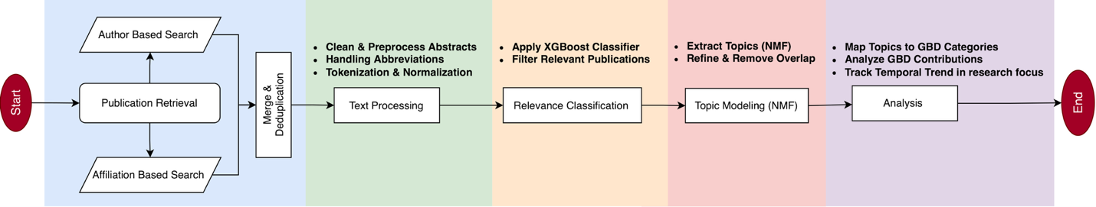
Fig. S1: Workflow of data acquisition, text processing, topic modeling, and GBD mapping.
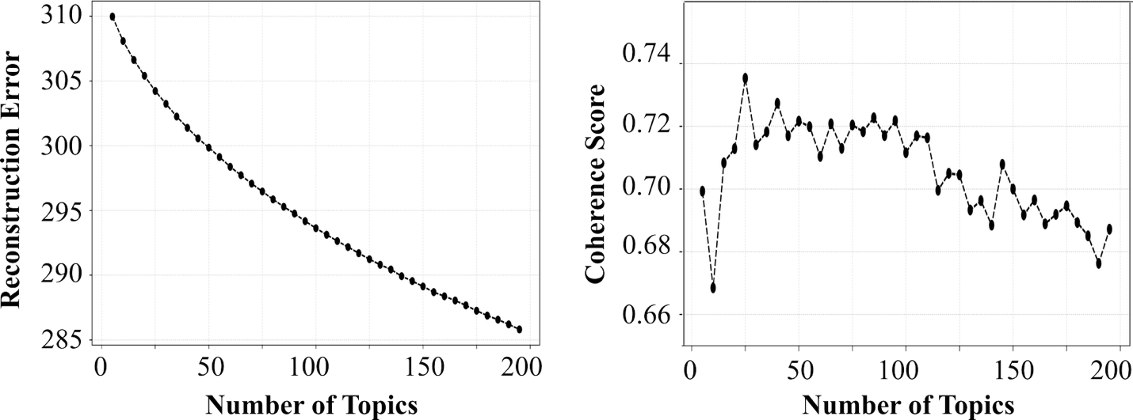
Fig. S2: Assessment of NMF model performance across varying topic numbers, with reconstruction error (left) and coherence score (right).
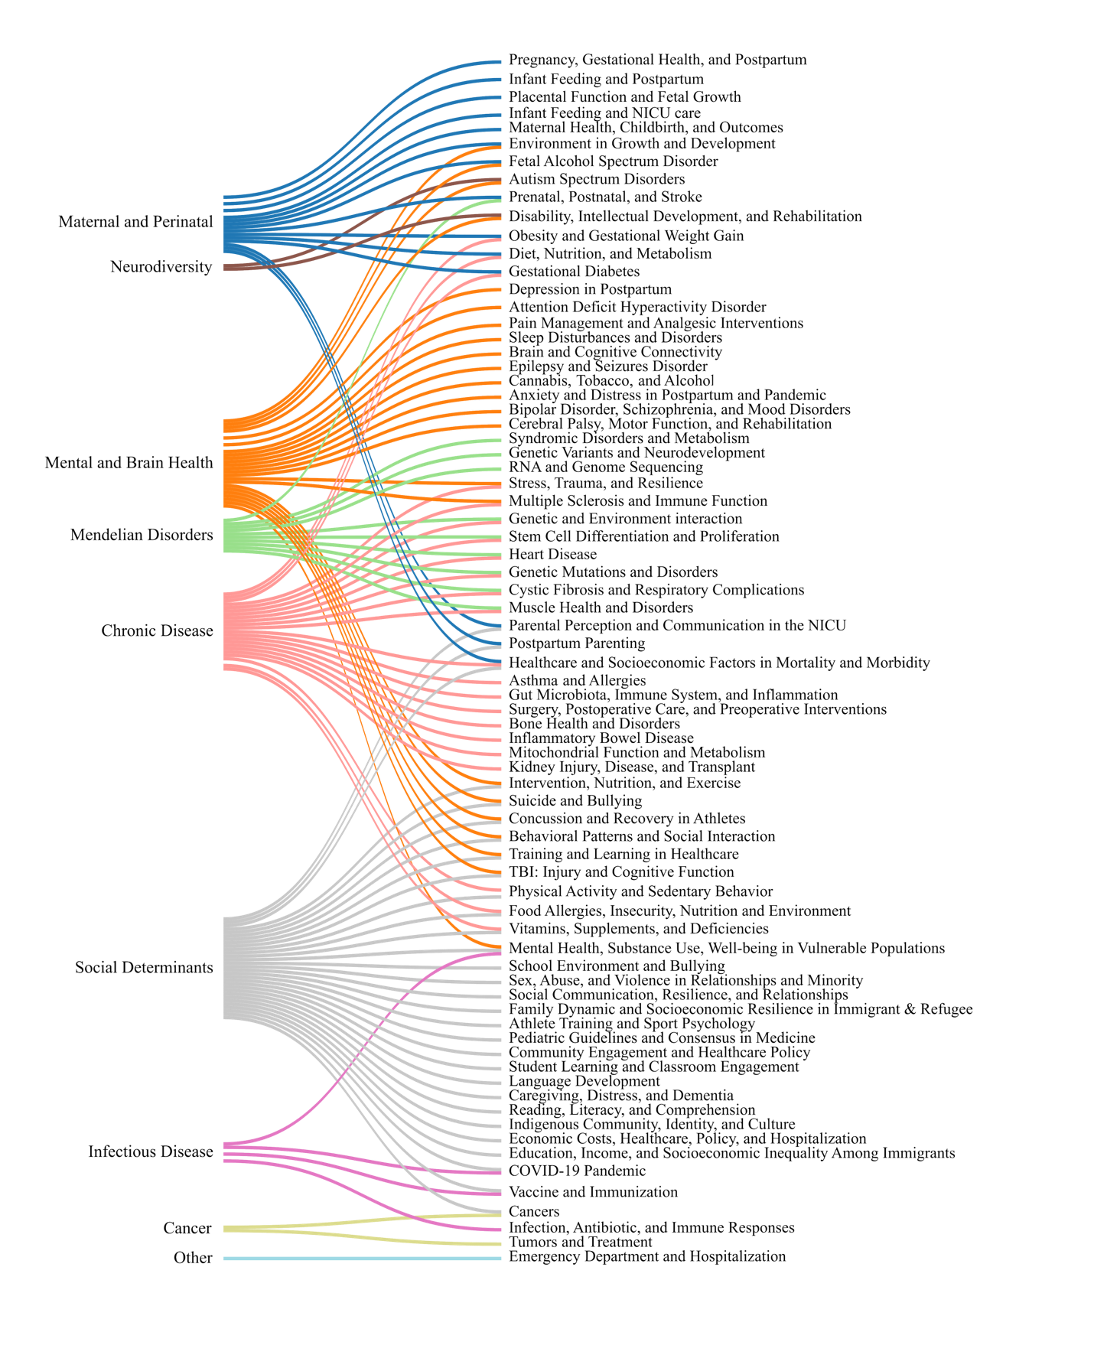
Fig. S3: Mapping topics to GBD categories.
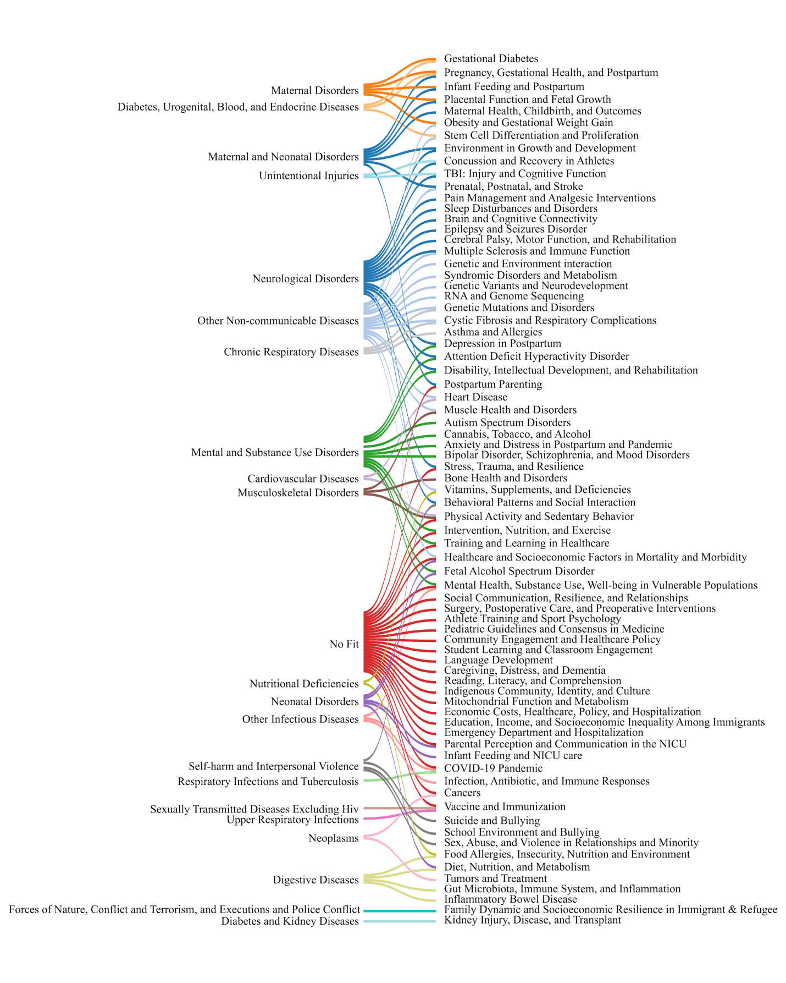
Fig. S4: Mapping topics to GBD subcategories.

Supplementary Tables
Table S1. List of research centers, universities, and hospitals related to child health research in Canada
Province | Centers, Hospital, University
Alberta | Alberta Children’s Hospital  Alberta Children’s Hospital Research Institute  Cancer Research Institute of Northern Alberta  Cumming School of Medicine, University of Calgary  Stollery Children’s Hospital  University of Alberta  University of Alberta, Faculty of Medicine and Dentistry  University of Calgary
British Columbia | BC Children’s Hospital  BC Children’s Hospital Research Institute  Children’s and Women’s Health Centre of British Columbia  The University of British Columbia  University of British Columbia, Faculty of Medicine
Ontario | CanChild Centre for Childhood Disability Research  Children’s Health Research Institute  Children’s Hospital of Eastern Ontario  Children’s Hospital of Western Ontario  École de médecine du Nord de l’Ontario  Holland Bloorview Kids Rehabilitation Hospital  Hospital for SickChildren, University of Toronto  McMaster Children's Hospital  McMaster University  McMaster University, Medical Centre  Michael G. DeGroote School of Medicine  Offord Centre for Child Studies McMaster  Queens University  Queens University, School of Medicine  Schulich School of Medicine & Dentistry  Sickkids Research Institute  Sunnybrook Health Sciences Centre  Thames Valley Children’s Centre  The Centre for Applied Genomics, University of Toronto  The Lunenfeld-Tanenbaum Research Institute of University of Toronto  Toronto Centre for Phenogenomics  Université Laurentienne  Université d’Ottawa, Faculté de Médecine  University of Ottawa  University of Toronto  University of Toronto, Faculty of Medicine  Western University
Manitoba | Children’s Hospital of Winnipeg  Max Rady College of Medicine, University of Manitoba  Rehabilitation Centre for Children Foundation  University of Manitoba
Newfoundland and Labrador | Memorial University of Newfoundland  Memorial University of Newfoundland, Faculty of Medicine
Nova Scotia | Dalhousie University  Dalhousie University, Faculty of Medicine  IWK Children’s Hospital  Izaak Walton Killam Hospital for Children
Quebec | Centre de recherche du CHU de Québec-Université Laval  Centre Universitaire de Santé McGill, Hôpital de Montreal Pour Enfants  CHU Sainte-Justine  McGill Faculty of Medicine and Health Sciences  School of Medicine, Montreal  Shriners Hospitals for Children  Université Laval  Université Laval, Faculté de Médecine  Université McGill  Université de Montréal, Faculté de Médecine  Université de Sherbrooke  Université de Sherbrooke, Faculté de Médecine et des Sciences de la Santé  University of Montreal
Saskatchewan | New Janeway Children’s Health and Rehabilitation Centre  Saskatchewan Pediatric Auditory Rehabilitation Center  University of Saskatchewan

Table S2. Performance metrics of NMF model
 |  |  |  |  |  |  | Confusion Matrix
Accuracy | Precision |  | Recall |  | F1 Score |  |  | Non-Relevant | Relevant
0.863 | 0.876 |  | 0.846 |  | 0.861 |  |  | 315(TN), 43(FP) | 55(FN), 303(TP)

Table S3. Categorized Causes from GBD list
Category: Subcategory | Cause name
Cancer:
Neoplasms | Acute lymphoid leukemia, Acute myeloid leukemia, Benign and in situ cervical and uterine neoplasms, Benign and in situ intestinal neoplasms, Bladder cancer, Brain and central nervous system cancer, Breast cancer, Burkitt lymphoma, Cervical cancer, Chronic lymphoid leukemia, Chronic myeloid leukemia, Colon and rectum cancer, Esophageal cancer, Gallbladder and biliary tract cancer, Hepatoblastoma, Hodgkin lymphoma, Kidney cancer, Larynx cancer, Lip and oral cavity cancer, Liver cancer due to NASH, Liver cancer due to alcohol use, Liver cancer due to hepatitis B, Liver cancer due to hepatitis C, Liver cancer due to other causes, Malignant neoplasm of bone and articular cartilage, Malignant skin melanoma, Mesothelioma, Multiple myeloma, Myelodysplastic, myeloproliferative, and other hematopoietic neoplasms, Nasopharynx cancer, Neuroblastoma and other peripheral nervous cell tumors, Non-melanoma skin cancer (basal-cell carcinoma), Non-melanoma skin cancer (squamous-cell carcinoma), Other benign and in situ neoplasms, Other eye cancers, Other leukemia, Other malignant neoplasms, Other non-Hodgkin lymphoma, Other pharynx cancer, Ovarian cancer, Pancreatic cancer, Prostate cancer, Retinoblastoma, Soft tissue and other extraosseous sarcomas, Stomach cancer, Testicular cancer, Thyroid cancer, Total Cancers excluding Non-melanoma skin cancer, Total cancers, Tracheal, bronchus, and lung cancer, Uterine cancer
Chronic disease:  Cardiovascular diseases | Alcoholic cardiomyopathy, Aortic aneurysm, Atrial fibrillation and flutter, Endocarditis, Hypertensive heart disease, Intracerebral hemorrhage, Ischemic heart disease, Ischemic stroke, Lower extremity peripheral arterial disease, Myocarditis, Non-rheumatic calcific aortic valve disease, Non-rheumatic degenerative mitral valve disease, Other cardiomyopathy, Other cardiovascular and circulatory diseases, Other non-rheumatic valve diseases, Pulmonary Arterial Hypertension, Rheumatic heart disease, Subarachnoid hemorrhage
Chronic respiratory diseases | Asbestosis, Asthma, Chronic obstructive pulmonary disease, Coal workers pneumoconiosis, Interstitial lung disease and pulmonary sarcoidosis, Other chronic respiratory diseases, Other pneumoconiosis, Silicosis
Diabetes and Kidney diseases | Chronic kidney disease due to diabetes mellitus type 1, chronic kidney disease due to diabetes mellitus type 2, Diabetes mellitus type 1, Diabetes mellitus type 2
Diabetes, urogenital, blood, and endocrine diseases | Acute glomerulonephritis, Benign prostatic hyperplasia, Chronic kidney disease due to glomerulonephritis, Chronic kidney disease due to hypertension, Chronic kidney disease due to other and unspecified causes, Endocrine, metabolic, blood, and immune disorders, Female infertility, Genital prolapse, Male infertility, Other gynecological diseases, Other hemoglobinopathies and hemolytic anemias, Other urinary diseases, Other endocrine, metabolic, blood, and immune disorders ,Polycystic ovarian syndrome, Premenstrual syndrome, Thyroid diseases, Urolithiasis, Uterine fibroids
Digestive diseases | Appendicitis, Chronic hepatitis B including cirrhosis, Chronic hepatitis C including cirrhosis, Cirrhosis due to alcohol, Cirrhosis due to other causes, Crohn's disease, Gastritis and duodenitis, Gastroesophageal reflux disease, Inflammatory bowel disease, Inguinal, femoral, and abdominal hernia, Nonalcoholic fatty liver disease including cirrhosis, Other digestive diseases, Pancreatitis, Paralytic ileus and intestinal obstruction, Peptic ulcer disease, Total burden related to Non-alcoholic fatty liver disease (NAFLD), Ulcerative colitis, Vascular intestinal disorders,
Musculoskeletal disorders | Gout, Low back pain, Neck pain, Osteoarthritis hand, Osteoarthritis hip, Osteoarthritis knee, Osteoarthritis other, Other musculoskeletal disorders, Rheumatoid arthritis
Other infectious diseases | Total burden related to hepatitis B, Total burden related to hepatitis C
Other non-communicable disease | Acne vulgaris, Age-related and other hearing loss, Age-related macular degeneration, Caries of deciduous teeth, Caries of permanent teeth, Cataract, Cellulitis, Decubitus ulcer, Fungal skin diseases, Glaucoma, Other oral disorders, Other sense organ diseases, Other skin and subcutaneous diseases, Othervision loss, Periodontal diseases, Pruritus, Psoriasis, Pyoderma, Scabies, Urticaria
Sense organ diseases | Near vision loss, Refraction disorders
Skin and subcutaneous diseases | Atopic dermatitis, Contact dermatitis, Seborrhoeic dermatitis
Infectious disease:
Diarrhea, lower respiratory, and other common infectious diseases | Diarrheal diseases, Lower respiratory infections
Enteric infections | Invasive Non-typhoidal Salmonella (iNTS), Other intestinal infectious diseases
HIV/AIDS and sexually transmitted infections | HIV/AIDS - Drug-susceptible Tuberculosis, HIV/AIDS - Extensively drug-resistant Tuberculosis, HIV/AIDS - Multidrug-resistant Tuberculosis without extensive drug resistance, HIV/AIDS resulting in other diseases
Hepatitis | Acute hepatitis E
Neglected tropical diseases and malaria | African trypanosomiasis, Ascariasis, Chagas disease, Cutaneous and mucocutaneous leishmaniasis, Cystic echinococcosis, Cysticercosis, Dengue, Ebola, Food-borne trematodiases, Guinea worm disease, Hookworm disease, Leprosy, Lymphatic filariasis, Malaria, Onchocerciasis, Other neglected tropical diseases, Rabies, Schistosomiasis, Trachoma, Trichuriasis, Visceral leishmaniasis, Yellow fever, Zika virus
Other infectious diseases | Acute hepatitis A, Acute hepatitis B, Acute hepatitis C, Diphtheria, Encephalitis, Measles, Meningitis, Other unspecified infectious diseases, Otitis media, Paratyphoid fever, Tetanus, Typhoid fever, Urinary tract infections and interstitial nephritis, Varicella and herpes zoster
Other non-communicable diseases | Viral skin diseases
Respiratory infections and tuberculosis | COVID-19, Drug-susceptible tuberculosis, Extensively drug-resistant tuberculosis, Latent tuberculosis infection, Multidrug-resistant tuberculosis without extensive drug resistance
Sexually transmitted diseases excluding HIV | Chlamydial infection, Genital herpes, Gonococcal infection, Other sexually transmitted infections, Syphilis, Trichomoniasis
Upper respiratory infections | Pertussis, Upper respiratory infections
Maternal and perinatal:
Diabetes, urogenital, blood, and endocrine diseases | Endometriosis
Maternal and neonatal disorders | Ectopic pregnancy, Maternal abortion and miscarriage
Maternal disorders | Indirect maternal deaths, Late maternal deaths, Maternal deaths aggravated by HIV/AIDS, Maternal hemorrhage, Maternal hypertensive disorders, Maternal obstructed labor and uterine rupture, Maternal sepsis and other maternal infections, Other direct maternal disorders
Neonatal disorders | Hemolytic disease and other neonatal jaundice, Neonatal encephalopathy due to birth asphyxia and trauma, Neonatal preterm birth, Neonatal sepsis and other neonatal infections, Other neonatal disorders
Other non-communicable diseases | Sudden infant death syndrome
Mendelian disorders:
Diabetes, urogenital, blood, and endocrine diseases | G6PD deficiency, G6PD trait, Sickle cell disorders, Sickle cell trait, Thalassemias, Thalassemias trait
Digestive diseases | Gallbladder and biliary diseases
Other non-communicable diseases | Alopecia areata, Congenital heart anomalies, Congenital musculoskeletal and limb anomalies, Digestive congenital anomalies, Down syndrome, Edentulism, Idiopathic epilepsy, Klinefelter syndrome, Neural tube defects, Orofacial clefts, Other chromosomal abnormalities, Other congenital birth defects, Turner syndrome, Urogenital congenital anomalies
Mental and brain health:
Mental and substance use disorders | Alcohol use disorders, Amphetamine use disorders, Anorexia nervosa, Anxiety disorders, Bipolar disorder, Bulimia nervosa, Cannabis use disorders, Cocaine use disorders, Conduct disorder, Dysthymia, Major depressive disorder, Opioid use disorders, Other drug use disorders, Other mental disorders, Schizophrenia
Neurological disorders | Alzheimer's disease and other dementias, Migraine, Motor neuron disease, Multiple sclerosis, Other neurological disorders, Parkinson's disease, Tension-type headache
Self-harm and interpersonal violence | Self-harm by firearm, Self-harm by other specified means
Neurodiversity: Mental and substance use disorders | Attention-deficit/hyperactivity disorder, Autism spectrum disorders, Idiopathic developmental intellectual disability
Other:
Transport injuries | Cyclist road injuries, Motor vehicle road injuries, Motorcyclist road injuries, Other road injuries, Pedestrian roadinjuries
Unintentional injuries | Adverse effects of medical treatment, Drowning, Falls, Fire, heat, and hot substances, Foreign body in eyes, Foreign body in other body part, Non-venomous animal contact, Otherexposure to mechanical forces, Other unintentional injuries, Poisoning by carbon monoxide, Poisoning by other means, Pulmonary aspiration and foreign body in airway, Unintentional firearm injuries, Venomous animal contact
Social Determinant:
Forces of nature, conflict and terrorism, and executions and police conflict | Conflict and terrorism, Exposure to forces of nature, Police conflict and executions
Nutritional deficiencies | Dietary iron deficiency, Iodine deficiency, Other nutritional deficiencies, Protein-energy malnutrition, Vitamin A deficiency
Other transport injuries | Other transport injuries
Self-harm and interpersonal violence | Physical violence by firearm, Physical violence by other means, Physical violence by sharp object, Sexual violence
Unintentional injuries | Electrocution, Environmental heat and cold exposure

