Appendix A: Supplementary Data Architecture and Hyperparameter Specifications
Table A1: Secondary Spatial Data Processing Protocols and Spatial Resolutions
Dataset Name | Source / Repository | Original Resolution | Extraction & Resampling Method | Model Pipeline Variable
OpenStreetMap (OSM) | OpenStreetMap Foundation (2025) | Vector Line | 100m segment segmentation & spatial join | Road Network Geometry & Tier
SRTM DEM v3 | NASA Earthdata / USGS (2014) | 30m Grid | Bilinear interpolation to segment node | Surface Elevation ($m$), Slope (${}_{​}^{∘}​$)
CHIRPS v2.0 | Climate Hazards Center (2014–2024) | 0.05° Grid | Spatial point-in-polygon extraction | 24-hr Max Rainfall Intensity ($mm$)
ESA WorldCover | European Space Agency (2021) | 10m Grid | 50m radial buffer land cover aggregation | Surface Impermeability Index ($0-1$)
Copernicus EMS / DFO | CEMS & Dartmouth Flood Obs. | Vector Polygons | Spatial intersection with road nodes | Binary Target ($Y=1$ flooded, $Y=0$ resilient)

Table A2: Machine Learning Hyperparameter Tuning Configuration (XGBoost)
Hyperparameter Name | Search Range / Options | Selected Optimal Value | Description / Function
n_estimators | 50 – 500 | 250 | Total number of gradient boosted trees
max_depth | 3 – 10 | 6 | Maximum tree depth to control model complexity
learning_rate ($η$) | 0.01 – 0.3 | 0.05 | Step size shrinkage to prevent overfitting
subsample | 0.5 – 1.0 | 0.8 | Subsample ratio of training instances
colsample_bytree | 0.5 – 1.0 | 0.7 | Subsample ratio of columns per tree
scale_pos_weight | 1.0 – 5.0 | 2.85 | Weight balance for SMOTE-adjusted class imbalance
Appendix B: Model Sensitivity and Spatial Validation
Table B1: 5-Fold Cross-Validation Performance Across Iterations (XGBoost)
Fold Iteration | ROC-AUC | F1-Score | Precision | Recall | Validation Accuracy
Fold 1 | 0.908 | 0.839 | 0.855 | 0.824 | 0.881
Fold 2 | 0.915 | 0.851 | 0.868 | 0.835 | 0.892
Fold 3 | 0.910 | 0.842 | 0.859 | 0.826 | 0.884
Fold 4 | 0.918 | 0.854 | 0.871 | 0.838 | 0.895
Fold 5 | 0.909 | 0.839 | 0.857 | 0.822 | 0.883
Mean ($±$ SD) | 0.912 ($±$0.004) | 0.845 ($±$0.007) | 0.862 ($±$0.007) | 0.829 ($±$0.007) | 0.887 ($±$0.006)

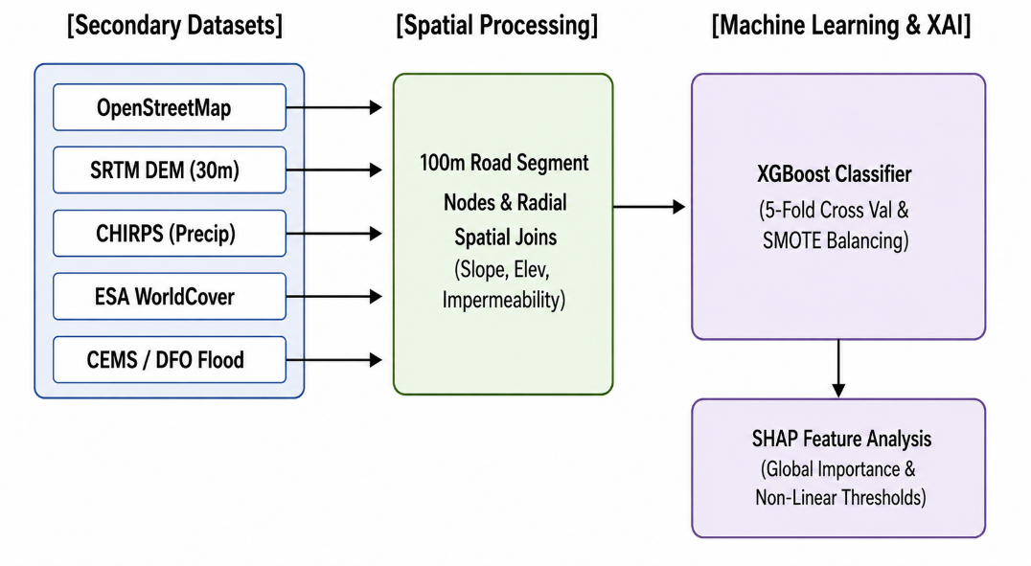
Figure A1: End-to-End Data Fusion and Model Architecture

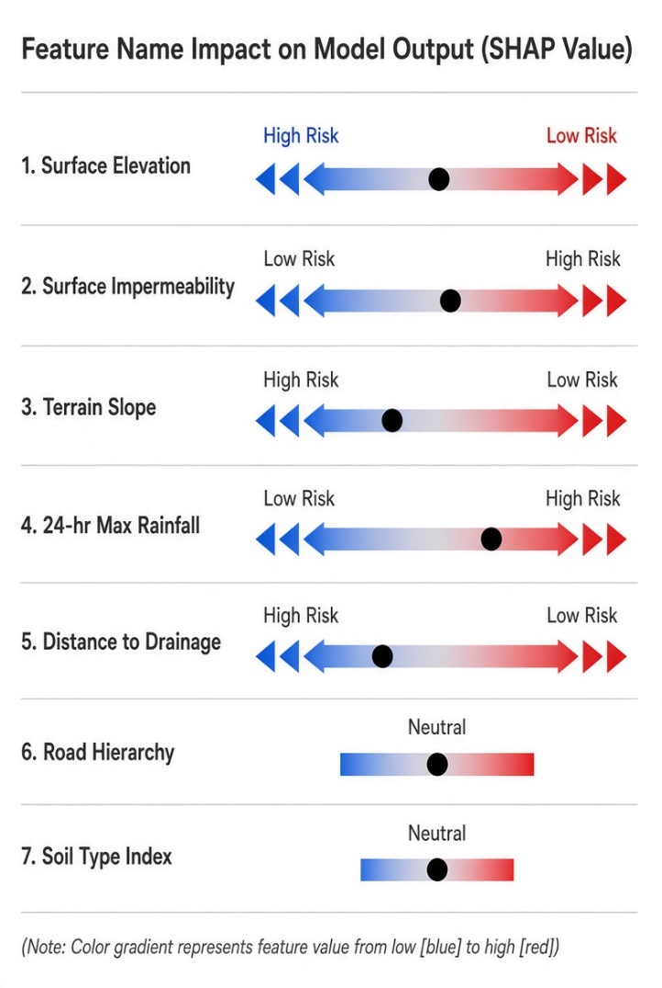
Figure A2: Conceptual SHAP Summary Plot (Global Feature Rankings)

