Supplementary Information
Companion to: Mechanical Frequency Combs via Three-Wave-Mixing Parametric Excitation: A Scalable Inertial-Sensing Modality

Supplementary Note S1

Device-B small-signal measurement and above-threshold comb spectrum
Fig. S1(a) shows the small-signal LDV transmission spectrum of Device B, plotted as out-of-plane velocity scaled by PZT drive voltage. Velocity was measured non-contactly with a Polytec laser Doppler vibrometer at a single point on the bridge, driven through the PZT actuator with a small-signal sinusoid swept across $0$–$400 kHz$. The voltage-scaled peak velocities at the two lines that set the FM-transduction operating point are:
- Mode 1 ($≈3.49 kHz$, $ω_{1}$): $2.64×{10}^{−1} m s^{−1} V^{−1}$.
- Pump line ($≈106.19 kHz$, $ω_{p}$): $2.66×{10}^{−2} m s^{−1} V^{−1}$.
The Device-B Mode 2 sits at $≈102.70 kHz$, so the three-wave-mixing resonance condition $ω_{p}≈ω_{1}+ω_{2}$ is satisfied to within the linewidth ($3.49+102.70=106.19 kHz$). Beyond these three operating lines, the small-signal sweep resolves the full Device-B mode spectrum out to $400 kHz$, consistent with the multi-mode linear response reported for Device A in main text Fig. 2(c). All measurements were taken at room temperature and ambient pressure unless otherwise noted.
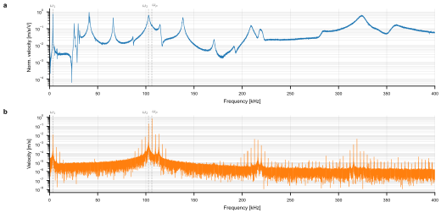
Fig. S1 — LDV measurement of Device B in the linear and above-threshold regimes. (a) Small-signal velocity transmission spectrum on a $0$–$400 kHz$ axis, scaled by PZT drive voltage. Mode 1 ($≈3.49 kHz$, $ω_{1}$) and the pump line ($≈106.19 kHz$, $ω_{p}$) lie within the swept band; their voltage-scaled peak velocities are listed above. The mode density above $≈200 kHz$ is consistent with the multi-mode linear response of the same PZT-on-Si bridge platform reported for Device A in main text Fig. 2(c). (b) Above-threshold velocity spectrum of Device B under the pump conditions used for the FM-transduction experiment of main text Figs. 5 and 6: a dominant carrier group near $ω_{p}$ together with harmonic comb groups around $2ω_{p}$ and $3ω_{p}$ confirms that the operating point established by panel (a) drives the bridge into three-wave-mixing-induced comb generation.

Supplementary Note S2

Shaker-test setup for the accelerometer demonstration
All accelerometer-mode validation experiments (main text Figs. 5 and 6) were performed on the bench-top setup shown in Fig. S2. Mechanical drive is provided by a custom shaker built around a commercial subwoofer driver: the moving cone of the subwoofer acts as the shaker armature, providing a large stroke and a flat low-frequency response that makes it well suited to the $≤100 Hz$ inertial-loading regime targeted in main text Figs. 5 and 6. A 3D-printed stage is rigidly fixed on top of the subwoofer cone and serves as the mounting platform for the device under test. The MEMS die (Device B) is wire-bonded to a small breakout PCB, which is in turn screwed to the 3D-printed stage; the stage simultaneously (i) raises the device into the focal plane of the LDV objective and (ii) provides additional rotational stiffness of the PCB carrier. Out-of-plane velocity at a single point on the bridge is measured non-contactly with a Polytec laser Doppler vibrometer; the LDV optical head and a co-aligned vision camera are visible in the upper portion of the photograph.
The subwoofer is driven by a single-tone signal-generator output through a power amplifier; the drive frequency, amplitude, and waveform are recorded synchronously with the LDV velocity time series. Because the shaker is custom-built rather than a metrology-grade unit, both the on-stage acceleration amplitude and the harmonic distortion of the cone motion were calibrated in-situ with the LDV itself: out-of-plane velocity of the bare 3D-printed stage was recorded under increasing drive amplitudes, the velocity time series was twice-differentiated (or equivalently scaled by $ω$) to recover acceleration, and the harmonic content was extracted from the velocity spectrum. This procedure verified that the cone motion remains sinusoidal — with no measurable harmonic distortion above the LDV noise floor — up to peak accelerations of at least $±100 m⋅s^{−2}$ ($≈±10 g$) over the drive bandwidth used in main text Figs. 5 and 6. The drive parameters reported for Figs. 5 and 6 ($50 Hz$ sinusoid, $≈±100 m⋅s^{−2}$ peak acceleration) are referenced to this LDV-based calibration. The same setup and calibration procedure are used for both threshold-crossing measurement and for the per-comb-line FM-demodulation runs.
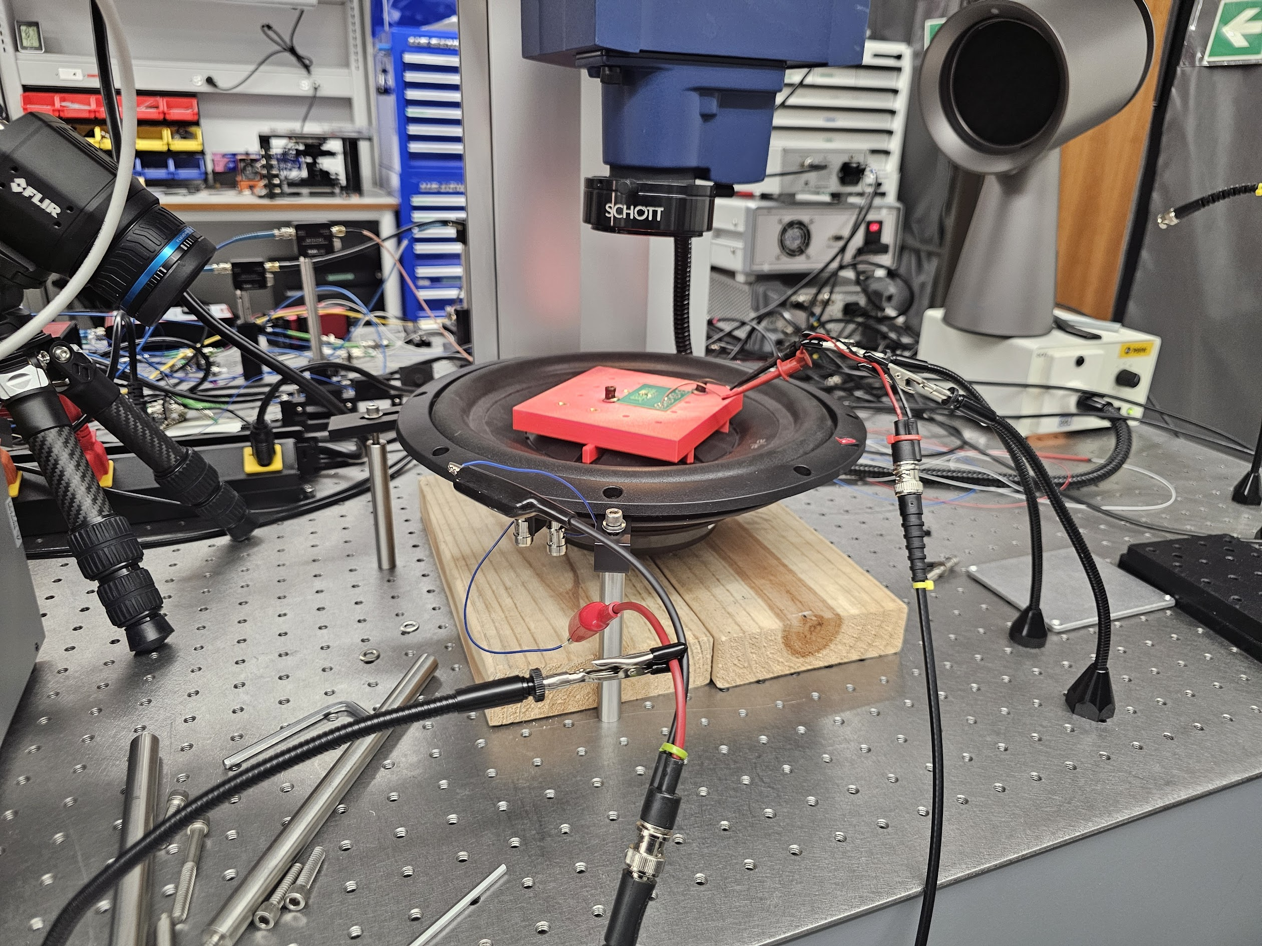
Fig. S2 — Shaker-test bench setup. Mechanical drive is provided by a custom shaker built around a commercial subwoofer driver; a 3D-printed stage is fixed on top of the subwoofer cone to act as the device-mounting platform. The Device-B breakout PCB (red, with the bonded MEMS die visible) is screwed to this 3D-printed stage. Out-of-plane velocity is measured non-contactly by a Polytec laser Doppler vibrometer (top, with a co-aligned vision camera visible); the same LDV is used to calibrate the on-stage acceleration amplitude and to verify the absence of measurable harmonic distortion up to $±10 g$. The setup feeds the per-comb-line FM-demodulation chain reported in main text Figs. 5 and 6.

Supplementary Note S3

FEM sensitivity sweep: bending-to-tension crossover with bridge thickness

Model setup
The mechanism under study is the axial-stress stiffening of the clamped–clamped bridge: under an inertial load, the central proof mass deflects out of plane, the clamped–clamped boundary forces mid-plane stretching, and the resulting axial stress shifts the mode-1 eigenfrequency that carries the FM-encoded signal in main text Figs. 5 and 6. To quantify this effect against the device-Si layer thickness $h$, a 3D static-prestress eigenfrequency study was constructed in COMSOL Multiphysics. The geometry is a deliberately simplified version of the as-fabricated stack of main text Methods: only the device-Si and the PZT layers are simulated, while the SiO$​_{2}$ BOX, the Ti/Pt bottom electrode, the Au top electrode, and the Si$​_{3}$N$​_{4}$ passivation are omitted. These omitted films are sub-$200 nm$ thick (much thinner than the structural Si and PZT layers) and their contribution to the mode-1 eigenfrequency and to the geometric stiffness under axial pre-stress is negligible; removing them substantially reduces the mesh size and the run time of the sweep without altering the physics under study. The bridge footprint ($6.70 mm$ clamped–clamped span with a central proof mass) and the full PZT-on-Si stack defined in main text Methods are held fixed; the PZT thickness is held at its nominal value ($2 μm$) and only the device-Si thickness is swept, through $h∈\{5, 10, 15\} μm$. The bridge is rigidly clamped at both ends and the central proof-mass region is preserved across the sweep so that only the bridge compliance changes. Inertial loading is imposed using COMSOL’s linearly accelerated reference frame applied to the entire structure: the prescribed acceleration $a$ is added uniformly to every material point as an equivalent body force, removing the need for a separately defined gravity load. The acceleration is swept over $a∈[0, 200] m⋅s^{−2}$ ($≈0$–$20 g$); for each value of $a$ the solver first computes the stressed static configuration (and the resulting mid-plane axial stress) and then extracts the mode-1 eigenfrequency $f_{1}(a)$ from a stressed-state eigenmode analysis. Linear elastic material properties are used throughout; piezoelectric coupling is disabled for the sensitivity sweep because the eigenfrequency shift is a purely mechanical (stress-stiffening) effect.

Results: bending-to-tension crossover
Fig. S3(a) shows the mode-1 eigenmode shape of the simplified two-layer (device-Si + PZT) clamped–clamped bridge, obtained from the COMSOL eigenfrequency analysis. Fig. S3(b) plots the simulated mode-1 frequency shift $δf_{1}(a)=f_{1}(a)−f_{1}(0)$ as a function of out-of-plane acceleration for the three device-Si thicknesses. For the thickest bridge ($h=15 μm$), $δf_{1}$ remains essentially flat across the full acceleration range: the flexural restoring stiffness ($∝t^{3}$) dominates the geometric stiffness ($∝t$) [3, 4], so the central-mass deflection at a given acceleration is too small to induce significant mid-plane stretching and the eigenfrequency is insensitive to the inertial load. As the device layer is thinned to $10 μm$ and then to $5 μm$, $δf_{1}(a)$ becomes monotonic and progressively steeper: the bridge enters the tension-dominated regime, in which the eigenfrequency shift is set by the axial pre-stress accumulated during mid-plane stretching of a compliant beam. The $5 μm$ trace exhibits the strongest stress-stiffening response and the largest $δf_{1}$ at $200 m⋅s^{−2}$. The present device ($14 μm$ device Si) therefore sits in the bending-dominated regime, which is consistent with the modest mechanical scale factor reported in main text Figs. 5 and 6 and motivates the thinning roadmap discussed in the Discussion.

Implications for device scaling
The FEA sweep supports three points relevant to future iterations of the device. (i) Within the geometry studied, the mechanical scale factor of the FM-encoded carrier is set by the competition between flexural and geometric stiffness, and thinning the device-Si layer is the most direct lever — the flexural-to-tension stiffness ratio scales as $t^{2}$ at fixed footprint (flexural stiffness $∝t^{3}$, geometric stiffness $∝t$), motivating thinning of the device-Si layer as the primary device-level lever for increased $δf_{1}/a$. (ii) The crossover from the bending regime into the tension regime occurs in the single-digit-micron thickness range for the present $6.70 mm$ footprint, which defines a target window for the next process run. (iii) The crossover is a purely geometric/structural effect: it does not require any change to the three-wave-mixing operating principle, to the pump configuration, or to the per-comb-line FM-demodulation pipeline, so the overtone-comb scaling demonstrated on Device B in main text Figs. 5 and 6 carries over directly to a thinned bridge.
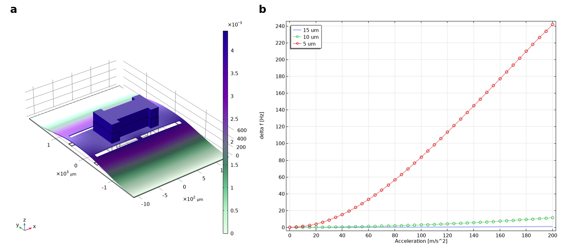
Fig. S3 — (a) Mode-1 eigenmode shape of the simplified two-layer (device-Si + PZT) clamped–clamped bridge, from the COMSOL static-prestress eigenfrequency sweep (shown for h = 15 μm under a = 20 m·s⁻²; colour scale: modal displacement magnitude, μm). The sub-$200 nm$ passivation, electrode, and BOX layers of the as-fabricated stack (main text Methods) are omitted because they do not contribute significantly to the eigenmode or to the geometric stiffness under axial pre-stress. (b) Finite-element-simulated mode-1 frequency shift $δf_{1}=f_{1}(a)−f_{1}(0)$ versus out-of-plane acceleration $a$ for device-Si thicknesses $h=5, 10,$ and $15 μm$, swept over $0$–$200 m⋅s^{−2}$. Acceleration is applied through COMSOL’s linearly accelerated reference frame. The $h=15 μm$ trace is essentially flat (bending-dominated; flexural stiffness $∝t^{3}$); thinning the device layer to $10 μm$ and $5 μm$ drives the bridge into the tension-dominated regime, in which mid-plane stretching of the proof-mass-loaded beam produces a monotonic, increasing $δf_{1}$ (geometric stiffness $∝t$).

Supplementary Note S4

Linear temporal coupled-mode theory model
Treating the LDV measurement as a single-port complex transmission $T(ω)$ of an $N$-mode linear resonator with a coherent direct-coupling background $t$, the TCMT amplitude equations in the slowly-varying envelope and weak-coupling limit reduce to a sum of complex Lorentzians plus a frequency-independent through term [1, 2]:
$$T(ω) = t + \sum_{n=1}^{N}{\frac{C_{n}}{r_{n}/2+j (ω_{n}−ω)}}$$
where:
- $ω_{n}$ is the angular eigenfrequency of mode $n$;
- $r_{n}$ is the energy decay rate (full-width at half-maximum in angular frequency); the loaded quality factor is $Q_{n}=ω_{n}/r_{n}$;
- $C_{n}∈C$ is the complex coupling coefficient. Its modulus sets the on-resonance amplitude ($|T(ω_{n})−t|≈2 |C_{n}|/r_{n}$); its phase $\text{arg}(C_{n})$ selects the line shape — real-positive $C_{n}$ yields a Lorentzian peak, real-negative $C_{n}$ yields a dip, and intermediate phases produce asymmetric line-shape profiles;
- $t∈C$ is the coherent direct-coupling background, fitted globally and essential for capturing dip-type features.
Because all line shapes share this single functional form, no per-mode line-shape branching is required.
This single-port multi-mode TCMT is the framework underlying the 18-mode fit of Device A in main text Fig. 2(c) and the linear-regime Device-B spectrum in Fig. S1(a). The per-mode parameters $\{ω_{n}, r_{n}, C_{n}\}$ extracted by this fit are the inputs the two-mode nonlinear CMT of main text Methods consumes; the linear-fit quality therefore bounds the nonlinear-model accuracy.

Supplementary references
[1] H. A. Haus, Waves and Fields in Optoelectronics (Prentice-Hall, Englewood Cliffs, NJ, 1984).
[2] W. Suh, Z. Wang, and S. Fan, “Temporal coupled-mode theory and the presence of non-orthogonal modes in lossless multimode cavities,” IEEE J. Quantum Electron. 40, 1511–1518 (2004).
[3] S. Bouwstra and B. Geijselaers, “On the resonance frequencies of microbridges,” in Tech. Dig. TRANSDUCERS ’91 (IEEE, San Francisco, CA, 1991), pp. 538–542.
[4] S. Schmid, L. G. Villanueva, and M. L. Roukes, Fundamentals of Nanomechanical Resonators (Springer, Cham, 2016).

