Supplementary material

Table 1. Country-level reported presence or absence of the five water-monitoring components included in the study. Values indicate reported presence (1) or absence (0) in the corresponding international data source. Absence should not be interpreted as definitive evidence that no operational monitoring program exists within the country.
ISO3 | Country | Biological | Physico-chemical | Water discharge | Wastewater treatment | Groundwater
AFG | Afghanistan | 1 | 1 | 0 | 0 | 1
ALB | Albania | 0 | 0 | 0 | 1 | 0
DZA | Algeria | 0 | 1 | 0 | 1 | 0
ASM | American Samoa | 0 | 0 | 0 | 1 | 0
AND | Andorra | 0 | 0 | 0 | 1 | 0
AGO | Angola | 0 | 0 | 0 | 0 | 0
ATG | Antigua and Barb. | 0 | 0 | 0 | 1 | 0
ARG | Argentina | 1 | 1 | 1 | 1 | 0
ARM | Armenia | 0 | 0 | 0 | 1 | 0
ABW | Aruba | 0 | 0 | 0 | 1 | 0
AUS | Australia | 1 | 1 | 1 | 1 | 1
AUT | Austria | 1 | 1 | 1 | 1 | 1
AZE | Azerbaijan | 0 | 0 | 0 | 1 | 0
BHS | Bahamas | 0 | 0 | 0 | 1 | 0
BHR | Bahrain | 0 | 0 | 0 | 1 | 0
BGD | Bangladesh | 1 | 1 | 0 | 0 | 0
BRB | Barbados | 0 | 0 | 0 | 1 | 0
BLR | Belarus | 0 | 0 | 0 | 1 | 0
BEL | Belgium | 1 | 1 | 1 | 1 | 1
BLZ | Belize | 0 | 0 | 0 | 0 | 0
BEN | Benin | 0 | 0 | 0 | 0 | 0
BMU | Bermuda | 0 | 0 | 0 | 1 | 0
BTN | Bhutan | 0 | 0 | 0 | 0 | 0
BOL | Bolivia | 1 | 1 | 1 | 0 | 0
BIH | Bosnia and Herz. | 0 | 1 | 0 | 0 | 0
BWA | Botswana | 0 | 0 | 0 | 1 | 0
BRA | Brazil | 1 | 1 | 1 | 1 | 1
VGB | British Virgin Is. | 0 | 0 | 0 | 1 | 0
BRN | Brunei | 0 | 0 | 0 | 0 | 0
BGR | Bulgaria | 0 | 1 | 0 | 1 | 1
BFA | Burkina Faso | 0 | 0 | 0 | 1 | 0
BDI | Burundi | 0 | 1 | 0 | 0 | 0
KHM | Cambodia | 0 | 1 | 0 | 0 | 0
CMR | Cameroon | 0 | 0 | 0 | 0 | 0
CAN | Canada | 1 | 1 | 1 | 1 | 1
CPV | Cape Verde | 0 | 0 | 0 | 1 | 0
CYM | Cayman Is. | 0 | 0 | 0 | 1 | 0
CAF | Central African Rep. | 0 | 0 | 0 | 0 | 0
TCD | Chad | 0 | 0 | 0 | 0 | 0
CHL | Chile | 1 | 1 | 1 | 1 | 1
CHN | China | 1 | 1 | 1 | 1 | 1
COL | Colombia | 1 | 1 | 1 | 0 | 0
COM | Comoros | 0 | 0 | 0 | 0 | 0
COG | Congo | 0 | 0 | 0 | 0 | 0
CRI | Costa Rica | 0 | 1 | 0 | 0 | 1
HRV | Croatia | 1 | 1 | 0 | 0 | 1
CUB | Cuba | 1 | 1 | 0 | 1 | 1
CUW | Curaçao | 0 | 0 | 0 | 1 | 0
CYP | Cyprus | 0 | 0 | 0 | 1 | 0
CZE | Czech Rep. | 0 | 1 | 1 | 1 | 1
COD | Dem. Rep. Congo | 0 | 1 | 0 | 0 | 0
PRK | Dem. Rep. Korea | 0 | 0 | 0 | 1 | 0
DNK | Denmark | 1 | 1 | 1 | 1 | 1
DJI | Djibouti | 0 | 0 | 0 | 1 | 0
DMA | Dominica | 0 | 0 | 0 | 1 | 0
DOM | Dominican Rep. | 0 | 0 | 0 | 0 | 0
ECU | Ecuador | 1 | 1 | 1 | 0 | 1
EGY | Egypt | 0 | 1 | 0 | 1 | 0
SLV | El Salvador | 0 | 0 | 0 | 0 | 1
GNQ | Eq. Guinea | 0 | 0 | 0 | 1 | 0
ERI | Eritrea | 0 | 0 | 0 | 0 | 0
EST | Estonia | 1 | 1 | 0 | 1 | 1
ETH | Ethiopia | 0 | 0 | 0 | 0 | 0
FRO | Faeroe Is. | 0 | 0 | 0 | 1 | 0
FJI | Fiji | 1 | 1 | 0 | 1 | 0
FIN | Finland | 1 | 1 | 1 | 0 | 1
PYF | Fr. Polynesia | 0 | 0 | 0 | 1 | 0
FRA | France | 1 | 1 | 1 | 1 | 1
GAB | Gabon | 0 | 0 | 0 | 0 | 0
GMB | Gambia | 0 | 0 | 0 | 0 | 1
GEO | Georgia | 0 | 0 | 0 | 1 | 0
DEU | Germany | 1 | 1 | 1 | 1 | 1
GHA | Ghana | 1 | 1 | 1 | 0 | 0
GIB | Gibraltar | 0 | 0 | 0 | 1 | 0
GRC | Greece | 1 | 1 | 1 | 1 | 0
GRD | Grenada | 0 | 0 | 0 | 1 | 0
GUM | Guam | 0 | 0 | 0 | 1 | 1
GTM | Guatemala | 1 | 1 | 0 | 1 | 0
GIN | Guinea | 0 | 0 | 0 | 0 | 0
GNB | Guinea-Bissau | 0 | 0 | 0 | 0 | 0
GUY | Guyana | 0 | 0 | 0 | 0 | 0
HTI | Haiti | 0 | 0 | 0 | 0 | 0
HND | Honduras | 0 | 0 | 0 | 0 | 0
HKG | Hong Kong | 0 | 0 | 0 | 1 | 0
HUN | Hungary | 1 | 1 | 1 | 1 | 0
ISL | Iceland | 0 | 1 | 0 | 1 | 1
IND | India | 1 | 1 | 1 | 1 | 1
IDN | Indonesia | 1 | 1 | 1 | 1 | 0
IRN | Iran | 1 | 1 | 1 | 1 | 0
IRQ | Iraq | 0 | 1 | 0 | 1 | 0
IRL | Ireland | 1 | 1 | 1 | 1 | 1
IMN | Isle of Man | 0 | 0 | 0 | 1 | 1
ISR | Israel | 1 | 1 | 0 | 1 | 1
ITA | Italy | 1 | 1 | 1 | 1 | 1
JAM | Jamaica | 0 | 0 | 0 | 0 | 1
JPN | Japan | 1 | 1 | 1 | 1 | 0
JEY | Jersey | 0 | 0 | 0 | 1 | 0
JOR | Jordan | 1 | 1 | 0 | 1 | 1
KAZ | Kazakhstan | 0 | 0 | 0 | 1 | 0
KEN | Kenya | 1 | 1 | 1 | 0 | 0
KIR | Kiribati | 0 | 0 | 0 | 0 | 0
KOR | Korea | 1 | 1 | 1 | 1 | 1
KWT | Kuwait | 0 | 0 | 0 | 1 | 0
KGZ | Kyrgyzstan | 0 | 0 | 0 | 0 | 0
LAO | Lao PDR | 0 | 1 | 1 | 0 | 0
LVA | Latvia | 1 | 1 | 0 | 1 | 1
LBN | Lebanon | 0 | 0 | 0 | 1 | 0
LSO | Lesotho | 0 | 1 | 0 | 0 | 1
LBR | Liberia | 0 | 0 | 0 | 0 | 0
LBY | Libya | 0 | 0 | 0 | 1 | 0
LIE | Liechtenstein | 0 | 0 | 1 | 1 | 0
LTU | Lithuania | 1 | 1 | 0 | 1 | 1
LUX | Luxembourg | 1 | 1 | 1 | 1 | 1
MAC | Macao | 0 | 0 | 0 | 1 | 0
MKD | Macedonia | 0 | 1 | 0 | 1 | 0
MDG | Madagascar | 0 | 0 | 0 | 0 | 1
MWI | Malawi | 0 | 0 | 0 | 0 | 0
MYS | Malaysia | 1 | 1 | 1 | 0 | 1
MDV | Maldives | 0 | 0 | 0 | 1 | 0
MLI | Mali | 1 | 1 | 1 | 0 | 0
MLT | Malta | 0 | 1 | 0 | 1 | 0
MHL | Marshall Is. | 1 | 1 | 0 | 1 | 0
MRT | Mauritania | 0 | 0 | 0 | 0 | 0
MUS | Mauritius | 0 | 0 | 0 | 1 | 0
MEX | Mexico | 1 | 1 | 1 | 1 | 1
FSM | Micronesia | 0 | 0 | 0 | 0 | 0
MDA | Moldova | 0 | 0 | 0 | 0 | 0
MCO | Monaco | 0 | 0 | 0 | 1 | 0
MNG | Mongolia | 0 | 0 | 0 | 1 | 0
MNE | Montenegro | 0 | 0 | 0 | 0 | 0
MAR | Morocco | 1 | 1 | 0 | 1 | 0
MOZ | Mozambique | 0 | 0 | 0 | 0 | 1
MMR | Myanmar | 0 | 0 | 0 | 0 | 0
MNP | N. Mariana Is. | 0 | 0 | 0 | 1 | 0
NAM | Namibia | 0 | 0 | 0 | 1 | 1
NRU | Nauru | 0 | 0 | 0 | 1 | 0
NPL | Nepal | 0 | 0 | 0 | 0 | 1
NLD | Netherlands | 1 | 1 | 1 | 1 | 1
NCL | New Caledonia | 0 | 0 | 0 | 1 | 0
NZL | New Zealand | 1 | 1 | 1 | 0 | 1
NIC | Nicaragua | 0 | 0 | 0 | 0 | 0
NER | Niger | 0 | 0 | 0 | 0 | 0
NGA | Nigeria | 0 | 0 | 0 | 0 | 1
NOR | Norway | 1 | 1 | 1 | 0 | 1
OMN | Oman | 0 | 0 | 0 | 1 | 0
PAK | Pakistan | 1 | 1 | 1 | 1 | 1
PLW | Palau | 0 | 0 | 0 | 1 | 0
PSE | Palestine | 0 | 0 | 0 | 1 | 1
PAN | Panama | 1 | 1 | 1 | 0 | 0
PNG | Papua New Guinea | 0 | 1 | 1 | 0 | 0
PRY | Paraguay | 0 | 0 | 1 | 0 | 0
PER | Peru | 1 | 1 | 1 | 1 | 0
PHL | Philippines | 1 | 1 | 1 | 0 | 0
POL | Poland | 1 | 1 | 1 | 1 | 0
PRT | Portugal | 1 | 1 | 1 | 1 | 1
PRI | Puerto Rico | 0 | 0 | 0 | 1 | 1
QAT | Qatar | 0 | 0 | 0 | 1 | 0
ROU | Romania | 0 | 1 | 0 | 1 | 0
RUS | Russia | 0 | 1 | 1 | 1 | 0
RWA | Rwanda | 0 | 1 | 0 | 0 | 1
SSD | S. Sudan | 0 | 0 | 0 | 0 | 0
LCA | Saint Lucia | 0 | 0 | 0 | 1 | 0
WSM | Samoa | 0 | 0 | 0 | 1 | 0
SMR | San Marino | 0 | 0 | 0 | 1 | 0
SAU | Saudi Arabia | 0 | 0 | 0 | 1 | 0
SEN | Senegal | 1 | 1 | 0 | 0 | 0
SRB | Serbia | 1 | 1 | 0 | 0 | 0
SYC | Seychelles | 0 | 0 | 0 | 1 | 0
SLE | Sierra Leone | 0 | 0 | 0 | 0 | 1
SGP | Singapore | 1 | 1 | 0 | 1 | 0
SXM | Sint Maarten | 0 | 0 | 0 | 1 | 0
SVK | Slovakia | 0 | 0 | 1 | 1 | 1
SVN | Slovenia | 0 | 1 | 1 | 0 | 1
SLB | Solomon Is. | 0 | 0 | 0 | 0 | 0
SOM | Somalia | 0 | 0 | 0 | 0 | 1
ZAF | South Africa | 1 | 1 | 0 | 1 | 1
ESP | Spain | 1 | 1 | 1 | 1 | 1
LKA | Sri Lanka | 1 | 1 | 0 | 0 | 0
KNA | St. Kitts and Nevis | 0 | 0 | 0 | 1 | 0
VCT | St. Vin. and Gren. | 0 | 0 | 0 | 1 | 0
SDN | Sudan | 0 | 1 | 1 | 0 | 0
SUR | Suriname | 0 | 0 | 0 | 0 | 0
SWZ | Swaziland | 0 | 0 | 0 | 0 | 0
SWE | Sweden | 1 | 1 | 1 | 1 | 1
CHE | Switzerland | 0 | 1 | 1 | 1 | 1
SYR | Syria | 0 | 0 | 0 | 0 | 0
STP | São Tomé and Principe | 0 | 0 | 0 | 0 | 0
TWN | Taiwan | 0 | 0 | 0 | 1 | 1
TJK | Tajikistan | 0 | 0 | 0 | 0 | 0
TZA | Tanzania | 1 | 1 | 0 | 0 | 1
THA | Thailand | 1 | 1 | 1 | 1 | 1
TLS | Timor-Leste | 0 | 0 | 0 | 0 | 0
TGO | Togo | 0 | 0 | 0 | 0 | 0
TON | Tonga | 0 | 0 | 0 | 1 | 0
TTO | Trinidad and Tobago | 0 | 0 | 0 | 1 | 0
TUN | Tunisia | 1 | 1 | 0 | 1 | 0
TUR | Turkey | 1 | 1 | 1 | 1 | 0
TKM | Turkmenistan | 0 | 0 | 0 | 1 | 0
TCA | Turks and Caicos Is. | 0 | 0 | 0 | 1 | 0
TUV | Tuvalu | 0 | 0 | 0 | 1 | 0
VIR | U.S. Virgin Is. | 0 | 0 | 0 | 1 | 0
UGA | Uganda | 1 | 1 | 0 | 0 | 1
UKR | Ukraine | 0 | 0 | 0 | 1 | 0
ARE | United Arab Emirates | 0 | 0 | 0 | 1 | 0
GBR | United Kingdom | 1 | 1 | 1 | 1 | 1
USA | United States | 1 | 1 | 1 | 1 | 1
URY | Uruguay | 1 | 1 | 0 | 0 | 0
UZB | Uzbekistan | 0 | 0 | 0 | 1 | 0
VUT | Vanuatu | 0 | 0 | 0 | 0 | 0
VEN | Venezuela | 0 | 0 | 0 | 1 | 0
VNM | Vietnam | 0 | 1 | 1 | 0 | 0
YEM | Yemen | 0 | 0 | 0 | 0 | 0
ZMB | Zambia | 0 | 0 | 0 | 0 | 0
ZWE | Zimbabwe | 0 | 1 | 0 | 0 | 1

Table 2. Description, thematic classification, units, data sources, temporal coverage, and transformations of the predictor variables retained in the Random Forest models.
variable | predictor | thematic_group | definition | unit | source | period | transformation | model_status
gdp_per_capita_usd | GDP per capita | Governance and Economy | Gross domestic product per capita | Current US dollars per person | World Development Indicators | Mean for 2018-2022 | None | Retained in final analytical dataset
industrial_valueadd_pct | Industrial value added | Governance and Economy | Industrial value added as a proportion of gross domestic product | Percent of GDP | World Development Indicators | Mean for 2018-2022 | None | Retained in final analytical dataset
literacy_adult_pct | Adult literacy | Education and Innovation | Adult literacy rate | Percent of adults | World Development Indicators | Mean for 2018-2022 | None | Retained in final analytical dataset
rd_expenditure_gdp_pct | R&D expenditure | Education and Innovation | Research and development expenditure | Percent of GDP | World Development Indicators | Mean for 2018-2022 | None | Retained in final analytical dataset
secondary_enroll_gross | Secondary enrollment | Education and Innovation | Gross secondary-school enrollment | Percent | World Development Indicators | Mean for 2018-2022 | None | Retained in final analytical dataset
log_land_area_km2 | Land area | Physical and Water Resources | Natural logarithm of national land area | Natural log of square kilometres | Derived from World Development Indicators | Country-level value retained in the integrated dataset | Natural-log transformation | Retained in final analytical dataset
mean_precip_mm | Mean precipitation | Physical and Water Resources | Long-term mean annual precipitation | Millimetres per year | World Development Indicators | Country-level value retained in the integrated dataset | None | Retained in final analytical dataset
renewable_water_m3_pc | Renewable water | Physical and Water Resources | Total renewable internal freshwater resources per capita | Cubic metres per person | World Development Indicators | Mean for 2018-2022 | None | Retained in final analytical dataset
drinkingwater_safe_pct | Safe drinking water | Physical and Water Resources | Population using safely managed drinking-water services | Percent of population | World Development Indicators | Mean for 2018-2022 | None | Retained in final analytical dataset
sanitation_safe_pct | Safe sanitation | Physical and Water Resources | Population using safely managed sanitation services | Percent of population | World Development Indicators | Mean for 2018-2022 | None | Retained in final analytical dataset
Individualism | Individualism | Social and Cultural | National cultural dimension describing individualism versus collectivism | Index | Wormley et al. (2022) | Country-level cultural estimate | None | Retained in final analytical dataset
LongTermOrientation | Long-term orientation | Social and Cultural | National cultural dimension describing long-term versus short-term orientation | Index | Wormley et al. (2022) | Country-level cultural estimate | None | Retained in final analytical dataset
Masculinity | Masculinity | Social and Cultural | National cultural dimension describing masculinity versus femininity | Index | Wormley et al. (2022) | Country-level cultural estimate | None | Retained in final analytical dataset
PowerDistance | Power distance | Social and Cultural | National cultural dimension describing acceptance of unequal power distribution | Index | Wormley et al. (2022) | Country-level cultural estimate | None | Retained in final analytical dataset
prejudice | Prejudice | Social and Cultural | Composite country-level prejudice index | Composite index | Wormley et al. (2022) | Country-level cultural estimate | None | Retained in final analytical dataset
UncertaintyAvoidance | Uncertainty avoidance | Social and Cultural | National cultural dimension describing discomfort with ambiguity and uncertainty | Index | Wormley et al. (2022) | Country-level cultural estimate | None | Retained in final analytical dataset
population_millions | Population | Demographic Characteristics | Total national population | Millions of inhabitants | Derived from World Development Indicators | Mean for 2018-2022 | Population divided by 1,000,000 | Retained in final analytical dataset
urban_pop_pct | Urban population | Demographic Characteristics | Population living in urban areas | Percent of population | World Development Indicators | Mean for 2018-2022 | None | Retained in final analytical dataset

Table 3. Data availability, missingness, and descriptive statistics of predictor variables before model fitting and train-only median imputation. Descriptive statistics were calculated only from finite observations before imputation. Predictors with more than 70% missing observations were excluded before model fitting.
variable | predictor | thematic group | total countries | available_n | missing_n | missing_pct | mean | sd | median | minimum | maximum
gdp_per_capita_usd | GDP per capita | Governance and Economy | 214 | 207 | 7 | 3.271 | 19198.968 | 28514.0424 | 7045.0067 | 259.736 | 201762.4628
industrial_valueadd_pct | Industrial value added | Governance and Economy | 214 | 199 | 15 | 7.0093 | 25.1994 | 11.3438 | 24.0311 | 4.9101 | 63.1042
literacy_adult_pct | Adult literacy | Education and Innovation | 214 | 108 | 106 | 49.5327 | 83.3653 | 18.5706 | 92.1493 | 30.63 | 100
rd_expenditure_gdp_pct | R&D expenditure | Education and Innovation | 214 | 113 | 101 | 47.1963 | 1.0245 | 1.167 | 0.5731 | 0.0102 | 5.8683
secondary_enroll_gross | Secondary enrollment | Education and Innovation | 214 | 170 | 44 | 20.5607 | 89.173 | 25.4098 | 93.3 | 21.1164 | 150.1908
log_land_area_km2 | Land area | Physical and Water Resources | 214 | 212 | 2 | 0.9346 | 10.7542 | 3.1085 | 11.4396 | 0.7177 | 16.6114
mean_precip_mm | Mean precipitation | Physical and Water Resources | 214 | 181 | 33 | 15.4206 | 1169.6801 | 802.9785 | 1030 | 18.1 | 3240
renewable_water_m3_pc | Renewable water | Physical and Water Resources | 214 | 182 | 32 | 14.9533 | 14546.1003 | 44529.7987 | 2476.4017 | 0 | 463744.0524
drinkingwater_safe_pct | Safe drinking water | Physical and Water Resources | 214 | 148 | 66 | 30.8411 | 69.9859 | 29.9035 | 79.1384 | 6.1589 | 100
sanitation_safe_pct | Safe sanitation | Physical and Water Resources | 214 | 143 | 71 | 33.1776 | 58.3149 | 29.9864 | 57.6053 | 7.0071 | 100
Individualism | Individualism | Social and Cultural | 214 | 116 | 98 | 45.7944 | 37.3276 | 21.2328 | 30 | 6 | 91
LongTermOrientation | Long-term orientation | Social and Cultural | 214 | 99 | 115 | 53.7383 | 45.3131 | 24.2258 | 44 | 0 | 100
Masculinity | Masculinity | Social and Cultural | 214 | 116 | 98 | 45.7944 | 47.0345 | 17.8325 | 46.5 | 5 | 100
PowerDistance | Power distance | Social and Cultural | 214 | 116 | 98 | 45.7944 | 66.5345 | 20.6416 | 70 | 11 | 100
prejudice | Prejudice | Social and Cultural | 214 | 199 | 15 | 7.0093 | -15211.6606 | 42512.1972 | -0.2456 | -170088 | 0.3048
UncertaintyAvoidance | Uncertainty avoidance | Social and Cultural | 214 | 116 | 98 | 45.7944 | 67.1379 | 21.6782 | 69.5 | 8 | 112
population_millions | Population | Demographic Characteristics | 214 | 212 | 2 | 0.9346 | 36.7576 | 141.6202 | 6.6578 | 0.0104 | 1409.228
urban_pop_pct | Urban population | Demographic Characteristics | 214 | 212 | 2 | 0.9346 | 61.7833 | 23.4392 | 63.2515 | 14.1973 | 100

Table 4. Complete permutation-based predictor importance and within-model rankings for the five water-monitoring components. Higher importance values indicate a larger reduction in model performance after permutation of the predictor. The main-text figure displays only the 12 highest-ranking predictors for each monitoring component.
response_code | response_label | rank_within_model | variable | predictor | thematic_group | importance
Bio3 | Biological monitoring | 1 | rd_expenditure_gdp_pct | R&D expenditure | Education and Innovation | 0.034566
Bio3 | Biological monitoring | 2 | population_millions | Population | Demographic Characteristics | 0.033295
Bio3 | Biological monitoring | 3 | Individualism | Individualism | Social and Cultural | 0.025498
Bio3 | Biological monitoring | 4 | PowerDistance | Power distance | Social and Cultural | 0.023059
Bio3 | Biological monitoring | 5 | log_land_area_km2 | Land area | Physical and Water Resources | 0.011442
Bio3 | Biological monitoring | 6 | secondary_enroll_gross | Secondary enrollment | Education and Innovation | 0.010002
Bio3 | Biological monitoring | 7 | UncertaintyAvoidance | Uncertainty avoidance | Social and Cultural | 0.00927
Bio3 | Biological monitoring | 8 | prejudice | Prejudice | Social and Cultural | 0.005703
Bio3 | Biological monitoring | 9 | mean_precip_mm | Mean precipitation | Physical and Water Resources | 0.00535
Bio3 | Biological monitoring | 10 | Masculinity | Masculinity | Social and Cultural | 0.005168
Bio3 | Biological monitoring | 11 | sanitation_safe_pct | Safe sanitation | Physical and Water Resources | 0.005158
Bio3 | Biological monitoring | 12 | urban_pop_pct | Urban population | Demographic Characteristics | 0.005073
Bio3 | Biological monitoring | 13 | gdp_per_capita_usd | GDP per capita | Governance and Economy | 0.00439
Bio3 | Biological monitoring | 14 | LongTermOrientation | Long-term orientation | Social and Cultural | 0.004116
Bio3 | Biological monitoring | 15 | industrial_valueadd_pct | Industrial value added | Governance and Economy | 0.00273
Bio3 | Biological monitoring | 16 | renewable_water_m3_pc | Renewable water | Physical and Water Resources | 0.00199
Bio3 | Biological monitoring | 17 | literacy_adult_pct | Adult literacy | Education and Innovation | 0.001466
Bio3 | Biological monitoring | 18 | drinkingwater_safe_pct | Safe drinking water | Physical and Water Resources | 0.001147
PhysChem3 | Physico-chemical monitoring | 1 | population_millions | Population | Demographic Characteristics | 0.048037
PhysChem3 | Physico-chemical monitoring | 2 | rd_expenditure_gdp_pct | R&D expenditure | Education and Innovation | 0.04376
PhysChem3 | Physico-chemical monitoring | 3 | Individualism | Individualism | Social and Cultural | 0.026422
PhysChem3 | Physico-chemical monitoring | 4 | log_land_area_km2 | Land area | Physical and Water Resources | 0.021004
PhysChem3 | Physico-chemical monitoring | 5 | PowerDistance | Power distance | Social and Cultural | 0.017072
PhysChem3 | Physico-chemical monitoring | 6 | secondary_enroll_gross | Secondary enrollment | Education and Innovation | 0.011621
PhysChem3 | Physico-chemical monitoring | 7 | gdp_per_capita_usd | GDP per capita | Governance and Economy | 0.010455
PhysChem3 | Physico-chemical monitoring | 8 | UncertaintyAvoidance | Uncertainty avoidance | Social and Cultural | 0.008158
PhysChem3 | Physico-chemical monitoring | 9 | prejudice | Prejudice | Social and Cultural | 0.007142
PhysChem3 | Physico-chemical monitoring | 10 | Masculinity | Masculinity | Social and Cultural | 0.007047
PhysChem3 | Physico-chemical monitoring | 11 | LongTermOrientation | Long-term orientation | Social and Cultural | 0.005974
PhysChem3 | Physico-chemical monitoring | 12 | industrial_valueadd_pct | Industrial value added | Governance and Economy | 0.005695
PhysChem3 | Physico-chemical monitoring | 13 | sanitation_safe_pct | Safe sanitation | Physical and Water Resources | 0.005605
PhysChem3 | Physico-chemical monitoring | 14 | drinkingwater_safe_pct | Safe drinking water | Physical and Water Resources | 0.004419
PhysChem3 | Physico-chemical monitoring | 15 | urban_pop_pct | Urban population | Demographic Characteristics | 0.00428
PhysChem3 | Physico-chemical monitoring | 16 | literacy_adult_pct | Adult literacy | Education and Innovation | 0.003258
PhysChem3 | Physico-chemical monitoring | 17 | mean_precip_mm | Mean precipitation | Physical and Water Resources | 0.002984
PhysChem3 | Physico-chemical monitoring | 18 | renewable_water_m3_pc | Renewable water | Physical and Water Resources | 0.001295
Flux3 | Water discharge monitoring | 1 | rd_expenditure_gdp_pct | R&D expenditure | Education and Innovation | 0.056357
Flux3 | Water discharge monitoring | 2 | population_millions | Population | Demographic Characteristics | 0.036391
Flux3 | Water discharge monitoring | 3 | Individualism | Individualism | Social and Cultural | 0.017461
Flux3 | Water discharge monitoring | 4 | log_land_area_km2 | Land area | Physical and Water Resources | 0.017327
Flux3 | Water discharge monitoring | 5 | PowerDistance | Power distance | Social and Cultural | 0.012098
Flux3 | Water discharge monitoring | 6 | sanitation_safe_pct | Safe sanitation | Physical and Water Resources | 0.009699
Flux3 | Water discharge monitoring | 7 | renewable_water_m3_pc | Renewable water | Physical and Water Resources | 0.008727
Flux3 | Water discharge monitoring | 8 | prejudice | Prejudice | Social and Cultural | 0.007815
Flux3 | Water discharge monitoring | 9 | drinkingwater_safe_pct | Safe drinking water | Physical and Water Resources | 0.00534
Flux3 | Water discharge monitoring | 10 | mean_precip_mm | Mean precipitation | Physical and Water Resources | 0.005198
Flux3 | Water discharge monitoring | 11 | literacy_adult_pct | Adult literacy | Education and Innovation | 0.005026
Flux3 | Water discharge monitoring | 12 | gdp_per_capita_usd | GDP per capita | Governance and Economy | 0.004942
Flux3 | Water discharge monitoring | 13 | Masculinity | Masculinity | Social and Cultural | 0.003623
Flux3 | Water discharge monitoring | 14 | UncertaintyAvoidance | Uncertainty avoidance | Social and Cultural | 0.003525
Flux3 | Water discharge monitoring | 15 | secondary_enroll_gross | Secondary enrollment | Education and Innovation | 0.002723
Flux3 | Water discharge monitoring | 16 | industrial_valueadd_pct | Industrial value added | Governance and Economy | 0.002174
Flux3 | Water discharge monitoring | 17 | urban_pop_pct | Urban population | Demographic Characteristics | 0.001678
Flux3 | Water discharge monitoring | 18 | LongTermOrientation | Long-term orientation | Social and Cultural | 0.000046
WW3 | Wastewater treatment | 1 | gdp_per_capita_usd | GDP per capita | Governance and Economy | 0.080293
WW3 | Wastewater treatment | 2 | urban_pop_pct | Urban population | Demographic Characteristics | 0.034013
WW3 | Wastewater treatment | 3 | prejudice | Prejudice | Social and Cultural | 0.021263
WW3 | Wastewater treatment | 4 | secondary_enroll_gross | Secondary enrollment | Education and Innovation | 0.021002
WW3 | Wastewater treatment | 5 | renewable_water_m3_pc | Renewable water | Physical and Water Resources | 0.020974
WW3 | Wastewater treatment | 6 | log_land_area_km2 | Land area | Physical and Water Resources | 0.015779
WW3 | Wastewater treatment | 7 | literacy_adult_pct | Adult literacy | Education and Innovation | 0.014489
WW3 | Wastewater treatment | 8 | mean_precip_mm | Mean precipitation | Physical and Water Resources | 0.014395
WW3 | Wastewater treatment | 9 | drinkingwater_safe_pct | Safe drinking water | Physical and Water Resources | 0.010034
WW3 | Wastewater treatment | 10 | sanitation_safe_pct | Safe sanitation | Physical and Water Resources | 0.009476
WW3 | Wastewater treatment | 11 | population_millions | Population | Demographic Characteristics | 0.008919
WW3 | Wastewater treatment | 12 | Individualism | Individualism | Social and Cultural | 0.005587
WW3 | Wastewater treatment | 13 | rd_expenditure_gdp_pct | R&D expenditure | Education and Innovation | 0.00491
WW3 | Wastewater treatment | 14 | UncertaintyAvoidance | Uncertainty avoidance | Social and Cultural | 0.004617
WW3 | Wastewater treatment | 15 | LongTermOrientation | Long-term orientation | Social and Cultural | 0.002726
WW3 | Wastewater treatment | 16 | PowerDistance | Power distance | Social and Cultural | 0.002615
WW3 | Wastewater treatment | 17 | Masculinity | Masculinity | Social and Cultural | 0.002561
WW3 | Wastewater treatment | 18 | industrial_valueadd_pct | Industrial value added | Governance and Economy | 0.000593
IGRAC | Groundwater monitoring | 1 | rd_expenditure_gdp_pct | R&D expenditure | Education and Innovation | 0.039501
IGRAC | Groundwater monitoring | 2 | PowerDistance | Power distance | Social and Cultural | 0.033369
IGRAC | Groundwater monitoring | 3 | Individualism | Individualism | Social and Cultural | 0.019524
IGRAC | Groundwater monitoring | 4 | population_millions | Population | Demographic Characteristics | 0.017459
IGRAC | Groundwater monitoring | 5 | drinkingwater_safe_pct | Safe drinking water | Physical and Water Resources | 0.016152
IGRAC | Groundwater monitoring | 6 | log_land_area_km2 | Land area | Physical and Water Resources | 0.012346
IGRAC | Groundwater monitoring | 7 | gdp_per_capita_usd | GDP per capita | Governance and Economy | 0.010656
IGRAC | Groundwater monitoring | 8 | sanitation_safe_pct | Safe sanitation | Physical and Water Resources | 0.007799
IGRAC | Groundwater monitoring | 9 | prejudice | Prejudice | Social and Cultural | 0.00717
IGRAC | Groundwater monitoring | 10 | UncertaintyAvoidance | Uncertainty avoidance | Social and Cultural | 0.0063
IGRAC | Groundwater monitoring | 11 | secondary_enroll_gross | Secondary enrollment | Education and Innovation | 0.006047
IGRAC | Groundwater monitoring | 12 | urban_pop_pct | Urban population | Demographic Characteristics | 0.00481
IGRAC | Groundwater monitoring | 13 | industrial_valueadd_pct | Industrial value added | Governance and Economy | 0.002826
IGRAC | Groundwater monitoring | 14 | LongTermOrientation | Long-term orientation | Social and Cultural | 0.002752
IGRAC | Groundwater monitoring | 15 | mean_precip_mm | Mean precipitation | Physical and Water Resources | 0.002547
IGRAC | Groundwater monitoring | 16 | Masculinity | Masculinity | Social and Cultural | 0.001987
IGRAC | Groundwater monitoring | 17 | renewable_water_m3_pc | Renewable water | Physical and Water Resources | 0.001093
IGRAC | Groundwater monitoring | 18 | literacy_adult_pct | Adult literacy | Education and Innovation | 0.00037

Table 5. Complete permutation-based predictor importance and within-model rankings for the five water-monitoring components. Higher importance values indicate a larger reduction in model performance after permutation of the predictor.
response code | response label | n countries | positive class | negative class | folds | repetitions | auc oof | auc ci95 lower | auc ci95 upper | accuracy | balanced accuracy | sensitivity | specificity | precision | f1 | kappa
Bio3 | Biological monitoring | 214 | S | N | 3 | 20 | 0.8799 | 0.8312 | 0.9285 | 0.8318 | 0.7841 | 0.6567 | 0.9116 | 0.7719 | 0.7097 | 0.5923
PhysChem3 | Physico-chemical monitoring | 214 | S | N | 3 | 20 | 0.8901 | 0.8465 | 0.9337 | 0.8084 | 0.799 | 0.7363 | 0.8618 | 0.7976 | 0.7657 | 0.6041
Flux3 | Water discharge monitoring | 214 | S | N | 3 | 20 | 0.9311 | 0.8931 | 0.969 | 0.8785 | 0.8024 | 0.6429 | 0.962 | 0.8571 | 0.7347 | 0.658
WW3 | Wastewater treatment | 214 | S | N | 3 | 20 | 0.9217 | 0.8877 | 0.9557 | 0.8364 | 0.8251 | 0.8828 | 0.7674 | 0.8496 | 0.8659 | 0.6565
IGRAC | Groundwater monitoring | 214 | S | N | 3 | 20 | 0.7997 | 0.7314 | 0.8679 | 0.8037 | 0.7203 | 0.5077 | 0.9329 | 0.7674 | 0.6111 | 0.487

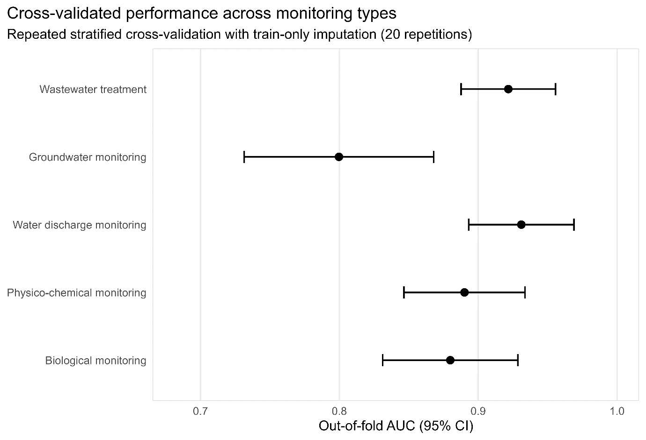
Figure 1. Cross-validated predictive performance of five Random Forest models representing distinct water-monitoring components.

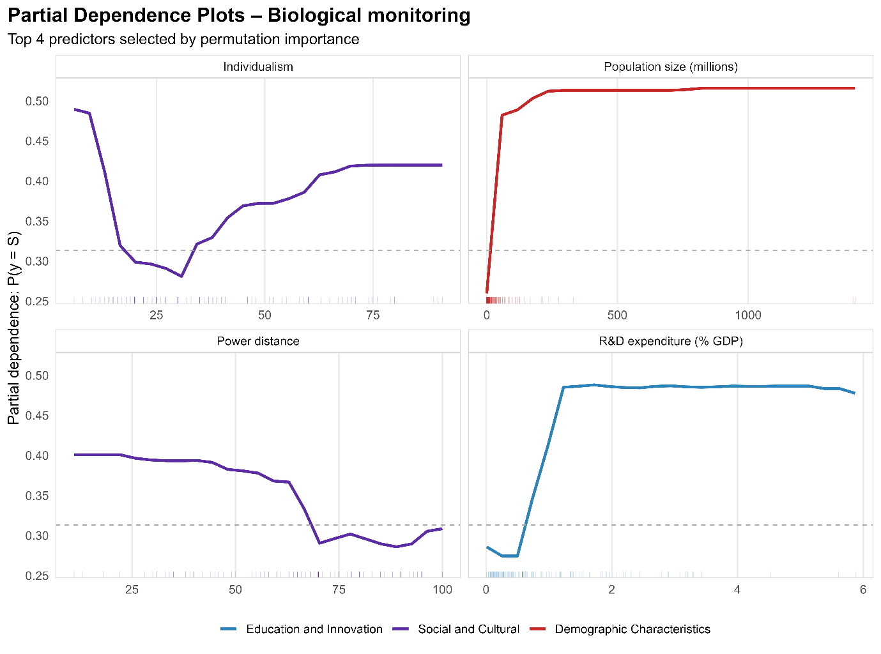
Figure 2. Partial dependence plots for the Biological monitoring Random Forest model.

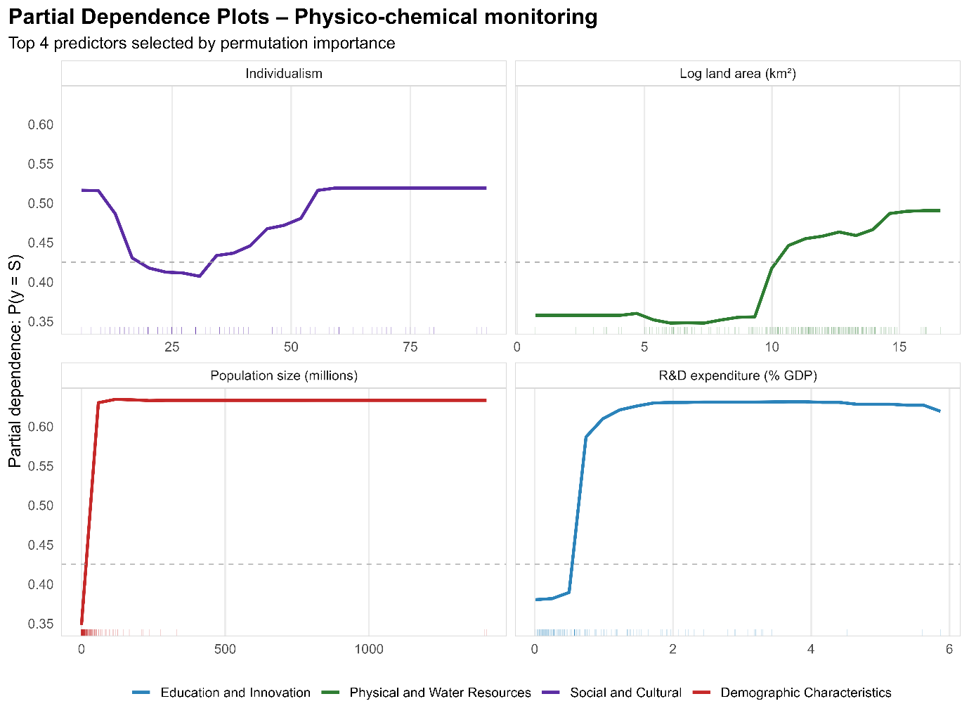
Figure 3. Partial dependence plots for the Physico-chemical monitoring Random Forest model.

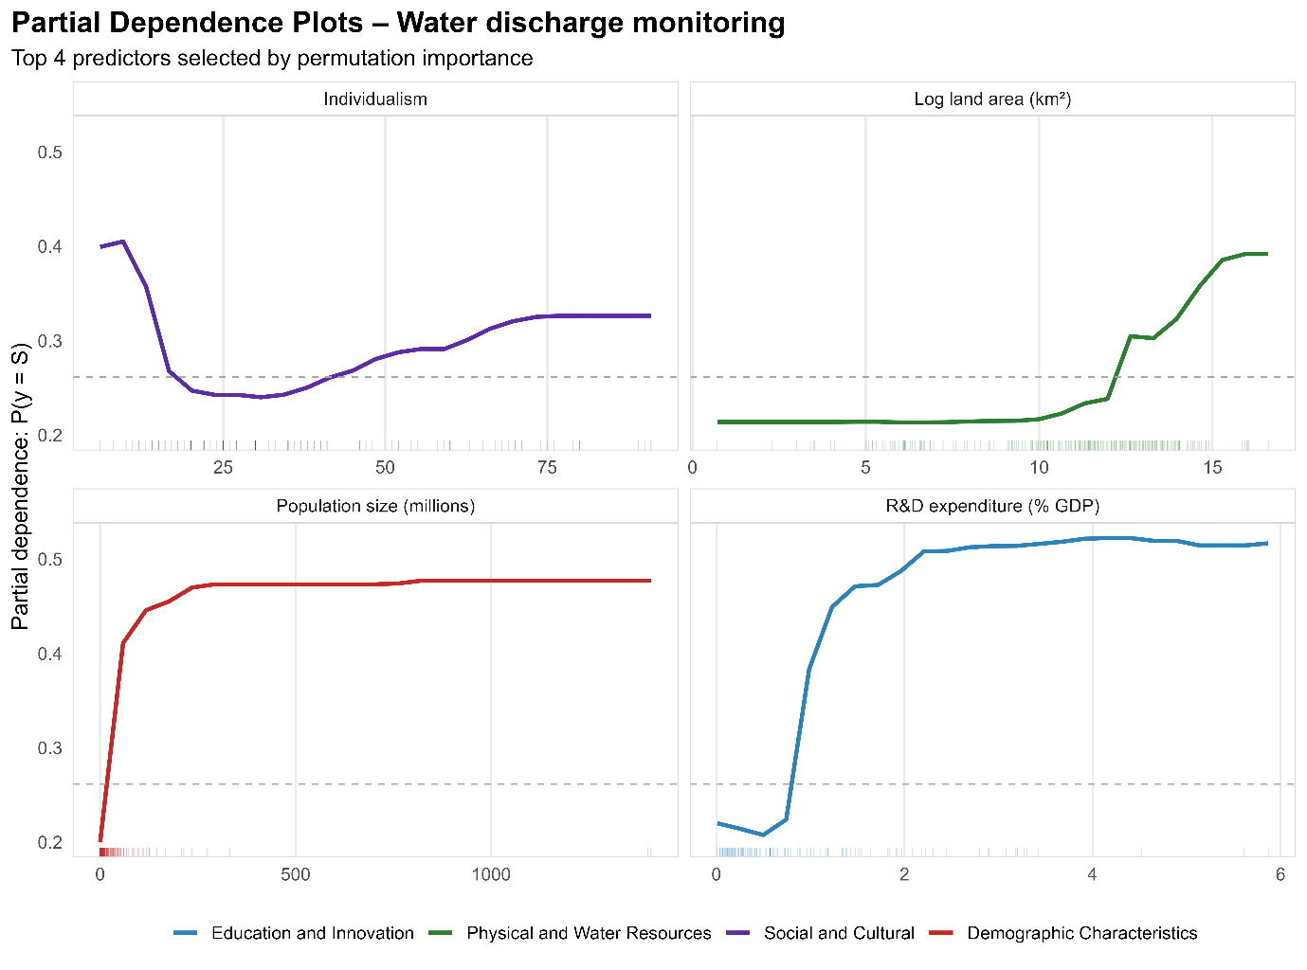
Figure 4. Partial dependence plots for the Water discharge monitoring Random Forest model.

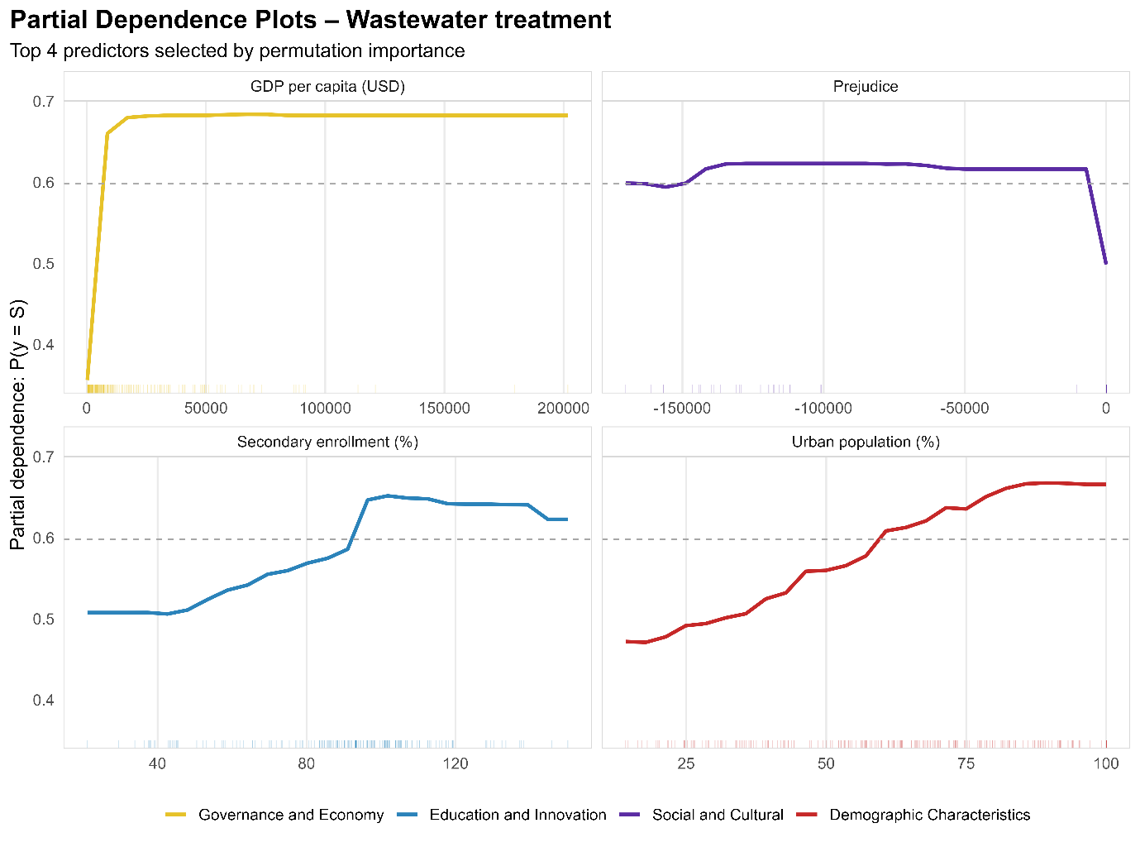
Figure 5. Partial dependence plots for the Wastewater treatment monitoring Random Forest model.

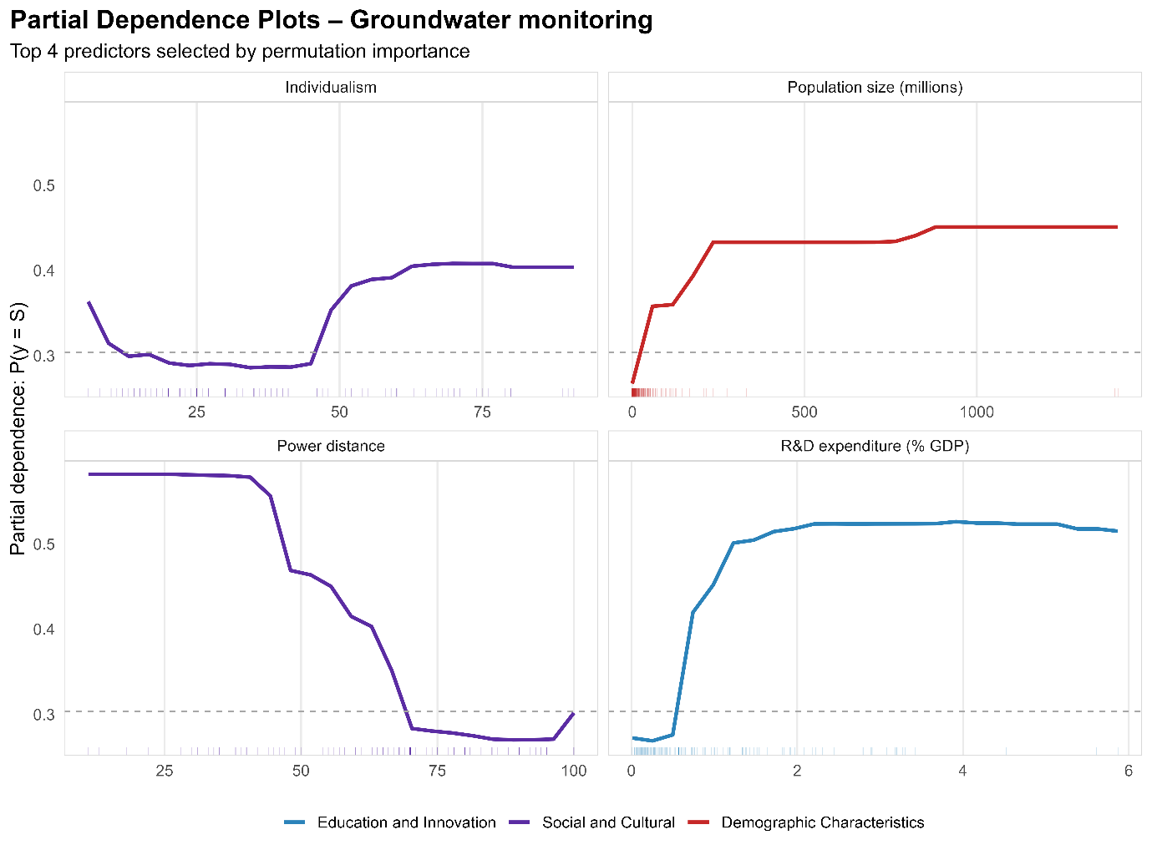
Figure 6. Partial dependence plots for the Groundwater monitoring Random Forest model.

