Beyond Reversal: Maternal Social Support Reshapes the Offspring Brain Transcriptome to Buffer Prenatal Stress in Mice
Monserrat Rodríguez González^{1,#}, Paula Thomas^{1,#}, Lucía Janicki¹, Erika Georgieff¹, Sergio Nemirowski², Verónica I. Cantarelli³, Marina F. Ponzio³, Mariela Chertoff¹, Bruno G. Berardino¹, and Eduardo T. Cánepa^{1,*}

¹Laboratorio de Neuroepigenética y Adversidades Tempranas, Departamento de Química Biológica, Facultad de Ciencias Exactas y Naturales, Universidad de Buenos Aires, and Instituto de Química Biológica de Ciencias Exactas y Naturales (IQUIBICEN), CONICET, Ciudad Autónoma de Buenos Aires, Argentina.
²Departamento de Química Biológica, Facultad de Ciencias Exactas y Naturales, Universidad de Buenos Aires, and Instituto de Química Biológica de Ciencias Exactas y Naturales (IQUIBICEN), CONICET, Ciudad Autónoma de Buenos Aires, Argentina.
³Instituto de Fisiología Humana “Dr. Oscar Orías”, Facultad de Ciencias Médicas and Instituto de Investigaciones en Ciencias de la Salud (INICSA-CONICET), Universidad Nacional de Córdoba, Santa Rosa 1085, X5000ESU Córdoba, Argentina

#These authors contributed equally to this work.

*Corresponding author at: Intendente Güiraldes 2160, Ciudad Universitaria, Pabellón 2, Lab QB75, C1428EGA Ciudad Autónoma de Buenos Aires, Argentina.
E-mail address: ecanepa@qb.fcen.uba.ar

METHODS
The following procedures, referenced in the main Methods, are described here in full.

Ethical Considerations
A control group without social support (CT) was not included in the present study. This decision was based on prior experiments conducted in our laboratory, in which no significant differences were detected between CT (control without support) and CTA (control with support) groups across multiple developmental and behavioral endpoints. These observations indicated that the presence of a familiar conspecific under non-stress conditions does not measurably influence the outcomes assessed in this study, supporting the use of CTA as an appropriate control condition.
Importantly, the primary aim of the present work was to evaluate whether support buffers the effects of prenatal stress, rather than to assess the impact of social housing per se under baseline conditions. Within this framework, the inclusion of a CT group would not directly contribute to testing the central hypothesis, while substantially increasing the number of animals required. Therefore, and in accordance with the principles of the 3Rs (Replacement, Reduction, and Refinement), particularly the principle of reduction, the experimental design was optimized to include only the groups necessary to address the specific research question. This approach is consistent with current recommendations for ethical and efficient use of animals in experimental research.

Behavioral testing
Behavioral testing was performed in dams and support females using a battery of standardized behavioral paradigms administered in the following order: elevated plus maze (EPM), novel object recognition (NOR), social interaction (SI), and forced swim test (FST), with a 4-day interval between consecutive tests to minimize potential carryover effects.
All behavioral experiments were conducted during the light phase of the light–dark cycle under controlled illumination conditions specific to each task. Animals were allowed to acclimate to the testing room prior to each session. All sessions were video-recorded and analyzed using ANY-maze™ Video Tracking Software (Stoelting). Behavioral scoring and data analysis were performed by an observer blind to the experimental treatment.

Elevated plus maze (EPM)
Testing was performed placing the mouse in the closed arm of the maze facing the center and allowing it to explore the apparatus for 5 min. Lights were set at 100 lx for the duration of the test.

Novel object recognition (NOR)
The novel object recognition (NOR) test was conducted in a square arena (45 × 45 × 45 cm) under 10 lux illumination. During the habituation phase, mice were individually placed in the empty arena and allowed to freely explore for 5 min; this phase was also used to assess basal locomotor activity. During the training phase, mice were returned to the arena for 10 min, during which two identical objects were placed equidistant from the arena walls along one of the diagonals. The recognition phase was performed 4 h after training, during which one familiar object was replaced with a novel object and mice were allowed to explore for 5 min. To assess memory reconsolidation, a reconsolidation phase was conducted 24 h after training, in which the familiar object remained in the arena while the previously novel object was replaced by a different novel object. Mice were allowed to explore for an additional 5 min.
To control for potential side bias, half of the mice were exposed to the novel object positioned on the right side of the arena and the remaining half to the left side. To control for differences in object salience, object identity was counterbalanced across animals. Object exploration time was quantified, and a discrimination index was calculated as (T_novel − T_familiar) / (T_novel + T_familiar).

Social interaction (SI)
The social interaction test was conducted using a three-chamber apparatus consisting of a rectangular black polystyrene cage (15 × 41 × 25 cm) partially divided into three equal compartments along the 41 cm axis. Two transparent acrylic cylinders (diameter: 7 cm; height: 15 cm), containing evenly distributed 1 cm diameter holes to allow olfactory and visual exploration, were placed in each of the two outer chambers. During the habituation phase, mice were allowed to freely explore the apparatus and the empty cylinders for 5 min. During the social phase, an unfamiliar same-sex, 3-week-old mouse was placed inside one of the cylinders, while an empty film container was placed inside the opposite cylinder, and mice were allowed to explore for 8 min. During the social novelty phase, the object was replaced by a novel unfamiliar mouse of the same age and sex, and mice were allowed to explore for an additional 8 min.
Social interaction and social novelty were quantified using a discrimination index. For sociability, the discrimination index was calculated as (T_social − T_object) / (T_social + T_object), where T_social corresponds to the time spent exploring the cylinder containing the conspecific and T_object corresponds to the time spent exploring the cylinder containing the object. For social novelty, the discrimination index was calculated as (T_novel − T_familiar) / (T_novel + T_familiar), where T_novel corresponds to the time spent exploring the cylinder containing the novel conspecific and T_familiar corresponds to the time spent exploring the cylinder containing the familiar conspecific.

Forced swim test (FST)
The forced swim test (FST) was performed by placing mice individually in a transparent cylindrical container filled with water for a total duration of 6 min. Behavioral activity was recorded throughout the session, and the time spent immobile, struggling, and swimming was quantified. Immobility was defined as the absence of active escape-directed behaviors, with mice making only the minimal movements necessary to keep their head above water. Struggling was defined as vigorous movements of the forelimbs directed against the walls of the cylinder, whereas swimming was defined as active horizontal movements throughout the container.

Corticosterone Determinations in Feces
An in-house enzyme immunoassay (EIA) with polyclonal antibody (anti- Corticosterone CJM006, CJ Munro, UC Davis, CA, USA), corticosterone standard and the corresponding horserad¬ish peroxidase conjugate was used. Cross-reactivities reported for CORT antibody values are: corticosterone (100%), desoxy¬corticosterone (14.25%), progesterone (2.65%), tetrahy-drocorticosterone (0.90%), testosterone (0.64%), cortisol (0.23%), prednisolone (0.07%), 11-deoxycortisol (0.03%), prednisone (< 0.01%), cortisone (< 0.01%) and estradiol 17β (< 0.01%). The assay sensitivity for corticosterone was 0.078 ng/ml, with intra-assay and inter-assay coefficients of variation under 12% and 10%, respectively.

Assessment of Affiliative and Prosocial Interactions Between Dams and Support Females
Affiliative and prosocial behaviors were assessed in pairs of adult female mice consisting of a future dam and a support female. Females within each pair were unrelated. This interaction was defined as the basal interaction and was evaluated for 8 consecutive days prior to mating of the future dam. Following mating and exposure to unpredictable stress, the same pair composed of the pregnant female and the support female was reunited at GD13, and their interaction was reassessed until delivery. This phase was defined as the post-stress interaction. In both the basal and post-stress interaction phases, behavioral observations were conducted twice daily, at 08:00 and 16:00 h, for 1 h per session. Interactions were scored every 3 min using an instantaneous sampling method. Behaviors were classified as active affiliative behaviors (including allogrooming, following, and sniffing), passive interactions (defined as physical contact without overt behavioral activity), or non-contact events. All interaction sessions were video-recorded, and behavioral scoring was performed offline by an observer blind to the experimental group assignment (CTA or ESA).

Maternal Bedding Preference Test
To assess maternal odor-based preference, pups were separated from their biological mother and placed in a clean holding cage 1 h prior to behavioral testing. The test was conducted in pups at PD14-PD15 in a square arena (45 x 45 x 45 cm) under 20 lux illumination. Along one side of the arena, a 10 cm-wide strip of bedding collected from the home cage of the pup's mother was placed, while an equivalent strip of bedding from the home cage of an unfamiliar dam was placed along the opposite side. The test pup was placed in the center of the arena and allowed to freely explore for 6 min. Maternal preference was quantified using a discrimination index, calculated as (T_maternal - T_non-maternal) / (T_maternal + T_non-maternal), where T_maternal corresponds to the time spent exploring the area containing the bedding from the biological mother and T_non-maternal corresponds to the time spent exploring the area containing bedding from an unfamiliar dam.

Four-hole board test
The four-hole board test was used to assess long-term spatial memory in offspring of both sexes. The test was conducted in a square arena (45 x 45 x 45 cm) equipped with a removable floor platform containing four circular holes (2 cm in diameter) located at each corner of the platform. During each session, mice were placed in the center of the platform and allowed to freely explore the apparatus for 6 min. The test was performed on two consecutive days, with the second session conducted 24 h after the first. The total number of nose pokes into the holes during the first session was used as an index of exploratory behavior, whereas long-term spatial memory was assessed as the decrease in nose pokes during the second session relative to the first session.

RNA sequencing, and differential expression analysis
Paired-end, demultiplexed and adapter-trimmed FASTQ files were received from Novogene Co. (USA). Read quality was evaluated using FastQC and MultiQC 13 and potential contaminants were assessed with FastQ Screen14. Reads were mapped to the GRCm39 reference genome available from Ensembl15 with HISAT216 and gene-level counts were obtained with the featureCounts tool from the Rsubread package17 ; within the R environment using the annotation file available from Ensembl (version 112). Low-count genes were filtered using the filterByExpr function from the edgeR package with default settings.
Differential expression (DE) analysis was carried out with DESeq2. Interactions between the factors sex and experimental groups were evaluated with likelihood ratio tests. The ashr shrinkage method was employed to improve log2 fold change (LFC) estimates, especially for genes with low counts.
After mapping to the reference genome, a median of 90,896,488 reads per library (range, 79,887,188–102,954,754; 150 bases) was obtained, excluding one low-quality sample. The median insert size was 282 bases (IQR, 240–322), with 94.11% of reads mapped with high quality (MAPQ = 60), 5.58% with low quality (MAPQ = 1), and 0.32% mapped ambiguously (MAPQ = 0). Gene-specific assignments by featureCounts yielded a median of 34,563,997 reads per library (range, 29,017,502–39,682,515).
Because the behavioral phenotypes of interest did not differ between male and female offspring, subsequent transcriptomic analyses were designed to identify treatment-related molecular mechanisms shared across sexes. Male and female samples were therefore analyzed jointly, while sex was incorporated as a covariate in the statistical model to account for baseline sex-dependent differences in gene expression.

Enrichment
Overrepresentation analysis (ORA) was performed using ToppGene Suite (ToppFun module) against the custom background of 14,863 expressed protein-coding genes (baseMean > 10), independently for the Gene Ontology Biological Process, Molecular Function, and Cellular Component domains. Gene symbol recognition was validated prior to analysis (see above); the platform recognized 325 of the 343 query genes and 14,352 of the 14,863 background genes, and these post-mapping values were used as N_query and N_background, respectively, in all downstream calculations, including fold enrichment (defined as the ratio of the observed to the expected proportion of annotated genes). To reduce redundancy arising from the hierarchical and overlapping structure of the GO ontology, enriched terms (FDR < 0.1) from each domain were processed with REVIGO using default semantic similarity settings (SimRel, C = 0.7), retaining only non-redundant representative terms. During this step, a small number of GO terms were found to be obsolete or to have been superseded by alternative identifiers in the current ontology release; in these cases, the term identifier and name reported by REVIGO were retained together with the original enrichment statistics (gene counts and p-value) of the corresponding legacy term, after confirming numerical correspondence between the two. Terms with fewer than 5 annotated genes in the reference background were additionally excluded from the final term set, as fold enrichment estimates based on such small denominators are highly unstable and not biologically informative.
Pre-ranked gene set enrichment analysis (GSEA) was performed using the fgsea package in R21 to the gene sets derived from the GO Biological Process ontology from https://www.gsea-msigdb.org/ (v2026.1 for mouse).

Analysis of differentially expressed lncRNAs
To evaluate the role of differentially expressed lncRNAs, particularly predicted loci (Gm and Rik nomenclature), that lack functional annotation in standard databases, we applied a guilt-by-association strategy based on co-expression. Using normalized read counts from all samples, log2-transformed and centered by sex to remove the sex-associated component of variance identified by principal component analysis, we computed Spearman rank correlations between each of the 76 lncRNAs and all expressed protein-coding genes (baseMean > 10; n = 14,863). Correlation p-values were adjusted for multiple testing (Benjamini-Hochberg) within each lncRNA. To account for the limited sample size, the analysis was repeated after excluding one outlier sample identified by PCA, and only lncRNA-gene pairs remaining significant (FDR < 0.05) in both analyses were retained as robust associations.

Table S1. Sequence of primers used in gene expression determinations by RT-qPCR

Gene | Sequence primer forward | Sequence primer reverse
Oxtr | GGACGTCAATGCGCCCAAAG | CGAGTTCGTGGAAGAGATGGC
Cd38 | CGCTGCCTCATCTACACTCA | AGTGGGGCGTAGTCTTCTCT
Drd2 | TTTGCAGACCACCACCAACTA | CTGAATTTCCACTCACCCACCA
Comt | CGAGGGGATGAGAGAGTCCT | CCAGCAACAGGAGACCCAAT
Slc6a4 | GGTTCTCCTGGCGTTTGCTA | CGTCATGCAGTTCACCACAC
Npas4 | CCAGGGCGACAGTATCTACG | CGGAAAAGGCGATCAGCATC
Hprt | CAGGCCAGACTTTGTTGGAT | TTGCGCTCATCTTAGGCTTT
Pgk1 | TGGGCAAGGATGTTCTGTTC | TGCAGTCCCAAAAGCATCAT

Results
Body weight, litter size, and offspring survival
First, we asked whether exposure to unpredictable stress and subsequent social support modify maternal body weight across gestation, lactation, and post-weaning periods. In parallel, body weight of the female social-support partners was monitored before and after the support period. Both analyses were conducted using repeated-measures mixed-effects models.
Regarding maternal body weight changes during gestation, significant interaction between treatment and time was observed, indicating that the effect of time on body weight depended on experimental group (F(10,113) = 3.994, p = 0.0001) (Fig. S1A). Because group differences were not constant across gestational days, post hoc multiple comparisons were performed to identify specific group effects. Tukey’s tests revealed that dams from ES group exhibited significantly lower body weight compared to CTA dams across the gestational period (p = 0.0205). Day-by-day analyses showed differences in gestational days GD9 (p = 0.0602), GD12 (p = 0.0236), and GD15 (p = 0.0108), exclusively between ES and CTA dams (Fig. S1A). Although prenatal stress in the absence of social support affected maternal body weight during gestation, this difference did not persist after delivery (F(2,25) = 0.3121, p = 0.7347) and was not associated with differences in offspring body weight at PD0 (F(2,48) = 0.2222, p = 0.8016) (Figs S1B and C).
During the lactation period, no significant differences in maternal body weight were detected among the three groups (F(12,150) = 1.033, p = 0.4220) (Fig. S1D). Similarly, at the onset of behavioral testing, dams from all groups displayed comparable body weights (F(2,24) = 0.2893, p = 0.7513) (Fig. S1E). For the female social-support partners, body weight was analyzed using a repeated-measures mixed-effects model with treatment and time as factors. No significant effect of treatment was observed indicating that the type of dam with which support females were paired did not influence their body weight, whereas a significant effect of time was detected, consistent with the expected increase over the approximately four-week interval (Fig. S1F). No treatment × time interaction was found.
Finally, no significant differences were observed in litter size (F(2,25) = 0.1172, p = 0.8899) or offspring survival at weaning (X²(2) = 0.1478, p = 0.9288) (Figs S1G and H). Moreover, offspring body weight at weaning did not differ significantly among groups in either females (H(2) = 2.002, p = 0.3675) or males (F(2, 48) = 1.343, p = 0.2708) (Figs S1I and J).
Overall, aside from the transient reduction in maternal body weight observed during gestation in stressed dams, prenatal stress exposure did not produce detectable effects on maternal weight across subsequent stages, nor did it impact litter size, offspring survival, or offspring body weight at weaning in either sex, indicating that reproductive outcomes and postnatal maternal condition were largely preserved across experimental groups.

Prenatal stress and social support modulate stress-coping strategies without inducing overt affective alterations
Next, we examined whether prenatal stress exposure and subsequent social support affected the emotional state of both mothers and support females. To this end, after the lactation period, animals were subjected to the Elevated Plus Maze (EPM) to assess anxiety-like behaviors and to the Forced Swim Test (FST) to evaluate depression-like behaviors, in both mothers and support females.
In the EPM, no significant differences were observed among mothers from the three experimental groups in relative distance traveled (F(2,24) = 0.2089, p = 0.8129) or time spent (H(2) = 0.0036, p = 0.9982) in the open arms (Figs S3A and B). Likewise, no differences were detected in the latency to enter the open arms (H(2) = 0.8179, p = 0.664), the number of open-arm entries (H(2) = 0.2405, p = 0.8867), or the total number of head-dipping behaviors (F(2,24) = 0.5011, p = 0.6120) (Figs S3C-E) indicating that stress exposure was not sufficient to induce the emergence of anxiety-like behaviors.
FST results showed no significant differences among mothers from the three groups in immobility time (H(2) = 2.225, p = 0.3288) or in latency to first immobility (H(2) = 2.181, p = 0.3361) (Figs 4S A and B). However, a trend was observed in struggle behavior (F(2,25) = 3.340, p = 0.0518) and in the latency to cease struggling (F(2,25) = 3.071, p = 0.0642) (Figs S4C and D). This trend was driven by a reduced duration of struggle and a shorter latency to abandon this behavior in mothers from the ESA group compared to mothers from the CTA and ES groups. These findings suggest that exposure to prenatal stress combined with subsequent social support promotes a more regulated coping strategy, characterized by a faster acceptance of the inescapability of the situation. In contrast, mothers from the ES group, which did not receive social support, exhibited values comparable to those of the CTA group, which was not exposed to prior stress.
Regarding the performance of support females in the EPM, no significant differences were found in distance traveled (U = 24, p = 0.1667) and time spent (t (16) = 1.628, p = 0.1230) in the open arms, or latency to enter the open arms (U = 28, p = 0.3045) (Figs S3F-H). A trend was observed in support females from the ESA group, which displayed a higher number of open-arm entries (t(16) = 1.858, p = 0.0816) and an increased number of head-dipping behaviors compared to support females from the CTA group (U = 20, p = 0.0775) (Figs S3I and J).
These results suggest a tendency toward more exploratory behavior in support females that accompanied previously stressed mothers, consistent with a prosocial modulation of perceived stress that facilitates exploratory and coping behaviors in novel environments.
Finally, no significant differences were detected in FST performance among support females in immobility time (t(17) = 0.6601, p = 0.5180), struggle behavior (t(17) = 0.7987, p = 0.4355), or in the latencies to enter (t(17) = 0.1621, p = 0.8731) or abandon (t(17) = 0.7763, p = 0.4483) each of these behavioral states, respectively (Figs 4SE-H).

Recognition Memory Assessment
The next step was to evaluate the effects of prenatal stress and social support on recognition memory by assessing the performance of male and female mice in the Novel Object Recognition (NOR) test.
No differences were observed among mothers from the three experimental groups in recognition memory assessed 4 h after the training session (F(2,25) = 1.133, p = 0.338), nor in total exploration time (F(2,25) = 1.827, p = 0.1818) (Figs. S5A and B). Twenty-four hours after training, the same animals were tested to assess memory reconsolidation by measuring exploration of the familiar object versus a different, novel object. Consistent with the earlier assessment, no significant differences were found among groups in the discrimination index (H(2) = 2.819, p = 0.2443) or in total exploration time (F(2,25) = 0.0167, p = 0.9835) (Figs S5C and D). During the training phase, mice did not show a preference for either of the two identical objects, and no lateralization bias was detected in object exploration. During the habituation session, no differences were observed in the total distance traveled by mothers across groups (H(2) = 1.320, p = 0.5168) (Figs S5E), indicating preserved locomotor activity and ruling out potential motor impairments as a confounding factor.
Similarly, support females did not exhibit significant group differences in recognition memory (t(16) = 0.1167, p = 0.9086) or memory reconsolidation (U = 33, p = 0.5579), nor in total exploration times in either testing condition (Figs. S5 F-I). During training, they did not show object preference or lateralization bias when exposed to two identical objects. Locomotor activity did not differ between groups (U = 37, p = 0.8286) (Fig. S5J).
Taken together, these results indicate that neither recognition memory nor its reconsolidation was affected by prenatal stress in mothers, nor by the subsequent social support period in support females.

Sociability and Social Novelty Recognition in the Three-Chamber Test
Finally, the three-chamber test was used to assess sociability in the three groups of mothers and the two groups of support females. This paradigm evaluated both social preference, by comparing exploration of a conspecific versus an inanimate object, and social novelty recognition, by presenting a familiar and a novel conspecific simultaneously.
No significant differences were found among the maternal groups in either social preference (F(2,25) = 2.515, p = 0.1011) or social novelty recognition (F(2,25) = 0.0663, p = 0.9360) (Figs. S6A and B). Likewise, no significant differences were detected between the two support-female groups in social preference (t(17) = 0.9396, p = 0.3606) or social novelty recognition (t(17) = 0.8932, p = 0.3842) (Figs. S6C and D).
Notably, mice from all groups failed to exhibit a significant preference for the social stimulus over the inanimate object, as well as for the novel conspecific over the familiar one. Thus, neither sociability nor social novelty preference was evident under the present experimental conditions.

Legends Supplementary figures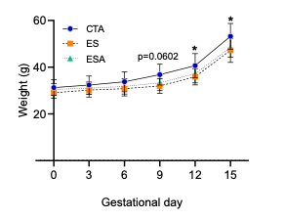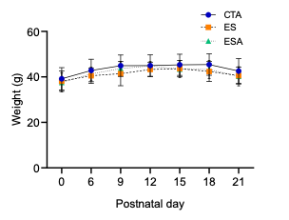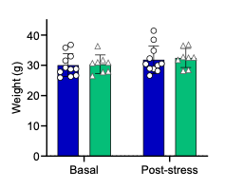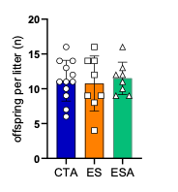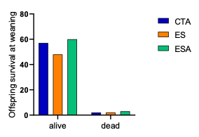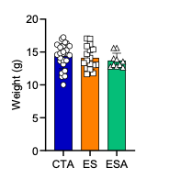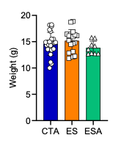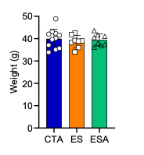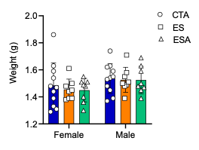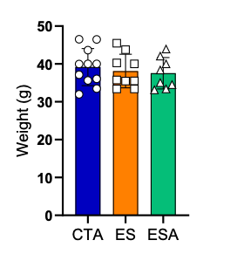
A
B
D
E
F
G
H
I
J
C
Figure S1. Maternal body weight, offspring growth, and reproductive outcomes. Maternal body weight was monitored throughout pregnancy (A), after parturition (B), during lactation (D), and at the end of the maternal behavior assessment (E). Offspring body weight at birth (PD0) is shown in panel C. Body weight of support partners before and after the social support period is shown in panel F. Reproductive outcomes included the number of pups born per dam (G) and the number of pups surviving until weaning (H). Body weight of female (I) and male (J) offspring at weaning (PD21) is also shown. For offspring body weight measurements at birth and weaning, one female and one male pup per litter were evaluated. Data are presented as mean ± SD (n = 8–11 animals per group).
Statistical analysis was performed using a mixed-effects model followed by Tukey’s multiple-comparisons test for panels A, D, and F; one-way ANOVA followed by Tukey’s multiple-comparisons test for panels B and J; one-way ANOVA followed by Dunnett’s multiple-comparisons test for panels E and G; two-way ANOVA followed by Tukey’s multiple-comparisons test for panel C; the Kruskal–Wallis test followed by Dunn’s multiple-comparisons test for panel I; and the chi-square test for panel H. Significant differences are indicated in the figure.
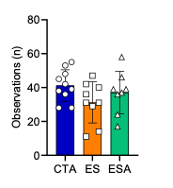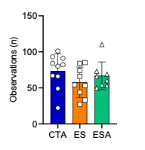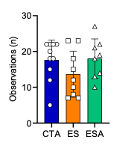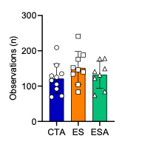
Passive nursing
Nest building
Passive contact
Eat + drink
A
C
B
D
Figure S2. Maternal behavior. Maternal behavior was assessed during the lactation period in CTA, ES, and ESA dams. The frequency of passive nursing (A), nest building (B), passive contact with pups (C), and eating and drinking activities (D) was quantified. Data are presented as mean ± SD (n = 8–12 per group). Statistical analysis was performed using the Kruskal–Wallis test followed by Dunn’s post hoc test for panels A and B, and one-way ANOVA followed by Tukey’s post hoc test for panels C and D. Significant differences are indicated in the figure.
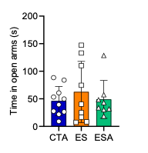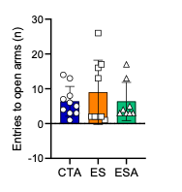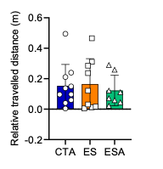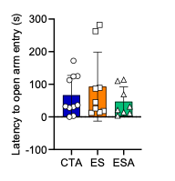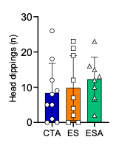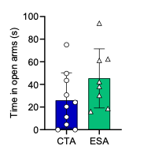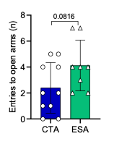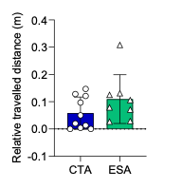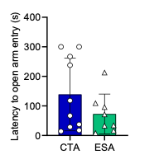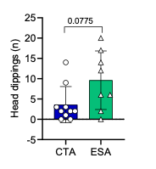
Dams
Support partners
A
B
C
D
E
F
G
H
I
J
Figure S3. Anxiety-like behavior in dams and support partners assessed in the Elevated Plus Maze (EPM). Anxiety-like behavior was evaluated in dams (A–E) and support partners (F–J) using the Elevated Plus Maze. Relative distance traveled (A, F), time spent in the open arms (B, G), latency to enter the open arms (C, H), frequency of entries into the open arms (D, I), and total number of head-dipping events (E, J) are shown. Data are presented as mean ± SD (n = 8–12 per group). For dams (A–E), statistical analysis was performed using the Kruskal–Wallis test followed by Dunn’s post hoc test for panels B-D, and one-way ANOVA followed by Tukey’s post hoc test for panels A and E. For support partners (F–J), statistical analysis was performed using an unpaired Student’s t-test for panels G and I and the Mann–Whitney test for panels F, H, and J. Statistical trends are indicated by adjusted p values.
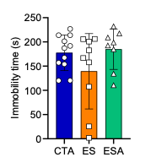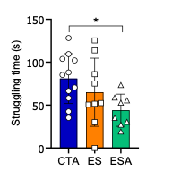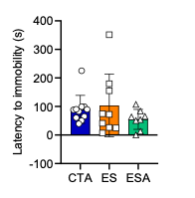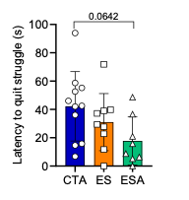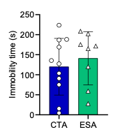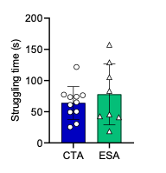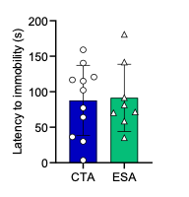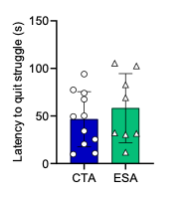
Dams
Support partners
A
B
C
D
E
F
G
H
Figure S4. Depression-like behavior in dams and support partners assessed in the Forced Swim Test (FST). Depression-like behavior was evaluated in dams (A–D) and support partners (E–H) using the Forced Swim Test. Immobility time (A, E), latency to become immobile (B, F), struggling time (C, G), and latency to cease struggling (D, H) are shown. Data are presented as mean ± SD (n = 8–12 per group). For dams (A–D), statistical analysis was performed using the Kruskal–Wallis test followed by Dunn’s post hoc test for panels A and C, and one-way ANOVA followed by Tukey’s post hoc test for panels B and D. For support partners (E–H), statistical analysis was performed using an unpaired Student’s t-test. Significant differences are indicated in the figure. Statistical trends are indicated by adjusted p values.
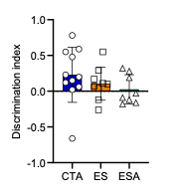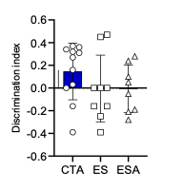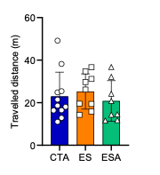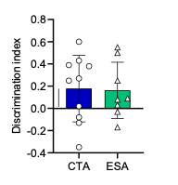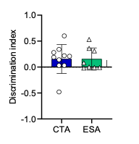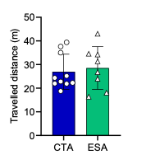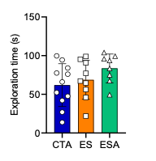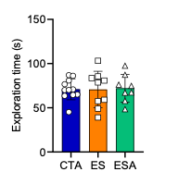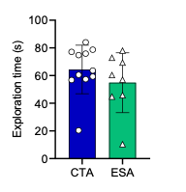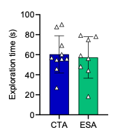
Dams
Support patterns
A
B
C
F
J
D
G
H
I
E
Figure S5. Recognition memory and reconsolidation in dams and support partners assessed in the Novel Object Recognition (NOR) test. Recognition memory and memory reconsolidation were evaluated in dams (A–E) and support partners (F–J) using the Novel Object Recognition test. The discrimination index for short-term recognition memory is shown in panels A and F, whereas the discrimination index for memory reconsolidation is shown in panels C and H. Exploration times during the short-term recognition memory test are shown in panels B and G, and exploration times during the reconsolidation test are shown in panels D and I. Distance traveled during the habituation phase is shown in panels E and J. Data are presented as mean ± SD (n = 8–12 per group).
For dams (A–E), statistical analysis was performed using one-way ANOVA followed by Tukey’s post hoc test for panel A, B and D and the Kruskal–Wallis test followed by Dunn’s post hoc test for panels C and E. For support partners (F–J), statistical analysis was performed using an unpaired Student’s t-test for panel F and I and the Mann–Whitney test for panels G, H and J.

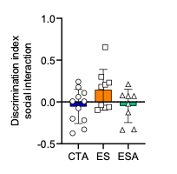
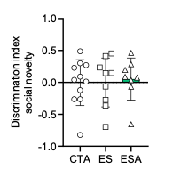
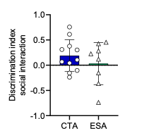
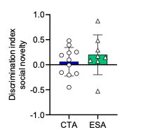
Dams
Support partners
A
B
C
D

Figure S6. Social interaction and social novelty in dams and support partners. Social behavior was evaluated in dams (A, B) and support partners (C, D) using the Social Interaction test. The discrimination index for social interaction is shown in panels A and C, whereas the discrimination index for social novelty is shown in panels B and D. Data are presented as mean ± SD (n = 8–12 per group). For dams (A, B), statistical analysis was performed using one-way ANOVA followed by Tukey’s post hoc test. For support partners (C, D), statistical analysis was performed using the unpaired Student’s t-test.
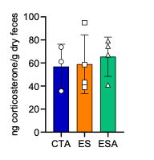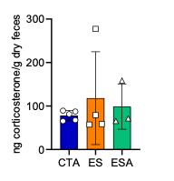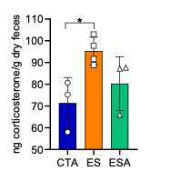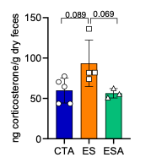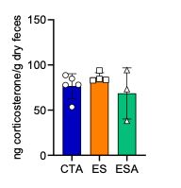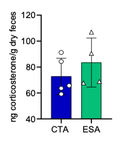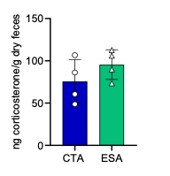
Dams
Support partners
A
B
C
D
E
F
G
Figure S7. Fecal corticosterone concentrations in dams and support partners throughout the experimental protocol. Fecal corticosterone concentrations (ng/g feces) were measured in dams at the pre-stress time point (A), after completion of the prenatal stress protocol (B), on the day of parturition (C), on postnatal day 7 (PD7), corresponding to the end of maternal behavior assessment (D), and at weaning (E). In support partners, fecal corticosterone concentrations were determined before the onset of the social support period (F) and at the end of the support period (G). Data are presented as mean ± SD (n = 3–5 females per group). Statistical analysis for dams (A–E) was performed using the Kruskal–Wallis test followed by Dunn’s post hoc test. Statistical analysis for support partners (F–G) was performed using the Mann–Whitney test. Significant differences are indicated in the figure.
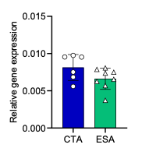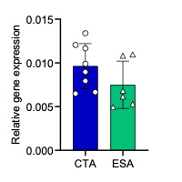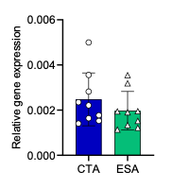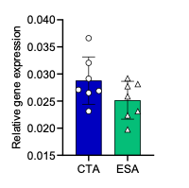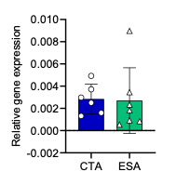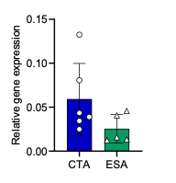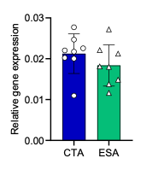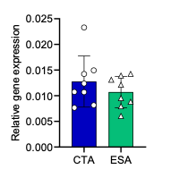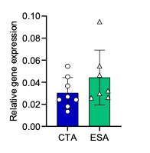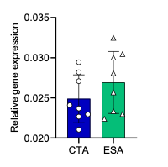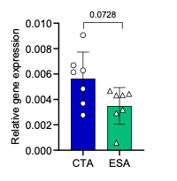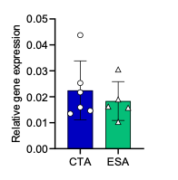
PFC
Amygdala
Oxtr
Cd38
Drd2
Comt
Slc6a4
Npas4
A
B
C
D
E
F
G
H
I
J
K
L
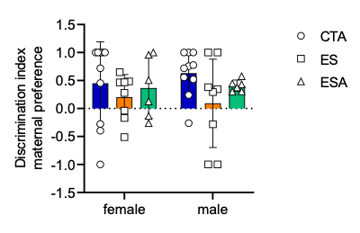
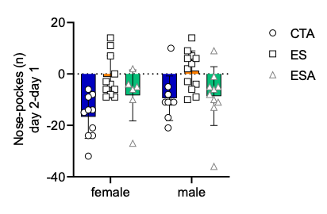
Figure S8. Expression of prosociality-related genes in the prefrontal cortex (PFC) and amygdala of support partners. Relative expression levels of the genes indicated in the figure were determined by RT-qPCR in the PFC (A–F) and amygdala (G–L) of support partners. Data are presented as mean ± SD (n = 8–12 per group). Statistical analysis was performed using an unpaired Student’s t-test for panels A–D, F, G, H, J, and L, and the Mann–Whitney test for panels E, I, and K. Statistical trends are indicated by adjusted p values.
A
B

Figure S9. Sex-specific analysis of maternal preference and spatial memory in offspring. (A) Discrimination index for maternal bedding preference in female and male offspring from the CTA, ES, and ESA groups. The discrimination index was calculated based on the preference for maternal bedding relative to bedding from an unfamiliar dam. Data are presented as mean ± SD (n = 6–10 animals per sex and group). Statistical analysis was performed using a two-way ANOVA with group and sex as factors, followed by Sidak’s multiple-comparisons test. (B) Difference in the number of nose-pokes between day 2 and day 1 in the 4-hole test in female and male offspring from the CTA, ES, and ESA groups. Data are presented as mean ± SD (n = 12 animals per sex and group). Statistical analysis was performed using a two-way ANOVA with group and sex as factors, followed by Tukey’s multiple-comparisons test.
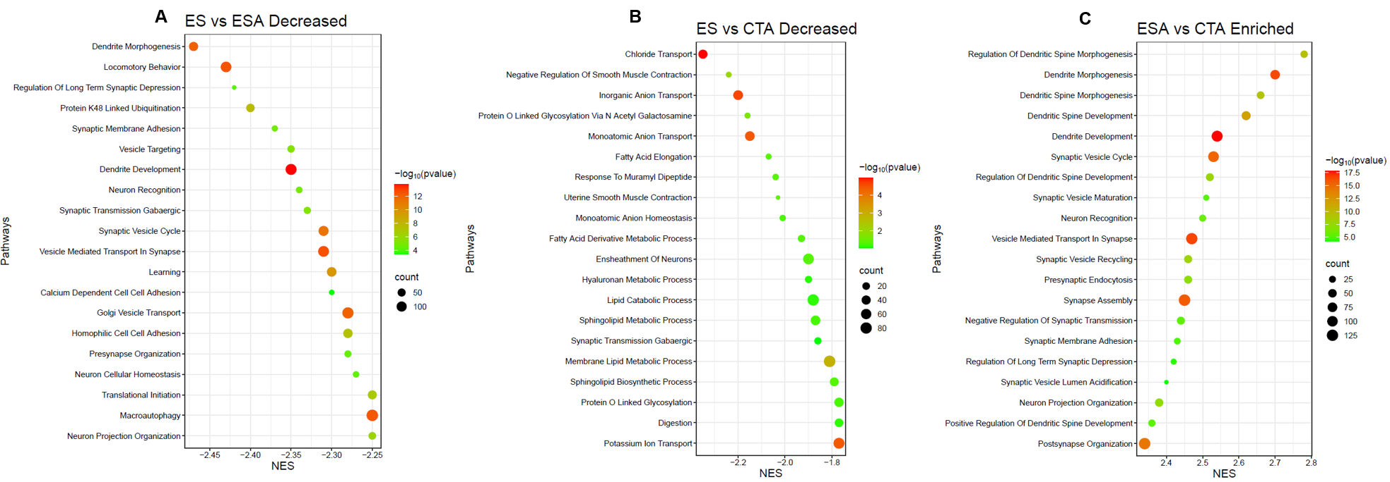
Figure S10. Gene set enrichment analysis (GSEA) of differentially expressed genes across experimental contrasts. Gene set enrichment analysis (GSEA) was performed to identify biological pathways associated with transcriptional changes across the three experimental contrasts. The 20 most significantly enriched gene sets meeting the predefined selection criteria of |NES| > 2 and adjusted p < 0.05 are shown for each comparison. (A) ES versus CTA, showing significantly negatively enriched pathways; (B) ES versus ESA, showing significantly negatively enriched pathways; and (C) ESA versus CTA, showing significantly positively enriched pathways. Gene sets are ranked according to normalized enrichment score (NES).

