Analytical solution of Advection diffusion equation in two dimensions with deposition velocity and its application in three dimensions
Khaled S.M. Essa*, H. M. Taha and Ahmed M. Mosallem
Department of Mathematics and Theoretical Physics, Nuclear Research Centre (NRC), Egyptian Atomic Energy Authority (EAEA), Cairo, Egypt
* Corresponding author: mohamedksm56@yahoo.com; https://orcid.org/0000-0003-1477-5475
Abstract
In this work the advection diffusion equation is solved in two directions under the effect of the deposition velocity at the ground, where we suppose that the solution is as function in two parameters which depend on the horizontal and vertical dimensions taking the form of wind speed and the vertical eddy diffusivity from Hanna et al. (1982) in all stability conditions. Then we compare between the proposed and published data which measuring before in three dimensions of published data before.

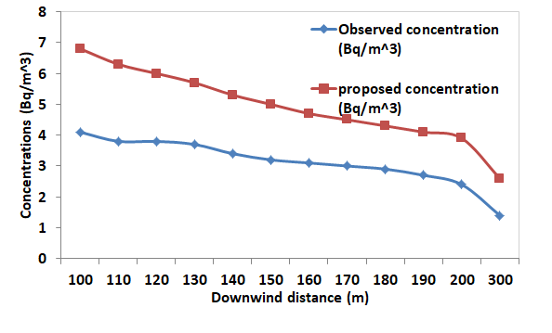
Fig. (1) Shows the variation of the proposed and observed concentrations via downwind distance in neutral stability.

