Table 1: Showing Percentage yield of Plant Extract
Plants | Root Powder used (g) | Solvent used (ml) | Extract obtained (g) | Percentage yield
Oroxylum indicum- EtOH (95%) | 100 | 1000 | 16.9 | 16.9 %
Oroxylum indicum- Hydro-EtOH (70%) | 100 | 1000 | 15.5 | 15.5 %
Oroxylum indicum- Aq. | 100 | 1000 | 13.5 | 13.5 %
Table 2: Preliminary phytochemical investigation of extracts
Phytochemical | Standard Test | Ethanolic | Hydro-EtOH | Aqueous
Alkaloids | Hager’s Test | +ve | +ve | +ve
Glycosides | Aq.NaOH test | +ve | +ve | +ve
Flavonoids | Alkaline Test | +ve | +ve | +ve
Tannins | Lead acetate Test | +ve | -ve | +ve
Steroids | Salkowski Test | +ve | +ve | -ve

Table 3: Total Phenol and flavonoid content of extract
Sample | Absorbance (Y) | C=X  (𝜇𝑔/𝑚l) | V  (mL) | M  (mg) | TPC
Total Phenol content
Gallic Acid | 2.486 | 387.1211298 | 0.5 | 1 | 193.5606
Extract | 1.345 | 201.1895709 | 0.5 | 1 | 100.5948
Total flavonoid content
Sample | Absorbance (Y) | C=X  (𝜇𝑔/𝑚l) | V  (mL) | M  (mg) | TFC
Quercetin | 0.527 | 83.07713199 | 1 | 1 | 83.07713199
Extract | 0.59 | 72.90630975 | 1 | 1 | 72.90630975

Table 4: 2D, 3D, structure & Smiles of selected ligands from Oroxylum Indicum
Code | Ligand Name | 2D | Pathway interaction | 2d structure | 3d structure
 | Flavanone,5,7-dihydroxy-6-methoxy- | COc1c(O)cc2c(c1O)C(=O)C[C@H](O2)c1ccccc1 | 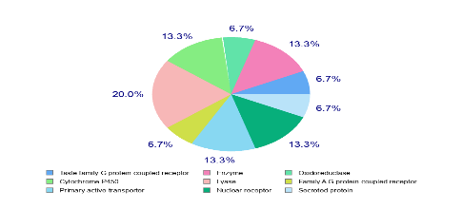 | 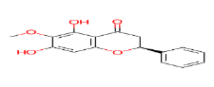 | 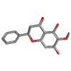
 | Scutellarin | OC(=O)[C@H]1O[C@@H](Oc2cc3oc(cc(=O)c3c(c2O)O)c2ccc(cc2)O)[C@@H]([C@H]([C@@H]1O)O)O | 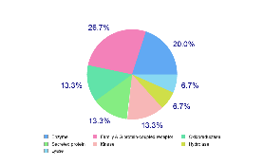 |  | 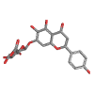
 | Oroxylin A | COc1c(O)cc2c(c1O)c(=O)cc(o2)c1ccccc1 | 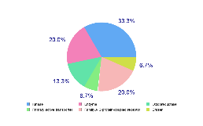 | 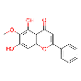 | 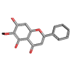
 | Nepetin | COc1c(O)cc2c(c1O)c(=O)cc(o2)c1ccc(c(c1)O)O | 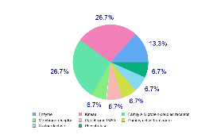 | 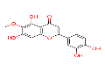 | 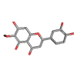
 | 6-Hydroxyluteolin | Oc1ccc(cc1O)c1cc(=O)c2c(o1)cc(c(c2O)O)O | 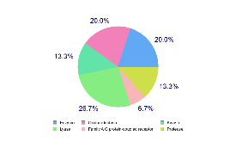 | 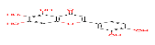 | 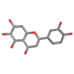
 | Chrysin | Oc1cc(O)c2c(c1)oc(cc2=O)c1ccccc1 | 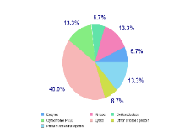 | 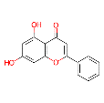 | 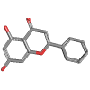
 | Baicalein | Oc1cc2oc(cc(=O)c2c(c1O)O)c1ccccc1 | 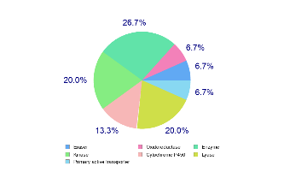 | 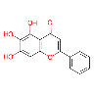  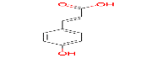 | 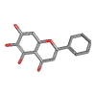
 | Dihydrobaicalein | O=C1CC(Oc2c1c(O)c(c(c2)O)O)c1ccccc1 | 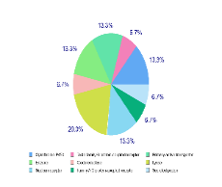 | 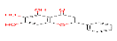 | 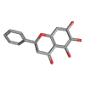
 | Scutellarein 7-rutinoside | OC1[C@@H](OC([C@H]([C@@H]1O)O)CO[C@@H]1OC(C)[C@@H]([C@@H](C1O)O)O)Oc1cc2oc(cc(=O)c2c(c1O)O)c1ccc(cc1)O | 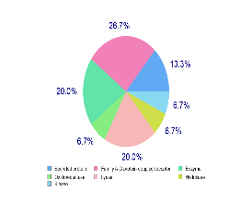 | 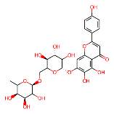 | 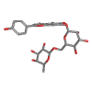
 | Apigenin 7,4'-dimethyl ether | COc1ccc(cc1)c1cc(=O)c2c(o1)cc(cc2O)OC | 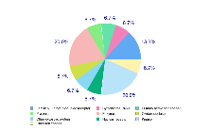 | 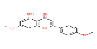 | 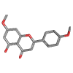
 | 4-Hydroxycinnamic acid | OC(=O)/C=C/c1ccc(cc1)O | 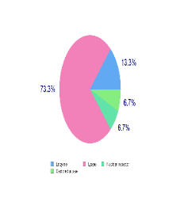 | 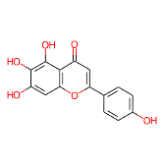 | 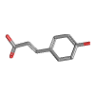
 | Scutellarein | Oc1ccc(cc1)c1cc(=O)c2c(o1)cc(c(c2O)O)O | 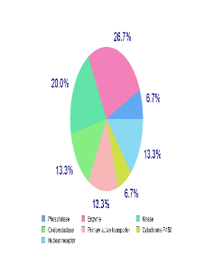 | 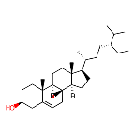 | 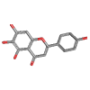
 | beta-Sitosterol | CC[C@@H](C(C)C)CC[C@H]([C@H]1CC[C@@H]2[C@]1(C)CC[C@H]1[C@H]2CC=C2[C@]1(C)CC[C@@H](C2)O)C | 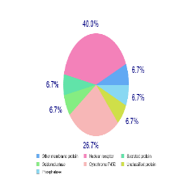 | 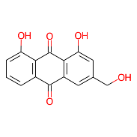 | 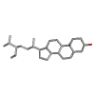
 | Aloe emodin | OCc1cc(O)c2c(c1)C(=O)c1c(C2=O)c(O)ccc1 |  | 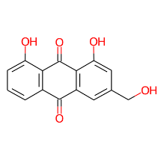 | 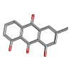
 | Baicalin | OC(=O)[C@H]1O[C@@H](Oc2cc3oc(cc(=O)c3c(c2O)O)c2ccccc2)[C@@H]([C@H]([C@@H]1O)O)O | 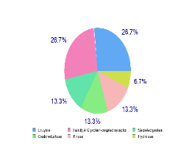 | 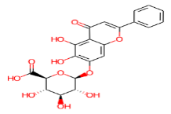 | 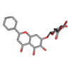
 | Anthraquinone | OC(=O)[C@H]1O[C@@H](Oc2cc3oc(cc(=O)c3c(c2O)O)c2ccc(cc2)O)[C@@H]([C@H]([C@@H]1O)O)O | 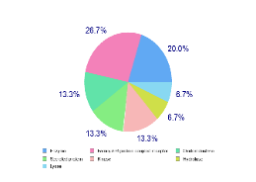 | 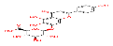 | 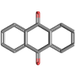
 | Oroxindin | COc1c(O[C@@H]2O[C@H](C(=O)O)[C@H]([C@@H]([C@H]2O)O)O)cc(c2c1oc(cc2=O)c1ccccc1)O | 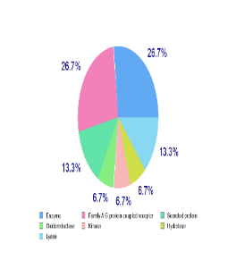 | 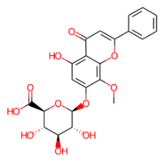 | 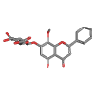
 | Hispidulin | COc1c(O)cc2c(c1O)c(=O)cc(o2)c1ccc(cc1)O | 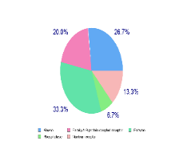 | 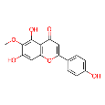 | 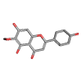
 | Ellagic acid | Oc1cc2c(=O)oc3c4c2c(c1O)oc(=O)c4cc(c3O)O | 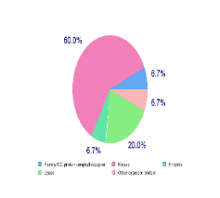 | 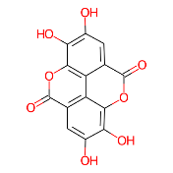 | 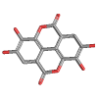
 | Dimethyl terephthalate | COC(=O)c1ccc(cc1)C(=O)OC | 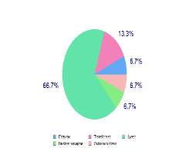 | 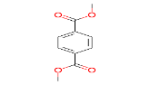 | 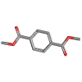
 | biochanin A | COc1ccc(cc1)c1coc2c(c1=O)c(O)cc(c2)O | 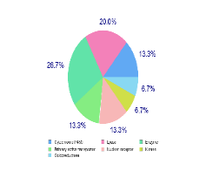 | 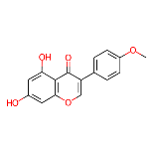 | 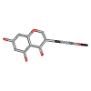
 | Myristic acid | CCCCCCCCCCCCCC(=O)O | 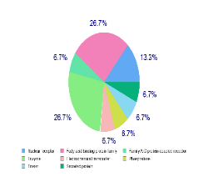 | 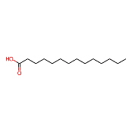 | 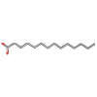
 | Lauric acid | CCCCCCCCCCCC(=O)O | 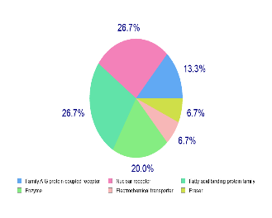 | 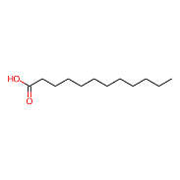 | 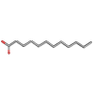
 | Octanoic acid | CCCCCCCC(=O)O | 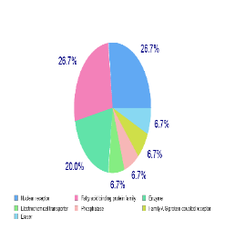 | 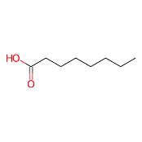 | 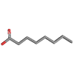
 | Stearic acid | CCCCCCCCCCCCCCCCCC(=O)O | 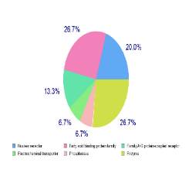 | 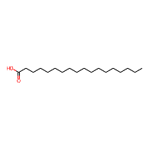 | 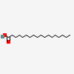
 | Baicalein 6-glucoside | OCC1O[C@@H](Oc2c(O)cc3c(c2O)c(=O)cc(o3)c2ccccc2)C([C@H]([C@@H]1O)O)O | 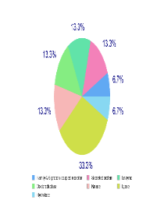 | 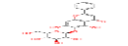 | 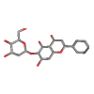
 | Palmitic acid | CCCCCCCCCCCCCCCC(=O)O | 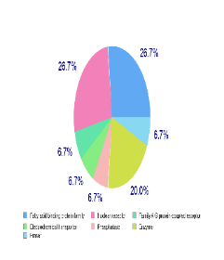 | 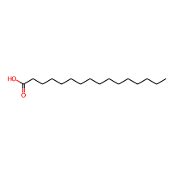 | 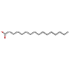
 | gamma-Tocopherol | C[C@H](CCC[C@@H](CCCC(C)C)C)CCC[C@]1(C)CCc2c(O1)c(C)c(c(c2)O)C | 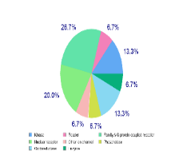 | 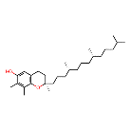 | 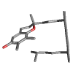
 | Palmitoleic acid | CCCCCC/C=CCCCCCCCC(=O)O | 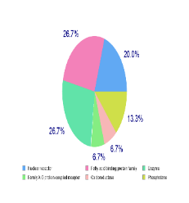 | 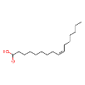 | 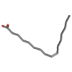
 | Oleic acid | CCCCCCCC/C=CCCCCCCCC(=O)O | 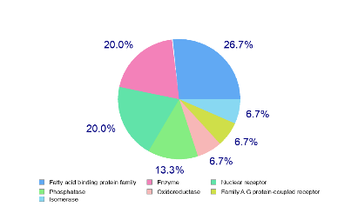 | 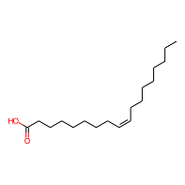 | 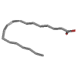
 | Linoleic acid | CCCCC/C=CC/C=CCCCCCCCC(=O)O | 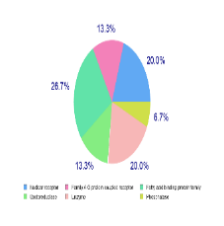 | 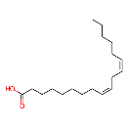 | 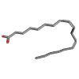
 | 5,7-Dihydroxy-2-phenyl-6-[3,4,5-trihydroxy-6-(hydroxymethyl)oxan-2-yl]oxychromen-4-one | OCC1OC(Oc2c(O)cc3c(c2O)c(=O)cc(o3)c2ccccc2)C(C(C1O)O)O | 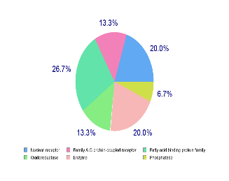 | 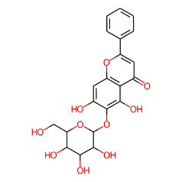 | 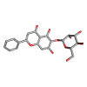
 | Prunetin | COc1cc(O)c2c(c1)occ(c2=O)c1ccc(cc1)O | 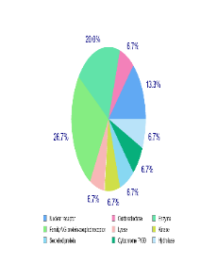 | 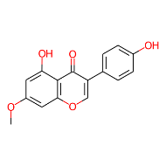 | 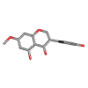

Table 5: The SwissADME evaluation profiles for several bioactive chemical structures.
Molecule Identifier | Code | Molecular Weight  gm/mol | Consensus log P o/w | GI Absorption | BBB Permeant | Skin Permeation log Kp (cm/s) | Lipinski Violations | drug-likeness and oral bioavailability profiles
Molecule 1 | OI 1. | 286.28 | 2.27 | High | Yes | -6.02 | 0 | 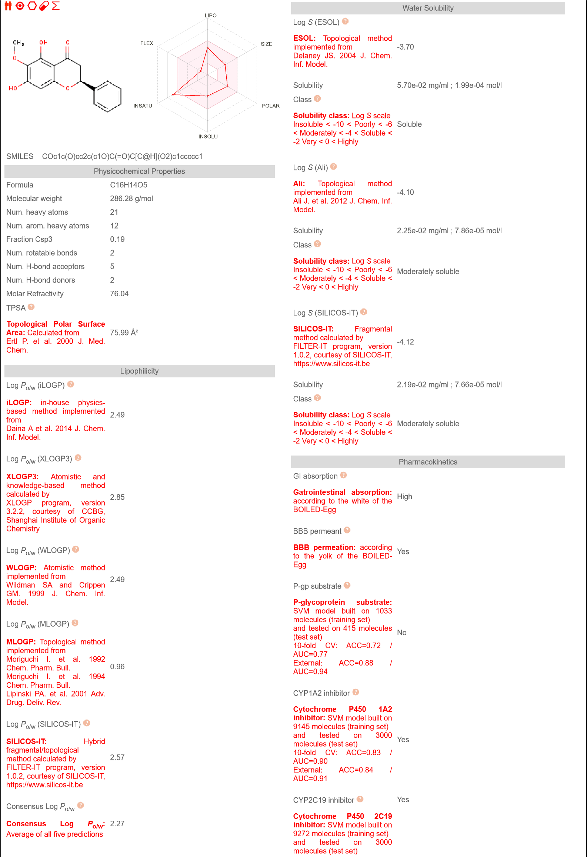
Molecule 2 | OI 2. | 462.36 | -0.22 | Low | No | -8.59 | 2 | 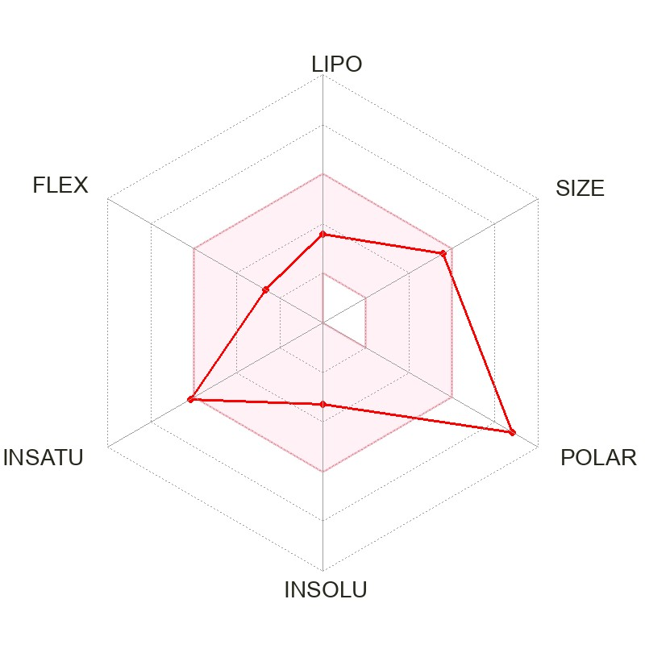
Molecule 3 | OI 3. | 284.26 | 2.56 | High | No | -5.56 | 0 | 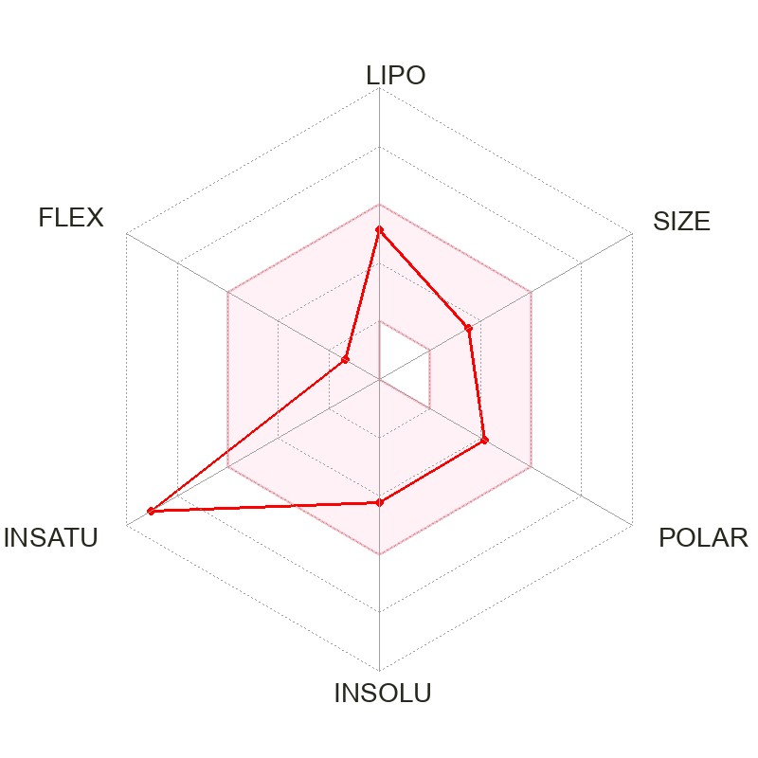
Molecule 4 | OI 4. | 316.26 | 1.74 | High | No | -6.45 | 0 | 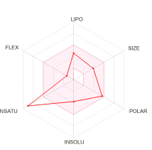
Molecule 5 | OI 5. | 302.24 | 1.42 | High | No | -6.60 | 0
Molecule 6 | OI 6. | 254.24 | 2.55 | High | Yes | -5.35 | 0 | 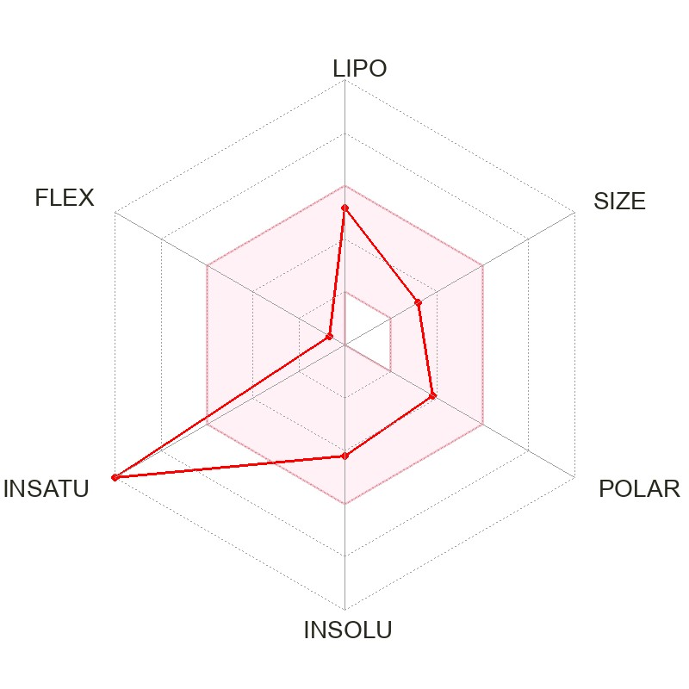
Molecule 7 | OI 7. | 270.24 | 2.24 | High | No | -5.70 | 0 | 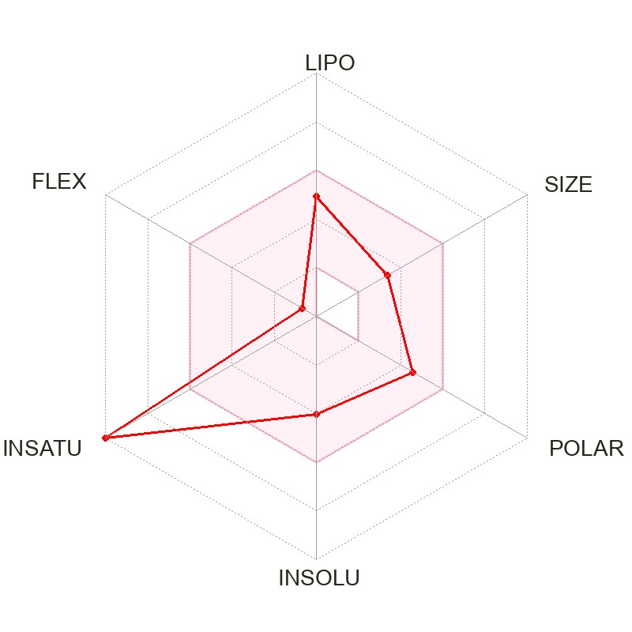
Molecule 8 | OI 8. | 272.25 | 1.94 | High | No | -6.17 | 0 | 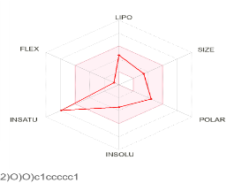
Molecule 9 | OI 9. | 594.52 | -1.02 | Low | No | -10.06 | 3 | 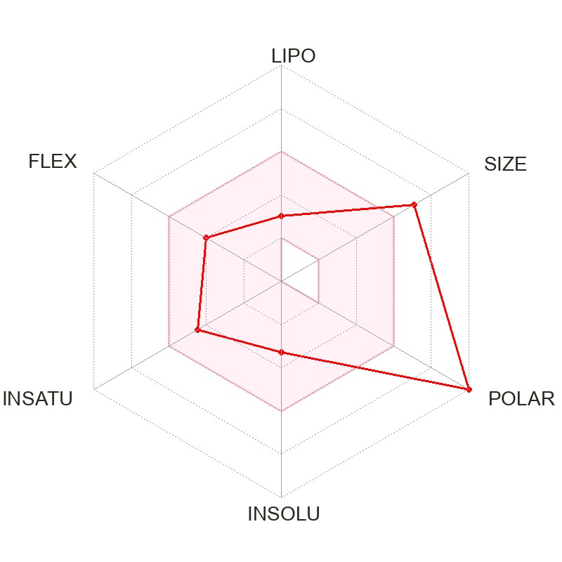
Molecule 10 | OI 10. | 298.29 | 2.79 | High | Yes | -5.51 | 0 | 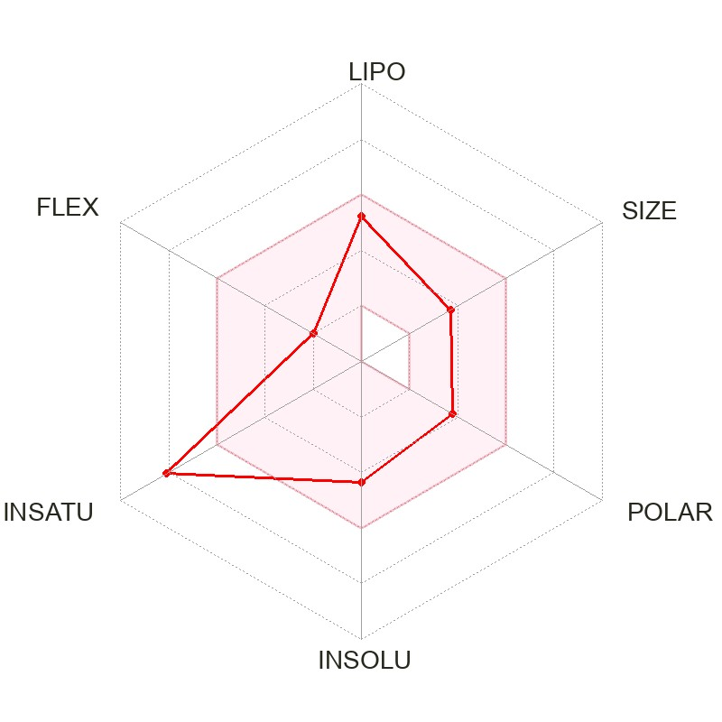
Molecule 11 | OI 11. | 164.16 | 1.26 | High | Yes | -6.26 | 0 | 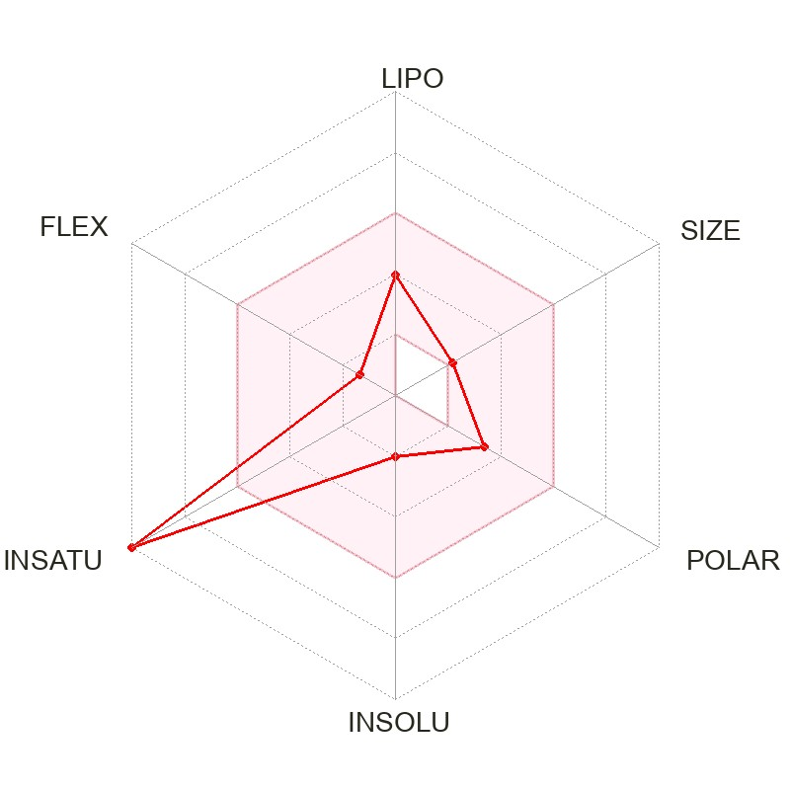
Molecule 12 | OI 12. | 286.24 | 1.81 | High | No | -6.16 | 0 | 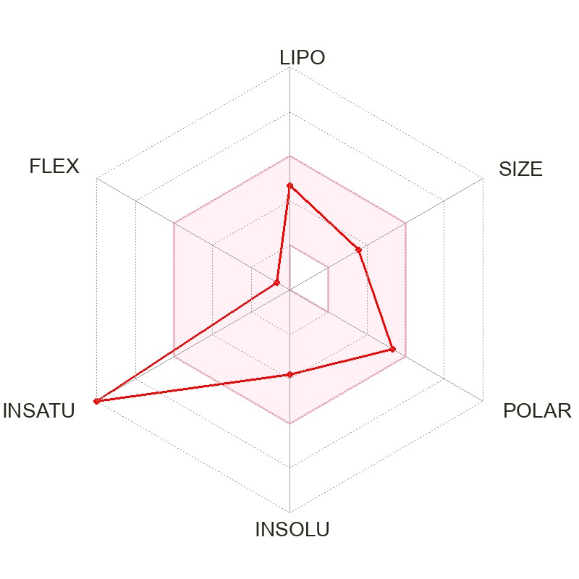
Molecule 13 | OI 13. | 414.71 | 7.24 | Low | No | -2.20 | 1 | 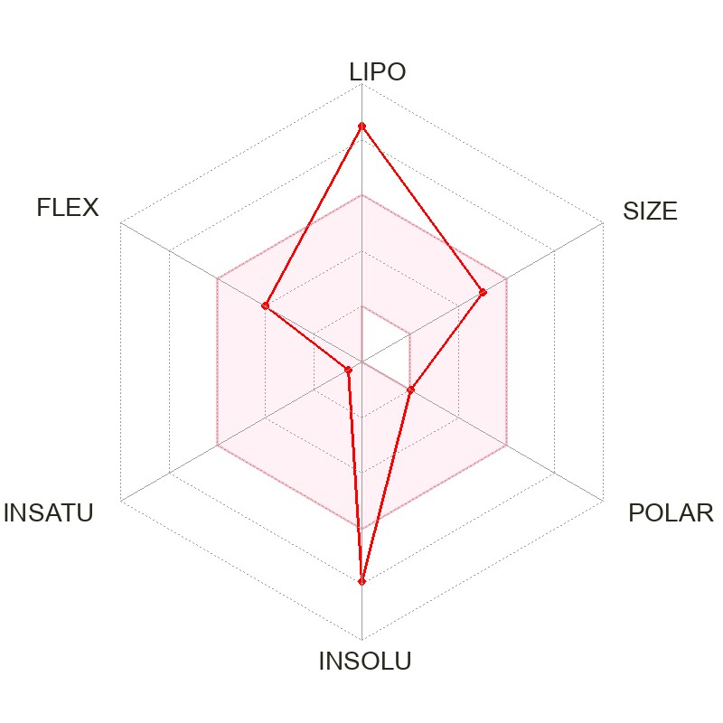
Molecule 14 | OI 14. | 270.24 | 1.50 | High | No | -6.66 | 0 | 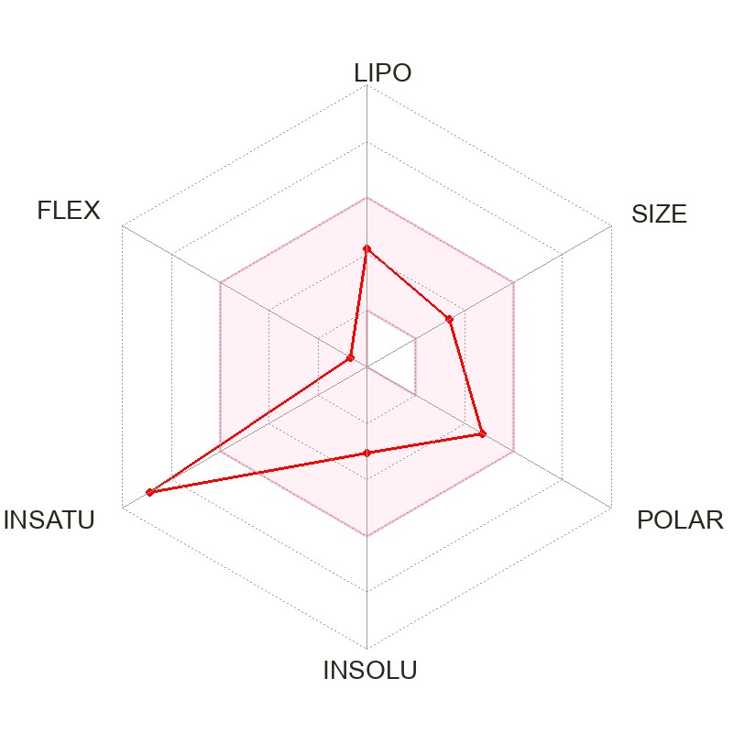
Molecule 15 | OI 15. | 446.36 | 0.25 | Low | No | -8.23 | 2 | 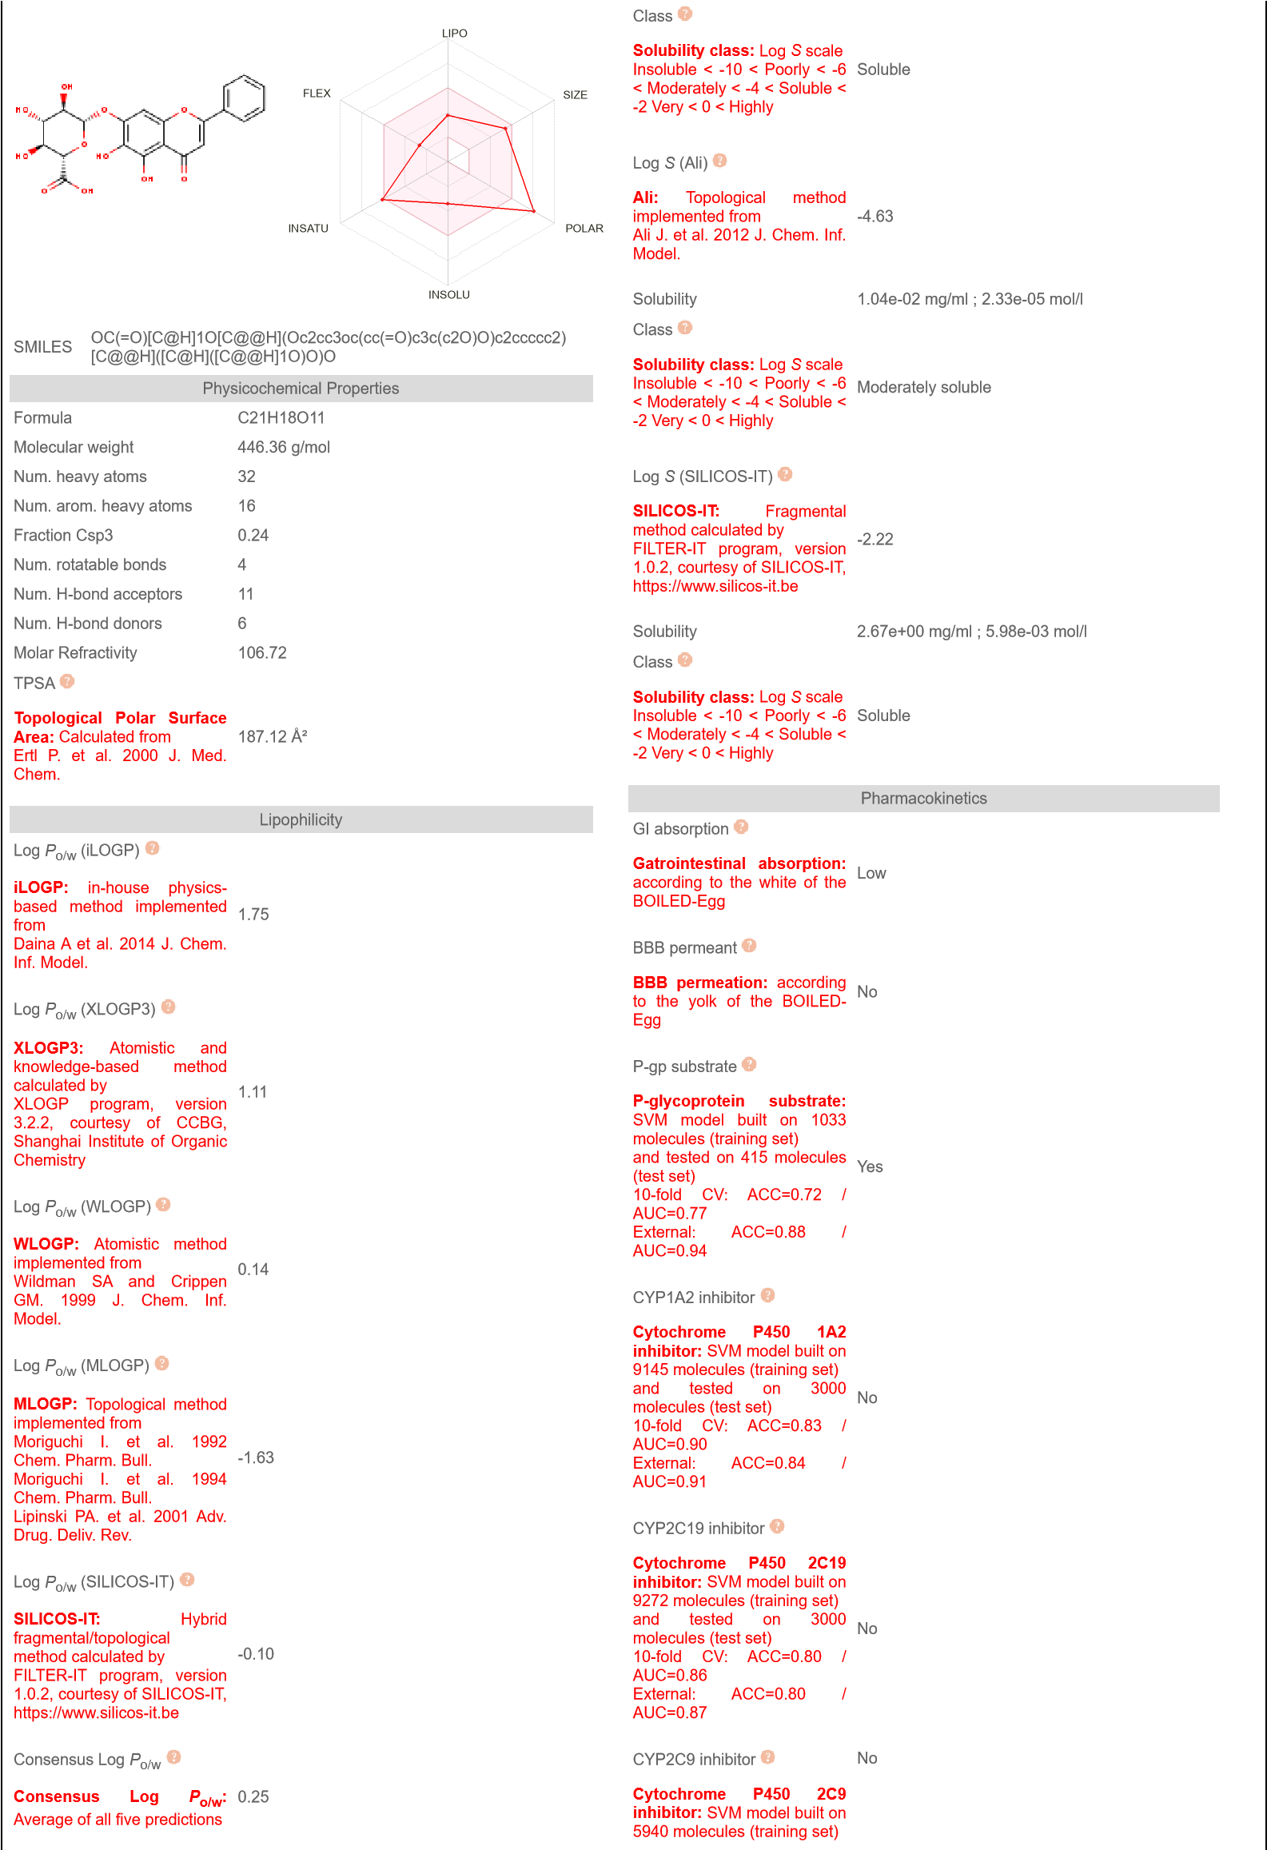
Molecule 16 | OI 16. | 462.36 | -0.22 | Low | No | -8.59 | 2
Molecule 17 | OI 17. | 460.39 | 0.49 | Low | No | -8.09 | 1 | 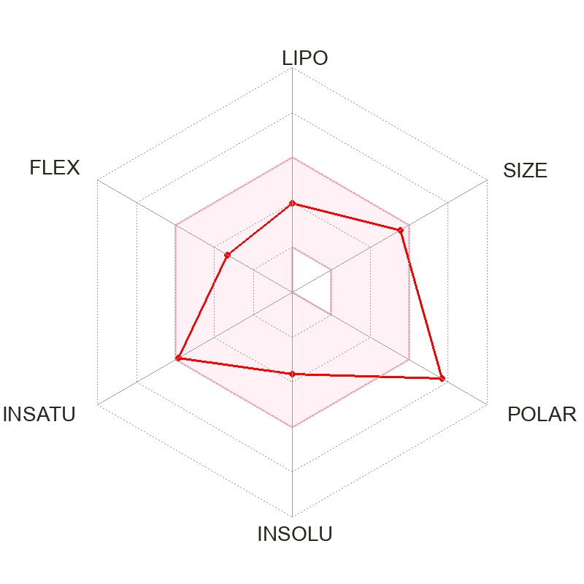
Molecule 18 | OI 18. | 300.26 | 2.12 | High | No | -6.01 | 0 | 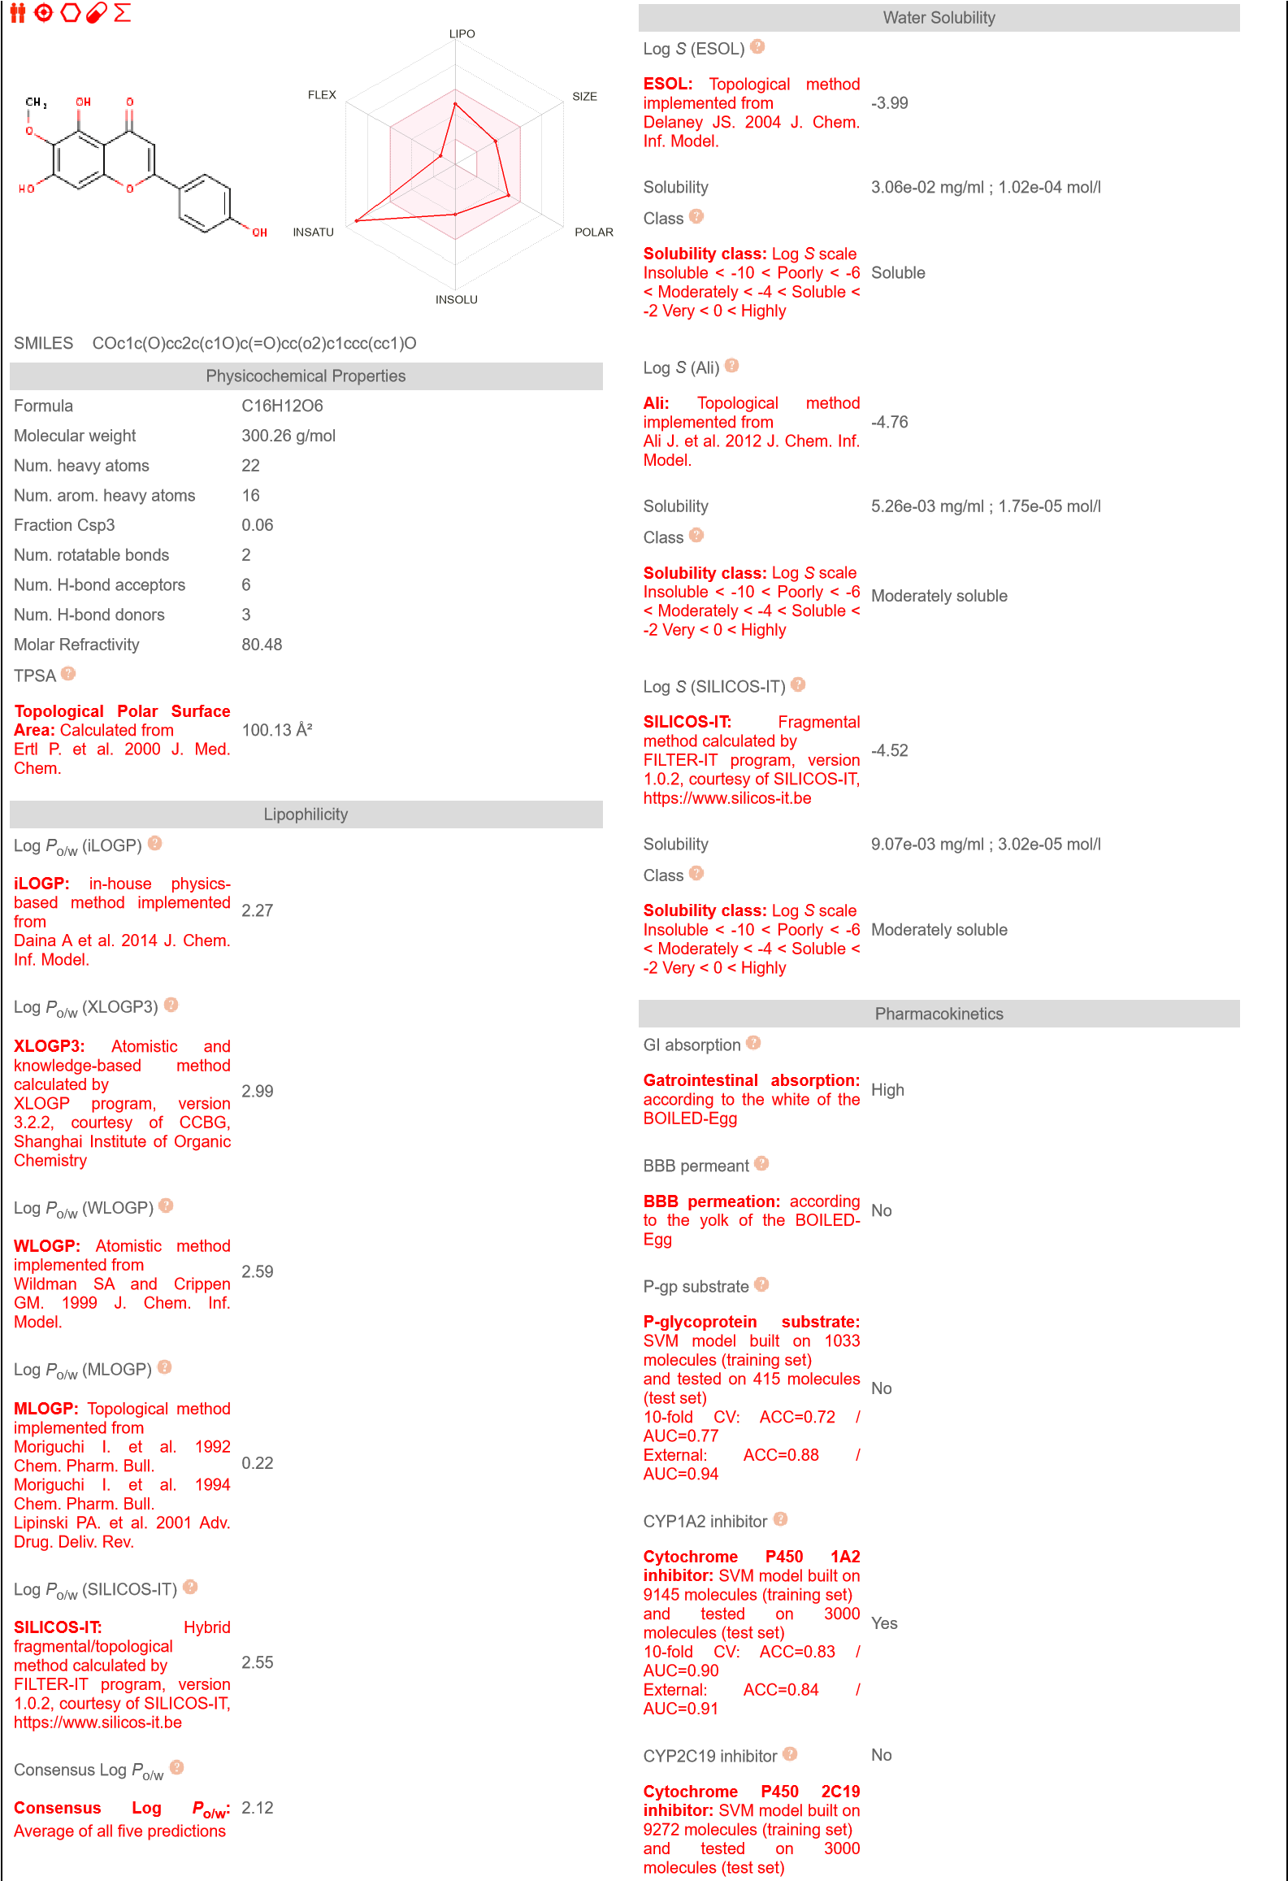
Molecule 19 | OI 19. | 302.19 | 1.00 | High | No | -7.36 | 0 | 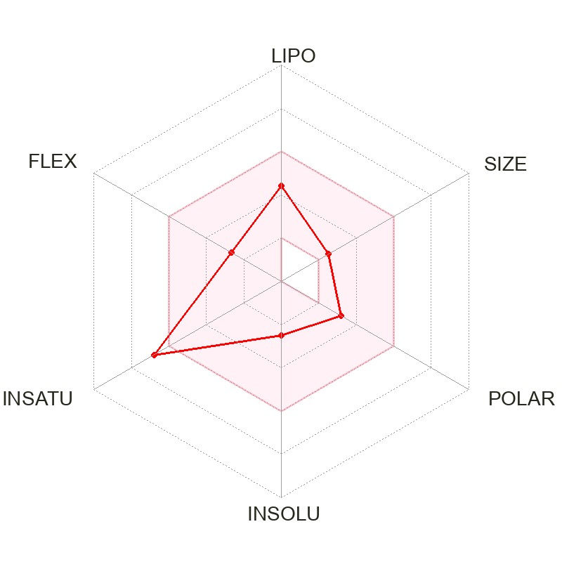
Molecule 20 | OI 20. | 194.18 | 1.85 | High | Yes | -5.89 | 0 | 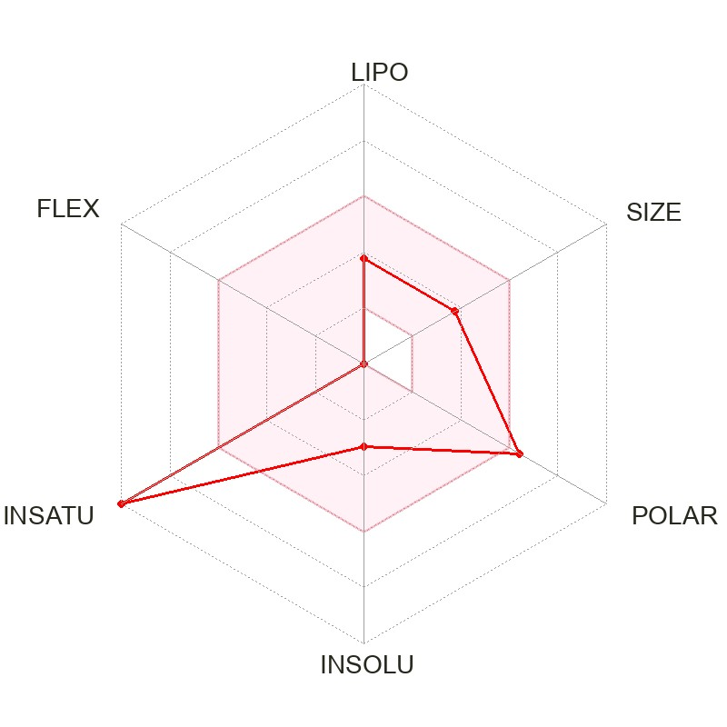
Molecule 21 | OI 21. | 284.26 | 2.44 | High | No | -5.91 | 0 | 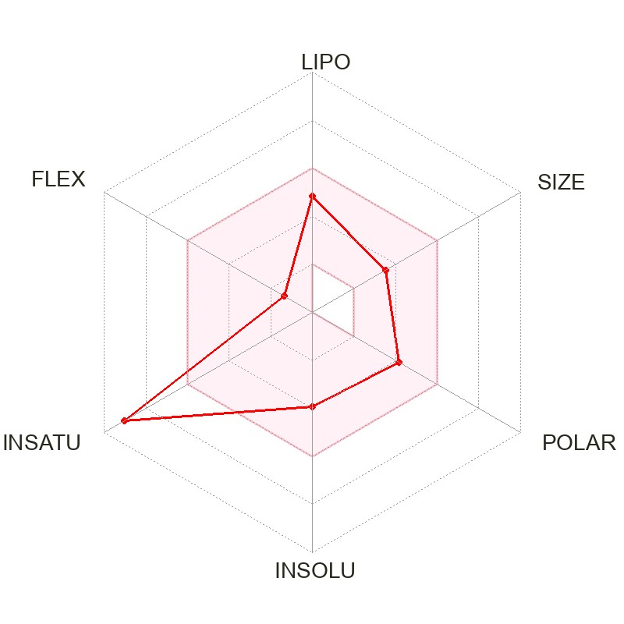
Molecule 22 | OI 22. | 228.37 | 4.45 | High | Yes | -3.35 | 0 | 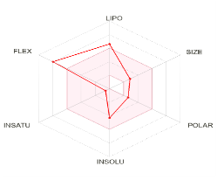
Molecule 23 | OI 23. | 200.32 | 3.51 | High | Yes | -4.54 | 0 | 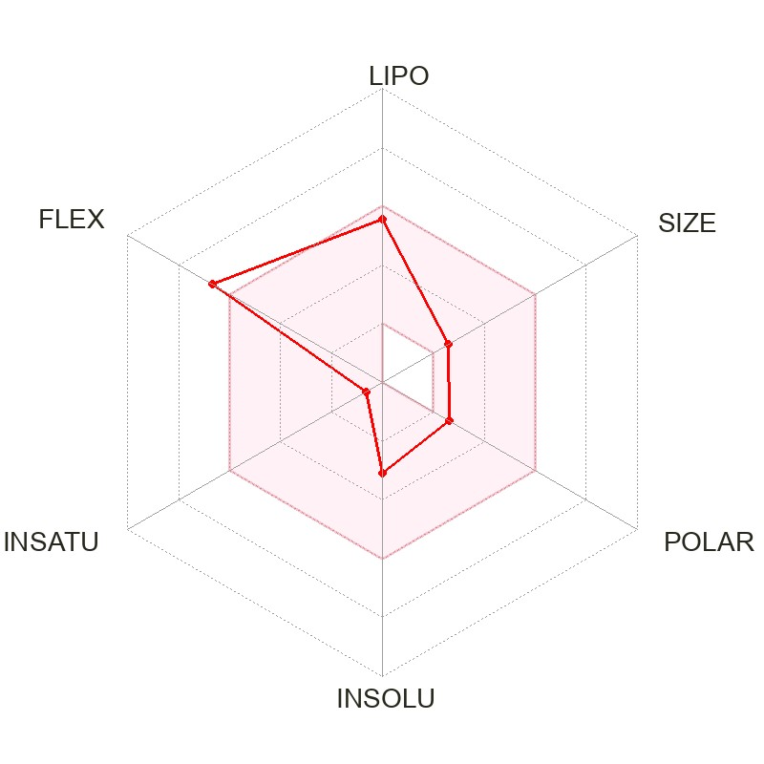
Molecule 24 | OI 24. | 144.21 | 2.23 | High | Yes | -5.01 | 0 | 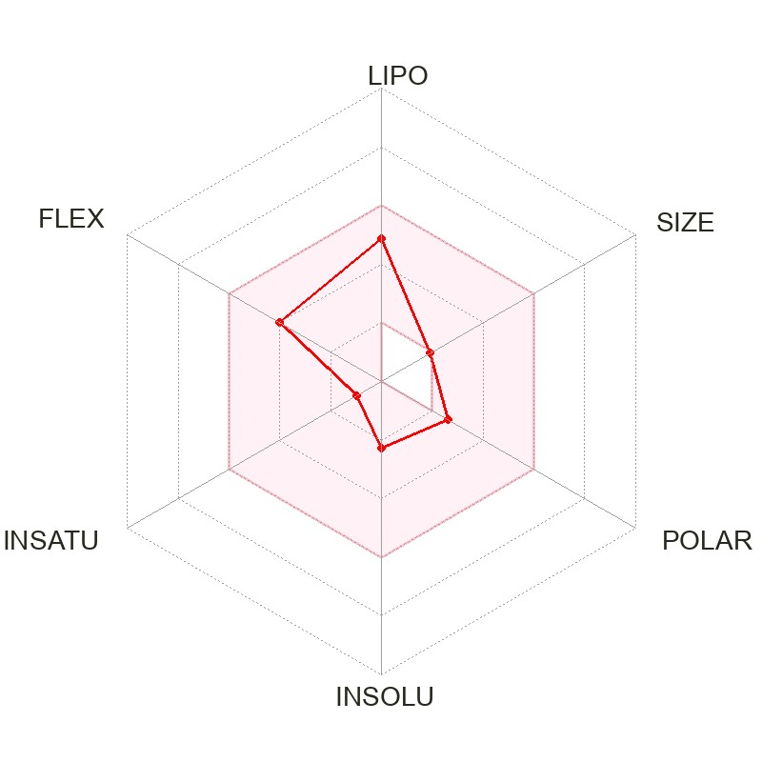
Molecule 25 | OI 25. | 284.48 | 5.93 | High | No | -2.19 | 1 | 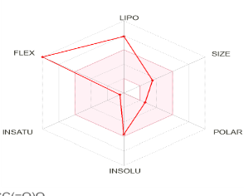
Molecule 26 | OI 26. | 432.38 | 0.34 | Low | No | -8.33 | 1 | 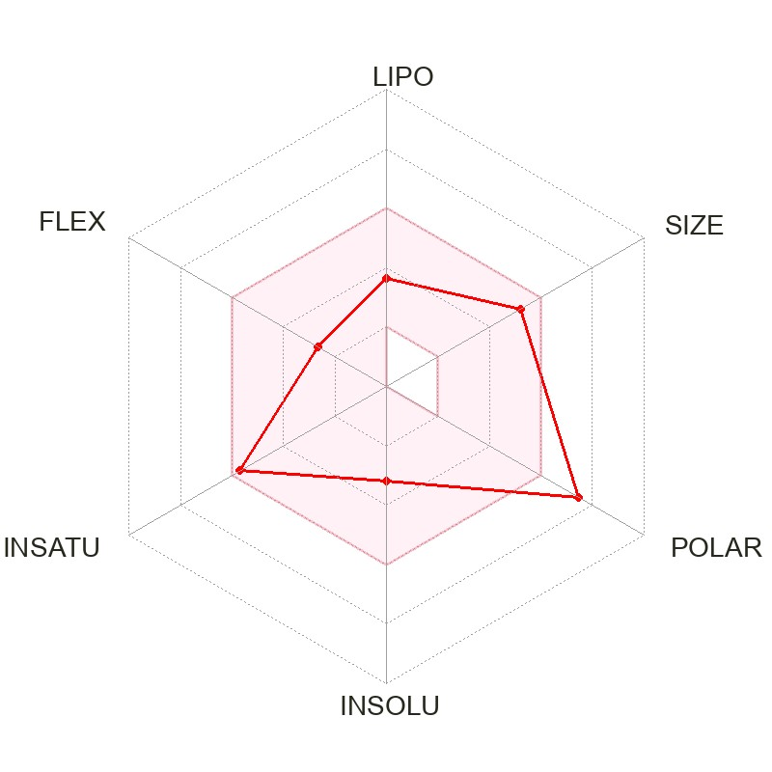
Molecule 27 | OI 27. | 256.42 | 5.20 | High | Yes | -2.77 | 1 | 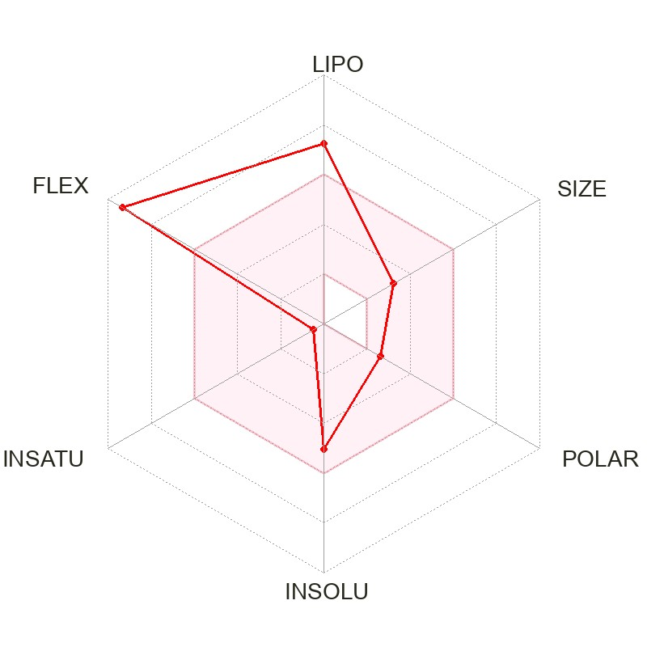
Molecule 28 | OI 28. | 416.68 | 7.83 | Low | No | -1.51 | 1 | 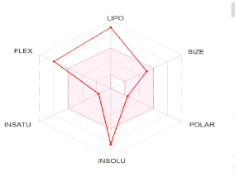
Molecule 29 | OI 29. | 254.41 | Linear (>4.15) | High | Yes | -1.51 | 1 | 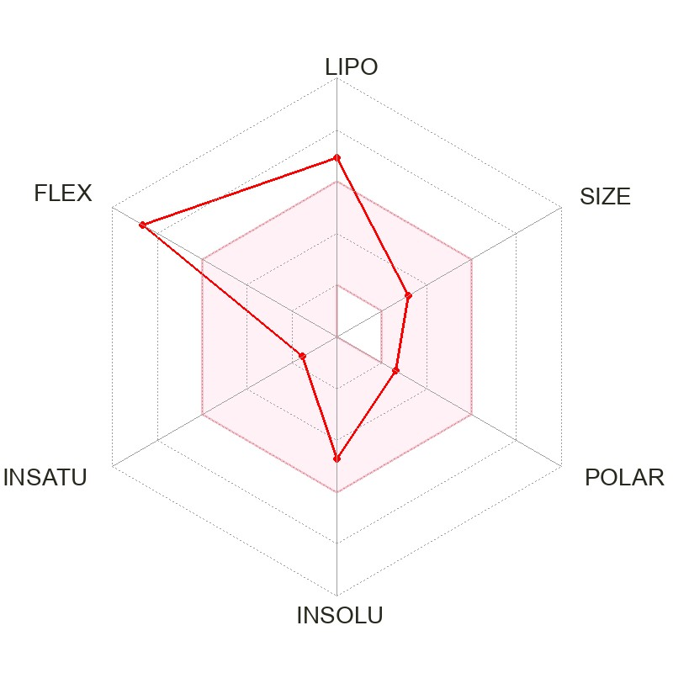
Molecule 30 | OI 30. | 284.48 | 5.93 | High | No | -2.19 | 1 | 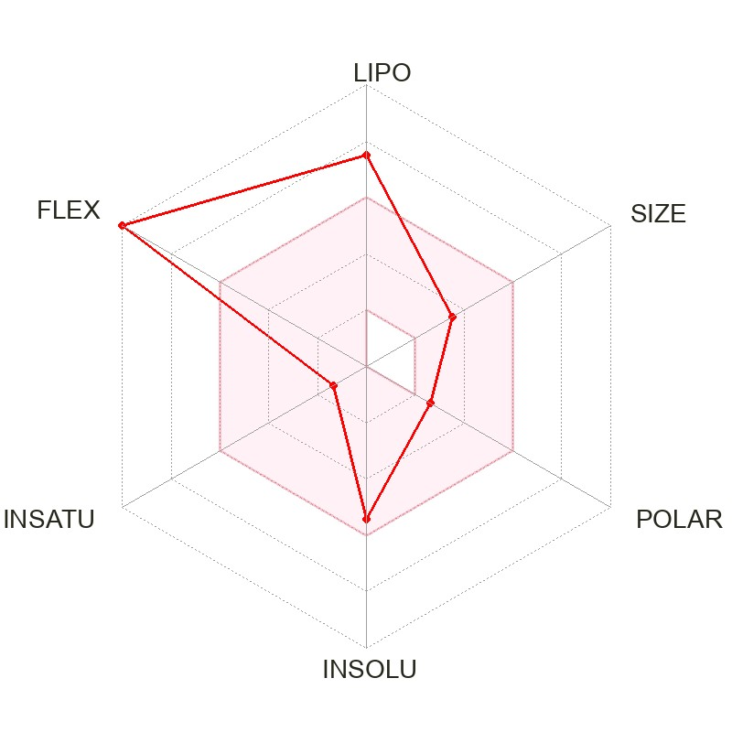
Molecule 31 | OI 31. | 280.45 | 5.42 | High | Yes | -2.45 | 0 | 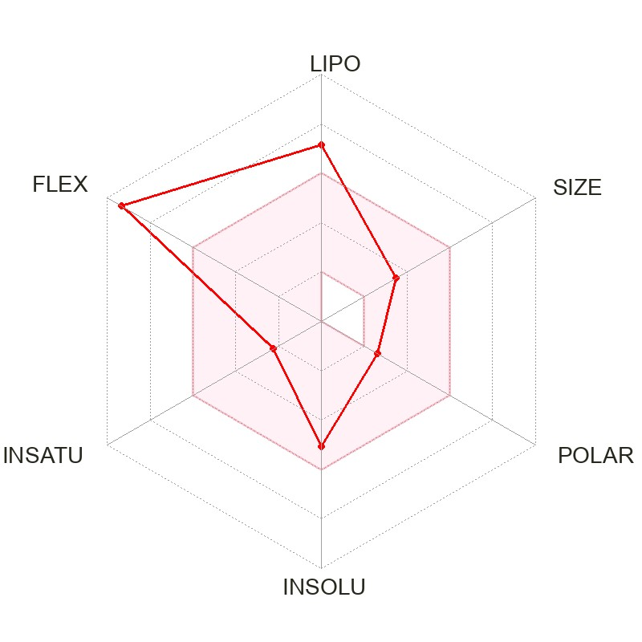
Molecule 32 | OI 32. | 432.38 | 0.34 | Low | No | -8.33 | 1
Molecule 33 | OI 33. | 284.26 | 2.44 | High | No | -5.91 | 0

Table 6: Disease and Target integration
Sr.no. | Chemical constituent name | Smile | Molecular formula | Molecular weight | Number of HBA | Number of HBD | MolLogP | MolLogS |  | MolPSA | MolVol | pKa of most Basic/Acidic group | BBB Score The Blood-Brain Barrier (BBB) Score | Number of stereo centers | Drug-likeness model score
 |  |  |  |  |  |  |  | (in Log(moles/L)) | (in mg/L)
 | Flavanone, 5,7-dihydroxy-6-methoxy- | COc1c(O)cc2c(c1O)C(=O)C[C@H](O2)c1ccccc1 | C16 H14 O5 | 286.08 | 5 | 2 | 2.88 | -3.20 | 179.79 | 59.95 A2 | 272.31 A3 | <0. / 8.25 | 3.16 | 1 | 0.39
 | Scutellarin | OC(=O)[C@H]1O[C@@H](Oc2cc3oc(cc(=O)c3c(c2O)O)c2ccc(cc2)O)[C@@H]([C@H]([C@@H]1O)O)O | C15 H15 N O3 | 257.11 | 3 | 1 | 2.68 | -2.84 | 375.19 | 43.86 A2 | 262.08 A3 | -3.04 / 3.75 | 4.25 | 0 | 0.29
 | Oroxylin A | COc1c(O)cc2c(c1O)c(=O)cc(o2)c1ccccc1 | C16 H12 O5 | 284.07 | 5 | 2 | 3.51 | -3.41 | 109.29 | 61.53 A2 | 281.33 A3 | <0. / 6.66 | 3.14 | 0 | 0.05
 | Nepetin | COc1c(O)cc2c(c1O)c(=O)cc(o2)c1ccc(c(c1)O)O | C16 H12 O7 | 316.06 | 7 | 4 | 2.62 | -3.14 | 231.00 | 94.63 A2 | 304.61 A3 | <0. / 6.66 | 2.65 | 0 | 0.44
 | 6-Hydroxyluteolin | Oc1ccc(cc1O)c1cc(=O)c2c(o1)cc(c(c2O)O)O | C15 H10 O7 | 302.04 | 7 | 5 | 2.42 | -2.94 | 348.45 | 102.39 A2 | 283.44 A3 | <0. / 6.51 | 2.55 | 0 | 0.29
 | Chrysin | Oc1cc(O)c2c(c1)oc(cc2=O)c1ccccc1 | C15 H10 O4 | 254.06 | 4 | 2 | 3.67 | -3.51 | 79.10 | 55.95 A2 | 249.59 A3 | <0. / 6.70 | 3.71 | 0 | 0.7
 | Baicalein | Oc1cc2oc(cc(=O)c2c(c1O)O)c1ccccc1 | C15 H10 O5 | 270.05 | 5 | 3 | 3.30 | -3.27 | 144.76 | 69.29 A2 | 260.17 A3 | <0. / 6.51 | 3.03 | 0 | 0.59
 | Dihydrobaicalein | O=C1CC(Oc2c1c(O)c(c(c2)O)O)c1ccccc1 | C15 H12 O5 | 272.07 | 5 | 3 | 2.68 | -2.93 | 322.46 | 67.71 A2 | 251.14 A3 | <0. / 8.10 | 3.05 | 1 | 0.29
 | Scutellarein 7-rutinoside | OC1[C@@H](OC([C@H]([C@@H]1O)O)CO[C@@H]1OC(C)[C@@H]([C@@H](C1O)O)O)Oc1cc2oc(cc(=O)c2c(c1O)O)c1ccc(cc1)O | C27 H30 O15 | 594.16 (> 500) | 15 (> 10) | 9 (> 5) | -0.04 | -1.51 | 18427.75 | 196.22 A2 | 519.85 A3 | <0. / 7.96 | 1.24 | 10 | 0.95
 | Scutellarein | Oc1ccc(cc1)c1cc(=O)c2c(o1)cc(c(c2O)O)O | C15 H10 O6 | 286.05 | 6 | 4 | 2.85 | -3.15 | 204.21 | 86.91 A2 | 270.71 A3 | <0. / 6.51 | 2.78 | 0 | 0.43
 | Apigenin 7,4'-dimethyl ether | COc1ccc(cc1)c1cc(=O)c2c(o1)cc(cc2O)OC | C17 H14 O5 | 298.08 | 5 | 1 | 4.17 | -4.66 | 6.52 | 53.42 A2 | 302.73 A3 | <0. / 10.09 | 3.92 | 0 | 0.23
 | 4-Hydroxycinnamic acid | OC(=O)/C=C/c1ccc(cc1)O | C9 H8 O3 | 164.05 | 3 | 2 | 1.66 | -1.66 | 3596.82 | 46.24 A2 | 162.15 A3 | <0. / 4.54 | 2.96 | 0 | -0.81
 | beta-Sitosterol | CC[C@@H](C(C)C)CC[C@H]([C@H]1CC[C@@H]2[C@]1(C)CC[C@H]1[C@H]2CC=C2[C@]1(C)CC[C@@H](C2)O)C | C29 H50 O | 414.39 | 1 | 1 | 8.45 (> 5) | -6.34 | 0.19 | 16.28 A2 | 519.36 A3 | <0. / 16.77 | 3.94 | 9 | 0.78
 | Aloe emodin | OCc1cc(O)c2c(c1)C(=O)c1c(C2=O)c(O)ccc1 | C15 H10 O5 | 270.05 | 5 | 3 | 2.14 | -2.59 | 699.71 | 76.39 A2 | 255.84 A3 | <0. / 9.06 | 2.93 | 0 | 0.01
 | Baicalin | OC(=O)[C@H]1O[C@@H](Oc2cc3oc(cc(=O)c3c(c2O)O)c2ccccc2)[C@@H]([C@H]([C@@H]1O)O)O | C21 H18 O11 | 446.08 | 11 (> 10) | 6 (> 5) | 1.78 | -2.03 | 4205.40 | 143.74 A2 | 397.35 A3 | <0. / 4.33 | 1.66 | 5 | 0.59
 | Anthraquinone | OC(=O)[C@H]1O[C@@H](Oc2cc3oc(cc(=O)c3c(c2O)O)c2ccc(cc2)O)[C@@H]([C@H]([C@@H]1O)O)O | C21 H18 O12 | 462.08 | 12 (> 10) | 7 (> 5) | 1.33 | -1.87 | 6225.11 | 161.36 A2 | 407.90 A3 | <0. / 4.33 | 1.61 | 5 | 0.84
 | Oroxindin | COc1c(O[C@@H]2O[C@H](C(=O)O)[C@H]([C@@H]([C@H]2O)O)O)cc(c2c1oc(cc2=O)c1ccccc1)O | C22 H20 O11 | 460.10 | 11 (> 10) | 5 | 1.74 | -2.09 | 3781.23 | 136.73 A2 | 418.58 A3 | <0. / 4.33 | 1.61 | 5 | 0.70
 | Hispidulin | COc1c(O)cc2c(c1O)c(=O)cc(o2)c1ccc(cc1)O | C16 H12 O6 | 300.06 | 6 | 3 | 3.06 | -3.15 | 211.39 | 79.15 A2 | 291.88 A3 | <0. / 6.66 | 2.88 | 0 | 0.46
 | Ellagic acid | Oc1cc2c(=O)oc3c4c2c(c1O)oc(=O)c4cc(c3O)O | C14 H6 O8 | 302.01 | 8 | 4 | 1.53 | -1.62 | 7265.67 | 105.23 A2 | 272.21 A3 | <0. / 7.05 | 2.51 | 0 | -1.11
 | Dimethyl terephthalate | COC(=O)c1ccc(cc1)C(=O)OC | C10 H10 O4 | 194.06 | 4 | 0 | 2.44 | -2.41 | 748.48 | 42.59 A2 | 189.06 A3 | <0. / 29.23 | 3.65 | 0 | -1.61
 | biochanin A | COc1ccc(cc1)c1coc2 c(c1=O)c(O)cc(c2)O | C16 H12 O5 | 284.27 | 5 | 2 | 2.5- 2.7 | -3.6 | 70 | 79.90 A2 | 238 | 6.9 | 5.3 | 3.2 | 0.75
 | Myristic acid | CCCCCCCCCCCCCC(=O)O | C14 H28 O2 | 228.21 | 2 | 1 | 5.63 (> 5) | -5.17 | 1.54 | 28.89 A2 | 270.11 A3 | <0. / 4.26 | 4.29 | 0 | -0.54
 | Lauric acid | CCCCCCCCCCCC(=O)O | C12 H24 O2 | 200.18 | 2 | 1 | 4.62 | -4.58 | 5.29 | 28.89 A2 | 234.30 A3 | <0. / 4.26 | 4.15 | 0 | -0.54
 | Octanoic acid | CCCCCCCC(=O)O | C8 H16 O2 | 144.12 | 2 | 1 | 2.59 | -2.39 | 591.59 | 28.89 A2 | 162.68 A3 | <0. / 4.26 | 3.68 | 0 | -0.54
 | Stearic acid | CCCCCCCCCCCCCCCCCC(=O)O | C18 H36 O2 | 284.27 | 2 | 1 | 7.65 (> 5) | -5.87 | 0.38 | 28.89 A2 | 341.74 A3 | <0. / 4.26 | 4.40 | 0 | -0.54
 | Baicalein 6-glucoside | OCC1O[C@@H](Oc2c(O)cc3c(c2O)c(=O)cc(o3)c2ccccc2)C([C@H]([C@@H]1O)O)O | C21 H20 O10 | 432.11 | 10 | 6 (> 5) | 1.02 | -1.79 | 7020.85 | 133.84 A2 | 391.73 A3 | <0. / 6.20 | 1.70 | 5 | 0.30
 | Palmitic acid | CCCCCCCCCCCCCCCC(=O)O | C16 H32 O2 | 256.24 | 2 | 1 | 6.64 (> 5) | -5.79 | 0.42 | 28.89 A2 | 305.93 A3 | <0. / 4.26 | 4.36 | 0 | -0.54
 | gamma-Tocopherol | C[C@H](CCC[C@@H](CCCC(C)C)C)CCC[C@]1(C)CCc2c(O1)c(C)c(c(c2)O)C | C28 H48 O2 | 416.37 | 2 | 1 | 9.48 (> 5) | -5.81 | 0.65 | 23.00 A2 | 499.52 A3 | <0. / 11.62 | 4.63 | 3 | 0.48
 | Palmito  leic acid | CCCCCC/C=CCCC CCCCC(=O)O | C16 H 30 O2 | 254.41 | 2 | 1 | 6.1 | 5.8 | 0.45 | 37.30 A2 | 278 A3 | 4.9 | 6.1 | 3.1 | 0.15
 | Oleic acid | CCCCCCCC/C=CCCCCCCCC(=O)O | C18 H34 O2 | 282.26 | 2 | 1 | 7.11 (> 5) | -5.75 | 0.50 | 28.89 A2 | 348.59 A3 | <0. / 4.26 | 4.40 | 0 | -0.30
 | Linoleic acid | CCCCC/C=CC/C=CCCCCCCCC(=O)O | C18 H32 O2 | 280.24 | 2 | 1 | 6.60 (> 5) | -5.69 | 0.58 | 28.89 A2 | 353.96 A3 | <0. / 4.26 | 4.40 | 0 | -0.30
 | 5,7-Dihydroxy-2-phenyl-6-[3,4,5-trihydroxy-6-(hydroxymethyl)oxan-2-yl]oxychromen-4-one | OCC1OC(Oc2c(O)cc3c(c2O)c(=O)cc(o3)c2ccccc2)C(C(C1O)O)O | C21 H20 O10 | 432.11 | 10 | 6 (> 5) | 1.02 | -1.79 | 7020.85 | 133.84 A2 | 391.73 A3 | <0. / 6.20 | 1.70 | 5 | 0.30
 | Prunetin | COc1cc(O)c2c(c1)occ(c2=O)c1ccc(cc1)O | C16 H12 O5 | 284.07 | 5 | 2 | 2.34 | -2.62 | 688.23 | 79.9 A2 | 281.98 A3 | <0. / 9.74 | 3.12 | 0 | 0.38

Table 8: Swiss target prediction
Sr.no. | chemical constituents | smiles | Swiss target prediction
 | Flavanone, 5,7-dihydroxy-6-methoxy- | COc1c(O)cc2c(c1O)C(=O)C[C@H](O2)c1ccccc1
 | Scutellarin | OC(=O)[C@H]1O[C@@H](Oc2cc3oc(cc(=O)c3c(c2O)O)c2ccc(cc2)O)[C@@H]([C@H]([C@@H]1O)O)O
 | Oroxylin A | COc1c(O)cc2c(c1O)c(=O)cc(o2)c1ccccc1
 | Nepetin | COc1c(O)cc2c(c1O)c(=O)cc(o2)c1ccc(c(c1)O)O
 | 6-Hydroxyluteolin | Oc1ccc(cc1O)c1cc(=O)c2c(o1)cc(c(c2O)O)O
 | Chrysin | Oc1cc(O)c2c(c1)oc(cc2=O)c1ccccc1 | 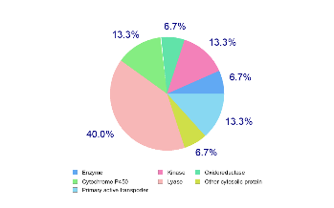
 | Baicalein | Oc1cc2oc(cc(=O)c2c(c1O)O)c1ccccc1
 | Dihydrobaicalein | O=C1CC(Oc2c1c(O)c(c(c2)O)O)c1ccccc1 | 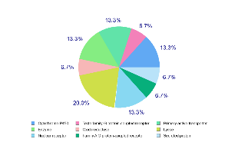
 | Scutellarein 7-rutinoside | OC1[C@@H](OC([C@H]([C@@H]1O)O)CO[C@@H]1OC(C)[C@@H]([C@@H](C1O)O)O)Oc1cc2oc(cc(=O)c2c(c1O)O)c1ccc(cc1)O
 | Apigenin 7,4'-dimethyl ether | COc1ccc(cc1)c1cc(=O)c2c(o1)cc(cc2O)OC
 | 4-Hydroxycinnamic acid | OC(=O)/C=C/c1ccc(cc1)O | 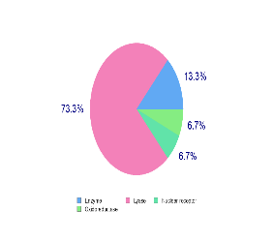
 | Scutellarein | Oc1ccc(cc1)c1cc(=O)c2c(o1)cc(c(c2O)O)O | 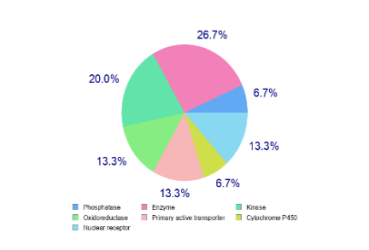
 | beta-Sitosterol | CC[C@@H](C(C)C)CC[C@H]([C@H]1CC[C@@H]2[C@]1(C)CC[C@H]1[C@H]2CC=C2[C@]1(C)CC[C@@H](C2)O)C | 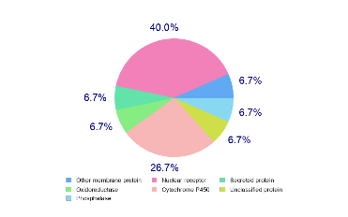
 | Aloe emodin | OCc1cc(O)c2c(c1)C(=O)c1c(C2=O)c(O)ccc1
 | Baicalin | OC(=O)[C@H]1O[C@@H](Oc2cc3oc(cc(=O)c3c(c2O)O)c2ccccc2)[C@@H]([C@H]([C@@H]1O)O)O | 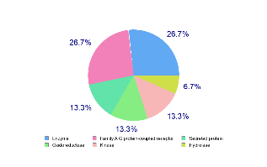
 | Anthraquinone | OC(=O)[C@H]1O[C@@H](Oc2cc3oc(cc(=O)c3c(c2O)O)c2ccc(cc2)O)[C@@H]([C@H]([C@@H]1O)O)O | 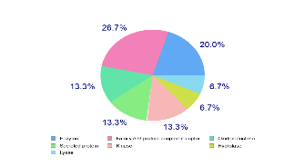
 | Oroxindin | COc1c(O[C@@H]2O[C@H](C(=O)O)[C@H]([C@@H]([C@H]2O)O)O)cc(c2c1oc(cc2=O)c1ccccc1)O | 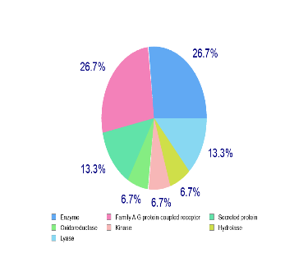
 | Hispidulin | COc1c(O)cc2c(c1O)c(=O)cc(o2)c1ccc(cc1)O | 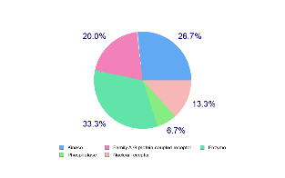
 | Ellagic acid | Oc1cc2c(=O)oc3c4c2c(c1O)oc(=O)c4cc(c3O)O | 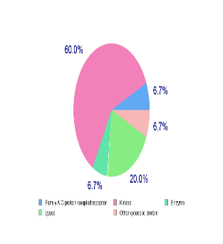
 | Dimethyl terephthalate | COC(=O)c1ccc(cc1)C(=O)OC | 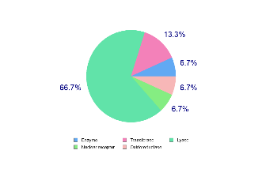
 | biochanin A | COc1ccc(cc1)c1coc2c(c1=O)c(O)cc(c2)O | 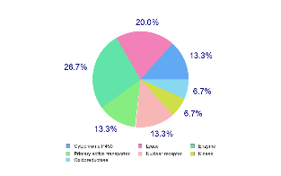
 | Myristic acid | CCCCCCCCCCCCCC(=O)O | 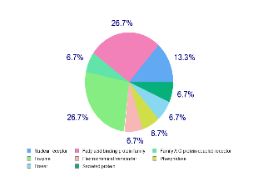
 | Lauric acid | CCCCCCCCCCCC(=O)O
 | Octanoic acid | CCCCCCCC(=O)O | 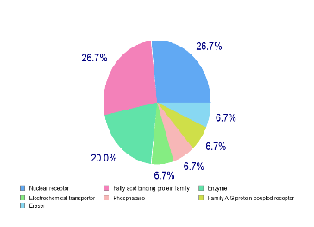
 | Stearic acid | CCCCCCCCCCCCCCCCCC(=O)O | 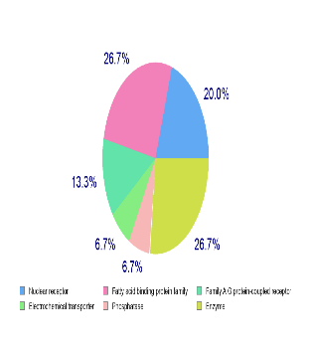
 | Baicalein 6-glucoside | OCC1O[C@@H](Oc2c(O)cc3c(c2O)c(=O)cc(o3)c2ccccc2)C([C@H]([C@@H]1O)O)O | 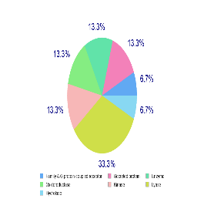
 | Palmitic acid | CCCCCCCCCCCCCCCC(=O)O | 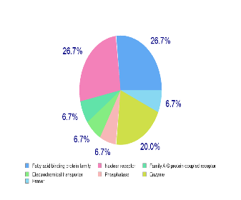
 | gamma-Tocopherol | C[C@H](CCC[C@@H](CCCC(C)C)C)CCC[C@]1(C)CCc2c(O1)c(C)c(c(c2)O)C | 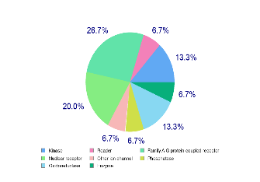
 | Palmitoleic acid | CCCCCC/C=CCCCCCCCC(=O)O | 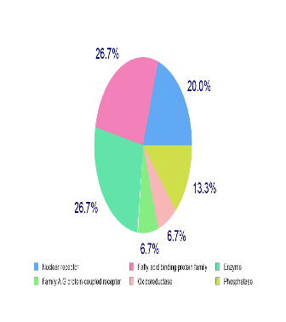
 | Oleic acid | CCCCCCCC/C=CCCCCCCCC(=O)O
 | Linoleic acid | CCCCC/C=CC/C=CCCCCCCCC(=O)O | 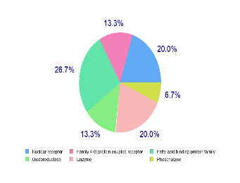
 | 5,7-Dihydroxy-2-phenyl-6-[3,4,5-trihydroxy-6-(hydroxymethyl)oxan-2-yl]oxychromen-4-one | OCC1OC(Oc2c(O)cc3c(c2O)c(=O)cc(o3)c2ccccc2)C(C(C1O)O)O
 | Prunetin | COc1cc(O)c2c(c1)occ(c2=O)c1ccc(cc1)O | 