Supplementary Information for
El Niño-Southern Oscillation, Indian Ocean Dipole, and Local Sea-Surface Temperature Forcing of Humid-Heat Extremes in the Arabian Peninsula
This document provides supplementary methods, validation analyses, additional figures, and supporting tables for the manuscript titled “El Niño-Southern Oscillation, Indian Ocean Dipole, and Local Sea-Surface Temperature Forcing of Humid-Heat Extremes in the Arabian Peninsula.”

1 Supplementary Methods

1.1 Data Notes
ERA5 has been validated in the region, and performs well versus the observations (Gleixner et al. 2020; Yilmaz 2023). Other studies in the Persian Gulf have noted issues with the magnitude and timing of daily peak humidity, but these issues are relatively minor and do not critically limit the analysis (Raymond et al. 2021, 2024).

1.2 Metric Creation Notes
To create specific humidity (q), Vapor pressure ($e$) was first computed from dew point temperature (T_{d}) using the Clausius–Clapeyron relation approximation:
$e=611.2exp\left(\frac{17.67 T_{d}}{T_{d}+243.5}\right)$
where T_{d} is in °C and $e$ is in $hPa$. From e, we can calculate q using the following equation.
$q=\frac{0.622e}{P − 0.378e}$
where P is in hPa and q is in kg kg⁻¹. Once $q$ is calculated, P, T_{a}, and q can be implemented into the moist adiabatic T_{w} equation.

1.3 Bayesian Modeling of City-Level HHEs to ENSO–IOD Variability
To quantify the influence of large-scale climate modes on HHEs experienced by major cities, we modeled daily city-level exceedances directly as a function of ENSO and IOD. For each city $c$, let $Y_{t}^{(c)}$ denote the daily maximum $T_{w}$. A fixed city-specific $p95$ threshold $u^{(c)}$ was used. Daily exceedances were represented by the indicator variable
$I_{t}^{(c)}=\{1, Y_{t}^{(c)}>u^{(c)} 0, Y_{t}^{(c)}≤u^{(c)} .$
Monthly lagged RONI ($N_{t}$) and DMI ($D_{t}$) indices were standardized to zero mean and unit variance and mapped onto the daily record such that all days within a given month shared the same ENSO and IOD covariate values. Exceedance frequency was modeled using a Bernoulli process (Lima et al. 2021; McCullagh and Nelder 1989),
$I_{t}^{(c)}∼Bernoulli​\left(p_{t}^{(c)}\right),$
where the exceedance probability was linked to ENSO and IOD through
$logit​\left(p_{t}^{(c)}\right)=η^{(c)}+δ_{N}^{(c)}N_{t}+δ_{D}^{(c)}D_{t}+δ_{ND}^{(c)}N_{t}D_{t}.$
Because RONI and DMI were standardized prior to model fitting, weakly informative N(0,1) priors were assigned to the corresponding regression coefficients and their interaction. The intercept was assigned an N(-3,2) prior, centering the baseline exceedance probability near 5%, consistent with the use of a historical ${95}^{th}$ percentile threshold.
To improve statistical efficiency in the Persian Gulf, Doha, Dubai, and Dammam were modeled using a partial-pooling structure while preserving city-specific responses to climate forcing,
$δ_{k,s}∼N({δ‾}_{k},τ_{k}),$
where ${δ‾}_{k}$ represents the Gulf-wide mean teleconnection response for predictor $k$ and $τ_{k}$ controls between-city variability. All remaining cities were modeled independently. This formulation stabilizes inference in cities with relatively few exceedance events while avoiding excessive shrinkage across distinct climatic regimes.
To assess whether ENSO and IOD also influence the severity of HHEs once a threshold is exceeded, exceedance magnitudes were modeled separately using a generalized Pareto distribution (GPD) (Pickands 1975; Coles 2001) The results are provided in Figure S1. For exceedance magnitudes,
$X_{t}^{(c)}=Y_{t}^{(c)}−u^{(c)}, Y_{t}^{(c)}>u^{(c)},$
and
$X_{t}^{(c)}∼GPD​\left(σ_{t}^{(c)},ξ^{(c)}\right),$
where the scale parameter was modeled as
$log​\left(σ_{t}^{(c)}\right)=α^{(c)}+β_{N}^{(c)}N_{t}+β_{D}^{(c)}D_{t}+β_{ND}^{(c)}N_{t}D_{t}.$
From the conditionally modeled GPD, we examine the $p50$ and $p80$ conditional probabilities of the distribution. These correspond to the unconditional $p97.5$ and $p99$ of the full distribution, and this is how it is presented in the results.
For both models, no temporal declustering was applied and exceedances were treated at the daily scale (Bommier 2014). Posterior samples were subsequently evaluated under prescribed ENSO–IOD states, including strong and extreme ENSO cases, to estimate exceedance probabilities and exceedance magnitudes under hypothetical climate conditions. This enables probabilistic assessment of humid-heat risk beyond the range of observed climate variability while fully propagating parameter uncertainty. Uncertainty is reported using the 94% highest density interval (HDI) of the posterior distribution. This interval was chosen as it is the default HDI in the Python package Arviz and also to differentiate from the commonly used 95% confidence intervals used in frequentist approaches (Kruschke and Liddell 2018). The post-model run diagnostics can be found in Table S2.

1.4 Bayesian Modeling of Basin SST Responses to ENSO–IOD Variability
To quantify how large-scale climate modes restructure the oceanic thermal state adjacent to the AP, we modeled SST anomalies within each basin using a Bayesian framework. For each basin $b$ (Persian Gulf, Red Sea, Gulf of Oman, and Gulf of Aden), let $y_{s,t}^{(b)}$ denote the SST anomaly at grid cell $s$ and time $t$.
Large-scale climate variability was represented using lagged indices of ENSO ($N_{t}$) and the IOD ($D_{t}$). Both predictors are standardized to zero mean and unit variance. To allow for asymmetric ENSO responses, we decompose into a piecewise linear structure:
$N_{t}^{+}=max(N_{t},0), N_{t}^{−}=min(N_{t},0),$
representing El Niño–like and La Niña–like conditions, respectively.
SST anomalies are modeled using a Student-$t$ regression (Gelman et al. 2013),
$y_{s,t}^{(b)}∼StudentT\left(ν,μ_{s,t}^{(b)},σ\right),$
with mean structure
$μ_{s,t}^{(b)}=α_{s}^{(b)}+β_{N^{+},s}^{(b)}N_{t}^{+}+β_{N^{−},s}^{(b)}N_{t}^{−}+β_{D,s}^{(b)}D_{t}+β_{N^{+}D,s}^{(b)}N_{t}^{+}D_{t}+β_{N^{−}D,s}^{(b)}N_{t}^{−}D_{t}.$
All regression coefficients are allowed to vary spatially,
$β_{k,s}^{(b)}∼N({β‾}_{k}^{(b)},σ_{k}^{(b)}),$
where ${β‾}_{k}^{(b)}$ represents the basin-wide mean response for predictor $k$, and $σ_{k}^{(b)}$ controls spatial variability across grid cells. The intercept $α_{s}^{(b)}$ is specified analogously. Weakly informative priors are assigned to all regression coefficients and hierarchical parameters. Because RONI and DMI are standardized to zero mean and unit variance, basin-level regression coefficients were assigned zero-centered normal priors,
$β_{k}‾∼N(0,(0.5s_{y})^{2}),$
where $s_{y}$ is the empirical standard deviation of basin SST anomalies. The basin-level intercept is assigned $α‾∼N(0,s_{y}^{2})$. Between-grid-cell standard deviations were assigned half-normal priors $τ_{α}∼HalfNormal(0.5s_{y})$ and $τ_{β_{k}}∼HalfNormal(0.25s_{y})$.
To quantify basin-scale responses, posterior draws of the mean shift were evaluated under prescribed ENSO–IOD states $(N,D)$ as
$Δμ_{s}^{(b)}(N,D)=β_{N^{+},s}^{(b)}N^{+}+β_{N^{−},s}^{(b)}N^{−}+β_{D,s}^{(b)}D+β_{N^{+}D,s}^{(b)}N^{+}D+β_{N^{−}D,s}^{(b)}N^{−}D,$
and subsequently averaged over all grid cells within each basin,
$Δμ^{(b)}(N,D)=\frac{1}{S_{b}}\sum_{s=1}^{S_{b}}{}Δμ_{s}^{(b)}(N,D),$
where $S_{b}$ denotes the number of valid grid cells in basin $b$. Uncertainty in basin-mean responses is quantified using the $94\%$ HDI of the posterior distribution. The post-model run diagnostics can be found in Table S3.

1.5 HHEs under Local SST Forcing
To isolate the thermodynamic contribution of local ocean warming to HHEs, we modeled city-level exceedance magnitudes as a function of basin-specific SST anomalies. For each city $c$, daily maximum $T_{w}$, $Y_{t}^{(c)}$, was extracted from the nearest grid cell during JJAS. $u^{(c)}$ is the $p95$ of $Y_{t}^{(c)}$ where exceedance magnitudes were defined as
$X_{t}^{(c)}=Y_{t}^{(c)}−u^{(c)}, Y_{t}^{(c)}>u^{(c)}$
For each adjacent basin $b(c)$, monthly basin-mean SST anomalies, $Δ{SST}_{t}^{(b)}$, were computed and mapped onto the daily exceedance record such that all exceedances within a given month shared the same SST anomaly. Exceedance magnitudes were modeled using a GPD (Pickands 1975; Coles 2001),
$X_{t}^{(c)}∼GPD​\left(σ_{t}^{(c)},ξ\right),$
where $σ_{t}^{(c)}$ is the city- and time-varying scale parameter and $ξ$ is a shape parameter shared across cities. The scale parameter was modeled as
$log(σ_{t}^{(c)})=α^{(c)}+γ^{(c)}Δ{SST}_{t}^{(b(c))}$
City-specific intercepts and SST sensitivities were estimated within a hierarchical Bayesian framework,
$α^{(c)}∼N(α‾,τ_{α}), γ^{(c)}∼N(γ‾,τ_{γ}),$
allowing partial pooling across Doha, Dammam, and Dubai while preserving city-level differences in the humid-heat response to local SST variability. Muscat, Aden, Basra, Kuwait City, and Jeddah were modeled independently.
Future humid-heat risk was assessed through controlled SST perturbation experiments, in which basin SST anomalies were uniformly increased by
$Δ{SST}^{(b)}∈+{0.5}^{∘}C,+{1.0}^{∘}C,+{1.5}^{∘}C,+{2.0}^{∘}C$
For each posterior draw, these perturbations were propagated through the fitted GPD scale parameter to estimate counterfactual changes in upper-tail humid-heat behavior, including changes in the ${97.5}^{th}$ and ${99}^{th}$ percentile of daily maximum $T_{w}$. This approach isolates the local thermodynamic influence of warmer adjacent SSTs while holding large-scale circulation and non-SST covariates fixed. Uncertainty is reported using the 94% HDI of the posterior distribution. The post-model run diagnostics can be found in Table S4.

1.6 Joint Bayesian Modeling of ENSO–IOD Variability and Local SST Variability with HHEs
To evaluate the combined influence of remote climate variability and local thermodynamic forcing on future HHEs, we developed a joint Bayesian model linking ENSO–IOD variability, basin-scale SST anomalies, and city-level HHE exceedance magnitudes. This framework combines the ENSO–IOD dependence of local basin SSTs with the dependence of HHE magnitude on local SSTs. Rather than estimating these relationships independently, the joint model estimates them simultaneously so that posterior uncertainty in the ENSO–IOD response of basin SSTs propagates into the corresponding HHE response.
For each city, the local SST anomaly entering the GPD scale parameter is modeled as a function of ENSO and IOD. City-level exceedance magnitudes are then modeled using the GPD formulation, such that the local SST covariate reflects both ENSO–IOD-associated SST variability and an imposed basin-warming perturbation. Thus, for a prescribed ENSO–IOD state $(N,D)$ and basin-warming perturbation $ΔT_{b}$, the SST forcing entering the HHE model can be represented conceptually as
$Δ{SST}_{joint}^{(b)}=Δμ^{(b)}(N,D)+ΔT_{b},$
where $Δμ^{(b)}(N,D)$ is the posterior basin SST response to ENSO and IOD. This joint SST forcing is propagated through the city-specific GPD relationship.
As in the previous city-level analyses, Doha, Dubai, and Dammam were modeled using partial pooling, while all remaining cities were estimated independently. Cities without an adjacent basin (Riyadh and Medina) were not included in the joint analysis. Posterior samples were evaluated under prescribed combinations of ENSO, IOD, and $+1^{∘}C$ or $+2^{∘}C$ basin-warming perturbations. These experiments quantify conditional changes in the $p97.5$ and $p99$ of daily maximum $T_{w}$ relative to neutral ENSO–IOD conditions and zero imposed basin warming while propagating uncertainty through both components of the model. Uncertainty is summarized using the 94% HDI. Post-model diagnostics are provided in Table S5.

2 Supplementary Tables
CMIP6 models used in this study, including the modeling institution, country of origin, approximate native atmospheric horizontal resolution, and model type. ESM denotes an Earth System Model and GCM denotes a coupled General Circulation Model.
Table S1: CMIP6 Models for Figure S2
Model | Modeling Center | Country | Resolution | Type
CanESM5 | Canadian Centre for Climate Modelling and Analysis (CCCma) | Canada | ${2.8}^{∘}×{2.8}^{∘}$ | ESM
CMCC-CM2-SR5 | Euro-Mediterranean Center on Climate Change (CMCC) | Italy | ${1.25}^{∘}×{0.94}^{∘}$ | GCM
CNRM-ESM2-1 | Centre National de Recherches Météorologiques–CERFACS (CNRM–CERFACS) | France | ${1.4}^{∘}×{1.4}^{∘}$ | ESM
EC-Earth3-Veg-LR | EC-Earth Consortium | Europe | ${1.1}^{∘}×{1.1}^{∘}$ | ESM
FGOALS-g3 | Chinese Academy of Sciences (CAS) | China | ${2.0}^{∘}×{2.25}^{∘}$ | GCM
IITM-ESM | Indian Institute of Tropical Meteorology (IITM) | India | ${1.9}^{∘}×{1.9}^{∘}$ | ESM
MIROC6 | University of Tokyo / NIES / JAMSTEC | Japan | ${1.4}^{∘}×{1.4}^{∘}$ | GCM
MPI-ESM1-2-LR | Max Planck Institute for Meteorology (MPI-M) | Germany | ${1.9}^{∘}×{1.9}^{∘}$ | ESM
NorESM2-MM | Norwegian Climate Centre | Norway | ${1.25}^{∘}×{0.94}^{∘}$ | ESM
Model convergence and sampling efficiency were assessed using the rank-normalized potential scale reduction factor ($\hat{R}$), bulk effective sample size (ESS), tail ESS, and Bayesian fraction of missing information (BFMI). Maximum $\hat{R}$ and minimum bulk ESS, tail ESS, and BFMI values across model parameters are reported for each model fit below.
Bernoulli Process–Bayesian Inference Model diagnostics
Table S2: Bernoulli Model Diagnostics
Location | Max $\hat{R}$ | Min ESS bulk | Min ESS tail | Min BFMI
Aden | 1.0 | 4076 | 3832 | 1.015
Basra | 1.0 | 5594 | 4483 | 0.977
Dammam | 1.0 | 4729 | 4120 | 0.646
Doha | 1.0 | 5603 | 4887 | 0.646
Dubai | 1.0 | 3950 | 3311 | 0.646
Jeddah | 1.0 | 5165 | 4284 | 0.988
Kuwait City | 1.0 | 5565 | 4232 | 0.958
Medina | 1.0 | 5497 | 3723 | 0.956
Muscat | 1.0 | 6000 | 3979 | 0.935
Riyadh | 1.0 | 5346 | 4192 | 0.936

Local SST–Remote ENSO–IOD Bayesian inference model diagnostics.
Table S3: Local SST Model Diagnostics
Location | Max $\hat{R}$ | Min ESS bulk | Min ESS tail | Min BFMI
Gulf of Aden | 1.0 | 1801 | 2822 | 0.765
Gulf of Oman | 1.0 | 1435 | 1993 | 0.897
Persian Gulf | 1.01 | 583 | 934 | 0.760
Red Sea | 1.0 | 943 | 1276 | 0.722

City-level humid-heat–local SST Bayesian inference model diagnostics.
Table S4: Local SST HHE Model Diagnostics
Location | Max $\hat{R}$ | Min ESS bulk | Min ESS tail | Min BFMI
Aden | 1.0 | 1890 | 2157 | 0.871
Muscat | 1.0 | 2072 | 2489 | 0.968
Basra | 1.0 | 5272 | 3464 | 0.863
Dammam | 1.0 | 4568 | 4122 | 0.863
Doha | 1.0 | 5585 | 4350 | 0.863
Dubai | 1.0 | 6040 | 5168 | 0.863
Kuwait City | 1.0 | 5028 | 4100 | 0.863
Jeddah | 1.0 | 1839 | 2107 | 0.911

Joint ENSO–IOD and local SST Bayesian inference model diagnostics.
Table S5: Joint Model Diagnostics
Location | Max R-Hat | Min ESS bulk | Min ESS tail | Min BFMI
Aden | 1.0 | 4276 | 3849 | 0.908
Basra | 1.0 | 5324 | 4365 | 0.908
Dammam | 1.0 | 5299 | 4988 | 0.908
Doha | 1.0 | 5136 | 4831 | 0.908
Dubai | 1.0 | 5521 | 5222 | 0.908
Jeddah | 1.0 | 3948 | 4205 | 0.908
Kuwait City | 1.0 | 4315 | 4054 | 0.908
Medina | 1.0 | 5650 | 4631 | 0.908
Muscat | 1.0 | 4315 | 4410 | 0.908
Riyadh | 1.0 | 4595 | 3286 | 0.908

3 Supplementary Figures
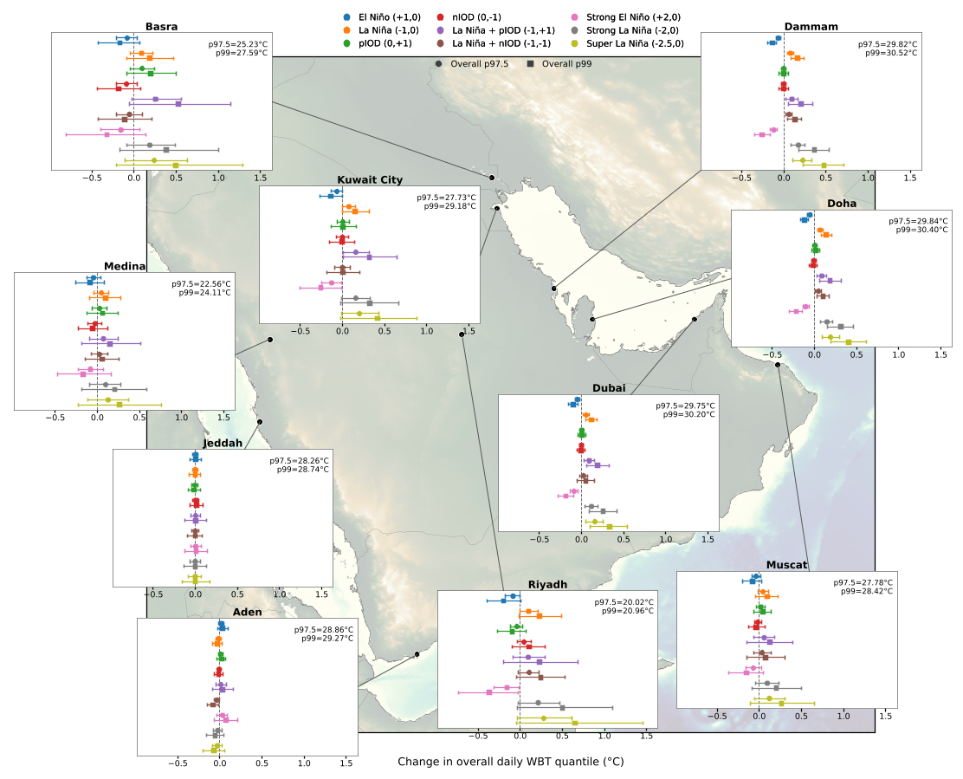 | Figure S1: City specific $p95$ $T_{w}$ HHEs responses to distinct scenarios for Basra, Dammam, Medina, Kuwait City, Doha, Jeddah, Dubai, Aden, Riyadh, and Muscat using a Generalized Pareto Distribution in the hierarchical Bayesian POT Framework. The baseline represents the historical $p97.5$ and $p99$ in the historical record. The bars represent the 94% Highest Density Interval (HDI)
GPD of Manuscript Figure 2
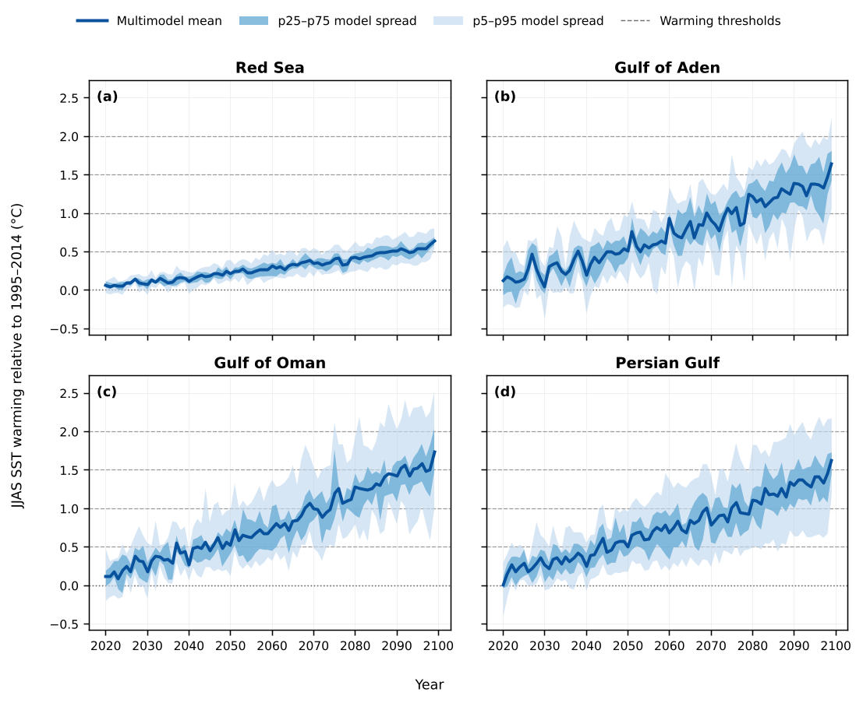 | Figure S2: Projected summer JJAS sea-surface temperature (SST) warming relative to the 1995–2014 climatology under SSP3–7.0 for the (a) Red Sea, (b) Gulf of Aden, (c) Gulf of Oman, and (d) Persian Gulf. The solid line denotes the CMIP6 multimodel mean, while the dark and light shaded envelopes represent the interquartile (25$​^{th}$–75$​^{th}$ percentile) and 5$​^{th}$–95$​^{th}$ percentile model spread, respectively. Horizontal dashed lines indicate the prescribed basin-warming perturbations (0.5, 1.0, 1.5, and 2.0 $​^{∘}C$) used in the SST sensitivity experiments presented in the main text.
CMIP6 Projected Warming in each Local Basin Modeled
Bommier, Esther. 2014. Peaks-over-Threshold Modelling of Environmental Data. Master's Thesis U.U.D.M. Project Report 2014:33. Department of Mathematics, Uppsala University.
Coles, Stuart. 2001. An Introduction to Statistical Modeling of Extreme Values. Springer Series in Statistics. Springer. https://doi.org/10.1007/978-1-4471-3675-0.
Gelman, Andrew, John B. Carlin, Hal S. Stern, David B. Dunson, Aki Vehtari, and Donald B. Rubin. 2013. Bayesian Data Analysis. 3rd ed. Chapman; Hall/CRC.
Gleixner, Stephanie, Teferi Demissie, and Gulilat Tefera Diro. 2020. “Did ERA5 Improve Temperature and Precipitation Reanalysis over East Africa?” Atmosphere 11 (9): 996. https://doi.org/10.3390/atmos11090996.
Kruschke, John K., and Torrin M. Liddell. 2018. “Bayesian Data Analysis for Newcomers.” Psychonomic Bulletin & Review 25 (1): 155–77. https://doi.org/10.3758/s13423-017-1272-1.
Lima, Carlos H. R., Hyun-Han Kwon, and Yong-Tak Kim. 2021. “A Bernoulli-Gamma Hierarchical Bayesian Model for Daily Rainfall Forecasts.” Journal of Hydrology 599 (August): 126317. https://doi.org/10.1016/j.jhydrol.2021.126317.
McCullagh, Peter, and John A. Nelder. 1989. Generalized Linear Models. 2nd ed. Chapman; Hall.
Pickands, James. 1975. “Statistical Inference Using Extreme Order Statistics.” The Annals of Statistics 3 (1): 119–31. https://doi.org/10.1214/aos/1176343003.
Raymond, Colin, Tom Matthews, Radley M. Horton, et al. 2021. “On the Controlling Factors for Globally Extreme Humid Heat.” Geophysical Research Letters 48 (23): e2021GL096082. https://doi.org/10.1029/2021GL096082.
Raymond, Colin, Tom Matthews, and Cascade Tuholske. 2024. “Evening Humid-Heat Maxima Near the Southern Persian/Arabian Gulf.” Communications Earth & Environment 5 (1): 1–8. https://doi.org/10.1038/s43247-024-01763-3.
Yilmaz, Meric. 2023. “Accuracy Assessment of Temperature Trends from ERA5 and ERA5-Land.” Science of The Total Environment 856 (January): 159182. https://doi.org/10.1016/j.scitotenv.2022.159182.

