Supplementary Information 1

Simulation
To complement the ex vivo fixed-tissue experiments and disentangle effects that cannot be independently controlled during acquisition, we performed 2-D Bloch–Torrey simulations targeting three factors: mesoscopic exchange regime, spatial-resolution coarsening (partial-volume averaging), and Rician noise. This simulation design directly tests the central observation that the apparent R₁–M₀ relationship and heterogeneity metrics are resolution-dependent in heterogeneous tissue but largely stable in uniform media.
A heterogeneous phantom was generated on a 30×30 grid (∆x = 15 µm) with Gaussian micro-domains in $M_{0}$ and $k$ (see Figure S1). Ground-truth relaxation was assigned as
$$\begin{aligned}R_{1} \left(x,y\right)=R_{0,free}\left(x, y\right)+ \frac{k\left(x,y\right)}{M_{0}\left(x,y\right)} \#\left(S1\right)\end{aligned}$$

with R_{0,free} = 1.0 ± 0.05 s⁻¹, M₀ ∈ [0.05,1.0], and k drawn uniformly from [0.92,4.28] s⁻¹. Three exchange regimes were defined by effective diffusion coefficient D, exchange duration $n_{TR}$ (number of TR intervals over which Bloch–Torrey exchange was applied with TR = 75 ms), and phantom geometry. Characteristic mixing lengths were summarized as $L=\sqrt{2Dn_{TR}TR}$:
- slow exchange: D = 7.0×10⁻¹⁰ m²/s, $n_{TR}$ = 5 (L ≈ 23μm); 16 Gaussian micro-domains — compartmentalized mixing, with L comparable to the native voxel size.
- fast exchange (diffusion): D = 2× 10⁻⁹ m²/s and $n_{TR}$ = 12, (L = 60 $μm$); same 16-domain geometry — high-mixing limiting case.
- fast exchange (geometry + diffusion): same D and $n_{TR}$ as fast exchange (diffusion), but 24 Gaussian micro-domains (denser occupancy) to geometrically increase mesoscopic mixing (L ≈ 60μm).
The slow-exchange ground truth (Figure S1, first column) contains fewer, more separated micro-domains, whereas the fast geometry + diffusion condition contains a denser micro-domain pattern (Figure S1, third column). A uniform-null phantom with no internal structure ($M_{0}$ = 0.8, $R_{1}$ = 2.0 $s^{-1}$, $k$ = 0) was included as a negative control (Figure S1, fourth column). Also, for the uniform-null phantom ($M_{0}$ = 0.8, $R_{1}$ = 2 s⁻¹, $k$ = 0), the diffusion coefficient was set to D = 5.0×10⁻¹⁰ m²/s and $n_{TR}$ = 5.

FLASH signal simulations included explicit finite-difference Bloch–Torrey evolution with periodic boundary condition (∆t = 0.1 ms, TR = 75 ms, TE = 5 ms, $T_{2}$ = 40 ms, flip angles 6° and 20°), followed by analytical two-angle DESPOT1 fitting to obtain apparent pixel-wise $R_{1,fit}$ and $M_{0,fit}$ in MATLAB.
We then compared effects of exchange at native resolution under noiseless conditions and with SNR = 25 (Figure S2), the effects of noise-only for a structure-less sample with SNR ∈ {5, 10, 20, 30, 40, 50, 70, 80, 100} (Figure S3), and the effects of resolution using Fourier truncation levels s ∈ {30, 28, 26, 24, 22, 20, 18, 16, 14, 13} to cover effective resolution from ∼15 to ∼35 µm (Figure S4). For the resolution analysis in Figure S4, the same underlying phantom maps were progressively low-pass filtered before signal simulation and DESPOT1 fitting. This allowed native-resolution and coarsened-resolution scatter plots, resolution-dependent slope/CV trends, and native-vs-coarse histograms to be compared from the same simulated tissue structure.
To explicitly separate possible noise effects from partial-volume effects, we also performed a joint SNR-resolution variation in which each SNR level was evaluated across the full resolution range (Figure S5). By simulating every SNR level across every resolution level, we separated two effects: the baseline shift in each fitted metric caused by noise, and the change caused by spatial averaging. Noise effects were interpreted as changing the overall level or spread of the data curves, whereas partial-volume averaging effects were assessed from how each metric changed along the resolution axis at fixed SNR. Unless otherwise noted, analyses used six independent phantom seed regions (5,400 pooled voxels per condition). The joint SNR–resolution grid (Figure S5) used three seeds (2,700 voxels per condition) for computational tractability. Uncertainty was quantified using nonparametric bootstrap resampling (400 resamples; 95% confidence intervals).
A one-factor-at-a-time sensitivity analysis was performed to determine which simulation parameters most strongly controlled native-to-coarse changes in slope, $R₁$ CV, and $M₀$ CV (Figure S6). Using the fast exchange (diffusion) scenario, D (0.5×, 1.0×, and 1.5× baseline 2.0 µm²/ms), $n_{TR}$ (±4 TRs from baseline 12), k-range ((0.7×, 1.0×, and 1.3×) baseline [0.92, 4.26] s⁻¹), σ(R₁,₀,free) (0.02, 0.05, and 0.08 s⁻¹), and SNR (15, 25, and 40) were perturbed independently while other parameters remained fixed. For each setting, phantoms were simulated and fitted at native (~15 µm) and coarsest (~35 µm) resolution, native-to-coarse differences were computed across four seeds, and mean ± SD, direction consistency, and impact scores were summarized. This tested whether resolution-dependent trends were driven by exchange/mixing and measurement noise rather than small baseline $R₁$ fluctuations. Separately, bootstrap uncertainty was estimated by pooling voxel-level fitted $R₁$ and $M₀$ values across six seeds for each regime and resolution, resampling voxels with replacement (400 iterations), recomputing slope and CV metrics on each resample, and taking 95% confidence intervals as the 2.5th and 97.5th percentiles of the resulting distributions (noiseless data; Figure S6d–f).

Simulation results
Figure S1 shows the defined ground-truth maps used in the simulation. The heterogeneous scenarios were constructed with spatially varying $R_{1}$, $M_{0}$, and $k$, where local $R_{1}$ values were assigned according to $R_{1} = R_{0,free} + k/M_{0}$ (see methods section). The slow-exchange scenario used fewer, more separated micro-domains, while the fast geometry + diffusion scenario used a denser micro-domain pattern. Because this heterogeneity was imposed by design, the simulation provides a controlled setting in which changes in fitted $R_{1}$, $M_{0}$, slope, and CV can be attributed to exchange regime, noise, and spatial averaging rather than to uncontrolled biological variability.
At native resolution in the noiseless condition, increasing exchange/mixing compacted fitted distributions and reduced branch-like sub-populations in $R_{1}$ vs $1/M_{0}$ (Figure S2). In the scatter plot (S. Figure S2a), the slow-exchange scenario spans the widest range of $1/M_{0}$ and $R_{1}$, with visibly separated branches that correspond to local micro-environments retaining their identity during the simulated readout. The fast-exchange scenarios show a progressively tighter point cloud, and the histograms show narrowing of the fitted $R_{1}$ and $M_{0}$ distributions. Figure S2g table quantifies this visual pattern: $R_{1}$ SD decreased from the slow exchange scenario to the fast-exchange scenarios, while the fitted slope remained positive but changed with mixing regime. This supports the interpretation that stronger mesoscopic mixing makes the fitted maps appear more homogenized, even though the underlying phantom remains spatially heterogeneous.
Adding noise at SNR = 25 visibly broadened the fitted scatter and reduced the visual separation between exchange-regime patterns (Figure S2d-f). Compared with the noiseless case, the slow-exchange scatter becomes more diffuse and less well described by a single linear fit, while the fast-exchange scenarios show marked widening of the fitted $R_{1}$ distributions. Figure S2h table shows that noise suppressed the fitted slope in the slow-exchange scenario but increased the fitted slope modestly in the two fast-exchange scenarios. In all cases, noise degraded $R^{2}$ and increased $R_{1}$ CV, indicating that noise broadens the apparent fitted distribution and weakens the linear $R_{1}-1/M_{0}$ relationship.
The uniform-null SNR sweep demonstrates that noise effects do not require any underlying tissue structure (Figure S3). The null scatter plots broaden as SNR decreases (Figure S3a), and the histograms show increasing spread in fitted $R_{1}$, $M_{0}$, and $1/M_{0}$ despite spatially constant ground truth (Figure S4b-c). The summary curves (Figure S3c-g) further show strong SNR dependence of $R_{1}$ CV, $M_{0}$ CV, apparent slope, and $R^{2}$. As summarized in Figure S3h table, noise alone generated substantial apparent heterogeneity in a phantom with spatially constant $R_{1}$ and $M_{0}$. This establishes a noise-only baseline for interpreting heterogeneous tissue simulations.
Resolution coarsening changed both the shape of the fitted scatter and the marginal distributions of fitted parameters (Figure S4). In the slow exchange example (Figure S4a), the native-resolution point cloud preserves a broad range of micro-environment-specific values, whereas the coarsened-resolution scatter (Figure S4b) is shifted and compressed by spatial averaging. The trend panels show that $R_{1}$ CV, $M_{0}$ CV, and slope (Figure S4d-f) are not fixed properties of the phantom but depend on the effective voxel size. The histogram panel (Figure S4c) provide the clearest visual analogue to the experimental observation: coarsening contracts the fitted parameter distributions and reduces the long high-$R_{1}$ tail. Figure S4f shows that the largest native-to-coarse slope change occurred in the slow-exchange scenario (blue plot), where spatially distinct micro-environments were most preserved at native resolution. The two fast-exchange scenarios showed smaller slope changes, consistent with greater pre-existing homogenization before spatial averaging. The CV changes (Figure S4d,e) were comparatively modest, indicating that slope and distribution width capture related but not identical aspects of the resolution-dependent behavior.
The uniform-null resolution control confirms that the coarsening procedure itself does not create the observed effects (Figure S4h-j). The fitted null scatter remains tightly clustered (Figure S3h), and the null CV curves (gray plot in Figure S4i,j) remain near zero across all resolution levels. In the same figure, the heterogeneous slow exchange scenario (blue plot in Figure S4i,j) shows clear nonzero CV and resolution dependence. This contrast demonstrates that the resolution-dependent changes in heterogeneous simulations arise from spatial averaging of true underlying variation, rather than from numerical artifacts introduced by Fourier truncation or DESPOT1 fitting.
The full SNR-resolution grid further separated the effects of noise and spatial averaging (Figure S5). The top-row scatter plots show that lowering SNR broadens the native-resolution $R_{1}-1/M_{0}$ cloud even before any resolution degradation is applied. The middle-row trend plots show that slope and CV metrics vary across the resolution ladder at each SNR, indicating that partial-volume averaging contributes additional metric changes beyond the baseline noise effect. The bottom-row delta plots summarize this interaction by showing that the native-to-coarse change is itself SNR-dependent. Thus, noise and blur were separable because each could be varied along an independent axis of the grid, but they were also interacting because the size and sometimes the direction of the native-to-coarse change depended on SNR.
Sensitivity analysis supported this interpretation (Figure S6). In the sensitivity panels, perturbing D substantially changed the mean native to-coarse slope shift, consistent with exchange/mixing being a major determinant of the apparent $R_{1}-1/M_{0}$ relationship. Perturbing SNR also produced large changes in ∆Slope variability, consistent with the SNR-resolution grid in Figure S5. By contrast, changing $σ(R_{1,0,free})$ produced visually and numerically negligible shifts, indicating that the observed slope changes were not driven by small random variations in baseline free-water relaxation. The bootstrap panels (Figure S6d-f) show that the major slope and CV trends are well resolved relative to resampling uncertainty. Selected sensitivity metrics are summarized in Figure S6h table.

Interpretation of simulation results
The simulations were designed to isolate mechanisms that are confounded in the fixed-tissue experiments and to test whether controlled variation of mixing, blur, and noise can reproduce the experimental direction of heterogeneity contraction. With diffusion-mediated exchange during steady-state evolution (finite-difference Bloch-Torrey, periodic boundaries), fitted maps and $R_{1}$–${1/M}_{0}$ scatter contract relative to ground truth, consistent with smoothing by exchange-driven mixing. A similar qualitative contraction arises from imaging-only resolution loss implemented by $k$-space truncation and refitting. Although outcomes can look similar in parameter space, the mechanisms are distinct: diffusion causes physical inter-voxel/compartment magnetization exchange during signal formation, whereas $k$-space truncation applies post-acquisition spatial averaging to already formed signal. The diffusion effect can be interpreted as a Gaussian-like blur whose width depends on $D$ and diffusion time.
These simulations are useful because they isolate effects that are confounded in fixed-tissue experiments. Experimentally, lower effective resolution is associated with contraction of $T_{1}$ and $M_{0}$ distributions in heterogeneous tissue but not in uniform phantom. In controlled simulations, we recover the same qualitative pattern and show that it arises from partial-volume averaging of true spatial heterogeneity, modulation by exchange-regime-dependent mesoscopic mixing, and additional bias from noise. Together, these results indicate that apparent heterogeneity metrics and the observed $R_{1}$ to $M_{0}$ coupling are emergent measures that depend on voxel scale and measurement conditions, not just fixed intrinsic tissue constants.
The simulation framework also addresses three practical concerns. First, noise alone can mimic heterogeneity (uniform-null SNR sweep, Figure S3). Second, resolution coarsening alone reshapes fitted maps in heterogeneous tissue (including slope/CV shifts). Third, the pipeline does not generate tissue-like heterogeneity in uniform media (near-zero null resolution trends, Figure S4 h-j). Combined with the joint SNR-resolution analysis (Figure S5), these results provide mechanistic separation of effects that cannot be independently manipulated in ex vivo acquisitions.
The SNR-resolution grid (Figure S5) is particularly important for interpreting experiments. In real acquisitions, larger voxels usually increase both partial-volume averaging and effective SNR, making their contributions difficult to separate. In simulation, SNR and resolution are varied independently. If noise were the only driver, SNR would shift baseline metrics with minimal fixed-SNR resolution trends (Figure S4 d-f). If blurring were the only driver, resolution trends would be similar across SNR levels. The observed behavior lies between these limits: SNR shifts baseline slope/CV (Figure S4 g,h), while coarsening adds additional within-SNR native-to-coarse changes. Thus, noise and blur are separable but interacting sources of bias.
Sensitivity analysis (Figure S6) supports the same mechanism. Strong sensitivity to $D$ indicates that apparent $R_{1}$–${1/M}_{0}$ behavior depends on mesoscopic mixing strength. Strong sensitivity to SNR indicates that fitting noise can shift measured slope and CV even when the underlying phantom is unchanged. In contrast, negligible sensitivity to $σ(R_{1,0,free})$ argues against a trivial explanation based on small random baseline-relaxation fluctuations. The dominant contributors are exchange-mediated mixing and measurement noise.
Interpretation should remain primarily qualitative rather than strictly quantitative. The model is mesoscopic, 2D, and phenomenological ($R_{1}=R_{0}+k/M_{0}$) and the fast-exchange scenarios should be interpreted as high-mixing limiting cases rather than as estimates of literal in vivo tissue diffusivity. Even with these limitations, controlled variation of mixing, blur, and noise reproduces the observed direction of heterogeneity contraction with coarsening in heterogeneous tissue while preserving stability in uniform controls.

Simulation figures
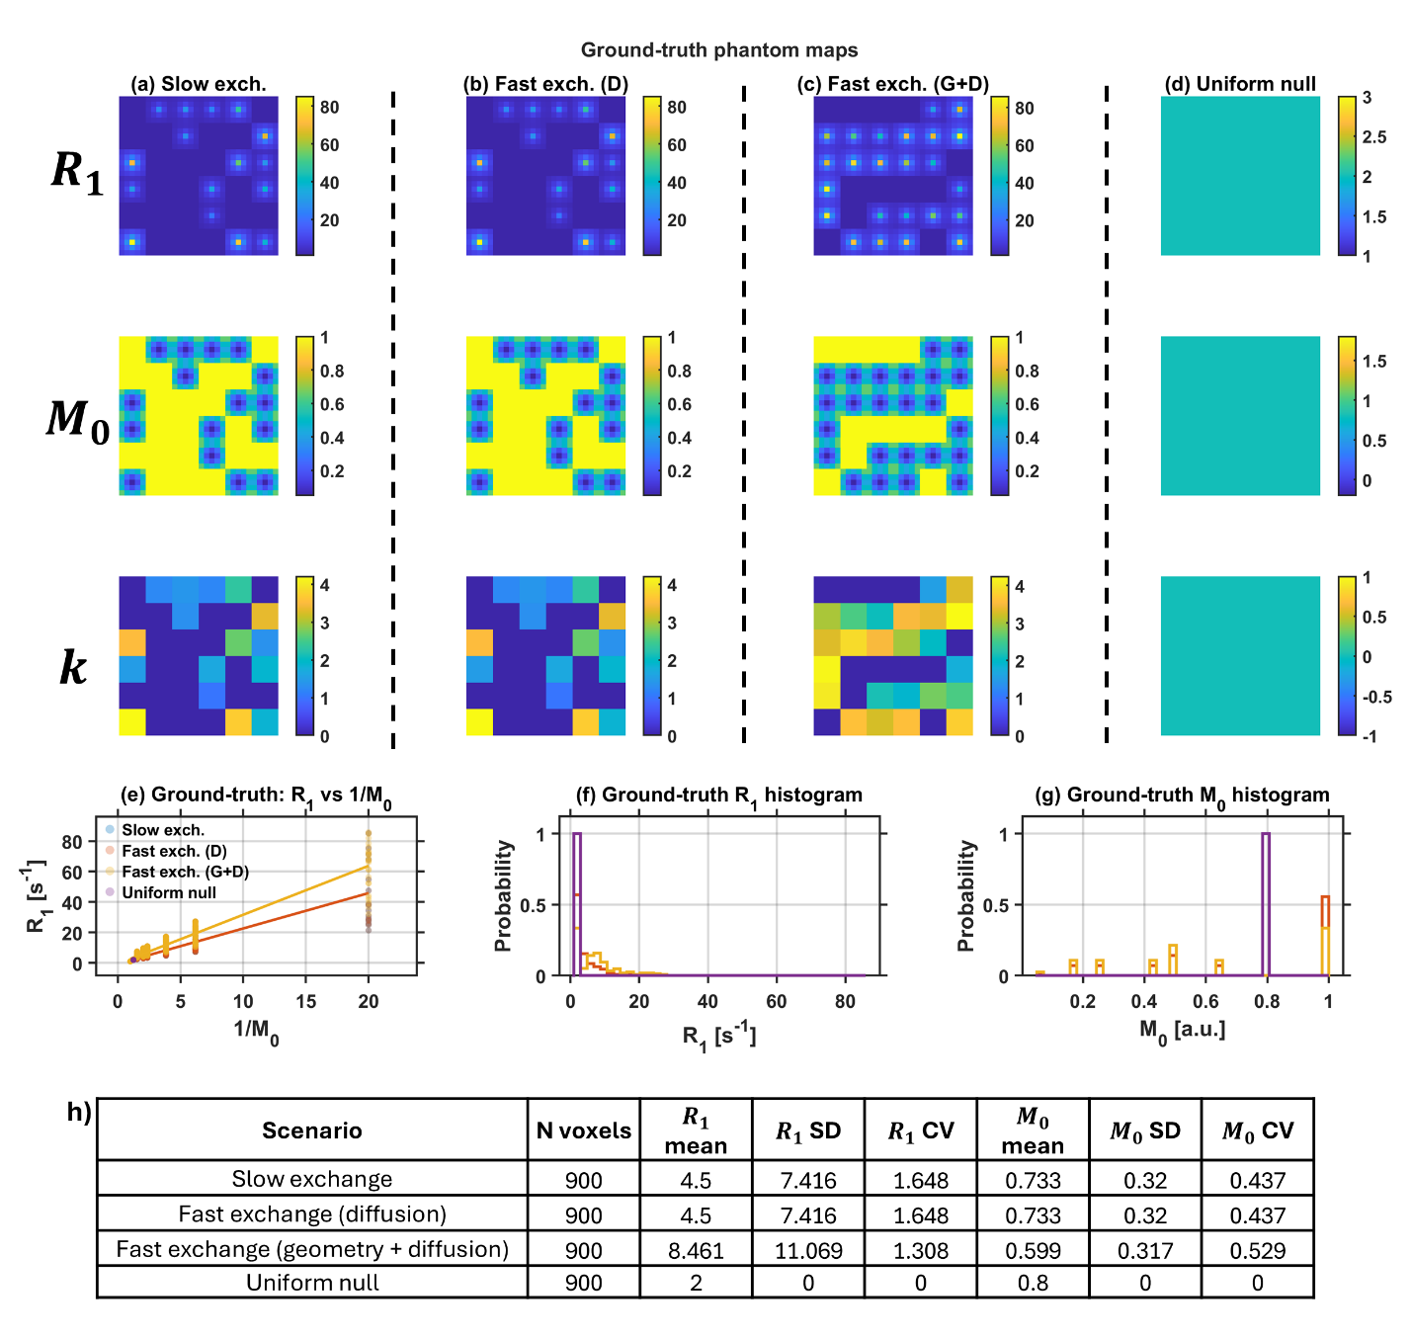
Figure S1. Ground-truth simulation phantoms and native-resolution exchange-regime summary. Prescribed R₁, M₀, and k maps are shown for three heterogeneous exchange scenarios: (a) slow exchange (D = 7.0×10⁻¹⁰ m²/s, $n_{TR}$ = 5; 16 Gaussian micro-domains), (b) fast exchange (diffusion) (D = 2.0×10⁻⁹ m²/s, $n_{TR}$ = 12; 16 micro-domains), and (c) fast exchange (geometry + diffusion) (same D and $n_{TR}$ as (b); 24 micro-domains), plus (d) a uniform-null control (M₀ = 0.8, R₁ = 2.0 s⁻¹, k = 0; D = 5.0×10⁻¹⁰ m²/s, $n_{TR}$ = 5). Maps were generated on a 30×30 grid (Δx = 15 µm) with R₀,free = 1.0 ± 0.05 s⁻¹, k drawn uniformly from [0.92, 4.28] s⁻¹, and local R₁ assigned as R₁ = R₀,free + k/M₀ (Eq. 5). Panels (e)–(g) show pooled ground-truth R₁ vs 1/M₀ and marginal R₁ and M₀ distributions across scenarios. After Bloch–Torrey SPGR simulation and two-flip-angle DESPOT₁ fitting at native resolution (noiseless; six seeds, 5,400 pooled voxels), the top table summarizes fitted linear metrics. Slopes were 1.29 (slow), 1.47 [fast exchange (D)], and 1.56 [fast exchange (G+D)]. R² was 0.68 (slow), 0.61 [fast exchange (D)], and 0.48 [fast exchange (G+D)]. Fitted R₁ CV was 0.55, 0.60, and 0.52, respectively. The bottom table reports changes after adding Rician noise at SNR = 25 (Δ = noisy − noiseless). Δslope was −0.61 (slow) but +0.48 and +0.25 for the fast-exchange arms. ΔR² was negative for all scenarios (−0.65 to −0.39). ΔR₁ CV was positive (+0.43 to +0.63), indicating noise-broadened fitted dispersion and regime-dependent changes in the apparent R₁–1/M₀ coupling.

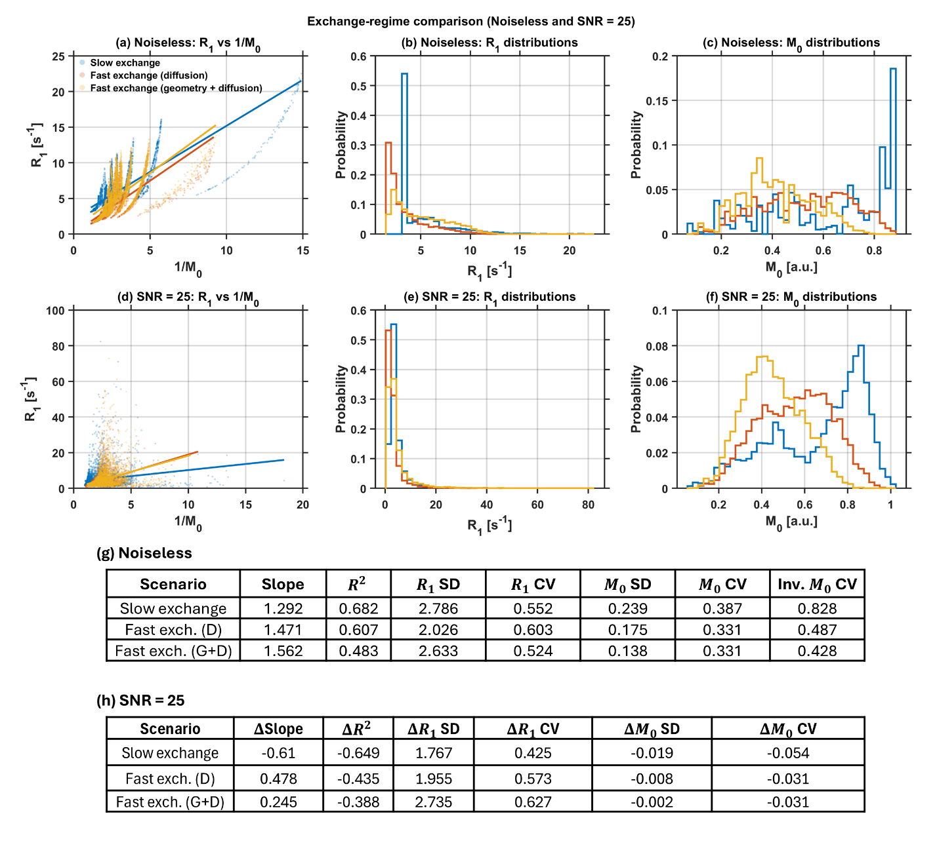
Figure S2. Exchange-regime comparison at native resolution (noiseless and SNR = 25). Native-resolution, pooled voxel-wise DESPOT₁ results are shown for three simulated exchange scenarios: slow exchange (D = 7.0×10⁻¹⁰ m²/s, $n_{TR}$ = 5; 16 Gaussian micro-domains), fast exchange (diffusion) (D = 2.0×10⁻⁹ m²/s, $n_{TR}$ = 12; 16 micro-domains), and fast exchange (geometry + diffusion) (same D and $n_{TR}$; 24 micro-domains), after Bloch–Torrey SPGR simulation and two-flip-angle fitting (six seeds; 5,400 voxels per scenario). Top row (a–c), noiseless: (a) fitted R₁ vs 1/M₀ scatter with linear fits; (b) and (c) fitted R₁ and M₀ distributions. Slow exchange shows the broadest, most structured R₁–1/M₀ cloud (slope = 1.29, R² = 0.68, fitted R₁ CV = 0.55), whereas the fast-exchange arms show more compact scatter (slopes 1.47 and 1.56; R² 0.61 and 0.48; R₁ CV 0.60 and 0.52). Bottom row (d–f), SNR = 25: the same panels after Rician noise. Noise broadens the point clouds, inflates high-R₁ tails in (e), and weakens linear fit quality. Table (g) summarizes noiseless metrics (slope, R², SD, CV); Table (h) gives Δ(noisy − noiseless). Noise suppressed slope in slow exchange (Δslope = −0.61) but increased it modestly in the fast-exchange arms (+0.48, +0.25); ΔR² was negative for all scenarios (−0.65 to −0.39); and ΔR₁ CV was positive (+0.43 to +0.63), indicating regime-dependent interaction between mesoscopic mixing and measurement noise rather than a uniform noise offset.

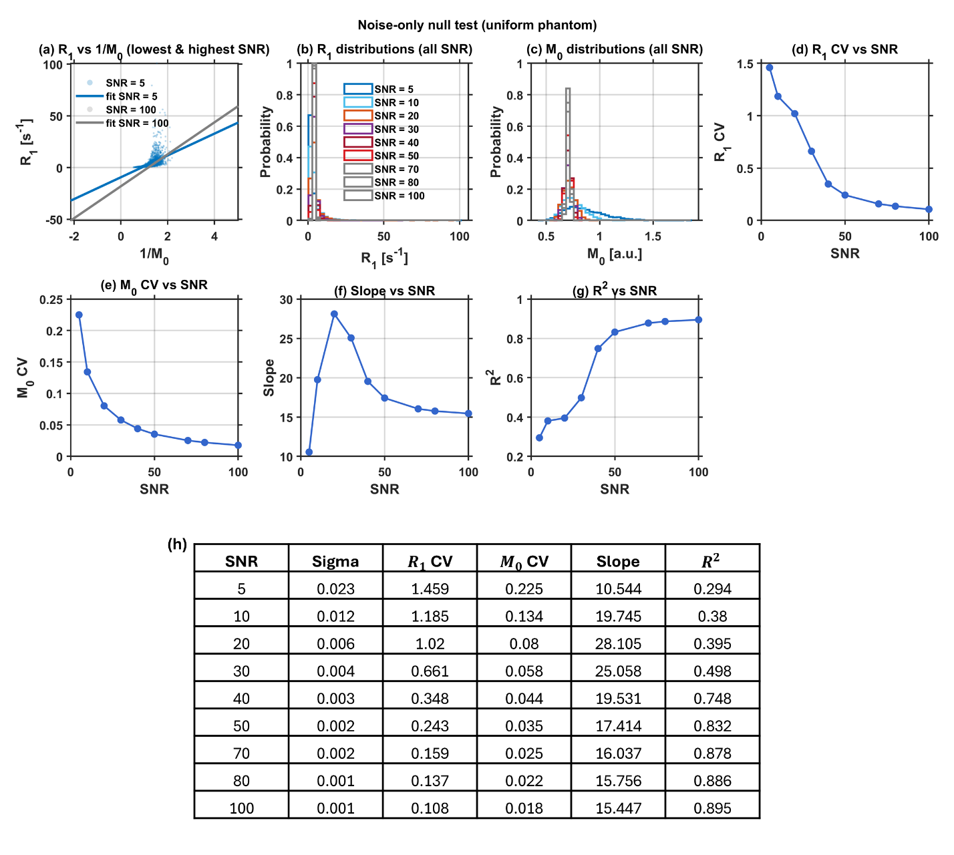
Figure S3. Noise-only null test on a uniform phantom (SNR sweep). Negative-control simulations used a spatially uniform phantom (M₀ = 0.8, R₁ = 2.0 s⁻¹, k = 0; D = 5.0×10⁻¹⁰ m²/s, nTR = 5) with no imposed microstructural heterogeneity. Rician noise was added at SNR ∈ {5, 10, 20, 30, 40, 50, 70, 80, 100}, followed by native-resolution two-flip-angle DESPOT₁ fitting. (a) Fitted R₁ vs 1/M₀ at the lowest (SNR = 5) and highest (SNR = 100) levels, showing noise-induced scatter and spurious linear trends despite constant ground truth. (b) and (c) Overlaid fitted R₁ and M₀ histograms across all SNR levels; distributions narrow as SNR increases but remain broader than expected for a truly uniform phantom at low SNR. (d)–(g) SNR dependence of fitted R₁ CV, M₀ CV, apparent slope, and R²: R₁ CV falls from 1.46 (SNR = 5) to 0.11 (SNR = 100), M₀ CV from 0.23 to 0.02, and R² rises from 0.29 to 0.90, whereas apparent slope is non-monotonic (peak ≈28 at SNR = 20). Table (h) lists σ and fitted metrics at each SNR. Because no tissue structure is present, apparent heterogeneity and R₁–1/M₀ coupling at low SNR reflect fitting noise alone and provide a baseline for interpreting heterogeneous tissue simulations (Figures S1–S2, S4–S6).

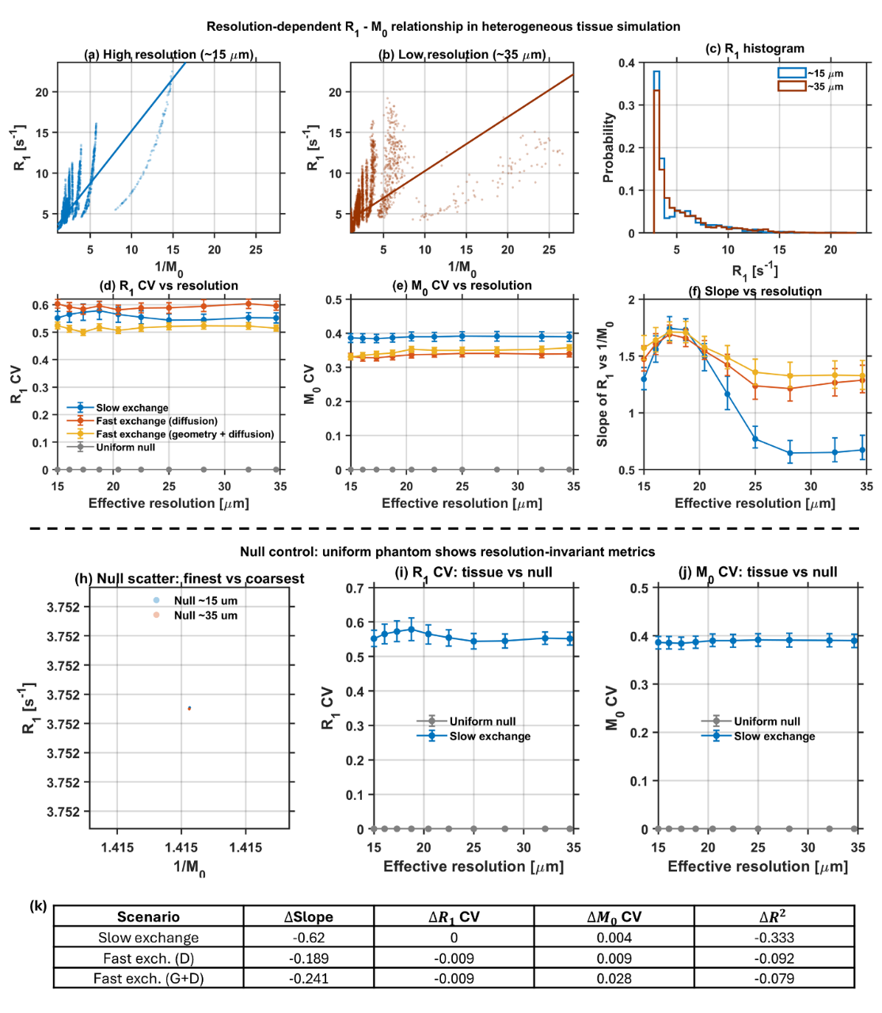

Figure S4. Resolution-dependent fitted R₁–M₀ relationship in heterogeneous tissue simulation (with uniform-null control). Noiseless native-to-coarse analysis used progressive Fourier k-space truncation of the same phantom maps (effective resolution ~15–35 µm; six seeds; bootstrap 95% CIs on trend curves). Top row (heterogeneous tissue; slow-exchange arm highlighted in scatter panels): (a) and (b) fitted R₁ vs 1/M₀ at ~15 µm and ~35 µm for slow exchange, showing scatter compression and reduced regression slope after spatial averaging; (c) native vs coarse R₁ histograms (distribution narrowing with coarsening); (d)–(f) R₁ CV, M₀ CV, and fitted slope versus effective resolution for slow exchange, fast exchange (diffusion), fast exchange (geometry + diffusion), and uniform null. Slope decreased most strongly for slow exchange (~1.3 to ~0.7 across the ladder), whereas fast-exchange arms showed smaller decreases. Tissue R₁ and M₀ CVs remained nonzero and comparatively flat, while the uniform null stayed at ~0. Middle row (null control): (h) fitted R₁ vs 1/M₀ at finest and coarsest resolution (overlapping cluster, no artificial spread); (i) and (j) R₁ and M₀ CV for slow exchange vs uniform null, confirming that resolution coarsening does not introduce spurious heterogeneity in a structure-free phantom. Table (k) gives native-to-coarse changes (Δ = coarsest − finest). Δslope was largest for slow exchange (−0.62) versus fast exchange (D) (−0.19) and (G+D) (−0.24). ΔR² was −0.33, −0.09, and −0.08, respectively, with minimal ΔR₁ CV and small positive ΔM₀ CV. Together, these results show that partial-volume averaging reshapes the apparent R₁–1/M₀ coupling in heterogeneous phantoms but not in uniform media, paralleling the experimental contraction seen in liver and onion versus PBS.

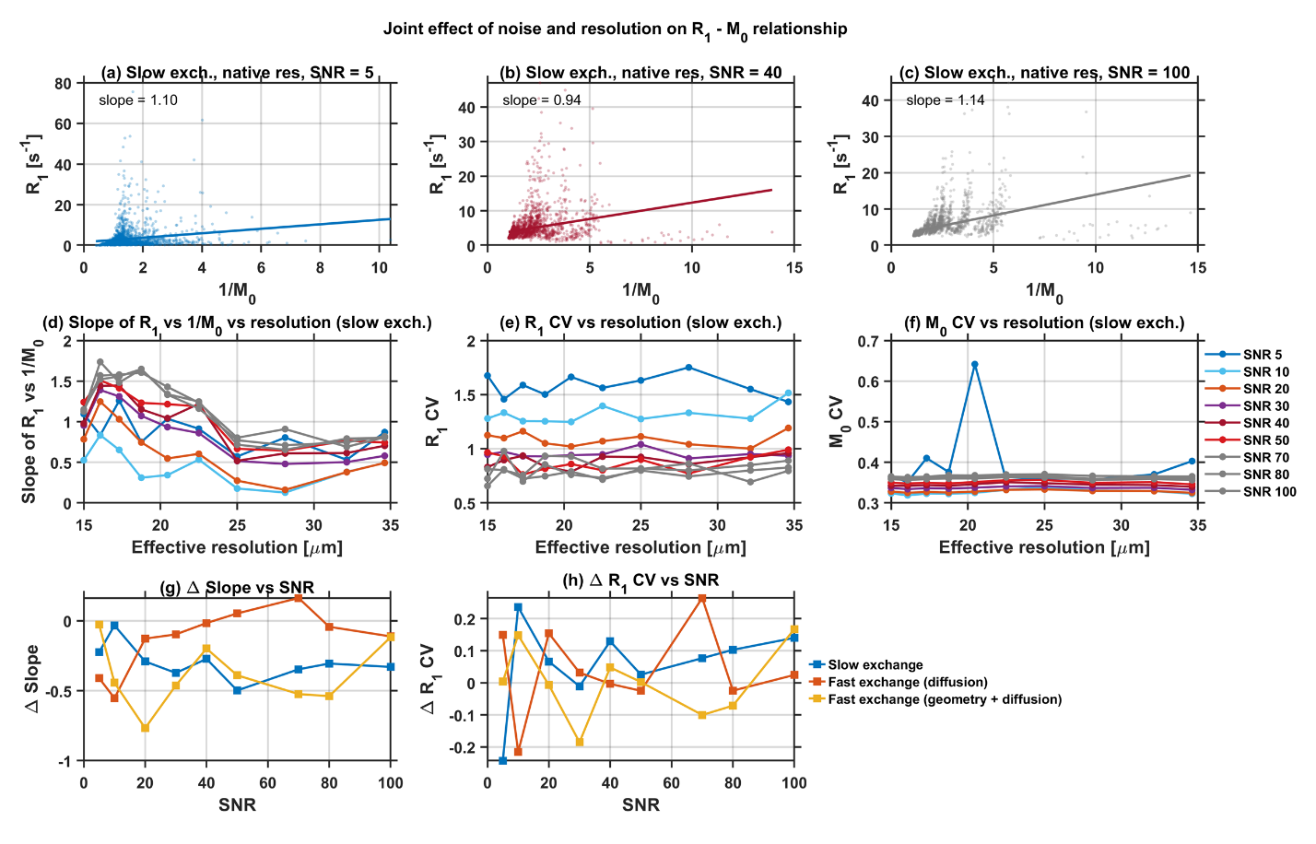

Figure S5. Joint effect of noise and resolution on the fitted R₁–M₀ relationship. A full SNR × resolution grid was simulated in the slow-exchange arm (and summarized for all exchange regimes in the bottom row) using independent Rician-noise levels and Fourier k-space coarsening (~15–35 µm; six seeds). Top row (a–c): native-resolution fitted R₁ vs 1/M₀ scatter for slow exchange at SNR = 5, 40, and 100, with linear fits (slopes 1.10, 0.94, and 1.14, respectively). Lower SNR broadens the cloud and degrades the apparent linear relationship before any resolution reduction. Middle row (d–f): fitted slope, R₁ CV, and M₀ CV versus effective resolution, with separate curves for SNR ∈ {5, 10, 20, 30, 40, 50, 70, 80, 100}. Slope generally decreases with coarsening at fixed SNR (partial-volume averaging), while R₁ CV is dominated by SNR level. M₀ CV is comparatively stable except at the lowest SNR. Bottom row (g–h): native-to-coarse changes (Δ = coarsest − finest) in slope and R₁ CV versus SNR for slow exchange, fast exchange (diffusion), and fast exchange (geometry + diffusion). Δslope is predominantly negative and SNR-dependent (e.g., at SNR = 50: −0.50 slow, −0.39 fast G+D, +0.05 fast D). ΔR₁ CV fluctuates between roughly −0.25 and +0.25 across regimes. Together, the panels show that noise shifts baseline fitted metrics and scatter width, whereas resolution coarsening adds further changes along the blur ladder. The two effects are independently controlled in simulation but interact, as the magnitude of native-to-coarse Δ metrics depends on SNR and exchange regime. This mirrors the experimental limitation that voxel enlargement usually alters both SNR and partial-volume averaging.

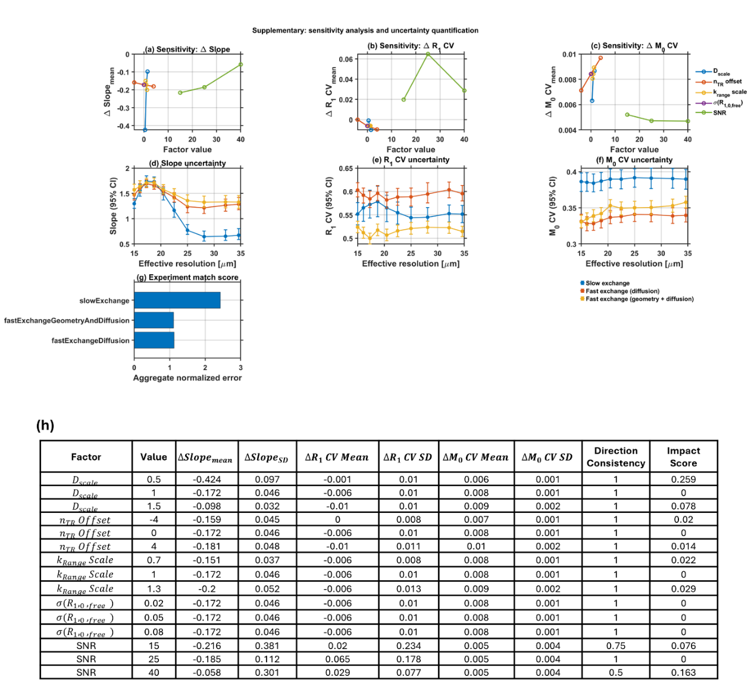

Figure S6. Sensitivity analysis and uncertainty quantification (simulation supplement). Native-to-coarse changes (Δ = coarsest − finest, ~34.6 µm vs ~15 µm) were evaluated under one-factor-at-a-time perturbations and nonparametric bootstrap resampling (400 resamples; 95% confidence intervals; six seeds). (a–c) Sensitivity: mean Δslope, ΔR₁ CV, and ΔM₀ CV in response to D scale (baseline D = 2.0 µm²/ms; tested at 1.0, 2.0, and 3.0 µm²/ms), $n_{TR}$ offset, k-range scale, σ(R₁,₀,free), and SNR. Perturbing the diffusion coefficient D and SNR produced the largest shifts in Δslope and ΔR₁ CV, whereas σ(R₁,₀,free) left all three metrics essentially unchanged. This indicates that resolution-dependent trends are driven by exchange/mixing and measurement noise rather than small baseline R₁ fluctuations. SNR showed a distinct effect on ΔR₁ CV (peak near SNR = 25 in panel b). (d–f) Bootstrap uncertainty: fitted slope, R₁ CV, and M₀ CV versus effective resolution (~15–35 µm) for slow exchange, fast exchange (diffusion), and fast exchange (geometry + diffusion). Slope trends were well resolved (non-overlapping CIs between native and coarsest for heterogeneous arms). R₁ CV was highest for fast exchange (diffusion) and lowest for fast exchange (G+D), while M₀ CV was highest for slow exchange. (g) Experiment-match score (aggregate normalized error; lower is better): slow exchange scored highest (~2.43), and the two fast-exchange arms scored similarly (~1.12 and ~1.11), indicating closer agreement with experimental native-to-coarse trends for faster-mixing regimes. (h) Sensitivity summary table: per-factor mean ± variability (SD) of native-to-coarse Δslope, ΔR₁ CV, and ΔM₀ CV, direction consistency across seeds, and impact score. The table confirms that D and SNR are the dominant contributors to resolution-dependent metric changes, whereas σ(R₁,₀,free) has negligible influence. Direction consistency was 100% for D, $n_{TR}$, k-range, and σ(R₁,₀,free) perturbations, but fell to 50–75% for extreme SNR settings, reflecting stronger noise-driven variability at low SNR.

Supplementary Information 2

Generalization of the Scale-Dependent Relaxation Sink Model

Part A:
Consider a small volume $v$ containing mass m in which there is complete mixing / fast exchange (see Figure S7) so that the relaxation rate within this unit is
$$\begin{aligned}R^{'}=R+\frac{km}{v} \#\left(C1\right)\end{aligned}$$

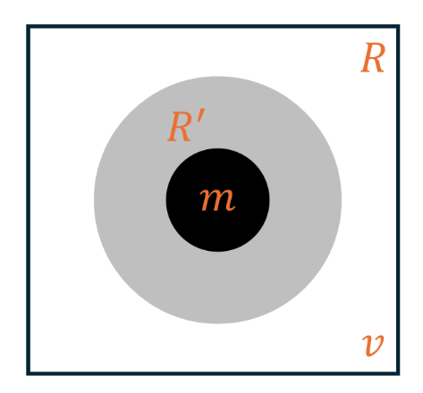
Figure S7: Definition of a relaxation sink. A sub-volume $v$ contains $n$ units of added material $m$ (total added mass $nm$). Under fast exchange $v$, the sink is characterized by a single effective rate $R\left(n\right)=R+k(\frac{nm}{v})$.

This “relaxation sink” is the largest volume to support averaging by fast exchange. Consider a larger volume V in an image = one voxel, in which there are N close-packed such units.
$$\begin{aligned}V=Nv \#\left(C2\right)\end{aligned}$$
$$\begin{aligned}M=Nm \#\left(C3\right)\end{aligned}$$
If the mass is homogenously distributed in this MR voxel, the relaxation rate remains unchanged despite the voxel volume (see Figure S8).
$$\begin{aligned}R_{V}^{'}= R_{v}^{'} \#\left(C4\right)\end{aligned}$$
A small voxel / high resolution has all relaxation due to mass M, which is averaged out, and N is small.

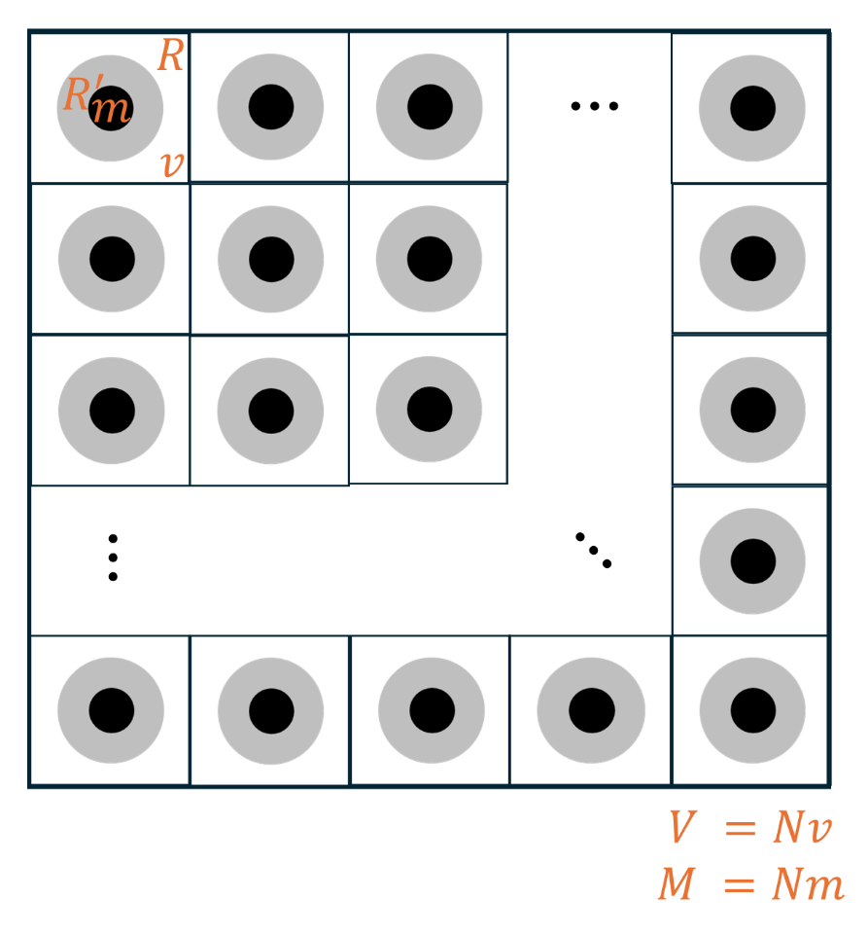
Figure S8. Homogeneous distribution within a voxel. A voxel of volume $V=Nv$ contains $N$ sinks, each with identical concentration $\frac{m}{v}$, so every sink has the same rate $R^{'}=R+k(\frac{m}{v})$ and the voxel-averaged rate does not depend on partitioning (N).

Now consider a second type of unit which contains no added mass, so it has a relaxation rate $R$. Suppose a voxel contains 2 types: half with no material, half with twice as concentrated (see Figure S9). Relaxation of the two compartments, each of volume $V/2$ are

$$\begin{aligned}R \#\left(C5\right)\end{aligned}$$

and
$$\begin{aligned}R^{'}=R+\frac{2km}{v} \#\left(C6\right)\end{aligned}$$
Continue dividing similarly: after N steps, we have a sub-volume $V/N$ with a relaxation rate
$$\begin{aligned}R^{'}=R+\frac{Nkm}{v} \#\left(C7\right)\end{aligned}$$
and sub volume $\frac{N-1}{N}V$ with rate R.

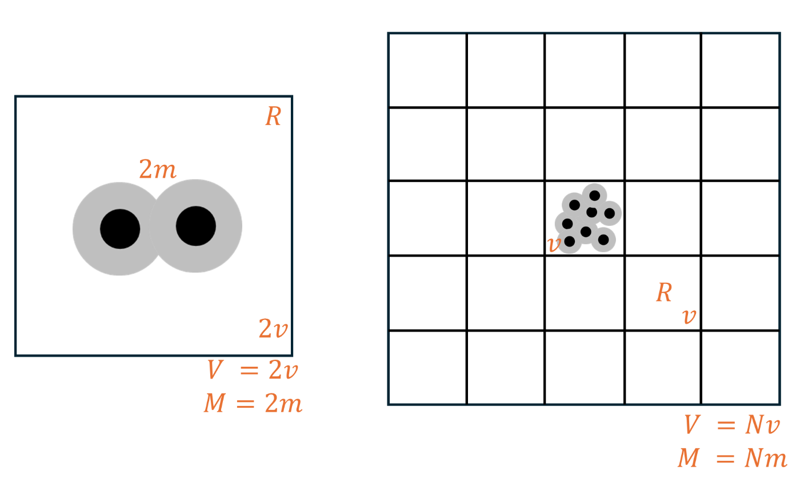
Figure S9: Extreme heterogeneous (two-point) distribution inside a voxel. One sink (volume $v$) contains all added mass in the voxel ($n=N ⇒total added mass Nm$), while the remaining $N-1$ sinks contain none ($n=0$).

The signal from the $N$ units in the voxel of volume $V$ is:

$$\begin{aligned}S=Vexp\left(-R_{eff}t\right)= \frac{N-1}{N} Vexp\left(-Rt\right)+ \frac{1}{N}Vexp\left(-R^{'}t\right) \#\left(C8\right)\end{aligned}$$

Or,
$$\begin{aligned}S=Vexp\left(-R_{eff}t\right)=Vexp\left(-Rt\right)+ \frac{V}{N} (\exp\left(-R^{'}t\right)-\exp\left(-Rt\right) )\#\left(C9\right)\end{aligned}$$
$$\begin{aligned}\frac{S}{V}=\exp\left(-Rt\right)\left[1+\frac{1}{N}\left\{\frac{\exp\left(-R^{'}t\right)-\exp\left(-Rt\right)}{\exp\left(-Rt\right)}\right\}\right] \#\left(C10\right)\end{aligned}$$
$$\begin{aligned}\frac{S}{V}=\exp\left(-Rt\right)\left[1+\frac{1}{N}\left(\exp\left(-R^{'}t+Rt\right)-1\right)\right] \#\left(C11\right)\end{aligned}$$
From $C7$, $R^{'}-R= \frac{Nkm}{v}$,
$$\begin{aligned}S^{'}=\frac{S}{V}=\exp\left(-R_{eff}t\right)=\exp\left(-Rt\right)\left(1+\frac{1}{N}\left(\exp\left(-\frac{Nkm}{v}t\right)-1\right)\right)\#\left(C12\right)\end{aligned}$$

The signal per voxel = $S’$ = image intensity, varies with $N$ and $v$ .

$$\begin{aligned}\frac{dS^{'}}{dv}=\frac{\exp\left(-Rt\right)}{N}\exp\left(-\frac{Nkmt}{v}\right)\frac{Nmkt}{v^{2}}\#\left(C13\right)\end{aligned}$$
Now, let us define $F=-\frac{1}{t}logS'$=$R_{eff}$
$$\begin{aligned}\frac{dF}{dv}=-\frac{1}{S^{'}t}\frac{dS^{'}}{dv} \#\left(C14\right)\end{aligned}$$

After plugging in the respective terms for $S^{'}$ and $\frac{dS^{'}}{dv}$ from equation $C13$ and $C14$,
$$\begin{aligned}\frac{dF}{dv}=-\frac{1}{t}\frac{(\frac{\exp\left(-Rt\right)}{N}exp\left(-\frac{Nkmt}{v}\right)\frac{Nmkt}{v^{2}})}{exp⁡(-Rt)(1+ \frac{1}{N}(exp\left(-\frac{Nkm}{v}t\right)-1))} \#\left(C15\right)\end{aligned}$$

$$\begin{aligned}\frac{dF}{dv}=-\frac{kM}{v^{2}}\frac{exp\left(-\frac{kMt}{v}\right)}{(N+ exp\left(-\frac{kMt}{v}\right)-1)} \#\left(C16\right)\end{aligned}$$

When $N=1$,
$$\begin{aligned}\frac{dF}{dv}=-\frac{kM}{v^{2}} \#\left(C17\right)\end{aligned}$$

Here, $\frac{kM}{v}$= relaxation rate above background. Typically > or ≈ 1 so $exp\left(-\frac{kMt}{v}\right)≪N-1$ even for low $N$, the above equation $C17$, $\frac{dF}{dv}=-\frac{kM}{v^{2}}.\frac{exp\left(-\frac{kMt}{v}\right)}{(N-1)}$ becomes less negative as $N$ increases. Larger voxels have larger $N$ so slope becomes less negative.

So, the question becomes: in general, a voxel contains a range of values of $nm/v$. Can this calculation be generalized by introducing a probability distribution $p(n)$ for $n$?

Part B: Generalization of the “Relaxation Sink” Model to a Distribution $p(n)$

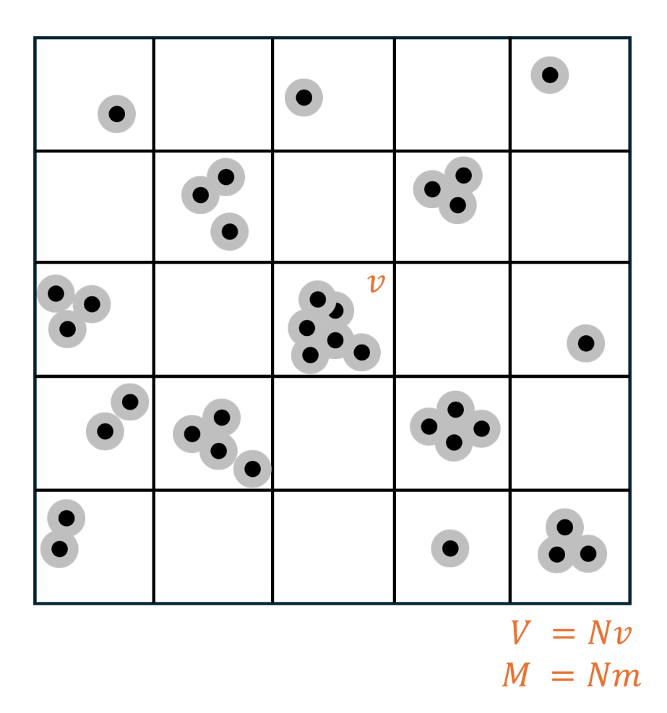
Figure S10. General heterogeneous distribution $p(n)$ across sinks. The voxel ($V=Nv$) is partitioned into sinks of volume $v$, each containing a variable number $n$ of added-mass units $m$. The distribution of occupancies $n$ across sinks defines $p(n)$, leading to $S^{'}\left(v\right)= exp\left( -R t \right)· \sum_{n=0}^{∞}{ p\left(n\right)} · exp\left( - \left( k\frac{nm}{v} \right)t \right)$.

This section provides a step-by-step derivation that generalizes the special-case voxel partitioning argument to the realistic situation where the number of “mass” inside a relaxation sink is a random variable $n$.

We model a voxel as being composed of many small sub-volumes (“relaxation sinks”) of equal volume $v$. Within each sink, fast exchange is assumed to hold, so the sink is characterized by a single effective relaxation rate.

Let:
• $R$ = baseline relaxation rate of the background tissue (Type #1).
• $m$ = a fixed ‘unit’ amount of additional material (Type #2) that increases relaxation.
• $n$ = nonnegative integer-valued random variable describing how many units m are present inside a sink.
• $k$ = proportionality constant relating added material to added relaxation.
• $t$ = evolution time (e.g., $TR$, $TE$, or the relevant relaxation-weighting time depending on the sequence).

We also use $V$ for voxel volume and $N$ for the number of sinks inside the voxel, where:
$V = Nv$ (so $N = V/v$)

If a given sink contains total added material equal to $nm$, then the added material concentration in that sink is $(nm)/v$. Under the fast-exchange assumption, the sink’s relaxation rate is:
$$\begin{aligned}R\left(n\right)=R+k\frac{nm}{v}\#\left(C18\right)\end{aligned}$$
For a sink with relaxation rate $R(n)$, the (normalized) signal contribution at time $t$ is:
$\begin{aligned}s\left(n\right)= exp\left( - R\left(n\right)t \right)\#\left(C19\right)\end{aligned}$by substituting the expression for $R(n)$:
$\begin{aligned}s\left(n\right)= exp\left( - \left(R+k\frac{nm}{v} \right)t \right)\#\left(C20\right)\end{aligned}$by factoring out the baseline term $exp(-R t)$:
$$\begin{aligned}s\left(n\right)= exp\left( -R t \right)·\exp{(-}\left(k\frac{nm}{v}\right)t) \# \left(C21\right)\end{aligned}$$

Voxel-averaged signal for a general distribution $p(n)$
In a realistic voxel, different sinks can contain different values of n. Let $p(n)$ denote the probability mass function (pmf) of n for a sink randomly drawn from the voxel. By definition:

$p(n) ≥ 0$ for $n = 0,1,2,...$
and
$$\sum_{n=0}^{∞}{ p(n) = 1}$$
Because MRI measures the volume-averaged magnetization, the voxel’s normalized signal (signal per unit volume) is the expectation of $s(n)$ over $p(n)$:
$$\begin{aligned}S^{'}\left(v\right)=E\left[s\left(n\right)\right]= \sum_{n=0}^{∞}{ p\left(n\right)}s\left(n\right) \#\left(C22\right)\end{aligned}$$

Insert the expression for $s(n)$:
$\begin{aligned}S^{'}\left(v\right)= \sum_{n=0}^{∞}{ p\left(n\right)} · exp\left( - \left( R+k\frac{nm}{v} \right)t\right)\#\left(C23\right)\end{aligned}$factor out $exp(-Rt)$:
$\begin{aligned}S^{'}\left(v\right)= exp\left( -R t \right)· \sum_{n=0}^{∞}{ p\left(n\right)} · exp\left( - \left( k\frac{nm}{v} \right)t \right)\#\left(C24\right)\end{aligned}$the unnormalized voxel signal $S$ (proportional to voxel volume) can be written as:
$$\begin{aligned}S\left(v\right)= V · S^{'}\left(v\right) \#\left(C25\right)\end{aligned}$$

Now, let’s define an effective relaxation rate $R_{eff}(v)$ such that the voxel-averaged normalized signal has the same form as a single exponential:

$\begin{aligned}S^{'}\left(v\right)= exp\left( - R_{eff}\left(v\right)t \right) \#\left(C26\right)\end{aligned}$take the natural logarithm of both sides:
$$\begin{aligned}\ln{S^{'}\left(v\right)}= - R_{eff}\left(v\right)t \#\left(C27\right)\end{aligned}$$

solve for $R_{eff}(v)$:
$$\begin{aligned}R_{eff}\left(v\right)= - \left(\frac{1}{t}\right)·\ln{S^{'}\left(v\right)}\#\left(C28\right)\end{aligned}$$

substitute the expression for $S'(v)$ to make the dependence on $p(n)$ explicit:
$$\begin{aligned}R_{eff}\left(v\right)= R - (1/t) · ln⁡( \sum_{n=0}^{∞}{ p\left(n\right)}· exp\left(- \left( k\frac{nm}{v} \right)t \right)\#\left(C29\right)\end{aligned}$$

Connection to the special case in Part A
The special case in the original note corresponds to an extreme two-point distribution for $n$: most sinks have no added material, and exactly one sink per voxel contains all the added material. If the voxel contains $N$ sinks, then a randomly chosen sink has:

• $n = 0$ with probability $\frac{N-1}{N}$
• $n = N$with probability $1/N$

This is the pmf:
$$\begin{aligned}p\left(n\right)=\frac{N-1}{N}· δ_{n,0} + \left(\frac{1}{N}\right)· δ_{n,N} \#\left(C30\right)\end{aligned}$$

Where $δ_{n,0}=\left\{\begin{aligned}1, &n=0 \\ 0, &n≠0\end{aligned}\right.$ and $δ_{n,N}=\left\{\begin{aligned}1, &n=N \\ 0, &n≠N\end{aligned}\right.$. Now, let’s evaluate equation (C24) for this case

$$S^{'}\left(v\right)= exp\left( -R t \right)· \sum_{n=0}^{∞}{ p\left(n\right)} · exp\left( - \left( k\frac{nm}{v} \right)t \right)$$
$$S^{'}\left(v\right)= exp\left( -R t \right)· \sum_{n=0}^{∞}{ p\left(n\right)} · f(n)$$
where $f\left(n\right)=exp\left( - \left( k\frac{nm}{v} \right)t \right)$. Now let’s evaluate
$$\begin{aligned}\sum_{n=0}^{∞}{p\left(n\right)f\left(n\right)= } \sum_{n=0}^{∞}{\left[\frac{N-1}{N}δ_{n,0}+\frac{1}{N}δ_{n,N}\right]f\left(n\right)}\#\left(C31\right)\end{aligned}$$

Since
$$\sum_{n=0}^{∞}{δ_{n,0}f\left(n\right)=f\left(0\right)=1}$$
$$\sum_{n=0}^{∞}{δ_{n,N}f\left(n\right)=f\left(N\right)=exp⁡\left(-\frac{kNm}{v}t\right)}$$
So equation (C31) becomes

$$\begin{aligned}\sum_{n=0}^{∞}{p\left(n\right)f\left(n\right)= }\frac{N-1}{N}+\frac{1}{N}exp⁡\left(-\frac{kNm}{v}t\right)\#\left(C32\right)\end{aligned}$$

Thus, $S^{'}\left(v\right)$ becomes
$$\begin{aligned}S^{'}\left(v\right) =\exp\left(-Rt\right)\left[\frac{N-1}{N}+\frac{1}{N}exp⁡\left(-\frac{kNm}{v}t\right)\right]\#\left(C33\right)\end{aligned}$$

which matches the special-case mixture form derived earlier.

Derivative with respect to $v$ (keeping all terms)
We want to find out how $R_{eff}$ changes with $v$, differentiate without dropping the exponential weights. Allow the possibility that the distribution $p$ may itself depend on $v$ (write $p_{v}\left(n\right)$). Start from:
$\begin{aligned}S^{'}\left(v\right)= \sum_{n=0}^{∞}{p_{v}\left(n\right)} · exp\left(- \left( R+k\frac{nm}{v} \right)t\right)\#\left(C34\right)\end{aligned}$Differentiate term-by-term using the product rule.

For each $n$, define: $f_{n}(v) = p_{v}(n)$ and $g_{n}(v) =exp(- ( R+k\frac{nm}{v} )t)$

Then
$$\begin{aligned}S^{'}\left(v\right)= \sum_{n=0}^{∞}{f_{n}\left(v\right)g_{n}(v)}\#\left(C35\right)\end{aligned}$$

Differentiate term-by-term:
$$\begin{aligned}\frac{dS^{'}}{dv}= \sum_{n=0}^{∞}{\frac{d}{dv}\left(f_{n}g_{n}\right)}=\sum_{n=0}^{∞}{ }\left[\left(\frac{df_{n}}{dv}\right)g_{n} + f_{n} \left(\frac{dg_{n}}{dv}\right)\right] \#\left(C36\right)\end{aligned}$$
Compute $\frac{dg_{n}}{dv}$ explicitly. First write $g_{n}(v)$ as a product:
$\begin{aligned}g_{n}\left(v\right)= exp\left( -R t \right)· exp\left(- \left( k\frac{nm}{v} \right)t\right) \#\left(C37\right)\end{aligned}$the second factor depends on $v$. Let $a = knmt$, so the factor is $exp\left(-\frac{a}{v}\right)$. Then:
$$\begin{aligned}\frac{d}{dv}\left[exp⁡\left(-\frac{a}{v}\right)\right]=exp\left(-\frac{a}{v}\right)∙\frac{d}{dv}\left(-\frac{a}{v}\right)\#\left(C38\right)\end{aligned}$$

$$\begin{aligned}\frac{d}{dv}\left(-\frac{a}{v}\right) =\frac{a}{v^{2}} \#\left(C39\right)\end{aligned}$$

Therefore:
$\begin{aligned}\frac{dg_{n}}{dv}= exp\left(- \left(R+ k\frac{nm}{v} \right)t\right)\left(\frac{knmt}{v^{2}}\right) \#\left(C40\right)\end{aligned}$Insert back into $dS'/dv$:
$$\begin{aligned}\frac{dS^{'}}{dv}= \sum_{n=0}^{∞}{\exp\left(- \left( R+k\frac{nm}{v} \right)t\right)}\left[\frac{dp_{v}\left(n\right)}{dv}+ p_{v}\left(n\right)\left(\frac{knmt }{v^{2}}\right)\right] \#\left(C41\right)\end{aligned}$$

Now use $R_{eff}(v) = -(1/t) ln S'(v)$. Differentiate:
$$\begin{aligned}\frac{dR_{eff}}{dv}= \frac{d}{dv}\left[-\left(\frac{1}{t}\right)lnS^{'}(v)\right]= -\left(\frac{1}{t}\right)\left(\frac{1}{S^{'}\left(v\right)}\right)\left(\frac{dS^{'}}{dv}\right) \#\left(C42\right)\end{aligned}$$

Substitute the expression for $dS'/dv$ to obtain the fully general derivative (no steps omitted):
$$\begin{aligned}\frac{dR_{eff}}{dv}= -\left(\frac{1}{tS^{'}}\right)\sum_{n=0}^{∞}{exp\left(- \left( R+k\frac{nm}{v} \right)t\right)}\left[\frac{dp_{v}\left(n\right)}{dv}+p_{v}\left(n\right)\left(\frac{knmt }{v^{2}}\right)\right] \# \left(C43\right)\end{aligned}$$

Simplified derivative when $p(n)$ does not depend on $v$
In some instances, it is reasonable to assume that $p(n)$ is fixed for the tissue, and the voxel-size dependence enters only through the factor $(nm/v)$ inside the exponential. In that case $\frac{dp_{v}(n)}{dv}=0$ and the derivative simplifies.
Start from the expression for $\frac{dS^{'}}{dv}$ and drop the $\frac{dp_{v}(n)}{dv}$ term:
$$\begin{aligned}\frac{dS^{'}}{dv}= \sum_{n=0}^{∞}{ } p\left(n\right)\exp\left(- \left( R+k\frac{nm}{v} \right)t\right) \left(\frac{knmt }{v^{2}}\right) \#\left(C44\right)\end{aligned}$$

Insert into $\frac{dR_{eff}}{dv}= -\frac{1}{tS^{'}}\frac{dS^{'}}{dv}$ :

$$\begin{aligned}\frac{dR_{eff}}{dv}= -\frac{1}{tS^{'}}\sum_{n=0}^{∞}{ p\left(n\right)\exp\left(- \left( R+k\frac{nm}{v} \right)t\right) \left(\frac{knmt }{v^{2}}\right) } \#\left(C45\right)\end{aligned}$$

Cancel $t$ and factor out $\left(\frac{km}{v^{2}}\right)$:
$$\begin{aligned}\frac{dR_{eff}}{dv}= -\frac{km}{v^{2}}\frac{\left[\sum_{n=0}^{∞}{n p\left(n\right)\exp\left(- \left( R+k\frac{nm}{v} \right)t\right) }\right]}{\sum_{n=0}^{∞}{p_{v}\left(n\right)}exp\left(- \left( R+k\frac{nm}{v} \right)t\right)} \#\left(C46\right)\end{aligned}$$

The denominator is positive, and the numerator is a weighted sum of nonnegative terms, hence nonnegative. Therefore, under the assumption $p\left(n\right)$ does not depend on $v$, i.e., $\frac{dp_{v}(n)}{dv}$ = 0, one obtains $\frac{dR_{eff}}{dv}≤ 0$ (and typically $<0$ unless $p$ is concentrated at $n = 0$).

Equivalent generating-function view
Define the dimensionless parameter:
$$\begin{aligned}α\left(v\right)= \frac{kmt}{v} \#\left(C47\right)\end{aligned}$$

Then the normalized signal can be written as:
$$\begin{aligned}S^{'}\left(v\right)=exp⁡(-Rt) \sum_{n=0}^{∞}{p(n)exp⁡( -α(v) n})\#\left(C48\right)\end{aligned}$$
The sum is the discrete Laplace transform of $p(n)$. If $G(z) = \sum_{n=0}^{∞}{p\left(n\right)z^{n}}$ is the probability generating function (pgf), then $\sum_{n=0}^{∞}{\exp\left(-αn\right)=G(\exp\left(-α\right))}$. This makes it explicit that the voxel-size dependence enters through $α∝1/v$.

In summary, the core generalization is that voxel signal is a weighted average over sinks with different $n$, and the effective relaxation rate is obtained by taking the negative log:
$$\begin{aligned}S^{'}\left(v\right)= \sum_{n=0}^{∞}{p(n)}exp\left(- \left( R+k\frac{nm}{v} \right)t\right)\# \left(C49\right)\end{aligned}$$
$\begin{aligned}R_{eff}\left(v\right)= -\left(\frac{1}{t}\right)lnS^{'}\left(v\right) \#\left(C50\right)\end{aligned}$This formulation reduces exactly to the special-case derivation when $p(n)$ is chosen as a two-point (clustered) distribution.

Supplementary Information 3

Supplementary Table 1: Liver 10 slice ROI analysis summary
Metric | High Resolution Value | Low Resolution Value | Percent Change
T₁ CV | 0.48 | 0.21 | -56.8
T₁ Std | 0.09 | 0.04 | -60.58
T₁ Mean | 0.19 | 0.17 | -8.7
M₀ CV | 0.17 | 0.12 | -31.91
M₀ Std | 15.11 | 10.16 | -32.78
M₀ Mean | 89.15 | 87.98 | -1.32
Abs Slope | 848.29 | 549.33 | -35.24
Intercept | -3.42 | -0.21 | -93.89
R² mean | 0.43 | 0.33 | -23.39

Supplementary Table 2: Green Onion 10 slice ROI analysis summary
Metric | High Resolution Value | Low Resolution Value | Percent Change
T₁ CV | 0.16 | 0.1 | -33.87
T₁ Std | 0.1 | 0.07 | -34.54
T₁ Mean | 0.67 | 0.66 | -1.01
M₀ CV | 0.21 | 0.2 | -5.31
M₀ Std | 0.1 | 0.09 | -5.37
M₀ Mean | 0.47 | 0.47 | 0
Abs Slope | |+0.05| | |-0.05| | 16.45
Intercept | 1.44 | 1.64 | 13.99
R² mean | 0 | 0.03 | 551.46

Supplementary Table 3: Spinal Cord 10 slice ROI analysis summary
Metric | High Resolution Value | Low Resolution Value | Percent Change
T₁ CV | 0.18 | 0.13 | -29.98
T₁ Std | 0.05 | 0.03 | -30.17
T₁ Mean | 0.25 | 0.25 | -0.55
M₀ CV | 0.08 | 0.06 | -25.86
M₀ Std | 0.03 | 0.03 | -25.89
M₀ Mean | 0.42 | 0.42 | -0.05
Abs Slope | 2.6 | 2.49 | -4.23
Intercept | -2.13 | -1.88 | -11.53
R² mean | 0.6 | 0.53 | -11.55

Supplementary Table 4: PBS 10 slice ROI analysis summary
Metric | High Resolution Value | Low Resolution Value | Percent Change
T₁ CV | 0.08 | 0.08 | -3.57
T₁ Std | 0.01 | 0.01 | -3.6
T₁ Mean | 0.15 | 0.15 | -0.03
M₀ CV | 0.04 | 0.04 | -0.79
M₀ Std | 0.07 | 0.07 | -0.76
M₀ Mean | 1.68 | 1.68 | 0.02
Abs Slope | 23.14 | 22.19 | -4.08
Intercept | -7.12 | -6.56 | -7.94
R² mean | 0.95 | 0.92 | -3.55

