Anaerobic oxidation of propane by thermophilic archaea from marine hydrothermal sediments
Niculina Musat^{1,2*}, Song-Can Chen^{3,4,5*}, Oliver Lechtenfeld⁶, Jing-Ling Yan^{3,4,5}, Xiyan Zhang¹, Ian Marshall¹, Jiaheng Ji², Denny Popp⁷, Lorenz Adrian⁸, Hans-Hermann Richnow⁹, Florin Musat^{1,2*}
¹Department of Biology, Section for Microbiology, Aarhus University, Aarhus, Denmark.
²Department of Technical Biogeochemistry, Helmholtz Centre for Environmental Research – UFZ, Leipzig, Germany.
³State Key Laboratory of Soil Pollution Control and Safety, Zhejiang University, Hangzhou, China.
⁴MOE Key Laboratory of Environment Remediation and Ecological Health, College of Environmental and Resource Sciences, Zhejiang University, Hangzhou, China.
⁵State Key Laboratory of Soil Pollution Control and Safety, College of Environmental and Resource Sciences, Zhejiang Provincial Key Laboratory of Agricultural Resources and Environment, Zhejiang University, Hangzhou, China.
⁶Department of Environmental Analytical Chemistry, Helmholtz Centre for Environmental Research – UFZ, Leipzig, Germany.
⁷Department of Applied Microbial Ecology, Helmholtz Centre for Environmental Research – UFZ, Leipzig, Germany.
⁸Department of Molecular Environmental Biotechnology, Helmholtz Centre for Environmental Research – UFZ, Leipzig, Germany.
⁹Atmospheric Chemistry Department (ACD), Leibniz Institute for Tropospheric Research - TROPOS, Leipzig, Germany

* Correspondence to:
NM: niculina.musat@bio.au.dk
SCC: songcan.chen@zju.edu.cn
FM: florin.musat@bio.au.dk

Supplementary Information

Cultivation of anaerobic, thermophilic propane oxidizers
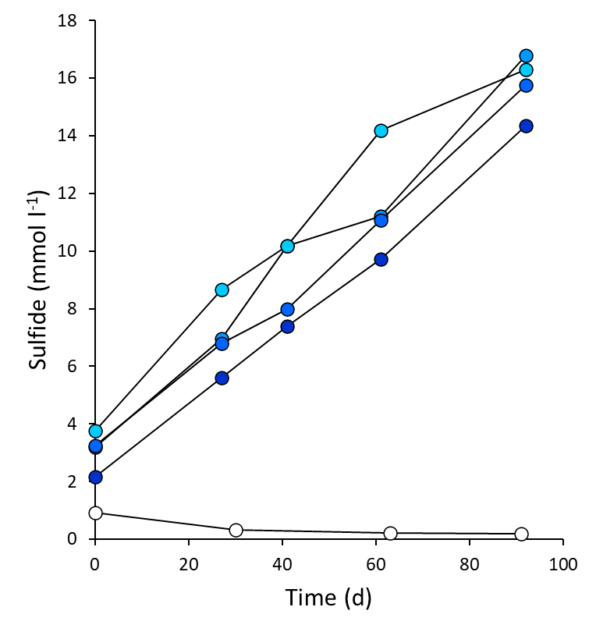
Figure S1| Propane-dependent sulfate reduction in replicate cultures of Ca. Syntrophoarchaeum upon substrate shift from butane to propane. Cultures produced approximately 12 mM sulfide within 90 days of incubation (solid circles). No sulfide was produced in propane-free controls (white circles).

Microbial community structure of the Propane50 culture
Metagenomic sequencing was performed on three replicate Propane50 cultures. From the assembled contigs, full-length 16S rRNA genes were retrieved with PhyloFlash and dereplicated into operational taxonomic units (OTU) at 97% sequence identity. The abundance of the 46 retrieved OTUs was determined by mapping read abundance. The two most abundant OTUs shared over 99% identity with Ca. Syntrophoarchaeaum caldarium (OTU_26) and Ca. Desulfofervidus auxilii (OTU_10) (Figure S2A). These two OTUs recruited 30 – 40% of all reads mapped to 16S rRNA genes (Figure S2B). The remaining OTUs with relative abundance >5% were affiliated with Methanofastidiosales and Thermoplasmatota lineage JdFR-43. The results were further validated by SingleM-based taxonomic profiling, which yielded similar results (Figure S2B). Ca. S. butanivorans was not detected by any of these approaches.
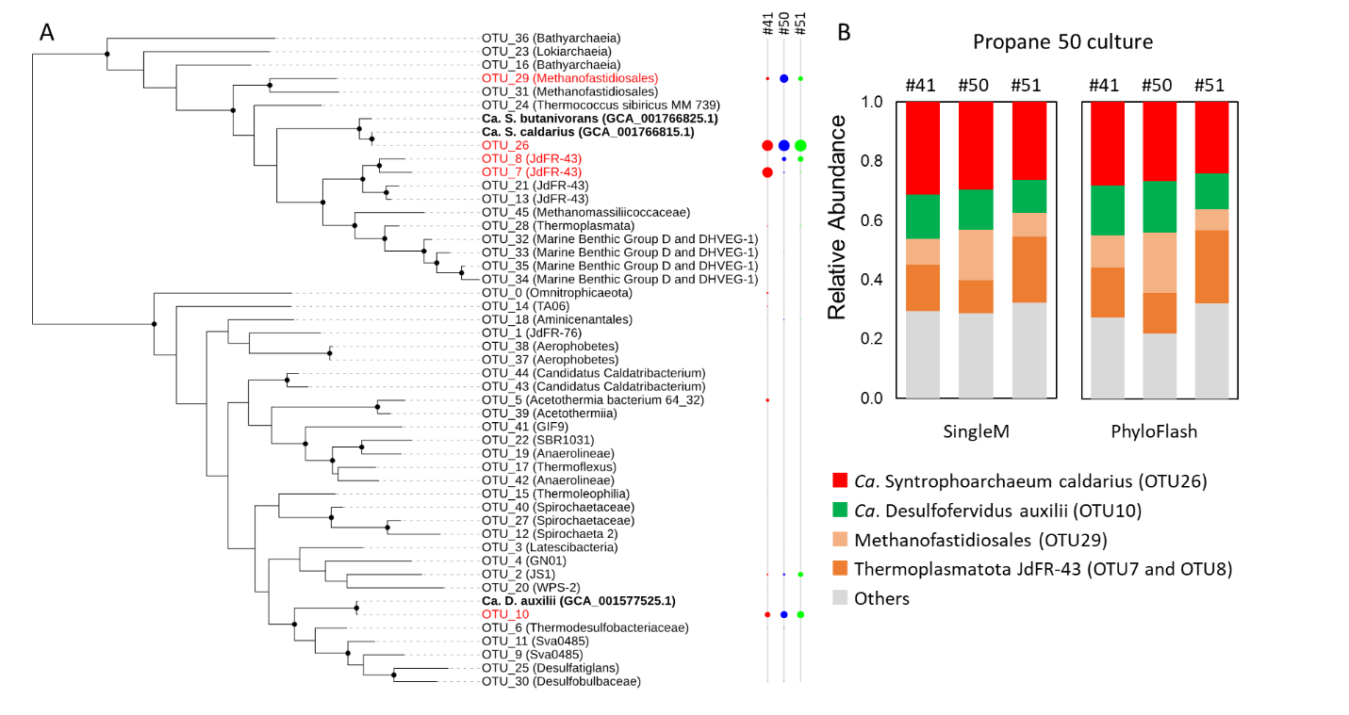
Figure S2| Microbial community structure of the Propane50 culture based on read abundance. A. Phylogenetic relationship of the full length 16S rRNA gene-based OTUs retrieved from Propane50 metagenomes. Circles on the right side reflect the relative abundance in the three replicate cultures. B. Relative abundance of the major OTUs based on SingleM and PhyloFlash.
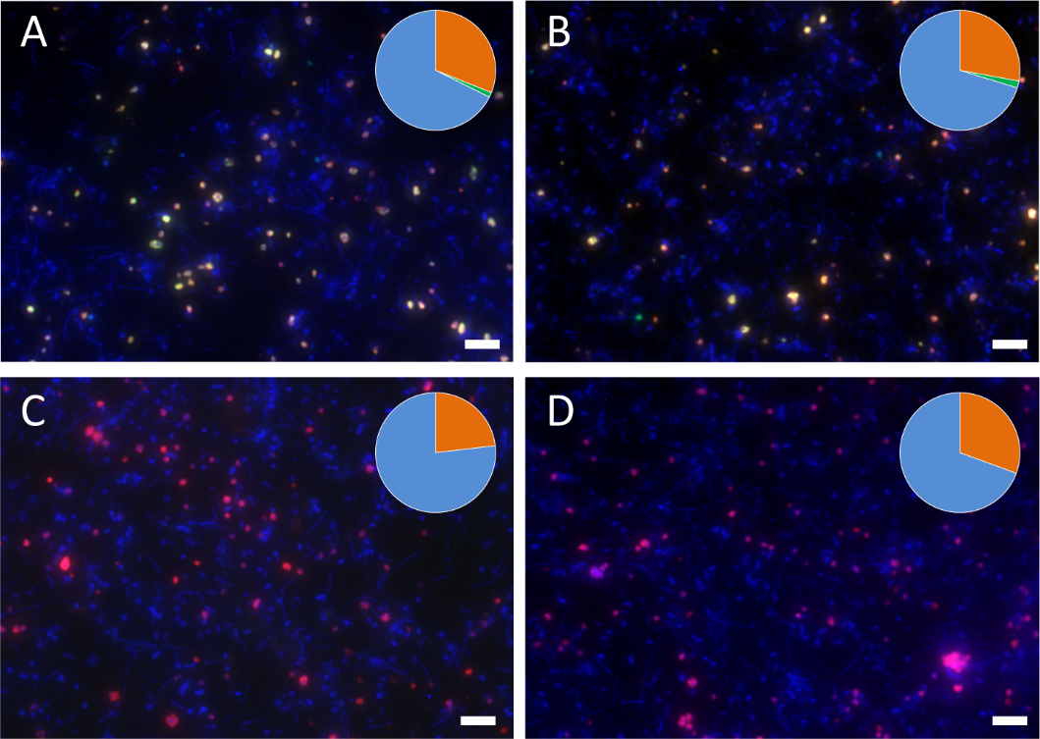
Figure S3| Fluorescence microscopy images of the Propane50 culture showing Ca. S. caldarium as the dominant archaeon. A-B. Double hybridizations of dispersed aggregates with oligonucleotide probes specific for Archaea (green) and for Ca. S. caldarium (red). Ca. S. caldarium hybridized with both probes, appearing orange. Almost all Archaea cells were represented by Ca. S. caldarium. C-D. Double hybridizations of dispersed aggregates with probes specific for Ca. S. butanivorans (green) and Ca. S. caldarium (red). Ca. S. butanivorans cells were not detected, while Ca. S. caldarium cells appear magenta overlapping of probe and DAPI signals. Insets in each image show the abundance of Ca. S. caldarium (orange, all panels), other Archaea (green, panels A-B), and Bacteria (blue, all panels). Images are representative of n > 60 images collected from n = 3 biological replicates. Scale bars = 5 μm, applicable to all panels.

Phylogenetic analysis of BssA homologs retrieved from bulk metagenome assemblies
A total of 97 homologs related to the alpha subunit of Ass (AssA) were identified from three replicate Propane50 cultures; most of these sequences (n = 90) cluster closely with pyruvate formate lyase, suggesting they are not functional alkylsuccinate synthases (Figure S4). The remaining seven sequences, likely derived from Atribacteria, formed a basal clade adjacent to the alpha subunit of benzylsuccinate synthases (BssA; Figure S4), an enzyme involved in aromatic hydrocarbon degradation ¹. However, all these sequences branched outside the monophyletic clade spanned by genuine assA genes from propane-oxidizing sulfate reducers or other characterized alkane-oxidizers (Figure S4), indicating they are unlikely to mediate propane oxidation. Corroborating this phylogenetic inference, none of the seven gene products were detected in protein extracts of Propane50 cultures.
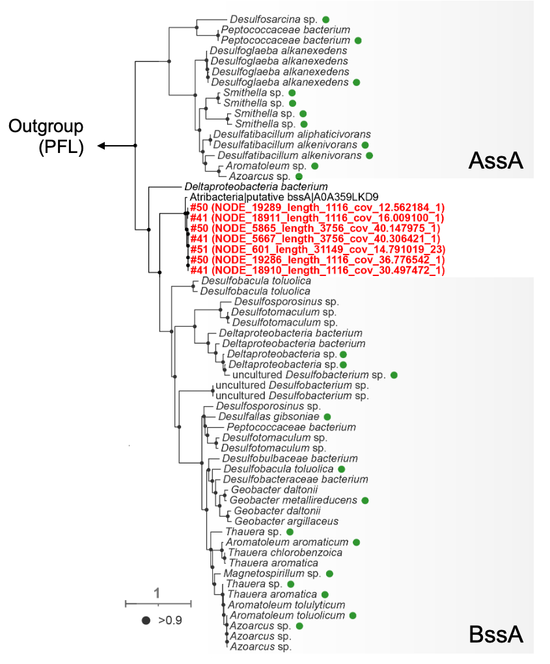
Figure S4 | Phylogeny of AssA homologs retrieved from bulk metagenome assemblies of three replicate Propane50 cultures (culture identifiers: #41, #50, and #51). Pyruvate formate lyase (PFL) is used as the outgroup. AssA homologs (n = 90) clustered with the PFL are not shown. The seven AssA homologs branch between the clade of alkylsuccinate synthase alpha subunit (AssA) and benzylsuccinate synthase alpha subunit (BssA) are highlighted in red. Branches with bootstrap support > 90% are indicated by black dots. Scale bar, number of amino acids substitution per site. Green circles indicate reference AssA/BssA sequences used to anchor clade assignment.

Analysis of alkyl-coenzyme M reductases in the Propane50 culture
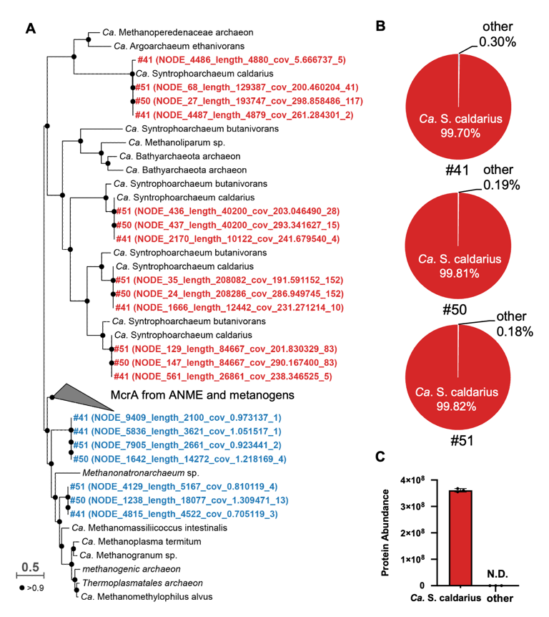
Figure S5 | Taxonomic composition and relative abundance of acrA in the metagenome and metaproteome of Propane50. A. Maximum-likelihood phylogenetic tree of acrA retrieved from the bulk metagenomic assemblies of three replicate Propane50 cultures (culture identifiers: #41, #50, and #51). Sequences affiliated with Ca. S. caldarium are marked in red, whereas all other sequences are shown in blue. Branches with bootstrap support >90% are indicated by black dots. Scale bar, number of substitutions of amino acids per site. B. Taxonomic composition of acrA in cultures #41, #50, and #51. The relative gene abundance was calculated based on average read coverage of the corresponding gene contig. C. Abundance of the AcrA proteins detected in the metaproteome of three independent Propane50 cultures.

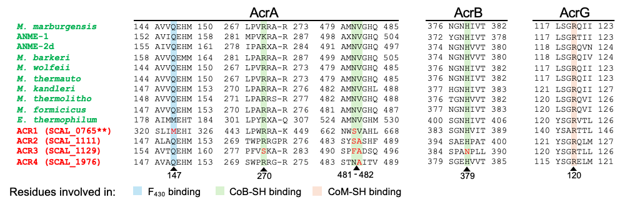
Figure S6 | Alignment of ACRs and identification of residues involved in stabilizing coenzyme M (CoM), coenzyme B (CoB), and the nickel F430 cofactor. The key residues are highlighted in α (AcrA), β (AcrB), and γ subunit (AcrG). Specifically, residues α147 (blue) and γ120 (red) are involved in binding F430 and CoM, respectively, while residues α481, α482, α270, and β379 (green) are involved in coordinating CoB. Amino acid substitutions at these specific positions within the four ACR complexes of Ca. S. caldarium are marked in red. Residue number corresponds to the methyl-coenzyme M reductase sequence from Methanothermobacter marburgensis.

Propane oxidation pathway in Ca. S. caldarium
The pathway for complete propane oxidation by Ca. S. caldarium was investigated using the genome and proteome data. Currently, it is not clear if 1-propyl-CoM and 2-propyl-CoM are independently oxidized, or if they are interconverted by an isomerase, as proposed for 1- and 2-alkyl-CoM during oxidation of butane or long-chain alkanes^{2,3}. Assuming 1-propyl-CoM as the main intermediate, by analogy with formerly proposed pathways ²⁻⁴ this will be eventually converted to propionyl-CoA.
Propionyl-CoA could be converted to acetyl-CoA through several pathways described or proposed in anaerobic microorganisms, including thermophilic archaea ⁵. The methylmalonyl-CoA pathway, which is common in sulfate-reducing and syntrophic bacteria, oxidizes propionyl-CoA to acetyl-CoA via succinyl-CoA and pyruvate ^{6,7}. Alternatively, propionyl-CoA can be processed through variants of the 3-hydroxypropionate / 4-hydroxybutyrate cycles ⁵, or through the methylcitrate pathway ⁸. A fourth pathway, proposed for propionate oxidation by Smithella propionica, involves dismutation of propionyl-CoA to acetyl-CoA and butyryl-CoA, with the latter undergoing beta-oxidation to two acetyl-CoA ⁹; to date, this pathway has not been biochemically characterized.
Methylmalonyl-CoA pathway. Genome annotation through standard pipelines (see Methods/Metagenome annotation and metabolic reconstruction) identified propionyl-CoA carboxylase (PCC), methylmalonyl-CoA mutase (MCM), succinyl-CoA ligase (SCS), a putative fumarase (FHT), pyruvate:oxaloacetate carboxyltransferase (ODC), and pyruvate:ferredoxin oxidoreductase (POR) (Figure 4, Extended Data Table 3). Of these, PCC, MCM and ODC were detected at high relative abundance in protein extracts (Extended Data Table 3).
A canonical (R)-/(S)-methylmalonyl-CoA epimerase was not identified. Currently, we cannot exclude that the racemization function is carried out by epimerases with low similarity to canonical enzymes, as found in other thermophilic archaea which use the methylmalonyl-CoA pathway ¹⁰.
In addition, canonical genes for succinate dehydrogenase and malate dehydrogenase were not identified in the genome of Ca. S. caldarium. These enzymes are essential for a functional methylmalonyl-CoA pathway. To account for the potential presence of highly divergent archaeal homologues, we analyzed the proteome of Ca. S. caldarium using machine learning and structural searches (see Methods/Proteome analysis via machine learning and structural search). Homology search using TM-Vec ¹¹ identified Scal_1741 as a potential CoM/CoB-dependent fumarate reductase subunit A (TfrA) ¹². Initial domain-based (e.g., PFAM or COG) analysis assigned Scal_1741 as an uncharacterized FAD-containing protein, similar to TfrA that belongs to the FAD-dependent oxidoreductase family. Although Scal_1741 shared very low sequence similarity (< 20%) with TfrA, they have the same structural fold, with a TM-Score of 0.52 and a DALI Z-score of 19.2. However, we could not identify with reasonable confidence a candidate gene for the Fe-S subunit of the CoM/CoB-dependent fumarate reductase, TfrB. Even when we assume that the role of TfrB could be fulfilled by one of the multiple heterodisulfide reductases (hdrABC) encoded in Ca. S. caldarium genome, caveats still remain: (a) Scal_1741 was not detected in protein extracts, and (b) TfrAB from Methanothermobacter thermoautotrophicus seems to lack the capacity to oxidize succinate to fumarate using artificial electron acceptors ¹².
Structural searches detected Scal_1889 as a potential malate dehydrogenase. Scal_1889 shares 39% sequence identity with D-malate dehydrogenase DmlA from E. coli, both belonging to the isocitrate and isopropylmalate dehydrogenases family. The predicted structure of Scal_1889 is highly similar to that of DmlA, with a TM-score of 0.94, a DALI Z-score of 51.3, and highly consistent residue distance maps (Figure S7). DmlA is known to convert malate to pyruvate, and Scal_1889 may retain the same function in Ca. S. caldarium.
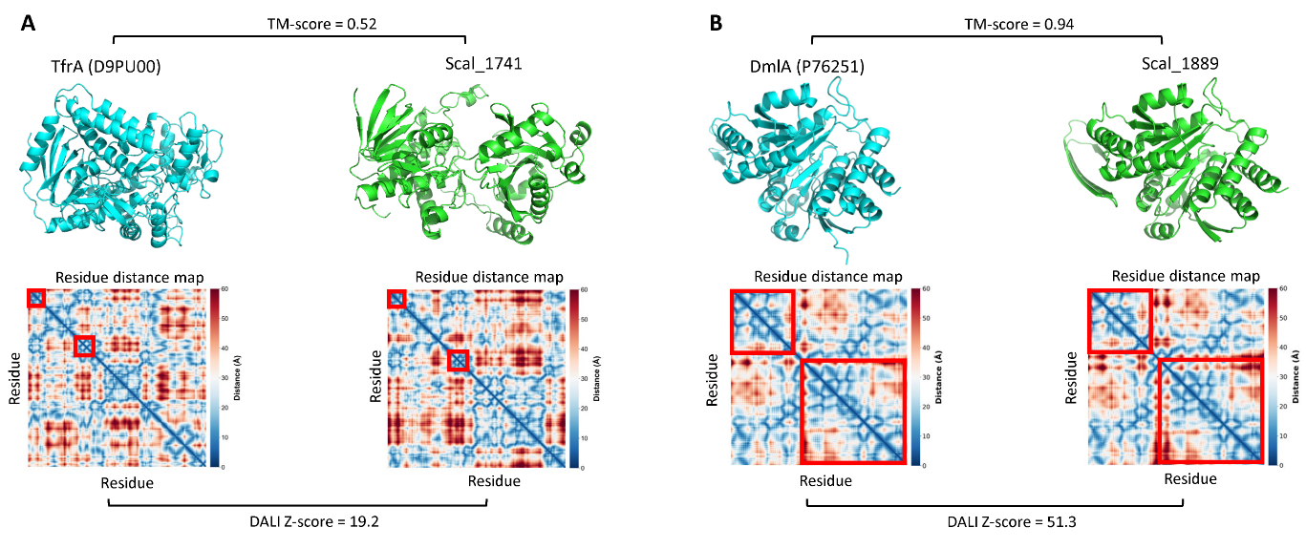
Figure S7 | Structure modelling and similarity matrices for candidate enzymes of the methylmalonyl pathway in Ca. S. caldarium. A. Identification of Scal_1741 as a putative CoM/CoB-dependent fumarate reductase subunit A (TfrA). B. Identification of Scal_1889 as a potential malate dehydrogenase.
In conclusion, sequence similarity, database annotation, domain composition and structural analyses identified almost all enzymes required for a functional methylmalonyl-CoA pathway in Ca. S. caldarium. Although a viable candidate for conversion of propionyl-CoA to acetyl-CoA, caveats remain, precluding a high-confidence assignment of this pathway to the propane oxidation pathway in Ca. S. caldarium.
3-Hydroxybutyrate / 4-hydroxybutyrate pathway. The hydroxypropionate-hydroxybutyrate cycle functions as a CO₂ fixation pathway in some autotrophic archaea ⁵. Parts of this cycle could be used to convert propionyl-CoA to acetyl-CoA. There are two possibilities: (a) the reverse 3-hydroxypropionate pathway, where propionyl-CoA is oxidized to acryloyl-CoA, and further converted to acetyl-CoA via malonyl-CoA; (b) propionyl-CoA carboxylation and isomerization to succinyl-CoA, further oxidation to 4-hydroxybutyryl-CoA which undergoes beta-oxidation to acetyl-CoA.
The genome of Ca. S. caldarium contains a complete set of genes assigned to the 3-hydroxypropionate pathway (Extended Data Table 3). Most of these were found in high abundance in the proteome, including acryloyl-CoA reductase/acyl-CoA dehydrogenase, 3-hydroxyacyl-CoA dehydrogenase, and malonyl-CoA reductase. We therefore consider the 3-hydroxypropionate pathway as the most likely route of conversion of propionyl-CoA to acetyl-CoA in Ca. S. caldarium (Figure 4).
The methylcitrate pathway. This pathway operates mostly in aerobic and facultatively anaerobic bacteria. Although genes associated with this pathway have been reported in some strict anaerobes, like Desulfurella acetivorans, the corresponding enzymes could not be detected in extracts of cells grown on propionate ⁸.
In this pathway propionyl-CoA is condensed with oxaloacetate to 2-methylcitrate by methylcitrate synthase. 2-Methylcitrate is converted to 2-methylisocitrate, which is cleaved into pyruvate and succinate by 2-methylisocitrate lyase. Succinate is recycled to oxaloacetate, while pyruvate is converted to acetyl-CoA. Key enzymes of this pathway, including methylcitrate synthase and 2-methylisocitrate lyase, are absent from the genome of Ca. S. caldarium, indicating that the methylcitrate pathway is unlikely to contribute to propane oxidation in this archaeon.
The propionate dismutation pathway. This pathway has been proposed based on stable isotope labeling patterns in Smithella. In this model, two molecules of propionyl-CoA are condensed to a branched C6, γ-ketoacyl-CoA, followed by rearrangement to a linear hexanoyl-CoA derivative ⁹. This transformation has been suggested to involve a B12-dependent mutase-like reaction, although the responsible enzyme has not been identified. Subsequent conversion to a β-ketoacyl-CoA intermediate has been proposed to proceed via a series of reduction and re-oxidation steps, after which the generated β-ketohexanoyl-CoA will enter beta-oxidation, yielding acetyl-CoA ⁹.
This pathway could account for the high abundance of methylmalonyl-CoA mutase and beta-oxidation enzymes detected in protein extracts (Extended Data Table 3). However, the pathway remains hypothetical and lacks direct biochemical evidence, and no candidate genes for the proposed key reactions could be identified in the genome of Ca. S. caldarium. We therefore consider this pathway unlikely to operate in this organism.

Supplementary tables
Supplementary Table 1|Oligonucleotide probes used to resolve the microbial community structure of the Propane50 culture. The formamide (FA) concentration applied in CARD-FISH assays is indicated.
Probe name | Probe sequence | FA (%) | Target | Reference
pSBU699 | 5’-GTCCCCCAGGTATCACAG-3’ | 30 | Ca. S. butanivorans | ¹³
pSCAL871 | 5’-CCCCAAGTGGTGAGCTTC-3’ | 30 | Ca. S. caldarium | ¹³
ARCH915 | 5'-GTGCTCCCCCGCCAATTCCT-3' | 35 | Ca. S. caldarium  Ca. S. butanivorans | ¹⁴
EUB338I-III | 5’-GCTGCCTCCCGTAGGAGT-3’  5’-GCAGCCACCCGTAGGTGT-3’  5’-GCTGCCACCCGTAGGTGT-3’ | 35 | Ca. Desulfofervidus auxilii HotSeep1, other Bacteria | ¹⁵  ¹⁶
NON338 | 5’-ACTCCTACGGGAGGCAGC-3’ | 35 | None | ¹⁷

Supplementary Table 2｜Properties of Ca. D. auxilii genome retrieved from three replicate Propane50 cultures (culture identifiers: #41, #50, and #51). Genome completeness and contamination were estimated using CheckM. The average nucleotide identity (ANI) is shown for each of the retrieved Ca. D. auxilii genomes, in comparison with the reference strain (GCA_001577525.1) identified in a thermophilic AOM culture ¹⁸.
Genome | Completeness (%) | Contamination (%) | ANI (%)
Ca. D. auxilii from # 41 | 83.77 | 1.69 | 98.68
Ca. D. auxilii from # 50 | 77.24 | 0.75 | 98.49
Ca. D. auxilii from # 51 | 94.21 | 2.64 | 98.05

Supplementary Table 3 | Genes encoding enzymes for dissimilatory sulfate reduction in Ca. D. auxilii. The abundance of gene products in proteomes of Propane50 cultures is shown. The abundance values are expressed as mean ± standard deviation, with the sample size indicated by n. Abbreviations: N.D., not detected; B.L.Q, below the limit of quantification.
Gene | Gene product | Locus tag | Propane50
sat | Sulfate adenylyltransferase | Daux_2314 | (1.4±0.0) × 10⁹ (n=3)
aprA | Adenylylsulfate reductase subunit alpha | Daux_0253 | (2.4±0.2) × 10¹⁰ (n=3)
aprB | Adenylylsulfate reductase subunit beta | Daux_0254 | (4.6±0.1) × 10⁹ (n=3)
dsrA | Dissimilatory sulfite reductase subunit alpha | Daux_2185 | (2.6±0.1) × 10⁹ (n=3)
dsrB | Dissimilatory sulfite reductase subunit beta | Daux_2184 | (1.4±0.0) × 10¹⁰ (n=3)
dsrC | Dissimilatory sulfite reductase | Daux_0090 | (5.0±0.1) × 10⁹ (n=3)
dsrP | Sulfite reductase-associated electron transfer protein | Daux_2294 | N.D.
dsrO | Sulfite reductase-associated electron transfer protein | Daux_2295 | N.D.
dsrJ | Sulfite reductase-associated electron transfer protein | Daux_2296 | N.D.
dsrK | Sulfite reductase-associated electron transfer protein | Daux_2297 | (2.7±0.1) × 10⁸ (n=3)
dsrM | Sulfite reductase-associated electron transfer protein | Daux_2298 | N.D.
qmoA | Apr-associated electron transfer protein | Daux_2188 | (6.6±0.1) × 10⁸ (n=3)
qmoB | Apr-associated electron transfer protein | Daux_2187 | (9.0±0.0) × 10⁸ (n=3)
qmoC | Apr-associated electron transfer protein | Daux_2186 | (8.6±4.6) × 10⁷ (n=2)

Supplementary Table 4 | Genes encoding enzymes potentially responsible for direct interspecies electron transfer in Ca. S. caldarium. The abundance of gene products in proteomes of Propane50 cultures is shown. The abundance values are expressed as mean ± standard deviation, with the sample size indicated by n. The subcellular localization of the proteins was predicted using Psortb. Abbreviations: N.D., not detected; B.L.Q, below the limit of quantification; CXXCH, the heme-binding motif.
Gene | Product Name | CXXCH  count | Subcellular localization | Locus tag | Propane50
MHCs | Multiheme cytochrome c | 19 | Extracellular | Scal_0144 | N.D.
MHCs | Multiheme cytochrome c | 5 | Cytoplasmic Membrane | Scal_0145 | N.D.
MHCs | Multiheme cytochrome c | 3 | Extracellular | Scal_0153 | N.D.
MHCs | Multiheme cytochrome c | 9 | Extracellular | Scal_0347 | N.D.
MHCs | Multiheme cytochrome c | 5 | Extracellular | Scal_0348 | N.D.
MHCs | Multiheme cytochrome c | 3 | Extracellular | Scal_0494 | N.D.
MHCs | Multiheme cytochrome c | 3 | Extracellular | Scal_0725 | N.D.
MHCs | Multiheme cytochrome c | 5 | Cytoplasmic Membrane | Scal_1096 | N.D.
MHCs | Multiheme cytochrome c | 9 | Cytoplasmic Membrane | Scal_1194 | (5.1±0.1) × 10⁸ (n=3)
MHCs | Multiheme cytochrome c | 9 | Extracellular | Scal_1259 | N.D.
MHCs | Multiheme cytochrome c | 8 | Cytoplasmic Membrane | Scal_1296 | (5.9±0.1) × 10⁸ (n=3)
MHCs | Multiheme cytochrome c | 3 | Cytoplasmic Membrane | Scal_1728 | N.D.
MHCs | Multiheme cytochrome c | 5 | Cytoplasmic Membrane | Scal_1764 | N.D.
MHCs | Multiheme cytochrome c | 5 | Extracellular | Scal_1981 | N.D.
MHCs | Multiheme cytochrome c | 6 | Extracellular | Scal_1982 | N.D.

Supplementary Table 5 | Genes encoding enzymes potentially responsible for direct interspecies electron transfer in Ca. D. auxilii. The abundance of gene products in proteomes of replicate Propane50 cultures are shown. The abundance values are expressed as mean ± standard deviation, with the sample size indicated by n. The subcellular localization of the proteins was predicted using Psortb. Abbreviations: N.D., not detected; B.L.Q, below the limit of quantification; CXXCH, the heme-binding motif.
Gene | Product Name | CXXCH count | Subcellular localization | Locus tag | Propane50
MHCs | Multiheme cytochrome c | 8 | Unknown | Daux_0187 | (3.9±0.1) × 10⁷ (n=3)
MHCs | Multiheme cytochrome c | 4 | Periplasmic | Daux_0125 | N.D.
MHCs | Multiheme cytochrome c | 4 | Periplasmic | Daux_0348 | N.D.
MHCs | Multiheme cytochrome c | 10 | Cytoplasmic | Daux_0541 | N.D.
MHCs | Multiheme cytochrome c | 12 | Periplasmic | Daux_0544 | N.D.
MHCs | Multiheme cytochrome c | 26 | Cytoplasmic | Daux_0556 | N.D.
MHCs | Multiheme cytochrome c | 5 | Cytoplasmic | Daux_0679 | N.D.
MHCs | Multiheme cytochrome c | 4 | Periplasmic | Daux_1247 | N.D.
MHCs | Multiheme cytochrome c | 2 | Cytoplasmic | Daux_1793 | N.D.
MHCs | Multiheme cytochrome c | 4 | Cytoplasmic | Daux_1864 | N.D.
MHCs | Multiheme cytochrome c | 4 | Periplasmic | Daux_2180 | N.D.
MHCs | Multiheme cytochrome c | 4 | Periplasmic | Daux_2269 | N.D.
MHCs | Multiheme cytochrome c | 4 | Cytoplasmic | Daux_2401 | N.D.

Supplementary Table 6 | Genes encoding type IV pili in Ca. S. caldarium. The abundance of gene products in proteomes of Propane50 cultures is shown. The abundance values are expressed as mean ± standard deviation, with the sample size indicated by n. Abbreviations: N.D., not detected; B.L.Q, below the limit of quantification.
Gene | Product Name | Locus tag | Propane50
pilA | Type IV pilus assembly protein | Scal_1157 | N.D.
pilA | Type IV pilus assembly protein | Scal_1058 | N.D.
pilA | Type IV pilus assembly protein | Scal_0285 | N.D.
pilG | Twitching motility protein | Scal_0120 | N.D.
pilJ | Twitching motility protein | Scal_2086 | N.D.
pilK | Type IV pilus assembly protein | Scal_0741 | N.D.
pilS | Sensor histidine kinase | Scal_0951 | N.D.
pilS | Sensor histidine kinase | Scal_0841 | N.D.
pilS | Sensor histidine kinase | Scal_0840 | N.D.
pilS | Sensor histidine kinase | Scal_0360 | B.L.Q.
pilS | Sensor histidine kinase | Scal_0121 | N.D.
pilS | Sensor histidine kinase | Scal_2088 | N.D.

Supplementary Table 7 | Genes encoding type IV pili in Ca. D. auxilii. The abundance of gene products in proteomes of Propane50 cultures is shown. The abundance values are expressed as mean ± standard deviation, with the sample size indicated by n. Abbreviations: N.D., not detected; B.L.Q, below the limit of quantification.
Gene | Product Name | Locus tag | Propane50
pilA | Type IV pilus assembly protein | Daux_0117 | N.D.
pilQ | Type IV pilus secretin | Daux_0605 | N.D.
pilO | Type IV pilus assembly protein | Daux_0603 | N.D.
pilM | Type IV pilus assembly protein | Daux_0601 | (1.2±0.0) × 10⁸ (n=3)
pilC | Type IV pilus assembly protein | Daux_2260 | N.D.
pilT | Twitching motility protein | Daux_1516 | (4.1±0.1) × 10⁷ (n=3)
pilT | Twitching motility protein | Daux_1517 | N.D.

References

1 Rabus, R. et al. Anaerobic microbial degradation of hydrocarbons: From enzymatic reactions to the environment. J. Mol. Microbiol. Biotechnol. 26, 5-28 (2016). https://doi.org:10.1159/000443997
2 Laso-Pérez, R. et al. Thermophilic archaea activate butane via alkyl-coenzyme M formation. Nature 539, 396-401 (2016). https://doi.org:10.1038/nature20152
3 Zehnle, H. et al. Candidatus Alkanophaga archaea from Guaymas Basin hydrothermal vent sediment oxidize petroleum alkanes. Nat. Microbiol. 8, 1199-1212 (2023). https://doi.org:10.1038/s41564-023-01400-3
4 Lemaire, O. N. & Wagner, T. A Structural View of Alkyl-Coenzyme M Reductases, the First Step of Alkane Anaerobic Oxidation Catalyzed by Archaea. Biochemistry 61, 805-821 (2022). https://doi.org:10.1021/acs.biochem.2c00135
5 Berg, I. A. et al. Autotrophic carbon fixation in archaea. Nat. Rev. Microbiol. 8, 447-460 (2010). https://doi.org:10.1038/nrmicro2365
6 Rabus, R., Hansen, T. A. & Widdel, F. in The Prokaryotes: Prokaryotic Physiology and Biochemistry (eds Eugene Rosenberg et al.) 309-404 (Springer Berlin Heidelberg, 2013).
7 Schink, B. Energetics of syntrophic cooperation in methanogenic degradation. Microbiol. Mol. Biol. Rev. 61, 262-280 (1997).
8 Pettinato, E. et al. Propionate metabolism in Desulfurella acetivorans. Front. Microbiol. Volume 16 - 2025 (2025). https://doi.org:10.3389/fmicb.2025.1545849
9 de Bok, F. A. M., Stams, A. J. M., Dijkema, C. & Boone, D. R. Pathway of Propionate Oxidation by a Syntrophic Culture of Smithella propionica and Methanospirillum hungatei. Appl. Environ. Microbiol. 67, 1800-1804 (2001). https://doi.org:10.1128/AEM.67.4.1800-1804.2001
10 Han, Y., Hawkins, A. S., Adams, M. W. W. & Kelly, R. M. Epimerase (Msed_0639) and Mutase (Msed_0638 and Msed_2055) Convert (<i>S</i>)-Methylmalonyl-Coenzyme A (CoA) to Succinyl-CoA in the Metallosphaera sedula 3-Hydroxypropionate/4-Hydroxybutyrate Cycle. Appl. Environ. Microbiol. 78, 6194-6202 (2012). https://doi.org:doi:10.1128/AEM.01312-12
11 Hamamsy, T. et al. Protein remote homology detection and structural alignment using deep learning. Nat. Biotechnol. 42, 975-985 (2024). https://doi.org:10.1038/s41587-023-01917-2
12 Heim, S., Künkel, A., Thauer, R. K. & Hedderich, R. Thiol : fumarate reductase (Tfr) from Methanobacterium thermoautotrophicum. Eur. J. Biochem. 253, 292-299 (1998). https://doi.org:https://doi.org/10.1046/j.1432-1327.1998.2530292.x
13 Chen, S.-C. et al. Back flux during anaerobic oxidation of butane support archaea-mediated alkanogenesis. Nat. Comm. 15, 9628 (2024). https://doi.org:10.1038/s41467-024-53932-9
14 Alm, E. W., Oerther, D. B., Larsen, N., Stahl, D. A. & Raskin, L. The oligonucleotide probe database. Appl. Environ. Microbiol. 62, 3557-3559 (1996). https://doi.org:doi:10.1128/aem.62.10.3557-3559.1996
15 Amann, R. I., Krumholz, L. & Stahl, D. A. Fluorescent-oligonucleotide probing of whole cells for determinative, phylogenetic, and environmental studies in microbiology. J. Bacteriol. 172, 762-770 (1990).
16 Daims, H., Brühl, A., Amann, R., Schleifer, K.-H. & Wagner, M. The Domain-specific Probe EUB338 is Insufficient for the Detection of all Bacteria: Development and Evaluation of a more Comprehensive Probe Set. Syst. Appl. Microbiol. 22, 434-444 (1999). https://doi.org:https://doi.org/10.1016/S0723-2020(99)80053-8
17 Wallner, G., Amann, R. & Beisker, W. Optimizing fluorescent in situ hybridization with rRNA-targeted oligonucleotide probes for flow cytometric identification of microorganisms. Cytometry 14, 136-143 (1993). https://doi.org:https://doi.org/10.1002/cyto.990140205
18 Krukenberg, V. et al. Candidatus Desulfofervidus auxilii, a hydrogenotrophic sulfate-reducing bacterium involved in the thermophilic anaerobic oxidation of methane. Environ. Microbiol. 18, 3073-3091 (2016). https://doi.org:10.1111/1462-2920.13283

