Design, synthesis, biological evaluation and molecular docking studies of 5-fluorouracil-dithiocarbamate conjugates

Yifeng Zhan^{1,3} · Youyun Wang³ · Puzhao Wang^{1,3} · Hongda Zhu ^{1,2,3} · Huiling Guo^{1,2,3} · Hongmei Sun ^{1,2,3} · Mingxing Liu^{1,2,3 *}

¹ Key Laboratory of Fermentation Engineering (Ministry of Education)
² National "111" Center for Cellular Regulation and Molecular Pharmaceutics
³ Hubei Key Laboratory of Industrial Microbiology, Hubei University of Technology,
Wuhan, 430068 China
* Corresponding author. E-mail: lmxing@hbut.edu.cn

Table of Contents:
Spectra of ¹H NMR and ¹³C NMR for all compounds P2-P7

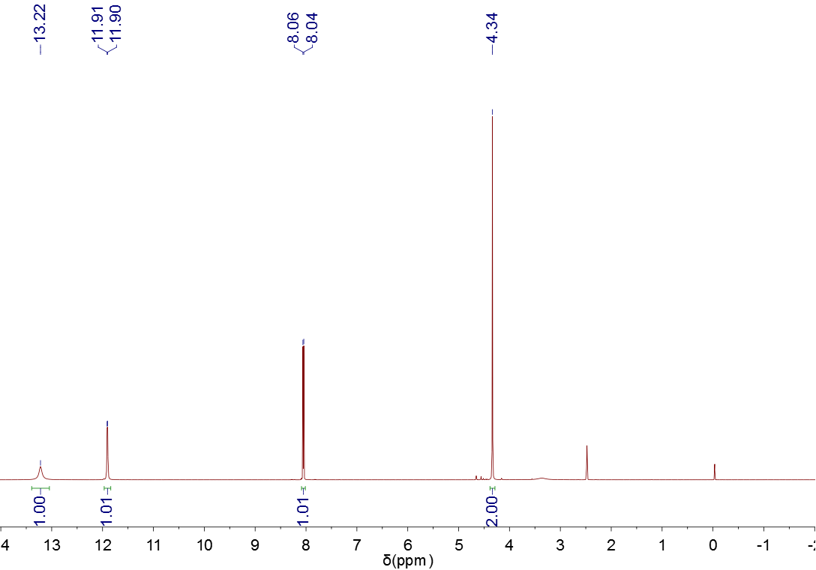
S1 ¹H-NMR of 5-fluorouracil -1- acetic acid

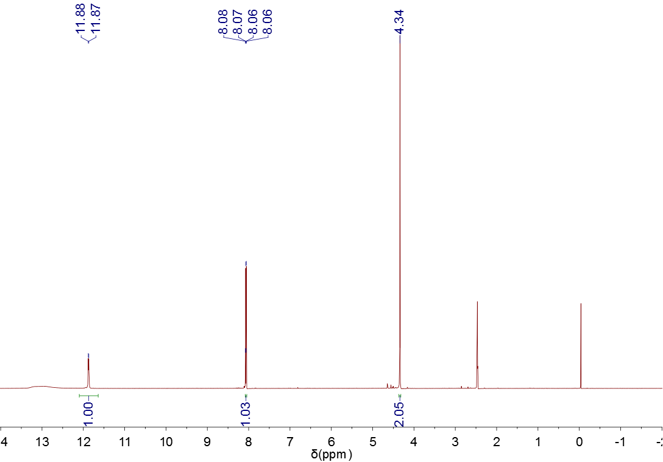
S2 ¹H-NMR of 5-fluorouracil -1- acetyl chloride
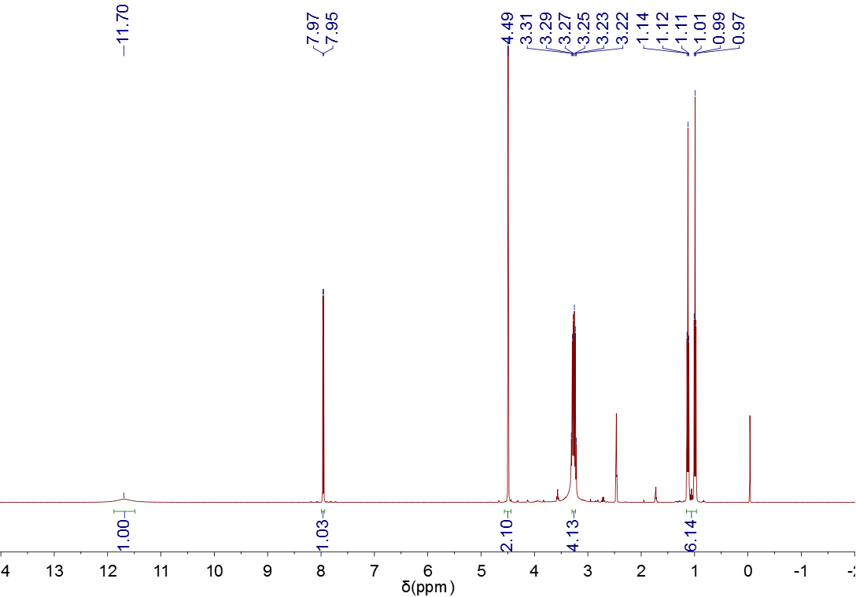
S3 ¹H-NMR of [2- (5´-fluorouracil) acetic acid-diethyldithiocarbamate] anhydride P1

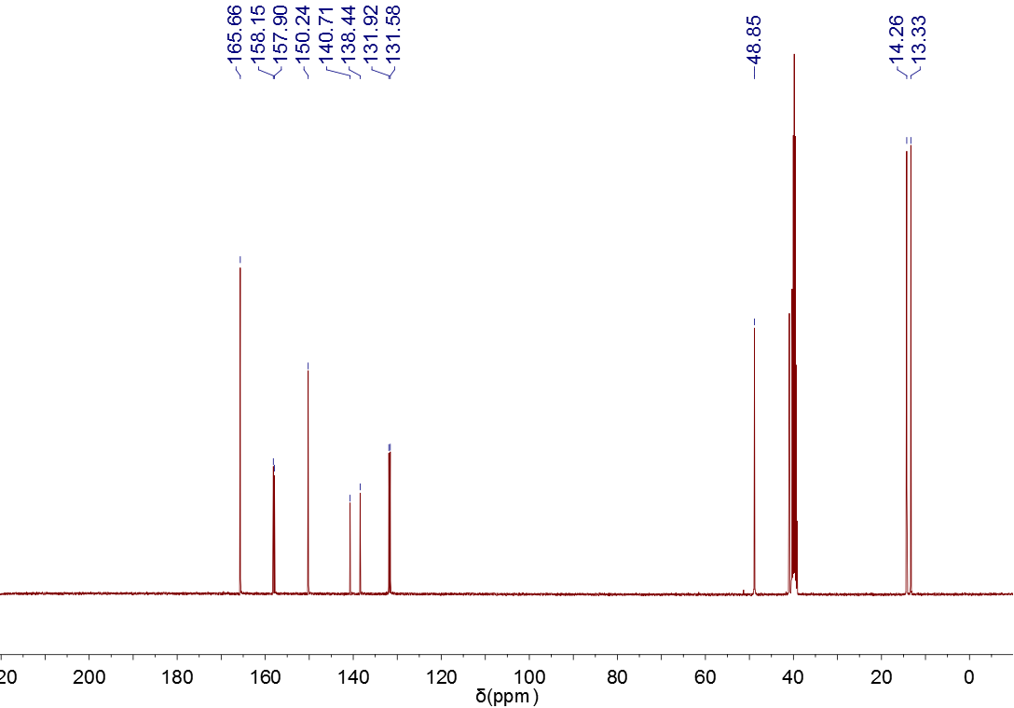
S4 ¹³C-NMR of [2- (5´-fluorouracil) acetic acid-diethyldithiocarbamate] anhydride P1

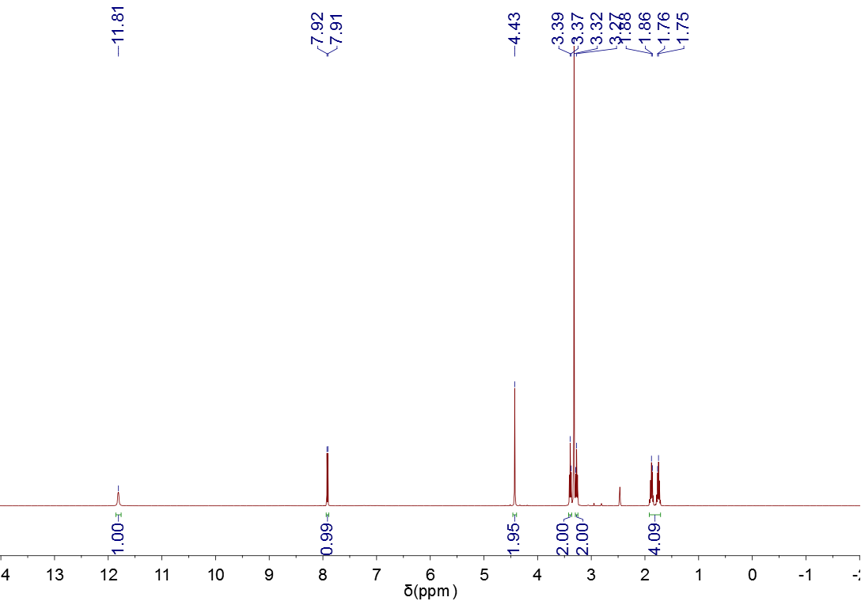
S5 ¹H-NMR of [2- (5´-fluorouracil) acetic acid-pyrrole alkyl dithiocarbamate] anhydride P2

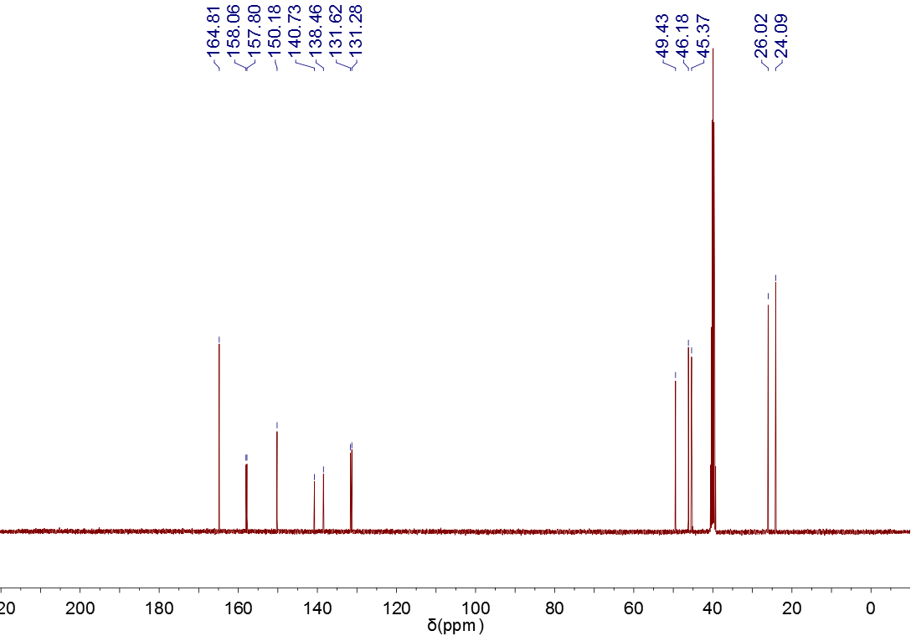
S6 ¹³C-NMR of [2- (5´-fluorouracil) acetic acid-pyrrole alkyl dithiocarbamate] anhydride P2
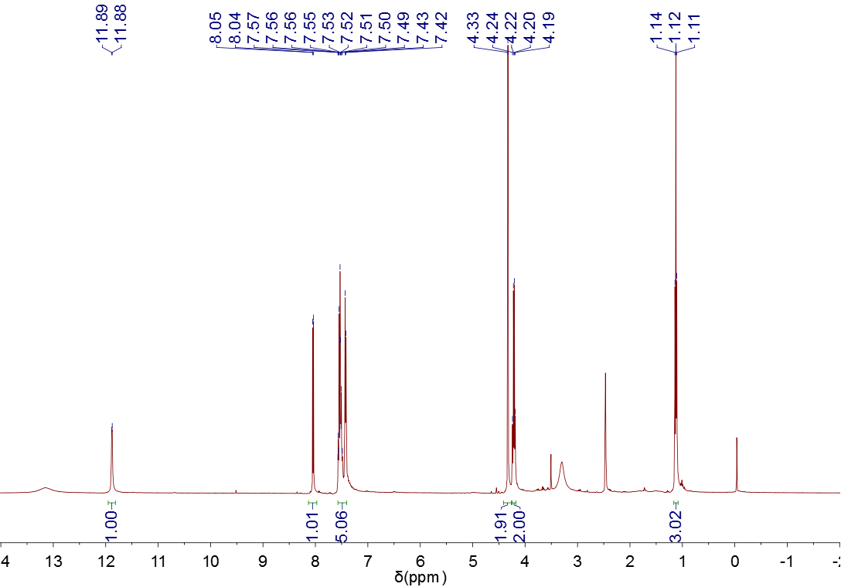
S7 ¹H-NMR of [2- (5´-fluorouracil) acetic acid - ethyl phenyl dithiocarbamate] anhydride P3

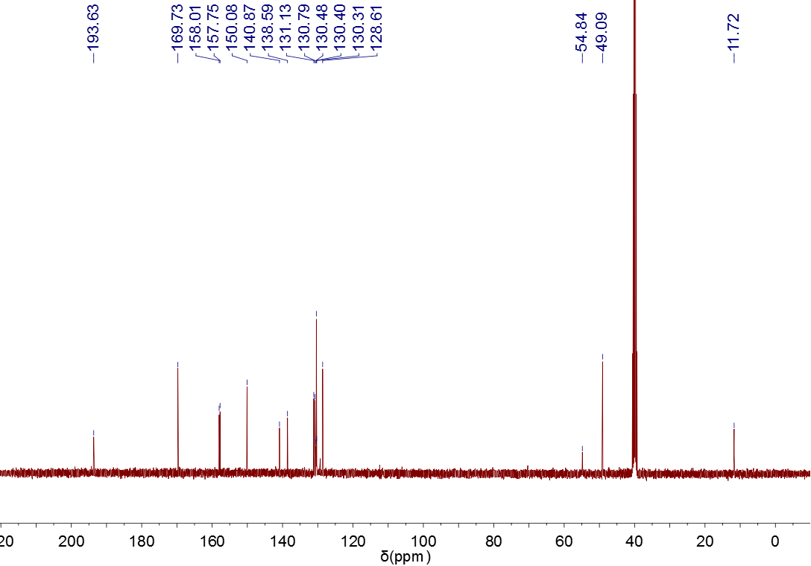
S8 ¹³C-NMR of [2- (5´-fluorouracil) acetic acid - ethyl phenyl dithiocarbamate] anhydride P3

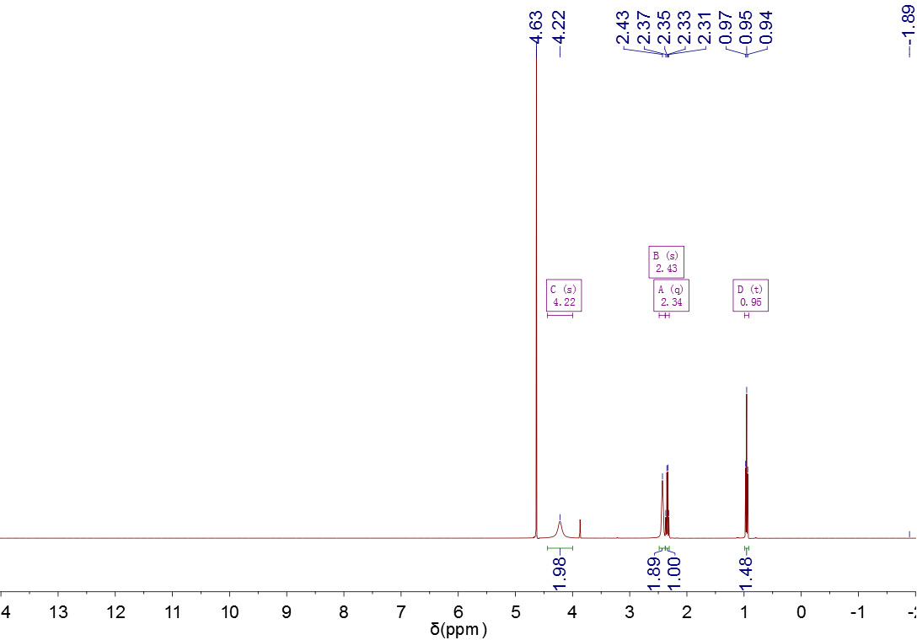
S9 ¹H-NMR of (N- ethyl) piperazinyl sodium dithiocarbamate

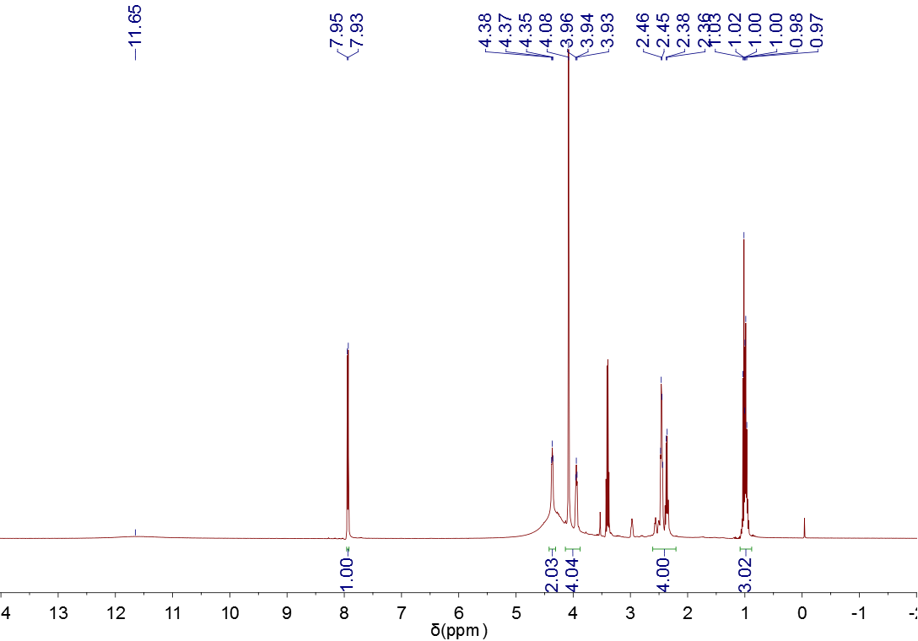
S10 ¹H-NMR of [2- (5´ -fluorouracil) acetic acid - (n-ethyl) piperazinyl dithiocarbamate] anhydride P4
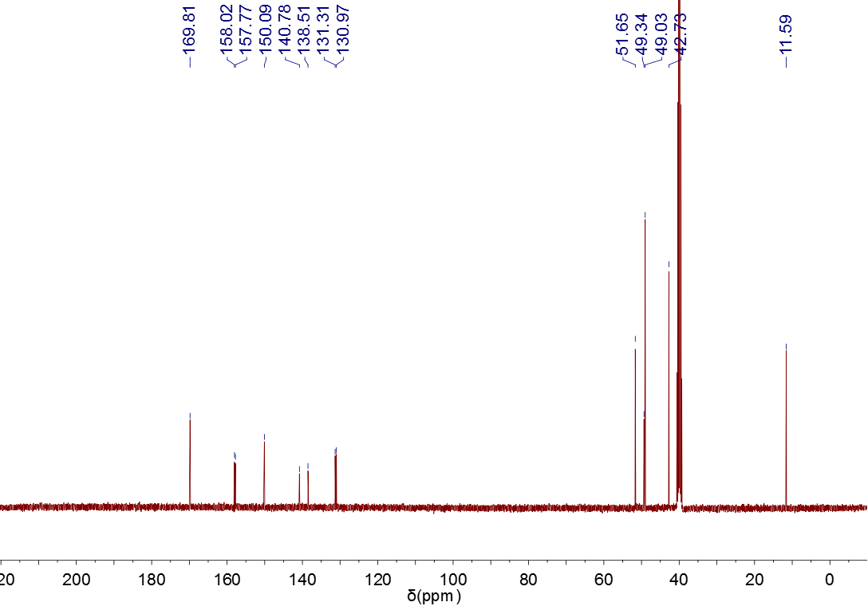
S11 ¹³C-NMR of [2- (5´ -fluorouracil) acetic acid - (n-ethyl) piperazinyl dithiocarbamate] anhydride P4

