Clone
Contrast Toddaculin
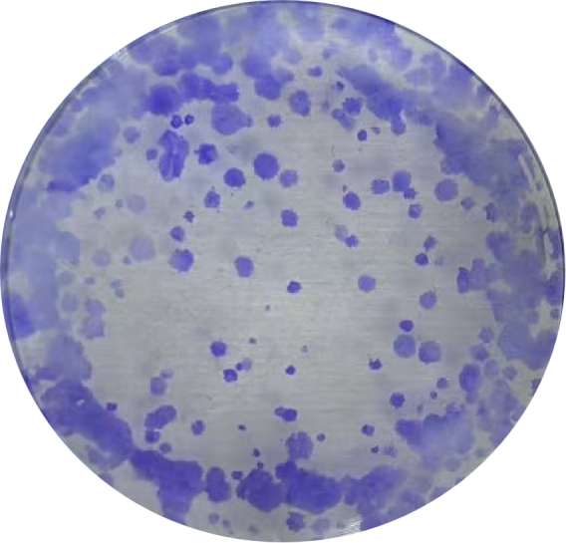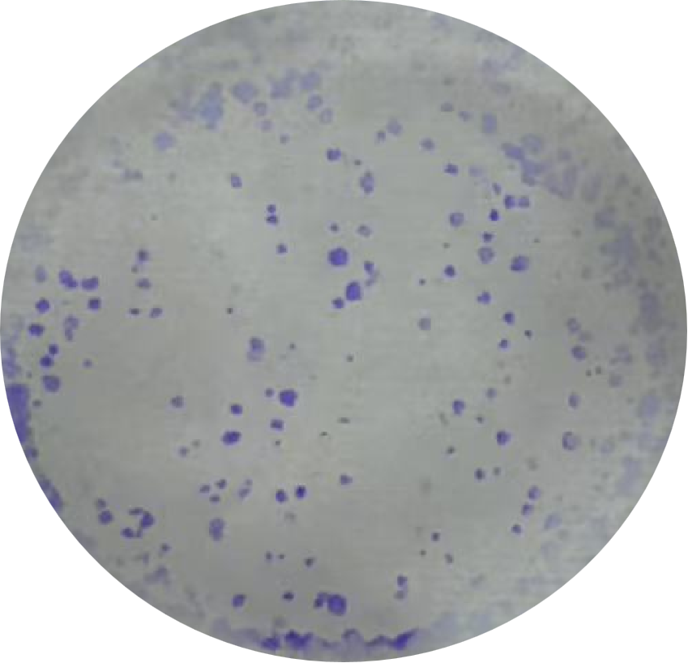

Scratch
Contrast Toddaculin
0h
24h

Transwell
Contrast Toddaculin

Tunel
Contrast Toddaculin
Tunel
Dapi
Merge

Ros
Contrast Toddaculin

He
Contrast Toddaculin
Liver
Kidney
Tumor
KI67
Contrast Toddaculin

