Supplementary Information for

Achieving restoration, conservation and poverty alleviation goals through Indonesia’s community forests
Matthew J. Struebig, Dominic Muenzel, Lindsay F. Banin, Sugeng Budiharta, Joseph Hutabarat, Courtney Morgans, Sonny Mumbunan, Emmy Primadona, Elizabeth H. Raine, Truly Santika, Kristin Olsen, Maria Voigt, Nurul Winarni, Jatna Supriatna, Zoe Davies, Robert J Smith.
Correspondence to m.j.struebig@kent.ac.uk

Section 1 Restoration potential, Ri

Calculating forest restoration potential
We quantified restoration potential as the inverse of the aboveground forest biomass as determined from remote sensing satellite imagery (Santoro & Cartus, 2021), avoiding highly degraded areas below a certain threshold (Eqn. S1).
 | $$R_{i}= \left\{\begin{aligned}\frac{B_{max}-B_{i}}{{Biomass}_{max}} if {Biomass}_{i}≥74 t {ha}^{-1} \\ 0 otherwise\end{aligned}\right.$$ | (Eqn. S1)
Restoration potential (R_{i}) was calculated for each ith 1 km² cell of the biomass raster dataset. It is calculated as the difference between the maximum biomass (B_{max}) occurring in a given province and landform type (lowland, wetland, upland, or montane, Fig. S1) and the biomass in that cell (B_{i}), divided by the maximum biomass. This reflects the inherent geographic variation in standing biomass in forests within and among provinces. Cells having a biomass <74 t/ha were assigned a restoration potential of 0.
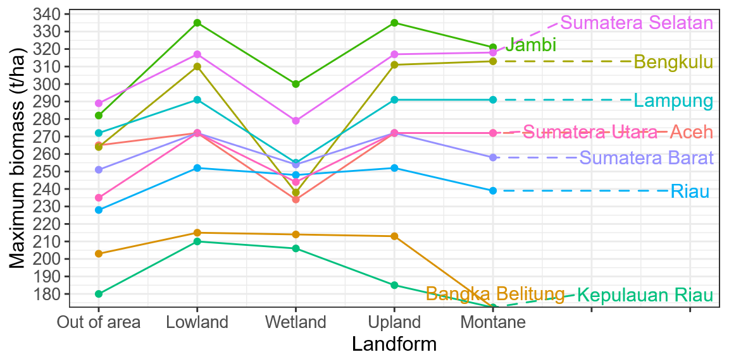
Figure S1. Calculating restoration potential for different landforms in Sumatra. Coloured lines show the maximum aboveground forest biomass (Santoro & Cartus, 2021) in Sumatran provinces within areas of undisturbed or degraded tropical moist forest (Vancutsem et al., 2021). The maxima are disaggregated by landform (Margono et al., 2014). Maximum biomass was used to calculate the conservation feature of forest restoration potential.

Applying a minimum biomass threshold
As a minimum biomass threshold to define forest we applied criteria from the High Carbon Stock Approach, which is commonly used for land-use planning in tropical forestry and agricultural sectors (Rosoman et al., 2017). Based on a carbon stock threshold of 35 t ha⁻¹ (i.e. 74 t ha⁻¹ of woody biomass using a standard conversion of 0.47(McGroddy et al., 2004), the methodology helps differentiate between ‘young regenerating forest’ with potential for restoration/regeneration, and ‘scrub’, which is typically too heavily degraded for restoration to be viable (i.e. prohibitive cost and low chance of success (Banin et al., 2023; Budiharta et al., 2014).
For example, Site A, a montane area in Bengkulu province having a biomass of 150 t ha⁻¹ could be restored to a maximum biomass of 331 t ha⁻¹ (Fig. S1), therefore restoration potential of site A is $\frac{331-150}{331}=0.54$. We calculated proportional, instead of absolute potential to account for differences in absolute maxima between landforms. Absolute restoration potential for site A would be $331-150=181 t/ha$. Comparing this to Site B, a wetland area in Bengkulu having a biomass of 110 t/ha where the maximum biomass is 238 t/ha (Fig. S1), proportional potential here is $\frac{238-110}{238}=0.54$ whereas absolute potential would be $238-110=128 t/ha$. Although both areas have the same proportional potential, site A has a higher absolute potential. To avoid creating a bias in the prioritisation analysis against selecting areas with low absolute maxima (e.g. wetlands in Bengkulu), we used proportional potential as the forest restoration conservation feature.

1.3 Sensitivity analysis of biomass thresholds on prioritisation solutions
We ran a sensitivity analysis to test five biomass threshold values and their impact on the prioritisation solutions (Fig. S2; S3):
- No threshold (i.e. 0);
- Transition from ‘open land’ and ‘scrub’ (<32 t ha⁻¹);
- Transition from ‘scrub’ to ‘young regenerating forest’ (<74 t ha⁻¹) – used in analyses
- Transition from ‘young regenerating forest’ to ‘high carbon stock forest’ (<160 t ha⁻¹);
- Half the maximum (<50% biomass_{max}).
Overall, our selected threshold of <74 t ha⁻¹ produced 60-95% similar solutions to those based on thresholds of 0 and <32 t ha⁻¹ when selecting the highest priority areas (area budget of 10%), and 38-79% similar solutions to thresholds of <160 and <50%. This confirms that our choice of the <74 t ha⁻¹ threshold balances sensitivity to early-stage forest transitions while maintaining consistency with alternative thresholds in prioritization outcomes.
Most of the differences due to using different thresholds were small, with most priority rankings unchanged or changing by ±10, amongst solutions. In other words, an area identified as highly important (i.e. selected when area budget was 10%) when using a threshold of <74 t ha⁻¹ was highly likely to be selected in the area budget of 10, 20, or 30% when based on an alternative threshold. A lower ranked area, selected when the area budget was ≥90%, was likely to be ranked low regardless of which threshold was used.

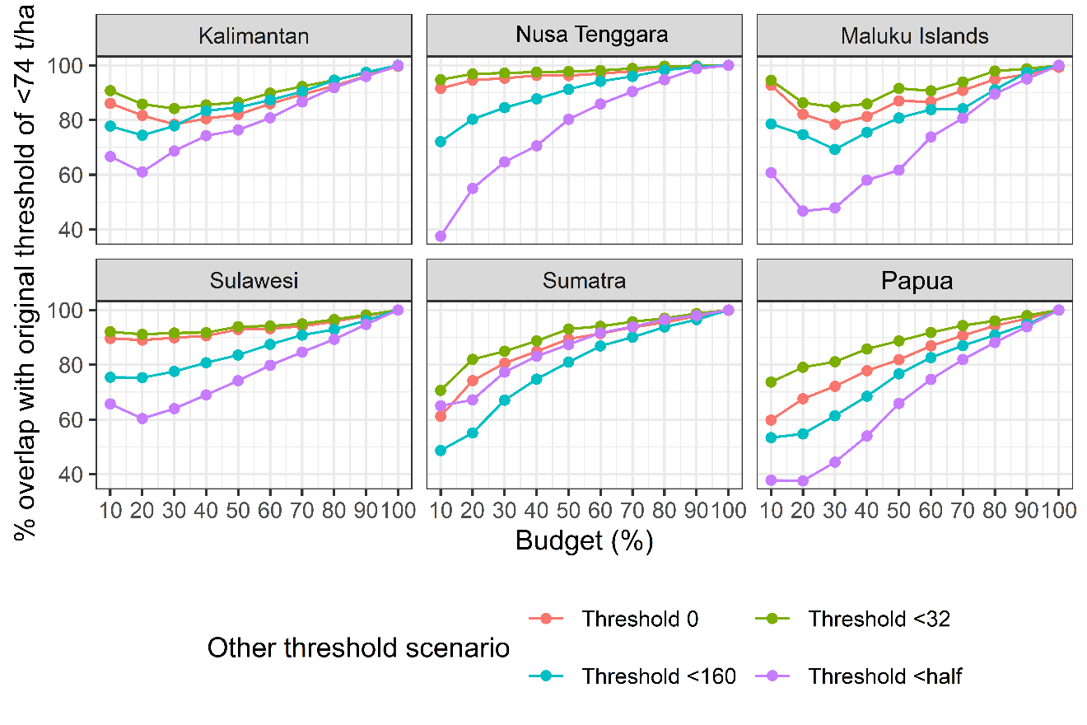
Figure S2. Sensitivity analysis of restoration potential threshold values. The y-axis shows the percentage overlap in the areas selected in solutions using four alternative thresholds compared to the <74 t ha⁻¹ threshold used in subsequent analyses. The x-axis shows the area budgets, with 10% being the highest priority areas which are selected first. Panels are for six regions of Indonesia and coloured lines show the different tested thresholds. Using the threshold ‘<half’ creates solutions that are most different from the <74 threshold used in the main analysis, followed by using the threshold <160, the threshold 0, and finally the threshold <32.

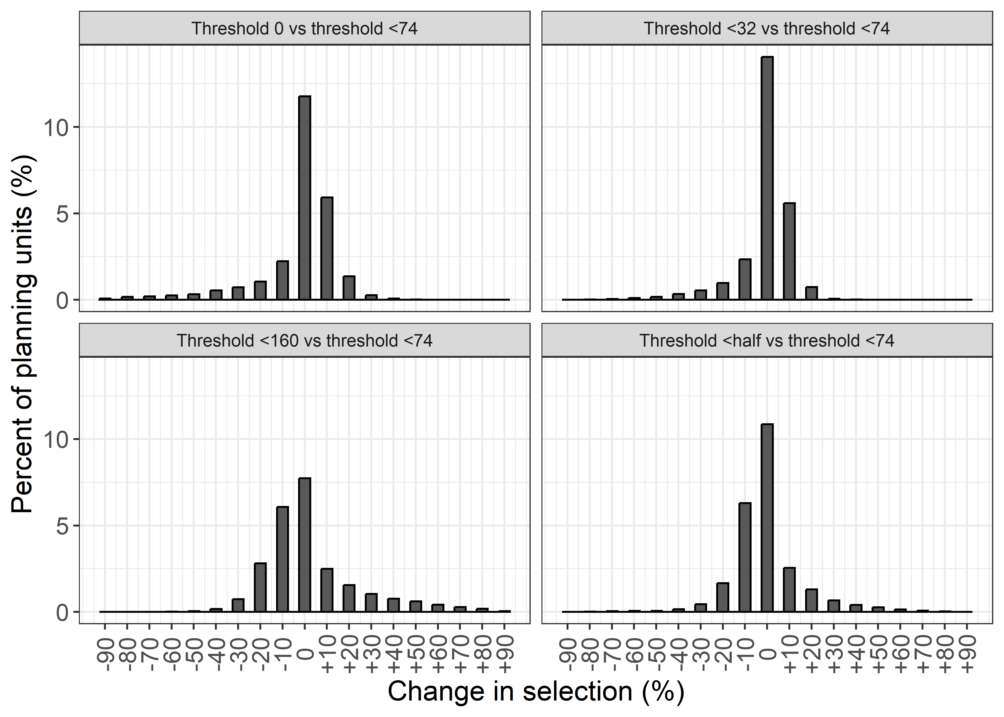
Figure S3. Histogram of changes in the selection priorities for Sumatra when using different biomass thresholds. Each plot shows the change in priority ranking between the original solution using a threshold of <74 t ha⁻¹ biomass and solution using an alternative threshold.

Section 2 Adaption of a Multidimensional Wellbeing Index for social forestry.
Table S1 Description of 15 indicators in each of five dimensions, and possible mechanisms between social forestry and well-being outcomes. Abbreviations for mechanisms: TENURE: Land tenure security; NTFP: Sustainable non-timber forest product harvesting/income; RIGHTS: Formal recognition of local/Indigenous rights; GOV: Local governance and community management associations.
Dimension | PODES Indicator | Description | Possible Mechanisms | Expected Outcome | Sources
Living Standards | WATER | Main source of drinking water | TENURE, NTFP | Improved land security and forest-based income allow for investment in clean water infrastructure. | 1, 2, 3
 | TOILET | Type of toilet facility | TENURE, NTFP | Household income gains from stable forest management allow for improved private sanitation. | 1, 2
 | FUEL | Type of cooking fuel | NTFP, TENURE | Switch from harvesting of fuelwood to cleaner fuel (LPG/Gas). | 1, 3
Health | FACILITIES | Availability of healthcare facilities | RIGHTS, GOV | Formal legal status facilitates better government service delivery and facility placement. | 1, 4
 | MALNUTRITION | Cases of malnutrition | NTFP, GOV | Enhanced food security through access to diverse forest-based nutrients and medicinal plants. Greater expenditure spent on food. | 1, 5
 | DISEASE | Mortality due to malaria or vomiting | GOV, NTFP | Community-led health treatments and improved local environments reduce disease mortality. | 1, 2
Education | PRIMARY | Presence of primary school | RIGHTS, GOV | Local management associations gain leverage for infrastructure and educational funding. | 1, 4
 | JUNIOR | Presence of junior high school | RIGHTS, GOV | Improved long-term village stability encourages secondary school development. | 1, 4
 | LITERACY | At least one literacy support programme | GOV | Community groups implement or host literacy programmes to support forest management tasks. | 1, 4
Infrastructure | SKTM | Number of households with poverty (SKTM) letters | TENURE, NTFP | Stabilised livelihoods lead to a decrease in the number of households requiring poverty certification. | 1, 2
 | MARKET | Presence of permanent or semi-permanent market in village | NTFP, GOV | Increased trade of non-timber forest products encourages market development. | 1, 3, 4
 | CREDIT | Availability of food credit, small business credit, etc. | TENURE, GOV | Legal tenure acts as collateral; management groups may form community credit unions. | 1, 2, 4
Social Cohesion | COOPERATION | Mutual-cooperation activities | GOV | Shared forest stewardship (e.g., Gotong Royong*) strengthens collective social bonds. | 1, 4
 | CRIME | Any serious crimes occur in the last 3 years | TENURE, GOV | Clear management rights and community oversight reduce resource-theft and local crime. | 1, 4
 | CONFLICT | A report of mass conflict in the past year | TENURE, RIGHTS | Formal recognition of land claims resolves tenure disputes and reduces inter-group conflict. | 1, 3
* Gotong royong is a foundational Indonesian philosophy of mutual assistance, communal cooperation, and shared responsibility. Translating to "jointly carrying a burden", it describes communities working together for the common good without expecting immediate financial compensation. This cultural ethos permeates many aspects of life in Indonesia, and is particularly pertinent to the concepts behind its social forestry programme.

Overview of sources linking the well-being indicators to social forestry contexts in Indonesia (more detailed breakdown of outcomes can be found in the supplemental material of these publications):
- (Morgans et al., 2024): The primary source for the 15-indicator multidimensional index and its application to Indonesian forest wellbeing.
- (Santika et al., 2019): Empirical evidence for how community forestry influences different poverty dimensions across Indonesia.
- (Hajjar et al., 2020): Global analysis confirming that community forests lead to improved social and environmental outcomes.
- (Fischer et al., 2023): Directly links formal community management and local rule-making to positive outcomes for carbon, biodiversity, and livelihoods.
- (Pradhan et al., 2026): Establishes the synergistic link between poverty reduction and biodiversity recovery through sustainable nature-dependent livelihoods

Section 3 Spatial aggregation of prioritisation solutions (boundary penalty)
Spatial aggregation in prioritisation solutions can be influenced by applying a boundary penalty (t). High penalties result in aggregated spatially-clustered solutions, while low penalties result in highly-ranked areas being small and patchily distributed amongst planning units. Prioritisation solutions with no boundary penalty applied are optimal since they capture the highest possible amount of each objective. However, this approach tends to prioritise areas that are small and highly fragmented over a planning region, which is undesirable for land-use planning decisions. As the penalty value increases, solutions become less optimal and achieve less of each objective, but selected areas become larger and spatially clustered. Some amount of spatial aggregation is generally desirable to minimise edge effects and facilitate management.
We adapted a standard approach of calibrating the boundary penalty (https://prioritizr.net/). We chose the highest possible penalty value for each province which had a <10% reduction in performance, or in other words the most spatially aggregated solution which achieved at least 90% of the restoration, biodiversity , and poverty alleviation objectives as compared to the unaggregated solutions (Fig. S4).
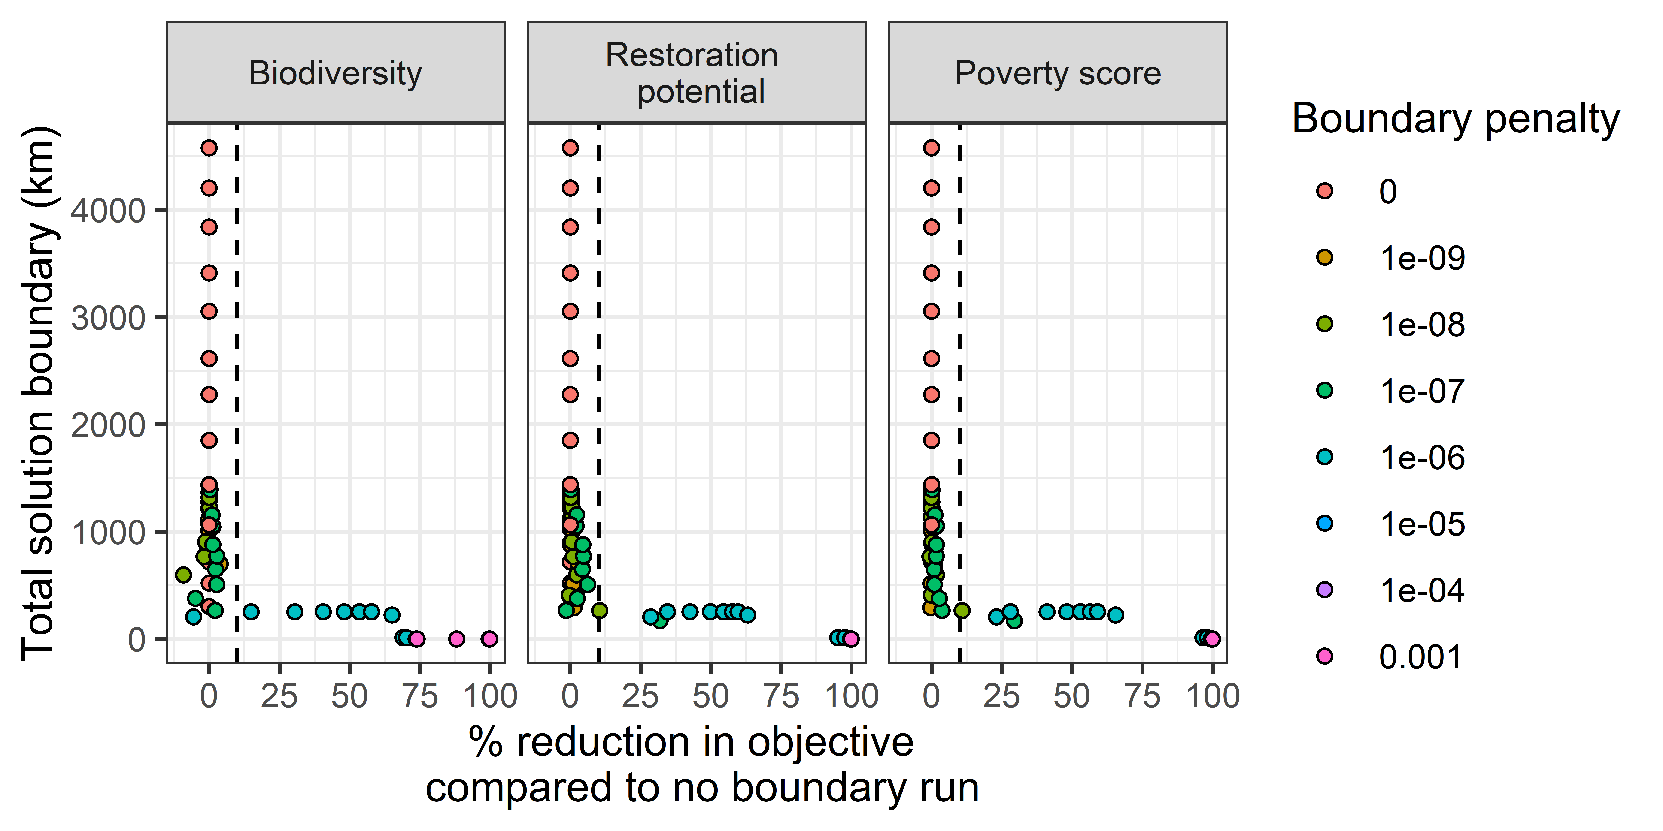
Figure S4. Effect of different boundary penalty values on prioritisation solutions in Bengkulu province, Sumatra. The y-axis gives the total outer perimeter length of the planning units selected in solutions. The x-axis gives the mean percentage reduction in the conservation features compared to runs using no boundary penalty. There are 10 dots for each unique boundary penalty value corresponding to the solution at 10%, 20%, …, 100% of the area budget. The three panels show the three different objectives. The dashed vertical line is drawn at 10% reduction.

Supplementary References
Banin, L. F., Raine, E. H., Rowland, L. M., Chazdon, R. L., Smith, S. W., Rahman, N. E. B., Butler, A., Philipson, C., Applegate, G. G., Axelsson, E. P., Budiharta, S., Chua, S. C., Cutler, M. E. J., Elliott, S., Gemita, E., Godoong, E., Graham, L. L. B., Hayward, R. M., Hector, A., … Burslem, D. F. R. P. (2023). The road to recovery: A synthesis of outcomes from ecosystem restoration in tropical and sub-tropical Asian forests. Philosophical Transactions of the Royal Society B: Biological Sciences, 378(1867), 20210090. https://doi.org/10.1098/rstb.2021.0090
Budiharta, S., Meijaard, E., Erskine, P. D., Rondinini, C., Pacifici, M., & Wilson, K. A. (2014). Restoring degraded tropical forests for carbon and biodiversity. Environmental Research Letters, 9(11), 114020. https://doi.org/10.1088/1748-9326/9/11/114020
Fischer, H. W., Chhatre, A., Duddu, A., Pradhan, N., & Agrawal, A. (2023). Community forest governance and synergies among carbon, biodiversity and livelihoods. Nature Climate Change, 13(12), 1340–1347. https://doi.org/10.1038/s41558-023-01863-6
Hajjar, R., Oldekop, J. A., Cronkleton, P., Newton, P., Russell, A. J. M., & Zhou, W. (2020). A global analysis of the social and environmental outcomes of community forests. Nature Sustainability, 4(3), 216–224. https://doi.org/10.1038/s41893-020-00633-y
Margono, B. A., Potapov, P. V., Turubanova, S., Stolle, F., & Hansen, M. C. (2014). Primary forest cover loss in indonesia over 2000-2012. Nature Climate Change, 4(8), 730–735. https://doi.org/10.1038/nclimate2277
McGroddy, M. E., Daufresne, T., & Hedin, L. O. (2004). Scaling of C:N:P stoichiometry in forests worldwide: Implications of terrestrial redfield-type ratios. Ecology, 85(9), 2390–2401.
Morgans, C. L., Jago, S., Andayani, N., Linkie, M., Lo, M. G. Y., Mumbunan, S., St. John, F. A. V., Supriatna, J., Voigt, M., Winarni, N. L., Santika, T., & Struebig, M. J. (2024). Improving well‐being and reducing deforestation in Indonesia’s protected areas. Conservation Letters, 17(3), e13010. https://doi.org/10.1111/conl.13010
Pradhan, N., Ibáñez, I., Chhatre, A., Duddu, A., Fischer, H. W., Newton, P., Oldekop, J. A., Wilson, S. J., & Agrawal, A. (2026). Advancing biodiversity through poverty solutions. Nature Sustainability. https://doi.org/10.1038/s41893-026-01816-9
Rosoman, G., Sheun, S. S., Opal, C., Anderson, P., & Trapshah, R. (2017). The HCS Approach Toolkit: Module 4—Forest and vegetation stratification. The HCS Approach Toolkit Version 2.0, (August).
Santika, T., Wilson, K. A., Budiharta, S., Kusworo, A., Meijaard, E., Law, E. A., Friedman, R., Hutabarat, J. A., Indrawan, T. P., St. John, F. A., & others. (2019). Heterogeneous impacts of community forestry on forest conservation and poverty alleviation: Evidence from Indonesia. People and Nature, 1(2), 204–219.
Santoro, M., & Cartus, O. (2021). ESA Biomass Climate Change Initiative (Biomass_cci): Global datasets of forest above-ground biomass for the years 2010, 2017 and 2018, v3. NERC EDS Centre for Environmental Data Analysis. https://doi.org/10.5285/5f331c418e9f4935b8eb1b836f8a91b8
Vancutsem, C., Achard, F., Pekel, J. F., Vieilledent, G., Carboni, S., Simonetti, D., Gallego, J., Aragão, L. E. O. C., & Nasi, R. (2021). Long-term (1990–2019) monitoring of forest cover changes in the humid tropics. Science Advances, 7(10), 1–22. https://doi.org/10.1126/sciadv.abe1603

