Supplementary File
Multiscale architecture and composition of two South Australian Bryozoa: Celleporaria cristata and Densipora corrugata
Kushani Jayasoma^{a*}, Laura M. Otter^{a 1}, Andrej Ernst^{b}, Michael W. Försterª, Joachim Scholz^{c}, Dorrit E. Jacobª
ª Research School of Earth Sciences, Australian National University, Canberra, Australia
^{b} Institute of Geology, University of Hamburg, Germany
^{c} Senckenberg – Leibniz Institution for Biodiversity and Earth System Research, Senckenberg Research Institute and Natural History Museum Frankfurt, Germany
¹ Present address: Department of Mineralogy and Crystallography, University of Vienna, Vienna 1090, Austria

*Corresponding author – kushani.jayasoma@anu.edu.au
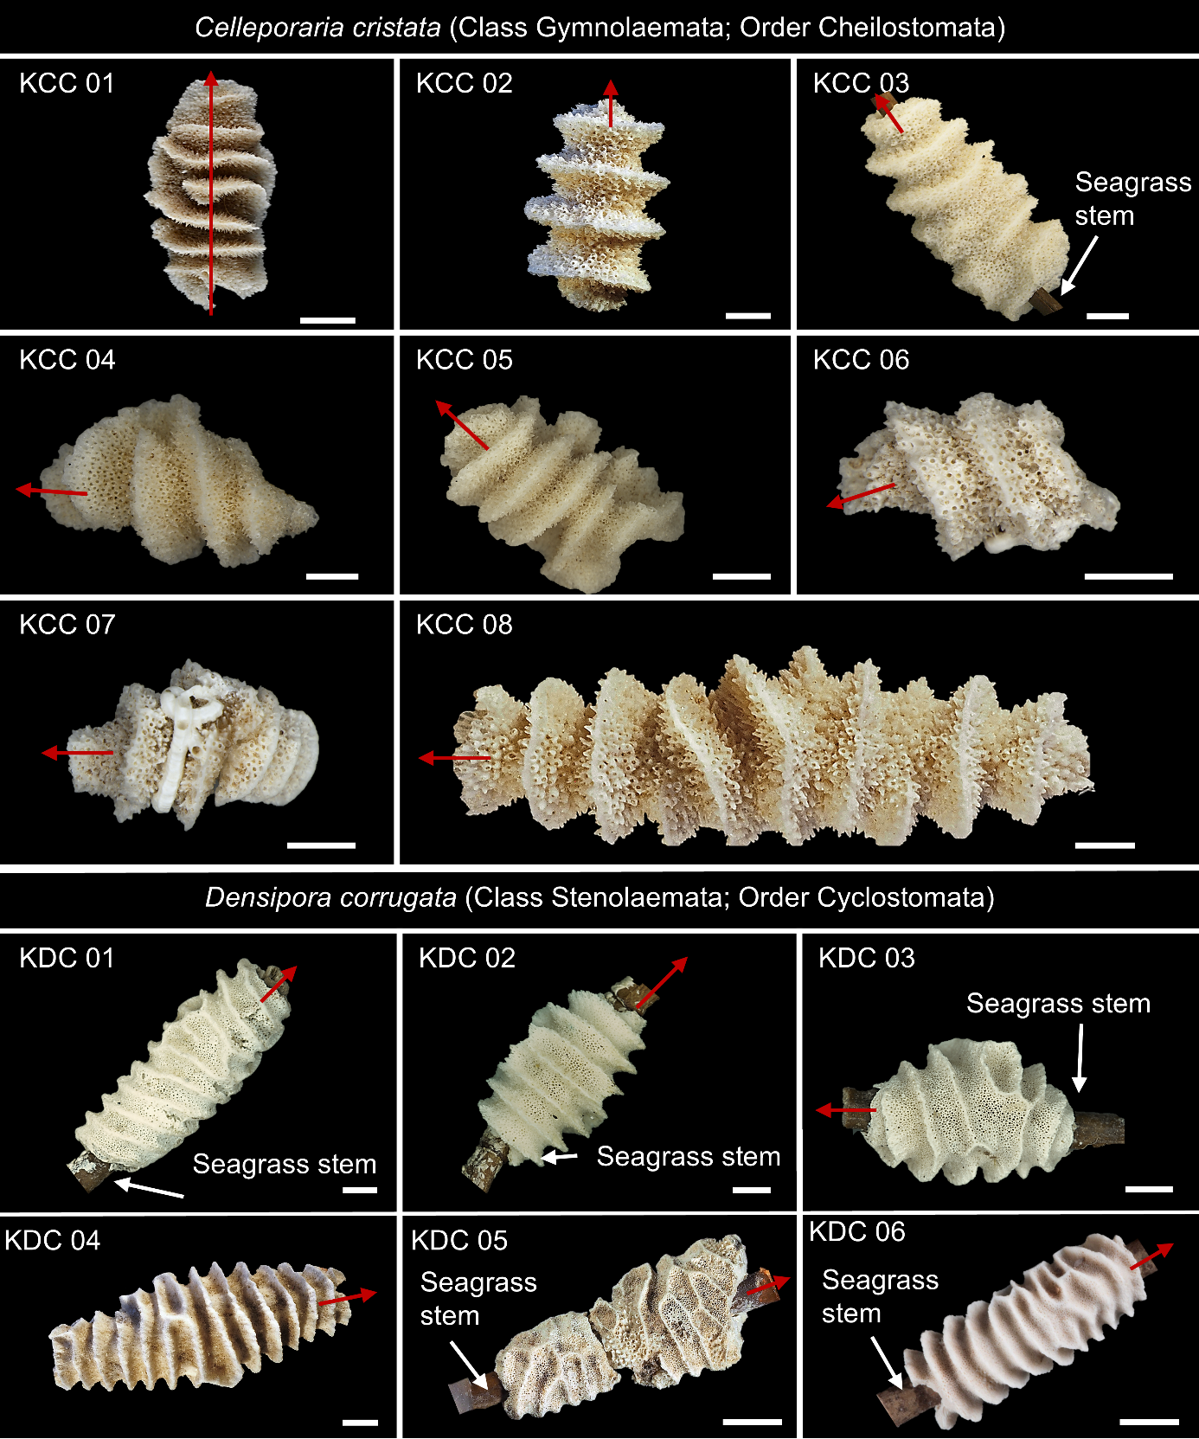
Supplementary Figure 1. Optical light microscope images of studied cheilostome Celleporaria cristata and cyclostome Densipora corrugata Bryozoa colonies (red arrows indicates the long axes of the colonies). See Suppl. Table 1 for Senckenberg Museum collection numbers. Scale bars: 2 mm in all figures.
Supplementary Figure 2. Optical microscope images of thin sections (transmitted light) (A) Longitudinal section and (B) transverse sections of C. cristata (A: SMF44802, B: SMF44806) showing ridges oriented approximately perpendicular to the colony’s long axis. Note the box-shaped zooids that are characteristic for Cheilostomata. (C) Longitudinal section and (D) transverse section of D. corrugata (C: SMF44807, D: SMF44806) showing ridges aligned approximately perpendicular to the colony’s long axis (seagrass stem). Note the tubular-shaped zooids which are characteristic for Cyclostomata. Scale bars 1 mm in all panels.
Supplementary Figure 3. D. corrugata (Sample SMF44794) (A) BSE image of a polished, longitudinal section of a colony (B) Exemplary micro-Raman map using the main calcite peak (ν₁) at 1085.5 cm⁻¹ of the area indicated by the rectangle in (A) showing the area to consist entirely of calcite. Scale bar in (A) is 500 µm.
Supplementary Figure 4. BSE images and EPMA elemental distribution maps for Na and Sr in a polished longitudinal section of C. cristata (A-C; sample SMF44817) and D. corrugata (D-G; sample SMF44791) colonies (A, D) BSE images of mapped areas (B, E) Na distribution, (C, F) Sr distribution. All scale bars are 200 µm.
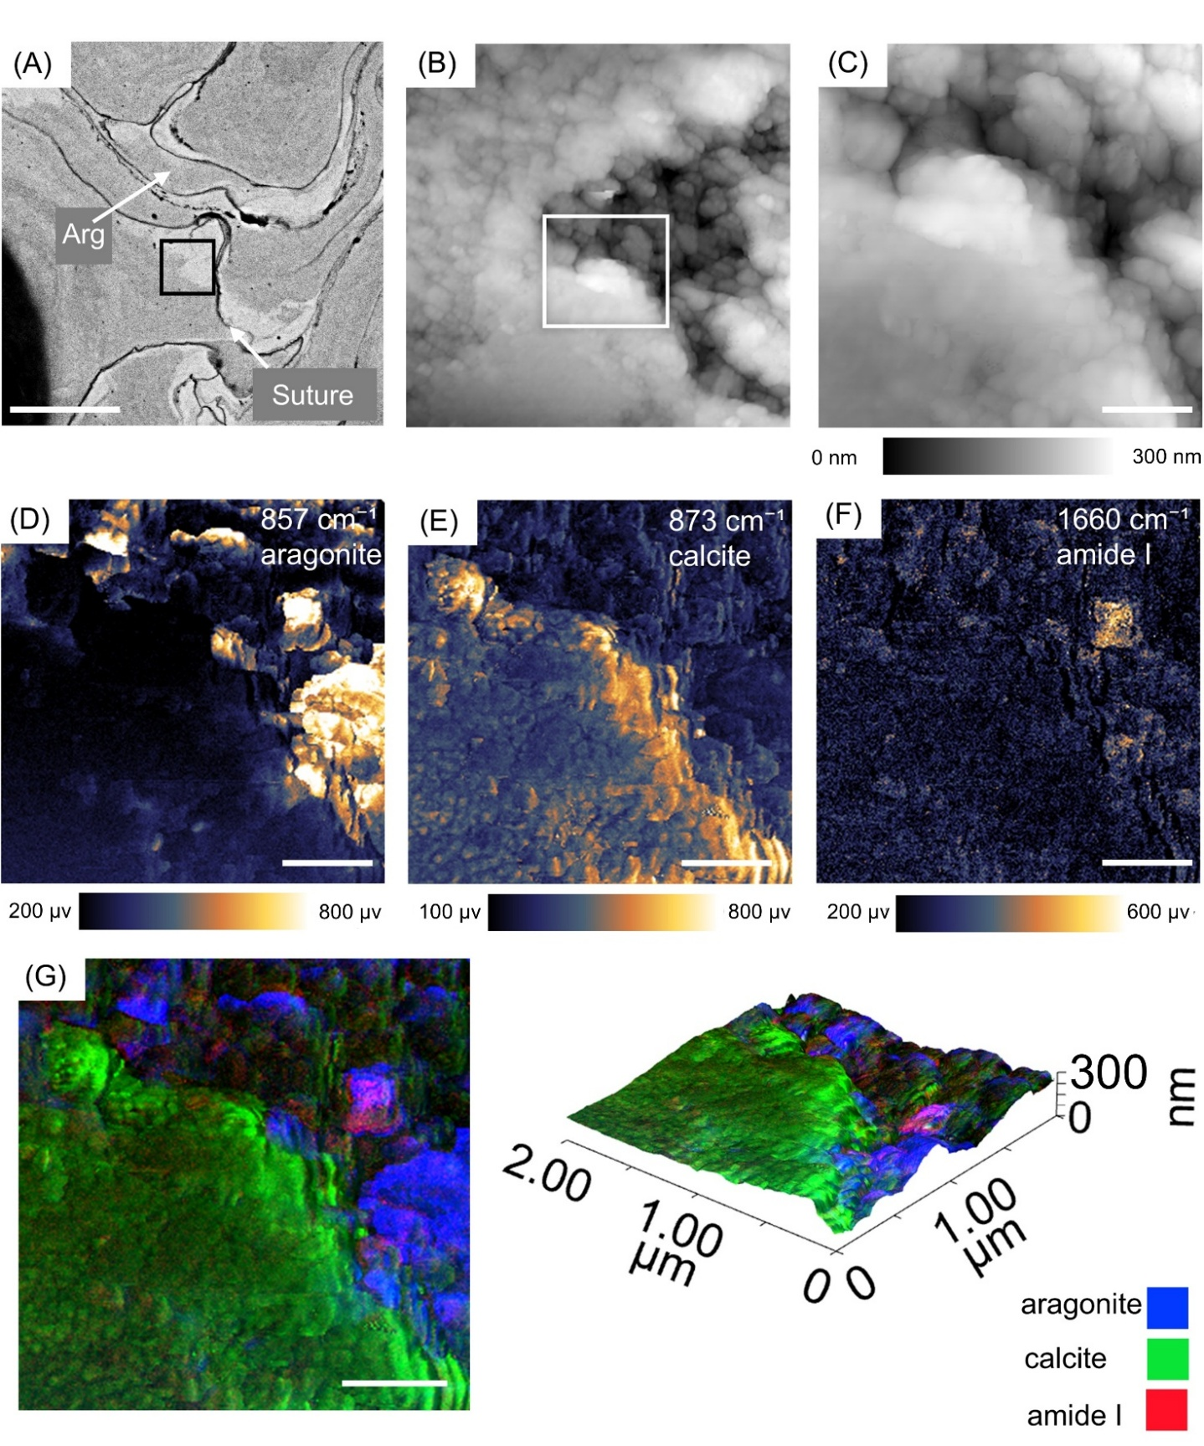
Supplementary Figure 5. Nanoscale molecular distribution maps obtained by Photo-induced Force Microscopy (PiFM), from a bimineralic area in a vertical wall of a C. cristata colony (A) BSE overview image of the area mapped by PiFM (rectangle) showing aragonite (Arg) distribution. (B) AFM topography overview map of the area marked by the rectangle in (A). (C) High-resolution (2 µm × 2 µm) AFM topography map of the area marked by the rectangle in (B). (D-F) PiFM nanoscale molecular distribution maps for wavenumbers identifying aragonite (Arg) (D), calcite (Cal) (E), and amide I (as a proxy for protein) (F). (G) Composite three-channel PiFM map, combining D to F, illustrating the absence of organics along the calcite-aragonite interface. (H) PiFM composite image overlain on the 3D topography illustrating the distribution of mineral species and organic components in relation to surface morphology, further indicating the presence of organic-rich areas (amide I) within the aragonite regions but not along the aragonite-calcite interface. No significant carbohydrate signal was observed in this mapped area. Scale bars: 10 µm (A), 1 µm (B), 500 nm (C-G).
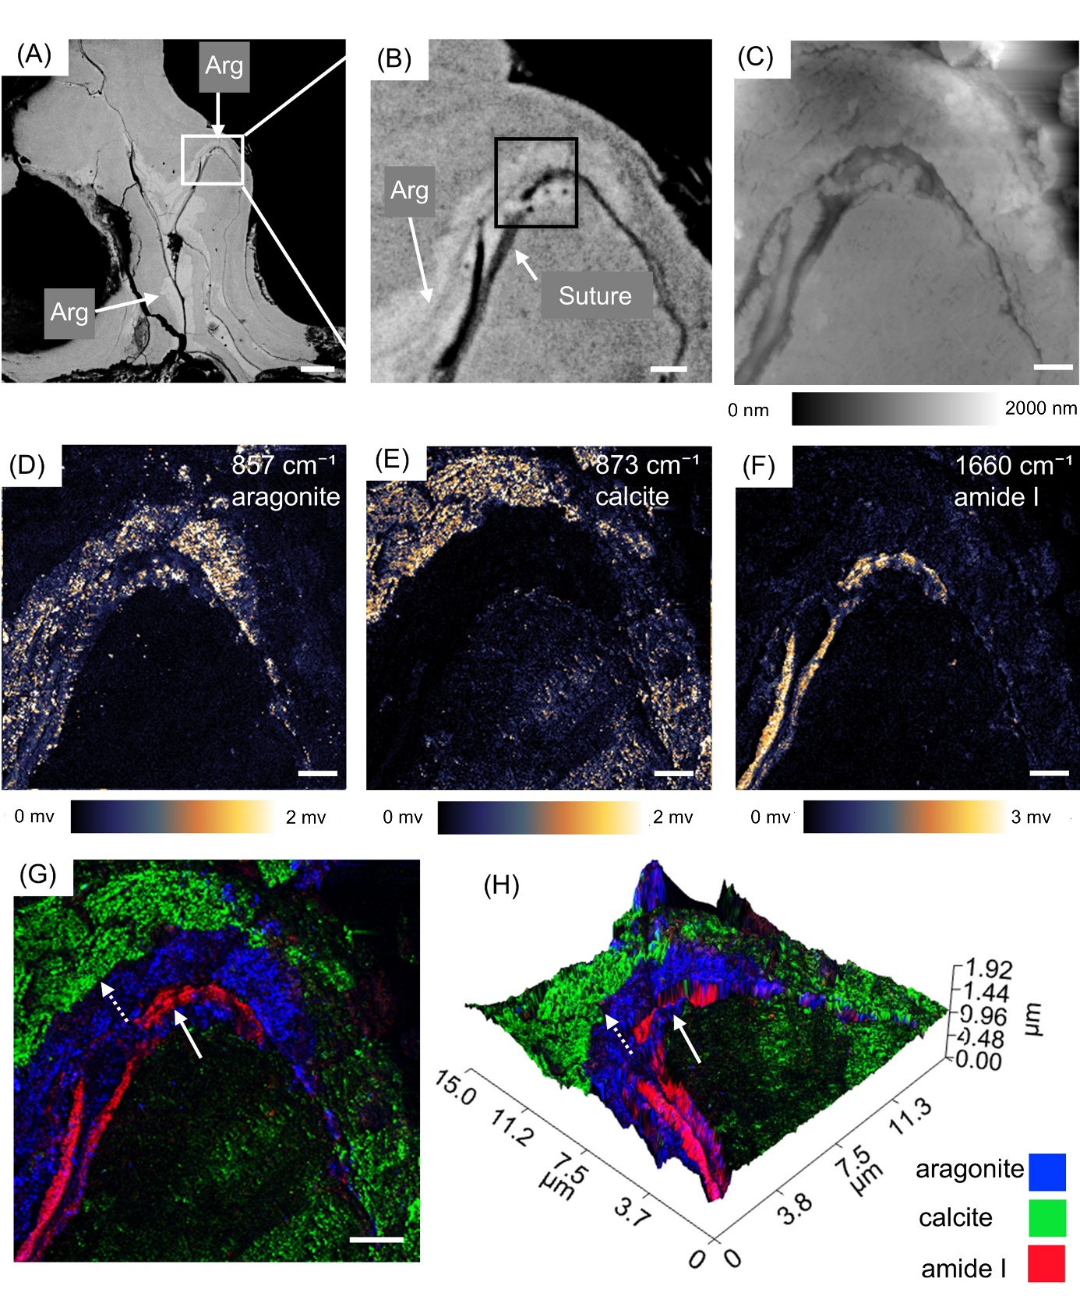
Supplementary Figure 6. Nanoscale molecular distribution maps, obtained by PiFM, from a longitudinal section of an interior vertical wall of C. cristata (sample (SMF44797) containing aragonite and an organic interface (A) BSE overview image of the vertical wall showing aragonite (Arg) distribution in light grey close to the organic layer. (B) AFM topography overview map of the area marked by the rectangle in (A). (C) High- resolution (15 µm × 15 µm) topography map of the area marked by the rectangle in (B). (D-F PiFM nanoscale molecular distribution maps for wavenumbers identifying aragonite (Arg) (C), calcite (d), and amide I(E). (F) Composite three-channel PiFM map combining D to F, illustrating the amide I signals co-located with the organic layer and absent along the aragonite-calcite interface(dashed-arrow). (G) Three channel PiFM composite overlain with (H) PiFM composite images overlain on 3D topography map, illustrating the distribution of mineral and organic components in relation to surface morphology, solid arrow in g and h indicate the interface between calcite and aragonite wall portions with the organic layer, while the dashed arrow indicates the interface without any detectable organic phases. Scale bars: 10 µm (A), 2 µm (B-G).

