Supplementary Table 1. Tukey's HSD critical values for all biochemical parameters (α = 0.05, k = 30, df error = 60)

Parameter | HSD Value | q-critical | SE | Sensitivity
PAL Activity 30 DAT | 0.0043 | 5.5663 | 0.000780 | Most sensitive
C4H Activity 30 DAT | 0.0108 | 5.5663 | 0.001940 | High sensitivity
PAL Activity 86 DAT | 0.0102 | 5.5663 | 0.001837 | High sensitivity
C4H Activity 86 DAT | 0.0154 | 5.5663 | 0.002758 | High sensitivity
Flavonoid 30 DAT | 2.3365 | 5.5663 | 0.4198 | Moderate
Flavonoid 86 DAT | 5.4349 | 5.5663 | 0.9764 | Moderate
Total Phenol 86 DAT | 9.0272 | 5.5663 | 1.6218 | Moderate
Total Phenol 30 DAT | 9.7786 | 5.5663 | 1.7567 | Moderate
Lignin 30 DAT | 28.8153 | 5.5663 | 5.1767 | Lower sensitivity
Lignin 86 DAT | 179.1018 | 5.5663 | 32.1759 | Lowest sensitivity

Note: SE = Standard Error of treatment means = √(MSerror/r); HSD = q-critical × SE; Lower HSD indicates greater sensitivity for detecting cultivar differences.

Supplementary Table 2: Pearson correlation coefficients between genotype mean biochemical traits and pooled mean aphid count (n = 30)
Biochemical trait | r | p (raw) | p (FDR)
Total phenol (30 DAT) | −0.854 | <0.001 | <0.001
Flavonoid (86 DAT) | −0.804 | <0.001 | <0.001
Total phenol – 86 DAT | −0.774 | <0.001 | <0.001
Lignin – 86 DAT | −0.734 | <0.001 | <0.001
Flavonoid – 30 DAT | −0.534 | 0.0024 | 0.0047
C4H activity – 86 DAT | −0.518 | 0.0034 | 0.0056
C4H activity – 30 DAT | −0.494 | 0.0055 | 0.0079
Lignin – 30 DAT | −0.355 | 0.0543 | 0.0679
PAL activity – 86 DAT | −0.239 | 0.204 | 0.227
PAL activity – 30 DAT | 0.102 | 0.592 | 0.592

Supplementary Table 3: Final stepwise multiple linear regression model for pooled mean aphid count
Predictor | β | SE | t | p
Intercept | 124.895 | 12.337 | 10.12 | <0.001
Total phenol – 30 DAT | −2.884 | 0.759 | −3.80 | <0.001
Flavonoid – 86 DAT | −0.814 | 0.375 | −2.17 | 0.039
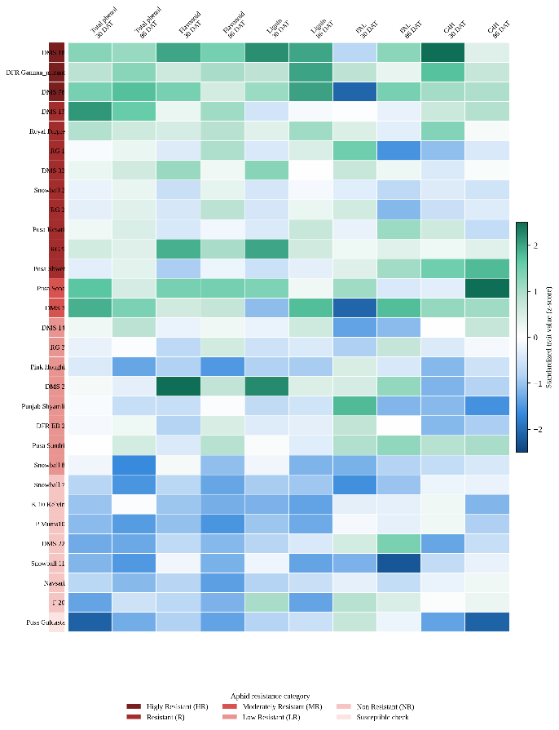
Supplementary Fig. 1. Biochemical profile of 30 chrysanthemum genotypes across five phenylpropanoid pathway traits (total phenol, flavonoid, lignin, PAL activity, C4H activity) measured at 30 and 86 days after transplanting, standardized as z-scores. Genotypes are ordered by aphid-resistance category (color strip, left) from highly resistant (dark red) to the susceptible check (pale).

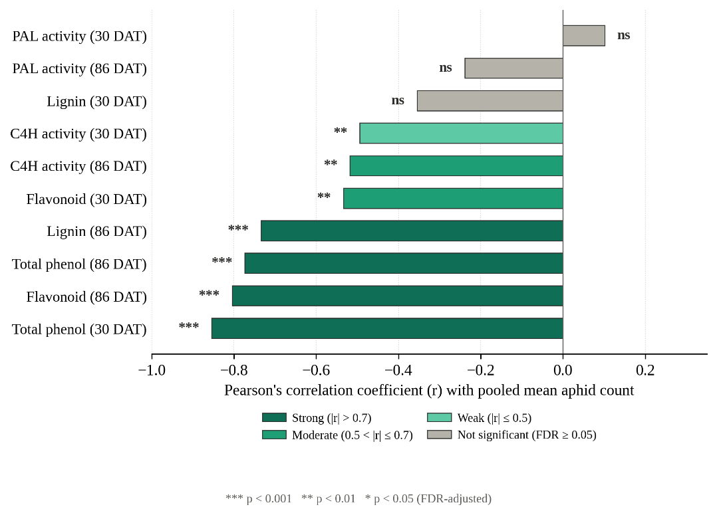
Supplementary Fig. 2: Standardized ridge regression coefficients (mean ± SD across 5-fold cross-validation, λ = 11.24) for the nine biochemical predictors retained after multicollinearity screening. Dark bars indicate predictors also retained in the final AIC-selected stepwise model.

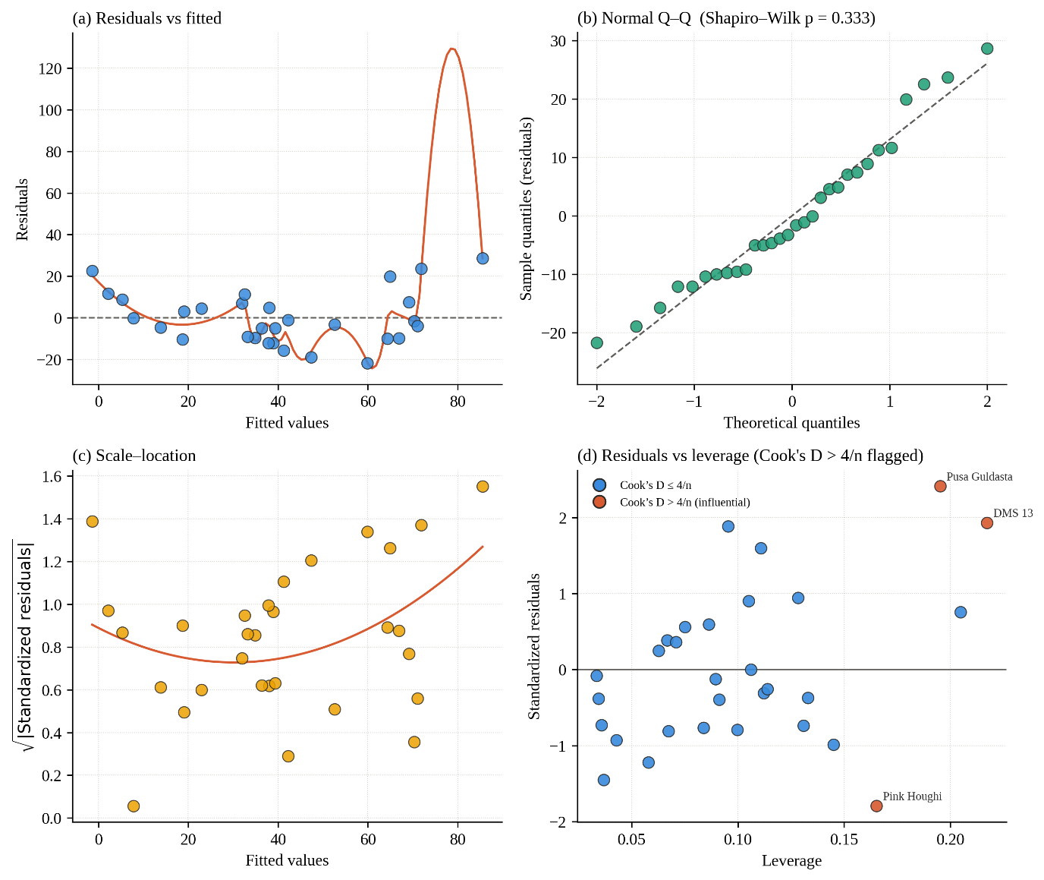
Supplementary Fig. 3: Diagnostic plots for the final regression model: (a) residuals vs. fitted values, (b) normal Q–Q plot of residuals, (c) scale–location plot, and (d) residuals vs. leverage with Cook's distance. Influential observations (Cook's D > 4/n) are highlighted in red in panel (d).

