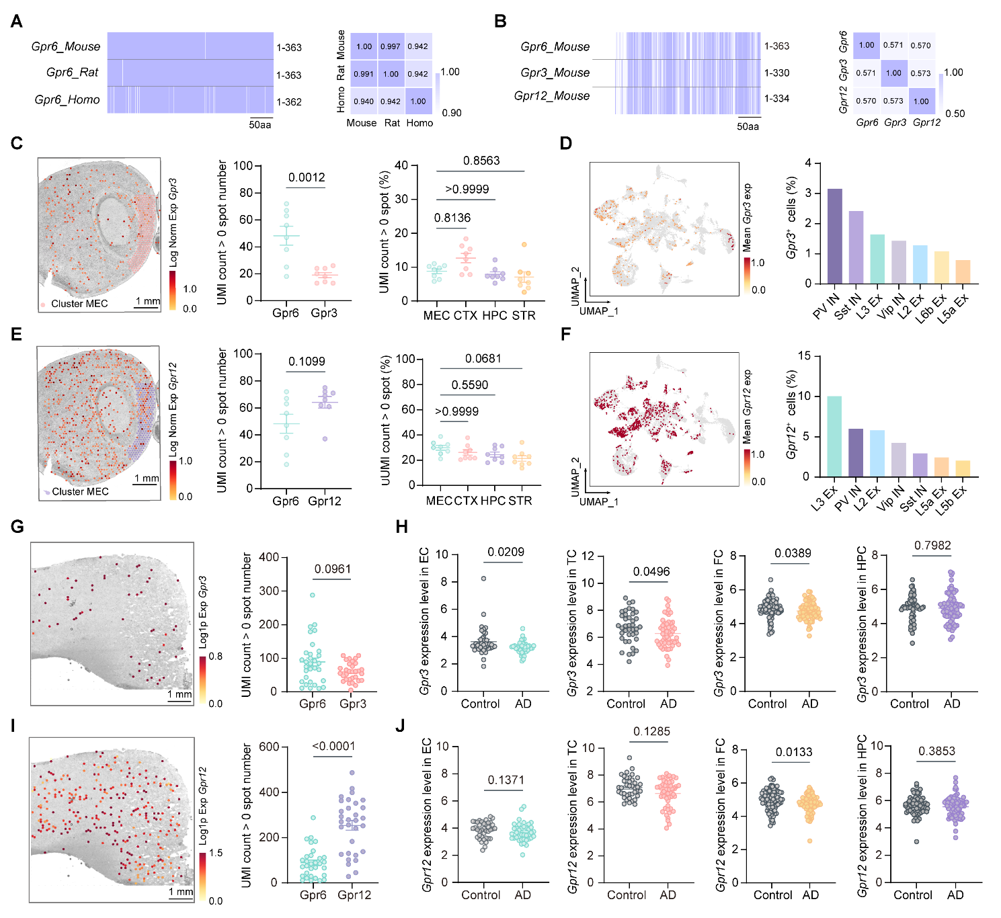
Figure S1. Conservation and comparative expression patterns of GPR6, GPR3, and GPR12.
(A) Cross-species sequence comparison of GPR6 among mouse, rat, and human.
(B) Sequence comparison of mouse GPR6, GPR3, and GPR12.
(C) Mouse 10× Visium map of Gpr3 expression and quantification of Gpr6- and Gpr3-positive spots in mouse EC. Positive spots were defined as UMI count > 0 (Gpr6 vs Gpr3, P = 0.0012; n = 8 sections, N = 2; Mann–Whitney U test). Regional Gpr3-positive spot proportions are shown on the right.
(D) Gpr3 expression across mouse MEC single-nucleus clusters and quantification of Gpr3-positive cell proportions.
(E) Mouse 10× Visium map of Gpr12 expression and quantification of Gpr6- and Gpr12-positive spots in mouse EC. Positive spots were defined as UMI count > 0 (Gpr6 vs Gpr12, P = 0.1099; n = 8 sections, N = 2; Mann–Whitney U test). Regional Gpr12-positive spot proportions are shown on the right.
(F) Gpr12 expression across public mouse MEC single-nucleus clusters and quantification of Gpr12-positive cell proportions.
(G) Human EC 10× Visium map of GPR3 expression and quantification of GPR6- and GPR3-positive spots (GPR6 vs GPR3, P = 0.0961; N = 31 sections/spatial samples; Mann–Whitney U test).
(H) GPR3 expression in public human bulk transcriptomic datasets from EC, TC, FC, and HPC (P values are shown in the panel; Mann–Whitney U test).
(I) Public human EC 10× Visium map of GPR12 expression and quantification of GPR6- and GPR12-positive spots (GPR6 vs GPR12, P < 0.0001; N = 31 sections/spatial samples; Mann–Whitney U test).
(J) GPR12 expression in public human bulk transcriptomic datasets from EC, TC, FC, and HPC (P values are shown in the panel; Mann–Whitney U test).
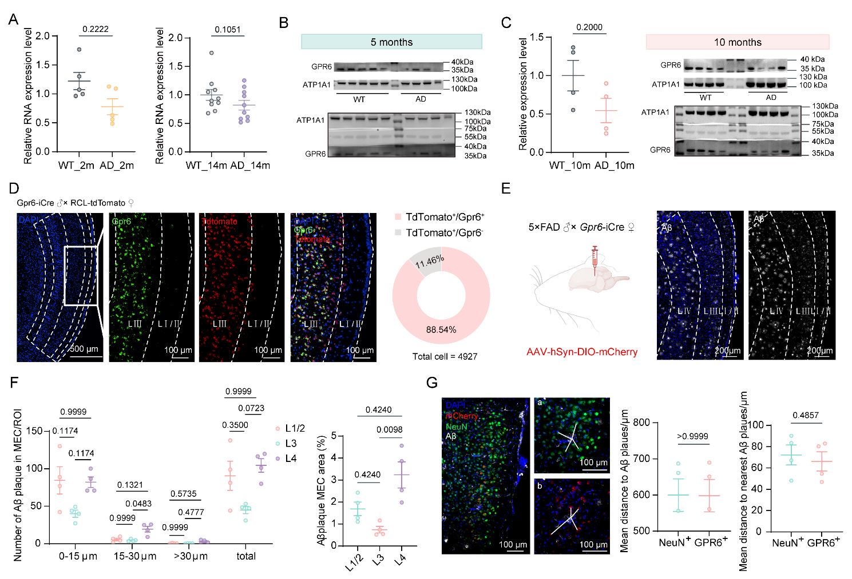Figure S2. Gpr6 expression and spatial relationship of endogenous Gpr6-expressing cells with Aβ plaques in mice.
(A) Gpr6 RNA expression in mouse MEC at 2 and 14 months of age (2 months: P = 0.2222, WT N = 5 mice, 5×FAD N = 5 mice; 14 months: P = 0.1903, WT N = 10 mice, 5×FAD N = 11 mice; Mann–Whitney U test).
(B) Western blots showing GPR6 and ATP1A1 expression in all 5-month-old WT and 5×FAD mouse MEC samples. ATP1A1 was used as the loading control.
(C) GPR6 protein levels and representative western blots from 10-month-old WT and 5×FAD mouse MEC samples (WT N = 4 mice, 5×FAD N = 4 mice; P = 0.2000; Mann–Whitney U test). ATP1A1 was used as the loading control.
(D) Validation of endogenous Gpr6-expressing cell labeling in Gpr6-iCre;tdTomato mice. RNAscope Gpr6 signal is shown in green and tdTomato in red. The pie chart quantifies the overlap between tdTomato-labeled cells and Gpr6-positive cells.
(E) AAV-hSyn-DIO-mCherry injection in 5×FAD;Gpr6-iCre mice and representative Aβ staining with MEC laminar segmentation. Aβ is shown in white and DAPI in blue.
(F) Quantification of Aβ plaque number and Aβ-positive area fraction across MEC laminar groups. Pairwise adjusted P values are shown in the panel.
(G) Representative images showing Aβ plaques, NeuN-positive neurons, and mCherry-labeled endogenous Gpr6-expressing cells. Lines indicate representative cell-to-plaque distance measurements. Quantification is shown on the right (mean distance to Aβ plaques, P > 0.9999; distance to nearest Aβ plaque, P = 0.4857; Mann–Whitney U test).
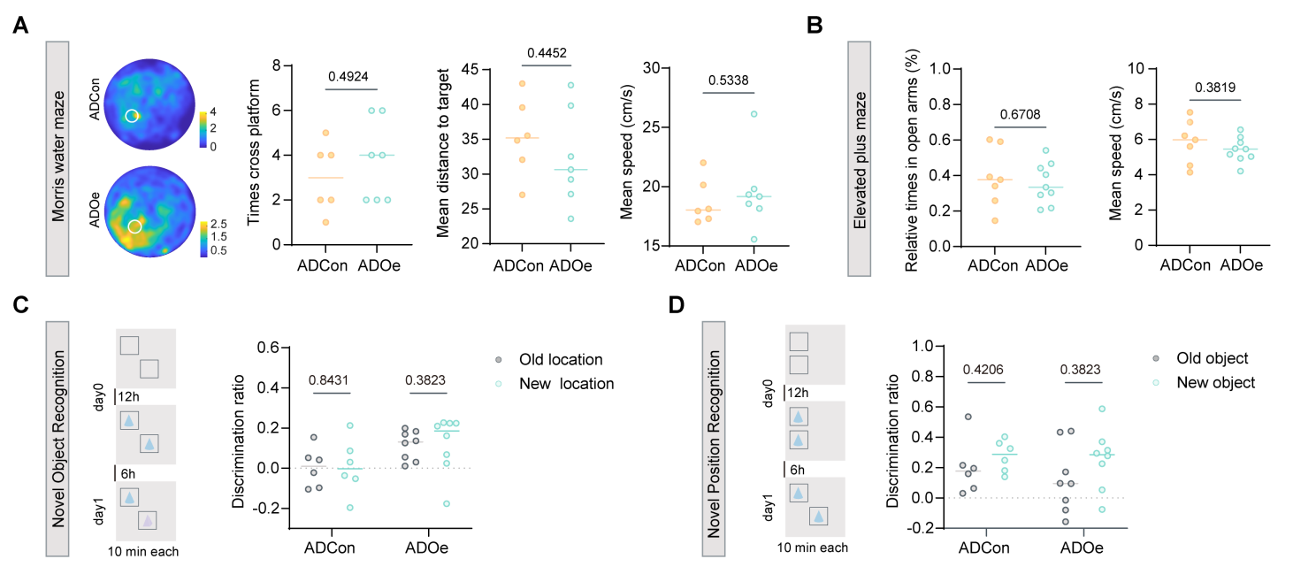
Figure S3. Behavioral control assays following MEC-targeted Gpr6 overexpression in 5×FAD mice.
(A) Morris water-maze probe test. Occupancy heatmaps and quantification of platform crossings, mean distance to the target, and mean speed are shown (platform crossings, P = 0.4924; distance, P = 0.4452; speed, P = 0.5338; ADCon: N = 7; ADOe: N = 9; Mann–Whitney U test).
(B) Elevated plus maze test. Open-arm time and mean speed are shown (open-arm time, P = 0.6708; speed, P = 0.3819; ADCon: N = 7; ADOe: N = 9; Mann–Whitney U test).
(C) Novel object recognition assay. Discrimination ratios for old and new objects are shown (ADCon, P = 0.4206; ADOe, P = 0.3823; N = 6 per group; Wilcoxon matched-pairs test).
(D) Novel location recognition assay. Discrimination ratios for old and new locations are shown (ADCon, P = 0.8431; ADOe, P = 0.3823; N = 6 per group; Wilcoxon matched-pairs test).
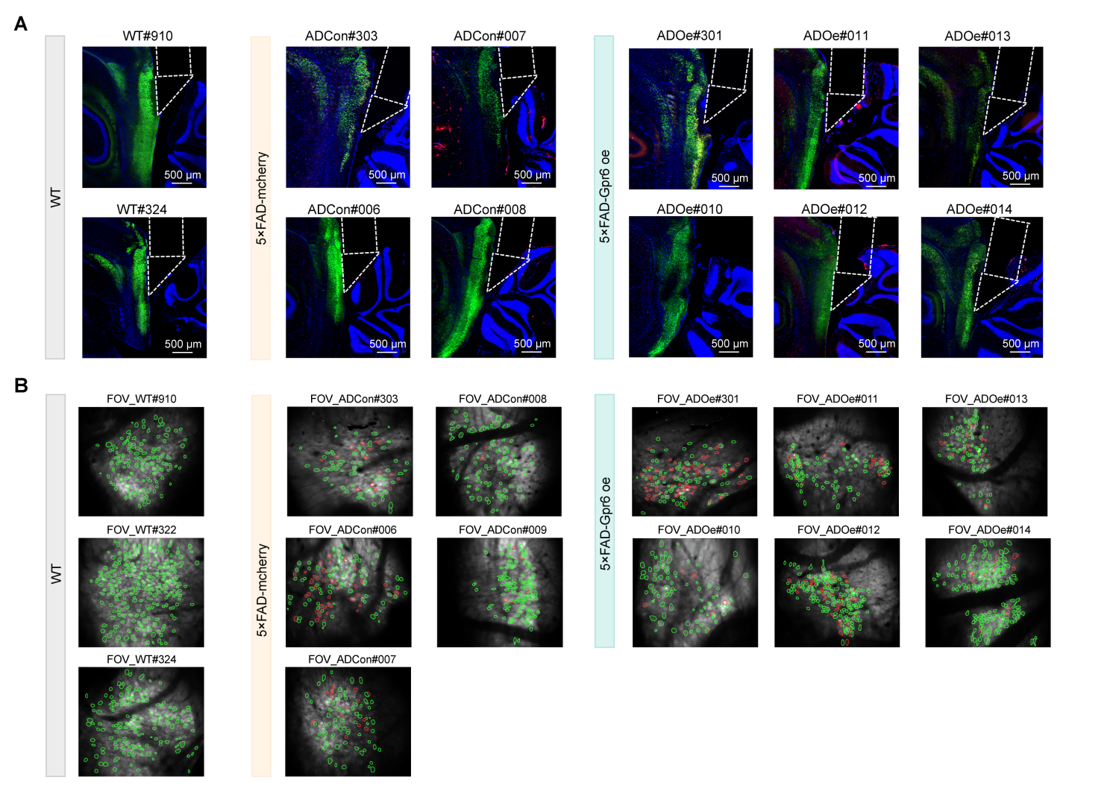
Figure S4. Brain sections and segmented cells in two-photon imaging FOVs across mice.
(A) Representative brain sections from WT, ADCon, and ADOe mice implanted with microprisms. White dashed outlines indicate the inferred microprism position based on the implantation track and tissue trace.
(B) Representative two-photon imaging FOVs with segmented cells. Cell contours are color-coded by viral labeling status: red, mCherry-positive cells; green, other detected cells.
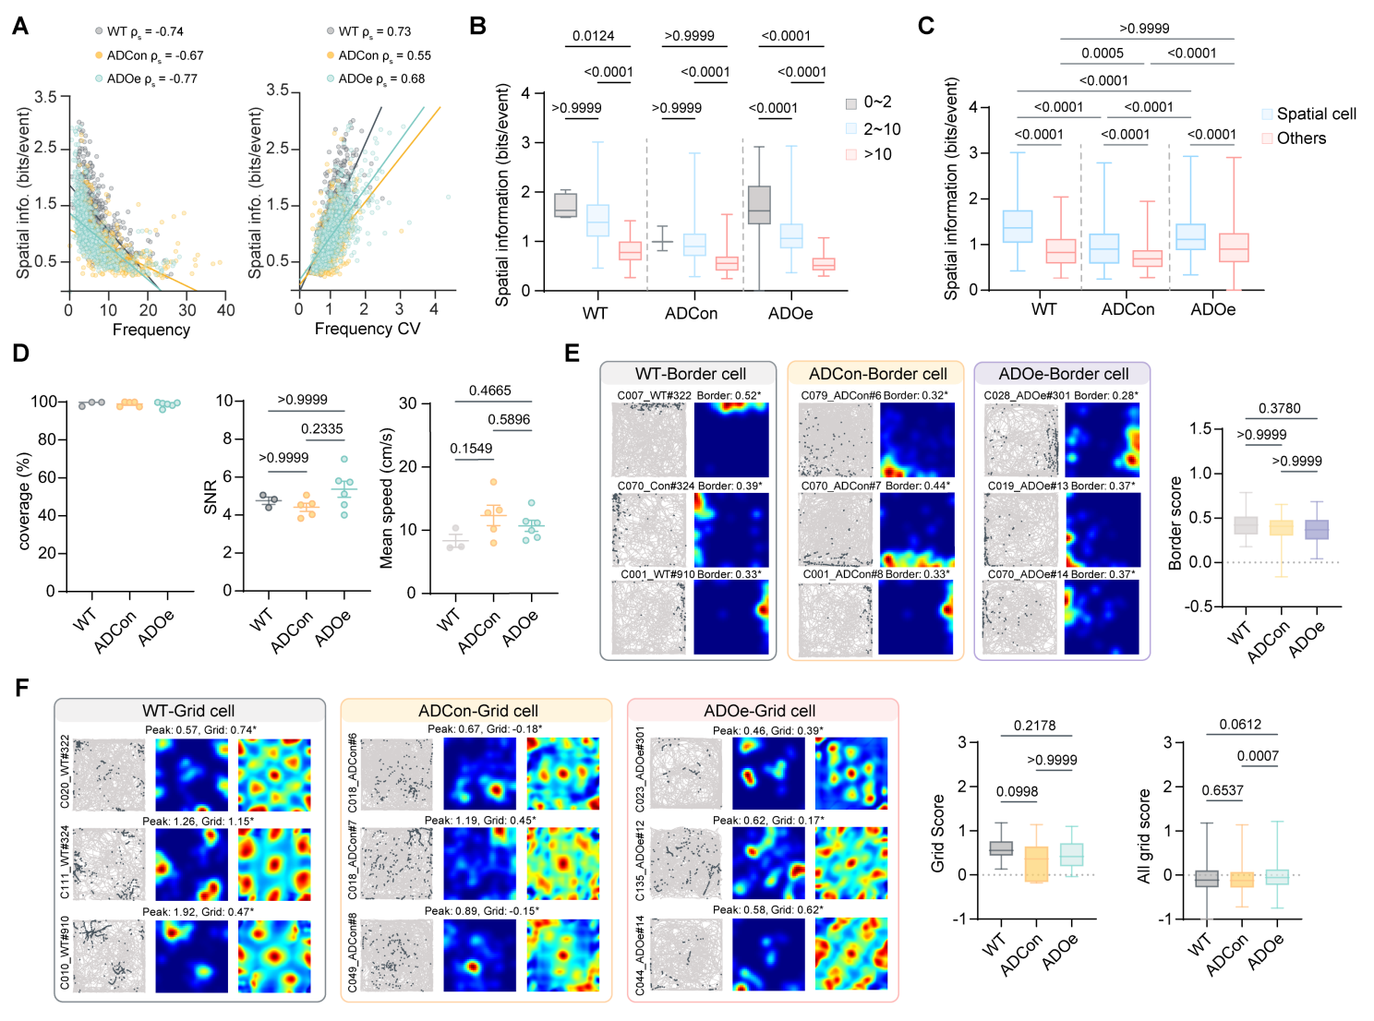
Figure S5. Activity-state-dependent spatial information and spatial-cell subtype analyses following MEC-targeted Gpr6 overexpression.
(A) Relationships between spatial information and calcium-event frequency or event-frequency CV across recorded MEC neurons. Spearman coefficients are indicated; all P < 0.0001.
(B) Spatial information across low-, intermediate-, and high-activity bins. Pairwise adjusted P values are shown in the panel.
(C) Spatial information in spatial cells and others cells. Spatial cells include grid, border, NGS, and HD cells (WT: 371 spatial, 131 others; ADCon: 205 spatial, 300 others; ADOe: 387 spatial, 395 others; P values are shown in the panel).
(D) Control metrics, including movement-field coverage, calcium signal-to-noise ratio, and mean movement speed (WT: N = 3; ADCon: N = 5; ADOe: N = 6; P values are shown in the panel).
(E) Representative border cells and border-score quantification. Pairwise adjusted P values are listed in the order WT vs ADCon, WT vs ADOe, and ADCon vs ADOe: P > 0.9999, P = 0.3780, and P > 0.9999 (WT: n = 78 cells, N = 3; ADCon: n = 18, N = 5; ADOe: n = 37, N = 6).
(F) Representative grid cells and quantification of grid score and all-grid score. Pairwise adjusted P values are listed in the same order as in E. Grid score: P = 0.0998, P = 0.2178, and P > 0.9999. All-grid score: P = 0.6537, P = 0.0612, and P = 0.0007 (WT: n = 40 cells, N = 3; ADCon: n = 9, N = 5; ADOe: n = 16, N = 6).
Pairwise comparisons were performed using Kruskal–Wallis tests with multiple-comparison correction unless otherwise stated.
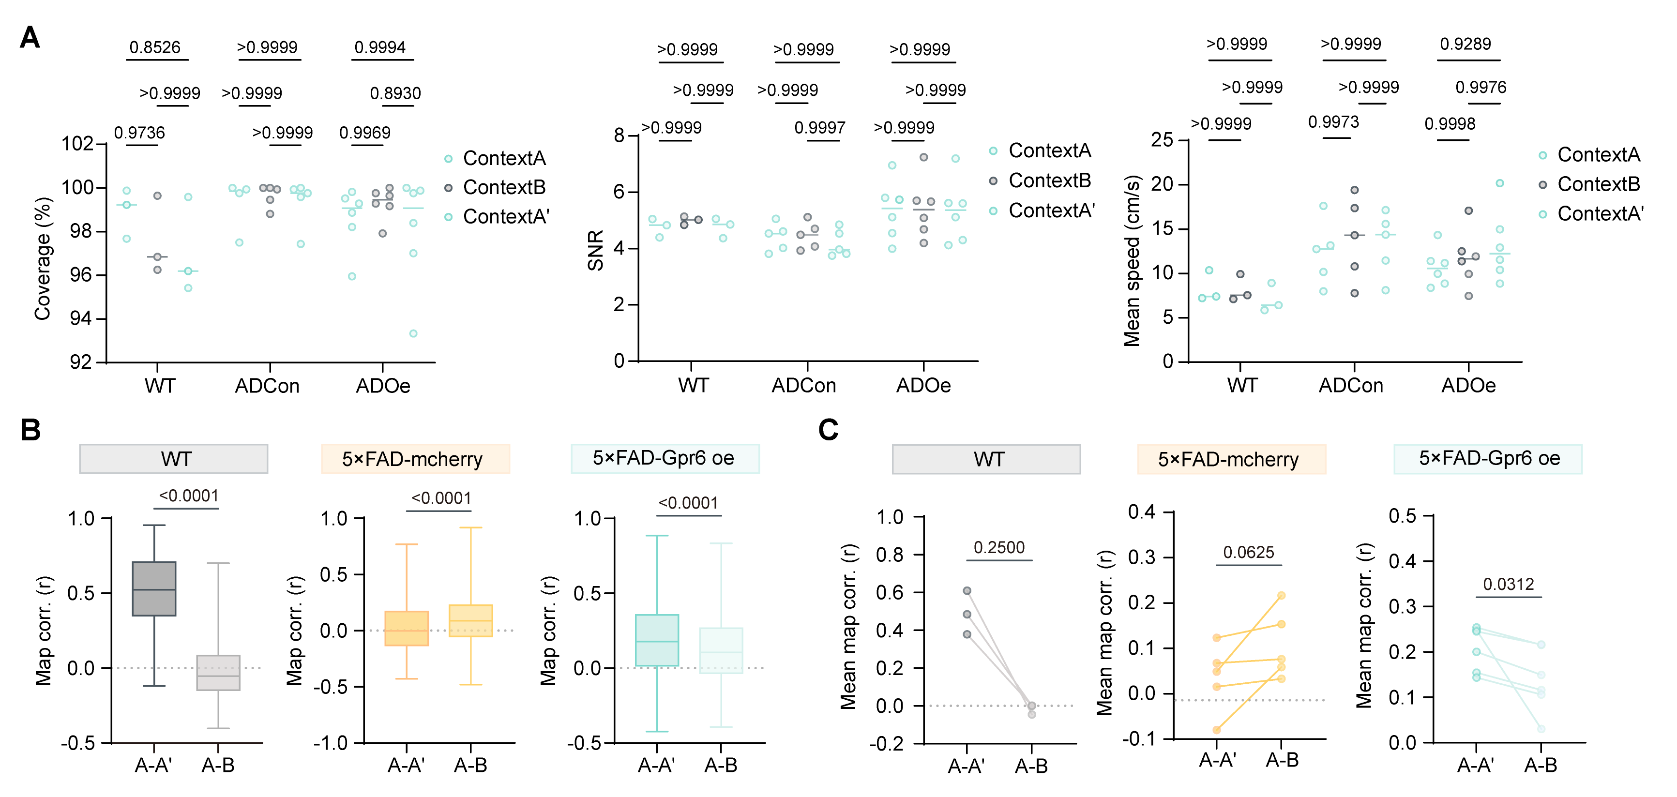
Figure S6. Session control metrics and map-correlation analyses across contexts following MEC-targeted Gpr6 overexpression.
(A) Control metrics across Context A, Context B, and repeated Context A′, including movement-field coverage, calcium signal-to-noise ratio, and mean movement speed. Pairwise adjusted P values are shown in the panel.
(B) Cell-level spatial map correlations across all recorded MEC neurons for A–A′ and A–B. Within-group A–A′ versus A–B comparisons were significant in all groups (WT, P < 0.0001; ADCon, P < 0.0001; ADOe, P < 0.0001; WT: n = 502 cells, N = 3; ADCon: n = 508, N = 5; ADOe: n = 783, N = 6).
(C) Mouse-level spatial map correlations for A–A′ and A–B. Mean map correlations were calculated for each mouse before within-group comparison (WT, P = 0.2500; ADCon, P = 0.0625; ADOe, P = 0.0312; WT: N = 3; ADCon: N = 5; ADOe: N = 6).
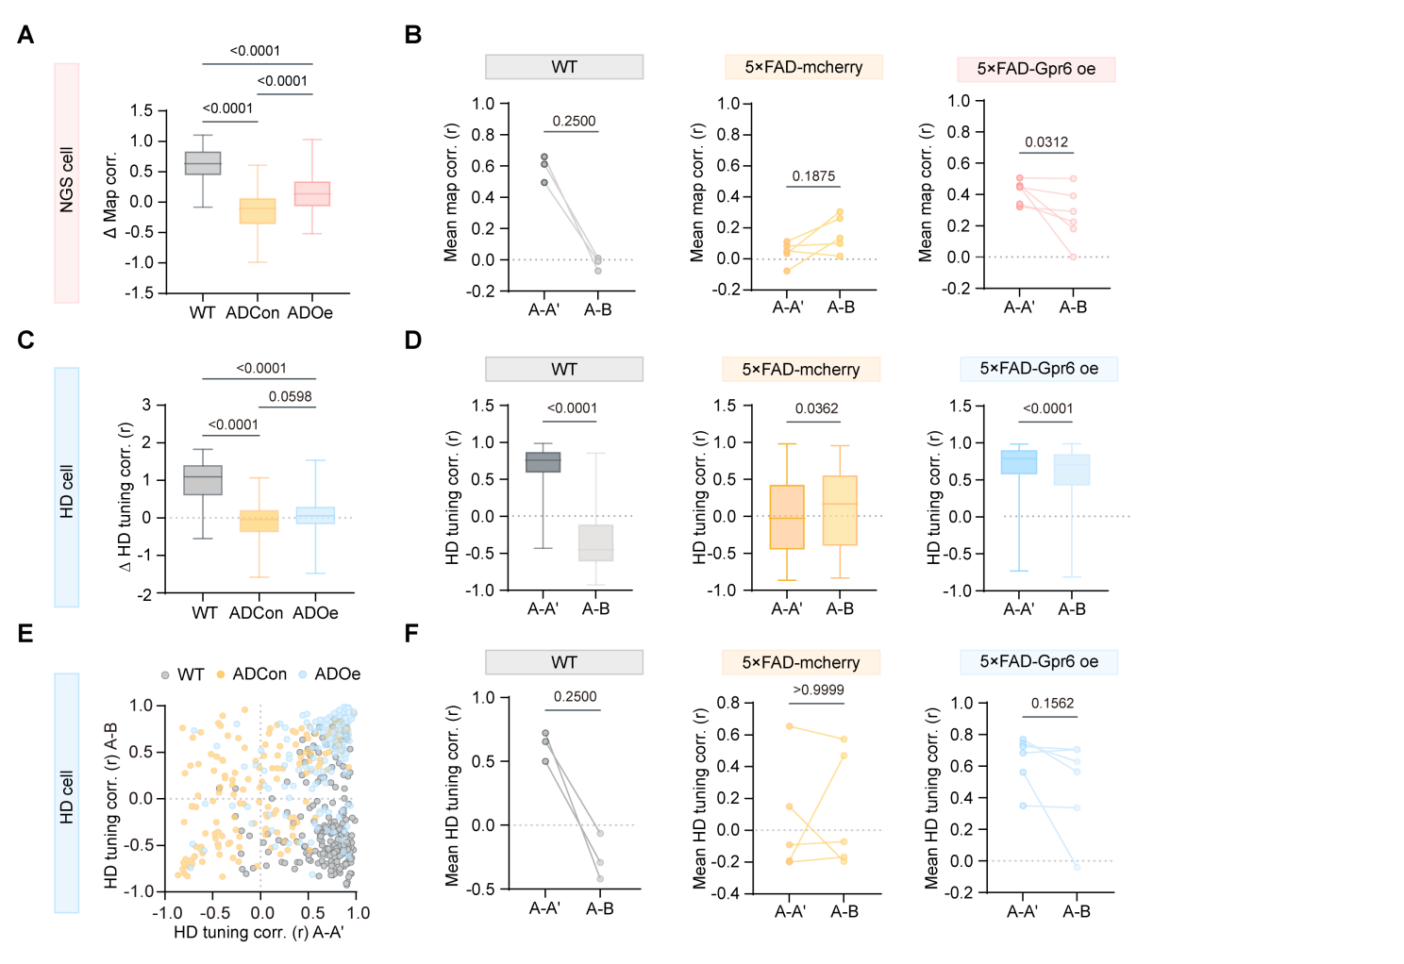
Figure S7. Cross-context correlation analyses of MEC spatial maps and head-direction tuning.
(A) NGS cell Δ map correlation, calculated as corr(A–A′) − corr(A–B). Pairwise adjusted P values are listed in the order WT vs ADCon, WT vs ADOe, and ADCon vs ADOe: P < 0.0001, P < 0.0001, and P < 0.0001 (WT: n = 217 cells, N = 3; ADCon: n = 114, N = 5; ADOe: n = 136, N = 6, Kruskal–Wallis tests).
(B) Mouse-level NGS map correlations for A–A′ and A–B. Mean map correlations were calculated for each mouse before within-group comparison (WT, P = 0.2500; ADCon, P = 0.1875; ADOe, P = 0.0312; WT: N = 3; ADCon: N = 5; ADOe: N = 6, Wilcoxon matched-pairs test).
(C) HD cell Δ tuning correlation, calculated as corr(A–A′) − corr(A–B). Pairwise adjusted P values are listed in the order WT vs ADCon, WT vs ADOe, and ADCon vs ADOe: P < 0.0001, P < 0.0001, and P = 0.0598 (WT: n = 202 cells, N = 3; ADCon: n = 156, N = 5; ADOe: n = 197, N = 6, Kruskal–Wallis tests).
(D) Cell-level HD tuning correlations for A–A′ and A–B within each group (WT, P < 0.0001; ADCon, P = 0.0362; ADOe, P < 0.0001, Wilcoxon matched-pairs test).
(E) Joint distributions of HD tuning correlations for A–A′ and A–B.
(F) Mouse-level HD tuning correlations for A–A′ and A–B. Mean tuning correlations were calculated for each mouse before within-group comparison (WT, P = 0.2500; ADCon, P > 0.9999; ADOe, P = 0.1562; WT: N = 3; ADCon: N = 5; ADOe: N = 6, Wilcoxon matched-pairs test).
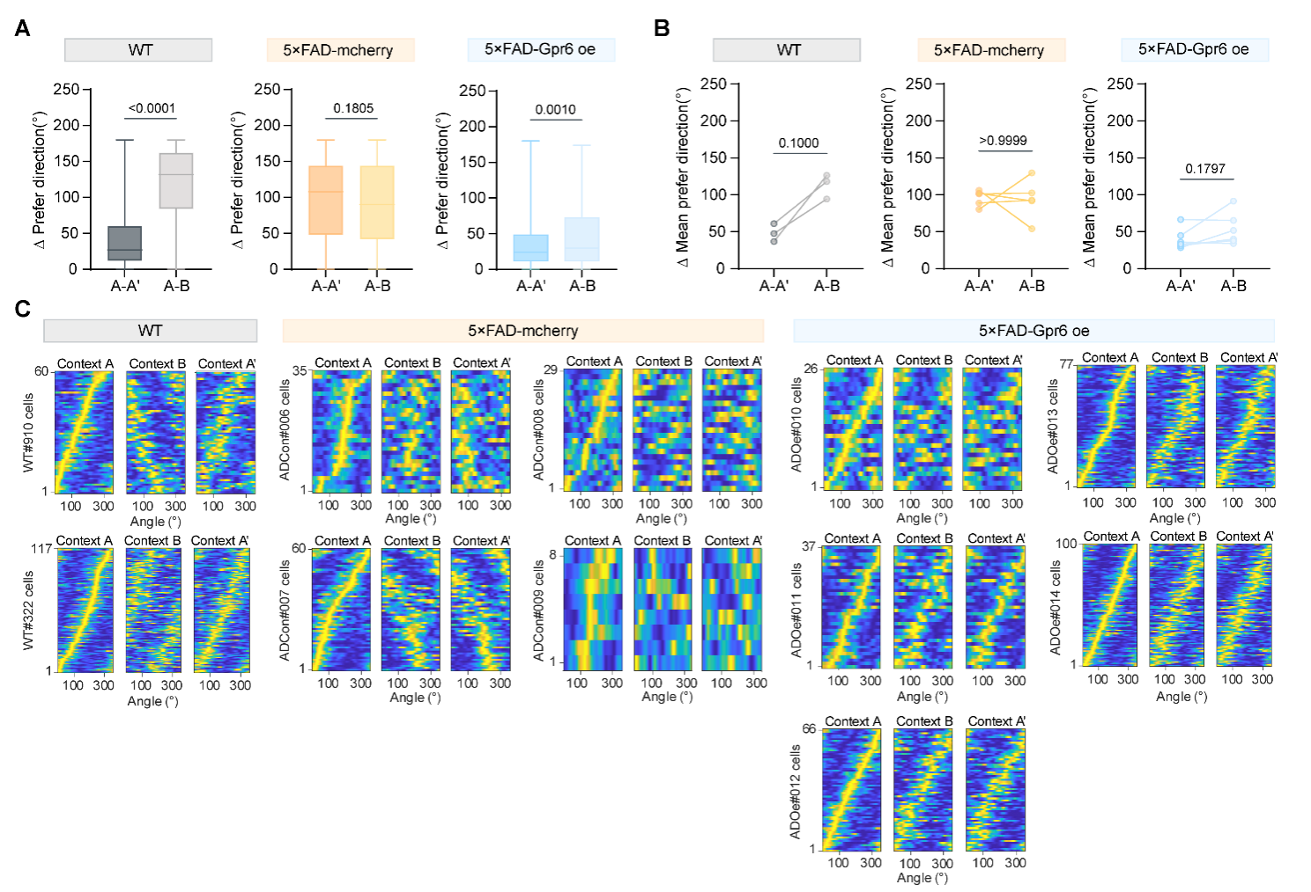
Figure S8. Preferred-direction differences of MEC head-direction cells across contexts.
(A) Cell-level preferred-direction differences in HD cells for A–A′ and A–B (WT, P < 0.0001; ADCon, P = 0.1805; ADOe, P = 0.0010; WT: n = 202 cells, N = 3; ADCon: n = 156, N = 5; ADOe: n = 197, N = 6; Wilcoxon matched-pairs test).
(B) Mouse-level mean preferred-direction differences in HD cells for A–A′ and A–B (WT, P = 0.1000; ADCon, P > 0.9999; ADOe, P = 0.1797; WT: N = 3; ADCon: N = 5; ADOe: N = 6; Wilcoxon matched-pairs test).
(C) Aligned HD tuning-curve heatmaps from individual mice across Context A, Context B, and Context A′. Tuning curves were aligned to the preferred direction in Context A.
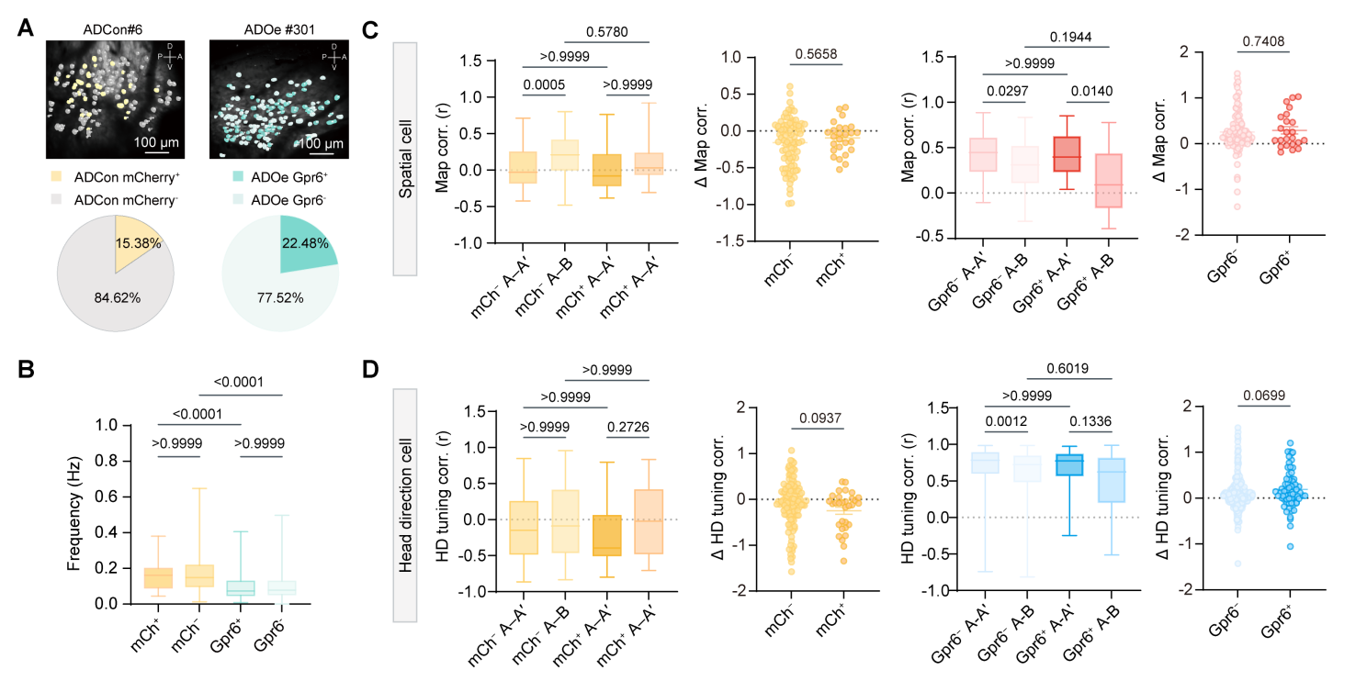
Figure S9. Activity and cross-context coding properties of mCherry-positive and mCherry-negative MEC neurons.
(A) Representative imaging fields showing virally labeled and non-labeled recorded MEC neurons in ADCon and ADOe mice. In ADCon mice, mCherry-positive neurons indicate control-virus-labeled cells. In ADOe mice, Gpr6+ neurons indicate mCherry-positive Gpr6-overexpressing cells, whereas Gpr6− neurons indicate mCherry-negative non-overexpressing recorded cells. Pie charts summarize the proportions of labeled and non-labeled recorded neurons.
(B) Calcium-event frequency of labeled and non-labeled neurons (ADCon: mCherry+ n = 78 cells, N = 5; mCherry− n = 429, N = 5; ADOe: Gpr6+ n = 176, N = 6; Gpr6− n = 606, N = 6; P values are shown in the panel).
(C) Map correlations and Δ map correlations of labeled and non-labeled spatial cells. Δ map correlation was calculated as corr(A–A′) − corr(A–B) (ADCon: mCherry+ n = 26 cells, N = 5; mCherry− n = 88, N = 3; ADOe: Gpr6+ n = 23, N = 5; Gpr6− n = 98, N = 6; P values are shown in the panel).
(D) HD tuning correlations and Δ HD tuning correlations of labeled and non-labeled HD cells. Δ HD tuning correlation was calculated as corr(A–A′) − corr(A–B) (ADCon: mCherry+ n = 31 cells, N = 3; mCherry− n = 124, N = 5; ADOe: Gpr6+ n = 65, N = 5; Gpr6− n = 275, N = 6; P values are shown in the panel).
Mann–Whitney U tests were used for labeled versus non-labeled comparisons. Kruskal–Wallis tests with multiple-comparison correction were used for comparisons involving more than two groups.
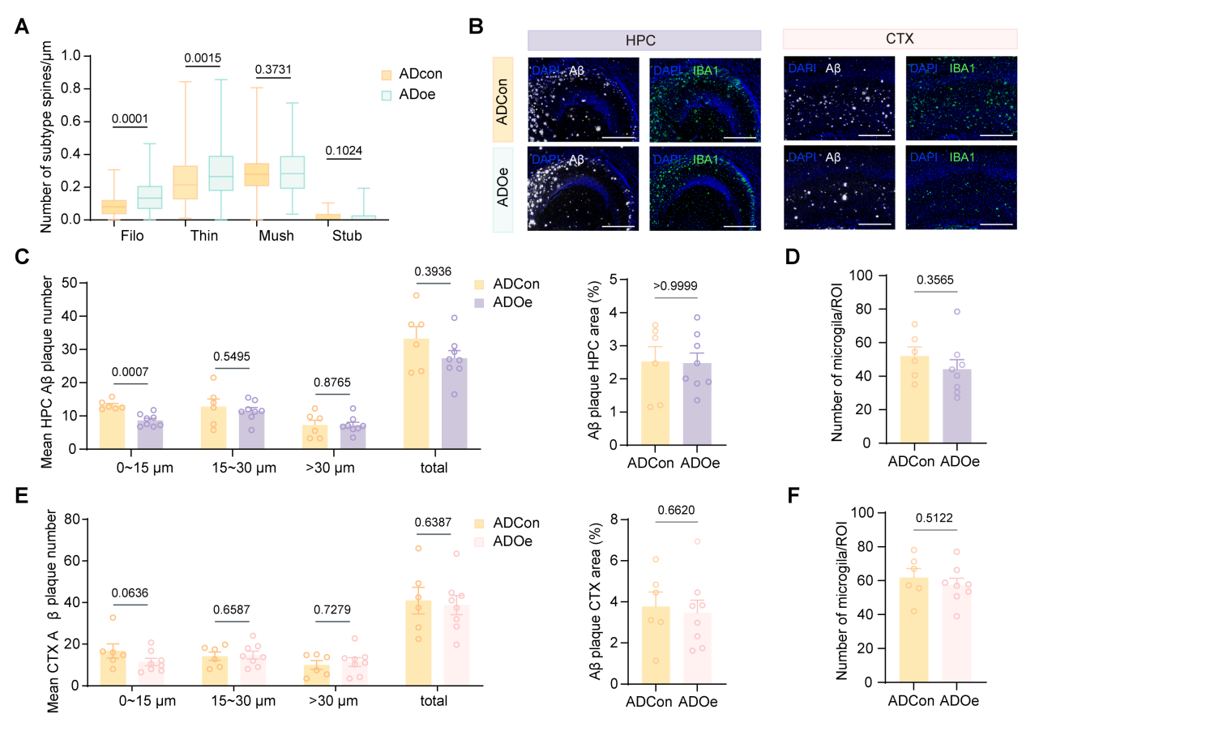
Figure S10. Spine subtype analysis and regional pathological assessment following MEC-targeted Gpr6 overexpression.
(A) Density of dendritic spine subtypes in MEC neurons from ADCon and ADOe mice. Gpr6 overexpression increased filopodia and thin spine densities, whereas mushroom and stubby spine densities were not significantly changed (filopodia, P = 0.0001; thin, P = 0.0015; mushroom, P = 0.3731; stubby, P = 0.1024; ADCon: n = 188 dendrites, N = 4; ADOe: n = 184, N = 4; Mann–Whitney U test).
(B) Representative Aβ and IBA1 immunostaining images in the hippocampus and cortex. Aβ is shown in white, IBA1 in green, and DAPI in blue.
(C) Hippocampal Aβ plaque number by diameter and total plaque number (0–15 μm, P = 0.0007; 15–30 μm, P = 0.5495; >30 μm, P = 0.8765; total plaque number, P = 0.3936; ADCon: N = 6; ADOe: N = 8; Mann–Whitney U test).
(D) Hippocampal Aβ-positive area fraction and microglial number per ROI (Aβ area, P > 0.9999; microglia, P = 0.3565; ADCon: N = 6; ADOe: N = 8; Mann–Whitney U test).
(E) Cortical Aβ plaque number by diameter and total plaque number (0–15 μm, P = 0.0636; 15–30 μm, P = 0.6587; >30 μm, P = 0.7279; total plaque number, P = 0.6387; ADCon: N = 6; ADOe: N = 8; Mann–Whitney U test).
(F) Cortical Aβ-positive area fraction and microglial number per ROI (Aβ area, P = 0.6620; microglia, P = 0.5122; ADCon: N = 6; ADOe: N = 8; Mann–Whitney U test).

