Supplementary Material
Supplementary Table 1. Summary of the foundation models evaluated in this study.
Model | Architecture/Patch Size | Pretraining resolution | Pretraining data | Class-token | Pooling
General-purpose vision foundation models
DINOv3-Large | ViT-Large/16 | 224 × 224, 512 × 512 | LVD-1689M | Yes | Class-token
Perception Encoder-Large | ViT-Large/14 | 336 × 336 | 5.4 billion image–text pairs | Yes | Attention-pooling
Efficient Universal Perception Encoder-Base | ViT-Base/16 | 256 × 256, 384 × 384, 512 × 512 | LVD-1689M | Yes | Class-token
CFP-based foundation models
RETFound-DINOv2 | ViT-Large/14 | 224 × 224 | 904,170 CFPs | Yes | Class-token
VisionFM-CFP | ViT-Base/16 | 224 × 224 | 1,010,293 CFPs | Yes | Class-token
RETFound-Green | ViT-Small/14 | 392 × 392 | 75,000 CFPs | No | Global Average Pooling
UrFound | ViT-Base/16 | 224 × 224 | 103,786 CFPs and 83,484 OCT slices with paired text | No | Global Average Pooling
RetiZero | ViT-Large/16 | 224 × 224 | 341,896 CFPs with paired text | No | Global Average Pooling
OCT-based foundation models
RETFound-MAE | ViT-Large/16 | 224 × 224 | 736,442 OCT slices (Moorfields Eye Hospital and Kermany dataset) | No | Global Average Pooling
VisionFM-OCT | ViT-Base/16 | 224 × 224 | 1,420,357 OCT slices | Yes | Class-token
MIRAGE-Large | ViT-Large/32 | 512 × 512 | 261,184 paired OCT slices and SLO images | No | Global Average Pooling
Models are grouped by the domain of their pretraining data: general-purpose models pretrained on natural images, models pretrained on colour fundus photographs (CFP), and models pretrained on OCT. For each model, the table lists the backbone architecture and patch size, the input resolution used during pretraining, a summary of the pretraining data, whether the backbone has a class token, and the pooling strategy used to obtain the image-level embedding. Architecture is denoted as ViT-size/patch size; for example, ViT-Large/16 indicates a large vision transformer operating on 16 × 16 pixel patches.
Abbreviations: CFP, colour fundus photograph;OCT, optical coherence tomography; SLO, scanning laser ophthalmoscopy; ViT, vision transformer.

Supplementary Figure 1. Point-based annotation and the point-guided clinical sign retrieval protocol used in Task 2.
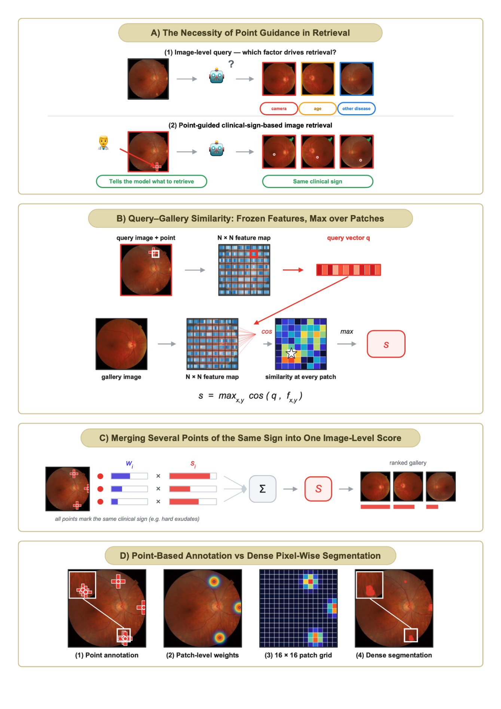

Overview of point-based annotation and point-guided clinical sign retrieval (Task 2). (A) Necessity of point guidance. (1) When the query is only an image, the target of the search is unclear: an ophthalmic image (a fundus photograph or an OCT B-scan) typically contains several coexisting findings, so retrieval may instead be driven by the camera or device, by age, or by a disease other than the one of interest. (2) A point annotation specifies which clinical sign the query refers to, so that the gallery is ranked by similarity with respect to that sign and the top-ranked images are expected to exhibit the same sign as the query. (B) Query-to-gallery patch similarity. The spatial feature map is taken from the frozen backbone before any aggregation, such as global average pooling, attention pooling, or class-token (CLS) pooling, and without task-specific adaptation. For each query patch containing the annotated points of a given clinical sign (defined in C), the patch's feature vector q is compared by cosine similarity with the feature vector at every position of the gallery image's ⌊H/P⌋ × ⌊W/P⌋ feature map, where H and W are the image height and width and P is the patch size, and the maximum score over all positions is taken as the patch score s (the star marks the arg max location). (C) Merging several points. The binary point map of a given sign (1 at an annotated point, 0 elsewhere) is smoothed with a 7 × 7 Gaussian kernel and average-pooled onto the ⌊H/P⌋ × ⌊W/P⌋ patch grid, which matches the feature map after patchification, then normalised so that the weights sum to one. Patches whose weight exceeds 1/(⌊H/P⌋ × ⌊W/P⌋) are taken as the query patches. The image-level score S for a query-gallery image pair is the weighted average of the patch-wise maxima s from (B), using these weights, so that all points annotated for the sign of interest in the query image (for example, several hard exudates) are summarised into a single score, with the weights reflecting both the proximity and the density of the annotated points. (D) Annotation. (1) A single image may contain several annotated points for the same clinical sign. (2) Following (C), the binary point map is smoothed with a Gaussian kernel. (3) The weight map is then average-pooled onto the ⌊H/P⌋ × ⌊W/P⌋ patch grid (P = 16 in this example) and normalised so that the weights sum to one. (4) Conventional dense pixel-wise segmentation instead requires every lesion boundary to be delineated, which makes annotation considerably more costly. Colour fundus photographs are shown for illustration only, and all annotations drawn on them are illustrative examples rather than the study ground truth.

Supplementary Figure 2. Task 1 (DR-CFP) performance on the internal validation dataset and four external validation datasets.
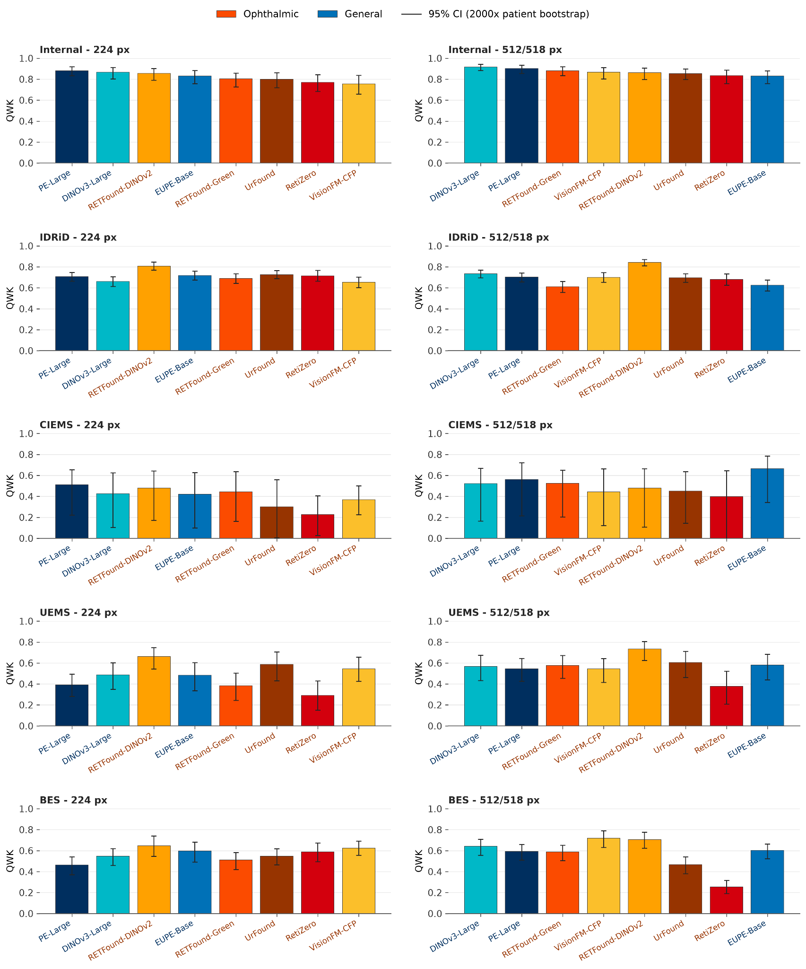
Quadratic weighted kappa (QWK) for each foundation model on International Clinical Diabetic Retinopathy (ICDR) severity grading from colour fundus photographs (CFP), evaluated on the internal validation dataset and on four external validation datasets (IDRiD, CIEMS, UEMS, and BES), and shown separately for the low-resolution (224 px) and high-resolution (512/518 px) settings. Bars represent point estimates and error bars denote 95% bootstrap confidence intervals from 2000 replicates. Resampling was performed at the patient level for all datasets except IDRiD, for which patient identifiers were unavailable and resampling was therefore performed at the image level. Orange bars indicate ophthalmic foundation models, and blue bars indicate general-purpose foundation models. Within each column, models are ordered by their QWK on the internal validation dataset.
Abbreviations: BES, Beijing Eye Study; CFP, colour fundus photograph; CIEMS, Central India Eye and Medical Study; DR, diabetic retinopathy; ICDR, International Clinical Diabetic Retinopathy; IDRiD, Indian Diabetic Retinopathy Image Dataset; QWK, quadratic weighted kappa; UEMS, Ural Eye and Medical Study.
Supplementary Figure 3. Task 1 (AMD-CFP) performance on the internal validation dataset and the external validation dataset.
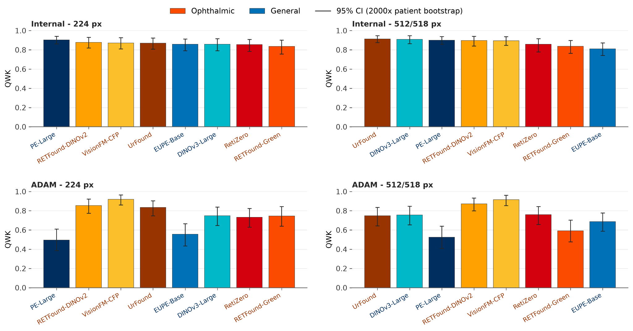
Quadratic weighted kappa (QWK) for each foundation model on four-class age-related macular degeneration (AMD) severity grading from colour fundus photographs (CFP), evaluated on the internal validation dataset and on the external validation dataset (ADAM), and shown separately for the low-resolution (224 px) and high-resolution (512/518 px) settings. Bars represent point estimates and error bars denote 95% bootstrap confidence intervals from 2000 replicates. Resampling was performed at the patient level for the internal validation dataset and at the image level for ADAM, for which patient identifiers were unavailable. Orange bars indicate ophthalmic foundation models, and blue bars indicate general-purpose foundation models. Within each column, models are ordered by their QWK on the internal validation dataset.
Abbreviations: ADAM, Automatic Detection challenge on Age-related Macular degeneration; AMD, age-related macular degeneration; CFP, colour fundus photograph; QWK, quadratic weighted kappa.

Supplementary Figure 4. Task 1 (AMD-OCT) performance on the internal validation dataset and the external validation dataset.
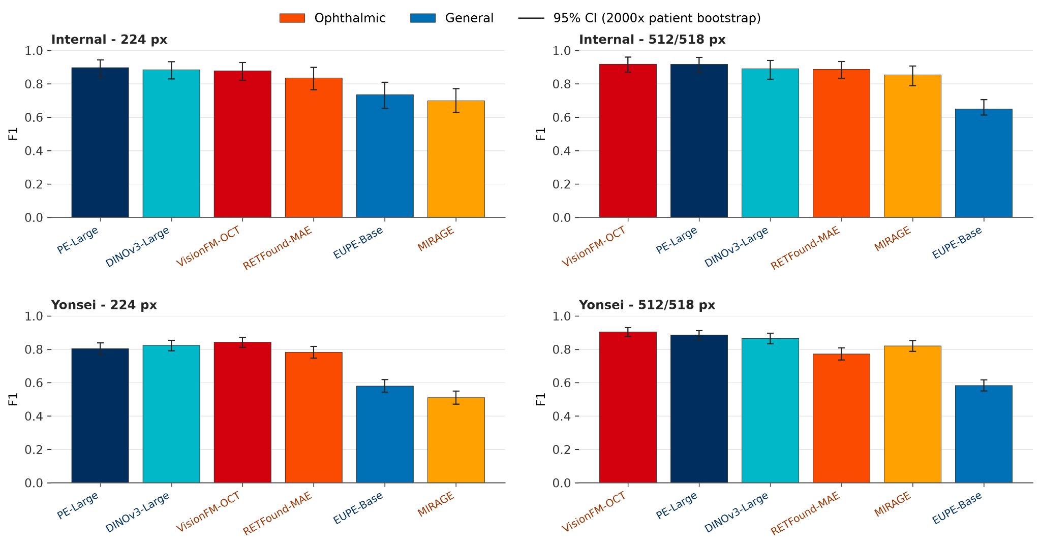
F1 score for each foundation model on three-class age-related macular degeneration (AMD) classification from optical coherence tomography (OCT) B-scans, evaluated on the internal validation dataset and on the external validation dataset (Yonsei), and shown separately for the low-resolution (224 px) and high-resolution (512/518 px) settings. Bars represent point estimates and error bars denote 95% bootstrap confidence intervals from 2000 replicates. Resampling was performed at the patient level for both the internal and the external validation datasets. Orange bars indicate ophthalmic foundation models, and blue bars indicate general-purpose foundation models. Within each column, models are ordered by their F1 score on the internal validation dataset.
Abbreviations: AMD, age-related macular degeneration; CI, confidence interval; OCT, optical coherence tomography.

Supplementary Figure 5. Task 2 (DR-CFP) retrieval performance for individual clinical signs across the internal and external datasets.
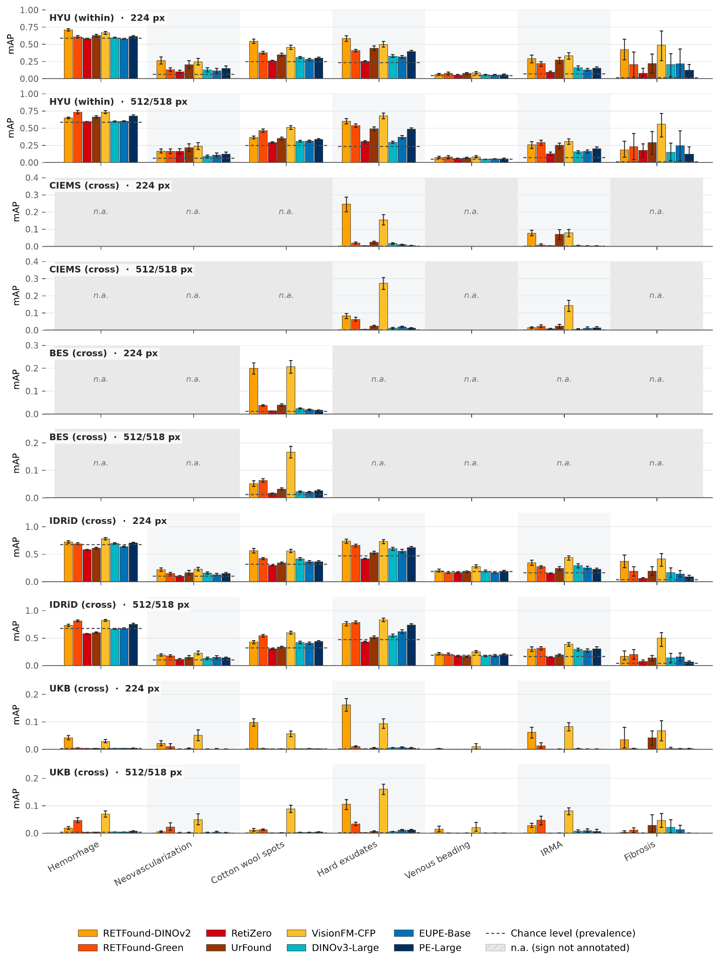
Mean average precision (mAP) for point-guided retrieval of each of seven clinical signs, shown separately for the internal dataset (HYU-DR-CFP, within-dataset retrieval) and each external dataset (CIEMS, BES, IDRiD, and UKB, cross-dataset retrieval), and for the low-resolution (224 px) and high-resolution (512/518 px) settings. Each query consists of a single image annotated for one clinical sign, with one or more points of that sign (for example, one or several hard exudates). Bars represent individual foundation models, colour-coded as in the key: orange bars indicate ophthalmic foundation models, and blue bars indicate general-purpose foundation models. Error bars denote 95% bootstrap confidence intervals from 2000 replicates, with resampling performed at the patient level over the query images. Dashed lines mark the chance level, given by the prevalence of each sign in the corresponding gallery. Shaded panels labelled n.a. indicate signs that were not annotated in that dataset. Note the differing y-axis scales across datasets.
Abbreviations: BES, Beijing Eye Study; CFP, colour fundus photograph; CIEMS, Central India Eye and Medical Study; DR, diabetic retinopathy; IDRiD, Indian Diabetic Retinopathy Image Dataset; IRMA, intraretinal microvascular abnormality; mAP, mean average precision; UKB, UK Biobank.

Supplementary Figure 6. Task 2 (AMD-CFP) retrieval performance for individual clinical signs across the internal and external datasets.
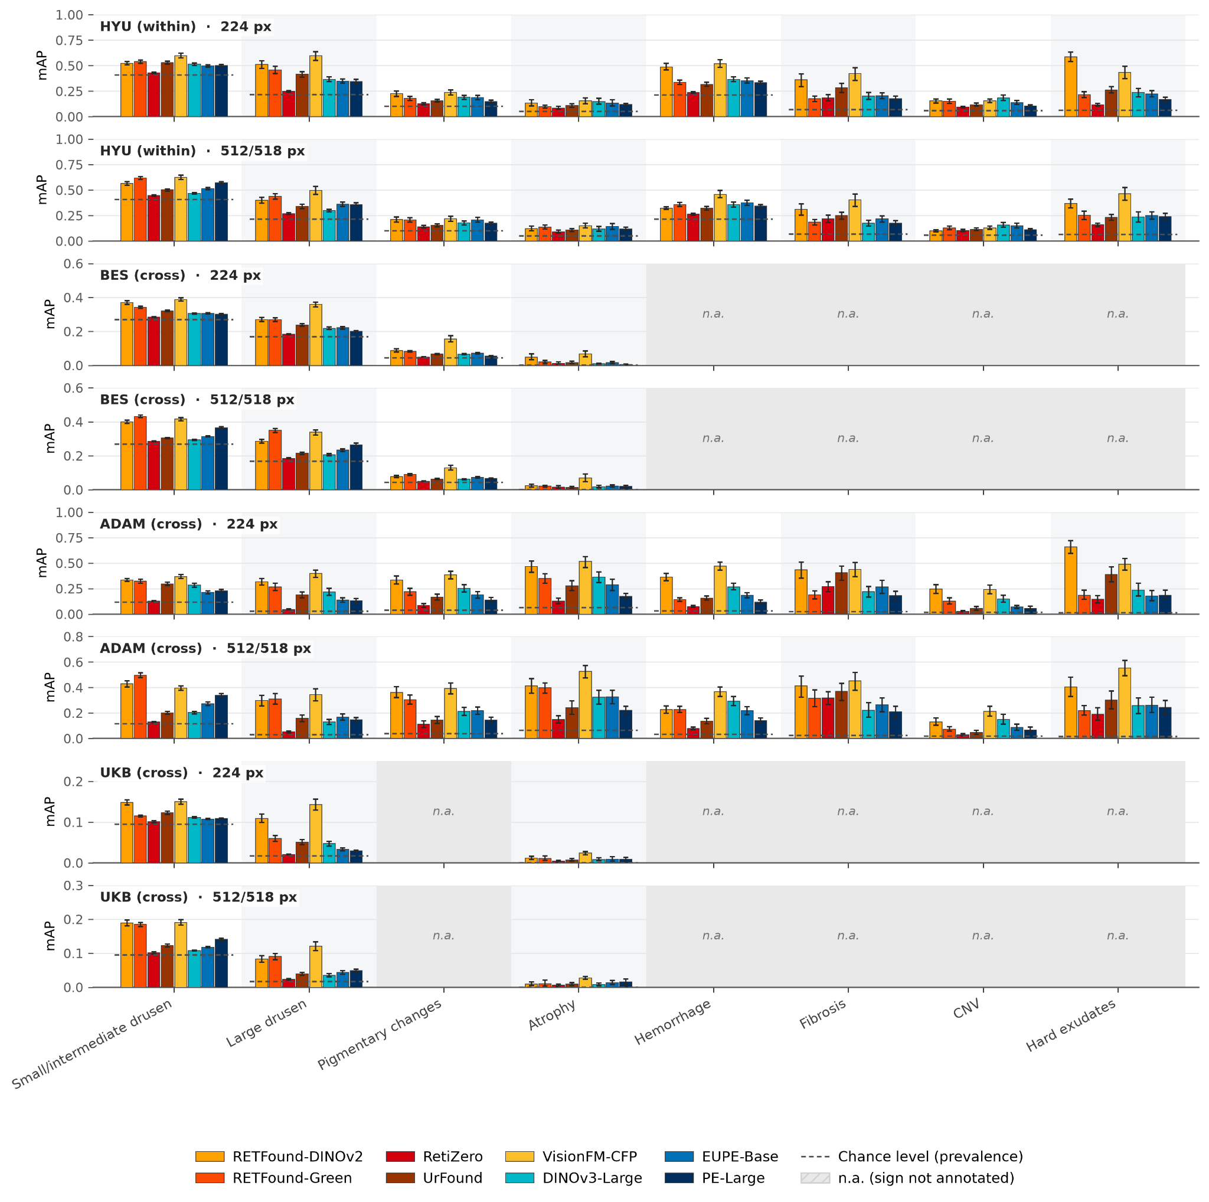
Mean average precision (mAP) for point-guided retrieval of each of eight clinical signs, shown separately for the internal dataset (HYU-AMD-CFP, within-dataset retrieval) and each external dataset (BES, ADAM, and UKB, cross-dataset retrieval), and for the low-resolution (224 px) and high-resolution (512/518 px) settings. Each query consists of a single image annotated for one clinical sign, with one or more points of that sign (for example, one or several large drusen). Bars represent individual foundation models, colour-coded as in the key: orange bars indicate ophthalmic foundation models, and blue bars indicate general-purpose foundation models. Error bars denote 95% bootstrap confidence intervals from 2000 replicates, with resampling performed at the patient level over the query images. Dashed lines mark the chance level, given by the prevalence of each sign in the corresponding gallery. Shaded panels labelled n.a. indicate signs that were not annotated in that dataset. Note the differing y-axis scales across datasets.
Abbreviations: ADAM, Automatic Detection challenge on Age-related Macular degeneration; AMD, age-related macular degeneration; BES, Beijing Eye Study; CFP, colour fundus photograph; CNV, choroidal neovascularisation; mAP, mean average precision; UKB, UK Biobank.
Supplementary Figure 7. Task 2 (AMD-OCT) retrieval performance for individual clinical signs across the internal and external datasets.
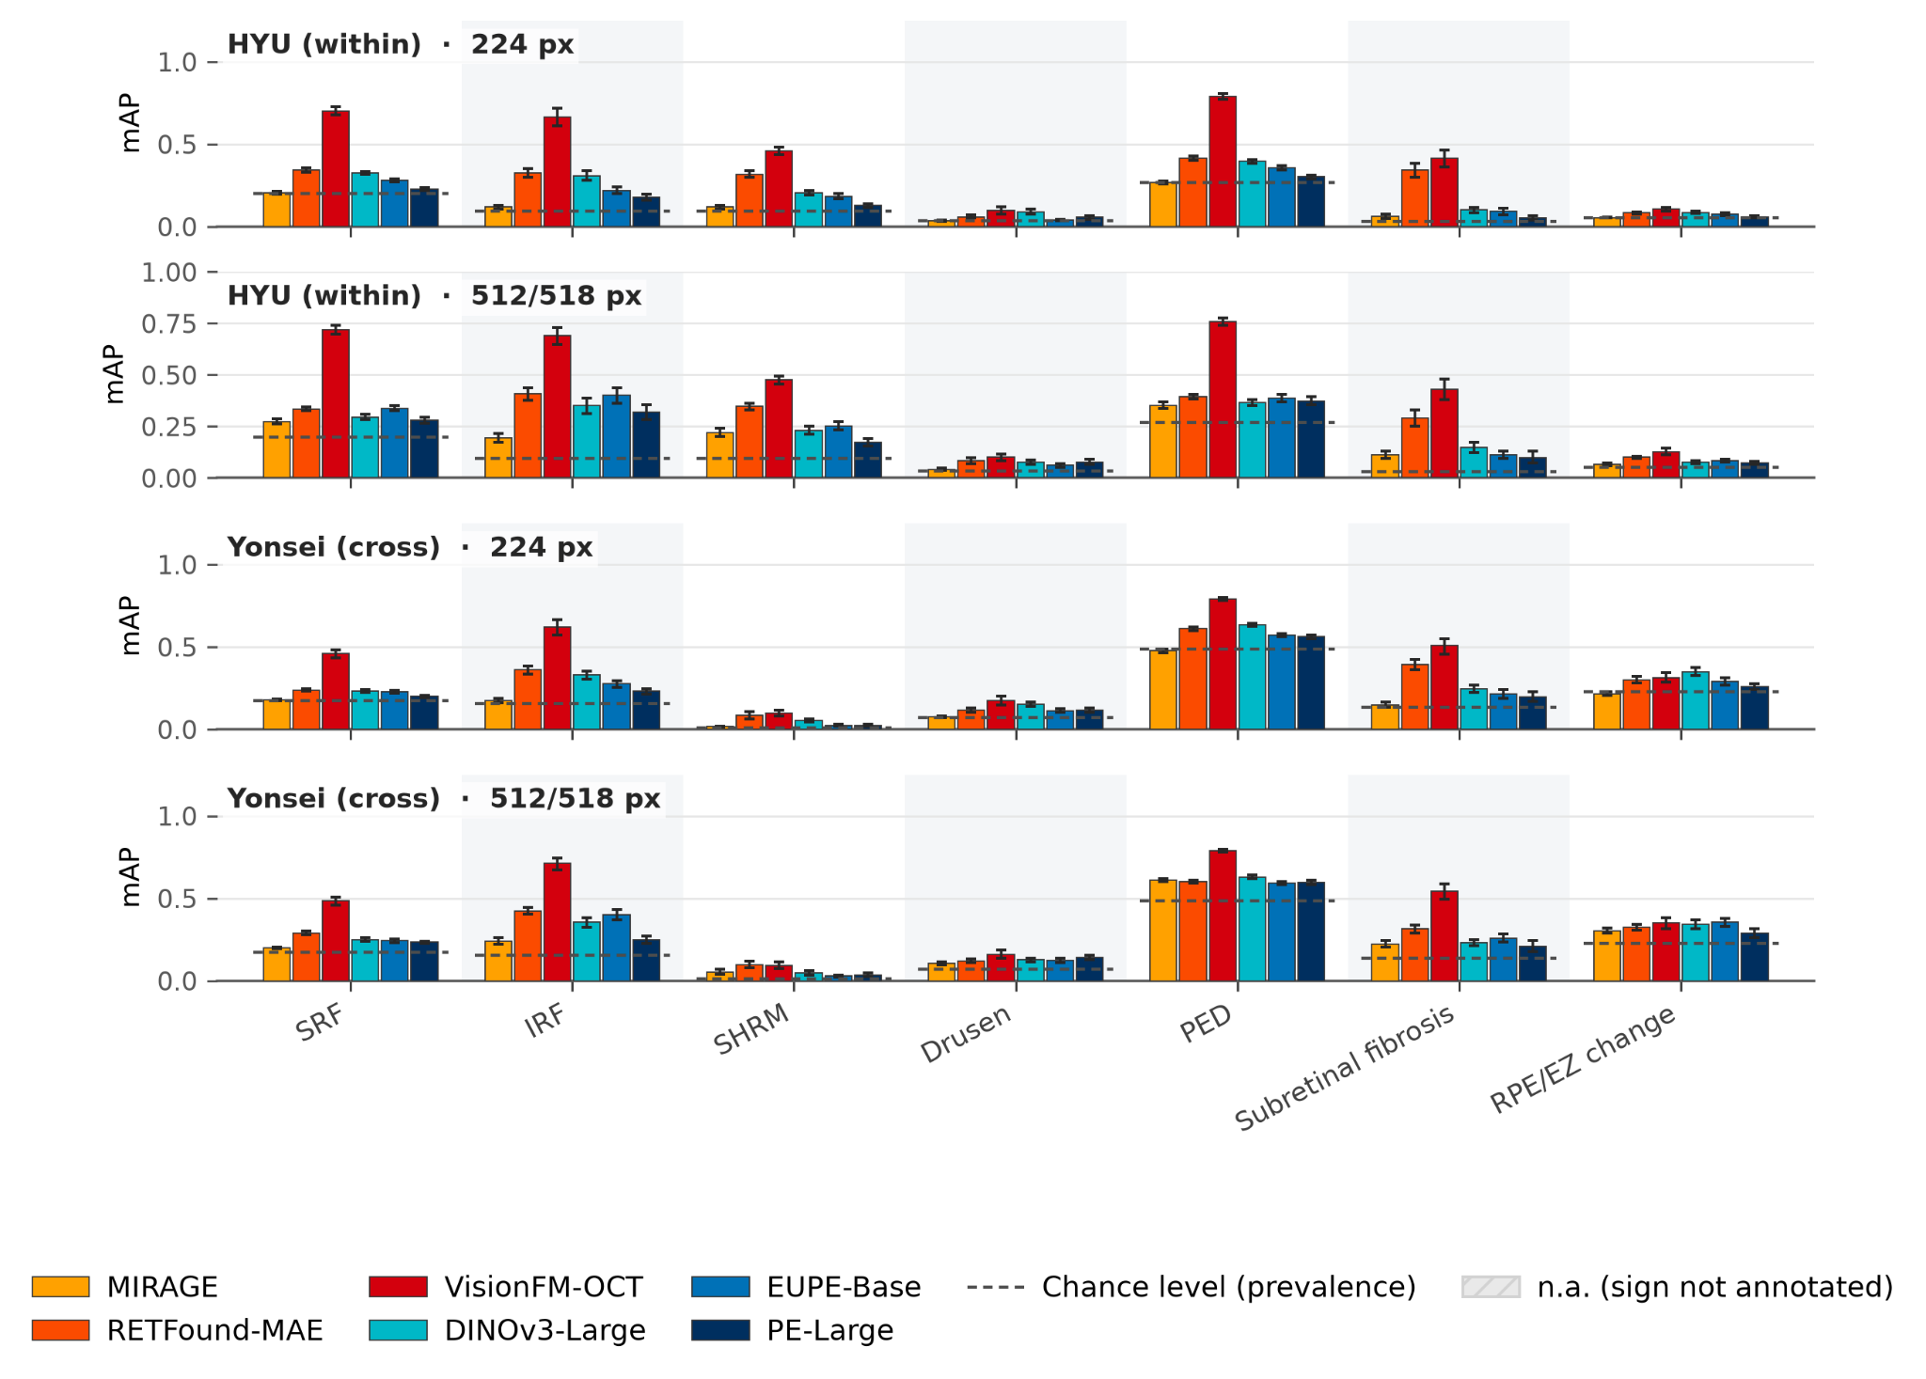
Mean average precision (mAP) for point-guided retrieval of each of seven clinical signs, shown separately for the internal dataset (HYU-AMD-OCT, within-dataset retrieval) and the external dataset (Yonsei, cross-dataset retrieval), and for the low-resolution (224 px) and high-resolution (512/518 px) settings. Each query consists of a single optical coherence tomography (OCT) B-scan annotated for one clinical sign, with one or more points of that sign. Bars represent individual foundation models, colour-coded as in the key: orange bars indicate ophthalmic foundation models, and blue bars indicate general-purpose foundation models. Error bars denote 95% bootstrap confidence intervals from 2000 replicates, with resampling performed at the patient level over the query images. Dashed lines mark the chance level, given by the prevalence of each sign in the corresponding gallery. All seven signs were annotated in both datasets.
Abbreviations: AMD, age-related macular degeneration; EZ, ellipsoid zone; IRF, intraretinal fluid; mAP, mean average precision; OCT, optical coherence tomography; PED, pigment epithelial detachment; RPE, retinal pigment epithelium; SHRM, subretinal hyperreflective material; SRF, subretinal fluid.

Supplementary Figure 8. Retrieval performance of attention probing, image-level features, and point-guided features taken across encoder depth.
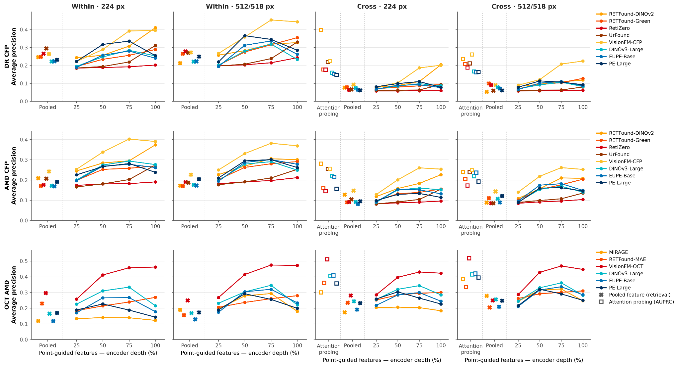
Retrieval performance, measured by mean average precision, was evaluated under the three settings shown along the x axis. In attention probing, the backbone was kept frozen and an attention-pooling head was trained for each clinical sign as a binary classification task; candidates were then ranked by the predicted probability. Pooled is the image-level feature produced by each frozen pretrained model's own aggregation scheme (class-token, average pooling or attention pooling). 25–100 % is point-guided feature aggregation applied to patch tokens taken from a given relative depth of the frozen encoder (25, 50, 75 and 100 % of network depth). In these two feature-based settings, candidates were ranked by cosine similarity to the query feature. Because the attention-probing heads were trained on all within (internal) data, only cross-cohort (external) retrieval is reported for that setting; ophthalmic foundation models retained their advantage there. Each dot and line represents one model, coloured warm for ophthalmic foundation models and cool for general-purpose vision models. Rows correspond to the three tasks (DR CFP, AMD CFP, OCT AMD), and columns to retrieval scope and input resolution; external retrieval was macro-averaged across independent cohorts so that each cohort contributes equally. The y axis is shared across columns within each row.

Supplementary Figure 9. Pointing Accuracy.
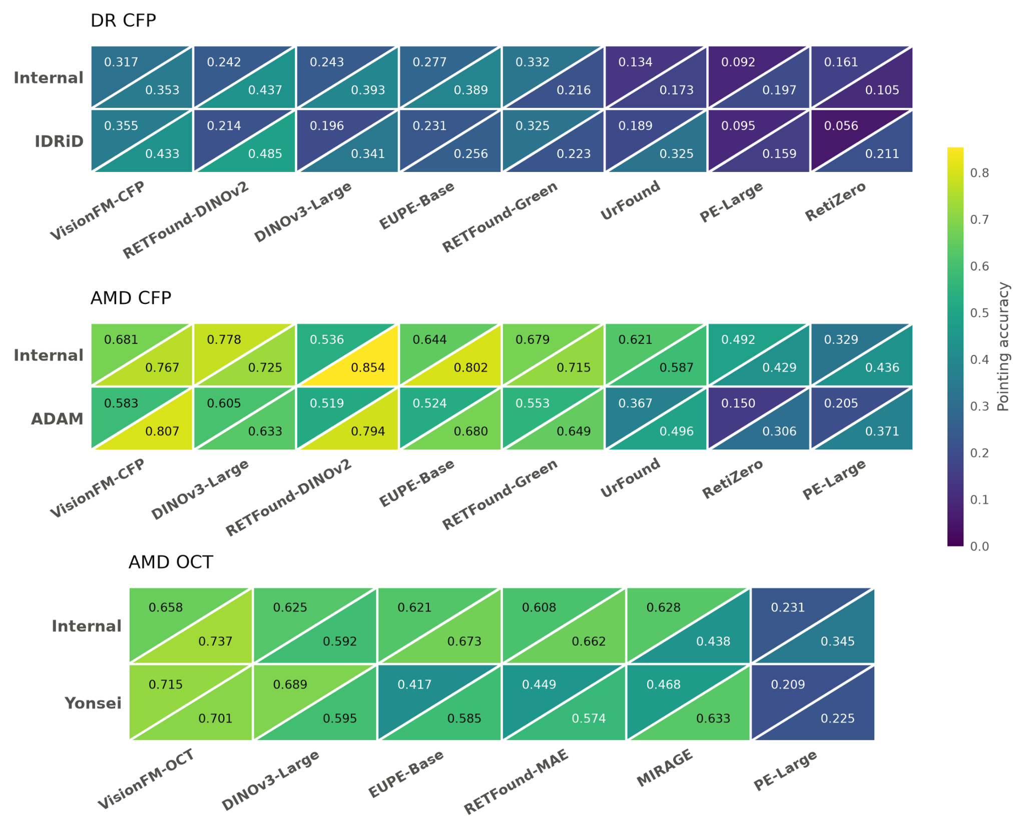
For each gallery image, the patch most similar to the query image is selected. Pointing accuracy is defined as the proportion of these selected patches that contain the queried clinical sign, and is computed only on correct top-1 retrievals (i.e., gallery images sharing the same clinical sign as the query), so that the metric reflects localisation quality rather than retrieval correctness. Panels correspond to the three tasks (DR CFP, AMD CFP, AMD OCT). Within each cell, the upper-left triangle shows the high-resolution input (512/518 px) and the lower-right triangle the low-resolution input (224 px). Values are unweighted means across lesion types within each task.

